The European Cardiac Arrhythmia Genetics (ECGen) Focus Group

Carol Ann Remme¹, Christophe Leclercq², Elijah R. Behr³

¹Department of Clinical and Experimental Cardiology, Heart Center, Amsterdam UMC, location Academic Medical Center, Amsterdam, The Netherlands
²Cardiologie, CHU Rennes, INSERM, LTSI-UMR 1099, University of Rennes, F-35000, Rennes, France
³Cardiology Research Centre and Cardiovascular Clinical Academic Group, Molecular and Clinical Sciences Institute, St. George's, University of London, London, United Kingdom; St. George's University Hospitals NHS Foundation Trust, London, United Kingdom.

Word count : 1399

Correspondence to:
Elijah R. Behr, MA, MBBS, MD
Cardiology Research Centre
Molecular and Clinical Sciences Institute
St George’s University of London
Cranmer Terrace
London
SW17 0RE
United Kingdom
Tel: +44 2087252994
Fax: +44 2087253416
Email: ebehr@sgul.ac.uk

Cardiac arrhythmia genetics- need for a multi-disciplinary network in Europe
Sudden cardiac death affects approximately three in every 100,000 European children and adults under the age of 35 every year. While it is uncommon, the impact on families and society is disproportionately greater than most sudden deaths occurring in older people. Most deaths are unheralded by prior symptoms or a family history and yet a majority are due to cardiac genetic disorders, mainly inherited arrhythmia syndromes such as long QT syndrome, catecholaminergic polymorphic ventricular tachycardia, Brugada syndrome and cardiomyopathies (Figure 1) (1). There is a clear need to identify patients and their families to mitigate their risk and prevent sudden death. The mission of the recently founded European Cardiac Arrhythmia Genetics (ECGen) focus group of the European Heart Rhythm Association (EHRA) is to address this need by improving education, training, patient guidelines and research in the field of inherited arrhythmia syndromes and genetic aspects of arrhythmia in Europe and further afield (2). The foundation for this focus group originated from the European Reference Network (ERN) for rare cardiac disease, GUARD-Heart, which was established to provide equality in patient care across Europe, facilitate education and training, and establish a collaborative network for governance and research. However, since the mission of GUARD-Heart extends well beyond the current and future coverage of the ERN, a need was recognised for a pan-European representative group of electrophysiology professionals and their colleagues working in the field of cardiac genetics as applied to arrhythmia syndromes, arrhythmias and sudden death.
ECGen is a multidisciplinary group and will therefore ensure collaboration with existing stakeholders, including i) the ESC Working Group for Myocardial and Pericardial Diseases (WGMPD) which addresses guidelines, education, training and research in the field of cardiomyopathy and its genetic basis, ii) the Association for European Cardiovascular Pathology (AECVP) which focuses on pathological and diagnostic guidelines and training in the investigation of sudden death including the role for genetic studies, iii) the European Society of Human Genetics (ESHG) which similarly has a broad interest in sudden death and cardiac genetics with a strong educational programme, iv) the newly founded ESC Council for Cardiovascular Genomics (CCG) whose mission is to encourage research, education and the sharing of genomic knowledge, v) the ESC Working Group on Cardiac Cellular Electrophysiology (WGCCE), providing a direct link with basic and translational arrhythmia research, vi) the arrhythmia and genetic working groups of the European Association of Preventive Cardiology (EAPC), and vii) the Association of Cardiovascular Nursing & Allied Professions (ACNAP).

The Objectives of ECGen
The objectives of the multi-disciplinary ECGen focus group, as depicted in Figure 2, are to:
- Develop and harmonise patient pathways and guidelines for clinical cardiology and genetic management of patients with arrhythmia syndromes and arrhythmic genetic disorders on behalf of EHRA and in collaboration with other European and international stakeholders, including the European Reference Network GUARD-Heart.
- Provide a framework for delivering education and training in the genetic arrhythmia field to European doctors and allied professionals.
- Provide a platform for interaction with national and European patient interest groups.
- Promote collaboration of members to collect data for research as well as interact with other stakeholders where objectives are shared.
- Collaborate with WGMPD, AECVP, ESHG, CCG, WGCCE, EAPC, and ACNAP.

ECGen committee composition and membership
During the first year, an Initial Committee was formed by members of the ERN GUARD-Heart and EHRA, which established the process for electing the first Elected Focus Group as well as procedures and membership rules. The Elected Committee will have a two-year term and will be subject to re-election every two years in the EHRA cycle. The ECGen Elected Committee is multi-disciplinary and consists of i) a Chairperson, Vice-Chairperson (deputises for Chairperson as required), and Past-Chairperson, who will all be consultant physicians; and ii) Members (at least 9), including five consultant physicians of which one must be a paediatric consultant physician, one trainee physician, one genetic nurse, one genetic counsellor and one scientist (2).. The ECGen Chairperson is a member of the EHRA Board as well as the ESC Council for Cardiovascular Genomics. ECGen members may be appointed by the EHRA President and the chairpersons of various EHRA committees to contribute to the association activities (Scientific Documents Committee, Education Committee, Congress Scientific Program Committee, Scientific Initiatives Committee). ECGen currently has 86 ordinary members; these require status as either a trainee or fully qualified adult or paediatric cardiologist, geneticist, pathologist, scientist, registered nurse or genetic counsellor with an interest in the field of cardiac arrhythmia genetics. Membership application forms can be filled in online at My ESC account under "New application”, and will be reviewed on a monthly basis. As an integral part of EHRA, all ECGen members have to be members of the association.

Ongoing and planned activities of ECGen
Prior to the first ECGen election, the focus group initial committee had already embarked on several initiatives. The Scientific Documents Committee in collaboration with ECGen successfully proposed an Expert Consensus Statement on the State of Genetic Testing for Cardiac Disease led by EHRA, in collaboration with the Heart Rhythm Society, Asia Pacific Heart Rhythm Society, and the Latin America Heart Rhythm Society, due to report in 2022. ECGen members also represented EHRA on the 2020 APHRS/HRS expert consensus statement on the investigation of decedents with sudden unexplained death and patients with sudden cardiac arrest, and of their families (3). Furthermore, the initial ECGen committee proposed to the Scientific Initiatives Committee to produce a survey on the provision of services and screening for patients and their families with Inherited Arrhythmia Syndromes, which identified significant heterogeneity in patient management across European centres and underscored the need for dedicated units and specialist services (4,5).
As a first initiative of the full elected committee, a survey of ECGen members was held in October 2020 to gain insight into the areas of priority. The three preferred areas of activities identified included development of i) recommendations and/or position statements, ii) European and international research networks, and iii) educational seminars, symposia, and webinars (for results, see Figure 3). Following this survey, a number of activities have been initiated to address the identified needs. In collaboration with other stakeholder’s, joint educational session proposals have been submitted for EHRA and ESC Congress, and a number of webinars have been organized, including the recent one on ‘Primary electrical disorders: between ECG and genes’ with Drs. Eric Schulze-Bahr, Michael Gollob and Michael Ackerman, and another planned for January 2022 titled ‘Cardiovascular genetics in practice: What to know for today and tomorrow’. Additionally, the EHRA Scientific Initiatives Committee developed a second survey based on a proposal from ECGen, , this time on Sudden Death in the Young (SUDY). This survey was prepared and distributed among EHRA Research Network and ERN members, and was aimed at gaining an understanding of i) the provision across Europe of services for families of decedents, the current heterogeneity of autopsy practise and post-mortem genetic studies, and the availability of family service referrals and psychological support, and ii) the variation of family investigation protocols and the role for provocation studies. Results from this survey indicated a significant heterogeneity of service provision and variable adherence to guidelines, and highlighted the need for improvement and expansion of existing specialist structures and access to autopsy (6).
The membership has also been encouraged to participate in research networks, for example a recent call was made to join the International Registry on "Atrial arrhythmias and Channelopathies". Furthermore, opportunities to join and collaborate with multiple research registries led by Guard-HEART will shortly be extended to the ECGen membership. Engagement with ACNAP has been initiated with the aim of promoting and recognising the role of the cardiac genetic specialist nurse in Europe, particularly in the management of SUDY families. Similarly, collaboration with the Young EP committee has begun by exploring opportunities for observer ships, mentorships and fellowships in the post-COVID era involving EP centres offering specialist cardiac genetics clinics led by ECGen members. Finally, proposals for scientific documents are being prepared on drug repurposing and personalized therapy in primary electrical disease and the management of arrhythmia syndromes during pregnancy.

Conclusion
ECGen will continue to forge opportunities for education and training, patient management and research in the field of cardiac arrhythmia genetics, by encouraging a multidisciplinary membership and collaboration across, ESC and Europe. We welcome all EHRA members with an interest in inherited arrhythmogenic diseases to join ECGen.

Conflict of interest
None declared.

References
1. Semsarian C, Ingles J, Wilde AA. Sudden cardiac death in the young: the molecular autopsy and a practical approach to surviving relatives. Eur Heart J. 2015;36(21):1290-6.
2. https://www.escardio.org/Sub-specialty-communities/European-Heart-Rhythm-Association-(EHRA)/About/the-european-cardiac-arrhythmia-genetics-focus-group-ecgen-of-ehra
3. Stiles MK, Wilde AAM, Abrams DJ, Ackerman MJ, Albert CM, Behr ER, Chugh SS, Cornel MC, Gardner K, Ingles J, James CA, Jimmy Juang JM, Kääb S, Kaufman ES, Krahn AD, Lubitz SA, MacLeod H, Morillo CA, Nademanee K, Probst V, Saarel EV, Sacilotto L, Semsarian C, Sheppard MN, Shimizu W, Skinner JR, Tfelt-Hansen J, Wang DW. 2020 APHRS/HRS expert consensus statement on the investigation of decedents with sudden unexplained death and patients with sudden cardiac arrest, and of their families. Heart Rhythm. 2021;18(1):e1-e50.
4. Conte G, Scherr D, Lenarczyk R, Gandjbachkh E, Boulé S, Spartalis MD, Behr ER, Wilde A, Potpara T. Diagnosis, family screening, and treatment of inherited arrhythmogenic diseases in Europe: results of the European Heart Rhythm Association Survey. Europace. 2020;22(12):1904-1910.
5. Conte G, Wilde A, Behr ER, Scherr D, Lenarczyk R, Gandjbachkh E, Crotti L, Brugada-Sarquella G, Potpara T. Importance of Dedicated Units for the Management of Patients With Inherited Arrhythmia Syndromes. Circ Genom Precis Med. 2021;14(2):e003313.
6. Behr ER, Scrocco C, Wilde AAM, Marijon E, Crotti L, Iliodromitis KE, Remme CA, Kosiuk J, Rudaka I, Brugada GS, Frampton K, Schulze-Bahr E, Jubele K, de Asmundis C, Hofman N, Tfelt-Hansen J, Boveda S, Conte G. Investigation on Sudden Unexpected Death in the Young (SUDY) in Europe: results of the European Heart Rhythm Association Survey. Europace. 2021 Aug 5:euab176. doi: 10.1093/europace/euab176.

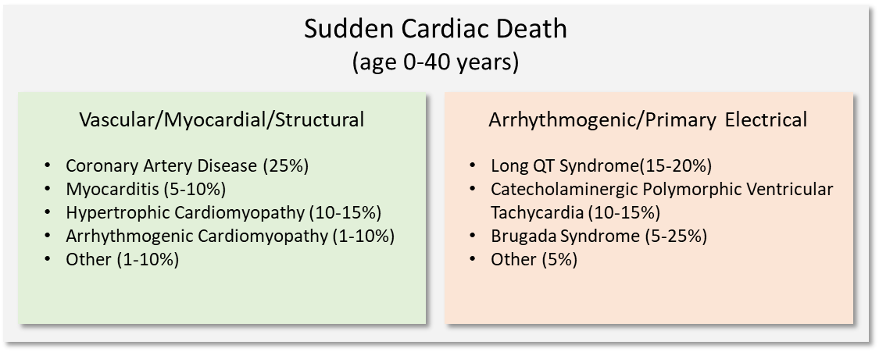

Figure 1. Causes of sudden cardiac death in the young (age 0-40 years) based on postmortem findings (redrawn from (1)). SADS, sudden arrhythmic death syndrome; HCM, hypertrophic cardiomyopathy; ARVC, arrhythmogenic right ventricular cardiomyopathy, LQTS, Long QT syndrome; CPVT, catecholaminergic polymorphic ventricular tachycardia.

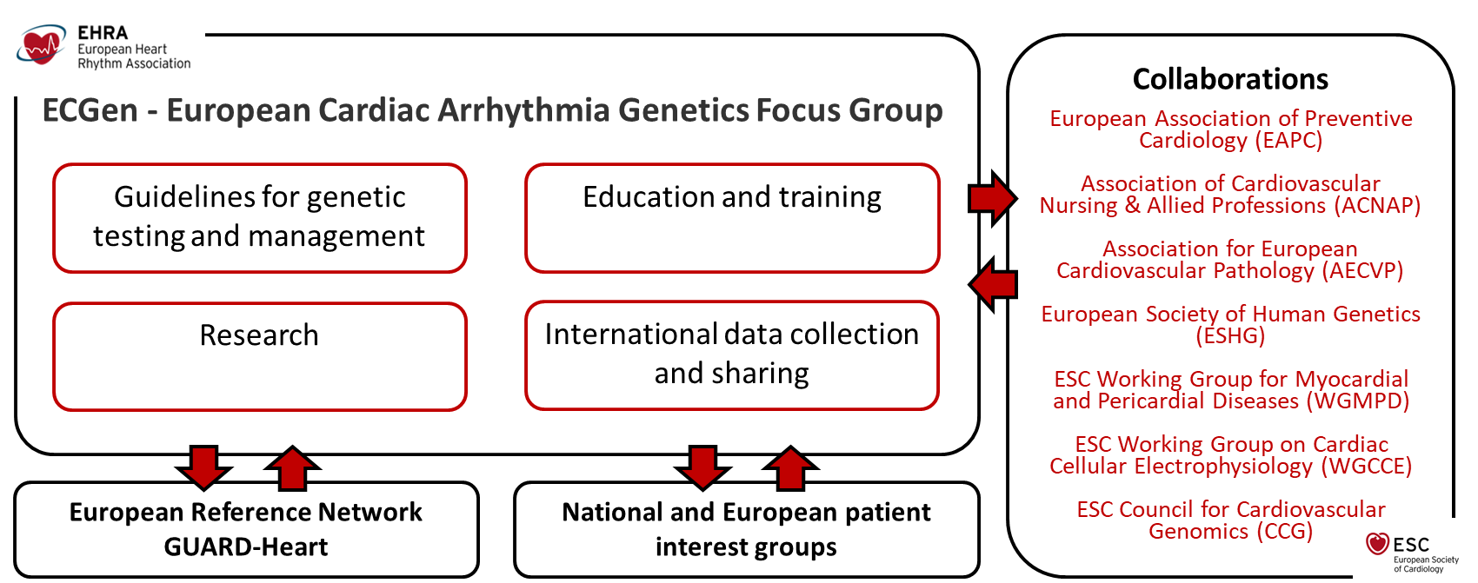

Figure 2. Overview of the objectives of ECGen.

Figure 3. Results from the ECGen member survey (n=50 respondents) with the three preferred areas of activities indicated in pink.

