Supplementary material
Supplementary Table
Estimates of incidence rate ratios (IRR) for secondary Pneumocystis jirovecii pneumonia (PjP) from the fitted general additive model with a cubic spline smoother for CD4 count. In addition, there was a highly significant association of PjP with lower CD4 counts (p<0.001). MSM: Men who have sex with men; IDU: intravenous drug use, CI: Confidence interval
Variable | IRR | 95% CI | p-value
Gender  Male  Female | Reference  1.23 | [0.98, 1.70] | 0.08
Age (per year) | 0.99 | [0.97, 1.00] | 0.03
Transmission Mode  ..MSM  ..IDU  ..Other  ..Heterosexual | Reference  1.34  1.20  0.96 | [1.00, 1.78]  [0.73, 1.95]  [0.72, 1.29] | 0.05  0.48  0.81
PjP Prophylaxis  .. No  Yes | Reference  1.16 | [0.59, 2.27] | 0.67
HIV plasma RNA (copies/mL)  ..Low (<400)  ..Medium (400-10’000)  High (>10’000) | Reference  2.02  5.11 | [1.19, 3.5]  [2.87, 9.12] | 0.01  <0.001
Interaction term  RNA x PjP Prophylaxis  Low (<400) and No PjP Prophylaxis  ..Medium (400-10’000) and PjP Prophylaxis  ..High (>10’000) and PjP Prophylaxis | Reference  1.02  1.35 | [0.26, 4.07]  [0.35, 5.22] | 0.98  0.67

Supplementary Figure
Incidence of secondary Pneumocystis Pneumonia (PjP) stratified plasma HIV-RNA levels from those off (left panel) and on (right panel) PjP prophylaxis. Plasma HIV-RNA levels: High >10’000, Medium 400-10’000, Low <400 copies/mL. From the fitted Poisson general additive model for a 35-year-old male IDU patient with 95% confidence intervals shown shaded in the respective colour.
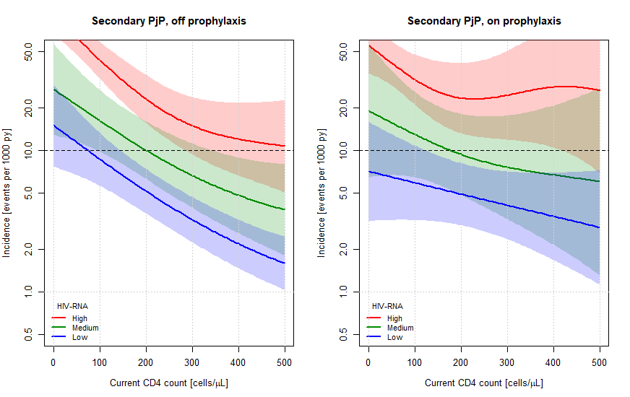

Notes: PjP Pneumocystis jirovecii pneumonia, HIV-RNA human immunodeficiency viruses (HIV) Ribonucleic acid, IDU: intravenous drug use, py person years, py person years.

