Supplementary Table 1: Read codes indicating dementia diagnosis on GP record (“GP diagnosis”)

Readcode | Description
1461.00 | H/O: dementia
3AE3.00 | GDS level 4 - moderate cognitive decline
3AE4.00 | GDS level 5 - moderately severe cognitive decline
3AE5.00 | GDS level 6 - severe cognitive decline
3AE6.00 | GDS level 7 - very severe cognitive decline
E00..00 | Senile and presenile organic psychotic conditions
E00..11 | Senile dementia
E00..12 | Senile/presenile dementia
E000.00 | Uncomplicated senile dementia
E001.00 | Presenile dementia
E001000 | Uncomplicated presenile dementia
E001100 | Presenile dementia with delirium
E001200 | Presenile dementia with paranoia
E001300 | Presenile dementia with depression
E001z00 | Presenile dementia NOS
E002.00 | Senile dementia with depressive or paranoid features
E002000 | Senile dementia with paranoia
E002100 | Senile dementia with depression
E002z00 | Senile dementia with depressive or paranoid features NOS
E003.00 | Senile dementia with delirium
E004.00 | Arteriosclerotic dementia
E004.11 | Multi infarct dementia
E004000 | Uncomplicated arteriosclerotic dementia
E004100 | Arteriosclerotic dementia with delirium
E004200 | Arteriosclerotic dementia with paranoia
E004300 | Arteriosclerotic dementia with depression
E004z00 | Arteriosclerotic dementia NOS
E00y.00 | Other senile and presenile organic psychoses
E00y.11 | Presbyophrenic psychosis
E00z.00 | Senile or presenile psychoses NOS
E012.00 | Other alcoholic dementia
E012.11 | Alcoholic dementia NOS
E012000 | Chronic alcoholic brain syndrome
E02y100 | Drug-induced dementia
E041.00 | Dementia in conditions EC
Eu00.00 | [X]Dementia in Alzheimer's disease
Eu00000 | [X]Dementia in Alzheimer's disease with early onset
Eu00011 | [X]Presenile dementia,, Alzheimer's type
Eu00012 | [X]Primary degenerative dementia, Alzheimer's type, presenile onset
Eu00013 | [X]Alzheimer's disease type 2
Eu00100 | [X]Dementia in Alzheimer's disease with late onset
Eu00111 | [X]Alzheimer's disease type 1
Eu00112 | [X]Senile dementia,,Alzheimer's type
Eu00113 | [X]Primary degenerative dementia of Alzheimer's type, senile onset
Eu00200 | [X]Dementia in Alzheimer's dis, atypical or mixed type
Eu00z00 | [X]Dementia in Alzheimer's disease, unspecified
Eu00z11 | [X]Alzheimer's dementia unspecified
Eu01.00 | [X]Vascular dementia
Eu01.11 | [X]Arteriosclerotic dementia
Eu01000 | [X]Vascular dementia of acute onset
Eu01100 | [X]Multi-infarct dementia
Eu01111 | [X]Predominantly cortical dementia
Eu01200 | [X]Subcortical vascular dementia
Eu01300 | [X]Mixed cortical and subcortical vascular dementia
Eu01y00 | [X]Other vascular dementia
Eu01z00 | [X]Vascular dementia, unspecified
Eu02.00 | [X]Dementia in other diseases classified elsewhere
Eu02000 | [X]Dementia in Pick's disease
Eu02100 | [X]Dementia in Creutzfeldt-Jakob disease
Eu02200 | [X]Dementia in Huntington's disease
Eu02300 | [X]Dementia in Parkinson's disease
Eu02400 | [X]Dementia in human immunodeficiency virus [HIV] disease
Eu02500 | [X]Lewy body dementia
Eu02y00 | [X]Dementia in other specified diseases classified elsewhere
Eu02z00 | [X] Unspecified dementia
Eu02z11 | [X] Presenile dementia NOS
Eu02z12 | [X] Presenile psychosis NOS
Eu02z13 | [X] Primary degenerative dementia NOS
Eu02z14 | [X] Senile dementia NOS
Eu02z15 | [X] Senile psychosis NOS
Eu02z16 | [X] Senile dementia, depressed or paranoid type
Eu04100 | [X]Delirium superimposed on dementia
F110.00 | Alzheimer's disease
F110000 | Alzheimer's disease with early onset
F110100 | Alzheimer's disease with late onset
F111.00 | Pick's disease
F112.00 | Senile degeneration of brain
F116.00 | Lewy body disease

Supplementary Table 2: Read codes indicating that GP has concern regarding dementia (“GP awareness”)

Readcode | Description
14Od.00 | At risk of dementia
1B1A.00 | Memory loss - amnesia
1B1A.11 | Amnesia symptom
1B1A.12 | Memory loss symptom
1B1A.13 | Memory disturbance
1B1A000 | Temporary loss of memory
1B1A100 | Short-term memory loss
1S23.00 | Memory impairment
1JA2.00 | Suspected dementia
38C1000 | Assessment for dementia
3A...12 | Dementia assessment
3A10.00 | Memory: own age not known
3A20.00 | Memory: present time not known
3A30.00 | Memory: present place not known
3A40.00 | Memory: present year not known
3A50.00 | Memory: own DOB not known
3A60.00 | Memory: present month not known
3A70.00 | Memory: important event not known
3A80.00 | Memory: important .person not known
3A91.00 | Memory: count down unsuccess.
3AA1.00 | Memory: address recall unsuccesful
3AD..00 | Dementia test
3AD1.00 | Ten item dementia test
3AD2.00 | Thirty seven item dementia test
3AD3.00 | Six item cognitive impairment test
3AE..00 | Global deterioration scale: assessment of primary degenerative dementia
3AE2.00 | GDS level 3 - mild cognitive decline
7P10400 | Neuropsychology test of memory
8HTY.00 | Referral to memory clinic
8IAe000 | Dementia advance care plan declined
8IAe200 | Dementia advance care plan review declined
8IBB000 | Dementia assessment not indicated
8IEn.00 | Referral to memory clinic declined
8T05200 | Referral for dementia assessment
9Nk1.00 | Seen in memory clinic
9OqD.00 | Dementia screening questionnaire sent to patient
9OqE.00 | Dementia screening questionnaire completed
9OqF.00 | No response to dementia screening invitation
E2A1000 | Mild memory disturbance
E2A1100 | Organic memory impairment
R00z011 | [D]Memory deficit
Z7CE400 | Memory disturbance (& amnesia (& symptom))
Z7CE412 | Memory loss symptom
Z7CE413 | Memory loss - amnesia
Z7CE414 | Memory disturbance
Z7CE415 | Loss of memory
Z7CE500 | Forgetful
Z7CE600 | Amnesia
Z7CE611 | Memory loss
Z7CE612 | Memory gone
Z7CE613 | Dysmnesia
Z7CE614 | Memory loss - amnesia
Z7CE615 | Loss of memory
Z7CE616 | LOM - Loss of memory
Z7CEA12 | Impairment of immediate recall
Z7CEC11 | Loss of memory for recent events
Z7CEC12 | No memory for recent events
Z7CED00 | Amnesia for day to day facts
Z7CEE00 | Amnesia for important personal information
Z7CEH00 | Memory impairment
Z7CEH11 | Memory dysfunction
Z7CEH12 | Memory deficit
Z7CEH14 | Memory problem
Z7CEH15 | Poor memory
Z7CEJ00 | Memory lapses
Z7CEK00 | Minor memory lapses
Z7CEL00 | Mild memory disturbance
Z7CEN00 | Confabulation
Z7CEN11 | Invents experiences to compensate for loss of memory
Z7CEO00 | Momentary confabulation
Z7CEP00 | Fantastical confabulation
Z7CF.00 | Observations of memory performance
Z7CF100 | Memory recall normal
Z7CF111 | Global memory recall within normal limits
Z7CF300 | Immediate recall observations
Z7CF400 | Digit span performance
Z7CF500 | Digit span forwards
Z7CF700 | Short-term memory within normal limits
Z7CF711 | Good short-term memory
Z7CF712 | No problem with short-term memory
Z7CF800 | Poor short-term memory
Z7CF811 | Short-term memory loss
Z7CF900 | Able to recall random address at five minutes
Z7CFA00 | Unable to recall random address at five minutes
Z7CFC00 | Unable to recall five digit number at five minutes
Z7CFF00 | Forgets what was going to do
Z7CFG00 | Forgets what was going to say
Z7CFH00 | Forgets recent activities
Z7CFI00 | Forgets what has just done
Z7CFJ00 | Forgets what has just said
Z7CFK00 | Forgets what has just read
Z7CFL00 | Forgets what has just seen
Z7CFM00 | Forgets what has just heard
Z7CFO00 | Poor long-term memory
Z7CFO11 | Long-term memory loss
Z7CFQ00 | Unable to remember own date of birth
Z7CFS00 | Unable to remember own age
Z7CFS11 | Cannot remember own age
Z7CFU00 | Unable to remember day of the week
Z7CFW00 | Unable to remember today's date
Z7CFa00 | Unable to remember current year
Z7CFe00 | Unable to remember name of current prime minister
Z7CFg00 | Cannot remember names of intimates
Z7CFh00 | Cannot remember birth dates of children
Z7CFi00 | Cannot remember wedding anniversary
Z7CFq00 | Unable to remember motor skills
Z7CFs00 | Unable to remember new motor skills
Z7CFw00 | Memory aided by use of diary
Z7CFx00 | Memory aided by use of labels
Z7CFz00 | Memory aided by use of lists
ZR3V.00 | Clinical dementia rating scale
ZR3V.11 | DRS - Clinical dementia rating scale
ZR3V.12 | CDR - Clinical dementia rating scale
ZR3V.13 | Dementia rating scale
ZRV9.00 | Kendrick battery for detection of dementia in the elderly
ZRV9.11 | Kendrick cognitive tests for the elderly

Supplementary Table 3: Read codes for GP related dementia administration (“GP administration”)

Readcode | Description
38C1300 | Assessment of psychotic and behavioural symptoms of dementia
66h..00 | Dementia monitoring
6AB..00 | Dementia annual review
8BM0200 | Dementia medication review
8BPa.00 | Antipsychotic drug therapy for dementia
8CMZ.00 | Dementia care plan
8CMZ000 | Dementia care plan agreed
8CMZ100 | Dementia care plan reviewed
8CMZ200 | Dementia care plan declined
8Hla.00 | Referral to dementia care advisor
8T05.00 | Referral to dementia service
8T05000 | Referral to dementia support organisation
8T05100 | Referral to dementia support organisation declined
9Ou..00 | Dementia monitoring administration
9Ou1.00 | Dementia monitoring first letter
9Ou2.00 | Dementia monitoring second letter
9Ou3.00 | Dementia monitoring third letter
9Ou4.00 | Dementia monitoring verbal invite
9Ou5.00 | Dementia monitoring telephone invite
9hD..00 | Exception reporting: dementia quality indicators
9hD0.00 | Excepted from dementia quality indicators: Patient unsuitable
9hD1.00 | Excepted from dementia quality indicators: Informed dissent

Supplementary Table 4: ICD-10 for dementia recording in HES and ONS datasets

ICD-10 Code | Description
F00* | Dementia in Alzheimer’s disease
F01* | Vascular dementia
F02* | Dementia in other diseases classified elsewhere
F03* | Unspecified dementia
G30* | Alzheimer's disease
*Note: All sub-codes included

Supplementary Table 5: Summary of dementia recording among all deaths from 2001-2015 (n=207,068) – One Year Registration Only

Year of Death | Total Deaths | Dementia recording on Death Certificate |  |  |  |  | Prior Dementia diagnosis in GP or HES records
 |  | Any mention |  | Listed as underlying cause only |  |  | GP diagnosis |  | HES diagnosis |  | GP or HES diagnosis plus death certificate |  | GP or HES diagnosis but not on death certificate
 | n | n | % of total deaths | n | % of total deaths | % of dementia deaths only* | n | % of total deaths | n | % of total deaths | n | % of total deaths | n | % of total deaths
2001 | 12,311 | 277 | 2.3% | 274 | 2.2% | 50.3% | 551 | 4.5% | 863 | 7.0% | 811 | 6.6% | 1,281 | 10.4%
2002 | 12,567 | 306 | 2.4% | 341 | 2.7% | 47.3% | 647 | 5.1% | 1,001 | 8.0% | 1,036 | 8.2% | 1,512 | 12.0%
2003 | 12,779 | 302 | 2.4% | 385 | 3.0% | 44.0% | 687 | 5.4% | 1,096 | 8.6% | 1,143 | 8.9% | 1,654 | 12.9%
2004 | 12,320 | 289 | 2.3% | 385 | 3.1% | 42.9% | 674 | 5.5% | 1,062 | 8.6% | 1,141 | 9.3% | 1,592 | 12.9%
2005 | 12,296 | 313 | 2.5% | 411 | 3.3% | 43.2% | 724 | 5.9% | 1,118 | 9.1% | 1,270 | 10.3% | 1,679 | 13.7%
2006 | 12,185 | 307 | 2.5% | 455 | 3.7% | 40.3% | 762 | 6.3% | 1,112 | 9.1% | 1,276 | 10.5% | 1,670 | 13.7%
2007 | 12,190 | 348 | 2.9% | 487 | 4.0% | 41.7% | 835 | 6.8% | 1,287 | 10.6% | 1,454 | 11.9% | 1,856 | 15.2%
2008 | 12,473 | 414 | 3.3% | 569 | 4.6% | 42.1% | 983 | 7.9% | 1,426 | 11.4% | 1,671 | 13.4% | 2,059 | 16.5%
2009 | 11,925 | 412 | 3.5% | 619 | 5.2% | 40.0% | 1,031 | 8.6% | 1,420 | 11.9% | 1,761 | 14.8% | 2,126 | 17.8%
2010 | 12,160 | 454 | 3.7% | 682 | 5.6% | 40.0% | 1,136 | 9.3% | 1,493 | 12.3% | 1,928 | 15.9% | 2,266 | 18.6%
2011 | 11,774 | 755 | 6.4% | 439 | 3.7% | 63.2% | 1,194 | 10.1% | 1,536 | 13.0% | 2,017 | 17.1% | 2,345 | 19.9%
2012 | 12,224 | 886 | 7.2% | 513 | 4.2% | 48.6% | 1,823 | 14.9% | 1,741 | 14.2% | 2,294 | 18.8% | 2,643 | 21.6%
2013 | 12,321 | 874 | 7.1% | 534 | 4.3% | 62.1% | 1,408 | 11.4% | 1,846 | 15.0% | 2,339 | 19.0% | 2,693 | 21.9%
2014 | 11,795 | 952 | 8.1% | 491 | 4.2% | 49.9% | 1,909 | 16.2% | 1,925 | 16.3% | 2,352 | 19.9% | 2,750 | 23.3%
2015 | 10,348 | 898 | 8.7% | 477 | 4.6% | 48.4% | 1,855 | 17.9% | 2,014 | 19.5% | 2,156 | 20.8% | 2,561 | 24.7%
All | 181,668 | 7,787 | 4.3% | 7,062 | 3.9% | 48.0% | 16,219 | 8.9% | 20,940 | 11.5% | 24,649 | 13.6% | 30,687 | 16.9%

* - Denominator is all deaths with any mention of dementia on death certificate
** - Denominator is all deaths with any mention of dementia on GP or HES record

Supplementary Table 6: Summary of dementia recording in GP and HES among all deaths certified with mention of dementia from 2001 to 2015 (n=19,627)

Year of Death | All deaths mentioning dementia | Has prior GP diagnosis |  | Has prior HES diagnosis |  | Has prior diagnosis (GP or HES) |  | Has prior GP diagnosis other GP information suggestive of dementia |  | Has prior diagnosis (GP or HES) or other GP information suggestive of dementia
 | n | n | % | n | % | n | % | n | % | n | %
2001 | 733 | 389 | 53.1% | 379 | 51.7% | 559 | 76.3% | 564 | 76.9% | 566 | 77.2%
2002 | 820 | 429 | 52.3% | 447 | 54.5% | 618 | 75.4% | 631 | 77.0% | 634 | 77.3%
2003 | 919 | 520 | 56.6% | 536 | 58.3% | 747 | 81.3% | 755 | 82.2% | 758 | 82.5%
2004 | 927 | 543 | 58.6% | 566 | 61.1% | 774 | 83.5% | 789 | 85.1% | 791 | 85.3%
2005 | 968 | 622 | 64.3% | 651 | 67.3% | 831 | 85.8% | 847 | 87.5% | 849 | 87.7%
2006 | 1,014 | 627 | 61.8% | 714 | 70.4% | 887 | 87.5% | 903 | 89.1% | 906 | 89.3%
2007 | 1,087 | 738 | 67.9% | 796 | 73.2% | 975 | 89.7% | 997 | 91.7% | 999 | 91.9%
2008 | 1,287 | 885 | 68.8% | 945 | 73.4% | 1,146 | 89.0% | 1,159 | 90.1% | 1,170 | 90.9%
2009 | 1,374 | 927 | 67.5% | 1,057 | 76.9% | 1,238 | 90.1% | 1,266 | 92.1% | 1,273 | 92.6%
2010 | 1,478 | 950 | 64.3% | 1,175 | 79.5% | 1,337 | 90.5% | 1,362 | 92.2% | 1,366 | 92.4%
2011 | 1,565 | 1,052 | 67.2% | 1,267 | 81.0% | 1,447 | 92.5% | 1,471 | 94.0% | 1,475 | 94.2%
2012 | 1,823 | 1,252 | 68.7% | 1,494 | 82.0% | 1,694 | 92.9% | 1,722 | 94.5% | 1,730 | 94.9%
2013 | 1,868 | 1,295 | 69.3% | 1,543 | 82.6% | 1,753 | 93.8% | 1,786 | 95.6% | 1,792 | 95.9%
2014 | 1,909 | 1,355 | 71.0% | 1,582 | 82.9% | 1,797 | 94.1% | 1,832 | 96.0% | 1,836 | 96.2%
2015 | 1,855 | 1,487 | 80.2% | 1,544 | 83.2% | 1,776 | 95.7% | 1,805 | 97.3% | 1,813 | 97.7%
All | 19,627 | 13,071 | 66.6% | 14,696 | 74.9% | 17,579 | 89.6% | 17,889 | 91.1% | 17,958 | 91.5%

Supplementary Figure 1: Summary of death recording by source in all deaths identified from CPRD database between 2001 and 2015
153 practices in CPRD recording data continuously 2001-2015
207,068 (100%)
Deaths identified on GP records & linked to ONS
19,627 (9.5%)
Dementia mentioned on ONS death certificate
10,253 (5.0%)
Dementia as underlying cause on ONS death certificate
32,111 (15.5%)
Dementia diagnosis previously on hospital record
26,255 (12.7%)
Dementia diagnosis previously on GP record
Note: A total of 1.7 million patients were actively registered for any time during 2001-2015
166,565 (80.4%)
No Dementia recorded anywhere
40,503 (19.6%)
Dementia diagnosis in ANY of 3 sources
Supplementary Figure 2: Death rate for all forms of dementia, England and Wales 2001 to 2016 for males and females

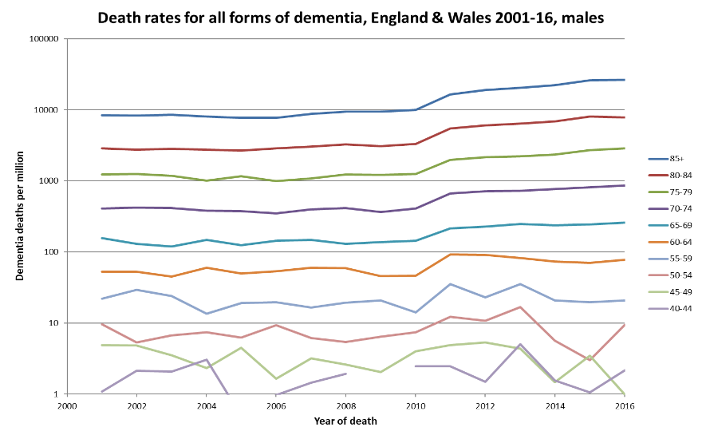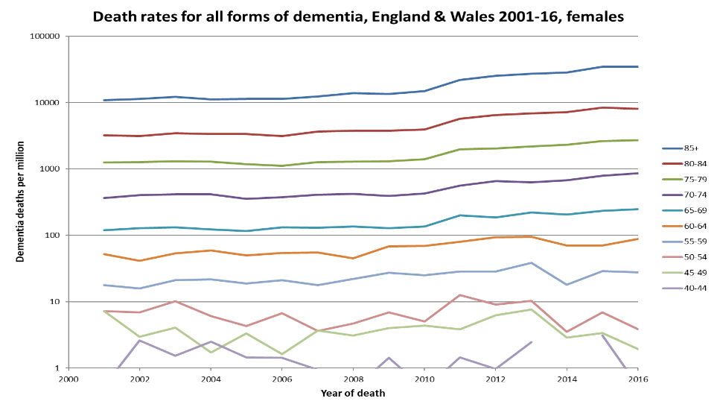

Footnotes:
1. These figures are based on data from the Office for National Statistics historical mortality datasets and have been plotted on a log scale
2. Restricted to ICD-10 (2001 onwards)
3. Coding changes occurred in 2001-02 (affecting vascular dementia mainly) and 2010-11 (affecting vascular and other specified forms of dementia much more than Alzheimer’s or unspecified)

