Can We Remove Scar and Fibrosis from Adult Human Myocardium?

Ali Vazir MBBS PhD¹, Kim Fox MD¹, Joseph Westaby MSc FRCPath², Sir Martin John Evans MA PhD FRS³, Stephen Westaby MD PhD⁴
- National Heart and Lung Institute, Imperial College London and ICMS, Royal Brompton Hospital
- University of Birmingham
- School of Biosciences, Cardiff University
- Institute of Life Sciences, University of Swansea, and Imperial College London

Address for Correspondence:
Professor K Fox
National Heart and Lung Institute
Dovehouse Street
London SW3 6LY, United Kingdom
Email: kim.fox@imperial.ac.uk

Abstract Word count: 197
Word Count: 4994 (inc refs, tab and legends)
Key words: Regenerative medicine, mesenchymal stromal cells, cardiac stem cells, heart failure, ischaemic cardiomyopathy, myocardial scar.

Abstract
The pathological processes leading to heart failure are characterised by the formation of fibrosis and scar, yet the dynamics of scar production and removal are incompletely understood. Spontaneous disappearance of myocardial collagen is reported in infancy but doubted in adulthood where scar volume constitutes a better prognostic indicator than the conventional parameters of ventricular function. Whilst certain drugs are known to attenuate myocardial fibrosis evidence is emerging that stem cell therapy also has the potential to reduce scar size and improve myocardial viability. Both animal studies and clinical trials support the concept that, as in infancy, cellular processes can be triggered to remove collagen and regenerate injured myocardium. The molecular mechanisms likely involve anti-fibrotic cytokines growth factors and matrix-metalloproteinases. Autologous cardiac, bone-marrow and adipose tissue derived stem cells have each shown efficacy. Specific immune privileged mesenchymal stem cells and genetically modified immunomodulatory progenitor cells may in turn provide an allogenic source for the paracrine effects. Thus autologous and allogenic cells both have the potential through paracrine action to reduce scar volume, boost angiogenesis and improve ventricular morphology. The potential benefit of myocardial cell therapy for routine treatment of heart failure is an area that requires further study.

Introduction
Surgery for anomalous left coronary artery from the pulmonary artery (ALCAPA) provides a rare opportunity to explore the potential for cardiac regeneration in the very young¹. These children present with myocardial infarction in infancy. Excision of myocardium in a reported case showed a mix of partial thickness scar and diffuse fibrosis; twelve years on magnetic resonance imaging showed the ventricle to look virtually normal, with all scar and fibrosis gone². Others have shown resolution of scar in adolescents after ALCAPA surgery³. How does the scar and fibrosis disappear? It appears that endogenous cardiac stem cells remain active for a finite time in infant and childhood myocardium and serve to reverse remodel the scarred ventricle. So, in the era of regeneration therapy could the same process be engineered for adult patients?

Development of cardiac fibrosis
Fibroblasts have a prominent role in the development of cardiac fibrosis. Their multilineage origin and their potential regulatory interactions are incompletely understood. Fibroblasts are distributed throughout the normal myocardium as strands and sheets between cardiac muscle fibres and are responsible cardiac structural and functional homeostasis. They express paracrine and cytokines and have complex interaction with cardiomyocytes, influencing their development and growth, and how they may adapt to physiological and pathophysiological circumstances⁴⁻⁷. Fibroblasts are responsible for the formation and maintenance of cardiac connective tissue, which have cellular and acellular components^{5, 8} that provide a scaffold for cardiomyocytes and for the whole heart⁹. The acellular component of the cardiac connective tissue is referred to as the extracellular matrix (ECM). Fibroblasts have the potential to migrate to areas of myocardium that have been damaged, for example during acute myocardial infarction, pressure and volume overload states. Fibroblasts intereact with pro-inflammatory cellular and signalling pathways, that lead to fibroblasts trans-differentiation into myofibroblasts, which are the primary effector cells in cardiac remodelling and fibrosis as summarised in figure 1. Myofibroblast do not appear in the normal myocardium, they may also originate from trans-differentiation of various other cell types such as fibrocyte, epithelial and epicardial, endothelial and haematopoietic cells into fibroblasts before they become activated into myofibroblasts¹⁰⁻¹³. The process of myofibroblast activation many mechanisms such as signaling from cytokines such as transforming growth factor (TGF-β), platelet-derived growth factor (PDGF), connective-tissue growth factor (CCN2), WNT-β-catenin, endothelin 1 (ET-1) and angiotensin II^{5, 14}. Neutrophils may also contribute to myofibroblast activation by means of NETosis, in which the enzyme peptidyl arginine deiminase type IV (PADI4) citrullinates arginine residues in histone tails within neucleosomes of neutrophils, leading to the release of decondensed chromatin concomitant with the activation of neutrophil–platelet complexes¹⁵. Pro-inflammatory cellular and fibrotic signalling pathways include TNF-α and IL-1β, aldosterone, angiotensin II, endothelin-1 and TGF-β, can lead to the apoptosis of cardiomyocytes, and via increased activity of matrix metalloproteinases and reduced activity of tissue inhibitor of matrix metalloproteinases (TIMPs) lead to breakdown of ECM, and adverse remodelling characterised by deposition of proteins such as precursors to collagen type I and type III ^{16, 17} by myofibroblasts within the ECM and formation of mature fibril-forming collagen molecules that are organized into fibrils leading to myocardial fibrosis^{4, 5, 14, 18} in the injured myocardium (i.e. reparative or replacement fibrosis), see figure 2, and also non-injured myocardium (i.e. reactive fibrosis). Cardiac fibrosis helps to preserve the integrity of the diseased heart; However, the consequences are increasing stiffness of the myocardial wall, impaired systolic and diastolic mechanical function and subsequent heart failure. Although the aetiology and pattern of fibrosis is different, the pathological pathway to formation of fibrosis in ischemic (characterized by focal areas of fibrosis), idiopathic dilated and hypertrophic cardiomyopathies (characterized by diffuse fibrosis) is likely to be similar¹⁹⁻²¹. Focal and diffuse fibrosis are associated with the development of electrophysiological abnormalities predisposing to cardiac arrhythmias²². Therefore, inhibiting or reversing fibrosis and its adverse consequences is an established target of many widely used clinical interventions for treating heart disease. Notably these have included drugs such as angiotensin-converting enzyme (ACE) inhibitors and aldosterone antagonist that in clinical studies have led to partial recovery of contractile function termed as ‘reverse remodelling’ which is associated better outcomes in heart failure^{23, 24}.

The Potential for Myocardial Regeneration in Adults
In the absence of a powerful extrinsic stimulus the capacity for adult myocardium to regenerate itself is negligible. Yet in other parts of the animal kingdom that regenerative capacity appears to exist. Zebra fish, when the apex of its heart is excised are capable of regenerating new cardiomyocytes within 4 weeks²⁵. Amir and colleagues showed that in biopsies taken from the right ventricle of neonates undergoing repair of congenital defects, the neonatal myocardium contains progenitor cells and transitional cells²⁶ . They also found that the relative density of progenitor cells declines during the first postnatal month. Suggesting that natural repair systems may exist in the myocardium and could be therapeutically reactivated. Experience with anomalous left coronary artery from the pulmonary artery strongly supports this hypothesis^{2, 3}. The potential for the cardiomyocyte cell proliferation is indirectly supported by two recent clinical studies. Canseco et al demonstrated that prolonged mechanical unloading in patients with cardiomyopathy treated by the use of left ventricular assist devices may induce adult human cardiomyocyte proliferation, possibly through prevention of mitochondria-mediated activation of DNA damage response²⁷. The latter is an important mechanism of cell cycle arrest in postnatal mammalian cardiomyocytes²⁸. In another clinical study, intravenous infusion of recombinant neuregulin, cimaglermin alfa (Neuregulin 1β3), a growth factor acting directly on cardiomyocytes and associated with cardiomyocyte proliferation, lead to a dose-dependent improvement in left ventricular ejection fraction in patients with heart failure and reduced ejection fraction already on optimal guideline-directed medical therapy²⁹. Further studies are required to improve our understanding of the mechanism behind cardiomyocyte proliferation and thus potential of myocardial regeneration.

Cell therapy
Cell therapy has the potential to remove scar and improve cardiac function in disease states such as heart failure and post myocardial infarction. The exact mechanisms of cardiac repair by such cell therapy is unclear, and there are two hypothetical mechanism that have been considered. These include direct cardiomyocyte differentiation and indirect stimulation of the reparative responses by paracrine effects³⁰. The origin, type and mode of delivery of stem cells is summarised in figure 3. In this review we have selected several clinical studies showing that cell therapy may reduce scar. These studies are categorised based on being autologous or allogenic stem cell or engineered Immunomodulatory progenitor cell studies and are summarised in table 1.

Autologous Stem Cells and Scar Reduction
Autologous stem cell therapy, refers to the administration of the subject’s own stem cell, these may be isolated from endomyocardial tissue, subcutaneous adipose tissue or bone marrow, then prepared in vitro and then administered into the subject’s own myocardium. Several studies discussed below have suggested that this method of cell therapy may reduce scar.

Cardiac derived autologous stem cell:
The Stem Cell Infusion in Patients with Ischaemic Cardiomyopathy (SCIPIO) trial, patients with post-infarction left ventricular dysfunction (LVEF<40%) were enrolled into treatment and control groups before coronary artery bypass grafting³¹. During coronary artery bypass grafting the right atrial appendage was removed then c-kit-positive, lineage-negative cardiac stem cells harvested, isolated and expanded at another hospital. The cells were re-administered by intra-coronary injection into the infarct related coronary on average 130 days post operatively. Subjects receiving the stem cells have a significantly greater improvement in LVEF (30% to 38.5%) by 4 months and infarct size had decreased by 30% at one year after treatment as measured by MRI scan. Furthermore, the treated patients derived clinical benefit through increased functional capacity and improved quality of life. The results of this trial have been questioned following recent data in a mouse model that C-kit positive cells can lead to the generation of cardiomyocytes, however at low level which is insignificant to have an impact on cardiac function³², therefore not supporting the hypothesis of SCIPIO trial.
In the Cardiosphere-Derived Autologous Stem Cells to Reverse Ventricular Dysfunction (CADUCEUS) trial, autologous cardiospheres were grown from endomyocardial biopsies in patients who had suffered previous myocardial infarction³³. The cells were given as an intra-coronary infusion in the infarct related artery in 17 patients with moderately reduced ejection fraction, on average 36 days after biopsy and 65 days post infarction. The absolute decrease in scar size was 45% for treated patients versus no change in controls one year after infusion. This translated into a sizeable decrease in scar mass and an increase in viable myocardium and systolic thickening.

Adipose tissue derived autologous stem cells:
Subcutaneous fat is a source of stem cells which can be readily obtained by liposuction, then prepared for immediate autologous transplantation without the need for culture or expansion³⁴. These stem cells can differentiate into cardiomyocytes or endothelial cells and provide growth factors and cytokines that promote tissue repair^{35, 36}. In the APOLLO prospective randomised double blind placebo controlled trial 14 patients with ST segment elevation myocardial infarction were given adipose derived cells or placebo via the intracoronary route then followed at six months with magnetic resonance imaging and single-photon emission computed tomography³⁷. Those who received cells had smaller scar size and better regional perfusion than controls. Similar results were also seen the in the PRECISE trial, in which the cells were delivered by trans-catheter endocardial injection³⁴.

Bone marrow derived autologous stem cell therapy:
Mesenchymal stem cells have been tested in clinical trials in both acute myocardial infarction and ischaemic cardiomyopathy patients undergoing coronary artery bypass surgery. One of the first trials in myocardial infarction by Janssens et al suggested the ability to reduce scar size³⁸. The prospective Randomised Study of Mesenchymal Stem Cell Therapy in Patients Undergoing Cardiac Surgery (PROMETHEUS) trial employed detailed segmental magnetic resonance imaging studies of treated areas of myocardium³⁹. Imaging suggested that mesenchymal stem cells exerted their effects locally at the site of injection contributing to reduced infarct size, enhanced tissue perfusion and improved segmental function. Whilst there did not appear to be an important effect on remote areas, scar mass was reduced by 47.5% compared to baseline in the injected territory.
The exact mechanism by which stem cell decrease scar mass is unclear, but it is likely to be via a paracrine fibrolytic mechanism. Then increase viable myocardium by recruitment of endogenous progenitors and induction of resident cardiomyocyte proliferation at the infarct border zone^{31, 33}. These growth factor-based mechanisms depend upon activation of endogenous reparative and regenerative pathways rather than long term engraftment and differentiation of newly introduced stem cells.
The harvesting of autologous cells from a sick patient poses logistic, economic and time constraints. Also, the majority of patients who could benefit from regenerative therapy are elderly with multiple comorbidities. A number of studies indicate that cells harvested from older donors with diabetes, renal failure or ischaemic heart disease manifest significantly reduced capacity for proliferation and neovascularization, limiting their therapeutic potential⁴⁰.

Allogenic Cell based Studies and scar reduction
The ultimate goal is to identify a ubiquitous ‘off the shelf’ donor cell with high regenerative capacity for unrelated recipients. As the adult bone marrow stem cells, also known as mesenchymal stem cells, are immune-privileged, they are able to survive and differentiate in immune-compatibility-mismatched allogenic or even xenogeneic recipients⁴¹. They are major histocompatibility class II negative but class I positive, thus protecting them from natural killer cell mediated elimination⁴². As a result, mesenchymal stem cells escape recognition by effector CD4+ T cells and avoid an allogenic rejection response⁴³. The signalling molecules secreted by mesenchymal stem cells are predominantly anti-inflammatory cytokines⁴¹. Laboratory studies have shown that mesenchymal stem cells reduce myocardial fibrosis and inhibit adverse remodelling through altered mRNA and protein expression of collagen types I and III together with inhibition of TGF-β and promotion of TIMP activity ^{44, 45}. The TRIDENT (Transendocardial Stem cell injection delivery Effects on Neomyogenesis) study showed that in 30 patients with heart failure randomised to transendocardial injection of 20 million (M) versus 100 M allogenic human mesenchymal stem cells. At 12 months, the group receiving 100 M cells had a reduction in scar size as well as an improving ejection fraction as measured by contrast CT⁴⁶. Serum levels of TNF-α were reduced in the study supporting the idea that mesenchymal cells may exert their benefits via an anti-inflammatory effect. A larger phase III study is being planned.

Allogenic Engineered Immunomodulatory Progenitor Cells and scar reduction
Recently there has been research into the production of a “cardiac specific mesenchymal stem cell-like” allogenic cell specifically for clinical use⁴⁷. The resulting immunomodulatory mesenchymal precursor cell type expresses significant upregulation of the markers CD 181, CD 182 and CD 304 as compared to conventional cells. These markers play an important role in the migration, penetration and angiogenic potential of stem cells. As such these immunomodulatory mesenchymal precursor cells are regarded as a “novel cell type” by the International Society for Stem Cell Research⁴⁸. They have been tested in an uncontrolled Phase II safety and efficacy trial where the cells were injected into the peri-infarct zone of 11 ischemic cardiomyopathy patients undergoing coronary bypass surgery specifically targeting scarred segments which were not amenable to revascularisation⁴⁷. In this uncontrolled study there was a significant decrease in infarct size at one year with a mean percentile reduction in scar area of 42.6%. Despite a lack of control, more than half of the patients also showed improved myocardial perfusion in territories designated “nonviable” before cell injection. The increased segmental perfusion correlated well with similar findings in the PROMETHEUS “injection only” segments which the authors compared with “surgically revascularised only” segments³⁹. Whilst the incomplete myocardial revascularisation undoubtedly contributed to an overall improvement in left ventricular ejection fraction and New York Heart Association functional class, coronary bypass grafts cannot remove scar. The mechanism for scar removal is likely to be through paracrine effects of the injected cells, which promote degradation of collagen Type I. Further controlled studies are required to assess the efficacy of these allogenic cells.

Conclusions

Our improved understanding of fibroblast and myofibroblast function, although incomplete, and their complex interaction between cellular and signalling pathways that lead to cardiac fibrosis and subsequent impairment of myocardial function has led to the general agreement that the mechanisms behind scar size reduction are multifactorial and paracrine in nature. Cell therapy may promote angiogenesis, removal of scar and possibly the renewal of function in nonviable myocardium; changes which could translate into functional benefit. However, this area requires further studies before cardiologists and cardiac surgeons can embrace regenerative medicine as an adjunct to their clinical endeavours.

Acknowledgement:
We are grateful for the help of Mr Joseph Ward in the preparation of this manuscript.
Conflict of Interest:
The authors declare the following conflict of interests: AV has received unrestricted grant from Celixir, SW owns stock and directorship in Calon Cardiotechnology/Celixir, KF consultancy with Celixir, JWestaby none, JWard none, ME Celixir stockholder.

Table 1 Human Clinical trials which demonstrated reduced myocardial scar size following cell therapy
Trial | Cell Origin | Cell  Type | Patients | n | Main Effects | ref  no:
Autologous Stem cell
SCIPIO 2011 | Heart | c-kit+ | Isc. CM | 16 | Reduced scar size  Improved LV function | 31
CADUCEUS 2014 | Heart | CDC | Recent MI | 25 | Reduced scar size | 33
APOLLO 2012 | Adipose | MSCs | AMI | 13 | Reduced scar size  Improved segmental perfusion | 37
PRECISE 2014 | Adipose | MSCs | Isc. CM | 27 | Reduced scar size  Improved oxygen consumption | 34
Janssens et al 2006 | Bone marrow | MSCs | AMI | 67 | Reduced scar size  Improved LV function | 38
PROMETHEUS 2014 | Bone Marrow | MSCs | Isc. CM with CABG | 6 | Reduced scar size  Improved segmental perfusion and LV function | 39
Allogenic Stem cells
TRIDENT Study 2017 | Bone Marrow | MSC | ISc CM | 30 | Reduced scar  Improved Ejection fraction | 46
Allogenic Immunomodulatory engineered progenitor cells
Anastasiadis et al 2016 | Bone Marrow | iMPs | Isc. CM with CABG | 11 | Reduced scar size  Improved LV function | 47
MSCs – mesenchymal stem cells, c-kit+ cardiospheres, CDC – cardiac derived stem cells
iMPs – immunomodulatory progenitor cells, Auto – autologous, Allo – allogenic. ISc.CM ischaemic cardiomyopathy, AMI – acute myocardial infarction, Recent MI – recent myocardial infarction, LV – left ventricle

References
1. Westaby S, Catarino PA, Katsumata T. Infant partial left ventriculectomy for failure to wean from cardiopulmonary bypass. Ann Thorac Surg 2001;71(2):717-9.
2. Westaby S, Archer N, Myerson SG. Long-term cardiac remodeling after salvage partial left ventriculectomy in an infant with anomalous left coronary artery from the pulmonary artery. J Thorac Cardiovasc Surg 2009;137(3):757-9.
3. Fratz S, Hager A, Schreiber C, Schwaiger M, Hess J, Stern HC. Long-term myocardial scarring after operation for anomalous left coronary artery from the pulmonary artery. Ann Thorac Surg 2011;92(5):1761-5.
4. Davis J, Molkentin JD. Myofibroblasts: trust your heart and let fate decide. J Mol Cell Cardiol 2014;70:9-18.
5. Kong P, Christia P, Frangogiannis NG. The pathogenesis of cardiac fibrosis. Cell Mol Life Sci 2014;71(4):549-74.
6. Mohamed TM, Abou-Leisa R, Stafford N, Maqsood A, Zi M, Prehar S, Baudoin-Stanley F, Wang X, Neyses L, Cartwright EJ, Oceandy D. The plasma membrane calcium ATPase 4 signalling in cardiac fibroblasts mediates cardiomyocyte hypertrophy. Nat Commun 2016;7:11074.
7. Porter KE, Turner NA. Cardiac fibroblasts: at the heart of myocardial remodeling. Pharmacol Ther 2009;123(2):255-78.
8. Spinale FG. Myocardial matrix remodeling and the matrix metalloproteinases: influence on cardiac form and function. Physiol Rev 2007;87(4):1285-342.
9. Caulfield JB, Borg TK. The collagen network of the heart. Lab Invest 1979;40(3):364-72.
10. Cieslik KA, Trial J, Crawford JR, Taffet GE, Entman ML. Adverse fibrosis in the aging heart depends on signaling between myeloid and mesenchymal cells; role of inflammatory fibroblasts. J Mol Cell Cardiol 2014;70:56-63.
11. Crawford JR, Haudek SB, Cieslik KA, Trial J, Entman ML. Origin of developmental precursors dictates the pathophysiologic role of cardiac fibroblasts. J Cardiovasc Transl Res 2012;5(6):749-59.
12. Ruiz-Villalba A, Simon AM, Pogontke C, Castillo MI, Abizanda G, Pelacho B, Sanchez-Dominguez R, Segovia JC, Prosper F, Perez-Pomares JM. Interacting resident epicardium-derived fibroblasts and recruited bone marrow cells form myocardial infarction scar. J Am Coll Cardiol 2015;65(19):2057-66.
13. Visconti RP, Markwald RR. Recruitment of new cells into the postnatal heart: potential modification of phenotype by periostin. Ann N Y Acad Sci 2006;1080:19-33.
14. Leask A. Getting to the heart of the matter: new insights into cardiac fibrosis. Circ Res 2015;116(7):1269-76.
15. Martinod K, Witsch T, Erpenbeck L, Savchenko A, Hayashi H, Cherpokova D, Gallant M, Mauler M, Cifuni SM, Wagner DD. Peptidylarginine deiminase 4 promotes age-related organ fibrosis. J Exp Med 2017;214(2):439-458.
16. Turner NA, Porter KE. Regulation of myocardial matrix metalloproteinase expression and activity by cardiac fibroblasts. IUBMB Life 2012;64(2):143-50.
17. van den Borne SW, Diez J, Blankesteijn WM, Verjans J, Hofstra L, Narula J. Myocardial remodeling after infarction: the role of myofibroblasts. Nat Rev Cardiol 2010;7(1):30-7.
18. Moore-Morris T, Guimaraes-Camboa N, Yutzey KE, Puceat M, Evans SM. Cardiac fibroblasts: from development to heart failure. J Mol Med (Berl) 2015;93(8):823-30.
19. Choudhury L, Mahrholdt H, Wagner A, Choi KM, Elliott MD, Klocke FJ, Bonow RO, Judd RM, Kim RJ. Myocardial scarring in asymptomatic or mildly symptomatic patients with hypertrophic cardiomyopathy. J Am Coll Cardiol 2002;40(12):2156-64.
20. Gunja-Smith Z, Morales AR, Romanelli R, Woessner JF, Jr. Remodeling of human myocardial collagen in idiopathic dilated cardiomyopathy. Role of metalloproteinases and pyridinoline cross-links. Am J Pathol 1996;148(5):1639-48.
21. Kwon DH, Halley CM, Carrigan TP, Zysek V, Popovic ZB, Setser R, Schoenhagen P, Starling RC, Flamm SD, Desai MY. Extent of left ventricular scar predicts outcomes in ischemic cardiomyopathy patients with significantly reduced systolic function: a delayed hyperenhancement cardiac magnetic resonance study. JACC Cardiovasc Imaging 2009;2(1):34-44.
22. Vasquez C, Morley GE. The origin and arrhythmogenic potential of fibroblasts in cardiac disease. J Cardiovasc Transl Res 2012;5(6):760-7.
23. Zannad F, Alla F, Dousset B, Perez A, Pitt B. Limitation of excessive extracellular matrix turnover may contribute to survival benefit of spironolactone therapy in patients with congestive heart failure: insights from the randomized aldactone evaluation study (RALES). Rales Investigators. Circulation 2000;102(22):2700-6.
24. Sigurdsson A, Swedberg K. Left ventricular remodelling, neurohormonal activation and early treatment with enalapril (CONSENSUS II) following myocardial infarction. Eur Heart J 1994;15 Suppl B:14-9; discussion 26-30.
25. Jopling C, Sleep E, Raya M, Marti M, Raya A, Izpisua Belmonte JC. Zebrafish heart regeneration occurs by cardiomyocyte dedifferentiation and proliferation. Nature 2010;464(7288):606-9.
26. Amir G, Ma X, Reddy VM, Hanley FL, Reinhartz O, Ramamoorthy C, Riemer RK. Dynamics of human myocardial progenitor cell populations in the neonatal period. Ann Thorac Surg 2008;86(4):1311-9.
27. Canseco DC, Kimura W, Garg S, Mukherjee S, Bhattacharya S, Abdisalaam S, Das S, Asaithamby A, Mammen PP, Sadek HA. Human ventricular unloading induces cardiomyocyte proliferation. J Am Coll Cardiol 2015;65(9):892-900.
28. Puente BN, Kimura W, Muralidhar SA, Moon J, Amatruda JF, Phelps KL, Grinsfelder D, Rothermel BA, Chen R, Garcia JA, Santos CX, Thet S, Mori E, Kinter MT, Rindler PM, Zacchigna S, Mukherjee S, Chen DJ, Mahmoud AI, Giacca M, Rabinovitch PS, Aroumougame A, Shah AM, Szweda LI, Sadek HA. The oxygen-rich postnatal environment induces cardiomyocyte cell-cycle arrest through DNA damage response. Cell 2014;157(3):565-79.
29. Lenihan DJ, Anderson SA, Lenneman CG, Brittain E, Muldowney JAS, Mendes L, Zhao PZ, Iaci J, Frohwein S, Zolty R, Eisen A, Sawyer DB, Caggiano AO. A Phase I, Single Ascending Dose Study of Cimaglermin Alfa (Neuregulin 1β3) in Patients With Systolic Dysfunction and Heart Failure. JACC: Basic to Translational Science 2016;1(7):576-586.
30. Madonna R, Van Laake LW, Davidson SM, Engel FB, Hausenloy DJ, Lecour S, Leor J, Perrino C, Schulz R, Ytrehus K, Landmesser U, Mummery CL, Janssens S, Willerson J, Eschenhagen T, Ferdinandy P, Sluijter JP. Position Paper of the European Society of Cardiology Working Group Cellular Biology of the Heart: cell-based therapies for myocardial repair and regeneration in ischemic heart disease and heart failure. Eur Heart J 2016;37(23):1789-98.
31. Bolli R, Chugh AR, D'Amario D, Loughran JH, Stoddard MF, Ikram S, Beache GM, Wagner SG, Leri A, Hosoda T, Sanada F, Elmore JB, Goichberg P, Cappetta D, Solankhi NK, Fahsah I, Rokosh DG, Slaughter MS, Kajstura J, Anversa P. Cardiac stem cells in patients with ischaemic cardiomyopathy (SCIPIO): initial results of a randomised phase 1 trial. The Lancet 2011;378(9806):1847-1857.
32. van Berlo JH, Kanisicak O, Maillet M, Vagnozzi RJ, Karch J, Lin SC, Middleton RC, Marban E, Molkentin JD. c-kit+ cells minimally contribute cardiomyocytes to the heart. Nature 2014;509(7500):337-41.
33. Malliaras K, Makkar RR, Smith RR, Cheng K, Wu E, Bonow RO, Marban L, Mendizabal A, Cingolani E, Johnston PV, Gerstenblith G, Schuleri KH, Lardo AC, Marban E. Intracoronary cardiosphere-derived cells after myocardial infarction: evidence of therapeutic regeneration in the final 1-year results of the CADUCEUS trial (CArdiosphere-Derived aUtologous stem CElls to reverse ventricUlar dySfunction). J Am Coll Cardiol 2014;63(2):110-22.
34. Perin EC, Sanz-Ruiz R, Sanchez PL, Lasso J, Perez-Cano R, Alonso-Farto JC, Perez-David E, Fernandez-Santos ME, Serruys PW, Duckers HJ, Kastrup J, Chamuleau S, Zheng Y, Silva GV, Willerson JT, Fernandez-Aviles F. Adipose-derived regenerative cells in patients with ischemic cardiomyopathy: The PRECISE Trial. Am Heart J 2014;168(1):88-95 e2.
35. Fraser JK, Schreiber R, Strem B, Zhu M, Alfonso Z, Wulur I, Hedrick MH. Plasticity of human adipose stem cells toward endothelial cells and cardiomyocytes. Nat Clin Pract Cardiovasc Med 2006;3 Suppl 1:S33-7.
36. Miyahara Y, Nagaya N, Kataoka M, Yanagawa B, Tanaka K, Hao H, Ishino K, Ishida H, Shimizu T, Kangawa K, Sano S, Okano T, Kitamura S, Mori H. Monolayered mesenchymal stem cells repair scarred myocardium after myocardial infarction. Nat Med 2006;12(4):459-65.
37. Houtgraaf JH, den Dekker WK, van Dalen BM, Springeling T, de Jong R, van Geuns RJ, Geleijnse ML, Fernandez-Aviles F, Zijlsta F, Serruys PW, Duckers HJ. First experience in humans using adipose tissue-derived regenerative cells in the treatment of patients with ST-segment elevation myocardial infarction. J Am Coll Cardiol 2012;59(5):539-40.
38. Janssens S, Dubois C, Bogaert J, Theunissen K, Deroose C, Desmet W, Kalantzi M, Herbots L, Sinnaeve P, Dens J, Maertens J, Rademakers F, Dymarkowski S, Gheysens O, Van Cleemput J, Bormans G, Nuyts J, Belmans A, Mortelmans L, Boogaerts M, Van de Werf F. Autologous bone marrow-derived stem-cell transfer in patients with ST-segment elevation myocardial infarction: double-blind, randomised controlled trial. Lancet 2006;367(9505):113-21.
39. Karantalis V, DiFede DL, Gerstenblith G, Pham S, Symes J, Zambrano JP, Fishman J, Pattany P, McNiece I, Conte J, Schulman S, Wu K, Shah A, Breton E, Davis-Sproul J, Schwarz R, Feigenbaum G, Mushtaq M, Suncion VY, Lardo AC, Borrello I, Mendizabal A, Karas TZ, Byrnes J, Lowery M, Heldman AW, Hare JM. Autologous mesenchymal stem cells produce concordant improvements in regional function, tissue perfusion, and fibrotic burden when administered to patients undergoing coronary artery bypass grafting: The Prospective Randomized Study of Mesenchymal Stem Cell Therapy in Patients Undergoing Cardiac Surgery (PROMETHEUS) trial. Circ Res 2014;114(8):1302-10.
40. Rando TA. Stem cells, ageing and the quest for immortality. Nature 2006;441(7097):1080-6.
41. Atoui R, Shum-Tim D, Chiu RC. Myocardial regenerative therapy: immunologic basis for the potential "universal donor cells". Ann Thorac Surg 2008;86(1):327-34.
42. Pittenger MF, Mackay AM, Beck SC, Jaiswal RK, Douglas R, Mosca JD, Moorman MA, Simonetti DW, Craig S, Marshak DR. Multilineage potential of adult human mesenchymal stem cells. Science 1999;284(5411):143-7.
43. Rasmusson I. Immune modulation by mesenchymal stem cells. Exp Cell Res 2006;312(12):2169-79.
44. Jiang W, Ma A, Wang T, Han K, Liu Y, Zhang Y, Dong A, Du Y, Huang X, Wang J, Lei X, Zheng X. Homing and differentiation of mesenchymal stem cells delivered intravenously to ischemic myocardium in vivo: a time-series study. Pflugers Arch 2006;453(1):43-52.
45. Xu X, Xu Z, Xu Y, Cui G. Effects of mesenchymal stem cell transplantation on extracellular matrix after myocardial infarction in rats. Coron Artery Dis 2005;16(4):245-55.
46. Florea V, Rieger AC, DiFede DL, El-Khorazaty J, Natsumeda M, Banerjee MN, Tompkins BA, Khan A, Schulman IH, Landin AM, Mushtaq M, Golpanian S, Lowery MH, Byrnes JJ, Hendel RC, Cohen MG, Valasaki K, Pujol MV, Ghersin E, Miki R, Delgado C, Abuzeid F, Vidro-Casiano M, Saltzman RG, DaFonseca D, Caceres LV, Ramdas KN, Mendizabal A, Heldman AW, Mitrani RD, Hare JM. Dose Comparison Study of Allogeneic Mesenchymal Stem Cells in Patients With Ischemic Cardiomyopathy (The TRIDENT Study). Circ Res 2017;121(11):1279-1290.
47. Anastasiadis K, Antonitsis P, Westaby S, Reginald A, Sultan S, Doumas A, Efthimiadis G, Evans MJ. Implantation of a Novel Allogeneic Mesenchymal Precursor Cell Type in Patients with Ischemic Cardiomyopathy Undergoing Coronary Artery Bypass Grafting: an Open Label Phase IIa Trial. J Cardiovasc Transl Res 2016;9(3):202-13.
48. Dominici M, Le Blanc K, Mueller I, Slaper-Cortenbach I, Marini F, Krause D, Deans R, Keating A, Prockop D, Horwitz E. Minimal criteria for defining multipotent mesenchymal stromal cells. The International Society for Cellular Therapy position statement. Cytotherapy 2006;8(4):315-7.

Figure Legend

Figure 1
Potential cellular and molecular mechanism leading to formation of cardiac fibrosis.
Myocardial Injury such as acute myocardial infarction leads to triggering of cellular and molecular mechanisms that lead to the development and activation of myofibroblasts, which are the primary effector cells that are central to development of excessive collagen deposition in the extracellular matrix required for repairing the injured myocardium and maintaining integrity of the heart. The subsequent cardiac fibrosis contributes to impaired systolic and diastolic function. Cellular and molecular pathways include secretion of cytokines (TGF-β, CCN2, PDGF, ET-1, angiotensin II) by macrophages, monocytes, lymphocytes and mast cell that lead to fibroblast trans-differentiation and activation into myofibroblasts. The latter also originate via trans-differentiation from other various cell types such as fibrocyte and peri-vascular and endothelial cells. Another important mechanism that leads to myofibroblast activation is by the process of NETosis, in which the enzyme peptidyl arginine deiminase type IV (PADI4) leads to the release of decondensed chromatin concomitant with the activation of neutrophil–platelet complexes (References 5 to 12). At the same time the upregulation of MMPs and downregulation of TIMPS leads to degradation of the extracellular matrix. Myofibroblasts via pro-fibrotic signalling leads to collagen deposition in the extracellular matrix and subsequent cardiac fibrosis.
Abbreviations: transforming growth factor β (TGF-β), platelet-derived growth factor (PDGF), connective-tissue growth factor (CCN2), endothelin 1 (ET-1), matrix metalloproteinases (MMP), tissue inhibitor of metalloproteinases (TIMPs) and Extracellular matrix (ECM). (References 4 to 18)

Figure 2
Cardiovascular Magnetic Resonance Imaging of scar
Gadolinium-enhanced contrast cardiovascular magnetic resonance images of scar (also referred to as replacement fibrosis) representing full thickness myocardial infarction of the basal to mid inferior and lateral wall in short axis (a) and in 2 chamber (b) views.

Figure 3
Summary of origin, type and delivery of cells used in human stem cell studies
Cardiosphere stem cells and c-Kit positive cell originate from cardiac tissue. Mesenchymal stem cells may originate from bone marrow or adipose tissue. Immunomodulatory progenitor cells, which are engineered from bone marrow of healthy individuals. Stem cells may be delivered via intra-myocardial injection via the epicardium at the time of cardiac surgery or by trans-catheter endocardial injection. Furthermore, cells may be delivered via coronary artery injection or via the cardiac vein. The patient’s own stem cells may be isolated, prepared and then injected into the patient i.e. autologous or stem cells may be isolated from healthy humans, prepared and then injected into a patient i.e. allogenic. See table 1 for references.

Figure 1
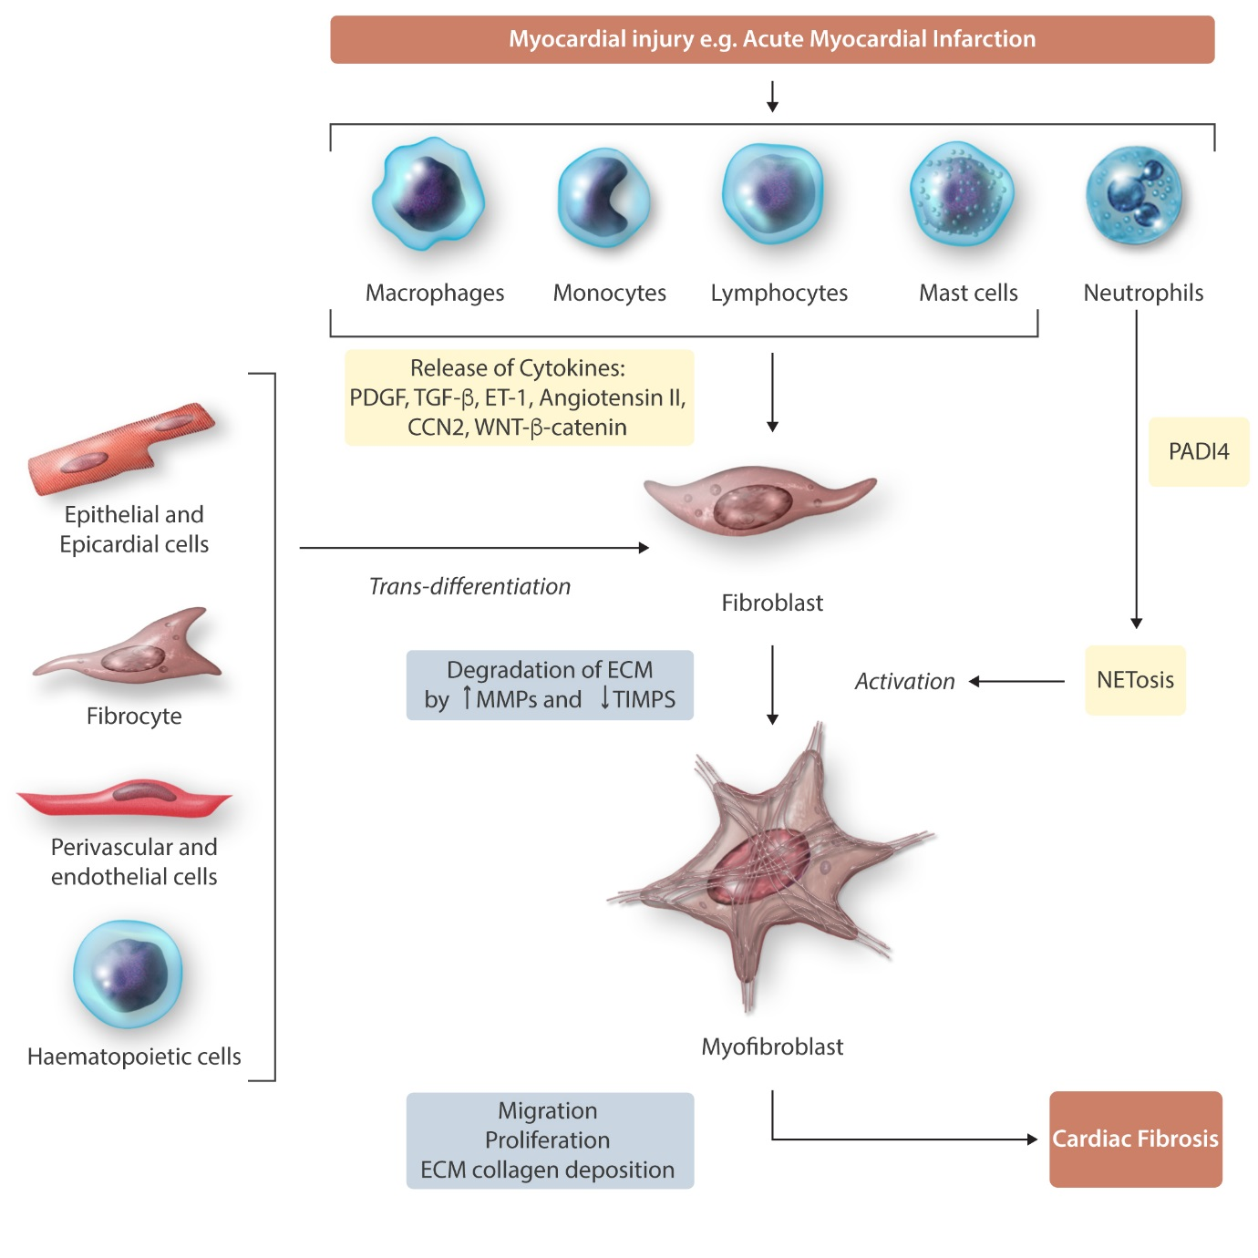

Figure 2a.
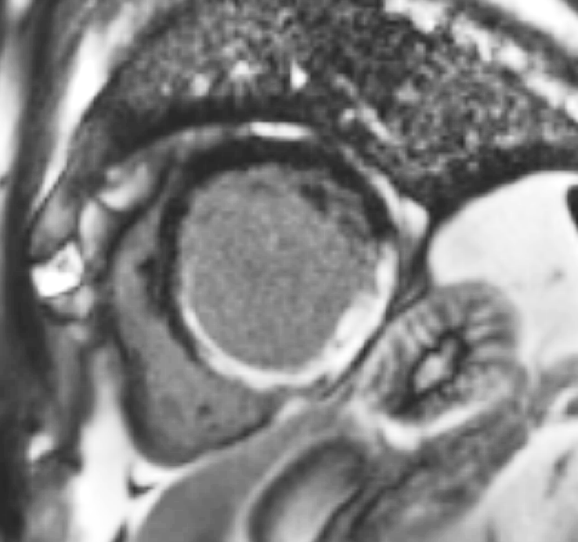

Figure 2b

Figure 3

