Table 1. Description of the included (sub) cohort studies
 |  | Total participants | Baseline period | End of follow-up | Baseline age  Mean (SD) | Lung cancers | Males  % | Current smokers  % | Cigarettes /dayª  Mean (SD) | Years of smokingª  Mean (SD) | BMI ≥ 25 kg/m²  % | Not em-ployed % | Married/  cohabiting  % | Neighborhood income^{b}  Mean (SD)
CEANS
Stockholm, Sweden
 | SDPP | 7,305 | 1992–1998 | 31-12-2011 | 47.0 (4.9) | 42 | 41 | 26 | 13.5 (7.4) | 27.8 (8.6) | 51 | 9 | 84 | 24.3 (4.2)
 | SIXTY | 3,660 | 1997–1999 | 31-12-2011 | 60 (0) | 38 | 50 | 21 | 13.3 (7.7) | 27.8 (8.6) | 65 | 32 | 74 | 24.7 (6.8)
 | SALT | 5,625 | 1998–2003 | 31-12-2011 | 57.3 (10.4) | 43 | 47 | 21 | 12.7 (8.0) | 37.6 (9.1) | 41 | 33 | 68 | 25.4 (6.6)
 | SNAC-K | 2,359 | 2001–2004 | 31-12-2011 | 72.5 (10.4) | 21 | 38 | 15 | 11.7 (8.3) | 43.2 (13.5) | 53 | 76 | 46 | 28.7 (2.2)
DCH, Copenhagen /Aarhus, Denmark |  | 52,779 | 1993–1997 | 31-12-2015 | 56.7 (4.4) | 1,474 | 47 | 36 | 16.5 (9.0) | 36.3 (7.7) | 56 | 22 | 71 | 20.1 (3.4)
DNC,
Denmark
 | DNC-1993 | 15,556 | 1993 | 31-12-2012 | 56.0 (8.3) | 299 | 0 | 37 | 13.8 (8.1) | 31.4 (9.9) | 28 | 29 | 68 | 19.2 (2.6)
 | DNC-1999 | 7,430 | 1999 | 31-12-2012 | 47.9 (4.1) | 25 | 0 | 33 | 13.2 (7.4) | 27.1 (7.1) | 30 | 5 | 76 | 19.0 (2.4)
EPIC-NL,
Netherlands
 | MORGEN | 17,792 | 1993–1997 | 31-12-2012 | 42.7 (11.2) | 170 | 46 | 35 | 15.7 (8.6) | 24.5 (10.6) | 49 | 31 | 65 | 12.2 (1.6)
 | Prospect | 13,640 | 1993–1997 | 31-12-2012 | 57.6 (6.0) | 191 | 0 | 23 | 13.6 (8.7) | 36.7 (7.6) | 55 | 49 | 77 | 13.1 (1.4)
HNR,  Ruhr area, Germany |  | 3,611 | 2000–2003 | 26-04-2017 | 59.1 (7.7) | 69 | 50 | 25 | 19.1 (12.5) | 33.9 (9.2) | 73 | 57 | 75 | 25.1 (8.1)
E3N,  France |  | 36,258 | 1989–1991 | 08-12-2014 | 52.8 (6.7) | 157 | 0 | 13 | 11.3 (9.1) | 28.5 (7.6) | 21 | 31 | 84 | 11.2 (3.0)
VHM&PP,  Vorarlberg, Austria |  | 140,089 | 1985–2005 | 31-12-2014 | 41.7 (14.9) | 1,387 | 44 | 20 | 15.6 (8.9) | 13.4 (8.2) | 42 | 29 | 69 | 22.9 (1.7)
Pooled cohort |  | 306,104 | 1985-2005 | 2011–2017 | 48.3 (13.4) | 3,916 | 34 | 24 | 15.2 (8.9) | 25.3 (13.1) | 43 | 29 | 72 | 19,8 (5,3)
CEANS: Cardiovascular Effects of Air Pollution and Noise in Stockholm; SDPP: The Stockholm Diabetes Preventive Program; SIXTY: The Stockholm cohort of 60-year-olds; SALT: Screening Across the Lifespan Twin Study; SNAC-K: The Swedish National Study of Aging and Care in Kungsholmen; DCH: Diet, Cancer and Health; DNC: Danish Nurses Cohort; EPIC-NL: European Prospective Investigation into Cancer and Nutrition, the Netherlands; MORGEN: Monitoring Project on Risk Factors and chronic diseases in the Netherlands; HNR: Heinz Nixdorf Recall study; E3N (EPIC-France): Etude Epidémiologique auprès de femmes de la Mutuelle Générale de l'Education Nationale; VHM&PP: Vorarlberg Health Monitoring and Prevention Programme.
ªAmong current smokers at baseline.
^{b}Euros x 1,000, year 2001.

Figure 1. Distribution of PM_{2.5} components for the year 2010 at baseline addresses estimated from SLR and random forest models.
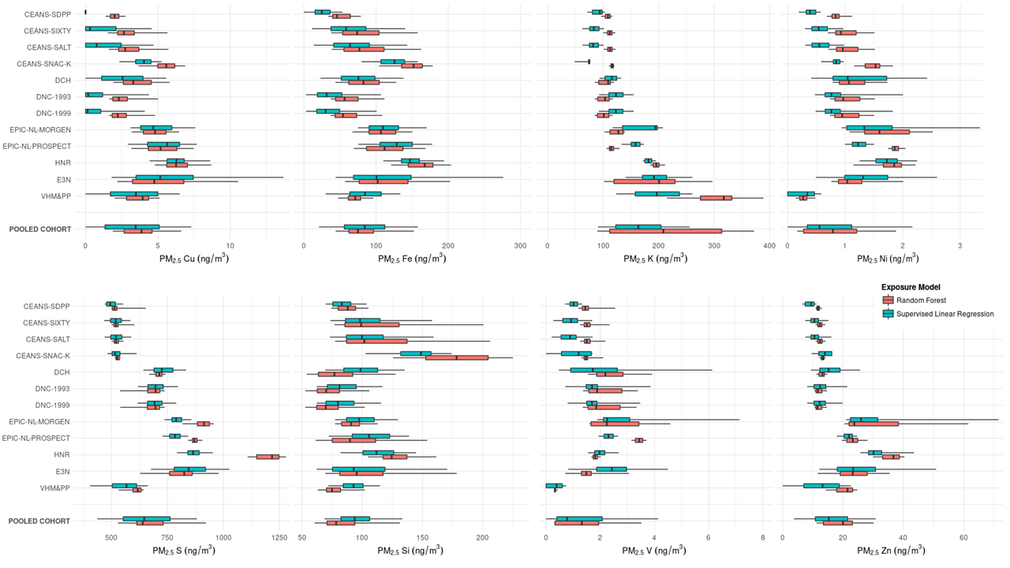
The box boundaries indicate P25 and P75; the bold line in the middle of the box – P50; whiskers indicate P5 and P95.
Table 2. Pooled analyses of PM_{2.5} components (SLR) exposure and risk of lung cancer
 |  |  | Model 1ª  N=306,104 |  |  |  | Model 2^{b}  N=306,104 |  |  |  | Model 3^{c}  N=306,104
PM_{2.5} component |  | Increment | HR | 95% CI |  |  | HR | 95% CI |  |  | HR | 95% CI
 | PM_{2.5} mass | 5 μg/m³ | 1.19 | 1.11 | 1.28 |  | 1.12 | 1.04 | 1.22 |  | 1.14 | 1.05 | 1.23
 | PM_{2.5} Cu | 5 ng/m³ | 1.21 | 1.12 | 1.32 |  | 1.02 | 0.94 | 1.11 |  | 1.04 | 0.96 | 1.13
 | PM_{2.5} Fe | 100 ng/m³ | 1.26 | 1.16 | 1.38 |  | 1.02 | 0.93 | 1.12 |  | 1.04 | 0.95 | 1.14
 | PM_{2.5} K | 50 ng/m³ | 1.12 | 1.06 | 1.18 |  | 1.09 | 1.04 | 1.15 |  | 1.10 | 1.05 | 1.16
 | PM_{2.5} Ni | 1 ng/m³ | 1.23 | 1.17 | 1.30 |  | 1.10 | 1.04 | 1.16 |  | 1.09 | 1.02 | 1.15
 | PM_{2.5} S | 200 ng/m³ | 1.45 | 1.31 | 1.59 |  | 1.23 | 1.12 | 1.35 |  | 1.22 | 1.11 | 1.35
 | PM_{2.5} Si | 100 ng/m³ | 1.84 | 1.56 | 2.18 |  | 1.17 | 0.98 | 1.39 |  | 1.14 | 0.96 | 1.35
 | PM_{2.5} V | 2 ng/m³ | 1.18 | 1.14 | 1.24 |  | 1.08 | 1.03 | 1.13 |  | 1.07 | 1.02 | 1.12
 | PM_{2.5} Zn | 10 ng/m³ | 1.09 | 1.05 | 1.13 |  | 1.02 | 0.98 | 1.07 |  | 1.03 | 0.98 | 1.07
HR, hazard ratio; CI, confidence interval
ªAdjusted for study (strata), age (time-scale), sex (strata), year of baseline visit
^{b}Further adjusted for smoking status, duration, intensity, intensity², BMI, marital status, and employment status
^{c}Further adjusted for 2001 mean income at the neighborhood level

Table 3. Pooled two-pollutant analyses of PM_{2.5} components (SLR) and co-pollutants and risk of lung cancer
 |  |  | Single pollutantª  N=306,104 |  |  |  | Adjusted for PM_{2.5} mass  N=306,104 |  |  |  | Adjusted for NO₂  N=306,104
PM_{2.5} component |  | Increment | HR | 95% CI |  |  | HR | 95% CI |  |  | HR | 95% CI
 | PM_{2.5} Cu | 5 ng/m³ | 1.04 | 0.96 | 1.13 |  | 0.92 | 0.82 | 1.03 |  | 1.04 | 0.90 | 1.20
 | PM_{2.5} Fe | 100 ng/m³ | 1.04 | 0.95 | 1.14 |  | 0.92 | 0.83 | 1.03 |  | 1.02 | 0.86 | 1.21
 | PM_{2.5} K | 50 ng/m³ | 1.10 | 1.05 | 1.16 |  | 1.08 | 1.01 | 1.15 |  | 1.10 | 1.04 | 1.16
 | PM_{2.5} Ni | 1 ng/m³ | 1.09 | 1.02 | 1.15 |  | 1.05 | 0.99 | 1.12 |  | 1.10 | 1.03 | 1.18
 | PM_{2.5} S | 200 ng/m³ | 1.22 | 1.11 | 1.35 |  | 1.21 | 1.06 | 1.39 |  | 1.31 | 1.17 | 1.48
 | PM_{2.5} Si | 100 ng/m³ | 1.14 | 0.96 | 1.35 |  | 1.01 | 0.83 | 1.22 |  | 1.17 | 0.92 | 1.49
 | PM_{2.5} V | 2 ng/m³ | 1.07 | 1.02 | 1.12 |  | 1.05 | 0.99 | 1.10 |  | 1.07 | 1.02 | 1.13
 | PM_{2.5} Zn | 10 ng/m³ | 1.03 | 0.98 | 1.07 |  | 0.98 | 0.93 | 1.27 |  | 1.02 | 0.98 | 1.07
HR, hazard ratio; CI, confidence interval
ªAdjusted for study (strata), age (time-scale), sex (strata), year of baseline visit, smoking status, duration, intensity, intensity², BMI, marital status, employment status, and 2001 mean income at the neighborhood level

Figure 2. Natural spline functions (3 df) of PM_{2.5} components (SLR) and lung cancer incidence
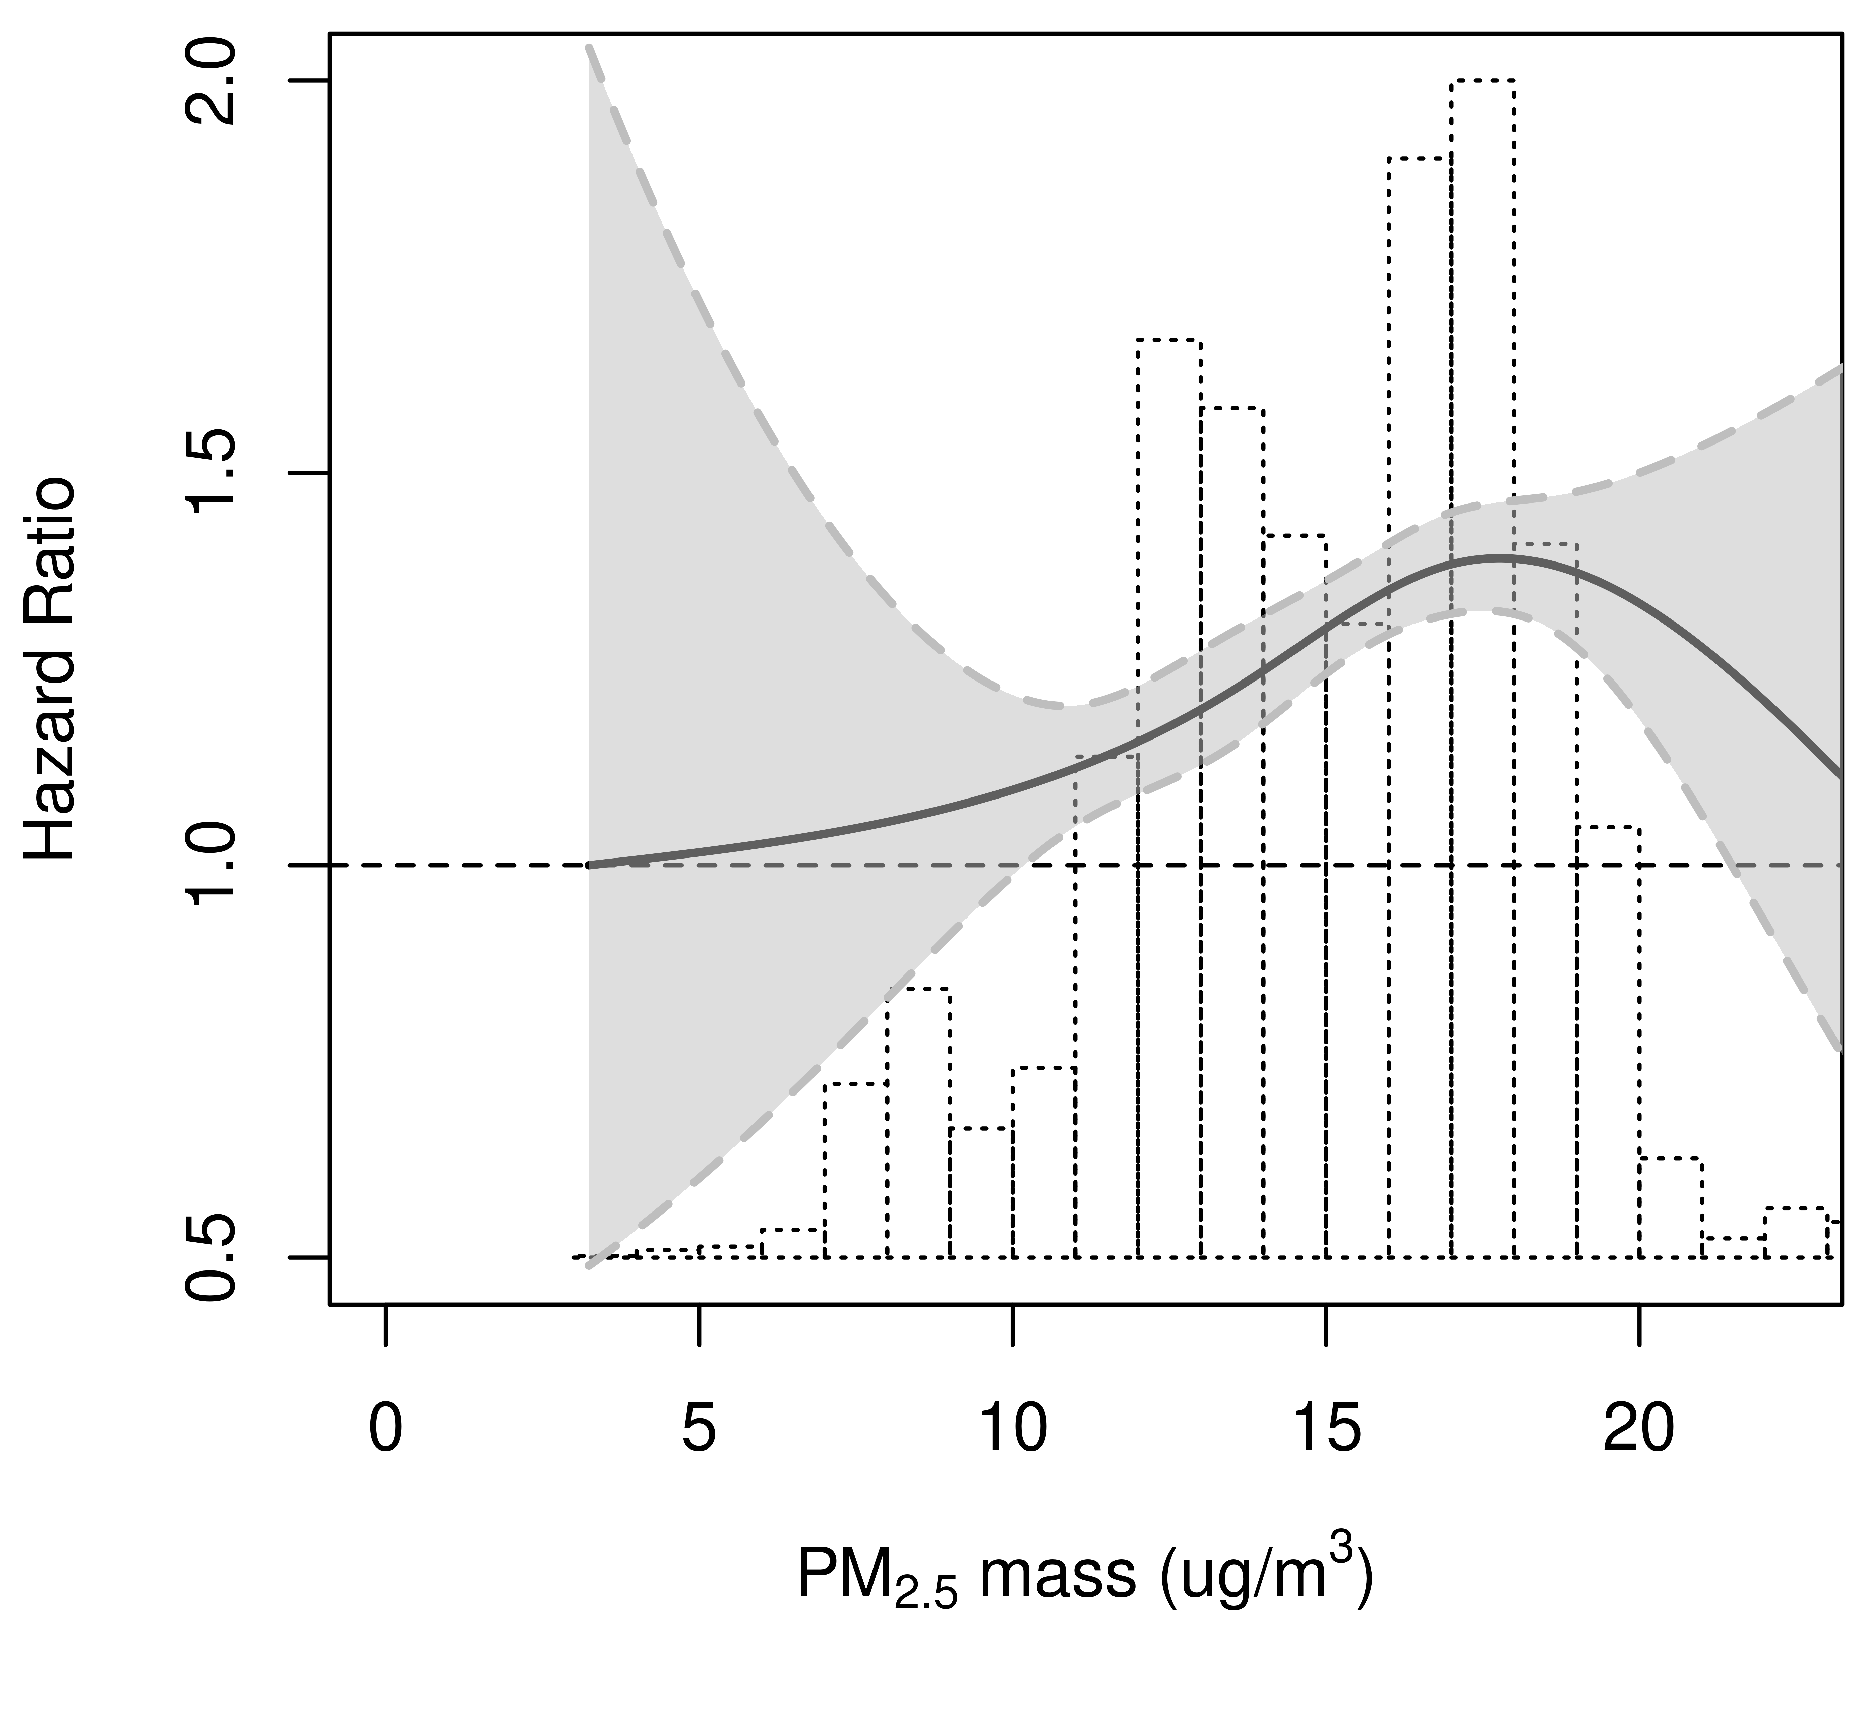 | 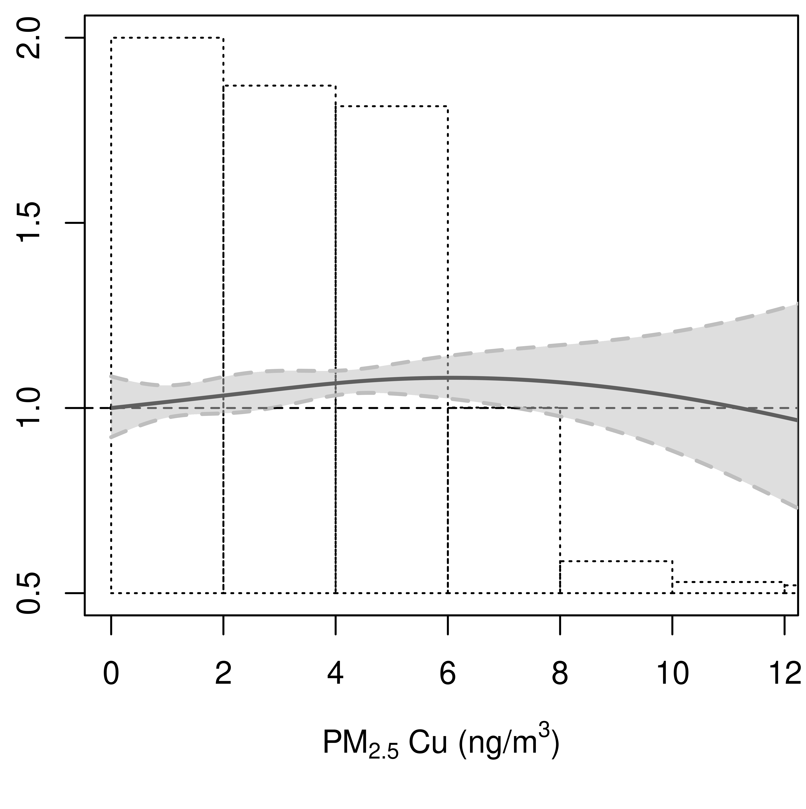 | 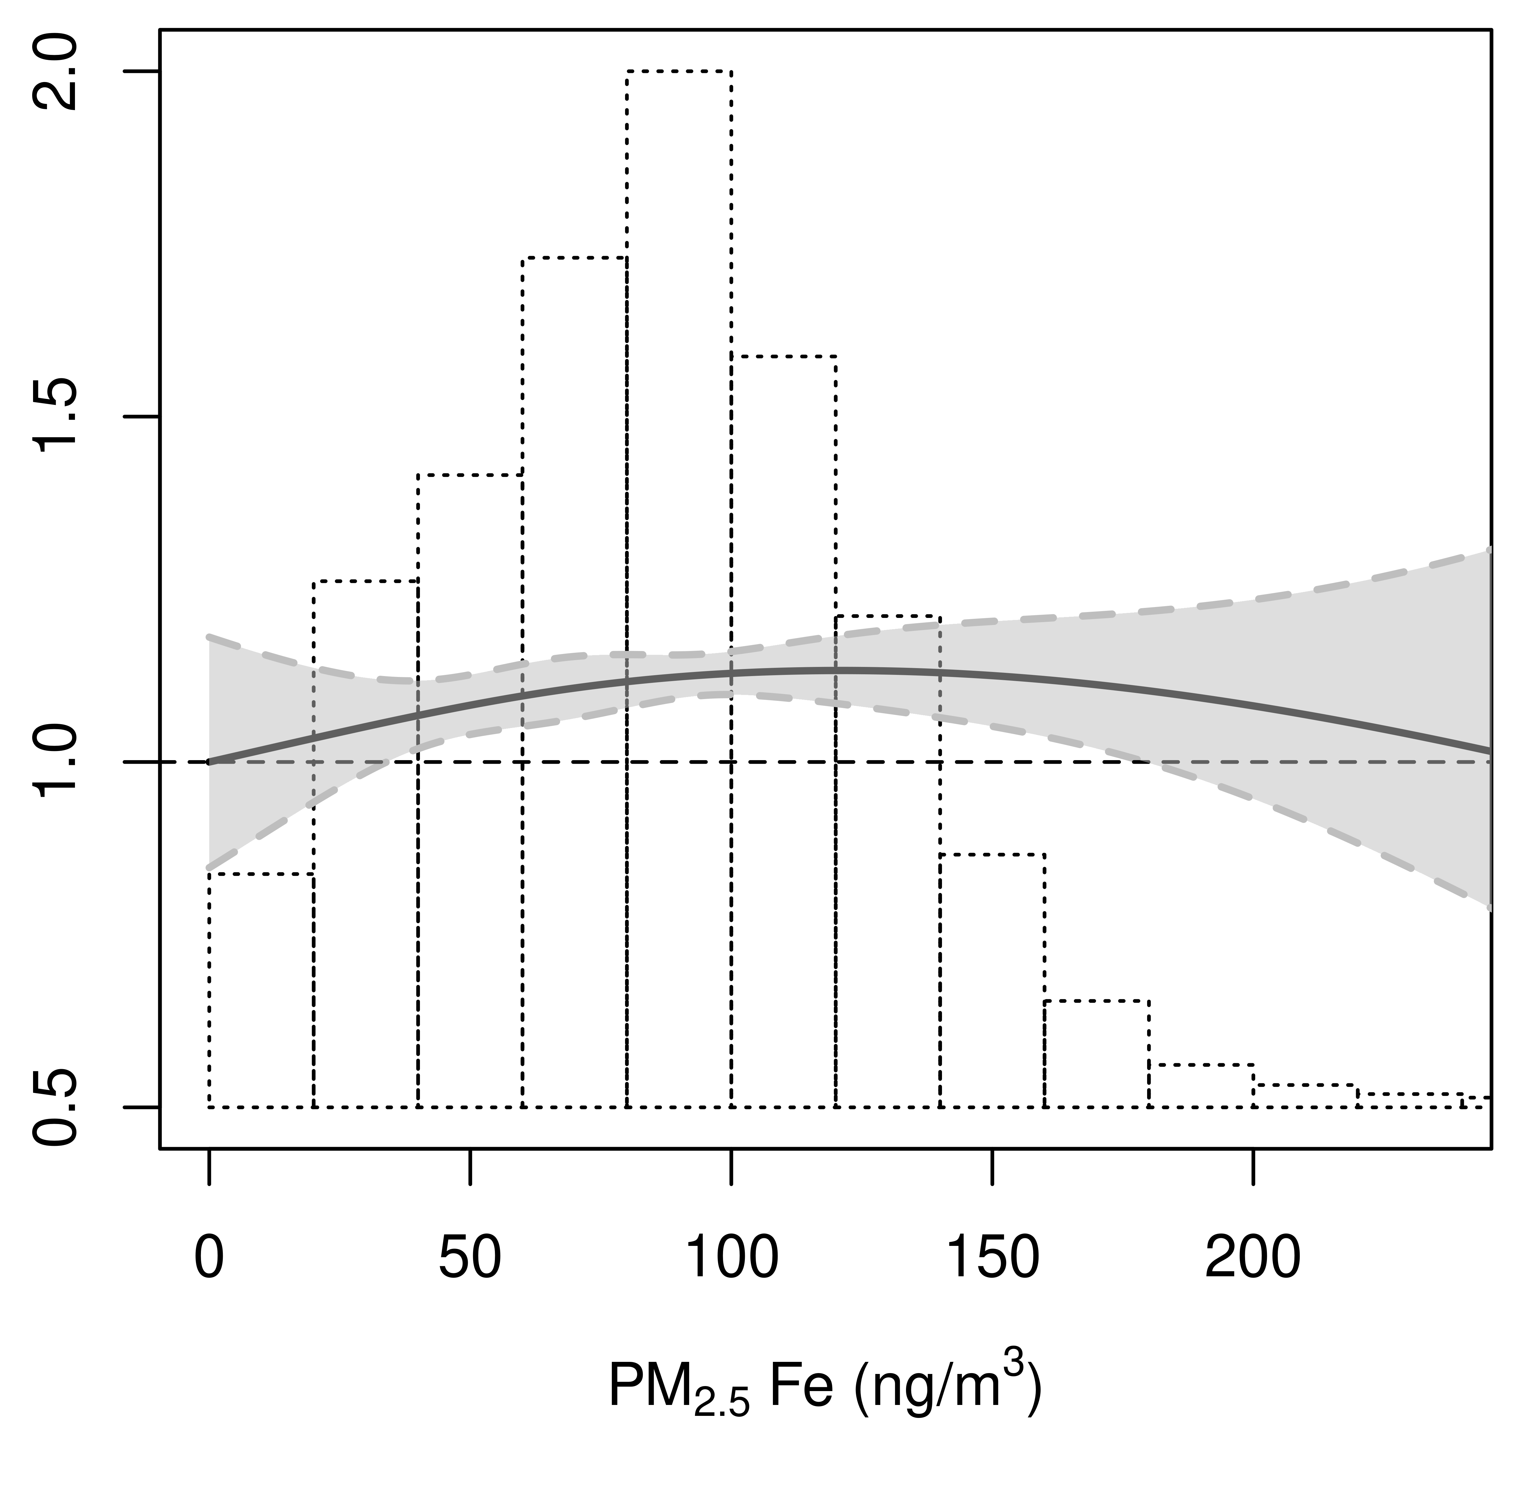
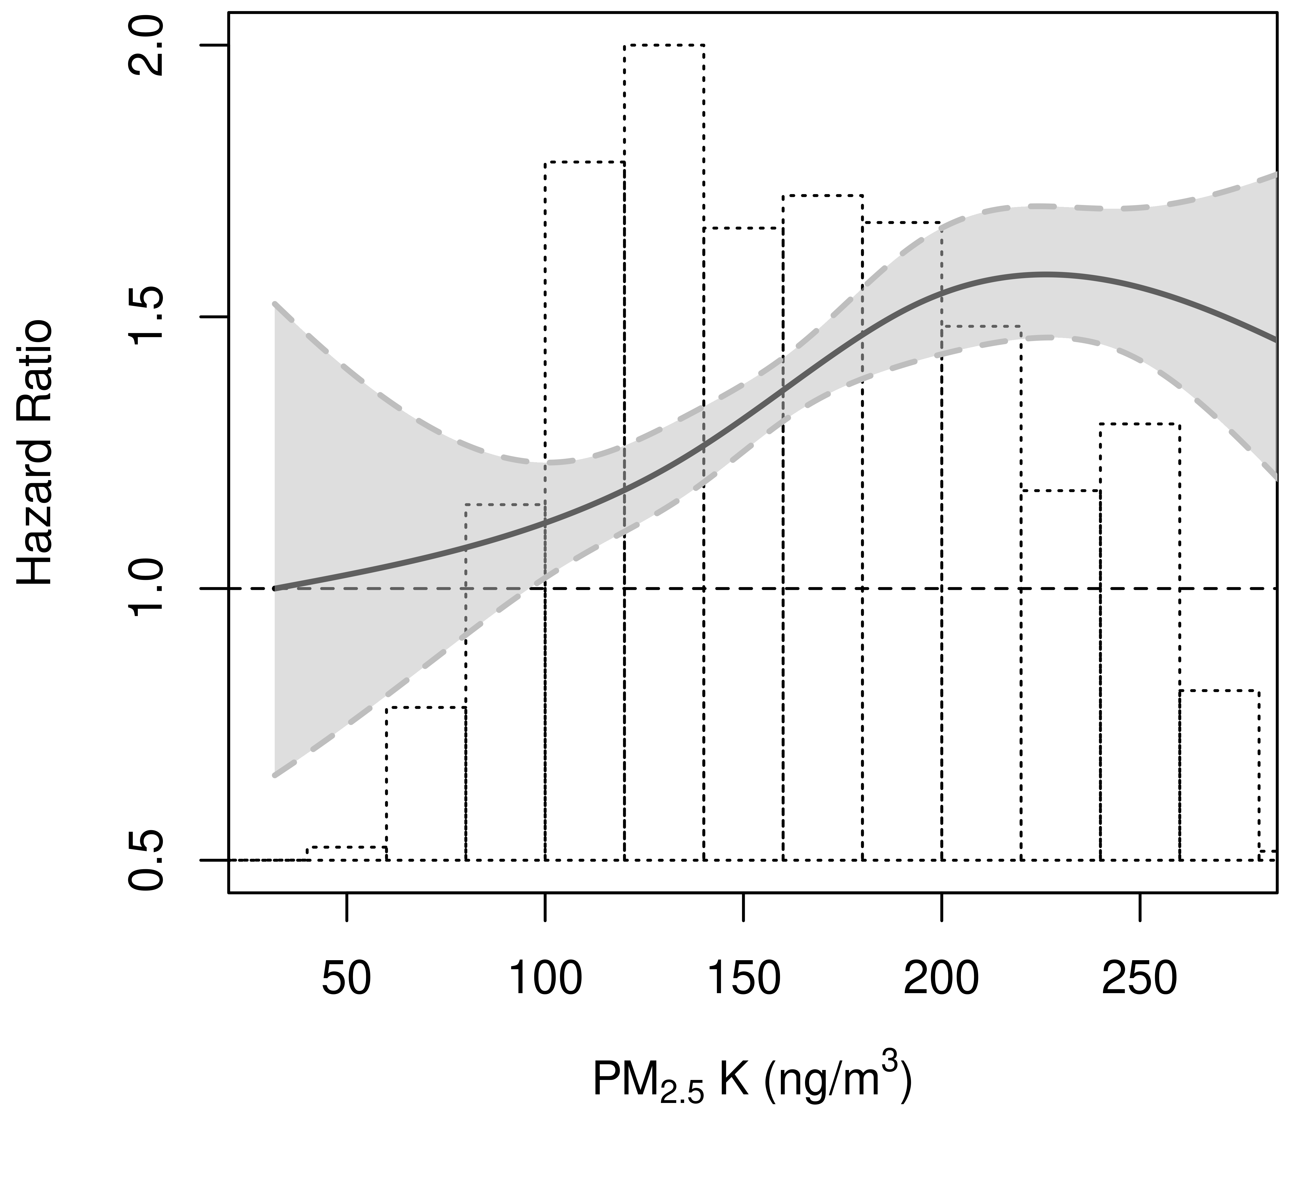 | 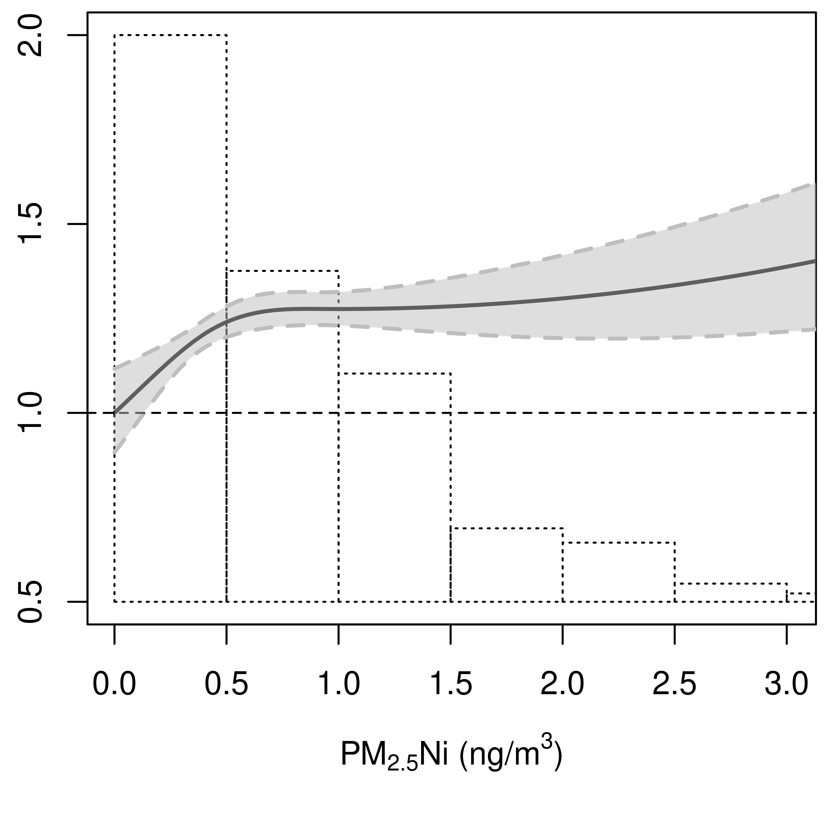 | 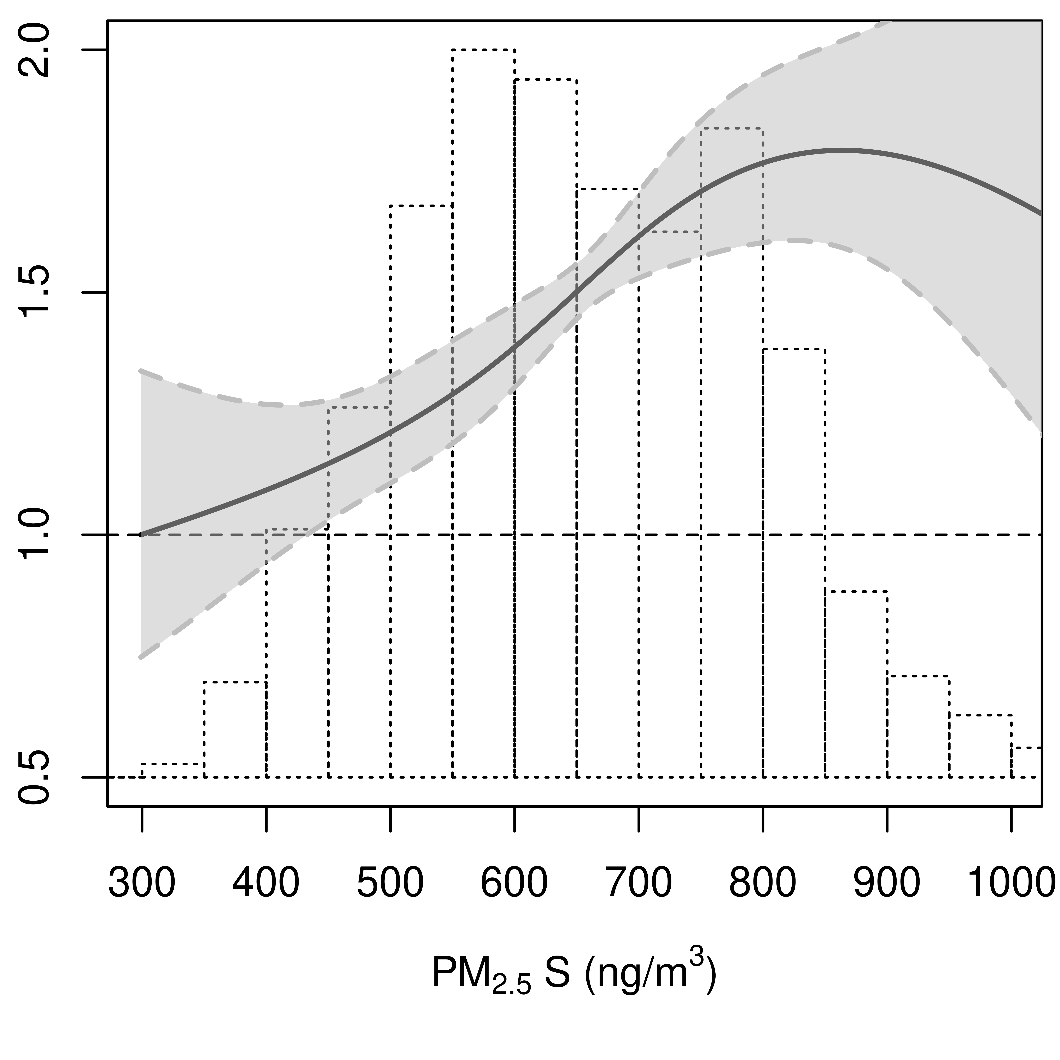
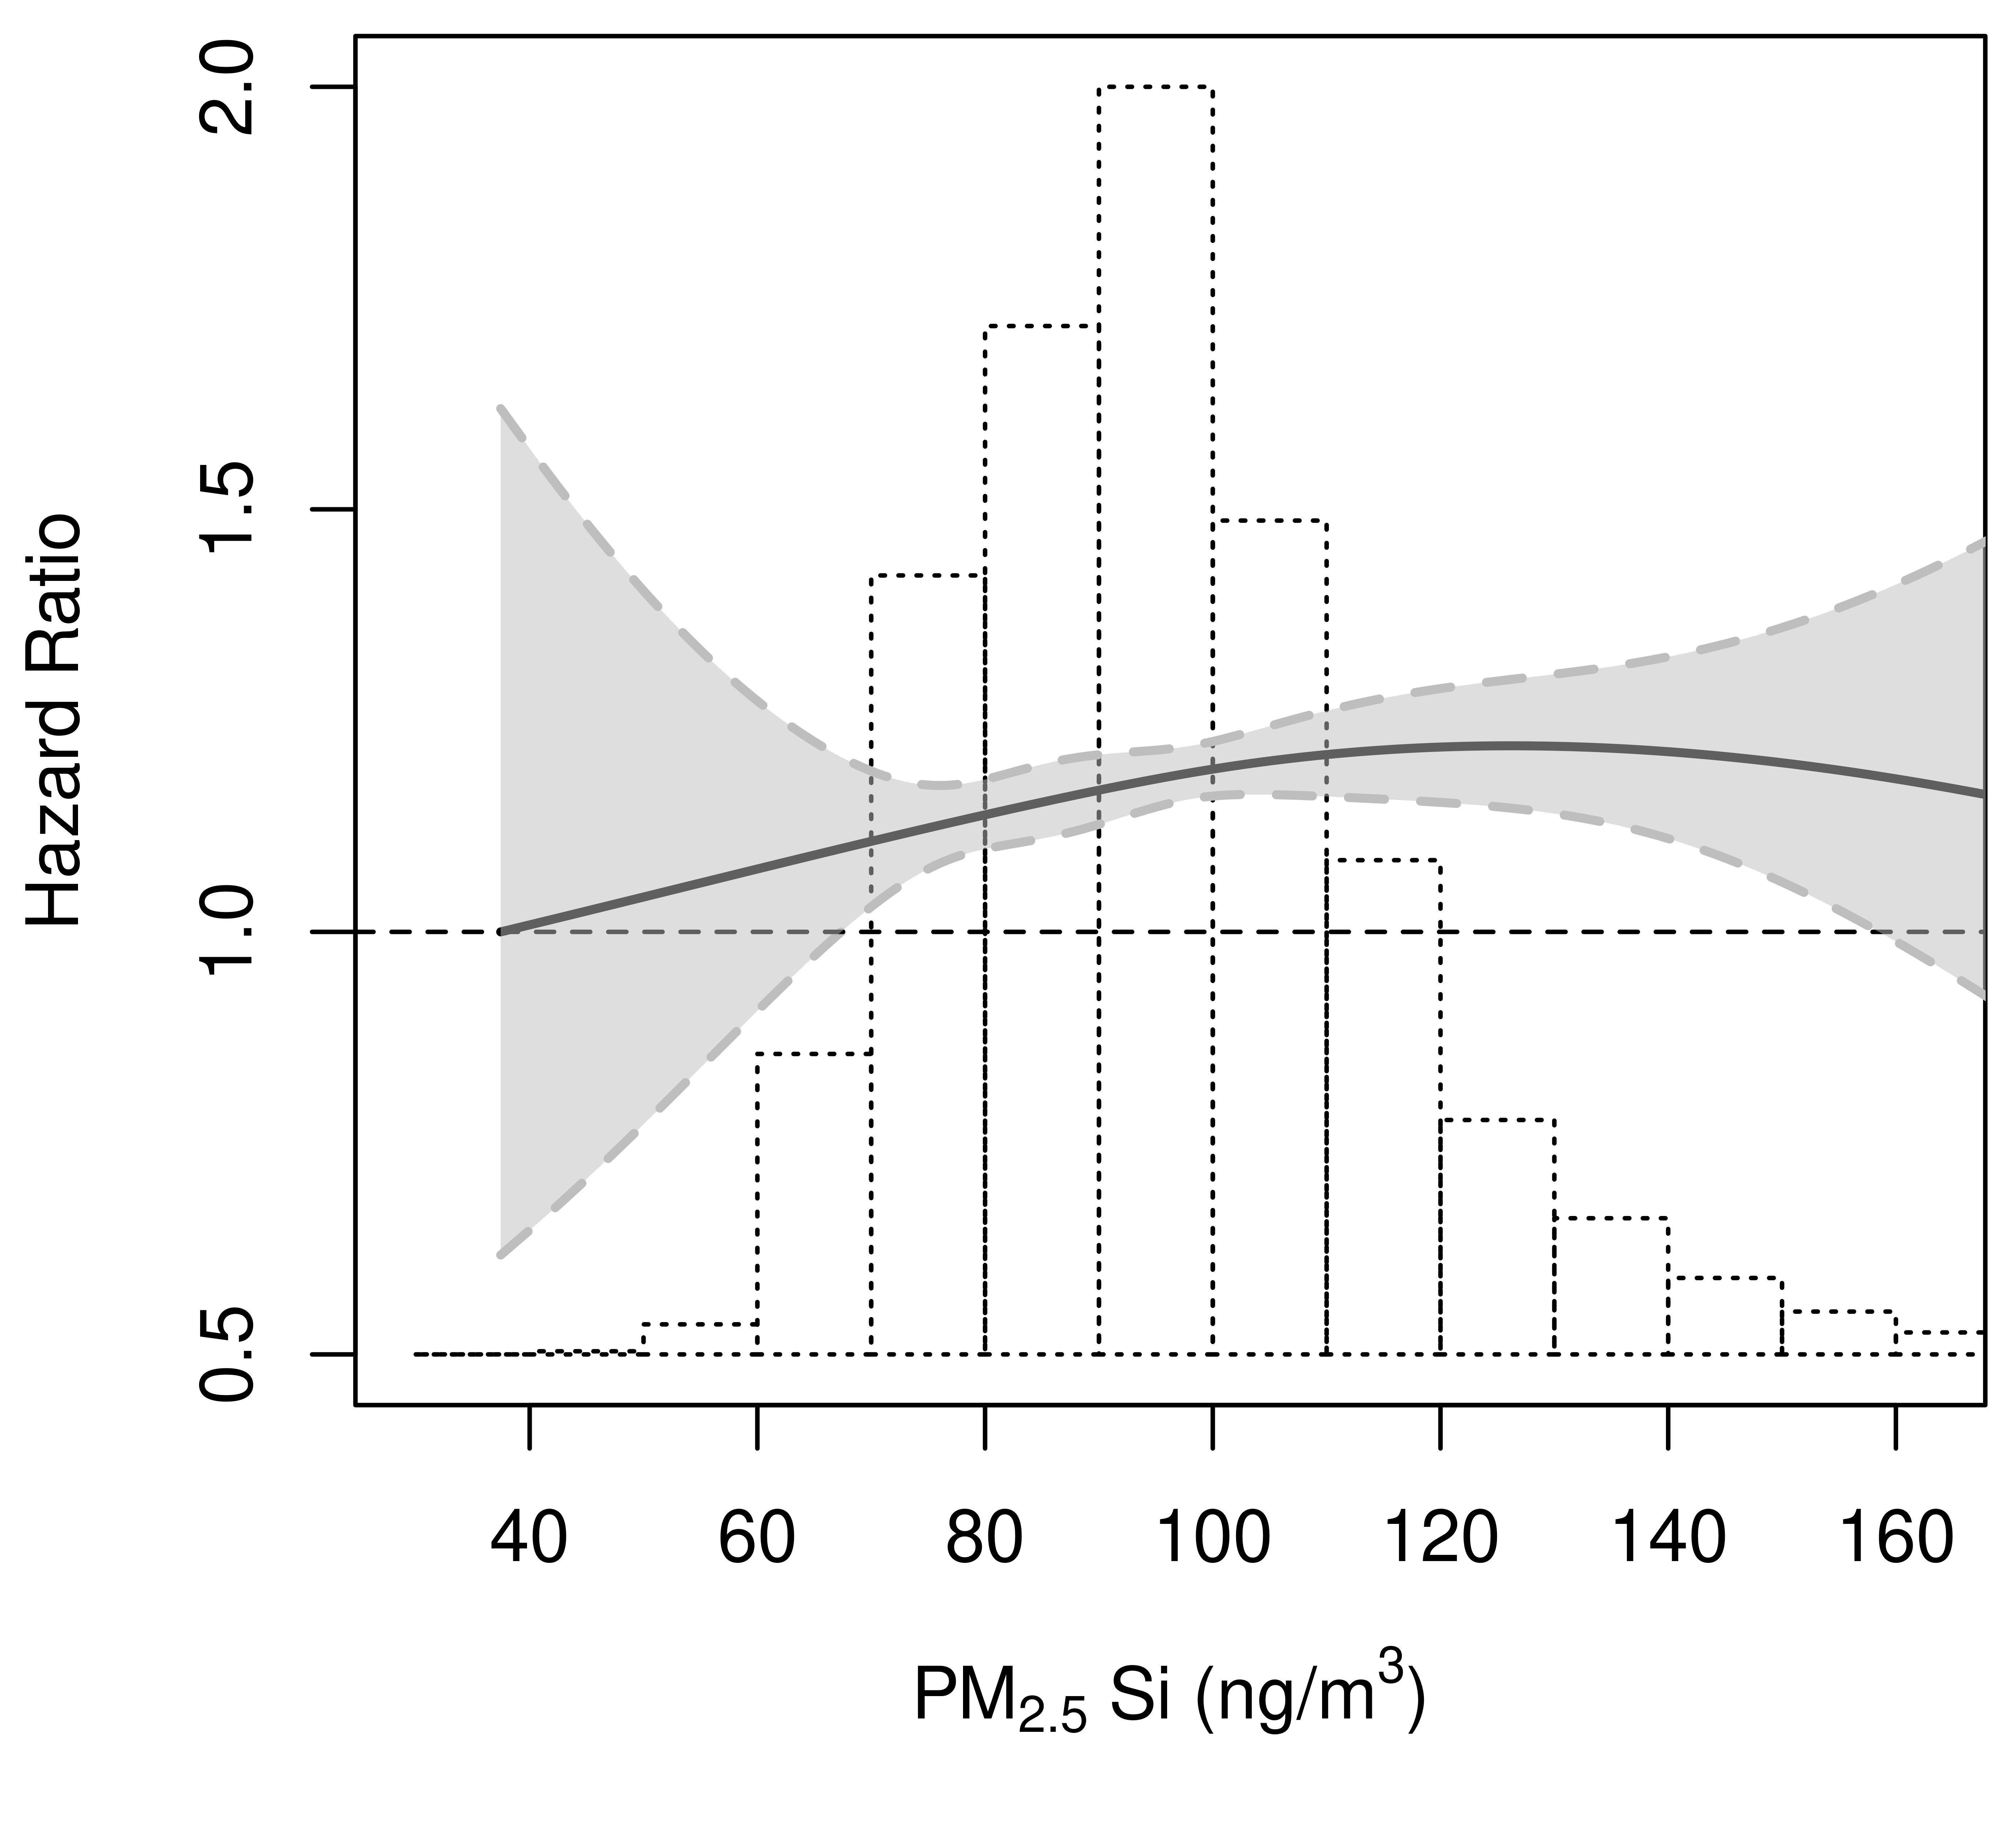 | 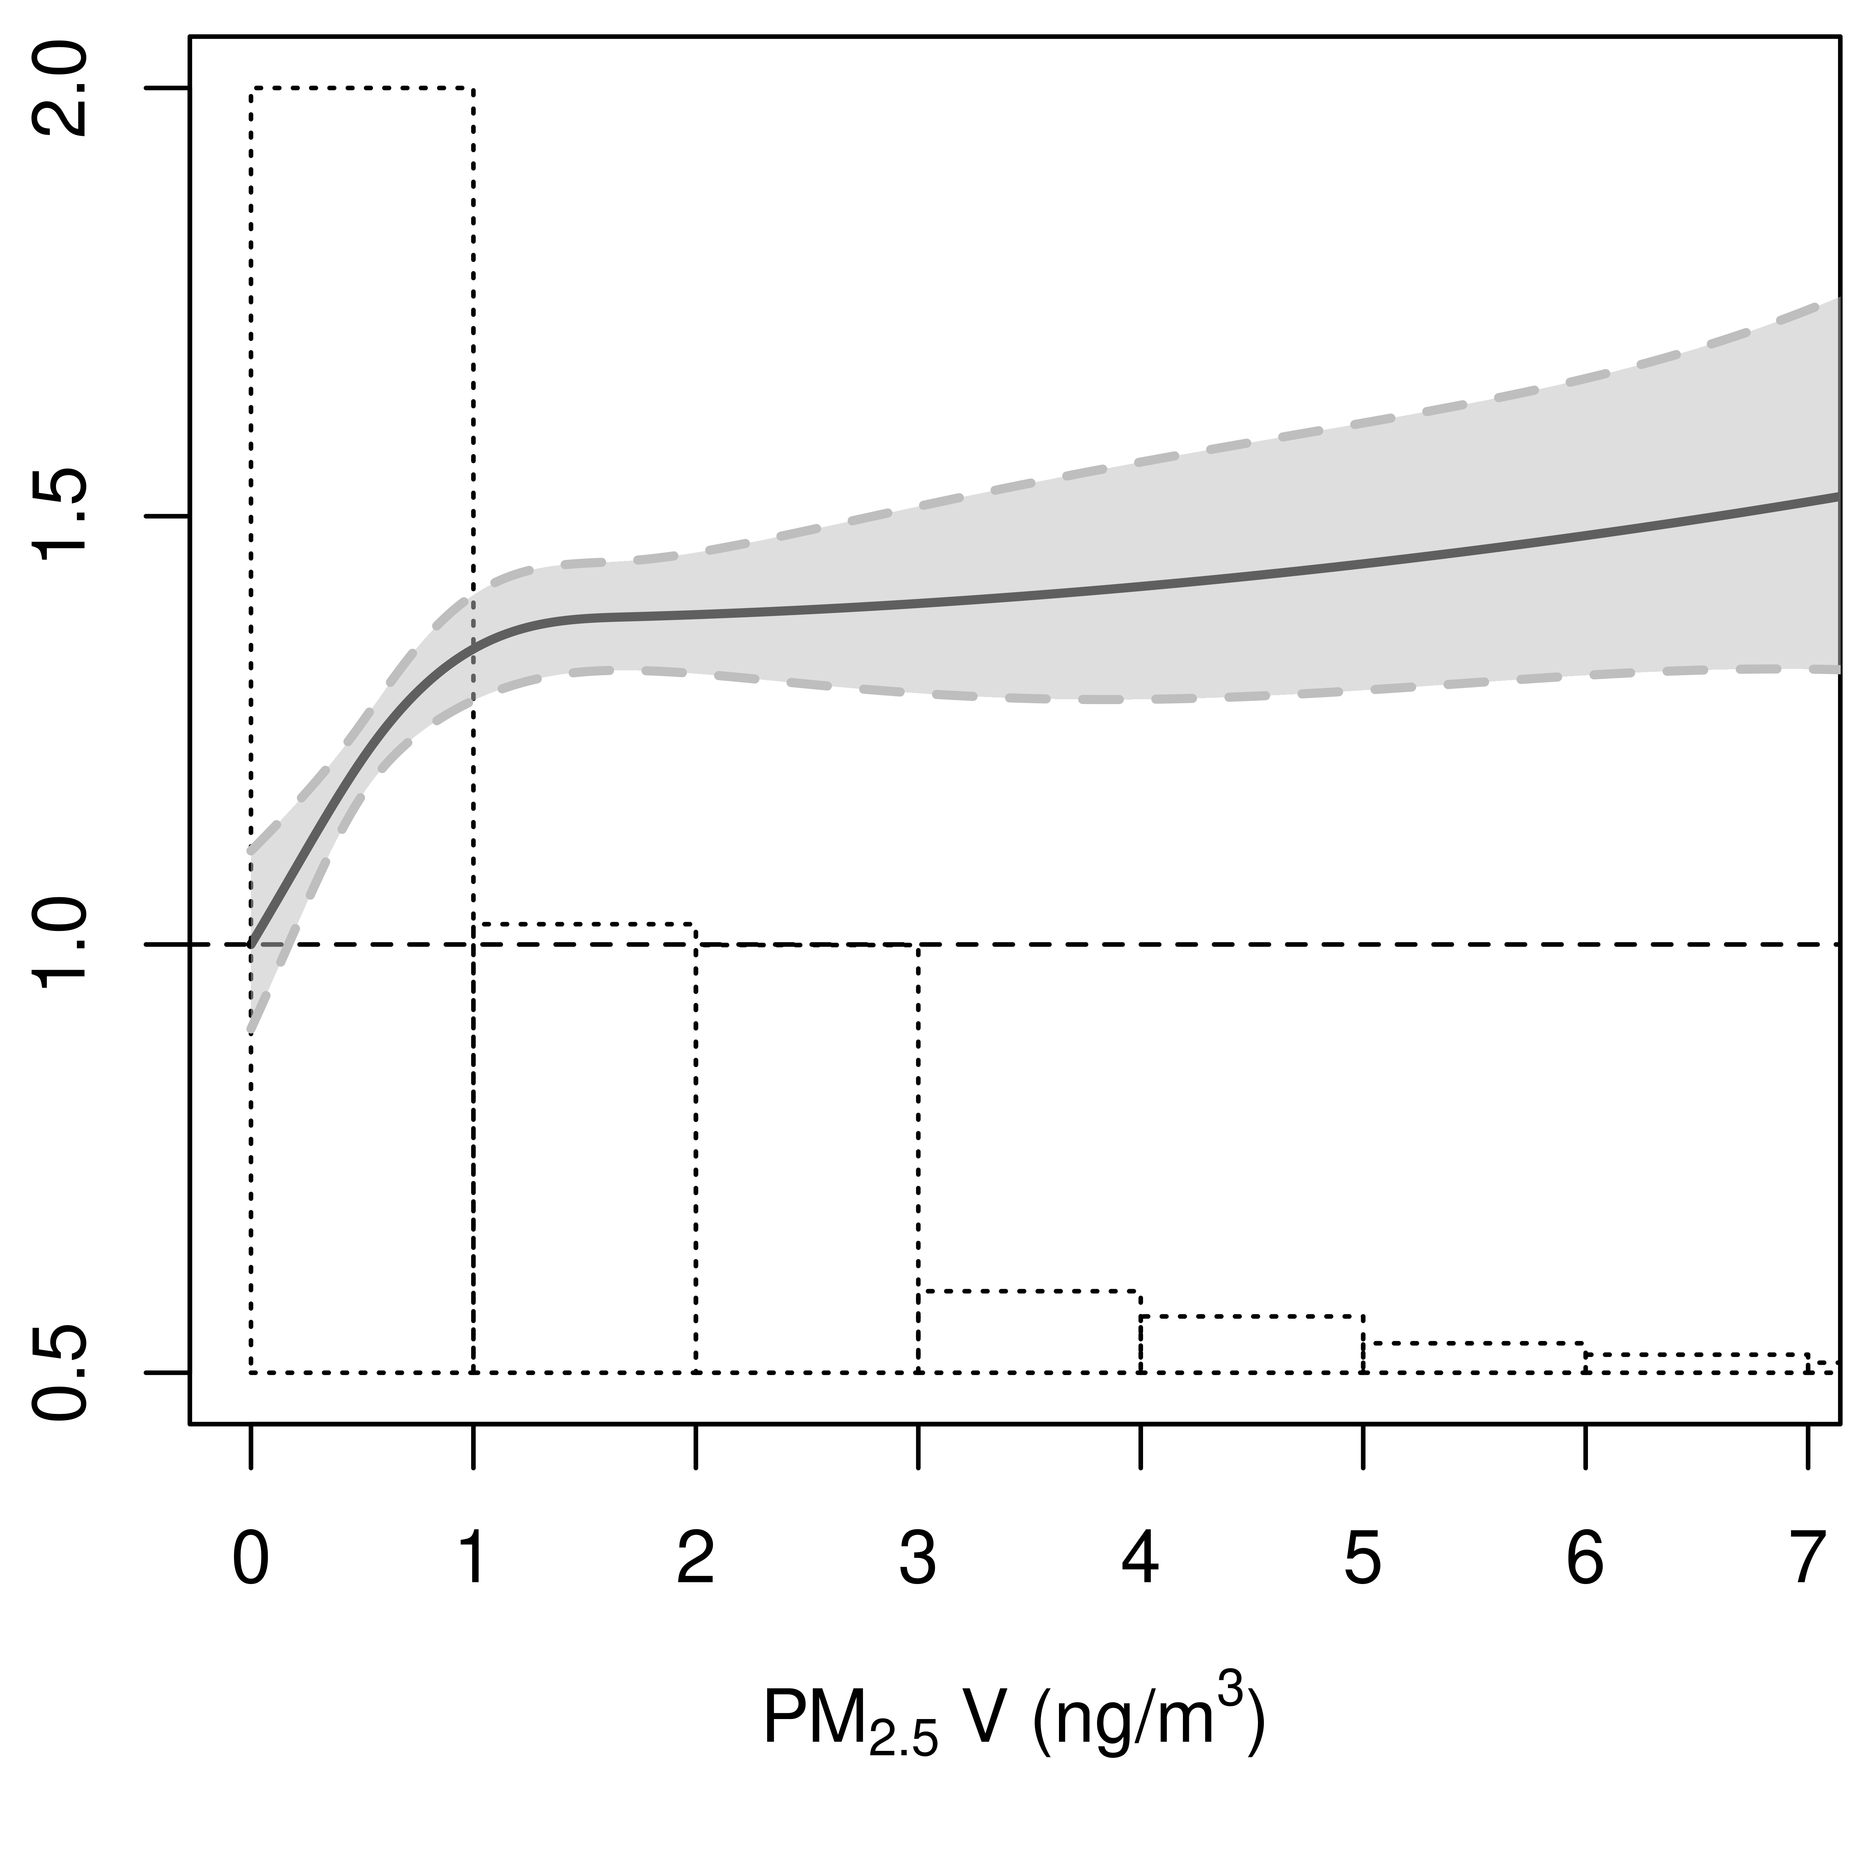 | 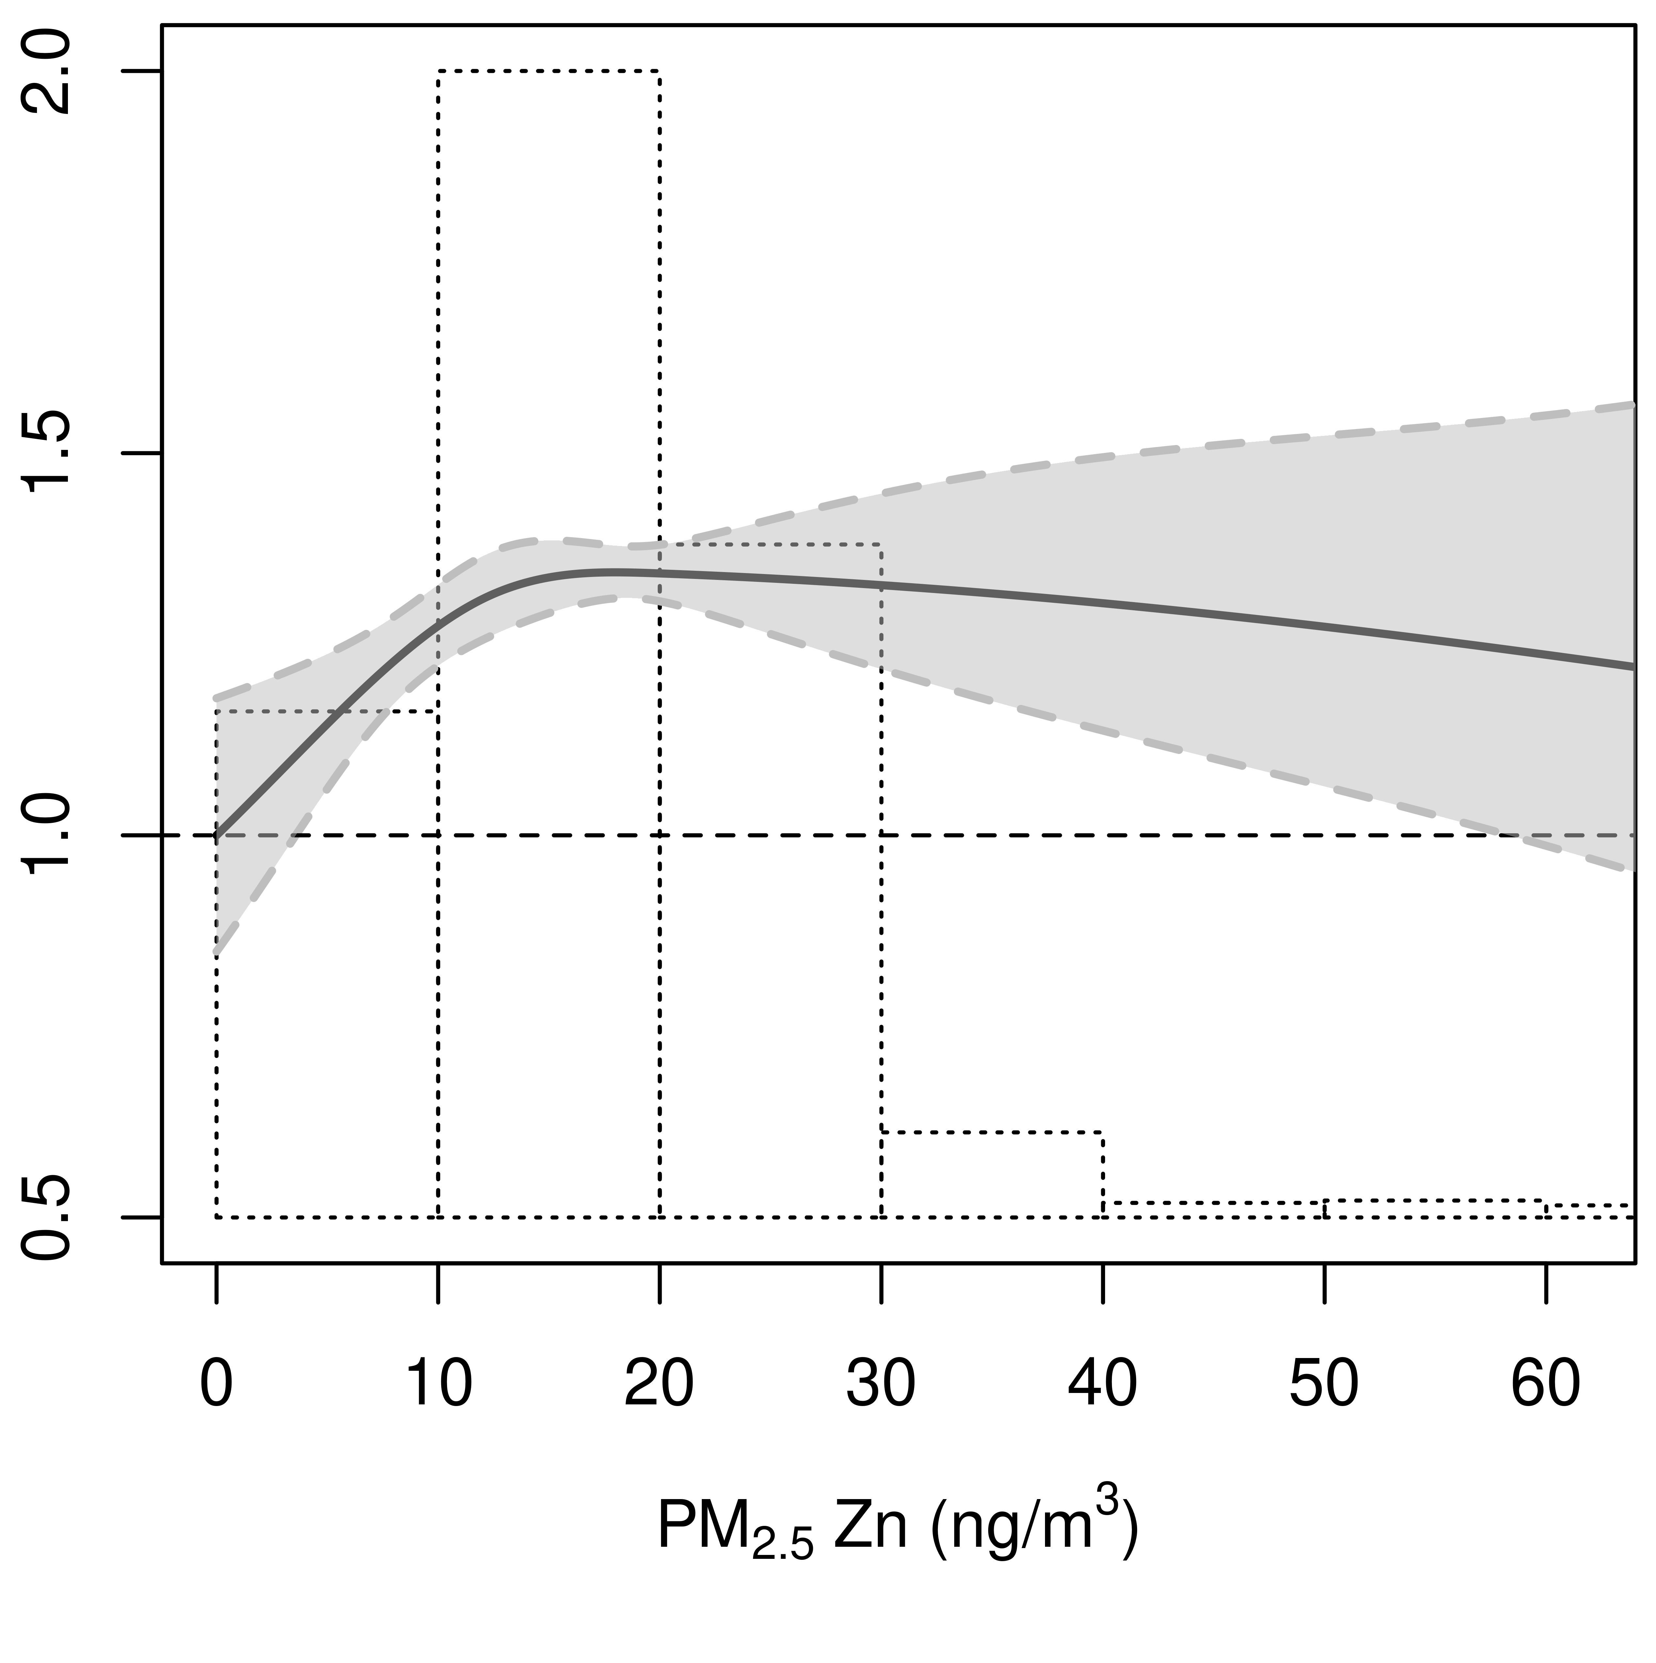

Figure 3. Associations between PM_{2.5} components and lung cancer based on SLR and random forest exposure algorithms (N=306,104)
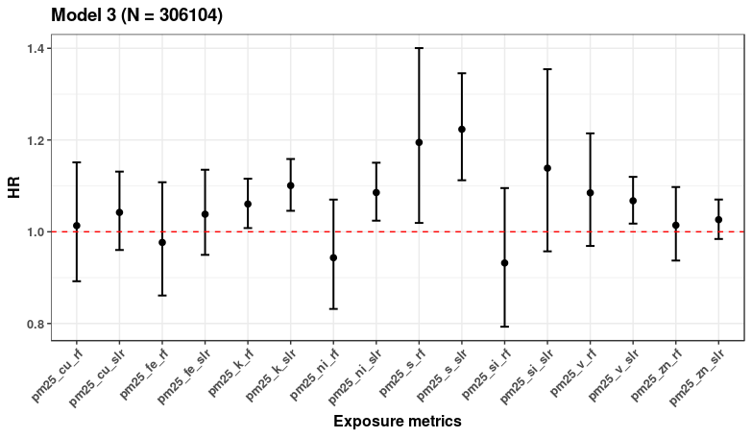
SLR, Supervised Linear regression; RF, Random Forest
Model 3 estimates adjusted for study (strata), age (time-scale), sex (strata), year of baseline visit, smoking status, duration, intensity, intensity², BMI, marital status, employment status, and 2001 mean income at the neighborhood level

