**Forecasting the type 2 diabetes mellitus epidemic and the role of key risk factors in Oman up to 2050: Mathematical modeling analyses**

Susanne F. Awad,1,2,3 Adhra Al-Mawali,4,5 Jawad A. Al-Lawati,6 Magdi Morsi,4 Julia A. Critchley,7 Laith J. Abu-Raddad1,2,3*

1Infectious Diseases Epidemiology Group, Weill Cornell Medical College – Qatar, Cornell University, Doha, Qatar

2World Health Organization Collaborating Centre for Disease Epidemiology Analytics on HIV/AIDS, Sexually Transmitted Infections, and Viral Hepatitis, Weill Cornell Medicine – Qatar, Doha, Qatar

3Department of Population Health Sciences, Weill Cornell Medicine, Cornell University, New York, USA

4Centre of Studies & Research, Ministry of Health, Muscat, Sultanate of Oman

5Strategic Research Program for Non-communicable Disease, The Research Council (TRC), Muscat, Sultanate of Oman

6Directorate General of Primary Health Care, Ministry of Health, Muscat, Sultanate of Oman

7Population Health Research Institute, St George’s, University of London, London, UK

**Word count:** Abstract: 229 words, Text: 4,409 words.

**Number of Boxes:** 1.

**Number of figures:** 4.

**Running head:** Diabetes epidemic in Oman.

***\*Corresponding author:***

Laith J. Abu-Raddad, Ph.D., Infectious Disease Epidemiology Group, World Health Organization Collaborating Centre for Disease Epidemiology Analytics on HIV/AIDS, Sexually Transmitted Infections, and Viral Hepatitis, Weill Cornell Medicine – Qatar, Qatar Foundation - Education City, P.O. Box 24144, Doha, Qatar. Telephone: +(974) 4492-8321. Fax: +(974) 4492-8333. E-mail: [lja2002@qatar-med.cornell.edu](mailto:lja2002@qatar-med.cornell.edu)

****Abstract****

**Objectives:** To investigate and forecast type 2 diabetes mellitus (T2DM) epidemic, its related risk factors, and cost in Oman by 2050.

**Methods:** An age-structured mathematical model was used to characterize T2DM epidemiology and trends in Oman between 1990-2050. The model was parametrized using current and quality data, including six nationally-representative population-based epidemiological surveys for T2DM and its key risk factors.

**Results:** The projected T2DM prevalence increased from 15.2% in 2020 to 23.8% in 2050. The prevalence increased from 16.8% and 13.8% in 2020 among women and men to 26.3% and 21.4% in 2050, respectively. In 2020, 190,489 Omanis were living with T2DM compared to 570,227 in 2050. The incidence rate per 1,000 person-years changed from 8.3 in 2020 to 12.1 in 2050. T2DM’s share of Oman’s national health expenditure grew by 36% between 2020-2050 (from 21.2% to 28.8%). Obesity explained 56.7% of T2DM cases in 2020 and 71.4% in 2050, physical inactivity explained 4.3% in 2020 and 2.7% in 2050, while smoking accounted for <1% of T2DM cases throughout 2020-2050. Sensitivity and uncertainty analyses affirmed these predictions.

**Conclusions:** T2DM epidemic in Oman is expected to increase significantly over the next three decades consuming nearly one-third of the national health expenditure. The T2DM burden is heavily influenced by obesity. Interventions targeting this single risk factor should be a national priority to reduce and control the burden of T2DM in Oman.

**Keywords**: Non-communicable disease; body mass index; risk factor; forecasting model; mathematical modeling; health expenditure; Oman; Middle East and North Africa

****Introduction****

Diabetes mellitus (DM) is one of the fastest growing global health challenges of the 21st century[1](#_ENREF_1" \o "International Diabetes Federation, 2019 #734). Based on the 2019 International Diabetes Federation’s (IDF) Diabetes Atlas, 463 million adults aged 20-79 years (prevalence of 9.6%) are estimated to be living with DM today, worldwide, and 700 million (prevalence of 10.9%) are projected to be living with the condition by 2045[1](#_ENREF_1" \o "International Diabetes Federation, 2019 #734). Specifically, the Middle East and North Africa (MENA) region is estimated to have the highest DM prevalence of all regions in both 2019 and 2045 (i.e., 12.8% and 15.7%, respectively)[1](#_ENREF_1" \o "International Diabetes Federation, 2019 #734).

It is well established that type 2 DM (T2DM), which accounts for around 90% of all DM cases, is linked to a variety of nonmodifiable and modifiable risk factors[1](#_ENREF_1" \o "International Diabetes Federation, 2019 #734). Nonmodifiable risk factors include age, genetics, and socio-demographic factors[2-4](#_ENREF_2" \o "Santosa, 2014 #531), while modifiable risk factors include unhealthy diet, obesity (defined by body mass index ≥30 kg/m2), physical inactivity, tobacco use, and alcohol, among others[3](#_ENREF_3" \o "Hu, 2011 #532), [5-7](#_ENREF_5" \o "Pan, 2015 #167).

Oman is one of the 21 countries and territories of the IDF MENA region with a population of 4.95 million in 2020, of which 56% are Omanis[8](#_ENREF_8" \o "National Centre for Statistics & Information of Oman, 2017 #742). With DM being a main concern to policy makers in this country, four national and two regional population-based surveys were conducted to estimate the DM prevalence and associated cardiovascular risk factors between 1991-2017[9-15](#_ENREF_9" \o "Asfour, 1995 #163). The surveys reported an increasing DM prevalence among Omani nationals ranging between 11%-15%[9-15](#_ENREF_9" \o "Asfour, 1995 #163). The surveys also reported on the prevalence of key risk factors for DM including obesity, which ranged between 13%-35%, tobacco use between 2%-9%, and physical inactivity between 38%-42%[9-15](#_ENREF_9" \o "Asfour, 1995 #163).

To investigate T2DM (not all DM cases) epidemiology and its projections in Oman up to 2050, we extended and adapted a recently-developed mathematical modeling approach[16](#_ENREF_16" \o "Awad, 2018 #319) and applied it to Oman. A key strength of this approach is that it factored (as model input) the totality of existing evidence on T2DM and its risk factors in this country, to elucidate the epidemiology and to generate inferences and predictions. Specifically, we forecasted the levels and trends in T2DM prevalence, incidence, and incidence rate, as well as the prevalence of obesity, tobacco use, and physical inactivity up to 2050. We also estimated the national heath expenditure directly attributed to T2DM, and delineated the epidemiological role of key risk factors in T2DM epidemiology in Oman.

****Methods****

An extension and adaptation of a published T2DM compartmental modeling approach[16](#_ENREF_16" \o "Awad, 2018 #319), [17](#_ENREF_17" \o "Awad, 2020 #743) was utilized to describe and characterize the dynamics of the T2DM epidemic in the Omani population (only Omani nationals). Description of the conceptual framework, model structure, data sources, model fitting, and model analyses are given in Box 1. Further details on the model can be found in Awad *et al.*[16](#_ENREF_16" \o "Awad, 2018 #319). In brief, this dynamical modelling approach, in contrast to earlier approaches applied to Oman’s T2DM epidemic[12](#_ENREF_12" \o "Al-Lawati, 2015 #739), [18-21](#_ENREF_18" \o "King, 1998 #145), captured the interplay between T2DM natural history, related risk factors, and demography. The model also stratified the Omani population by age, gender, and by the general progression states of susceptible and living with T2DM. The susceptible and T2DM populations were further stratified into different compartments according to their risk-factor status including “healthy” (defined as having none of the included T2DM-related risk factors), obesity, tobacco use (hereafter referred to as smoking), physical inactivity, and the different overlaps between these risk factors (Box 1).

**Data sources and model fitting**

Model input parameters were set based on epidemiological and natural history data as described in Box 1 and listed in Table S1, or by fitting the model to existing data on demography, T2DM prevalence (assuming all reported DM cases were T2DM), and T2DM-related risk factors for Oman. The gender- and age-specific demographic structure of the Omani nationals was obtained from the National Centre for Statistics and Information of Oman (NCSI; Figure S1)[8](#_ENREF_8" \o "National Centre for Statistics & Information of Oman, 2017 #742). Gender- and age-specific T2DM, obesity, smoking, and physical inactivity prevalence data were obtained from the Oman’s four nationally-representative population-based surveys conducted between 1991-2017[9-11](#_ENREF_9" \o "Asfour, 1995 #163), [15](#_ENREF_15" \o "Oman Ministry of Health, 2017 #769), as well as from two regional community-based surveys conducted in the Nizwa district in 2001 and 2010[13](#_ENREF_13" \o "Oman Ministry of Health, 2002 #740), [14](#_ENREF_14" \o "Al-Siyabi H, 2010 #741). The characteristics of these surveys are summarized in Table S2.

***<Box 1 insert>***

All the nationally-representative prevalence measures for T2DM and its risk factors were equally weighted during model fitting, but the regional prevalence measures were ‘anchored’ to fit only the prevalence trend, and not the absolute prevalence level, as they are not nationally representative. The latter fitting was implemented per an existing “anchoring” fitting method[22](#_ENREF_22" \o "Ayoub, 2018 #507), [23](#_ENREF_23" \o "Ayoub, 2020 #806). T2DM incidence rate and six other gender- and age-specific transition rates, listed in Box 1, were derived through the model’s best fit of the input data.

**Projecting the burden of T2DM and risk factors**

Using the best fit parameters, the gender- and age-specific prevalence of T2DM, obesity, smoking, and physical inactivity were estimated between 1990-2050 in the 20-79 years old population. Total number of prevalent and incident T2DM cases (i.e., annual number of new cases), and incidence rate were also predicted for the studied time period. Through a population attributable fraction approach[16](#_ENREF_16" \o "Awad, 2018 #319), [24](#_ENREF_24" \o "Llorca, 2004 #422), the effect of each risk factor on T2DM was also estimated.

To fit the actual obesity trend in the survey data[9-15](#_ENREF_9" \o "Asfour, 1995 #163), the *age-specific* rate of obesity was allowed to increase (through a logistic function) between 1990-2050. Meanwhile, as informed by the survey data[9-15](#_ENREF_9" \o "Asfour, 1995 #163), the *age-specific* rates of smoking and physical inactivity were assumed constant throughout the studied period. Hence, the demographic structure of the population was the only driving factor of the temporal change in the prevalence of smoking and physical inactivity.

**Estimating the health expenditure attributed to T2DM**

Oman’s health expenditure that is directly attributed to T2DM was estimated using the Jönsson approach[25](#_ENREF_25" \o "Jonsson, 1998 #183). This was done by adjusting the *per capita* health expenditure using the relative ratio () of all health expenditure of T2DM individuals compared to non-T2DM individuals, as informed by the global literature[25](#_ENREF_25" \o "Jonsson, 1998 #183), [26](#_ENREF_26" \o "Bommer, 2017 #771).

The temporal change in Oman’s *per capita* health expenditure was based on the observed historical trend between 1998-2010, as reported in Oman’s Health Vision 2050 report (Figure S2)[27](#_ENREF_27" \o "Undersecretariat for Planning Affairs, 2014 #777). Meanwhile, between 2011-2050, two scenarios were considered: Oman’s *per capita* health expenditure was fixed at its 2010 level (i.e., $568 United States [US] dollars[27](#_ENREF_27" \o "Undersecretariat for Planning Affairs, 2014 #777)), or the observed trend between 1998-2010 was extrapolated into the future (Figure S2)[27](#_ENREF_27" \o "Undersecretariat for Planning Affairs, 2014 #777). As informed by the international literature[25](#_ENREF_25" \o "Jonsson, 1998 #183), [26](#_ENREF_26" \o "Bommer, 2017 #771), an  between 2-3 was applied to bracket the range of T2DM attributable spending. No discounting was applied for costs.

**Sensitivity analyses**

Sensitivity analyses were conducted to assess the robustness of our predictions. In the first analysis, instead of the observed increase in the age-specific obesity prevalence in Oman’s surveys[9-15](#_ENREF_9" \o "Asfour, 1995 #163), this prevalence was assumed to be constant between 2017-2050 at its 2016 level (Figure S7A). Hence, the demographic structure of the population was the only driving factor of the temporal change in obesity prevalence.

In the second analysis, obesity prevalence was assumed to grow, but at a slower rate than predicted in the main analysis, hence reaching an obesity prevalence in 2050 that was ten percentage points lower than that projected in the main analysis (Figure S7B). This analysis is meant to reflect the impact of an intervention targeting obesity as part of the national response.

Given the evidence indicating that self-reported physical activity is inflated relative to objective biomarkers[28](#_ENREF_28" \o "National Health Service, 2009 #188), the third sensitivity analysis assessed the effects of a higher (but reasonable at 75%) prevalence of physical inactivity on T2DM prevalence (Figure S7C).

Given that the demographic structure in 2040 (i.e. “population pyramid”) as reported by the NCSI (Figure S8A) is different from that projected for Oman by the Population Division of the United Nations Department of Economic and Social Affairs (Figure S8B)[29](#_ENREF_29" \o "United Nations, 2019 #258), the fourth sensitivity analysis assessed the effects of a demographic structure that is similar to that of the United Nations Department of Economic and Social Affairs’ projections[29](#_ENREF_29" \o "United Nations, 2019 #258) (by enforcing a declining trend in the birth rate over the next two decades).

Although the estimates of the relative risks (RRs) of developing T2DM with respect to each key risk factor and the RR of mortality with T2DM were obtained from large and quality prospective studies[5-7](#_ENREF_5" \o "Pan, 2015 #167), the robustness of the model predictions were further assessed through additional univariate sensitivity analyses by varying these RRs (using their estimated 95% confidence intervals).

**Uncertainty analysis**

To specify the range of uncertainty in the estimated and projected T2DM outcomes, a multivariable uncertainty analysis of 1,000 runs was conducted. In each uncertainty run of the model, the key structural model parameters (Table S1) including the RR of mortality and of developing T2DM if obese, smoker, and physically inactive were varied simultaneously applying Latin Hypercube sampling from a multidimensional distribution of the parameters. This sampling technique, implemented in MATLAB through the function LHSDESIGN[30](#_ENREF_30" \o "The MathWorks, 2019 #178), is a statistical sampling approach to generate random samples of the input parameter values and systematically uses the information about the whole parameter space in conducting the uncertainty runs[31](#_ENREF_31" \o "Stein, 1987 #778). The technique aims to spread the sampled points evenly across all possible values within the parameter range[31](#_ENREF_31" \o "Stein, 1987 #778). For parameters with no prior confidence interval or plausibility range (such as the RR of mortality), we assumed ±30% uncertainty around the parameters’ point estimates, as informed by an existing approach[16](#_ENREF_16" \o "Awad, 2018 #319). For each set of new input parameter values, the T2DM model was refitted and the 95% uncertainty intervals (UIs) were calculated for each model outcome.

The mathematical model and all analyses were conducted using MATLAB 2019a[30](#_ENREF_30" \o "The MathWorks, 2019 #178).

****Results****

The best-fit of the model to the size of the Omani population is in Figure S1. The best fit of the model to the gender- and age-specific prevalence data for T2DM (Figure S3), obesity (Figure S4), smoking (Figure S5), and physical inactivity (Figure S6) across the different surveys are also shown in Supplementary Material. The model produced good fits to these data (fitting process was terminated, and goodness of fit assessed, at a tolerance of 10−4 for the error function[30](#_ENREF_30" \o "The MathWorks, 2019 #178)).

**Projecting the T2DM burden**

The model projected an increase in T2DM prevalence from 15.2% (95% UI: 14.7%–15.7%) in 2020, to 18.0% (95% UI: 17.3%–18.9%) in 2030, and to 23.8% (95% UI: 22.5%–25.4%) in 2050 (Figure 1A and Figure S10). T2DM prevalence increased among women from 16.8%-26.2% between 2020-2050. T2DM prevalence increased among men from 13.8%-21.4% between 2020- 2050 (Figure 1A). For comparison with IDF estimates (please note discussion), T2DM prevalence was also projected for the years 2019 and 2045 to be 15.0% and 22.5%, respectively.

***<Figure 1 insert>***

The number of Omanis living with T2DM was predicted to increase from 190,489 in 2020, to 282,585 in 2030, and to 570,227 in 2050 (Figure 1B), while the annual number of new T2DM cases (i.e. T2DM incidence) increased from 17,230, to 25,432, and to 47,559, respectively (Figure 1D). The incidence rate per 1,000 person-years also increased from 8.3 in 2020, to 9.7 in 2030, and to 12.1 in 2050 (Figure 1C). The absolute number of T2DM prevalent and incident cases as well as incidence rate per 1,000 person-years were higher among Omani women compared to men (Figure 1B-D).

**Estimating** **the health expenditure attributed to T2DM**

Assuming an  of 2-3 and *fixed per capita* health expenditure between 2011-2050, the total health expenditure attributed to T2DM was estimated to be $97.5–$171.1 million in 2020, $140.1–$241.0 million in 2030, and $267.1–$444.5 million in 2050 (Figure 2A). Given the number of Omanis living with T2DM (Figure 1B), $512.0–$898.0, $495.8–$852.7, and $468.4–$779.5 would be spent per T2DM case in 2020, 2030, and 2050, respectively (Figure 2B).

***<Figure 2 insert>***

Total health expenditure attributed to T2DM was $119.1–$208.9 million in 2020, $233.1–$400.9 million in 2030, and $680.7–$1,132.9 million in 2050, assuming an  of 2-3 and *increased per capita* health expenditure between 2011-2050 (Figure 2C and Figure S2). Given the number of Omanis living with T2DM (Figure 1B), $625.2–$1,096.7, $824.9–$1,418.6, and $1,193.8–$1,986.8 would be spent per T2DM case in 2020, 2030, and 2050, respectively (Figure 2D).

For these same years, T2DM would consume 12.1%–21.2%, 13.8%-23.8%, and 17.3%-28.8% of Oman’s national health expenditure (Figure 2E).

**Projecting the prevalence of obesity, smoking, and physical inactivity**

Assuming continuation of the increasing (logistical) trend in obesity prevalence as per the survey data (Figure S4)[9-14](#_ENREF_9" \o "Asfour, 1995 #163), the model projected an increase in obesity prevalence from 35.9% in 2020 to 69.1% in 2050 (Figure 3A), with the increase most pronounced for women (Figure 3A). Smoking and physical inactivity prevalence remained stable at 6.6% and 35.0%, respectively, between 2020-2050 (Figure 3B-3C). Women had lower smoking prevalence (0.3%) than men (12.6% between 2020-2050; Figure 3B). Women had higher physical inactivity prevalence (about 46% between 2020-2050) than men (about 25% between 2020-2050; Figure 3C).

***<Figure 3 insert>***

**Impact of obesity, smoking, and physical inactivity on T2DM**

**The p**roportion of incident **T2DM** cases attributed to obesity increased from 56.7% in 2020, to 63.5% in 2030, and to 71.4% in 2050 (Figure 3D). In women, this proportion was predicted to increase from 67.8% to 80.5% between 2020-2050. In men, this proportion was predicted to increase from 45.5% to 64.1% between 2020-2050 (Figure 3D).

**The proportion of incident** T2DM cases attributed to smoking slightly decreased from 0.6% in 2020 and 2030, to 0.5% in 2050 (Figure 3E). In women, this proportion remained stable at 0.02% between 2020-2050. In men, this proportion decreased from 1.6% to 1.2% between 2020-2050 (Figure 3E).

**The proportion of incident** T2DM cases attributed to physical inactivity also decreased from 4.3% in 2020, to 3.6% in 2030, and to 2.7% in 2050 (Figure 3F). In women, this proportion decreased from 4.9% to 3.0% between 2020-2050. In men, this proportion decreased from 3.4% to 2.4% between 2020-2050 (Figure 3F).

**Sensitivity analyses**

Figure 4A shows the impact on T2DM prevalence of assuming that the age-specific obesity prevalence remained stable after 2017 (Figure S7A). T2DM prevalence increased from 15.2% in 2020 to 17.1% in 2050. In women, T2DM prevalence increased from 16.8% to 18.7% between 2020-2050. In men, T2DM prevalence increased from 13.7% to 15.6% between 2020-2050 (Figure 4A). T2DM incidence rate per 1,000 person-years flattened at 7.9 between 2020-2050 (Figure S9A).

Figure 4B shows the impact on T2DM prevalence of assuming that obesity prevalence increased at a slower rate compared to the main prediction, hence reaching a prevalence level in 2050 that was ten percentage points lower (i.e. 59.1% instead of 69.1% in 2050; Figure S7B). T2DM prevalence increased from 15.2% in 2020 to 21.0% in 2050. In women, T2DM prevalence increased from 16.8% to 23.4% between 2020-2050. In men, T2DM prevalence increased from 13.7% to 18.8% between 2020-2050 (Figure 4B). T2DM incidence rate per 1,000 person-years increased from 7.8 to 10.9 between 2020-2050 (Figure S9B).

***<Figure 4 insert>***

Figure 4C shows the impact on T2DM prevalence of assuming a higher (but stable) physical inactivity prevalence of 75% (Figure S7C). T2DM prevalence increased from 15.2% in 2020 to 24.1% in 2050. In women, T2DM prevalence increased from 16.8% to 26.5% between 2020-2050. In men, T2DM prevalence increased from 13.7% to 21.8% between 2020-2050 (Figure 4C). T2DM incidence rate per 1,000 person-years increased from 8.3 to 12.2 between 2020-2050 (Figure S9C).

Figure 4D shows the impact on T2DM prevalence of assuming a demographic structure that is similar to that projected by the United Nations Department of Economic and Social Affairs for Oman [45] (by enforcing a declining trend in the birth rate over the next two decades; Figure S8B). T2DM prevalence increased from 15.2% in 2020 to 27.2% in 2050. In women, T2DM prevalence increased from 16.8% to 30.1% between 2020-2050. In men, T2DM prevalence increased from 13.7% to 24.3% between 2020-2050 (Figure 4D). T2DM incidence rate per 1,000 person-years increased from 8.5 to 18.2 between 2020-2050 (Figure S9D).

Figure S10 provides further sensitivity analyses demonstrating that the projected T2DM prevalence is sensitive to the value of the RR of developing T2DM if obese and RR of mortality in persons with T2DM compared to the general population. However, the projected prevalence was insensitive to variations in the remaining parameters (Figure S10). In 2050, T2DM prevalence ranged from 20.9%–26.8% and 22.4%–25.3% by varying (over the 95% confidence interval) the RR of developing T2DM if obese in women and men, respectively (Figure S10). T2DM prevalence ranged from 22.9%–25.0% and 23.2%–24.7% by varying the RR of mortality with T2DM in women and men, respectively (Figure S10).

**Uncertainty analysis**

Figure S11 shows the results of the uncertainty analysis for the trend in T2DM prevalence between 1990-2050. The range of uncertainty was relatively small highlighting that the predicted T2DM prevalence was consistent despite the uncertainty in the input parameters. Since the model is constrained by current data, the uncertainty interval was narrow at current times, but wider as we approached 2050.

****Discussion****

T2DM prevalence in Oman was projected to increase within the next decade (2020-2030) by 18.5%, and further by 31.8% between 2030-2050. Over 2020-2050, Oman will witness nearly 200% increase in the number of Omanis living with T2DM. This will result in T2DM consuming 29% of the national health expenditure by the year 2050 (that is one out of every three US dollars spent on health). Oman provides currently national health services to all Omanis free of charge, mainly through the oil and gas revenues. However, the volatility of this source of income coupled with the emergence of other global threats, such as the one recently witnessed due to the pandemic of the Coronavirus Disease 2019 (COVID-2019), questions the sustainability of current health service financing (including for DM)[27](#_ENREF_27" \o "Undersecretariat for Planning Affairs, 2014 #777).

The *relative* roles of smoking and physical inactivity in the epidemic were forecasted to decline between 2020-2050, despite their prevalences remaining stable, as the growth in the T2DM epidemic will be largely driven by the projected increase in obesity (Figure 3). These findings demonstrate that Oman is confronted with a serious challenge of high and increasing T2DM epidemic if obesity is not controlled over the coming years.

Our projections are based on currently available data for the trends in risk factors and the demographic structure of the population, but future trends could be subject to changes due to intervention programs among others. Thus, the projections provided in this study should be compared to and validated with future data coming from nationally-representative population-based surveys for T2DM and its risk factors. Having said so, sensitivity analyses employing alternative scenarios for the trends in obesity, physical inactivity, and demographic structure affirmed the predicted growing trend in T2DM prevalence and incidence, but suggested that the projected growth of the epidemic could be smaller (by 13%-28%) if obesity trend stabilizes soon or does not increase substantially over the coming decades.

Several randomized clinical trials have demonstrated the feasibility of reducing the risk of T2DM by 31%-58% by targeting individuals at high risk of T2DM with lifestyle interventions, such as diet, exercise, or through pharmacological (metformin) interventions[32-34](#_ENREF_32" \o "Tuomilehto, 2011 #802). Evidence has shown also that structural interventions targeting obesity, smoking, and physical inactivity, have the potential to positively impact the T2DM epidemic[35](#_ENREF_35" \o "Afshin, 2017 #731). Such interventions include increasing taxation on sugar-sweetened beverages (i.e., fiscal regulations), or subsidizing healthier foods (such as fruits and vegetables)[35](#_ENREF_35" \o "Afshin, 2017 #731).

Currently, there are no intervention programs in Oman addressing obesity at community-level, and health educational programs or nutritional interventions remain modest[36](#_ENREF_36" \o "Mabry, 2014 #779). T2DM health response includes dedicated DM clinics at the primary health care level with full access to all medications needed to treat T2DM and associated cardiovascular risk factors, with clear pathways for secondary and tertiary referral services. A local DM registry is also kept in every primary care clinic acting as a surveillance and screening tool for DM complications and for annual screening of DM related complications. Additionally, obesity clinics have recently been introduced in most primary health care facilities.

From June 2019, Oman also introduced an excise tax on all soda drinks (50% of retail price) and all energy drinks (100% of retail price), and a 100% tax on all tobacco products[37](#_ENREF_37" \o "Ministry of Legal Affairs, 2019 #776). The scope of excise taxation is planned to be widened to include all sugar-containing drinks from October 2020[38](#_ENREF_38" \o "Oman, 2020 #803). Yet, it is not known whether increasing taxation on such products will attenuate the T2DM epidemic in Oman. Further considerations and investigations are required to assess the impact of such interventions.

The percentage increase in T2DM prevalence projected in this study was lower than that projected by the IDF for the duration 2019-2045. Our study predicted that T2DM prevalence will increase by 50.0%, while the IDF estimated an increase of 67.5%[1](#_ENREF_1" \o "International Diabetes Federation, 2019 #734). These differences may be explained by differences in the included survey data inputs as well as differences in the implemented modeling methodology. We used all survey data available for Oman and a dynamical population-level model for T2DM and its key risk factors, while the IDF approach implements a logistic regression method with a specific criteria for which surveys to be included as input data, apparently including only one survey from Oman[1](#_ENREF_1" \o "International Diabetes Federation, 2019 #734). Other studies, using different methodologies, also indicated a rapidly growing T2DM epidemic in Oman[12](#_ENREF_12" \o "Al-Lawati, 2015 #739), [39](#_ENREF_39" \o "Al-Riyami, 2010 #774).

The forecasted increase in T2DM incidence rate in Oman contrasts with the flattening or even decline seen in T2DM incidence rate in high-income countries[40](#_ENREF_40" \o "Magliano, 2019 #829). A recent systematic review showed that T2DM incidence rate has flattened or declined in recent years in a number of high-income countries[40](#_ENREF_40" \o "Magliano, 2019 #829). The main reason behind the different trajectory between Oman and these countries is the different demographic structure. The Omani population is young (with a median age of 24 in 2020[8](#_ENREF_8" \o "National Centre for Statistics & Information of Oman, 2017 #742)), and its aging effect will need to unfold over several decades thus driving higher T2DM incidence rate.

Nevertheless, the forecasted T2DM epidemic in Oman in this study is similar to that forecasted for other Gulf countries, such as in Kuwait[1](#_ENREF_1" \o "International Diabetes Federation, 2019 #734), Saudi Arabia[1](#_ENREF_1" \o "International Diabetes Federation, 2019 #734), [41](#_ENREF_41" \o "Al-Quwaidhi, 2014 #147), United Arab Emirates[1](#_ENREF_1" \o "International Diabetes Federation, 2019 #734), Qatar[1](#_ENREF_1" \o "International Diabetes Federation, 2019 #734), [16](#_ENREF_16" \o "Awad, 2018 #319), and Bahrain[1](#_ENREF_1" \o "International Diabetes Federation, 2019 #734). It is also similar to that in other MENA countries, beyond the Gulf region, such as in Tunisia[1](#_ENREF_1" \o "International Diabetes Federation, 2019 #734), [42](#_ENREF_42" \o "Saidi, 2015 #104) and Jordan[1](#_ENREF_1" \o "International Diabetes Federation, 2019 #734), [17](#_ENREF_17" \o "Awad, 2020 #743). While this suggests that there could be homogeneity in the underlying T2DM epidemiology in this region despite the differences in the socio-economic conditions across MENA countries, the underlying demographic structures could be still different. For instance, applying a similar mathematical modeling approach, T2DM prevalence in Qatar and Jordan was projected to grow by 43% and 29%, by 2050, respectively[16](#_ENREF_16" \o "Awad, 2018 #319), [17](#_ENREF_17" \o "Awad, 2020 #743), while T2DM prevalence in Oman was projected to grow by 56%. These differences are explained in part by differences in the demographic structure of these populations.

Our study has limitations. First, the study did not include the expatriate population of Oman as this analysis was intended for the permanent and stable population of this country. Expatriates residing in Oman are not permanent residents, they come to Oman for work through work visas and not immigrant visas, and most often stay for a limited number of years. Further, the national surveys[9-15](#_ENREF_9" \o "Asfour, 1995 #163) that formed the bulk of input data to our model did not include this transient population of Oman, and thus cannot be included in our analyses.

Second, the study did not account for other risk factors for T2DM such as gestational diabetes and hypertension. While these risk factors were not explicitly accounted for in the model, their impact on T2DM prevalence and incidence is indirectly factored in the “baseline” incidence rate, that is in the part of the population who is not obese, not smoker, and not physically inactive. Thus, explicit inclusion of such factors would only change the baseline incidence rate, but not likely to affect the projections for T2DM prevalence and incidence rate, nor the estimated role for obesity, smoking, and physical inactivity.

Third, we used all national surveys conducted in Oman at different time points, but such volume of evidence could result in variations in the survey approach, time-point, design, geographic coverage, and methods used to ascertain DM and risk factors[43](#_ENREF_43" \o "Galea, 2007 #724), [44](#_ENREF_44" \o "Marston, 2008 #728). Outcome definitions, potential selection and information biases, and response rates differed from one survey to another[43](#_ENREF_43" \o "Galea, 2007 #724), [44](#_ENREF_44" \o "Marston, 2008 #728). Our projections thus are contingent on the representativeness of these surveys. However, by factoring in the totality of the T2DM surveys through such mathematical modeling approach, model fitting may ensure best fit to data, accounting for adjustments/corrections to these data as well as weights for the level of confidence in each survey data point—irrespective of the discrepancies and limitations in available data.

Finally, the relative ratio of health expenditure in T2DM individuals versus non-T2DM individuals was not age-dependent nor Oman-specific. However, to bracket the estimates of the T2DM economic burden, we used the conventional range of 2-3 to be consistent with the global empirical evidence[25](#_ENREF_25" \o "Jonsson, 1998 #183). The estimates of the RRs of T2DM with respect to the risk factors and the RRs of disease-related mortality were obtained from large, quality prospective studies that were pooled through global systematic reviews and meta-analyses[5-7](#_ENREF_5" \o "Pan, 2015 #167), albeit the representativeness of these RRs for the population of Oman is unknown. However, given that these RRs were pooled from multiple settings and they represent biological mechanisms that are probably universal in their effect, variations in these RRs may have limited impact on our results. Indeed, we conducted several sensitivity analyses to assess the robustness of our predictions to variations in these RRs. The analyses demonstrated that our results were mainly sensitive to the RR of developing T2DM if obese (Figure S10), which is well-established in the literature[45](#_ENREF_45" \o "Staimez, 2013 #807), [46](#_ENREF_46" \o "Guh, 2009 #3). We also conducted a multivariable uncertainty analysis to assess the robustness of our predictions. The analysis indicated narrow uncertainty intervals around the point estimates (Figure S11), affirming our predictions.

In conclusion, the T2DM epidemic in Oman is projected to substantially increase over the next three decades, consuming a large proportion of the country’s national health expenditure. The main driving factor for this increase is the rising prevalence of obesity. Ensuring long-run financial sustainability for T2DM response in Oman is a concern, given the country’s high public budget contribution, unstable revenues, and the ongoing demographic and epidemiological health transitions. Therefore, our findings highlight the need for large-scale population-level interventions that emphasize on T2DM prevention and that alleviate the burden of obesity.

T2DM prevention should be implemented at both national and governorate levels with multi-sectorial, governmental, and societal support, as T2DM is an emerging threat to social and economic development. In addition, aiming at reducing the modifiable risk factors for T2DM, existing public awareness campaigns and interventions need to be expanded by strengthening the implementation of the Oman’s National Policy for Diet, Physical Activity and Health[36](#_ENREF_36" \o "Mabry, 2014 #779), and introducing legislations on foods and beverages. Moreover, implementation of the physical activity toolkit ACTIVE, launched by the World Health Organization[47](#_ENREF_47" \o "World Health Organization, 2018 #780), could be beneficial to encourage adoption of active lifestyles and to reduce sedentary lifestyles. Finally, the country needs to streamline the health information systems to guarantee reliable, complete, and quality data for evidence-based practice and decision making in T2DM prevention and control.

****Acknowledgments****

**This publication was made possible by NPRP grant number 10-1208-160017 from the Qatar National Research Fund (a member of Qatar Foundation). The statements made herein are solely the responsibility of the authors. The authors are also grateful for infrastructure support provided by the Biostatistics, Epidemiology, and Biomathematics Research Core at Weill Cornell Medicine-Qatar.**

****Conflict of Interests****

**The authors have declared that no competing interests exist.**

****Author Contributions****

LJA conceived the study. SFA and LJA designed the model and conducted the analyses. AAM, JAA, and MM contributed survey data and analyses of these survey data. SFA, AAM, JAA, MM, and LJA analyzed and interpreted the results. JAC contributed to the interpretation of the results. SFA wrote the first draft of the article. All authors contributed to the writing of the manuscript.

References

1. International Diabetes Federation. IDF Diabetes Atlas. Ninth edition 2019. (Available at: <https://www.diabetesatlas.org/upload/resources/2019/IDF_Atlas_9th_Edition_2019.pdf>. Accessed: 24 Nov. 2019). 2019.

2. Santosa A, Wall S, Fottrell E, Hogberg U, Byass P. The development and experience of epidemiological transition theory over four decades: a systematic review. Global health action. 2014;7:23574.

3. Hu FB. Globalization of diabetes: the role of diet, lifestyle, and genes. Diabetes care. 2011;34(6):1249-57.

4. World Health Organization. The global burden of disease: 2004 update (available at: <http://www.who.int/healthinfo/global_burden_disease/GBD_report_2004update_full.pdf>). Switzerland: World Health Organization; 2008.

5. Pan A, Wang Y, Talaei M, Hu FB, Wu T. Relation of active, passive, and quitting smoking with incident type 2 diabetes: a systematic review and meta-analysis. The lancet Diabetes & endocrinology. 2015;3(12):958-67.

6. Fiona C. Bull, Timothy P. Armstrong, Tracy Dixon SH, Andrea Neiman, Pratt M. Comparative Quantification of Health Risks. Global and Regional Burden of Disease Attribution to Selected Major Risk Factors. Chapter 10: Physical Inactivity. (available at: <http://www.who.int/publications/cra/chapters/volume1/0729-0882.pdf?ua=1>). World Health Organization; 2004.

7. Abdullah A, Peeters A, de Courten M, Stoelwinder J. The magnitude of association between overweight and obesity and the risk of diabetes: a meta-analysis of prospective cohort studies. Diabetes research and clinical practice. 2010;89(3):309-19.

8. National Centre for Statistics & Information of Oman. Population Projections 2020-2040 (Available at: <https://ncsi.gov.om/Elibrary/LibraryContentDoc/ben_projection-Eng_87f44b27-0bf3-4a80-b2d2-1ead231a0165.pdf>). 2017.

9. Asfour M, Lambourne A, Soliman A, Al‐Behlani S, Al‐Asfoor D, Bold A, et al. High prevalence of diabetes mellitus and impaired glucose tolerance in the Sultanate of Oman: results of the 1991 national survey. Diabetic medicine. 1995;12(12):1122-5.

10. Al Riyami A, Elaty MA, Morsi M, Al Kharusi H, Al Shukaily W, Jaju S. Oman world health survey: part 1-methodology, sociodemographic profile and epidemiology of non-communicable diseases in Oman. Oman Med J. 2012;27(5):425-43.

11. Al-Lawati JA, Al Riyami AM, Mohammed AJ, Jousilahti P. Increasing prevalence of diabetes mellitus in Oman. Diabetic Medicine. 2002;19(11):954-7.

12. Al-Lawati JA, Panduranga P, Al-Shaikh HA, Morsi M, Mohsin N, Khandekar RB, et al. Epidemiology of Diabetes Mellitus in Oman: Results from two decades of research. Sultan Qaboos University medical journal. 2015;15(2):e226-33.

13. Oman Ministry of Health. Summary Report of the Nizwa Healthy Lifestyle Project Survey 2001. Muscat, Oman: Ministry of Health. 2002.

14. Al-Siyabi H A-AZ, Al-Hinai H, Al-Hinai S. . Nizwa Healthy Lifestyle Project Evaluation Report 2010. Ad Dakhiliyah, Oman: Ministry of Health. 2010.

15. Oman Ministry of Health. National Health Survey of Non-Communicable Diseases Risk Factors (Available at: <https://www.who.int/ncds/surveillance/steps/oman/en/>). 2017.

16. Awad SF, O'Flaherty M, Critchley J, Abu-Raddad LJ. Forecasting the burden of type 2 diabetes mellitus in Qatar to 2050: A novel modeling approach. Diabetes research and clinical practice. 2018;137:100-8.

17. Awad SF, Huangfu P, Dargham SR, Ajlouni K, Batieha A, Khader YS, et al. Characterizing the type 2 diabetes mellitus epidemic in Jordan up to 2050. Under Review. 2020.

18. King H, Aubert RE, Herman WH. Global burden of diabetes, 1995-2025: prevalence, numerical estimates, and projections. Diabetes care. 1998;21(9):1414-31.

19. Guariguata L, Whiting DR, Hambleton I, Beagley J, Linnenkamp U, Shaw JE. Global estimates of diabetes prevalence for 2013 and projections for 2035. Diabetes research and clinical practice. 2014;103(2):137-49.

20. Amos AF, McCarty DJ, Zimmet P. The rising global burden of diabetes and its complications: estimates and projections to the year 2010. Diabet Med. 1997;14 Suppl 5:S1-85.

21. Fatih Mutlu, Abdulbari Bener, Afnan Eliyan, Hamsa Delghan, Enas Nofal, Luma Shalabi, et al. Projection of Diabetes Burden through 2025 and Contributing Risk Factors of Changing Disease Prevalence: An Emerging Public Health Problem. J Diabetes Metab. 2014;5:341.doi:10.4172/2155-6156.1000341.

22. Ayoub HH, Al Kanaani Z, Abu-Raddad LJ. Characterizing the temporal evolution of the hepatitis C virus epidemic in Pakistan. J Viral Hepat. 2018;25(6):670-9.

23. Ayoub HH, Chemaitelly H, Kouyoumjian SP, Abu-Raddad LJ. Characterizing the historical role of parenteral antischistosomal therapy in hepatitis C virus transmission in Egypt. Int J Epidemiol. 2020.

24. Llorca J, Delgado-Rodriguez M. A new way to estimate the contribution of a risk factor in populations avoided nonadditivity. J Clin Epidemiol. 2004;57(5):479-83.

25. Jonsson B. The economic impact of diabetes. Diabetes care. 1998;21 Suppl 3:C7-10.

26. Bommer C, Heesemann E, Sagalova V, Manne-Goehler J, Atun R, Barnighausen T, et al. The global economic burden of diabetes in adults aged 20-79 years: a cost-of-illness study. The lancet Diabetes & endocrinology. 2017;5(6):423-30.

27. Undersecretariat for Planning Affairs. Health Vision 2050, Quality Care Sustained Health (available at: <https://www.moh.gov.om/documents/16506/119833/Health+Vision+2050/7b6f40f3-8f93-4397-9fde-34e04026b829>; accessed May 31, 2020). Muscat: Ministry of Health, Oman; 2014.

28. National Health Service. Health Survey for England 2008-Physical activity and fitness (available at: <http://www.hscic.gov.uk/pubs/hse08physicalactivity>). NHS; 2009.

29. United Nations, Department of Economic and Social Affairs, Population Division. World Population Prospects: The 2019 Revision, DVD Edition. (Available at: <https://esa.un.org/unpd/wpp/Download/Standard/Population/>) 2019 [

30. The MathWorks, Inc. MATLAB. The language of technical computing. 8.5.0.197613 (R2019a). Natick, MA, USA: ed: The MathWorks, Inc.; 2019.

31. Stein M. Large Sample Properties of Simulations Using Latin Hypercube Sampling. Technometrics. 1987;29(2):143-51.

32. Tuomilehto J, Schwarz P, Lindström J. Long-Term Benefits From Lifestyle Interventions for Type 2 Diabetes Prevention. Time to expand the efforts. 2011;34(Supplement 2):S210-S4.

33. Lindstrom J, Ilanne-Parikka P, Peltonen M, Aunola S, Eriksson JG, Hemio K, et al. Sustained reduction in the incidence of type 2 diabetes by lifestyle intervention: follow-up of the Finnish Diabetes Prevention Study. Lancet. 2006;368(9548):1673-9.

34. Knowler WC, Fowler SE, Hamman RF, Christophi CA, Hoffman HJ, Brenneman AT, et al. 10-year follow-up of diabetes incidence and weight loss in the Diabetes Prevention Program Outcomes Study. Lancet. 2009;374(9702):1677-86.

35. Afshin A, Penalvo JL, Del Gobbo L, Silva J, Michaelson M, O'Flaherty M, et al. The prospective impact of food pricing on improving dietary consumption: A systematic review and meta-analysis. PLoS One. 2017;12(3):e0172277.

36. Mabry R, Owen N, Eakin E. A National Strategy for Promoting Physical Activity in Oman: A call for action. Sultan Qaboos University medical journal. 2014;14(2):e170-e5.

37. Ministry of Legal Affairs. Royal Decree 23/2019 Promulgating the Excise Tax Law (Available at: <http://mola.gov.om/eng/legislation/decrees/details.aspx?Id=553&type=L>; Accessed: May 20, 2020). 2019.

38. Oman adds “sweetened drinks” to the “sin-tax” list (available at: <http://wafoman.com/2020/06/18/oman-adds-sweetened-drinks-to-the-sin-tax-list/?lang=en>; Accessed June 2020) [press release]. 2020.

39. Al-Riyami A. Type 2 Diabetes in Oman: Can we learn from the Lancet editorial. Oman Med J. 2010;25(3):153-4.

40. Magliano DJ, Islam RM, Barr ELM, Gregg EW, Pavkov ME, Harding JL, et al. Trends in incidence of total or type 2 diabetes: systematic review. BMJ. 2019;366:l5003.

41. Al-Quwaidhi AJ, Pearce MS, Sobngwi E, Critchley JA, O'Flaherty M. Comparison of type 2 diabetes prevalence estimates in Saudi Arabia from a validated Markov model against the International Diabetes Federation and other modelling studies. Diabetes research and clinical practice. 2014;103(3):496-503.

42. Saidi O, O'Flaherty M, Mansour NB, Aissi W, Lassoued O, Capewell S, et al. Forecasting Tunisian type 2 diabetes prevalence to 2027: validation of a simple model. BMC public health. 2015;15:104.

43. Galea S, Tracy M. Participation rates in epidemiologic studies. Annals of epidemiology. 2007;17(9):643-53.

44. Marston M, Harriss K, Slaymaker E. Non-response bias in estimates of HIV prevalence due to the mobility of absentees in national population-based surveys: a study of nine national surveys. Sex Transm Infect. 2008;84 Suppl 1:i71-i7.

45. Staimez LR, Weber MB, Narayan KMV, Oza-Frank R. A systematic review of overweight, obesity, and type 2 diabetes among Asian American subgroups. Curr Diabetes Rev. 2013;9(4):312-31.

46. Guh DP, Zhang W, Bansback N, Amarsi Z, Birmingham CL, Anis AH. The incidence of co-morbidities related to obesity and overweight: a systematic review and meta-analysis. BMC public health. 2009;9:88.

47. World Health Organization. ACTIVE: a technical package for increasing physical activity (avialable at: <https://apps.who.int/iris/bitstream/handle/10665/275415/9789241514804-eng.pdf?ua=1>; accessed June 1, 2020). 2018.

48. Nakagami T, Decoda Study Group. Hyperglycaemia and mortality from all causes and from cardiovascular disease in five populations of Asian origin. Diabetologia. 2004;47(3):385-94.

49. Lagarias JC, J. A. Reeds, M. H. Wright,and P. E. Wright. Convergence Properties of the Nelder-MeadSimplex Method in Low Dimensions. SIAM Journal of Optimization. 1998;9(1):112-47.

**Box 1.** Description of the mathematical modeling methodology applied in this study. 

**Figure 1.** The projected type 2 diabetes mellitus (T2DM) epidemic among Omanis aged 20-79 years, 1990-2050. **A)** T2DM Prevalence. **B)** Total number of Omanis living with T2DM. **C)** T2DM incidence rate. **D)** Annual number of new T2DM cases.

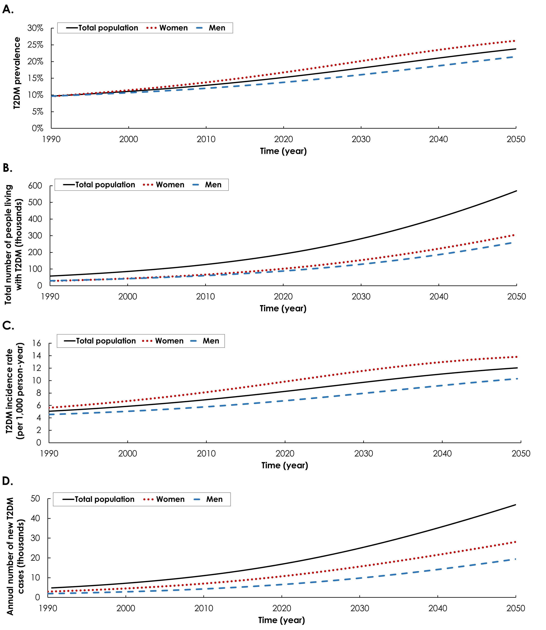

**Figure 2. Projected health expenditure on type 2 diabetes mellitus (T2DM) in Oman, 2020-2050. A) Total expenditure** and **B)** expenditure per T2DM case assuming ***fixed annual per capita* health expenditure between 2011-2050. C)** Total expenditure and **D)** expenditure per T2DM case assuming ***increasing annual per capita* health expenditure between 2011-2050** based on extrapolation of the historical trend[27](#_ENREF_27" \o "Undersecretariat for Planning Affairs, 2014 #777). **E) Proportion of Oman’s total health expenditure spent on T2DM. Health expenditure was calculated as per the** Jönsson’s **approach**[25](#_ENREF_25" \o "Jonsson, 1998 #183)**.**

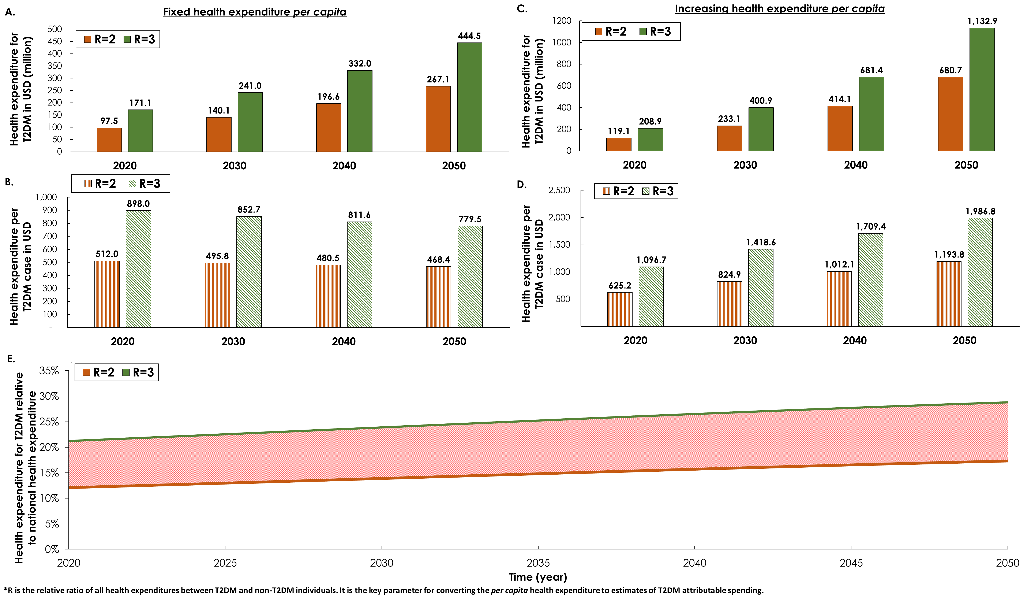

**Figure 3. Projections for type 2 diabetes mellitus (T2DM) related risk factors among Omanis, 2020-2050. The figure shows projected prevalence of A) obesity, B) smoking, and C) physical inactivity, and proportions of T2DM cases that are attributable to D) obesity, E) smoking, and F) physical inactivity.**

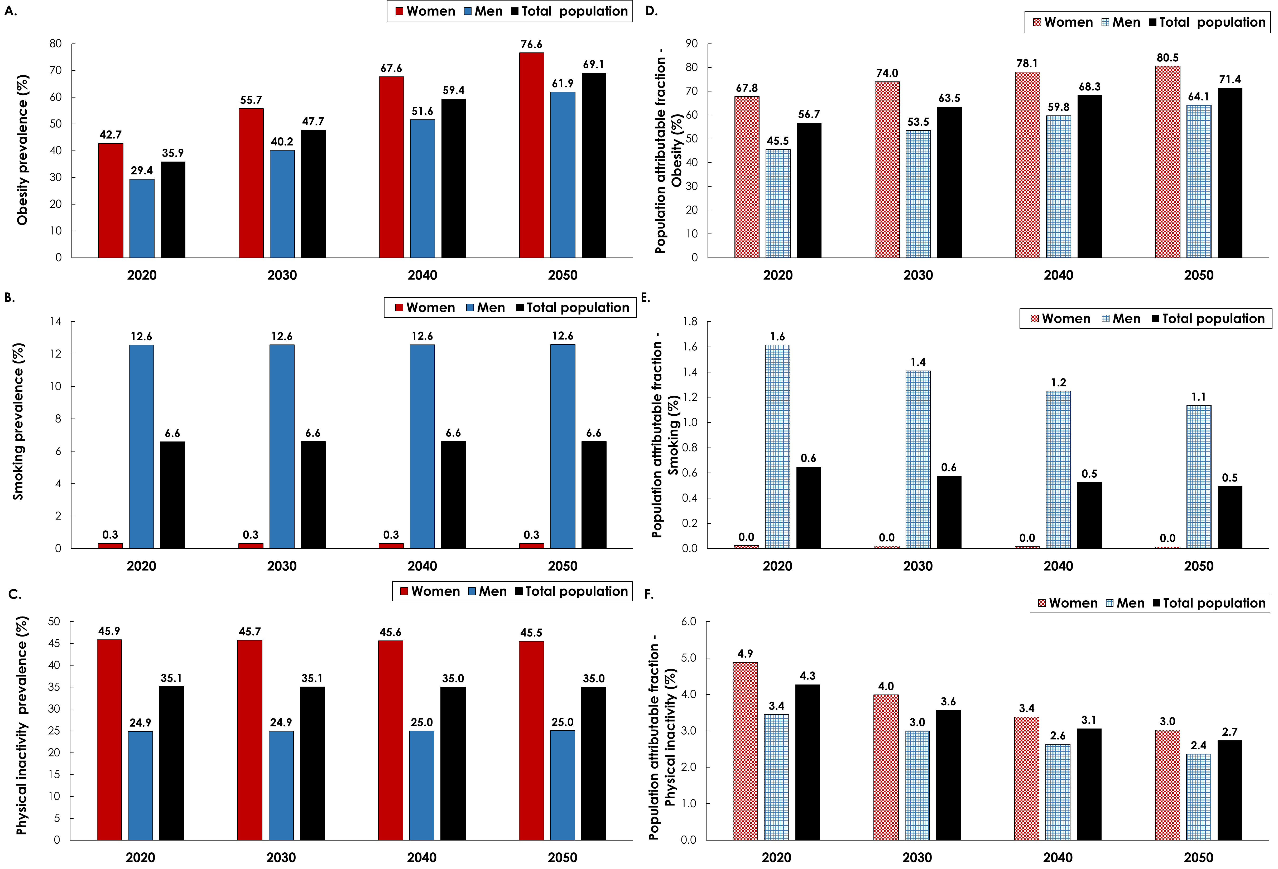

**Figure 4.** Sensitivity analyses. Projected type 2 diabetes mellitus (T2DM) prevalence in Omanis aged 20-79 years, between 1990-2050, assuming **A)** the *age-specific* obesity prevalence remained stable after 2017, **B)** lower obesity prevalence than projected in the main analysis between 2017-2050, **C)** higher prevalence of physical inactivity than that self-reported in the Omani surveys[9-14](#_ENREF_9" \o "Asfour, 1995 #163), and **D)** demographic structure similar to that projected by the Population Division of the United Nations Department of Economic and Social Affairs[29](#_ENREF_29" \o "United Nations, 2019 #258).

