10-Minute Consultation
Tick bite
Mohammad S Razai, academic clinical fellow in primary care¹
Katja Doerholt, consultant in paediatric infectious diseases²
Eva Galiza, clinical research fellow in paediatric infectious diseases³
Pippa Oakeshott, professor of general practice¹
¹ Population Health Research Institute, St George University of London, London, UK
² St George’s University Hospital NHS Foundation Trust, London, UK
³ Institute for Infection & Immunity, St George’s University of London, London, UK
Correspondence to M S Razai mrazai@sgul.ac.uk

What you need to know
• Most tick bites do not cause Lyme disease
• A “bull’s eye” red rash of erythema migrans is diagnostic for Lyme disease
• An antibiotic course of doxycycline for three weeks is first line treatment in patients with erythema migrans rash to prevent disseminated disease

A 14 year old boy presents with a one week history of a rash behind his knee. He has recently been on a hiking holiday to the Scottish Highlands where he had a tick bite. His mother is worried about Lyme disease.
Lyme disease (Lyme borreliosis) is caused by Borrelia burgdorferi bacteria transmitted through bites from infected ticks.¹ It is common in Europe and North America.¹⁻³ More than 1500 people receive a laboratory confirmed diagnosis of Lyme disease each year in the UK,⁴ and 300 000 in the US.⁵ A study in UK primary care estimated an incidence of 12.1 (95% confidence interval 11.1 to 13.2) per 100 000 individuals per year.⁶
An accurate diagnosis can facilitate early treatment and prevent complications affecting the central nervous system, joints, skin, and/or heart.⁷ Further, general practitioners can allay patients’ concerns about the disease and provide referral when necessary.
This article offers a guide to assessing and managing tick bites in primary care.

What you should cover
History
Take a detailed history of exposure to tick bite and symptoms.
Risk assessment
Ask about
• Recreational or occupational activities that risk exposure to ticks, such as outdoor sports, camping, hiking, forestry, and farming
• Travel, particularly over the past month, to areas where Lyme disease is common. In the UK, Scotland has the highest incidence, followed by south-west and southern England.⁶ Ticks are common in rural and forested regions with wooded or grassy areas and humid environments, but also in urban gardens and parks⁶
• A history of tick bite. Some patients recall a tick bite, others do not. Ticks crawl and can bite anywhere on the body
• An estimate of how long the tick was attached can help to understand transmission of any infection. Most people who recognise a tick bite remove the tick before it can transmit Borrelia.⁷ The North American tick species takes about 36 hours to transmit infection and in some European species transmission occurs after 17 hours.⁸
Symptoms of Lyme disease
Around 70-80% of patients with Lyme disease report a classic red rash called erythema migrans.⁷ ⁹ Guidelines from the National Institute for Health and Care Excellence (NICE) ⁷ recommend considering Lyme disease as a possible diagnosis in patients presenting with several generalised or focal symptoms listed in table 1 especially if there is history of tick exposure in high risk areas. Early infection may be asymptomatic in 1-7% of people.¹⁰ Between 2% and 3% of patients present with late and more severe manifestations such as neuroborreliosis, usually if an earlier stage was missed.¹¹
Examination
Conduct a thorough physical examination to look for tick bites. Bites are more common on the ankles, behind the knees, and in the groin in adults, and in the head and neck area in children. Check under the hair and behind the ears. Localised lymphadenopathy may occur in children and adults.
Erythema migrans
This rash is mostly seen at the site of the tick bite and is diagnostic of Lyme disease. It is usually painless, more than 5 cm in diameter with gradually increasing size, and has a central clearing that gives the appearance of bull’s eye (fig 1, fig 2).⁷ The appearance can vary, however.⁹ The rash can appear any time from three days after the initial tick bite, but usually becomes visible after 1-4 weeks.¹²Patients may miss the rash if they are unaware of having had a tick bite, particularly if the bite was where they cannot see, such as at the back of the knee.
Fig 1 An engorged tick on human skin with early erythema migrans rash
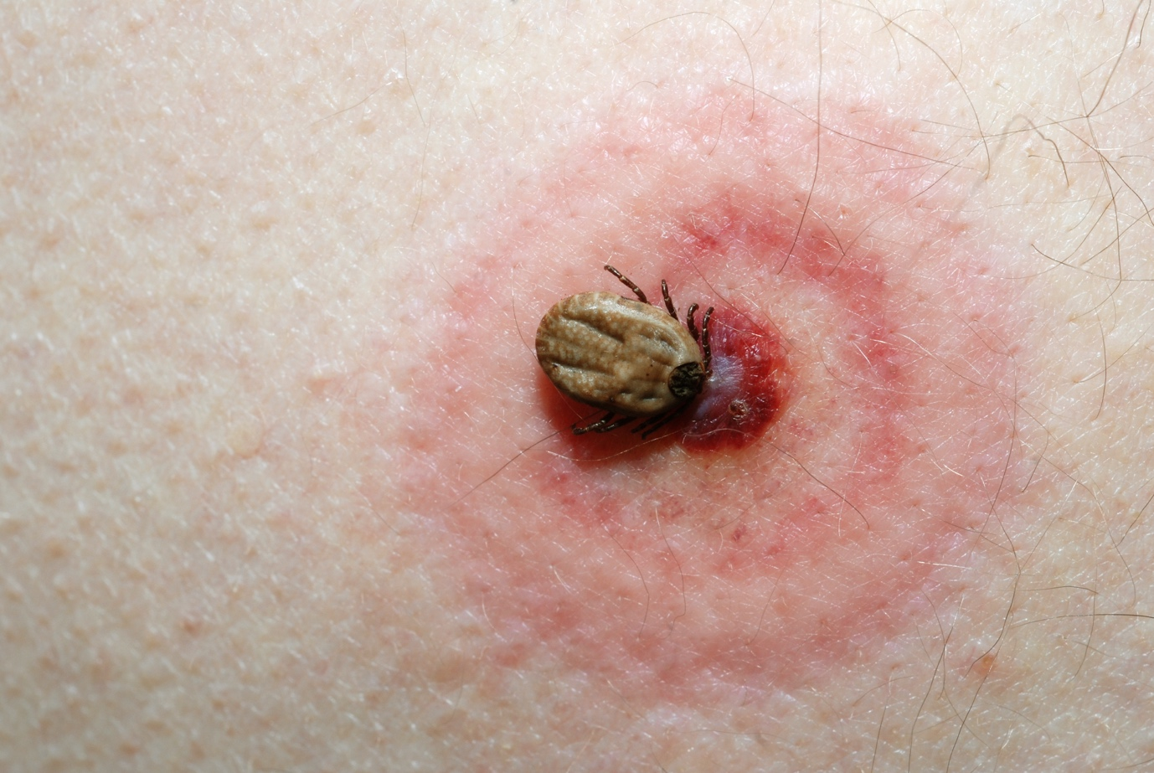

Fig 2 Developed erythema migrans rash
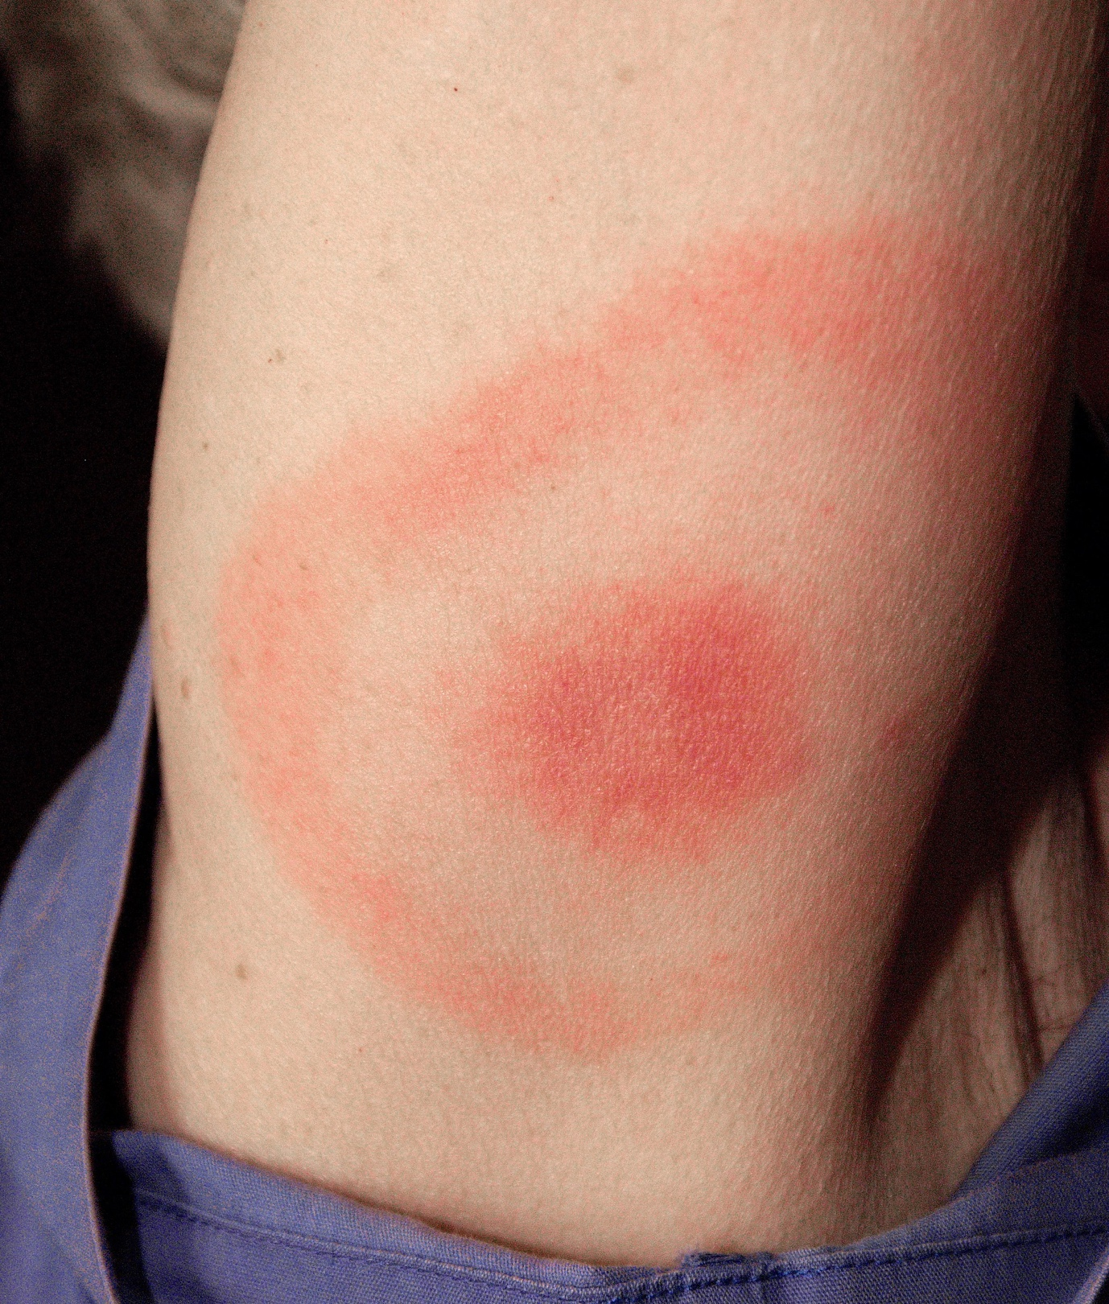
A tick bite can also cause a local inflammatory reaction that typically recedes within 48 hours. This is differentiated from erythema migrans by the presence of itching, pain, and warmth.⁷

Table 1 Clinical signs and symptoms of Lyme disease⁷ ⁹ ¹⁰
Stages of disease | System | Signs and symptoms
Early localised disease (<30 days from exposure to tick bite) | Localised skin; systemic | Erythema migrans rash (70-80%)  Headache  Malaise  Flactuating and migratory joint or muscle aches and pain  Fever and sweats (rare)
Early disseminated disease (<3 months after exposure) | Skin; systemic; neurological; heart; eyes | Multiple erythema migrans rash  Headache  Malaise  Fatigue  Migratory joint or muscle aches and pain  Swollen glands  Fever and sweats  Facial palsy (10-50%); presents as or becomes bilateral in 23%—most common sign of Lyme neuroborreliosis in children) In adults: radicular pain with back or neck pain which is worse at night and is not adequately controlled by simple analgesia  Unexplained cranial nerve palsies  Meningitis (2%)  Mononeuritis multiplex  Motor or sensory radiculopathy  Paraesthesia  Heart block (rare)  Pericarditis (1%)  Keratitis (rare)
Late disseminated disease (>3 months after exposure) | Skin rashes; joints; neurological; eyes | Acrodermatitis chronica atrophicans (1-3%) a slowly progressive red or bluish lesion which may become atrophic.  Inflammatory arthritis affecting one or more joints, often involving the knee joint, may be fluctuating and migratory (arthritis is a presenting symptom in 28% of cases in the US, 3-7% in Europe)¹⁰ Lyme arthritis is less painful compared to septic arthritis and is not accompanied by fever.  Encephalitis (rare)  Neurocognitive presentations (cognitive impairment, such as memory problems and difficulty concentrating.  Unexplained white matter changes on brain imaging  Uveitis
What you should do
Ask patients about their understanding of Lyme disease and their concerns. Reassure them that most people have no symptoms except the rash and no complications. Box 1 and box 2 list preventive measures and reliable sources of information that you can share with patients for prevention of Lyme borreliosis and other tick-borne diseases such as babesiosis and tick-borne encephalitis¹³
Box 1 Resources for patients
Patient information leaflet from Public Health England: https://assets.publishing.service.gov.uk/government/uploads/system/uploads/attachment_data/file/718980/LymeDisease_SignsAndSymptoms_requested_changes_June_2018_final_Clean.pdf
NHS information on Lyme disease: https://www.nhs.uk/Conditions/Lyme-disease
Patient information leaflet on preventing tick bites and removing ticks from Public Health England: https://www.gov.uk/government/publications/tick-bite-risks-and-prevention-of-lyme-disease

Box 2 Tips for patients on prevention of Lyme disease
• When going to areas where ticks are common, such as parks, gardens, forests, and wooded areas (even at urban sites), wear suitable clothing and shoes to cover exposed skin and apply insect/tick repellents
• Check your clothes and body regularly for ticks when outdoors and after you get home, and check the hair in young children
• Remove any ticks with a pair of fine-tipped tweezers by grasping the tick very close to the skin. Once the tick is held, pull it upwards firmly but slowly. See Public Health England’s website for advice on tick removal (box 1). Apply antiseptic gel to the affected area or wash thoroughly with antibacterial soap¹⁴

If the patient is symptomatic
Offer antibiotic treatment to patients with an erythema migrans rash to prevent disseminated disease, and to patients who are systemically unwell with a confirmed or high risk of tick exposure.^{7, 15}NICE guidelines recommend a course of doxycycline for 21 days as first line treatment.⁷ Consult national or local treatment guidelines where you practice, as these may vary.
Investigations include serological tests for Lyme disease. Offer testing in patients with no erythema migrans rash but a high clinical suspicion of Lyme disease based on symptoms and a confirmed or risk of tick exposure.⁷ ⁹
If the patient has a history of tick bite and no symptoms
NICE guidelines caution against making a diagnosis of Lyme disease in patients with no symptoms, even if they have a history of tick bite.⁷ No treatment is required if the patient is well and has no rash.
Explain that most tick bites are harmless and do not transmit Lyme disease.⁷ ⁹ Apart from in high risk areas, most ticks (≥85%) are not infected.⁹ In Europe including the UK, between 5% and 40% of ticks may be infected.¹ Only 2-3% of people with a tick bite develop Lyme disease.⁹
Ask the patient to make another appointment if they feel unwell, develop a rash, or get symptoms of fever, malaise, muscle and joint aches, headache, neck pain or stiffness or facial weakness.
Referral
Offer referral to a specialist in infectious diseases for assessment and testing if the diagnosis is uncertain or the patient has persistent symptoms attributed to Lyme borreliosis following antimicrobial treatment. ⁷ ⁹ Refer urgently to the relevant specialty if the patient presents with focal symptoms, such as neurological or cardiac complications or uveitis.

Education into practice
• What features in a patient’s history would prompt you to suspect Lyme disease?
• How would you discuss the management of tick bite with your patient?
• Think of a patient with a history of tick bite that you have seen in your practice. What were their concerns? Based on reading this article, what would you do differently during that appointment?

How patients were involved in the creation of this article
Our patient co-author Eva Galiza had Lyme disease. She suggested that we discuss diagnostic uncertainty, investigations, and prevention in this article. She stressed the importance of clear safety netting advice and recommended reliable, evidence-based resources for patients. We are grateful for her contribution to this article.
Box end
Competing interests: we have read and understand the BMJ policy on declaration of interests and declare the following interests: none
Provenance and peer review: commissioned, based on an idea from the author.
<eref>1 European Centre for Disease Prevention and Control. Lyme Borreliosis in Europe Fact Sheet. 2014. https://www.ecdc.europa.eu/sites/portal/files/media/en/healthtopics/vectors/world-health-day-2014/Documents/factsheet-lyme-borreliosis.pdf</eref>
<eref>2 Lindgren E, Jaenson T. Lyme borreliosis in Europe: influences and climate change, epidemiology, ecology and adaptation measures. World Health Organization Regional Office for Europe, 2006. https://www.euro.who.int/__data/assets/pdf_file/0006/96819/E89522.pdf</eref>
<jrn>3 Sykes RA, Makiello P. An estimate of Lyme borreliosis incidence in Western Europe. J Public Health (Oxf) 2017;39:74-81. PubMed</jrn>
<eref>4 Public Health England. Lyme disease epidemiology and surveillance. 2018. https://www.gov.uk/government/publications/lyme-borreliosis-epidemiology/lyme-borreliosis-epidemiology-and-surveillance.</eref>
<jrn>5 Kuehn BM. CDC estimates 300,000 US cases of Lyme disease annually. JAMA 2013;310:1110. PubMed doi:10.1001/jama.2013.278331</jrn>
<jrn>6 Cairns V, Wallenhorst C, Rietbrock S, Martinez C. Incidence of Lyme disease in the UK: a population-based cohort study. BMJ Open 2019;9:e025916. PubMed doi:10.1136/bmjopen-2018-025916</jrn>
<eref>7 National Institute for Health and Care Excellence. Lyme disease. NG95. 2018. www.nice.org.uk/guidance/NG95.</eref>
<jrn>8 Cook MJ. Lyme borreliosis: a review of data on transmission time after tick attachment. Int J Gen Med 2014;8:1-8. PubMed doi:10.2147/IJGM.S73791</jrn>
<jrn>9 Kullberg BJ, Vrijmoeth HD, van de Schoor F, Hovius JW. Lyme borreliosis: diagnosis and management. BMJ 2020;369:m1041. PubMed doi:10.1136/bmj.m1041</jrn>
<jrn>10 Hatchette TF, Davis I, Johnston BL. Lyme disease: clinical diagnosis and treatment. Can Commun Dis Rep 2014;40:194-208. PubMed doi:10.14745/ccdr.v40i11a01</jrn>
<jrn>11 Steere AC, Sikand VK. The presenting manifestations of Lyme disease and the outcomes of treatment. N Engl J Med 2003;348:2472-4. PubMed doi:10.1056/NEJM200306123482423</jrn>
<jrn>12Strle F, Nelson JA, Ruzic-Sabljic E, et al. European Lyme borreliosis: 231 culture-confirmed cases involving patients with erythema migrans. Clin Infect Dis 1996;23:61-5

<eref>13 Public Health England. Guidance. Rare tick-borne infections diagnosed in England. 2020. https://www.gov.uk/government/news/rare-tick-borne-infections-diagnosed-in-england#:~:text=Public%20Health%20England%20(%20PHE%20)%20can,being%20acquired%20in%20the%20UK. </eref>
<eref>14 Public Health England. Guidance. “Be tick aware”—toolkit for raising awareness of the potential risk posed by ticks and tick-borne disease in England. 2018. https://assets.publishing.service.gov.uk/government/uploads/system/uploads/attachment_data/file/694157/PHE_Tick_Awareness_Toolkit.PDF.</eref>
<eref>15Cruickshank M, O'Flynn N, Faust SN; Guideline Committee. Lyme disease: summary of NICE guidance. BMJ. 2018;361:k1261. Published 2018 Apr 12. doi:10.1136/bmj.k1261

