Imaging in gynecological disease series

Full Title: Transperineal and endovaginal ultrasound for evaluating sub-urethral masses: A comparison to magnetic resonance imaging

Short title: Ultrasound imaging of sub-urethral masses
NA Okeahialam¹, A Taithongchai¹, AH Sultan¹², R Thakar¹³
¹Croydon University Hospital, London UK
² Honorary Reader, St. George’s University of London
³ Honorary Senior Lecturer, St George’s University of London

Corresponding Author:
Miss Ranee Thakar
Consultant Obstetrician and Urogynaecology Subspecialist
Croydon University Hospital
530 London Rd, Thornton Heath CR7 7YE
Email: ranee.thakar@nhs.net
Telephone: 02084013161

Introduction: 349 words
Discussion: 982 words
Key words: Sub-urethral masses, Peri-urethral mass, Urethral Diverticulum, Pelvic floor ultrasound, Transperineal ultrasound, 3D Endovaginal ultrasound, Magnetic resonance imaging

Contribution:
What are the novel findings of this work?
This is the largest series comparing pelvic floor ultrasound including two-dimensional perineal pelvic floor ultrasound and three-dimensional endovaginal ultrasound with Magnetic Resonance Imaging (MRI) for the detection of sub-urethral masses.

What are the clinical implications of this work?
With further research in this area, pelvic floor ultrasound could become an important modality for sub-urethral imaging with enhanced diagnostic accuracy, and aid the surgeon with surgical planning and counseling of patients.

ABSTRACT
Objectives
To determine the effectiveness of pelvic floor ultrasonography (PFUS) in the detection and evaluation of sub-urethral masses, using Magnetic Resonance Imaging (MRI) as the reference standard.

Methods
A retrospective analysis of ultrasound and MRI scans of all sub-urethral masses from one urogynecology clinic over a 14-year period (July 2006 to March 2020). All women were examined with two-dimensional perineal pelvic floor ultrasound (2D pPFUS) with or without three-dimensional endovaginal ultrasound (3D EVUS), using the Flex Focus 500 ultrasound or Pro Focus 2202 system (BK Medical, Herlev, Denmark). Intra-class correlation coefficients (ICC 3,1) were used to assess the agreement between PFUS imaging and MRI measurements.

Results
Forty women underwent PFUS (3D EVUS and/or 2D pPFUS alone) and MRI. The agreement between PFUS and MRI for detecting a sub-urethral mass was 85% [95% CI 70.2% to 94.3%]). The ICC analysis showed good to excellent agreement for the distance between the sub-urethral mass and the bladder neck (ICC 3,1= 0.89, standard error measurement (SEM)=3.64 mm) and the largest diameter of the mass on MRI and 2D pPFUS (ICC 3,1=0.93, SEM=4.31mm). Good to excellent agreement was found for the distance between the sub-urethral mass and the bladder neck (ICC 3,1= 0.88, SEM= 3.48 mm) and the largest diameter of the mass on MRI and 3D EVUS (ICC 3,1= 0.94, SEM= 4.68 mm).

Conclusions
2D pPFUS and 3D EVUS are useful in the imaging of sub-urethral masses. We have demonstrated that measurements of sub-urethral masses taken with PFUS and MRI do not differ significantly and can be used interchangeably dependent on availability and expertise.

Main Text:

1. Aim
To determine the effectiveness of pelvic floor ultrasonography (PFUS) in the detection and evaluation of sub-urethral masses, using Magnetic Resonance Imaging (MRI) as the reference standard.

2. Background
Epidemiology:
Sub-urethral masses are either congenital or acquired in etiology. Incidence is difficult to estimate due to few cases being reported; however in population based studies, reported rates are less than 1%.^{1,2} They occur in all ages but most frequently in women aged 30-60 years.³ Differential diagnoses include urethral diverticulum, Gartner duct cysts, vaginal inclusion cysts, Skene gland abscess and urethral caruncle.^{1,4–6} Urethral diverticulum is the most common, accounting for approximately 80% of cases.¹

Microscopy:
Congenital sub-urethral masses arise from various embryological components and remnants of the genitourinary system, particularly Müllerian. They may display columnar, ciliated-columnar or stratified squamous epithelium.^{3,7} Inclusion cysts are lined with stratified squamous epithelium and may contain purulent material.^{3,7} However, urethral diverticula are typically lined with transitional epithelium, but may undergo squamous or glandular metaplasia secondary to chronic inflammation.⁸

Macroscopy:
Sub-urethral masses have a smooth external surface and may be filled with caseous, purulent or thin mucoid material.⁷ They are usually small but vary in size, ranging between a few millimeters to over five centimeters in diameter.⁹

Clinical symptoms and Prognosis:
Signs and symptoms include a painful palpable mass, dyspareunia, vaginal discharge, dysuria and voiding dysfunction.⁴ Most sub-urethral masses are benign and can be successfully surgically excised. However, operation of an undiagnosed urethral diverticulum can result in complications including urethral stricture and urethrovaginal fistula.⁴ Therefore, accurate imaging and pre-operative planning is important.

Although MRI has not formally been defined as the imaging reference standard, it is a recommended modality in the detection of sub-urethral masses.⁴ In recent years there has been increasing popularity of PFUS in the diagnosis of pelvic floor disorders by urogynecologists, although it is not a modality commonly used by gynecologists .^{10,11} Compared to MRI, ultrasound offers better availability of equipment and reporter, reduced cost, lesser patient restriction as well as improved patient tolerance.¹² Also, MRI has been reported to have a potential detection error rate of 7.3% for sub-urethral masses.¹³
3. Case series
Methods:
This is a retrospective analysis of ultrasound and MRI scans of all sub-urethral masses from one urogynecology clinic over a 14-year period (February 2007 to March 2020). Women with a vaginal lump or lower urinary tract symptoms suggestive of a sub-urethral mass were referred to the clinic either by their General Practitioner or a different specialty team within the hospital.

All women were examined with two-dimensional perineal pelvic floor ultrasound (2D pPFUS) with or without three-dimensional endovaginal ultrasound (3D EVUS), using the Flex Focus 500 ultrasound system or Pro Focus 2202 system (BK Medical, Herlev, Denmark). 2D pPFUS was performed using a convex transducer applied to the perineum. Images were obtained in the coronal, axial and sagittal planes. 3D EVUS was performed by placing the endocavity probe in a neutral position in the vagina, obtaining images in a mid-sagittal view and a 3D volume of the surrounding structures. If the mass was too large or distal, it was not possible to perform 3D EVUS. Ultrasound was performed with the women in a supine position and the bladder partially filled. The urethra was seen as a hypoechoic structure extending from the bladder base to the vaginal opening. Cystic structures were seen as hypoechoic areas and solid masses of mixed echogenicity. Images were analysed by reporting on the presence of a sub-urethral mass, its size, location and any communication with the urethral lumen. Size of the mass was measured in millimeters in the coronal, axial and sagittal diameters. Location was measured as the distance from the most proximal boundary of the mass to the bladder neck in a sagittal plane. Communication with the urethral lumen was diagnosed when there was any disruption of the hyperechoic rhabdosphincter with a hypoechoic connection between the mass and the urethral lumen.

MRI is considered the reference standard in this series. MRI was performed with unenhanced T1-weighted and T2-weighted images. A sub-urethral mass was diagnosed if a mass lesion was present and located posterolateral to the urethra.¹⁴ Size of the mass was measured in millimeters in the axial and sagittal diameters. Location was measured as the distance from the most proximal boundary of the mass to the bladder neck in a sagittal plane. Communication with the urethral lumen was diagnosed when there was any disruption in the hypointense rhabdosphincter connecting the mass to the urethral lumen.

In addition to imaging results, outcome management (conservative or surgical) and histology results were noted. All clinical and ultrasound information was entered into a dedicated Microsoft Excel database.

Data was analyzed using SPSS version 26.0.0.0. Continuous variables are reported as median (range) or median (interquartile range [IQR]). Nominal variables are presented as number(percent). The normality of distribution of continuous variables was tested using the Shapiro-Wilk test. Differences between two measurements was analyzed with the wilcoxon-signed rank test. To assess the agreement between PFUS imaging and MRI measurements, intra-class correlation coefficients (ICC 3,1) were used. A value between 0.75-0.9 indicated good agreement and >0.90 indicated excellent agreement.¹⁵ Standard errors of measurement (SEM) were then calculated to measure the range of error of each measurement.

(b) Results
Forty women underwent both PFUS (3D EVUS and/or 2D pPFUS alone) and MRI. The median age was 50 years (range 22-78). The most common symptoms leading to referral were: sensation of a vaginal lump 26(65.0%), stress urinary incontinence 16(40.0%), voiding dysfunction 6(15.0%) and dysuria 6(15.0%). On clinical examination, all 40 women had a palpable sub-urethral mass. Table 1 further describes the baseline characteristics of these patients.

MRI detected a sub-urethral mass in 34 women. PFUS correctly detected a sub-urethral mass in all 34 women on 2D pPFUS; 27 also had 3D EVUS. However, PFUS also detected a sub-urethral mass in the remaining 6 women. Therefore, the agreement between PFUS and MRI for detecting a sub-urethral mass was 85% [95% CI 70.2% to 94.3%]). Most sub-urethral masses were classified as simple and unilocular with hypoechoic contents (75.0%); 27.5% were complex due to septations leading to a number of fluid-filled locules within the mass; 17.5% of masses encircled the urethra: described as “horse-shoe” in appearance. Figure 1 and 2 demonstrate these differing appearances of sub-urethral masses on 2D pPFUS and 3D EVUS. The ultrasound appearance of the sub-urethral masses in comparison to MRI are shown in Table 2. The six sub-urethral masses detected on ultrasound but not on MRI were distal (median distance from the cyst to the bladder neck 30.9 mm [range 28.3-34.0]) with a median diameter of 7.8 mm (range 5.0-15.0). Table 3 further describes the ultrasound characteristics of sub-urethral masses not detected on MRI.

Table 4 describes the agreement between measurements for sub-urethral masses detected both on 2D pPFUS and 3D EVUS in comparison to MRI. There was no significant difference in the distance between the sub-urethral mass to the bladder neck or the largest diameter of mass measured on MRI in comparison to 2dPFUS and 3D EVUS respectively.
The ICC analysis showed good agreement for the measured distance between the sub-urethral mass and the bladder neck on MRI and 2D pPFUS (ICC 3,1= 0.89, Standard error measurement (SEM)=3.64 mm) and excellent agreement (ICC 3,1= 0.93 SEM=4.31 mm) for the largest diameter of the sub-urethral mass.
The ICC analysis showed good agreement for the measured distance between the sub-urethral mass and the bladder neck on MRI and 3D EVUS (ICC 3,1= 0.88, SEM=3.48 mm) and excellent agreement (ICC 3,1= 0.94, SEM=4.68 mm) for the largest diameter of the sub-urethral mass.

Connection to the urethra (Figure 1 B and D) was detected on PFUS (2D pPFUS in the sagittal plane) in seven women. In total, 17/40 women underwent cystoscopy (traditionally used to diagnose a urethral connection)⁴ and a urethral connection was seen in five. PFUS (2D pPFUS in the sagittal plane) agreed with cystoscopy in two cases (40%) and MRI agreed with cystoscopy in one (20%) (Table 2).

Eighteen women (45%) underwent surgical excision of their sub-urethral mass. All 18 were detected both on PFUS and MRI. Twelve women (30%) declined surgical intervention, five (12.5%) did not attend further follow-up and in five women (12.5%) their sub-urethral mass spontaneously resolved. The most common histological finding described by pathology was urethral diverticulum in 11 patients. Of these, 36.4% had evidence of nephrogenic metaplasia and 36.4% had evidence of chronic inflammation and ulceration. Other histological diagnoses included: benign sub-urethral cyst in two women (with ciliated and squamous epithelium respectively, and so likely congenital in origin), one large Bartholin’s cyst, two leiomyoma, one malignant mesonephric adenocarcinoma and one malignant melanoma.¹⁶ The only ultrasound features present, allowing distinction between sub-urethral masses of differing etiology was the presence of a urethral connection in urethral diverticula; seen on 2dPFUS in 3 (27.3%) urethral diverticula. Urethral connection was also only seen in 1(9.1%) urethral diverticula on MRI. Table 5 further describes the ultrasound and MRI findings of the different histological diagnoses highlighting that both modalities identified similar features on PFUS and MRI.

Discussion:
This case series compares PFUS to MRI in the detection and evaluation of sub-urethral masses. The main strength of our study is that it comprises of the largest cohort of women with sub-urethral masses which compares PFUS to MRI; a recommended imaging modality. Additionally, ultrasound images were analyzed blinded to MRI results. Limitations include its retrospective design and PFUS and MRI imaging were not performed on the same day, which may have led to fluctuations in sub-urethral mass size. Furthermore, as not all women underwent surgical excision, only 45% of diagnoses were confirmed histologically. However, in keeping with a previous large series which found that 84% of sub-urethral masses were secondary to a urethral diverticula, we found the same on histological examination in the majority of our cohort (61%).¹

Our clinical findings concur with sonographic and gross macroscopic features described by others.^{5,7,10,17–20} Sub-urethral mass size ranged between 1.0-7.2 centimeters with most being unilocular with low level internal echoes.^{5,10,17} Mass contents may include debris, purulent, caseous or mucoid fluid; accounting for the differing internal echogenicity reported.⁷ Other studies have reported that sub-urethral masses may also be complex and multilocular due to internal septae.^{17,18} Particularly urethral diverticula, which have been described to be complex and encircle the urethra, as described in this study.²⁰ Urethral leiomyomas are reported to be well-circumscribed with varying consistency, therefore, may be hypoechoic, particularly when cystic degeneration has occurred.^{21,22} This happens typically in larger masses, like the leiomyoma we described which measuring 72 millimeters in its largest diameter on PFUS.²² Although a urethral connection was seen only in the urethral diverticula, the remaining pathologies did not possess any distinguishing ultrasound characteristics. With regards to sub-urethral masses secondary to carcinoma or inflammation, there is even greater difficulty in reliably differentiating between them.¹⁰ We demonstrated, the sub-urethral masses secondary to malignant melanoma and mesonephric adenocarcinoma; published as a case report, also possessed similar ultrasound features to those of differing etiology.¹⁶

MRI is a recommended imaging modality in the detection of sub-urethral masses,⁴ as MRI provides good delineation of urethral anatomy due to its soft tissue contrast. T2-weighted images typically demonstrate sub-urethral masses well, as their fluid contents appear bright.^{23,24} MRI is reported to be able to delineate the ostium of a urethral diverticulum in 85% of cases, which other modalities such as cystoscopy and ultrasound have been described to often miss.²⁴ Dietz et al however, have shown how multiplanar transperineal ultrasound can be used to identify an ostium. In their large retrospective study of 4121 women, diverticula ostia were seen in both the mid-sagittal and axial planes.²⁰ In this study, a diverticulum ostium was demonstrated on PFUS and confirmed on cystoscopy in 40% of patients, compared to 20% with MRI.
We showed that PFUS is comparable to MRI in its ability to assess the structure and consistency of sub-urethral masses. Detection agreement between PFUS and MRI was 85% and the measurement agreement between PFUS and MRI measurements; diameter and the distance between the mass and bladder neck were good to excellent. Figure 3 and 4 demonstrate the ability of 2D pPFUS and 3D EVUS to produce images consistent with and comparable to MRI findings. Other studies have compared 3D PFUS to MRI in the investigation of other pelvic floor pathologies such as pelvic organ prolapse and levator ani defects , which have shown moderate to excellent correlation between both modalities. ^{25–28} However no study to date has compared the two in the evaluation of sub-urethral masses.
PFUS did not miss any sub-urethral masses detected on MRI. However, a possible sub-urethral mass was seen in an additional 15% of women in comparison to MRI. These masses were smaller in size and distal in comparison to those detected on both modalities. It is important to note that these women did not have diagnostic confirmation with histology, meaning we were unable to confirm true abnormality versus artifact, but it is unlikely as these women presented with symptoms. However, MRI errors in detecting sub-urethral masses have previously been described in the literature. Chung et al performed pre-operative MRI in 41 patients with a sub-urethral mass. In 7.3% of cases, the MRI failed to identify presence of a sub-urethral mass.¹³ Potential reasons for this included MRI’s limited sensitivity in identifying masses with little fluid content and those small in size. Also, MRI is not dynamic and captures a sequence of images at a single time point.¹³ These image slices can be relatively thick (3-6 mm) with spacing between slices, meaning areas could be missed and lesions may not be identified.²⁹

Three-dimensional ultrasound in particular offers advantages including its real-time imaging, and superior temporal and spatial resolution.³⁰ Furthermore, the ability to manipulate the high-resolution 3D volumes in all planes, including the axial plane; previously only visible on MRI, allows for effective visualization of pelvic floor anatomy and pathology.³⁰ Although 3D EVUS modality can obtain anatomical views that 2D pPFUS cannot, essential images can still be obtained solely from two-dimensional imaging. The limitation of 3D EVUS, is that it may cause discomfort particularly with large and inflammatory masses and can compress and displace the urethra.³¹ This may explain the inability to identifying a diverticulum ostium on 3D EVUS in this series. Therefore, in this situation 2dPFUS would suffice. However, multiplanar transperineal systems are also available which allow real‐time 3D (or 4D) assessment of the pelvic floor³⁰.
Overall, ultrasound allows patients to be assessed at one clinic appointment; examination, assessment of history and ultrasound findings. This enables correlation with patient symptoms, with subsequent discussion and counseling of further management if required. Furthermore, it aids pre-operative planning and can be used intra-operatively to anticipate possible complications such as bladder or urethral injury based on anatomical proximity, therefore potentially improving surgical outcomes. This imaging modality is not readily available in all units, it is highly operator dependent and requires expertise for interpretation. It is however rapidly becoming a popular tool amongst pelvic floor clinicians.
(d) Conclusion
2D pPFUS and 3D EVUS are both useful in the imaging of sub-urethral masses. We have demonstrated that measurements of sub-urethral masses taken with PFUS and MRI do not differ significantly and can be used interchangeably dependent on availability and expertise.

References:
1. Blaivas JG, Flisser AJ, Bleustein CB, Panagopoulos G. Periurethral Masses: Etiology and Diagnosis in a Large Series of Women: Obstet Gynecol. 2004;103(5, Part 1):842-847. doi:10.1097/01.AOG.0000124848.63750.e6
2. El-Nashar SA, Bacon MM, Kim-Fine S, Weaver AL, Gebhart JB, Klingele CJ. Incidence of female urethral diverticulum: a population-based analysis and literature review. Int Urogynecol J. 2014;25(1):73-79. doi:10.1007/s00192-013-2155-2
3. Patel AK, Chapple CR. Female urethral diverticula: Current Opinion in Urology. 2006;16(4):248-254. doi:10.1097/01.mou.0000232045.80180.2f
4. Archer R, Blackman J, Stott M, Barrington J. Urethral diverticulum. Obstet Gynecol. 2015;17(2):125-129. doi:10.1111/tog.12192
5. Cross JJL, Fynes M, Berman L, Perera D. Prevalence of Cystic Paraurethral Structures in Asymptomatic Women at Endovaginal and Perineal Sonography. Clinical Radiology. 2001;56(7):575-578. doi:10.1053/crad.2000.0709
6. Lone F, Sultan AH, Thakar R. Long-term outcome of transurethral injection of hyaluronic acid/dextranomer (NASHA/Dx gel) for the treatment of stress urinary incontinence (SUI). Int Urogynecol J. 2010;21(11):1359-1364. doi:10.1007/s00192-010-1211-4
7. Deppisch LM. Cysts of the Vagina: Classification and Clinical Correlations. Obstetrics & Gynecology. 1975;45(6):632-637. doi:10.1097/00006250-197506000-00007
8. Cocco AE, MacLennan GT. Unusual Female Suburethral Mass Lesions. Journal of Urology. 2005;174(3):1106-1106. doi:10.1097/01.ju.0000175154.91747.14
9. Migliari R, Pistolesi D, D’Urso L, Muto G. Recurrent Pseudodiverticula of Female Urethra: Five-year Experience. Urology. 2009;73(6):1218-1222. doi:10.1016/j.urology.2008.07.040
10. Shobeiri SA, Rostaminia G, White D, Quiroz LH, Nihira MA. Evaluation of Vaginal Cysts and Masses by 3-Dimensional Endovaginal and Endoanal Sonography. Journal of Ultrasound in Medicine. 2013;32(8):1499-1507. doi:10.7863/ultra.32.8.1499
11. Dietz HP. The evolution of ultrasound in urogynecology. Ultrasound Obstet Gynecol. 2010;36(6):655-657. doi:10.1002/uog.8829
12. Chaudhari VV, Patel MK, Douek M, Raman SS. MR Imaging and US of Female Urethral and Periurethral Disease. RadioGraphics. 2010;30(7):1857-1874. doi:10.1148/rg.307105054
13. Chung DE, Purohit RS, Girshman J, Blaivas JG. Urethral Diverticula in Women: Discrepancies Between Magnetic Resonance Imaging and Surgical Findings. Journal of Urology. 2010;183(6):2265-2269. doi:10.1016/j.juro.2010.02.016
14. Itani M, Kielar A, Menias CO, Dighe MK, Surabhi V, Prasad SR, O’Malley R, Gangadhar K, Lalwani N. MRI of female urethra and periurethral pathologies. Int Urogynecol J. 2016;27(2):195-204. doi:10.1007/s00192-015-2790-x
15. Koo TK, Li MY. A Guideline of Selecting and Reporting Intraclass Correlation Coefficients for Reliability Research. Journal of Chiropractic Medicine. 2016;15(2):155-163. doi:10.1016/j.jcm.2016.02.012
16. Shoeir S, Balachandran AA, Wang J, Sultan AH. Mesonephric adenocarcinoma of the vagina masquerading as a suburethral cyst. BMJ Case Reports. Published online July 3, 2018:bcr-2018-224758. doi:10.1136/bcr-2018-224758
17. Gugliotta G, Calagna G, Adile G, Polito S, Speciale P, Perino A, Adile B. Use of trans-labial ultrasound in the diagnosis of female urethral diverticula: A diagnostic option to be strongly considered: Trans-labial US for urethral diverticula. J Obstet Gynaecol Res. 2015;41(7):1108-1114. doi:10.1111/jog.12676
18. Keefe B, Warshauer DM, Tucker MS, Mittelstaedt CA. Diverticula of the female urethra: diagnosis by endovaginal and transperineal sonography. American Journal of Roentgenology. 1991;156(6):1195-1197. doi:10.2214/ajr.156.6.1903021
19. El-Zein C, Khoury N, El-Zein Y, Bulbul M, Birjawi G. Intraoperative translabial ultrasound for urethral diverticula: A road map for surgeons. European Journal of Radiology. 2009;70(1):133-137. doi:10.1016/j.ejrad.2007.12.012
20. Gillor M, Dietz HP. Translabial ultrasound imaging of urethral diverticula. Ultrasound Obstet Gynecol. 2019;54(4):552-556. doi:10.1002/uog.20305
21. Goss J. Evaluation of Urethra and Anterior Wall Vaginal Leiomyoma by Translabial/Transurethral Sonography. Journal of Diagnostic Medical Sonography. 2010;26(1):42-45. doi:10.1177/8756479309346447
22. Pavlica P, Bartolone A, Gaudiano C, Barozzi L. Female paraurethral leiomyoma: ultrasonographic and magnetic resonance imaging findings. Acta Radiol. 2004;45(7):796-798. doi:10.1080/02841850410001376
23. Hahn WY, Israel GM, Lee VS. MRI of Female Urethral and Periurethral Disorders. American Journal of Roentgenology. 2004;182(3):677-682. doi:10.2214/ajr.182.3.1820677
24. Greiman AK, Rolef J, Rovner ES. Urethral diverticulum: A systematic review. Arab Journal of Urology. 2019;17(1):49-57. doi:10.1080/2090598X.2019.1589748
25. Hainsworth AJ, Pilkington SA, Grierson C, Rutherford E, Schizas AMP, Nugent KP, Williams AB. Accuracy of integrated total pelvic floor ultrasound compared to defaecatory MRI in females with pelvic floor defaecatory dysfunction. BJR. 2016;89(1068):20160522. doi:10.1259/bjr.20160522
26. Wang X, Ren M, Liu Y, Zhang T, Tian J. Perineal Ultrasound Versus Magnetic Resonance Imaging (MRI) Detection for Evaluation of Pelvic Diaphragm in Resting State. Med Sci Monit. 2018;24:4449-4454. doi:10.12659/MSM.906648
27. Notten KJB, Kluivers KB, Fütterer JJ, Schweitzer KJ, Stoker J, Mulder FE, Beets-Tan RG, Vliegen RFA, Bossuyt PM, Kruitwagen RFPM, Roovers J-PWR, Weemhoff M. Translabial Three-Dimensional Ultrasonography Compared With Magnetic Resonance Imaging in Detecting Levator Ani Defects: Obstetrics & Gynecology. 2014;124(6):1190-1197. doi:10.1097/AOG.0000000000000560
28. Javadian P, O’Leary D, Rostaminia G, North J, Wagner J, Quiroz LH, Shobeiri SA. How does 3D endovaginal ultrasound compare to magnetic resonance imaging in the evaluation of levator ani anatomy?: Evaluation of Levator Ani Anatomy. Neurourol Urodynam. 2017;36(2):409-413. doi:10.1002/nau.22944
29. Del Gaizo A, Silva AC, Lam-Himlin DM, Allen BC, Leyendecker J, Kawashima A. Magnetic resonance imaging of solid urethral and peri-urethral lesions. Insights Imaging. 2013;4(4):461-469. doi:10.1007/s13244-013-0259-3
30. Dietz HP. Ultrasound imaging of the pelvic floor. Part II: three-dimensional or volume imaging: Ultrasound imaging of the pelvic floor. Ultrasound Obstet Gynecol. 2004;23(6):615-625. doi:10.1002/uog.1072
31. Umek WH, Obermair A, Stutterecker D, Häusler G, Leodolter S, Hanzal E. Three-dimensional ultrasound of the female urethra: comparing transvaginal and transrectal scanning: 3D ultrasound of the urethra. Ultrasound Obstet Gynecol. 2001;17(5):425-430. doi:10.1046/j.1469-0705.2001.00416.x

(f) Legends.
Figure 1(A, B, C, D): Three-dimensional endovaginal ultrasound images of different sub-urethral masses
Figure 1 A: Three-dimensional endovaginal ultrasound image of a large simple sub-urethral mass involving the left anterolateral vaginal wall.
Figure 1 B: Three-dimensional endovaginal ultrasound image of a large simple circumferential sub-urethral mass
Figure 1 C: Three-dimensional endovaginal ultrasound image of a sub-urethral mass filled with low level (“ground glass”) internal echoes
Figure 1 D: Three-dimensional endovaginal ultrasound image of a distal sub-urethral mass deviating the urethra, filled with low level (“ground glass”) internal echoes
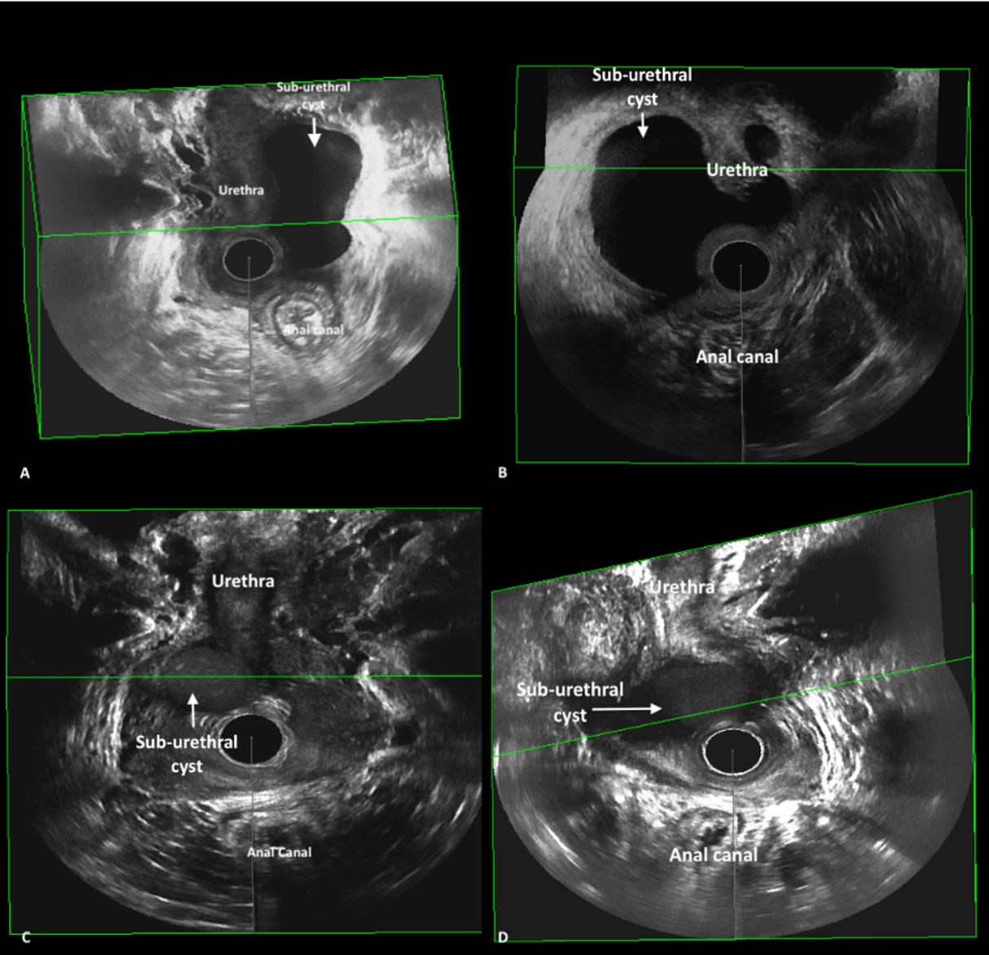

Figure 2(A, B, C, D): Two-dimensional perineal pelvic floor ultrasound images of different sub-urethral mass
Figure 2 A: Sagittal two-dimensional perineal pelvic floor ultrasound of a simple sub-urethral mass
Figure 2 B: Sagittal two-dimensional perineal pelvic floor ultrasound of a complex sub-urethral mass with septations with a communicating tract(ostium)
Figure 2 C: Sagittal two-dimensional perineal pelvic floor ultrasound image of a distal sub-urethral mass filled with low level (“ground glass”) internal echoes.
Figure 2 D: Sagittal two-dimensional perineal pelvic floor ultrasound image of a simple sub-urethral mass with a communicating tract(ostium).
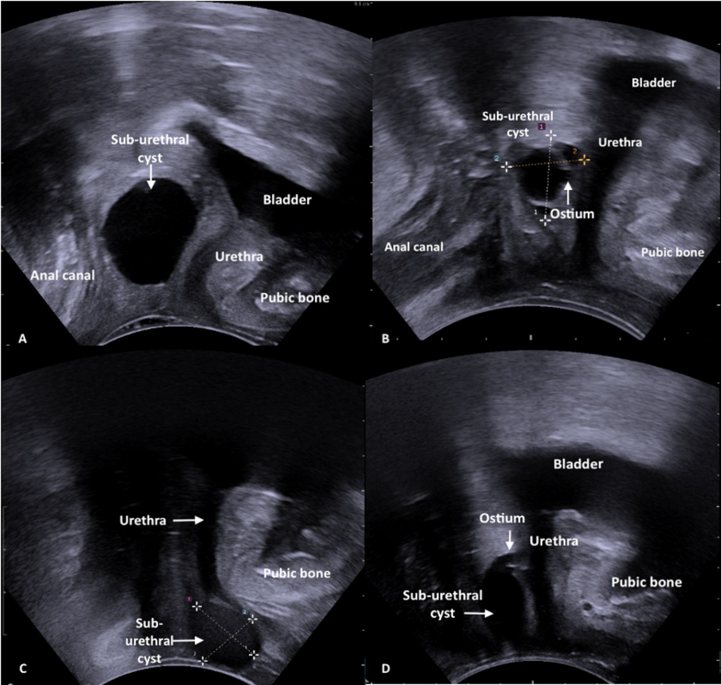

Figure 3(A, B, C, D): A comparison of T2-weighted MRI and pelvic floor ultrasound images of a sub-urethral mass in one woman.
Figure 3 A: Axial T2- weighted MRI image of a circumferential sub-urethral mass with internal septations.
Figure 3 B: Sagittal T2- weighted MRI image of a circumferential sub-urethral mass with internal septations. At the level of the lower third of the urethra, 11.9 mm from the bladder neck.
Figure 3 C: Three-dimensional endovaginal ultrasound image of a sub-urethral mass with internal septations encircling the urethra almost entirely
Figure 3 D: Sagittal two-dimensional transperineal ultrasound of a sub-urethral mass with internal septations
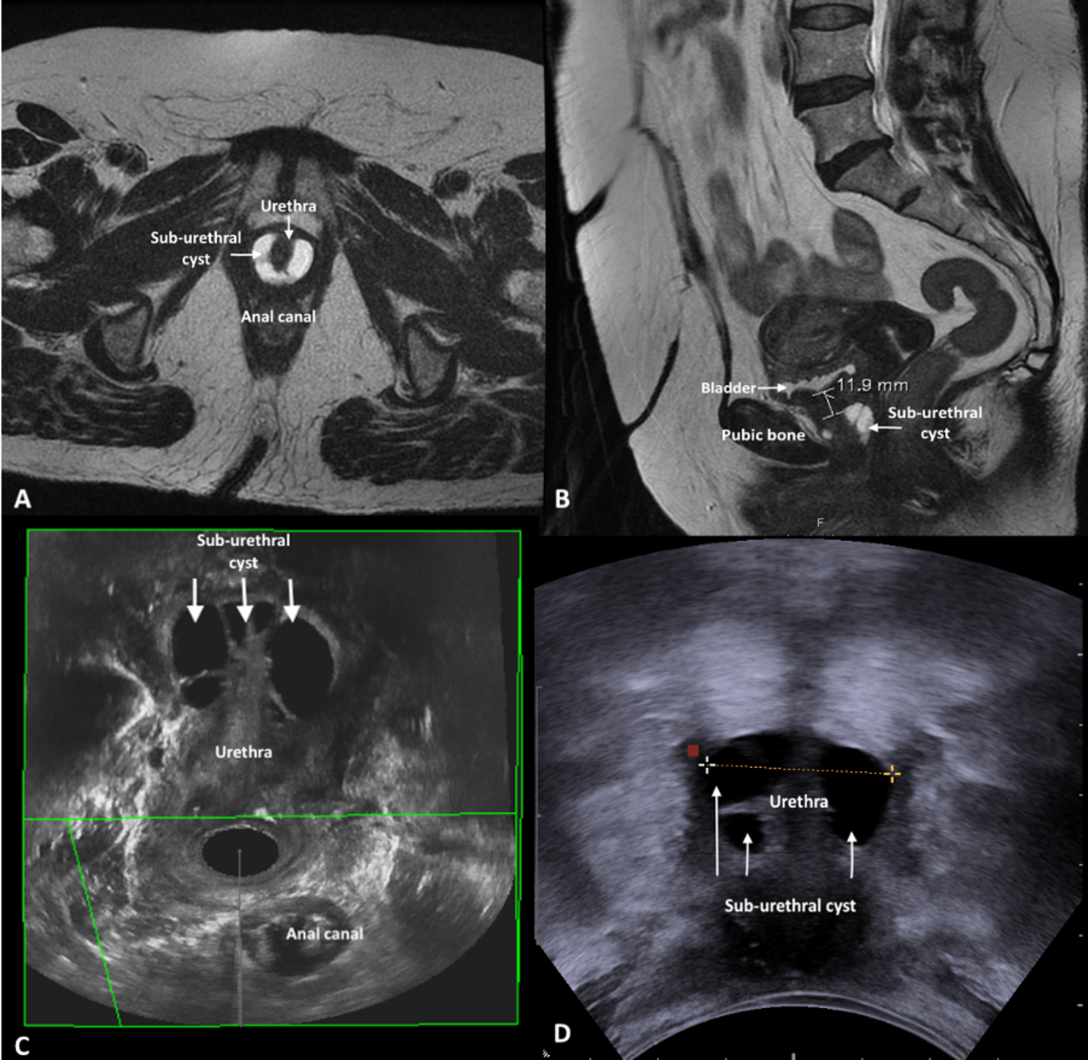

Figure 4(A, B, C, D): A comparison of T2-weighted MRI and pelvic floor ultrasound images of a sub-urethral mass in one woman.
Figure 4 A: Sagittal T2- weighted MRI image of a right lateral sub-urethral mass involving the anterolateral vaginal wall with an atypical low signal intensity
Figure 4 B: Axial T2- weighted MRI image of a right lateral sub-urethral mass involving the anterolateral vaginal wall with an atypical low signal intensity
Figure 4 C: Three-dimensional endovaginal ultrasound image of a simple sub-urethral mass involving the right anterolateral vaginal wall.
Figure 4 D: Sagittal two-dimensional perineal pelvic floor ultrasound image of a simple sub-urethral mass involving the right anterolateral vaginal wall.
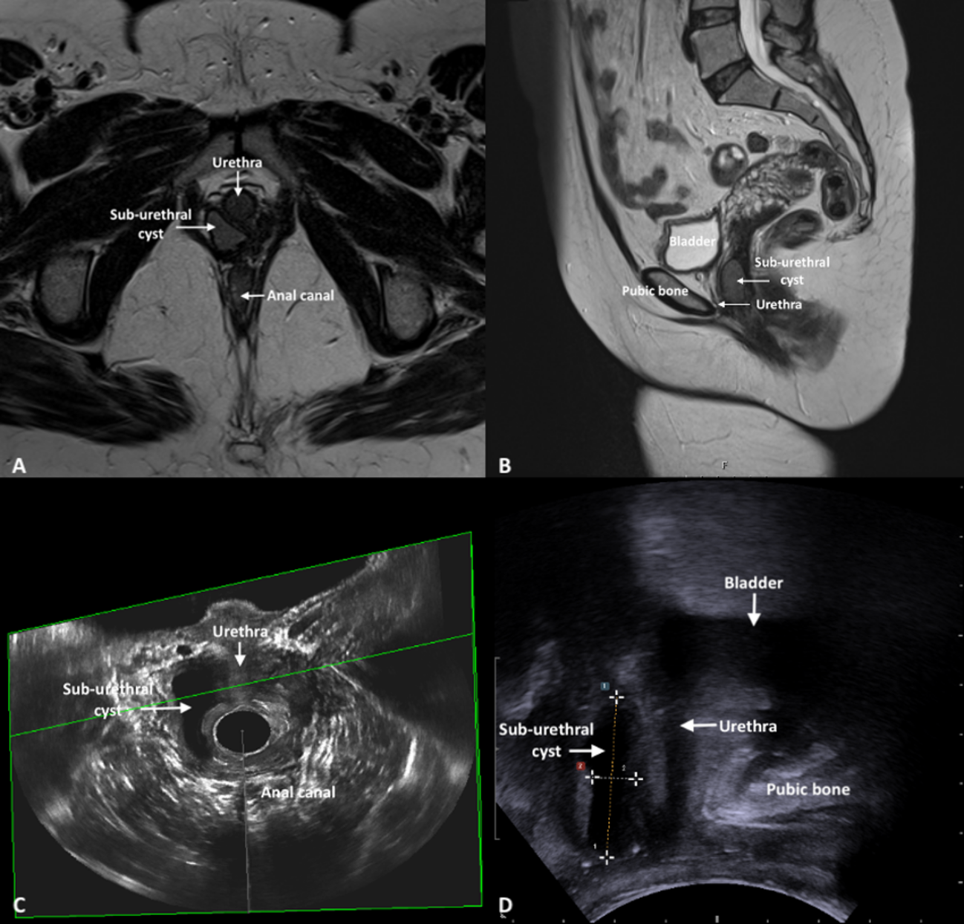

Table 1: Baseline characteristics of the 40 included patients:
Characteristics | N=40
Age (median[range]) | 50(22-78)
Parity(median[range]) | 2(0-6)
Presenting symptoms leading to referral | N (%)
Vaginal lump | 26(65.0)
SUI | 16(40.0)
Urge Urinary Incontinence | 4(10.0)
Voiding dysfunction | 6(15.0)
Recurrent UTI | 5(12.5)
Dysuria | 6(15)
Post-micturition dribble | 3(7.5)
Vaginal Discharge | 2(5.0)
Dyspareunia | 5(12.5)
Vaginal Pain | 5(12.5)
Post-micturition dribble | 4(10.0)
Hematuria | 2(5.0)
Clinical examination
Palpable sub-urethral mass | 40(100)

N=Number
SUI= Stress urinary incontinence
UTI= Urinary Tract Infection

Table 2: Ultrasound and MRI characteristics of sub-urethral masses detected with both modalities:
PFUS | N (%)  N= 34 | MRI (T2 weighted) | N (%)  N=34
Largest diameter (mm)*  (median([range]) | 19.2(1.0-67.3) | Largest diameter (mm)*  (median([range]) | 19.5(2.7-79.0)
Distance to bladder neck (mm)(median([range]) * | 11.5(0.0-40.0) | Distance to bladder neck (mm)(median([range]) * | 12.0(0.0-36.0)
Connection to urethra ¶ | 7(20.6) § | Connection to urethra ¶ | 1(2.9)
Confirmation of urethral connection on cystoscopy (n=5) † | 2(40.0) | Confirmation of urethral connection on cystoscopy (n=5) † | 1(20.0)
Encircling urethra | 7(20.6) | Encircling urethra | 10(29.4)
Type of mass |  | Type of mass
Uniloculated | 23(67.6) | Uniloculated | 26(76.5)
Multiloculated | 11(32.4) | Multiloculated | 8(23.5)
Echogenicity |  | Signal Intensity
Hyperechoic | 3(8.8) | Low | 3(8.8)
Mixed echogenicity | 3(8.8) | Intermediate | 4(11.8)
Hypoechoic | 28(82.4) | High | 27(79.4)
N= Number
MRI- Magnetic Resonance Imaging
PFUS- Pelvic Floor Ultrasound
*The smallest measurement taken either 2D perineal pelvic floor ultrasound or 3D endovaginal ultrasound was used
*The largest measurement taken from either 2D perineal pelvic floor ultrasound or 3D endovaginal ultrasound was used
¶- Urethral connection was seen only on two-dimensional transperineal ultrasound in the mid-sagittal plane.
§- Five of these women did not have a cystoscopy
† Five sub-urethral masses had a urethral connection noted on cystoscopy

Table 3:
Ultrasound characteristics of sub-urethral masses not detected on MRI:
N=6 | N (%)
Type of mass
Uniloculated | 6(100)
Multiloculated | 0(0)
Echogenicity
Hyperechoic | 2(33.3)
Mixed echogenicity | 2(33.3)
Hypoechoic | 2(33.3)
Measurements
Distance from cyst to bladder neck (mm) (median[range]) * | 30.9(28.3-34.0)
Largest Diameter(mm) (median[range])* | 7.8(5.0-15.0)
N=Number
*The smallest measurement taken either 2D perineal pelvic floor ultrasound or 3D endovaginal ultrasound was used
*The largest measurement taken from either 2D perineal pelvic floor ultrasound or 3D endovaginal ultrasound was used

Table 4: Comparison of MRI and PFUS measurements of sub-urethral masses detected on imaging
Detection on Imaging
2DpPFUS | MRI  N=34  [Median (IQR)] | 2DpPFUS  N=34  [Median (IQR)] | p- value* | ICC (3,1) | 95% CI | SEM (mm)
Distance from cyst to Bladder Neck (mm) | 12.5(6.8-24.9) | 15.6(8.5-24.8) | 0.15 | 0.89 | 0.79-0.95 | 3.64
Largest diameter (mm) | 19.5(15.3-28.8) | 17.8(11.6-29.3) | 0.05 | 0.93 | 0.85-0.97 | 4.31
3D EVUS | MRI  N=24 | 3D EVUS  N=24 | p- value* | ICC (3,1) | 95% CI | SEM
Distance from cyst to Bladder Neck (mm) | 12.4(8.0.-18.4) | 11.9(7.4-16.4) | 0.58 | 0.88 | 0.70-0.95 | 3.48
Largest diameter (mm) | 18.0(13.9-36.8) | 20.5(14.1-34.3) | 0.63 | 0.94 | 0.85-0.98 | 4.68
n/N=number
MRI- Magnetic resonance imaging
PFUS- Pelvic floor ultrasound
2D pPFUS- Two-dimensional perineal pelvic floor ultrasound
3D EVUS- Three- dimensional endovaginal ultrasound
IQR- Interquartile range
ICC- Intra Class Correlation Coefficient
CI- Confidence Interval
SEM- Standard Error of Measurement
*p-value calculated using the Wilcoxon Signed Ranks Test

Table 5: Ultrasound and MRI morphology according to the histological origin of the sub-urethral mass
Ultrasound | Urethral Diverticulum N=11 | Benign sub-urethral cyst N=2 | Bartholin’s cyst  N=1 | Leiomyoma  N=2 | Adenocarcinoma  N=1 | Melanoma  N=1
Distance from cyst to bladder neck (mm) (median[range])* | 11.0(8.0-40.0) | 10.2(8.0-12.4) | 17.0 | 0.0 | 11.0 | 5.0
Largest Diameter(mm) (median[range])* | 17.0(5.0-27.0) | 29.7 (24.3-35.0) | 44.9 | 69.7(67.3-72.1) | 48.0 | 36.0
Urethral connection (N [%]) | 3(27.3) | 0(0) | 0(0) | 0(0) | 0(0) | 0(0)
Encircling urethra (N [%]) | 5(45.5) | 0(0) | 1(0) | 0(0) | 0(0) | 0(0)
Type of mass (N [%])
Uniloculated | 6(54.5) | 1(50.0) | 1(100) | 2(100) | 0(0) | 0(0)
Multiloculated | 5(45.5) | 1(50.0) | 0(0) | 0(0) | 1(100) | 1(100)
Echogenicity (N [%])
Hyperechoic | 0(0.0) | 0(0) | 0(0) | 0(0) | 0(0) | 0(0)
Mixed echogenicity | 2(18.2) | 0(0) | 0(0) | 1(50) | 1(100) | 1(100)
Hypoechoic | 9(81.8) | 2(100) | 1(100) | 1(50) | 0(0) | 0(0)
MRI
Distance from cyst to bladder neck (mm) (median[range]) | 12.0(6.0-36.0) | 10.0(6.6-13.4) | 13.5 | 0.0 | 13.6 | 3.6
Largest Diameter(mm) (median[range]) | 17.0(5.0-29.0) | 31.5(29.0-34.0) | 45.0 | 66.0(53.0-79.0) | 31.0 | 40.0
Urethral connection (N [%]) | 1(9.1) | 0(0) | 0(0) | 0(0) | 0(0) | 0(0)
Encircling urethra (N [%]) | 4(36.4) | 0(0) | 1(00) | 0(0) | 0(0) | 0(0)
Type of mass (N [%])
Uniloculated | 8(72.7) | 1(50.0) | 1(100) | 2(100) | 1(100) | 0(0)
Multiloculated | 3(27.3) | 1(50.0) | 0(0) | 0(0) | 0(0) | 1(100)
Signal intensity (N [%])
Low | 1(9.1) | 0(0) | 0(0) | 0(0) | 1(100) | 0(0)
Intermediate | 0(0) | 0(0) | 0(0) | 1(50.0) | 0(0) | 1(100)
High | 10(90.9) | 2(100) | 1(100) | 1(50.0) | 0(0) | 0(0)
*N=Number
*The smallest measurement taken from either 2D perineal pelvic floor ultrasound or 3D endovaginal ultrasound was used
*The largest measurement taken from either 2D perineal pelvic floor ultrasound or 3D endovaginal ultrasound was used

