Table 1: Characteristics of infants at moment of ARTI episode.(Online only)
Reference testª |  | RSV positive |  | RSV negative
 | Total ARTI episodes  n=162 | BinaxNOW® positive  (TP)  n=5 | BinaxNOW® negative  (FN)  n=61 | BinaxNOW®  negative  (TN)  n=96
Age at moment of ARTI episode,  days (median [IQR]) | 84 [39-178] | 42 [33-203] | 99 [49-197] | 67 [34-161]
Sex, male (n (%))^{b} | 94 (58.0%) | 4 (80.0%) | 33 (54.1%) | 57 (59.4%)
Comorbidity, (n (%))^{c} | 4 (2.5%) | 1 (20.0%) | 3 (4.9%) | 0 (0%)
Duration of symptoms^{d}  days (median, [IQR]) | 3 [2-5] | 4 [2-5] | 3 [2-4] | 3 [2-6]
Level of care needed  (n, (%))^{e}  Non MA-ARTI  MA-ARTI  Hospitalised  PICU | 41 (25.3%)  83 (51.2%)  36 (22.2%)  11 (30.6%) | 0 (0.0%)  3 (60.0%)  2 (40.0%)  2 (100%) | 5 (8.2%)  28 (45.9%)  28 (45.9%)  7 (25.0%) | 36 (37.5%)  52 (54.2%)  6 (6.3%)  2 (33.3%)
Country (n, (%))  Netherlands  United Kingdom  Spain | 118 (72.8%)  14 (8.6%)  30 (18.5%) | 3 (60.0%)  0 (0.0%)  2 (40.0%) | 53 (86.9%)  0 (0.0%)  8 (13.1%) | 62 (64.6%)  14 (14.9%)  20 (20.8%)
ReSViNET score^{f}  (median [IQR]) | 3 [1-6] | 6 [5-16] | 5 [3-9] | 1 [1-3]
Reference test (n, (%))  Alere i RSV  Xpert Xpress Flu/RSV | 120 (74.1%)  42 (25.9%) | 5 (100.0%)  0 (0.0%) | 32 (52.5%)  29 (47.5%) | 83 (86.5%)  13 (13.5%)
Categorical data are expressed as frequency (%) and continuous data are expressed as median [interquartile range]. Percentages may not equal 100, because of rounding and missing values. P-values were not determined because of the low number of positive test results with BinaxNOW RSV.
Abbreviations: ARTI, acute respiratory tract infection; n, number of ARTI episodes; FN, false negative; MA-ARTI medically attended acute respiratory tract infection; PICU, pediatric intensive care unit; TN, true negative; TP, true positive;
ªAlere i RSV or Xpert Xpress Flu/RSV were used as reference test.
^{b} Including ten males which were tested twice
^{c} None of the infants with comorbidity were tested twice
^{d} Data available for 125 episodes
^{e} Data available for 160 episodes
^{f} Data available for 99 episodes
Table 2: Primary analysis of BinaxNOW® RSV performance.
 | Sensitivity (%) | Specificity (%) | PPV (%) | NPV (%)
Primary analysis (n=162)  95% CI (%) | 7.6 (5/66)  3.3-16.5 | 100 (96/96)  96.2-100.0 | 100 (5/5)  56.6-100.0 | 61.1 (96/157)  54.3-68.4
Data are percentages (proportions) of BinaxNOW RSV test results compared to the reference test.
Abbreviations: ; PPV, positive predictive value; NPV, negative predictive value; n, number of ARTI episodes; 95% CI, 95% confidence interval

Table 3: BinaxNOW RSV performance by different variables. (online only)
 | Sensitivity (%) | Specificity (%) | PPV (%) | NPV (%)
Level of care neededª  Non-MA ARTI (n=41)  MA ARTI (n=83)  Hospitalised (n=36)  PICU (n=11)  P value | 0 (0/5)  9.7 (3/31)  6.7 (2/30)  22.2 (2/9)  0.726 | 100 (36/36)  100 (52/52)  100 (6/6)  100 (2/2)  NA | NA (0/0)  100 (3/3)  100 (2/2)  100 (2/2)  NA | 87.8 (36/41)  65.0 (52/80)  17.6 (6/34)  22.2 (2/9)  <0.005
Age  <= 60 days (n=68)  > 60 days (n=93)  P value | 12.5 (3/24)  4.8 (2/42)  0.345 | 100 (44/44)  100 (51/51)  NA | 100 (3/3)  100 (2/2)  NA | 67.7 (44/65)  56.0 (51/91)  0.183
Duration of symptoms  before testing^{b}  <= 5 days (n=98)  > 5 days (n=26)  P value | 9.8 (5/51)  0 (0/8)  >0.999 | 100 (47/47)  100 (18/18)  NA | 100 (5/5)  NA (0/0)  NA | 50.5 (47/93)  69.2 (18/26)  0.119
ReSViNET score^{c}  <= 3 (n=53)  > 3 (n=46)  P value | 0 (0/17)  12.8 (5/39)  0.309 | 100 (36/36)  100 (7/7)  NA | NA (0/0)  100 (5/5)  NA | 67.9 (36/53)  17.1 (7/41)  <0.005
Data are percentages (proportions) of BinaxNOW RSV performance test results compared to the reference test. ReSViNET score was used to evaluate disease severity (Suppl fig 1)
Abbreviations: ARTI, acute respiratory tract infection; MA-ARTI medically attended acute respiratory tract infection; NPV, negative predictive value; PICU, pediatric intensive care unit; PPV, positive predictive value; n, number of ARTI episodes
ª Data available for 160 episodes
^{b} Data available for 125 episodes
^{c} Data available for 99 episodes
Table 4: Overview of characteristics of published studies about the performance of BN compared to molecular tests in children. (online only)
Study | Age | Type of ARTI | Reference test | Type of sample | POC setting | n= | Sensitivity (95% CI) | Specificity (95% CI)
Present study | <1 year (median, 84 days) | Hospitalised, (non)-MA ARTI | Alere i,  Xpert Xpress | NS (flocked swabs in 3 ml UTM/M4RT | Yes | 162 | 7.6%  (3.3 – 16.5) | 100%  (96.2-100)
Bruning et al., 2014[18] | <16 years | Hospitalised, (PICU), respiratory illness | RT-PCR | NPS, NPW | No | 66 | 80%  (64.3-95.7) | 100%  (NA)
Jung et al.,  2016[19] | <2 years | Hospitalised, ALRI | RT-PCR | NPS in 1.5 ml VTM (in-house) | No | 91 | 71.4% (61.4-79.7) | NA
Khanom et al., 2011[11] | <5 years | Hospitalised, ARTI | RT-PCR | NPS in 1 ml VTM (in-house) | Yes | 159 | 41.2% (27.9-55.8) | 100%  (95.7-100)
Miernyk et al., 2010[7] | <3 years (mean 9.3 months) | Hospitalised, LRTI | RT-PCR | NPW | No | 311 | 72%  (61-74) | 97%  (94-99)
Mills et al., 2011[12] | <2 years (mean 7 months) | ED, respiratory symptoms | RT-PCR | NPA, NPW | Yes | 579 | 83%  (79-87) | 83%  (78-87)
Papenburg et al., 2013[20] | <3 years (median 5.7 months) | Hospitalised, ARTI | RT-PCR | NPA | No | 720 | 80%  (76-83.5) | 96.9%  (94-98.6)
Pfeil et al., 2014[21] | <3 years (mean 7.9 months) | Hospitalised, ARTI | RT-PCR | NW | Yes | 242 | 63%  (61-76) | 100%  (NA)
Abbreviations: ARTI, acute respiratory tract infection; ED, emergency department; LRTI, lower respiratory tract infection; MA-ARTI medically attended acute respiratory tract infection; NS, nasal swab; NPA, nasopharyngeal aspirate; NPS, nasopharyngeal swab; NPW, nasopharyngeal wash; NW, nasal wash; NPV, negative predictive value; PICU, paediatric intensive care unit; POC, point-of-care; RT-PCR; reverse transcription polymerase chain reaction.

Figure 1: Study flow chart showing eligible ARTI episodes and test results of samples which were tested by BinaxNOW® RSV and the reference test.
Abbreviations: ARTI, acute respiratory tract infection; n, number of ARTI episodes; BN, BinaxNOW® RSV; RSV, respiratory syncytial virus
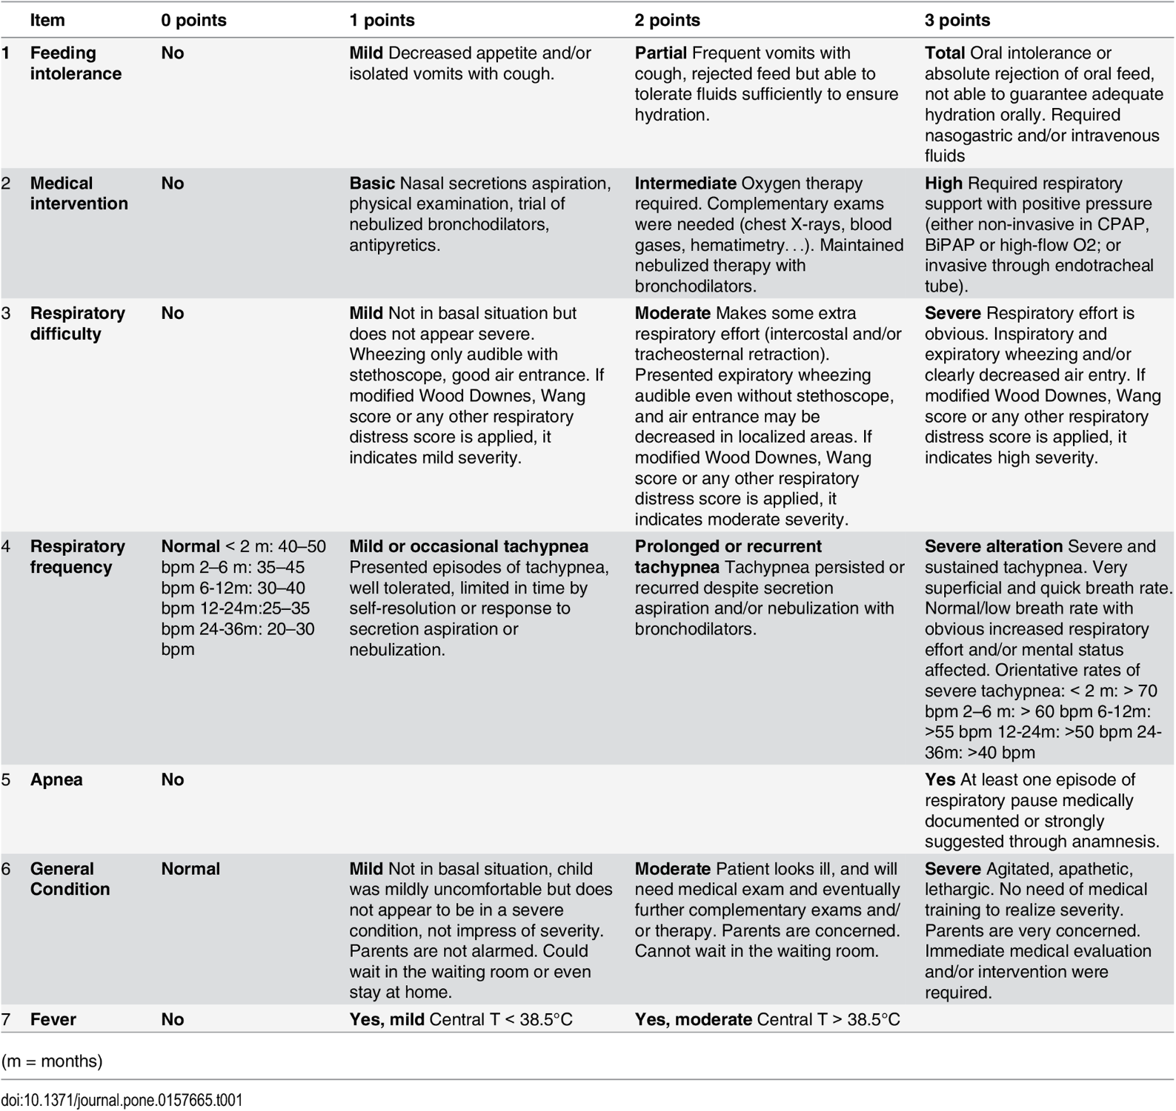
Supplementary Table 1: ReSViNET score: Each clinical symptom is scored according to the description provided. The total score forms the ReSViNET score (0-20).[15]

