Title: Two under recognised limitations of NNT
Authors:
Professor Sir Nicholas J Wald FRS FRCP FMedSci
Institute of Health Informatics
University College London
n.wald@ucl.ac.uk
Population Health Research Institute
St George’s University of London
nwald@sgul.ac.uk

Professor Joan K Morris PhD
Population Health Research Institute
St George’s University of London

Word count: 631

Keywords:
Limitations of NNT
Number-needed-to-treat
Estimating treatment effect
Quantifying health benefits

Two under recognised limitations of NNT
The number-needed-to-treat (NNT) is often used as a measure of treatment benefit, for example, in the effect of statins in preventing a heart attack in people selected as being at risk. It is intended to indicate the number of people that need to be treated to prevent one case of a specific disorder. The NNT is the reciprocal of the absolute risk reduction between a treated and untreated group. Limitations of the use of NNT have been described^{1,2} but two important limitations have not been sufficiently recognised, one because of how the absolute risk reduction is estimated, and the other because of a false assumption on the application of NNT to the prevention of chronic disease.
The first limitation, which is often ignored, is that the NNT depends on the time interval over which the medical event of interest is assessed. For example, if, over one year, the rate of events in a treated and untreated group were 5/100 and 10/100 respectively the NNT would be the reciprocal of 5/100 (10/100 - 5/100) ie 20. If the time interval were extended to 5 years, and the corresponding estimates were 25/100 and 50/100 the NNT would be the reciprocal of 25/100 (50/100 – 25/100) ie 4 instead of 20 with no change in the relative risk reduction – 50% in both cases (1-[5/100 ÷ 10/100 and 25/100 ÷ 50/100] respectively). A timeframe can be specified, such as, the number of clinical events arising in one year.³ However, this estimate will vary as people get older and for many interventions treatment is long-term and even lifelong, for example using medicines to lower blood pressure and the use of statins to lower serum cholesterol. In such circumstances what is of interest is the expected lifetime benefit.
The second limitation, which is inadequately recognised, is that the absolute risk reduction, on which the NNT estimate is based, assumes that the effect of treatment is dichotomised into some individuals benefitting by not having the medical event which treatment is designed to prevent and other individuals having no benefit at all. In practice this complete separation is rarely true. More often all individuals treated have some benefit but the benefit means that the medical event is delayed, unless they die from an unrelated cause of death first.
The figure compares the health benefits from a treatment to prevent myocardial infarction (MI) using MI cases avoided (as used to estimate NNT) and the more appropriate method using years of life gained without an MI. For individual 1 there is no benefit from treatment whichever method is used because a non-MI death occurs before the individual would have had an MI without treatment. With individual 2 there is a treatment benefit using years of life gained without an MI (8 years) but no benefit when counting MI cases. With individual 3 there is a benefit using either method but the method using years of life gained without an MI (5 years) quantifies the benefit whereas the other method does not.
The two limitations can be overcome by estimating two measures previously described⁴: i) the proportion of people who will benefit to some extent from the intervention over their lifetime and ii) among these people the average years of life gained without the clinical event that the intervention seeks to prevent. The proportion of people who benefit will be everyone who would have had the clinical event without the intervention. The average years of life gained on treatment which can be estimated using standard life table analysis based on age-specific incidence rates in a given population.
The two limitations described here can have a significant impact on judging the value of medical interventions. Failure to recognise these limitations can substantially underestimate the benefit of preventive treatments.
Nicholas J Wald FRS FRCP, Joan K Morris PhD
Population Health Research Institute
St George’s University of London
nwald@sgul.ac.uk

References

1 Laupacis A, Sackett DL, Roberts RS. An assessment of clinically useful measures of the consequences of treatment. N Engl J Med 1988;318:1728-33
2 Saver JL, Lewis RJ. Number needed to treat: conveying the likelihood of a therapeutic effect. JAMA 2019;321:798-9
3 Heller RF, Edwards R, McElduff P. Implementing guidelines in primary care: can population impact measures help? BMC Public Health. 2003;3:7
4 Wald NJ, Morris JK. Quantifying the health benefits of chronic disease prevention: a fresh approach using cardiovascular disease as an example. Eur J Epidemiol 2014;29:605-612

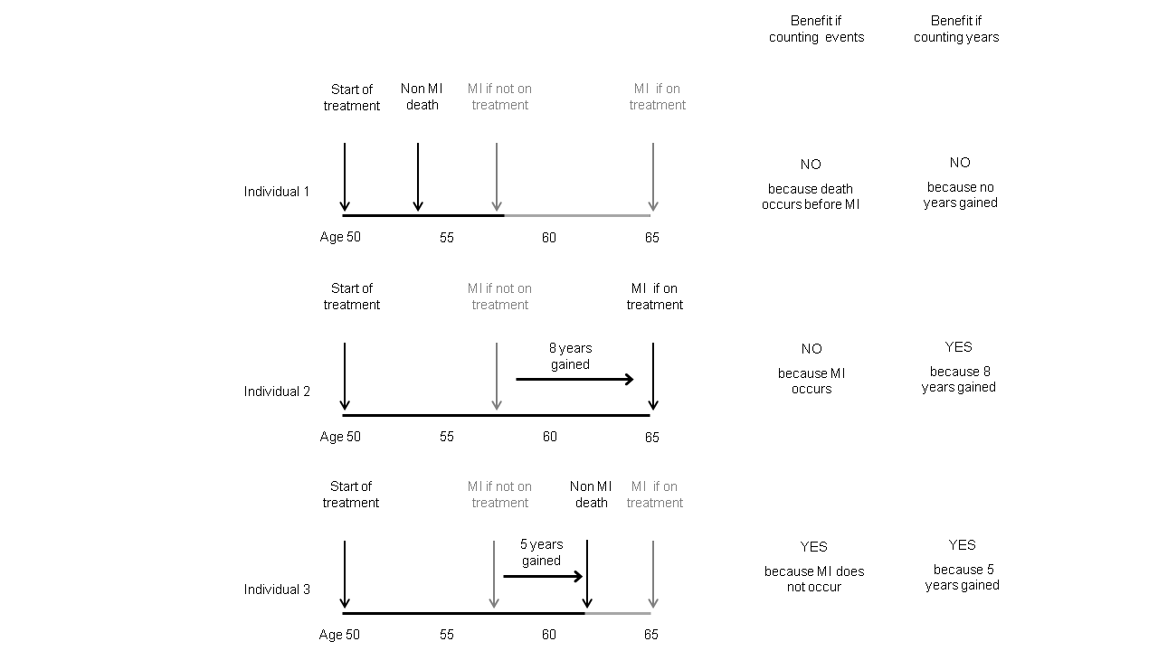
Figure: Comparison of two methods of assessing the health benefits of treatment to prevent myocardial infarction in three individuals

