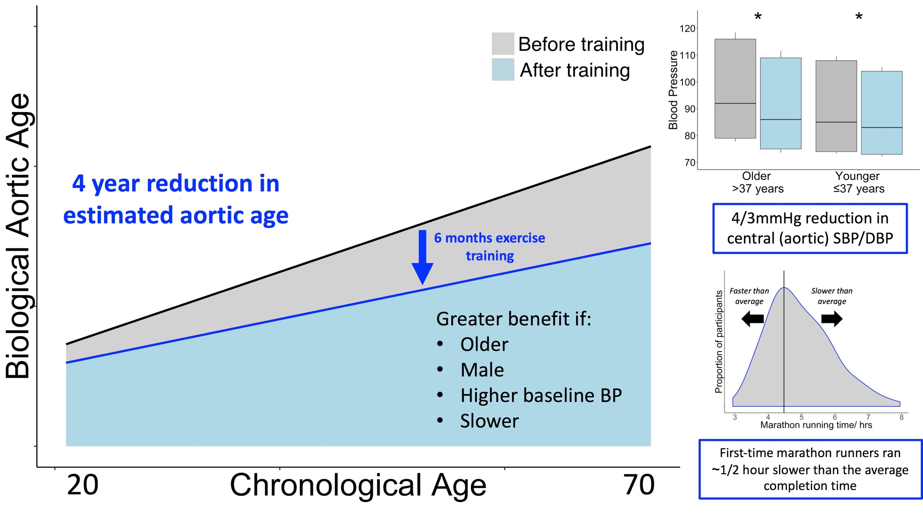
Central Illustration Training and completion of a first-time marathon reverses age-related aortic stiffening and reduces central (aortic) blood pressure. Biological aortic age was calculated from the baseline age-stiffness relationship at assessment six months before and two weeks after a first marathon. The reduction in aortic stiffness was equivalent to a four-year reduction in estimated aortic age. These benefits were greater in older, male, slower runners with higher baseline systolic blood pressure (BP), in adjusted models. Data are the linear age-stiffness relationship before and after exercise training; and systolic, diastolic BP and mean arterial pressure. Abbreviations: *= p<0.05.

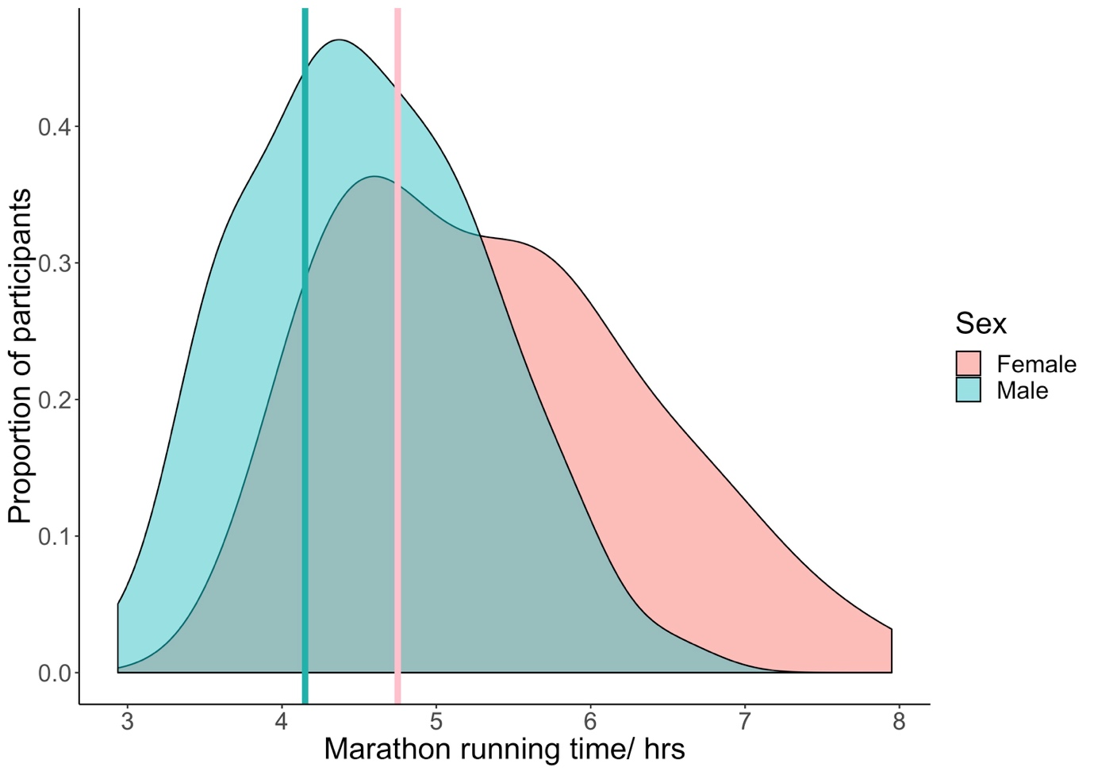
Figure 1 London Marathon running times for study participants. Vertical lines represent the average of the median running times for the 2016 and 2017 London Marathons.

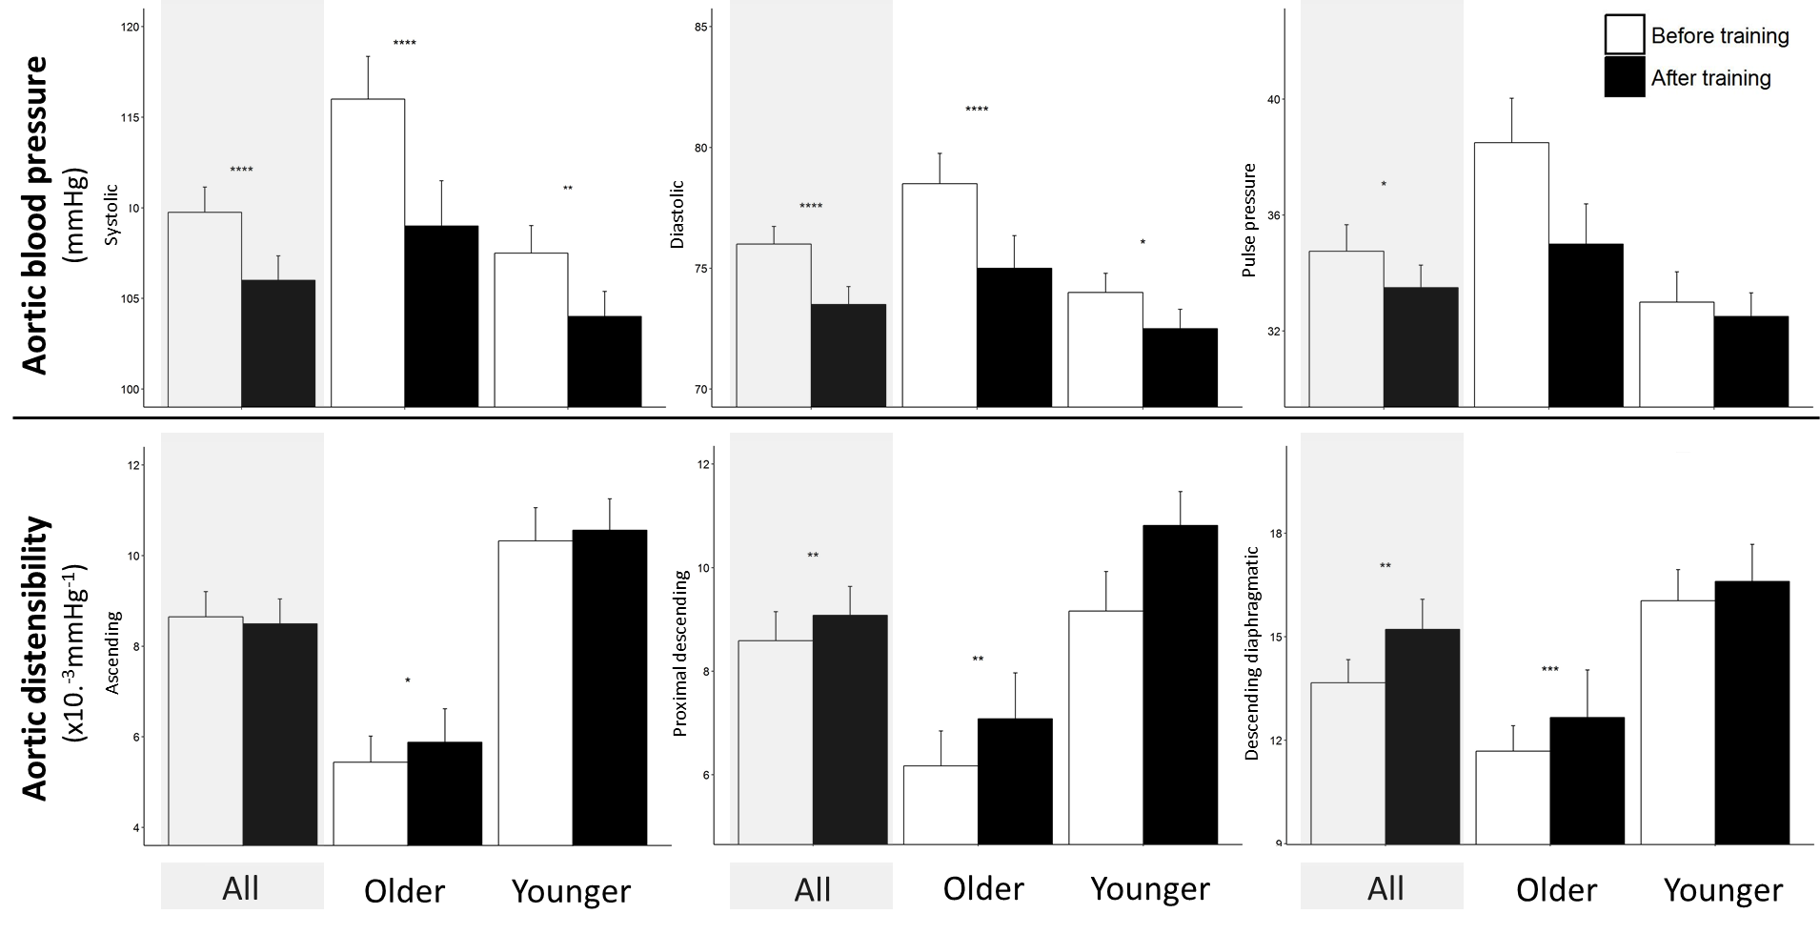

Figure 2 Greater change with exercise training in aortic blood pressure (top) and distensibility (bottom) in older age category (>37 years old). Data are median and standard error. Abbreviations: * p<0.05; ** p<0.01;*** p<0.001; **** p<0.0001.

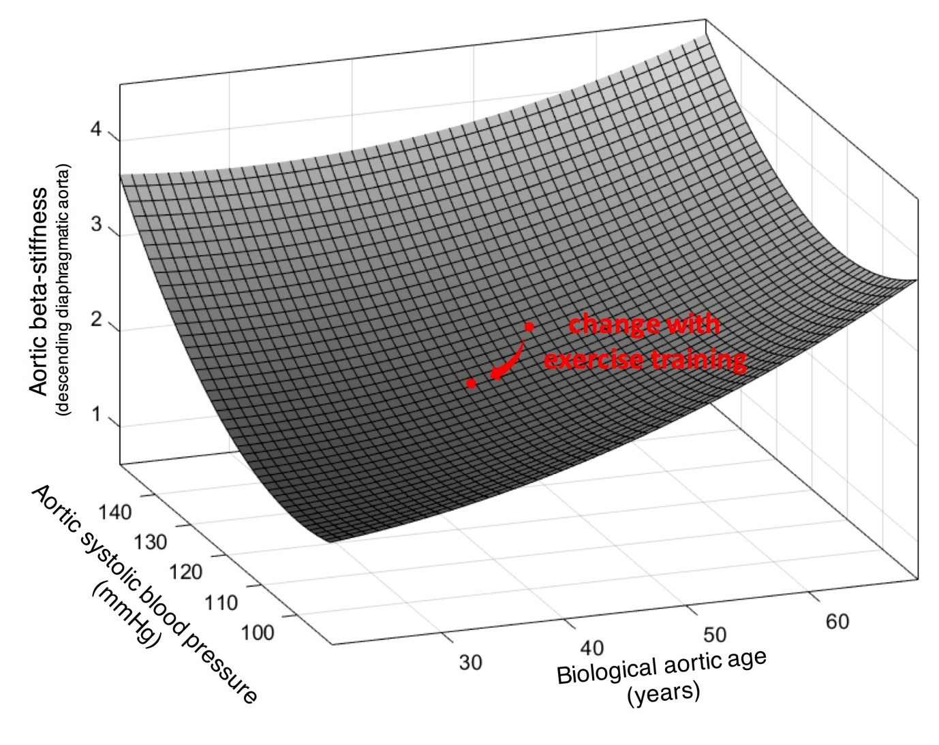

Figure 3 Baseline central (aortic) systolic blood pressure, aortic stiffness and estimated diaphragmatic aortic age; and the change (red arrow) with exercise training for the average older marathon completer.

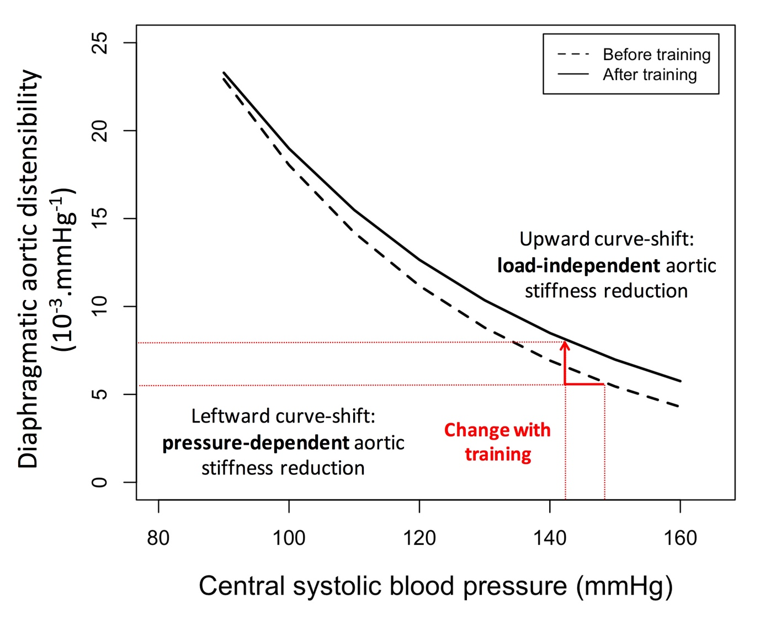
Figure 4 Reduction in aortic stiffness with exercise stiffness is due to both intrinsic structural (load-independent) and functional (pressure-dependent) changes. At higher arterial pressure, the aorta is functionally stiffer, but this relationship is not linear. Exercise training results in a reduction in pressure-dependent distensibility (leftward shift along the curve), and additionally a reduction in intrinsic β-stiffness (upward shift of the curve), contributing to a greater reduction in stiffness (red arrows and lines). In this schematic, data are fitted to an exponential for the cohort both before and after exercise training.

