Correspondence

Low Cerebrospinal Fluid White Cell Counts and Mortality in HIV-associated Pneumococcal Meningitis
Mark W. Tenforde^{1,2}, Graeme Meintjes³, Margaret Mokomane⁴, Thomas S. Harrison⁵, Madisa Mine⁴, Joseph N. Jarvis^{6,7*}

¹ Division of Allergy and Infectious Diseases, University of Washington School of Medicine, Seattle, WA USA
² Department of Epidemiology, University of Washington School of Public Health, Seattle, WA, USA
³Welcome Centre for Infectious Diseases Research in Africa, Infectious Disease and Molecular Medicine Unit and Department of Medicine, University of Cape Town, Cape Town, South Africa
⁴Botswana National Health Laboratory, Gaborone, Botswana
⁵Centre for Global Health, Institute for Infection and Immunity, St. George’s University of London, UK
⁶Botswana Harvard AIDS Institute Partnership, Gaborone, Botswana
⁷ Department of Clinical Research, Faculty of Infectious and Tropical Diseases, London School of Hygiene and Tropical Medicine, London, UK
*Corresponding author: Joseph N Jarvis, Botswana Harvard AIDS Institute Partnership, Private Bag BO 320, Gaborone, Botswana. Email: joseph.jarvis@lshtm.ac.uk
Keywords: Meningitis; Streptococcus pneumoniae; HIV; cerebrospinal fluid; Africa
Word count: 705
Dear Editor,

We read with interest the case report by Duss and colleagues, “Pneumococcal meningitis without pleocytosis in a patient infected with HIV-1”^{[1]}. We have previously noted similar findings in a large cohort of primarily HIV-positive adult patients being investigated for meningitis in South Africa^{[2]}. Two of 57 (4%) of patients with culture confirmed pneumococcal meningitis had acellular (0 cells/µL) cerebrospinal fluid (CSF), and a further three (5%) had CSF white cell counts of ≤ 10 cells/µL with < 5 polymorphonuclear cells/µL. We have also recently reported results from a large national meningitis study in Botswana, including 238 cases of culture-confirmed pneumococcal meningitis^{[3]}. A lack of CSF pleocytosis (total CSF WCC <5 cells/µL) was observed in 10% (24/238) of cases. Both studies reported results from laboratory-based surveillance studies, thus detailed individual data regarding HIV status and CD4 counts were lacking, however the vast majority of individuals with pneumococcal meningitis in both settings with HIV status data available were HIV-positive (97% in South Africa and at least 64% in Botswana) with low median CD4 cell counts (287 cells/µL and 221 cells/µL respectively)^{[2, 3]}.

Duss and colleagues speculate that that HIV-related immunosuppression could have hindered leucocyte migration through the blood–brain barrier, impairing effective immune control of S. pneumoniae. They further speculate that this resultant lack of inflammation could have contributed to the favourable outcome seen in their case^{[1]}.

We agree that it is highly plausible that HIV-related immunosuppression is likely to have contributed to the lack of an effective cellular immune response to S. pneumoniae, as we have described in detail in HIV-associated cryptococcal meningitis (CM)^{[4-6]}. We have previously reported that a significant proportion of individuals with both HIV-associated CM and tuberculous meningitis (TBM) have acellular CSF (0 cells/µL in 16% and 5% respectively)^{[2]}. However, in both CM^{[4, 6]} and TBM^{[7-9]} this lack of CSF white cell response is associated with increased rather than decreased mortality. In patients with HIV-associated CM the lack of an effective immune response at the site of infection, indicated by low CSF white cell counts, low levels of pro-inflammatory cytokines, and low levels of innate immune cell activation markers, is strongly associated with increased pathogen burden and death^{[4, 6]}.

Our recent data from the Botswana National Meningitis Study suggests that a paucity of CSF inflammation may also be a risk factor for poor outcome in HIV-associated pneumococcal meningitis^{[3]}. Increased CSF white cell counts were significantly associated with lower 10-week mortality, with each log₁₀ increase in WCC (cells/µL) associated with a hazards ratio for death of 0.77 (95% confidence interval 0.63-0.94, p=0.01) (Figure 1). Although prior smaller studies from African settings have not replicated this finding^{[10]}, and the very limited analyses of CSF cytokine levels in patients with HIV-associated pneumococcal meningitis have not revealed clear differences between survivors and those who died^{[10]}, our observation suggesting that a blunted inflammatory response in HIV-associated pneumococcal meningitis is associated with higher mortality could in part explain the lack of mortality benefit observed in trials of adjunctive corticosteroid therapy for pneumococcal meningitis in high HIV-prevalence settings ^{[11]}.

An excess mortality risk associated with very low levels of CSF inflammation in HIV-associated pneumococcal meningitis is in keeping with the “host damage-response framework”^{[12]}, which explains microbial pathogenesis as a continuum, with host damage occurring as a result of microbial virulence or the host immune response^{[13]}. The underlying immune environment in which infection occurs is thus critical to determining outcome. In the context of profound immune suppression such as advanced HIV-disease the lack of effective inflammation leads to unchecked pathogen replication and adverse outcomes; the appropriate management for which involves rapidly acting antimicrobial agents and possibly augmentation of effective immune responses^{[14]}. Conversely, in the context of an intact immune system (or even HIV-infection with relatively high CD4 counts^{[13, 15]} or following initiation of antiretroviral therapy^{[16-19]}) excessive inflammation may lead to tissue damage and poor outcomes; the appropriate management for which involves suppression of detrimental inflammation (e.g. with corticosteroids in pneumococcal meningitis in HIV-negative individuals^{[20]}) and antimicrobial therapy. At which point inflammatory responses become detrimental rather than protective will likely vary from pathogen to pathogen and requires more study; but applying this conceptual framework to the management of pneumococcal meningitis may enable more appropriate treatments to be utilised, stratified by patient population or potentially individualised at the patient level, according to underlying immune status and the inflammatory response observed.

Acknowledgements
The research was funded by the National Institute for Health Research (NIHR) using additional Official Development Assistance (ODA) funding. JNJ is a Research Professor (Ref RP-2017-08-ST2-012). The views expressed are those of the author(s) and not necessarily those of the NHS, the NIHR or the Department of Health and Social Care.

Figure 1. Cerebrospinal fluid white cell counts in 238 patients with culture confirmed pneumococcal meningitis in Botswana, stratified by 10-week mortality (47% died, n=112). The box plots show median and interquartile ranges (IQRs), with whiskers indicating the range. The p-value was derived from a rank-sum test.

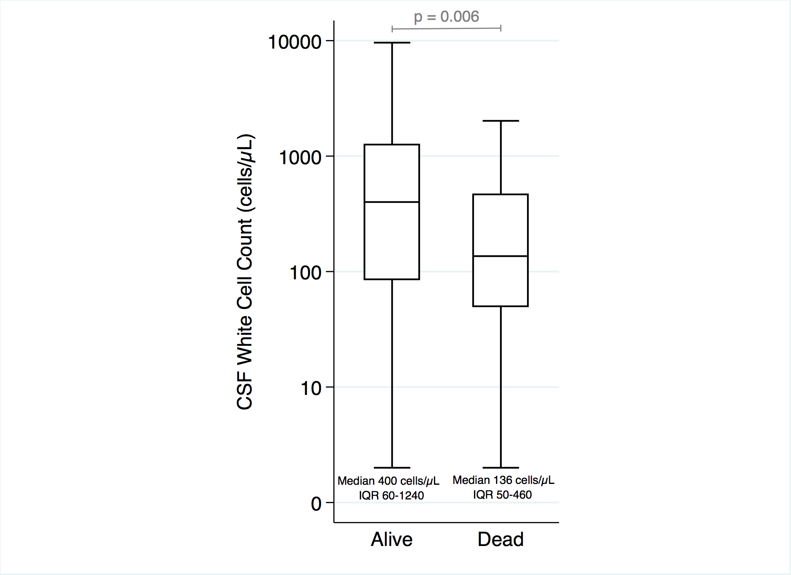

References
1. Duss FR, Moulin K, Moret Bochatay M, Bally F. Pneumococcal meningitis without pleocytosis in a patient infected with HIV-1. AIDS 2019; 33(4):765-766.
2. Jarvis JN, Meintjes G, Williams A, Brown Y, Crede T, Harrison TS. Adult meningitis in a setting of high HIV and TB prevalence: findings from 4961 suspected cases. BMC Infect Dis 2010; 10(1):67.
3. Tenforde MW, Mokomane M, Leeme TB, Tlhako N, Tsholo K, Chebani T, et al. Mortality Outcomes in Culture-positive and Culture-negative Adult Meningitis in the Botswana National Meningitis Survey: A Prevalent Cohort Study. Lancet Infectious Diseases 2019; IN PRESS.
4. Jarvis JN, Bicanic T, Loyse A, Namarika D, Jackson A, Nussbaum JC, et al. Determinants of mortality in a combined cohort of 501 patients with HIV-associated Cryptococcal meningitis: implications for improving outcomes. Clin Infect Dis 2014; 58(5):736-745.
5. Jarvis JN, Casazza JP, Stone HH, Meintjes G, Lawn SD, Levitz SM, et al. The phenotype of the Cryptococcus-specific CD4+ memory T-cell response is associated with disease severity and outcome in HIV-associated cryptococcal meningitis. J Infect Dis 2013; 207(12):1817-1828.
6. Jarvis JN, Meintjes G, Bicanic T, Buffa V, Hogan L, Mo S, et al. Cerebrospinal fluid cytokine profiles predict risk of early mortality and immune reconstitution inflammatory syndrome in HIV-associated cryptococcal meningitis. PLoS Pathog 2015; 11(4):e1004754.
7. Thwaites GE, Simmons CP, Than Ha Quyen N, Thi Hong Chau T, Phuong Mai P, Thi Dung N, et al. Pathophysiology and prognosis in vietnamese adults with tuberculous meningitis. J Infect Dis 2003; 188(8):1105-1115.
8. Thao LTP, Heemskerk AD, Geskus RB, Mai NTH, Ha DTM, Chau TTH, et al. Prognostic Models for 9-Month Mortality in Tuberculous Meningitis. Clin Infect Dis 2018; 66(4):523-532.
9. Cresswell FV, Bangdiwala AS, Meya DB, Bahr NC, Vidal JE, Török ME, et al. Absence of cerebrospinal fluid pleocytosis in tuberculous meningitis is a common occurrence in HIV co-infection and a predictor of poor outcomes. Int J Infect Dis 2018; 68:77-78.
10. Wall EC, Gritzfeld JF, Scarborough M, Ajdukiewicz KM, Mukaka M, Corless C, et al. Genomic pneumococcal load and CSF cytokines are not related to outcome in Malawian adults with meningitis. J Infect 2014; 69(5):440-446.
11. Scarborough M, Gordon SB, Whitty CJ, French N, Njalale Y, Chitani A, et al. Corticosteroids for bacterial meningitis in adults in sub-Saharan Africa. The New England journal of medicine 2007; 357(24):2441-2450.
12. Casadevall A, Pirofski LA. The damage-response framework of microbial pathogenesis. Nat Rev Microbiol 2003; 1(1):17-24.
13. Panackal AA, Williamson KC, van de Beek D, Boulware DR, Williamson PR. Fighting the Monster: Applying the Host Damage Framework to Human Central Nervous System Infections. MBio 2016; 7(1):e01906-01915.
14. Jarvis JN, Meintjes G, Rebe K, Williams GN, Bicanic T, Williams A, et al. Adjunctive interferon-gamma immunotherapy for the treatment of HIV-associated cryptococcal meningitis: a randomized controlled trial. Aids 2012; 26(9):1105-1113.
15. Tugume L, Rhein J, Hullsiek KH, Mpoza E, Kiggundu R, Ssebambulidde K, et al. HIV-Associated Cryptococcal Meningitis Occurring at Relatively Higher CD4 Counts. J Infect Dis 2019; 219(6):877-883.
16. Scriven JE, Rhein J, Hullsiek KH, von Hohenberg M, Linder G, Rolfes MA, et al. Early ART After Cryptococcal Meningitis Is Associated With Cerebrospinal Fluid Pleocytosis and Macrophage Activation in a Multisite Randomized Trial. J Infect Dis 2015; 212(5):769-778.
17. Meya DB, Okurut S, Zziwa G, Rolfes MA, Kelsey M, Cose S, et al. Cellular immune activation in cerebrospinal fluid from ugandans with cryptococcal meningitis and immune reconstitution inflammatory syndrome. J Infect Dis 2015; 211(10):1597-1606.
18. Marais S, Lai RPJ, Wilkinson KA, Meintjes G, O'Garra A, Wilkinson RJ. Inflammasome Activation Underlying Central Nervous System Deterioration in HIV-Associated Tuberculosis. J Infect Dis 2017; 215(5):677-686.
19. Marais S, Wilkinson KA, Lesosky M, Coussens AK, Deffur A, Pepper DJ, et al. Neutrophil-associated central nervous system inflammation in tuberculous meningitis immune reconstitution inflammatory syndrome. Clin Infect Dis 2014; 59(11):1638-1647.
20. de Gans J, van de Beek D, Investigators EDiABMS. Dexamethasone in adults with bacterial meningitis. N Engl J Med 2002; 347(20):1549-1556.

