Introduction
As the population ages, people are increasingly likely to have more than one chronic disease (multimorbidity) and to take multiple medicines (polypharmacy). Clinical pharmacists are being deployed in primary care to help manage long term conditions and advise on the use of multiple medicines, improving the value and outcomes from medicines. Over 15 months (2015-17), a complex care management team in Wandsworth ran a pilot incorporating 2 clinical pharmacists to support medicine optimisation and offer medicine-related support for patients with multiple long-term conditions.

Aim
To investigate the aspects of care provided by a clinical pharmacist that were most effective, specifically: the optimal number of patient contacts, reason for the visit, where this occurred and what happened at the visit.

Methods
Patients needing support were identified and reviewed by clinical pharmacists on several occasions. Input by clinical pharmacists included medicine reconciliation, transfer of medication plans between care settings, assessing efficacy and safety of medicines and reviewing patient’s treatment preferences and adherence. Clinical pharmacists collected intervention level data relating to type, time and reason for intervention. In a secondary analysis, patient-level data was analysed. Each patient contact was assigned a sequential visit number and the site, intervention, reason and duration of intervention by visit number was determined.

Results
308 patients were reviewed (185(60%) female, 121(39%) male, age 80±11 years (mean±SD) range 25-103) and 1789 inventions were made. Patients received 3±3 visits, range 1-22. At the first visit, 49% interventions were major changes, 45% interventions were to improve safety and 21% visits took >30 minutes (fig 1c). At subsequent visits, interventions were decreasingly likely to be major changes (fig 1a), less likely to focus on safety and more likely to focus on efficacy (fig 1b) and took less time (fig 1c). 765(43%) of interventions took place at home, 442(25%) were done through virtual review, 61(3%) through healthcare and 512(29%), the site was unclear. Compared to those occurring virtually or in hospital, interventions at home were more likely to comprise a major change (60% vs 47%) and less likely to be monitoring or information (19% vs 36%), p<0.001.
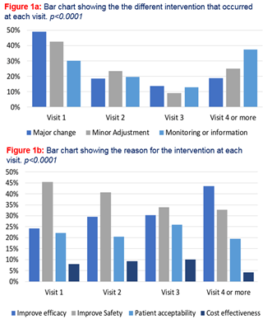

Conclusion
Results from the study may provide a platform for clinical pharmacists to construct their care pathways around. For example, each patient has three visits booked with visit one being allocated 30 minutes where major changes are addressed. Subsequent visits focusing on adjusting and monitoring medicines may be shorter.

