Abstract
Title
Effect of A1 vs a2TM milk exposure at an early developmental age on the endogenous opioid system of the rat brain
Introduction:
Evidence indicates that nutrition can affect early brain development leading to changes in behaviour. Prolonged milk casein exposure after the normal age of weaning in rats, has been shown to affect the opioid system and lead to changes in behaviour possibly via a gut-brain axis mechanism (Farshim et al., 2016). Caseins metabolite beta-casomorphin-7 (BCM-7) is biologically active. It has a high affinity for the mu opioid receptor (MOPr) and has been implicated in neurological deficits associated with schizophrenia and autism. Bovine milk has two major types of casein; the A1 type and the A2 type. The A1 type yields BCM-7 whilst the A2 type does not. The aim of this study was to assess whether prolonged exposure of rats during the early post-weaning age to milk containing both A1 and A2 casein (A1/A2) as opposed to a2TM milk containing only A2 casein, would cause alterations to the central opioid system.
Methods:
Male, Wistar Albino rats (N=8) were given either 100ml of A1/A2 milk or a2TM milk twice a day, or no milk from post-natal day 21 (PND) until PND26. Each group consisted of 8 rat pups. Depressive-like behaviour was then assessed with the use of the forced swim test on PND26. Rat pups were killed on PND27; brains were removed and frozen at - 80 °C and subsequently sectioned using a cryostat for quantitative receptor autoradiographic binding experiments. Changes to MOPr density was assessed with the use of quantitative autoradiographic receptor binding in brain serial sections (complete mapping). Sections were treated with the selective MOPr ligand [³H] DAMGO (4nM).
Results:
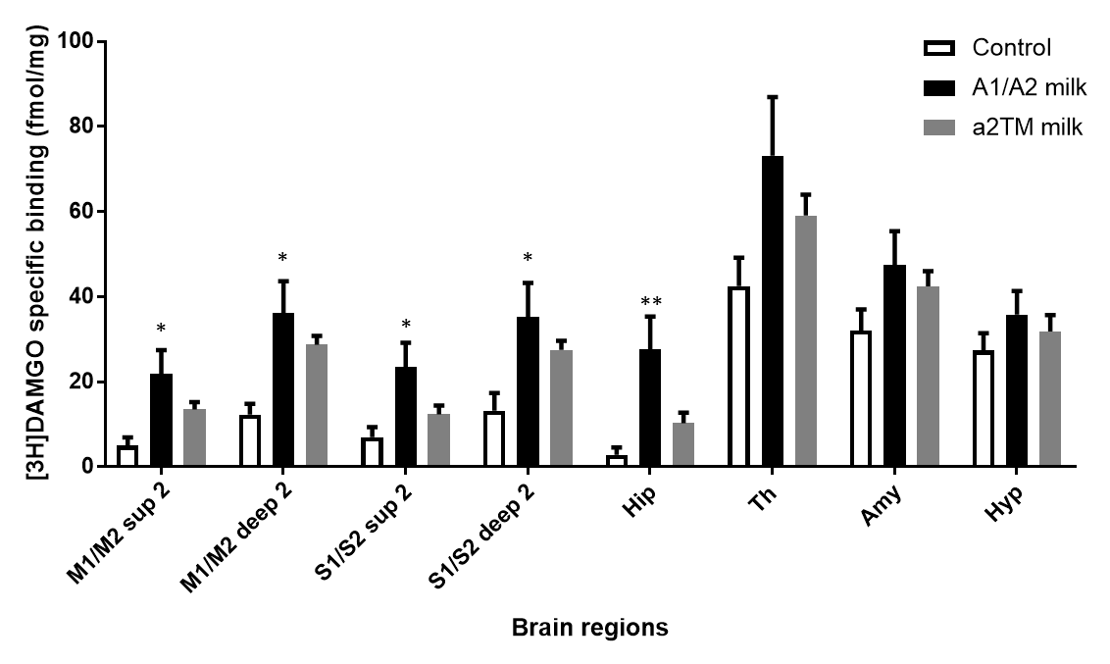
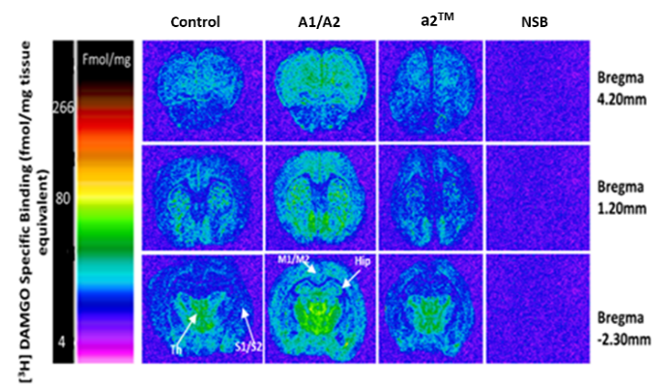
Prolonged exposure to A1/A2 milk caseins did indeed lead to significant changes in the opioid system (p<0.05, N=8, One Way ANOVA) with increased MOPr binding observed in the somatosensory cortex, motor cortex and the hippocampus of rats exposed to A1/A2 milk compared to controls (Fig.1). No significant alterations to MOPr were observed between brains of rats exposed to a2TM milk and control groups (Fig 2).

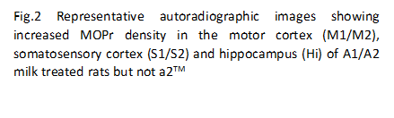
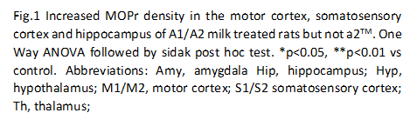
ADD N=8 adter “control”
Conclusion:
The findings suggest that ingestion of BCM-7 at an early developmental age does indeed modulate the opioid system of the brain. The behavioural consequences of these alterations and the mechanism by which BCM-7 may be causing these changes are under investigation in our laboratory.
References
Farshim, P., Walton, G., Chakrabarti, B., Givens, I., Saddy, D., Kitchen, I., R. Swann, J. and Bailey, A. (2016). Maternal Weaning Modulates Emotional Behavior and Regulates the Gut-Brain Axis. Scientific Reports, 6, 21958

