Review for ‘Allergy’ ALL-2018-01060 (revised)

Proteolytic, Lipidergic and Polysaccharide Molecular Recognition Shape Innate Responses to House Dust Mite Allergens

Alain Jacquet¹ and Clive Robinson²

¹Chula Vaccine Research Center, Faculty of Medicine, Chulalongkorn University, Bangkok 10330, Thailand*. ²Institute for Infection and Immunity, St George’s, University of London, London SW17 0RE, UK†.

*Author for correspondence: Assoc. Prof. Dr. Alain Jacquet
Chula Vaccine Research Center, Faculty of Medicine,
Chulalongkorn University,
1873 Rama IV Road, Pathumwan,
Bangkok 10330, Thailand.
Tel: (+66) 02 2563659
Fax: (+66) 02 6523100
alain.j@chula.ac.th

†c.robinson@sgul.ac.uk

Short Title : Innate Sensing of House Dust Mite Allergens

Keywords: House dust mite; protease allergen; Toll-like receptors; lipid-binding protein; polysaccharide

Abbreviations

ADAM A disintegrin and metalloprotease
ADI Allergen delivery inhibitor
ASL Airway surface liquid
ATP Adenosine 5’-triphosphate
Blo t Blomia tropicalis
CCL C-C chemokine ligand
CXCL C-X-C chemokine ligand
CD Cluster of differentiation
cDC2 Myeloid/conventional dendritic cell
CRAC Calcium release-activated calcium channel
DAMP Danger-associated molecular pattern
DC Dendritic cell
DC-SIGN Dendritic cell-specific intercellular adhesion molecule-3-grabbing non-integrin
Der p Dermatophagoides pteronyssinus
Der f Dermatophagoides farinae
EGFR Epidermal growth factor receptor
GM-CSF Granulocyte macrophage-colony stimulating factor
GPCR G protein-coupled receptor
HDM House dust mite
HMGB1 High mobility group box protein 1
IL Interleukin
ILC2 Type 2 innate lymphoid cell
KLRG-1 Killer cell lectin-like receptor sub-family G, member 1
LPS Lipopolysaccharide
MAPK Mitogen associated protein kinase
MD-2 Myeloid differentiation factor 2
MDA-5 Melanoma differentiation-associated protein-5
MyD88 Myeloid differentiation primary response 88
NFκB Nuclear factor κB
NLR NOD-like receptor
NLRP3 NOD-like receptor family, pyrin domain containing 3
PAMP Pathogen-associated molecular pattern
PAR Protease-activated receptor
PRR Pattern-recognition receptor
r Recombinant
RAGE Receptor for advanced glycation end products
RIG-I Retinoic acid inducible gene-I
RIP2 Receptor interacting protein2
RTK Receptor tyrosine kinase
SFA Saturated fatty acid
Th2 Type 2 T-helper cell
Th17 Type 17 T-helper cell
TIRAP Toll/interleukin receptor domain-containing activator protein
TLR Toll-like receptor
TNFAIP3 Tumour necrosis factor α-induced protein 3
TSLP Thymic stromal lymphopoietin
Abstract
House dust mites (HDMs) are sources of an extensive repertoire of allergens responsible for a range of allergic conditions. Technological advances have accelerated the identification of these allergens and characterised their putative roles within HDMs. Understanding their functional bioactivities is illuminating how they interact with the immune system to cause disease and how interrelations between them are essential to maximise allergic responses. Two types of allergen bioactivity, namely, proteolysis and peptidolipid/lipid binding, elicit IgE and stimulate bystander responses to unrelated allergens. Much of this influence arises from Toll-like receptor (TLR) 4 or TLR2 signalling and, in the case of protease allergens, the activation of additional pleiotropic effectors with strong disease linkage. Of related interest is the interaction of HDM allergens with common components of the house dust matrix, either through their binding to allergens or their autonomous modulation of immune receptors. Herein, we provide a contemporary view of how proteolysis, lipid-binding activity and interactions with polysaccharides and polysaccharide molecular recognition systems co-ordinate the principal responses which underlie allergy. The power of the catalytically competent group 1 HDM protease allergen component is demonstrated by a review of disclosures surrounding the efficacy of novel inhibitors produced by structure-based design.
Introduction
Understanding the structures and intrinsic bioactivities of allergens is key to decoding the interactions which link them to immune responses. For allergens from house dust mites (HDMs), attention initially focussed on the serodominant group 1 allergens and from this body of work it is apparent that their cysteine protease activity contributes broadly to the development and progression of allergic sensitisation in experimental models (1, 2). More recently, consideration has turned to allergens which have other bioactivities. These endeavours provide further awareness of the critical pathways which support allergic responses through a combination of pathogen-associated molecular patterns (PAMPs), danger-associated molecular patterns (DAMPs) and innate immune receptors.

The development of allergy is complex due to the varied influences which link risk factors with the manifestations of disease. Amongst these are maternal-foetal interactions, the timing of exposures to environmental stimuli at key checkpoints in the ontogeny of the immune system, genetic predisposition, and the systems biology integration of complex network components which dictate these interactions. Some of these factors remain either poorly-defined or have linkages which are incompletely understood, or frankly missing, from present knowledge.

This article reviews recent progress in solving the nature of HDM allergens and their myriad interactions with the innate immune system which instruct the development and exacerbation of disease. The allergens of specific interest, and their actions, are summarised in Table 1. While some of these findings are based on studies with purified allergens in native or recombinant forms, many have involved the use of HDM extracts obtained from commercial sources or produced in-house by laboratories with suitable facilities. These extracts are known to contain the serodominant allergens of groups 1 and 2 and have been used as the feedstock for the purification of others including, but not limited to, the serine peptidase allergens of groups 3, 6 and 9. Despite any limitations arising from their undefined nature, or in mimicking the natural exposure of humans to inhalant allergens they are the most representative model of real-life HDM exposure and have provided insights into fundamental mechanisms.

HDM Allergens and Toll-Like Receptors (TLRs)
A meta-analysis of epidemiological studies indicates that polymorphisms in TLR2 (rs3804099) and TLR4 (rs4986791) are risk factors for asthma (3). In TLR4, rs4986791 (T399I mutation) creates a mis-sense change in the extracellular region of the receptor and an impaired expression of TLR4 in the airways which leads to a blunted response to inhaled bacterial lipopolysaccharide (LPS) in humans (4). A second TLR4 polymorphism, rs4986790 (D299G) was found in atopic children not sensitised to HDM. This has been associated with the risk of asthma (but not rhinoconjunctivitis) (5), but not replicated in another survey (6), or in a meta-analysis of 14 different studies (3).

This TLR4 hyporesponsiveness to LPS and asthma risk is consistent with the notion that microbial multiplicity and exposure to high levels of LPS mitigate against the development of allergy (7-9){Celedon, 2007 #295;Ege, 2011 #294}{Celedon, 2007 #295;Ege, 2011 #294}{Celedon, 2007 #295;Ege, 2011 #294}{Celedon, 2007 #295;Ege, 2011 #294}{Celedon, 2007 #295;Ege, 2011 #294}. The PARSIFAL study demonstrated that maternal exposure to microbes from farms increased the expression of TLR4 and CD14 (a co-receptor of the TLR4 signalling pathway) in children from farming communities and this was associated with a reduction in the development of allergic disease (10). Whereas conflicting results were obtained about the association of TLR4 genetic polymorphism with allergy, CD14 genetic variation was associated with eczema and atopic sensitization risk (11, 12). The level of LPS in farm dust is critical for this protective phenomenon (9). Chronic exposure to high levels of LPS down-regulated NF-κB signalling in airway epithelial cells via enhanced expression of A20 (9, 13). Collectively, these data suggest an important role for TLR4 signalling pathways in the regulation of allergic responses.

In addition to mutations in TLR, disease risk is also affected by polymorphisms in co-receptors, signalling pathway components and in host enzymes which process LPS. Examples linked to TLR4 and/or TLR2 are to be found with CD14 which is associated with risk of atopy, asthma and eczema (11, 12, 14-16), the rs8177374 putative loss of function mutation in TRIF-related adapter molecule (TIRAP) (17), and in acyloxyacyl hydrolase (15, 18, 19). Acyloxyacyl hydrolase is found in dendritic cells and neutrophils and removes the 3-(acyloxy)acyl chains of lipid A to generate a product which antagonises responses to bacterial LPS in a CD14-independent manner (20). From these and other observations it is apparent that TLR4 is involved in a complex interplay of events which dictate key events in allergic disease.

TLR4
Functional TLR4 signalling via myeloid differentiation primary response 88 (MyD88) is an important element in the development of pulmonary sensitisation to HDM allergens in experimental models. Studies using TLR4 conditional knockout mice, or in irradiated bone marrow chimeric wild-type and TLR4^{-/-} mice, or in simple TLR4^{-/-} or MyD88 -/- deficiency models, demonstrate that TLR4 activation in the airway epithelium presages the activation of dendritic cells (DCs) and an ensuing production of antibody in response to HDM extracts (21, 22). Once sensitisation has been established, TLR4 signalling contributes to a classical Th2-dependent eosinophilic lung inflammation (21, 23, 24). Some studies indicate that eosinophil recruitment is only partially reliant on TLR4/MyD88 at this stage because 25-50% of eosinophil recruitment survives TLR4 or MyD88 deficiency (22, 25), whereas another study in mice deficient in TLR4 has provided evidence of an increase in total IgE and augmented eosinophil recruitment to the airways of mice given repeated exposures to an HDM extract (26). The mechanism of this latter effect is not known, but a linkage between TLR4 activation and lung-resident myeloid-derived suppressor-like cells has been proposed such that suppression of Th2 responses are lost in the absence of TLR4 (26). In contrast to the consequence of stimulating TLR4 on structural cells, the activation of TLR4 expressed on haematopoietic cells promotes neutrophil migration (25) which is notable because a fast-recruited and rapidly-resolved neutrophilic infiltrate can be seen in response to HDM allergen extracts or Der p 1 when administered by aerosol in rodent models of HDM sensitisation, and in humans a Th17-driven neutrophilia is a feature of severe asthma, especially during exacerbations (27-33). In addition to signalling through TLR4, HDM extract exposure enhances TLR4 expression by epithelial cells. While this may augment signalling via this pathway after sensitisation (34), the effects of this have to be considered alongside possible effects from other sources such as CD11b⁺Gr-1^{int} suppressive cells (26). It would be interesting to investigate whether this suppressive mechanism underpins the protection against allergy associated with increased TLR4 exposure in children born to mothers exposed to high levels of LPS (10).

The archetypal exogenous ligand of TLR4, bacterial LPS, has a complex concentration-effect relationship in allergy. Low concentrations promote allergic sensitisation (21), whereas high levels/repeated exposure impairs sensitisation by up-regulating tumour necrosis factor α-induced protein 3 (TNFAIP3), a negative regulator of NFκB which is located downstream of the TLR4 signalling pathway (13). Deletion of TNFAIP3 accentuates responses to HDM allergens with a Th17 bias (13, 35). In contrast, deficiency in acyloxyacyl hydrolase in mice produces a refractoriness to HDM stimulation as a consequence of tolerance of airway epithelial cells to LPS (36).

The over-arching influence of TLR4 in the initiation of allergy to inhaled HDM extracts in experimental models, and its association with asthma as a risk factor raises questions about its mechanism(s) of ligation, its regulation and whether the principles apply to HDM allergens encountered via the nasal airways or through the skin. In attempting to resolve the complexities of TLR4 in allergy it is important to consider that while LPS is a ligand for the receptor and LPS exposure is associated with disease risk, it is but one known binding partner for TLR4. In particular, the binding modes of host-derived endogenous ligands of TLR4 may differ significantly from LPS and operate receptor signalling with biased agonism. Furthermore, the overall consequence of TLR4 ligation will be determined by the interplay of factors which regulate the availability of ligands at receptors and the activatability of the latter. While there is an evolving understanding of these relationships for LPS and TLR4, almost nothing is known about the dynamic and kinetic events which determine the activation of TLR4 by endogenous ligands. Gaining further insight into these complexities requires a powerful range of investigative techniques and experimental models.

Group 2 HDM allergens and TLR4
The first mechanistic connection between HDM allergens and TLR4 came from studies of group 2 allergens. Through their structural homology with myeloid differentiation factor-2 (MD-2), the co-receptor of TLR4 which binds LPS, group 2 allergens can substitute for MD-2 in facilitating LPS-triggered TLR4 signalling (37). This provides insight into how HDM allergens may be linked to the vital role of TLR4 (Figure 1). For Th2-mediated responses, findings suggest a dominant role for TLR4 expression by structural cells (21), implying that the localisation of accessible TLR4 and its regulation in the airway epithelium are paramount. Under quiescent conditions, TLR4 in epithelial cells may be mainly compartmentalised within endosomes or expressed basolaterally, with its intramembrane mobility constrained by the ‘fence’ function of tight junctions (TJs) (2, 38-40). The relative impermeability of the airway epithelium to intact native Der p 2 (prepared by immunoaffinity chromatography with acid elution and polishing by size exclusion) has been noted. This suggests a necessity for derogation of the TJ barrier by group 1 HDM allergens for optimal interaction between Der p 2 and cell surface TLR4 (41), a process which would incidentally facilitate the apical presentation of the receptor. This co-dependence of group 1 and group 2 allergens in epithelia with intact TJs provides a rationale to reconcile the indispensability of TLR4 signalling with the dominance of protease activity in promoting responses to HDM allergens in mouse models (41, 42).

Group 1 HDM allergens and TLR4
The adjuvanticity of certain HDM allergens is pivotal in the development of allergic sensitisation and influences the responses to HDM allergens lacking such bioactivity and, similarly, allergens from unrelated sources (1, 2, 42-46). Allergens with proteolytic activity have received most attention in this regard (1). By Referee request, we were asked to consider a paper which apparently refutes the contention that HDM proteases contribute to allergic sensitisation. The study by Post et al. (47) investigated the composition of different HDM extracts and their effects on allergic sensitisation – a topic which has relevance to understanding immune responses in the airways and which is also of pragmatic importance given the widespread use of allergen extracts as experimental tools. While these reagents have convenience, differences in their composition and methods of manufacture can introduce some problems for reproducibility and data interpretation. This paper is instructive in this regard as it invites inferences to be drawn between strands of data for biochemical activity and effector responses evoked in vitro and in vivo (47). However, it did not seek to address any mechanism by direct intervention in an in vivo setting. The findings are worth discussion because they neatly encapsulate the technical barriers which must be confronted in defining the nature of extracted material and which may significantly affect the interpretation of mechanistic immunology studies conducted with such extracts. The lack, at the time that work was undertaken, of optimised substrates and suitably selective and potent inhibitors to measure true active site concentrations of defined components is reflected in the data reported in that manuscript, some of which is puzzling and some apparently contradictory. A conclusion of Post et al. (47) was that proteases and chitinases in HDM extracts are not critical for allergic sensitisation. In fact, inspection of the data leads to a different view: The only extract to increase total IgE, induce allergen-specific IgE and elevate the IL-13 content of lung homogenates was the one which had the highest ranking in terms of either serine or cysteine peptidase activity (47). This was delivered intranasally and without treatment with a reducing agent. This picture is at odds with the stated conclusions of their 2012 paper and, it seems, the received impression of others. In a later study (48) the same extract with protease activity was used by these authors to show that when administered under the same conditions, elevations in total IgE were attenuated in protease-activated receptor (PAR)-2 -/- mice. PAR-2 is an activatable target of HDM serine peptidase allergens, so these findings suggest that total IgE may be influenced through a non-canonical trypsin-like serine peptidase activity. In contrast, Post et al. found that the production of HDM-specific IgE was not attenuated in PAR-2 -/- mice (48). As shown by Zhang and her co-workers, the production of allergen-specific IgE and elevation of total IgE can, however, be prevented by selective Der p 1 inhibitors in HDM extracts which contain functional cysteine and serine protease activities (41). Indeed in their later study, Post et al. speculated that cysteine protease activity may be involved in IgE responses (48), a viewpoint which is the reverse of the earlier opinion (47). More recently disclosed studies with inhibitors produced by structure-based chemical design strongly reinforce this concept (41) and a benefit of inhibiting Der p 1 in this way may be the consequent protection of airway antiprotease defences (which act as endogenous inhibitors of serine peptidase HDM allergens) because Der p 1 is a serpin inactivator (49, 50).

We note en passant that a HDM extract from Greer Laboratories was found to have low-ranking proteolytic activity in the studies reported by Post et al. (47, 48). This is somewhat surprising based on our own unpublished findings, but it is worthy of remark because this material has been widely used in mechanistic studies. It should be borne in mind, however, that measurements of activity made in arbitrary units with non-optimised substrates (47) may be misleading; they are poor surrogates for the deconvolution of active site concentrations and an understanding of catalytic activity. Given the popularity of this extract as an experimental tool, it seems prudent to characterise its behaviour in greater detail.

Thus, a reasonable contemporary view is that group 1 allergens are significant foundations of the adjuvanticity of HDM extracts. Protease activity is linked to the ability to elicit IgE production and Der p 1 inhibitors are prophylactic in mice exposed to aerosolised HDM extracts (41, 51). As both protease activity and TLR4 are highly significant components in the development of allergy to HDM, this implies a linkage between group 1 allergens and TLR4 ligation (1, 2). But what unites these components, and what is their provenance?

A recently identified pathway in human airway epithelial cells and a previously unrecognised property of group 1 HDM allergens together provide an explanation of this HDM protease allergen to TLR4 paradox (1, 42, 52). This cardinal route (Figure 2) links key components of the PAR signalling pathway (involving epidermal growth factor receptor (EGFR), the myosin motor gating of pannexons, ATP release, and activation of a disintegrin and metalloprotease (ADAM) 10) with gene expression. This gene expression is mediated by intracellular reactive oxidant species (ROS) whose roles in regulating redox-sensitive transcription factors and signalling pathways is well established (1, 42, 52). A critical step is the activation of TLR4, which is ultimately dependent on the prothrombinase activity of group 1 HDM allergens (1, 42, 52). This enables the generation of thrombin and the canonical activation of PAR-1 and PAR-4 to initiate ROS production. The major dependency of this process on group 1 HDM allergens makes it susceptible to inhibitors of group 1 allergens (42). Unexpectedly, this cycle converges with signalling initiated through TLR3, retinoic acid-inducible gene-I (RIG-I) and melanoma differentiation-associated protein-5 (MDA-5) by viral RNA, suggesting a linkage to virus-induced disease exacerbations, especially relevant to asthma (42). The subsequent activation of TLR4 involves an ensemble of endogenous ligands which includes fibrinogen and its cleavage products (1). The airway epithelium has the uncommon capacity of expressing and releasing all component (α, β, γ) chains of fibrinogen, and silencing of the encoding genes blocks the response to HDM allergen extracts (1). This involvement of fibrinogen-derived products in TLR4 activation by group 1 HDM allergens mirrors the precedent established by proteases from Aspergillus oryzae (53, 54). High Mobility Group Box protein (HMGB1) is another potential member of the activating ensemble, operating through either TLR4 or receptor for advanced glycation end products (RAGE). After HDM allergen inhalation in a mouse model of acute allergic inflammation, RAGE was engaged secondary to TLR4 and amplified HMBG1, resulting in the expression of epithelium-derived IL-25 and IL-33 (24). TLR2 might also ligate HMBG1, but this remains to be demonstrated in HDM allergy (55).

Miscellaneous HDM allergens as candidate activators of TLR4
The newly-identified D. farinae allergen, Der f 35, is of interest because it contains a conserved MD-2-related lipid recognition domain like the group 2 mite allergens (56). However, whether this is functional for TLR4 activation remains to be determined.

Group 14 allergens are apolipophorin I/II-like proteins which are lipid transport molecules. These proteins contain a vitellogenin domain which can bind microbial ligands including LPS, lipoteichoic acid and β-glucans (57), suggesting that group 14 allergens might present these, or others, to PRRs such as TLR4. However, recombinant (r) expression of the intact allergens has been hampered by their molecular weight (177 kDa), although production of an N-terminal rDer f 14 fragment bearing a lipid-binding vitellogenin domain was successful (58).

TLR2
The ligand repertoire of TLR2 includes lipoteichoic acids, lipopeptides and peptidoglycans. TLR2-dependent signalling relies on the formation of heterodimers with TLR1 or TLR6 in a process facilitated by binding of the lipid chains of lipoproteins with the hydrophobic faces of the individual receptors. This is best characterised by structural analysis of TLR1/2 associated with the synthetic lipopeptide Pam3CSK4 (59). Less described, but of interest given the current trajectory of understanding, is the potential heterologous interaction of TLR2 with TLR4 (60, 61). Additionally, TLR2 operates in association with a range of putative co-receptors (including: CD14 – involved as well in responses to LPS via TLR4; scavenger receptors; and the C-type lectin domain receptor, dectin-1) (62). While heterodimeric or cross-talk relationships expand the ligand repertoire of monomeric PRRs, their consequences for signal transduction are uncertain.

Whereas several lines of evidence suggest that TLR4 is a significant factor in pulmonary sensitization to HDM allergens in experimental models, the importance of TLR2 is less clear. In TLR2-deficient mice the phenotypic hallmarks of sensitisation to HDM extracts (airway hyperreactivity, Th2 cytokines, cellular infiltration) were unaffected, but uncharacterised component(s) in the extract operated TLR2-mediated signalling in cells transfected with the receptor (22). Other work in mice has suggested that TLR2, but not TLR4, is involved in β-glucan mediated sensitisation to HDM allergens via the nose, whereas pulmonary sensitisation required TLR4 (34). Intriguingly, TLR2 may be involved in the sensitisation to ovalbumin through increased epithelial expression of thymic stromal lymphopoietin (TSLP) and the C-C chemokine ligand-2 (CCL-2)-dependent recruitment of basophils (63). Although these responses were ablated in TLR2-deficient mice, suggesting causal connection, a mechanistic linkage remains to be established. In contrast to the allergy-promoting, inflammatory role of TLR4 ligation seen in acute-subacute exposures to HDM extracts (21, 25), other evidence suggests that the effects of TLR2 activation may be more nuanced. In some circumstances, TLR2 activation exerts an anti-inflammatory role through the signal transduction factor c-fos; under other conditions its ligation is pro-inflammatory, however (62, 64, 65). Further developing the theme that organ-specific differences exist in TLR utilisation in allergic sensitisation in mice, TLR2 has been shown to drive Th2-dependent responses to Der p 2 in skin that were independent of functional TLR4 (66).

The structural capacity of the hydrophobic pocket in group 2 HDM allergens which enables the binding of LPS (67) suggests that other moieties might be ligated, enabling assorted lipid cargoes to interact with a range of TLRs. Lipids have various effects on TLR behaviour; saturated fatty acids (SFAs) promote their migration to membrane lipid rafts, receptor dimerisation, and inflammatory signalling, whereas polyunsaturated fatty acids are inhibitory (68) (Figure 1). While SFAs are substantially less potent than either natural (eg LPS) or synthetic (eg Pam3CSK4) lipopeptides, implying that binding energy is sub-optimal without a peptide moiety, lauric acid and palmitic acid could activate TLR signalling through homodimerisation of TLR4 or heterodimerisation of TLR2 with TLR1 (69). Moreover, palmitic acid was recently shown to bind to MD-2, alluding to effects on TLR4 (70).

Environmental encounters with HDM allergens occur alongside contact with fatty acids derived from microbial and other components of house dust. It is noteworthy that lipid binding proteins occur across the constellation of allergens from diverse sources (eg herbaceous dicotyledons, tree pollens, latex, animal danders etc) and this function is a potential feature of HDM allergens too (71). Beyond the better studied HDM allergens of group 2, members of groups 5, 7, 13, 14, 21 and 35 exhibit similarity with fatty acid/lipid binding proteins (71). Future investigations will be required to establish if some, or all, of these allergens and their lipid cargoes are capable of activating TLR signalling. Other studies involving some of these allergens are now emerging, as described below (Figure 1).

Group 5 and group 21 HDM allergens and TLR2
Consistent with a functionalist view of allergenicity, the structurally homologous allergens Der p 5 and Der p 21 may share allergenic features (71, 72). While not serodominant, their putative interactions with TLRs imply an influence over the progression of allergy (72). The unitary structure of Der p/f 5 and Der p/f 21 is a three-helical bundle protein capable of oligomerisation (73-75). In the dimeric form revealed by X-ray crystallography, an interfacial hydrophobic pocket is formed between the monomers, offering potential ligation of lipids and facilitation of interactions with TLRs (74). In spite of this, recombinant Der p 5 binds lipids under mildly acidic conditions (as found in the mite midgut) in monomeric form also (74, 76, 77), and through such cargo activates TLR2-NFκB-mitogen-activated protein kinase (MAPK)-dependent signalling in airway epithelial cells (77). Analogous evidence exists for Der p 21 (72).

Group 7 HDM allergens and TLR2
Group 7 allergens from D. pteronyssinus and D. farinae possess a lipid-binding domain, formed from antiparallel β-sheets woven around a helical core, which can weakly bind the lipopeptide polymyxin (78, 79). Although structural homology with LPS-binding protein suggests that LPS might be their preferred ligand, surprisingly this is probably not so; while rDer p7 (glycosylated) stimulated the dendritic cell-specific intercellular adhesion molecule-3-grabbing non-integrin (DC-SIGN)-dependent expression of IL-6, OX40L and Jagged-1 by DCs it was relatively insensitive to the blockade of TLR4 (80). The group 7 allergen, Blo t 7, from the tropical mite Blomia tropicalis is less identical (~30%) to its Dermatophagoides genus counterparts (>85% identical), but the lipid binding site is well conserved and binds hydrophobic ligands. Recombinant Blo t 7 stimulates TLR2-dependent production of IL-8 and GM-CSF by airway epithelial cells (81), suggesting that TLR2 may be a preferred interaction partner of group 7 allergens depending on the lipid cargo.

Group 13 HDM allergens and TLR2
Group 13 allergens cannot be exported from HDM cells because they lack a leader sequence and, consequently, are found in HDM bodies rather than faecal pellets (82). This may account for the low prevalence of sensitisation in people with respiratory symptoms, whereas reactivity in atopic dermatitis is greater (83). Structurally, Der f 13 contains a hydrophobic binding pocket comprising a β-barrel formed from 10 antiparallel strands (84), and its sequence similarity to cytoplasmic fatty acid binding proteins alludes to group 13 HDM allergens having a fatty acid transport function. Functional lipid binding ability for Blo t 13 (85) and for rDer p 13 has been shown and evoked the TLR2-dependent production of IL-8 and GM-CSF by airway epithelial cells (82). The cellular response to rDer p 13 was maintained after proteolysis of the allergen, so ligand retention by the allergen is unnecessary, implying that transfer of the immunomodulatory lipid to TLR2 or a TLR2 co-receptor (viz: CD14, CD36) occurs.

Group 31 HDM allergens and TLR2
The recently identified Der f 31 allergen is a cofilin analogue (86). Cofilins are small ADP-binding proteins which depolymerise actin. Significant roles have been proposed for cofilins in cellular defence against pathogens because they regulate a variety of PRRs through actin dynamics (87). However, while little is known about the role of cofilins in allergy, rDer f 31 initiates the TLR2-dependent/TLR4-independent release of TSLP and IL-33 by airway epithelial cells and activates lung-resident type 2 innate lymphoid cells (ILC2s)(88). How the cofilin-like nature of the allergen contributes is unknown, but linkage with TLR2 can be inferred.

TLR2 may also be activated through the recognition of chitin presented by HDM allergens with a putative chitin binding domain (viz: groups 12, 15, 18 and 23. See later).

HDM Allergens and Polysaccharide PAMP Recognition
HDM allergens with potential binding sites for lipids, lipopolysaccharides or lipoproteins can present those molecules at appropriate PRRs to activate innate immunity. Analogously, polysaccharide PAMPs might be presented to PRRs for similar effect, in addition to any autonomous actions they possess. A current perspective of these interactions is depicted in Figure 3. Among moieties of interest, chitin has received attention as a component of the HDM exoskeleton, mid-gut epithelial matrix and the peritrophic membrane of faecal pellets (89).

Chitin (polymeric β-(1-4)-poly-N-acetyl-D-glucosamine) has complex biological effects which are dependent on polymer size and physical form (89-91). These include the upregulation of IL-25, IL-33 and TSLP in airway epithelial cells, activation of IL-5 and IL-13 release by ILC2s leading to the stimulation of immune responses with Th2 polarisation (92). In acidic mammalian chitinase-deficient mice, an accumulation of chitin in the airways produced a sustained induction of IL-33, leading to a slowly-resolving allergic response to HDM challenge characterised by the presence of γδ T cells, CD4⁺ T cells, neutrophils and eosinophils (93). Conversely, enzymatic degradation of chitin initiated its phagocytosis, activated caspases-1 and -7 and ameliorated allergic responses (94). Chitin is also an adjuvant for ovalbumin (95), their combination providing a robust Th1-, Th2- and Th17-mediated airway inflammation characterised by an eosinophil response which is dependent on IL-33 (but not IL-25, TSLP or IL-17A) (96). A significant recruitment of neutrophils is noted also (95, 96). Responses to HDM-derived chitin are fully attenuated in TLR2-deficient mice suggesting that components of the mite exoskeleton or faecal pellets operate directly or indirectly via TLR2 (95).

These observations raise the question of whether chitin acts autonomously or requires binding by allergens. The latter possibility arises from bioinformatic prediction of chitin-binding domains in mite allergens from groups 12 (Blomia), 15, 18 and 23 (Dermatophagoides)(71). The group 15 and 18 allergens have some homology with glycosyl hydrolase family 18 chitinases (but are only weakly related to each other and differ significantly in frequency of immunoreactivity) (97-99), while the group 12 and 23 allergens could represent peritrophins, the latter allergen from D. pteronyssinus known to be associated with the peritrophic membrane of faecal pellets (71, 100). However, rDer p 23 lacks functional chitin-binding activity (101, 102), whereas Blo t 12 binds and produces an augmented allergic response (103). In spite of this, a causal linkage between binding and augmentation of the allergic response has not been established. Understanding the behaviour of the group 15 and 18 allergens is more enigmatic. If functionally active, these molecules might release chitin from the peritrophic membrane of inhaled faecal pellets; alternatively they might simply bind chitin without processing it. However, despite a chitin recognition domain, binding affinity of Der p 18 is low and the putative chitinase domain notably lacks a glutamic acid residue necessary for catalytic competence (99).

Another aspect of polysaccharide PAMPs is the effect of (1-3)-β-D-glucan polymers on allergic responses. Concomitant exposure to HDM allergens and β-glucans is normal because glucan biopolymers may themselves be components of faecal pellets. Furthermore, cell walls of fungi are a source of β-1,6 branched D-glucans and fungi are constituents in the matrix of house dust. The diversity of β-glucans is expressed in the variations of their branching structure and differing physicochemical properties. Like many biopolymers, this compositional complexity affects properties and functions; insoluble, particulate β-glucans (typical of β-glucans having fungal, bacterial or yeast origin) are reported as pro-inflammatory in some studies, whereas soluble forms generally lack stimulatory activity (104). While some evidence suggests that β-glucans act as adjuvants in the development of Th2/Th17-biased airway inflammation to HDM, a dichotomy surrounds the participation of dectin-1 as the receptor mediating these adjuvant effects (105-107) . As exemplification of these complexities, one study of responses of mice to purified particulate β-glucans reported an exacerbation of Th2 responses to HDM extracts which was dectin-1 independent (105). In contrast, another found that HDM-induced allergic inflammation was reduced in dectin-1-deficient mice and traced the significant interaction to dectin-1⁺ CD11b⁺ dendritic cells (DCs)(106). In common with many DC-expressed PRRs engaged by allergens, this implies that maximal activation of this process is dependent on the transepithelial passage of the HDM allergens and microbial ligands. The difference between these findings may be that the former study used a purified β-glucan to augment the effect of an HDM extract (which coincidentally was of similar commercial origin in both), whereas the latter relied on activation of dectin-1 by an uncharacterised component in an HDM extract.

In contradistinction to an adjuvant effect of β-glucans, the activation of dectin-1 in structural cells has been linked to inhibition of allergic responses through a decrease in IL-33 release by epithelial cells and a reduction in IL-13⁺ ILC2 cells (108). This investigation employed wild-type littermate and dectin-1-deficient mice, together with experiments in chimeric mice. Surprisingly, the activation of dectin-1 was independent from β-glucans. Unexpectedly, the ligand was Der p 10, a mite tropomyosin (108). The protective role of epithelial dectin-1 activation by tropomyosins translates to humans. Indeed, dectin-1 expression by primary cultures of bronchial epithelial cells from patients with asthma was reduced compared to non-asthmatic donors (108). Moreover, the similar reduction in dectin-1 levels observed in nasal epithelial cells from patients with chronic rhinosinusitis was attendant with an enhanced IL-33 release on activation with HDM extracts (108). Underlying this behaviour was an intronic CLEC7A (dectin-1) polymorphism (re58677678A/G) which is associated with reduced lung function in children (108). This intriguing study raises many questions with implications for allergy and, more generally, for innate immunity. As a potential regulatory checkpoint, it may confirm opportunities for novel therapeutic interventions in allergy at upstream levels where useful disease-modifying benefits could be anticipated and optimally exploited.

HDM Allergens and NOD-Like Receptors (NLRs)
Currently available data offer contrasting views on the contribution of NLRs, such as the multimeric NOD-like receptor family, pyrin domain containing 3 (NLRP3) inflammasome complex, to the development of responses to HDM. Some data demonstrate a similarity of HDM-induced airway inflammation in wild-type and Nlrp3-/- mice, despite uric acid (a DAMP known to trigger the inflammasome-IL-1β axis) being released (109, 110), while one study reported that NLRP3 surprisingly blunted IL-33-dependent airway inflammation caused by HDM (111). In contrast, other work has reported that a potent and selective NLRP3 inhibitor significantly reduced airway cell and mediator responses to airway challenge by HDM extract (112).

Speculatively, these contrasting data might arise because of differences in the functionally active doses of HDM extracts impacting on the airways after aerosol challenge instillation into the nares or trachea. In some studies, the amounts of HDM extract administered are large – especially when compared with natural human exposures to HDM allergens. It is possible, therefore, that some studies reveal mechanisms seen only with high doses of HDM extracts. By way of illustration, it is interesting to consider the possible relationship between ATP release, uric acid release, inflammasome activation and apoptosis. ATP is involved as a mediator in HDM induced airway inflammation in mice, in human airway epithelial cell models and in allergen challenge in patients; it is well recognised as an activator of NLRP3 (42, 113-116). In airway cell models, apoptosis is a notable, but infrequent, response to HDM extracts and involves allergens with cysteine and serine peptidase activity (117). In similar tests the generation of ROS, which is ATP-dependent via pannexon opening, is almost entirely dependent on Der p 1 protease activity when cells are activated by levels of HDM extract which carefully model in vivo exposure to HDM allergens (42). Under these conditions the majority of cells do not become apoptotic, but at significantly higher concentrations of HDM extracts a loss of cell viability and developing insensitivity to Der p 1-selective inhibitors can be observed (Zhang, Chen, Garrod & Robinson, unpublished observations). At these higher concentrations of HDM extract, uric acid release is a progressive feature of HDM responses in airway epithelial cells (118). Uric acid can act as an adjuvant but is also functions as part of the antioxidant repertoire of the airways (119, 120). In the absence of any predisposing factors which increases the sensitivity threshold of the pathway, NLRP3 inflammasome activation may therefore be an extreme response to HDM extracts. It is also likely that other NLRs are involved because receptor interacting protein2 (RIP2) contributes to HDM-induced airway inflammation in experimental models (121). RIP2 is a serine/threonine kinase which functions as an adapter molecule for NOD2 in creating a scaffold for the direction of gene expression by NFκB and mitogen-activated protein kinases. There is clearly much still to learn about the contributions of NLRs to HDM allergy and the therapeutic possibilities that they might bring, especially given the drug discovery interest in RIP2 as a therapeutic target and the association of polymorphic variations in NOD2 with dysregulated signalling pathways in diverse diseases.

Other Aspects of HDM Protease Allergens
Group 1 HDM Allergens and Reactive Oxidants
Group 1 HDM allergens form a discrete sub-family of C1 cysteine proteases differentiated from the family archetypes (eg papain, cathepsins) by the size and behaviour of their prodomains (122). These HDM allergens are believed to retain their catalytic activity when bound to IgE, enabling bimodal activation of cells bearing allergen-specific IgE. Various cellular targets of their proteolytic activity have been identified and are reviewed elsewhere (1, 2). Unexpectedly, the group 1 allergens act as prothrombinases, enabling the formation of thrombin and the canonical activation of PAR-1 and PAR-4 in airway epithelial cells (52) (Figure 2). By means of carefully orchestrated intermediate steps involving effectors which have pleiotropic roles in allergy (1, 2, 42) this leads to TLR4 activation and the generation of intracellular reactive oxidants (ROS) in the signalling nexus described earlier (52, 114) (Figure 2).

The significance of ROS generated by this process lies in their control of gene expression through redox-regulated transcription factors and signalling pathways. Among these, ROS generation is implicated in the release of IL-33 by airway epithelium and regulated by nuclear factor (erythroid-derived 2)-like 2 (123, 124). The structure of IL-33 comprises three regions - a nuclear localiser domain, a cytokine domain which encodes its bioactivity, and, interposed between them, a protease-sensitive domain which is cleavable by Der p 1 and other allergens, or by proteases from inflammatory cells or damaged structural cells, to generate a super-active truncated form of IL-33 (125-128)} (Figure 2).

The role of IL-33 is of considerable interest, mechanistically and as a therapeutic target (125, 129-134). IL-33 regulates interactions between epithelial cells and ILC2s or innately-responding T_{H}2 cells and their ability to release IL-13, a cytokine which underpins collateral priming through signalling via the common α-subunit of IL-13 and IL-4 receptors (126, 135-146).

Ectodomain shedding by ADAM 17 and ADAM 10 is a feature of the ROS-generating cycle activated by group 1 HDM allergens (114) (Figure 2). ADAM 10 has multiple actions relevant to allergy, ranging from its ‘sheddase’ activity on B cell CD23, the low affinity IgE receptor (147) to C-C chemokine (CCL) or C-X-C chemokine (CXCL) ligands and signalling molecules (viz: CCL20, CCL2, CCL5, CX3CL1, CXCL8, CXCL-16, IL-6R, amphiregulin, TNFα and heparin-binding EGF-like growth factor)(48, 148-151).

Group 1 HDM Allergens and Intercellular Adhesion
Another significant target of ADAM 10 is E-cadherin. Antigen-presenting DCs are regulated by epithelial cells through E-cadherin in an inverse relationship with TSLP expression (152, 153). Analogously, E-cadherin is a binding partner of killer cell lectin-like receptor sub-family G, member 1 (KLRG-1) expressed by ILC2s and ligation of KLRG-1 exerts checkpoint control over IL-5 and IL-13 production by ILC2s, an early innate step in allergy initiation (154) (Figure 2).

Occludin and the claudin family of transmembrane adhesion proteins of tight junctions are targets of HDM protease allergens (2, 41) (Figure 2). These discoveries arose from studies in human airway epithelial cells exposed to HDM faecal pellets at an air-liquid interface. Mechanistic investigations (studies of epithelial permeability in relation to biochemical events and quantitative changes in expression of discrete proteins) were undertaken with HDM extracts and purified allergen under conditions which attempted to achieve a realistic mimicry of allergen concentrations in airway surface liquid (ASL) (155). These solution phase studies were conducted in serum-free conditions which resemble the composition of ASL. However, the activation of plasma proteins by cysteine and serine peptidase HDM allergens suggests that junctional adhesion may be affected by a more diverse array of factors in active disease (1).

A recent study has further highlighted their proteolytic vulnerability by using the first extracellular loop of claudin 1 as a model of claudin family members which perform a ‘sealing’ function (viz: claudins-1, -3, -4, -5, -7 and -18, which are well-expressed in airway epithelium)(41). Examination of cleavage by Der p 1 revealed a conserved Leu-Leu dyad within the claudin repertoire of human airway epithelial cells and which is also a known Der p 1 cleavage site in occludin (41). This suggests that occludin and lung-expressed claudins have a cleavable ‘hot spot’ which renders them particularly vulnerable to Der p 1 (2).

HDM Allergens of Groups 3, 6 and 9
These 25-28 kDa serine peptidases evoke variable immunoreactivity in patients. Group 3 HDM allergens have tryptic specificity, while group 6 are chymotryptic. Less is known about the collagenolytic serine peptidases of group 9 (71). These serine peptidase allergens cleave epithelial TJs, activate PARs (especially PAR-2 which is up-regulated in asthmatic airways (156)), and induce cytokine release (1, 41). In mast cells, Der p 3 operates Ca²⁺ release-activated Ca²⁺ channels (CRAC) through PAR-4 cleavage (157). CRAC opening is also linked to cytokine production by airway epithelial cells stimulated through PAR-2 and other, uncharacterised, mechanisms by HDM extracts containing cysteine and serine peptidase activity (158). Given the prothrombinase nature of group 1 HDM allergens, the uncharacterised mechanism may involve PARs -1 and -4 (52) and, consistent with this, CRAC channel inhibition prevents ROS generation. A supporting actor may be the orphan receptor Mas-related G-protein coupled receptor X1 incriminated in PAR-2-dependent responses (159).

Innovative Therapeutic Interventions
Novel approaches which target selected checkpoints in disease development are attractive propositions because of their potential to staunch complex downstream effector cascades near their points of initiation. The aim of this strategy is to circumvent the limitations of downstream interventions by targeting these checkpoints, or the processes which activate them. Although conceptually simple there are, however, significant hurdles to achieving clinical success. Direct modulation of effector pathway checkpoints may be associated with unintended consequences, resulting in an unattractive safety profile, whereas interventions based on activator mechanisms requires a clinically significant target which influences a broad range of allergic disease.

Although therapeutic strategies based on modifying PAMP recognition or PRR responses in HDM allergy remain relatively untested in the clinic, promising data have been obtained in preclinical models. For example, airway delivery of a TLR4 antagonist (LPS from Rhodobacter sphaeroides) impaired HDM-induced lung inflammation (21). In other studies, the blockade of chitin-TLR2 interaction by staphylococcal superantigen-like protein 3 suppressed chitin-mediated inflammation and an inhibitor selective for the NLRP3 inflammasome reduced HDM-induced airway inflammation (112, 160). Data such as these encourage further examination of the principles underlying this approach and invite a search for clinically tractable checkpoints which combine efficacy and safety.

Exploiting the keystone role of proteases in the initiation and progression of allergy, a structure-based drug design campaign has been conducted against Group 1 HDM allergens (1, 161, 162). This is an example of an intervention strategy based on an activating mechanism involving a target which is a clinically relevant, broad-spectrum initiator/influencer of allergic responses. The target concept is biologically and chemically attractive. As a non-human target, the challenges of designing compounds to achieve selectivity are reduced, and as a target which acts primarily through extracellular pathways there are no requirements to engineer compounds which are highly cell-permeant. Furthermore, in preclinical in vivo models the drug target is biochemically identical to that seen clinically which provides an unusual degree of confidence in translatability. This drug discovery programme has created new molecular entities named ‘allergen delivery inhibitors’ (ADIs). Several ADI chemotypes directed against group 1 HDM allergens combine high potency with selectivity and duration of protection in experimental models, some with developability credentials for topical delivery to the airways and skin (1, 41, 161). A feature of these ADIs is their inhibition of innate response pathways, notably TLR4-dependent ROS production (42). A corollary of inhibiting this effect of group 1 HDM allergens is that these ADIs prevent the formation of thrombin and the pannexon-dependent release of ATP (1, 42, 52, 114), thus modulating a major innate signalling network involving IL-33 and other cytokines and chemokines. Consistent with earlier observations made using Der p 1 and the non-selective, irreversible cysteine protease inhibitor E-64, ADI compounds with an irreversible action (compound 1, Figure 4) are prophylactic. Moreover, they prevent the development of sensitisation to HDM extracts generally, indicating benefits against unrelated allergens (1, 2, 41). This behaviour is replicated by an exemplar from a pyruvamide ADI chemotype which combines high potency and selectivity with a reversible mechanism of action against the allergen target (compound 2, Figure 4). This distinction between inhibitory mechanisms is of significance because it fundamentally affects the developability of these compounds.

The protein targets of the serine peptidase HDM allergens of groups 3, 6 and 9 have some overlap with the group 1 cysteine peptidase allergens, but they are not inhibited by ADI compounds. The efficacy with which ADIs prevent IgE-dependent sensitisation to HDM extracts (and the inability of a serine peptidase inhibitor combined with and ADI to provide further benefit) suggests, therefore, that the serine peptidase allergens are functionally subsidiary to the group 1 cysteine peptidases in this regard (41, 51), either because they of secondary mechanistic importance or because the inhibition of the group 1 allergens leverages benefits from endogenous serpins in ASL.

With the compilation of sequence information for the D. pteronyssinus genome (163), it has been possible to search for sequences which resemble known protease allergens. Interestingly, two candidate sequences have been identified which can be aligned with Der p 1 (164). While no functional evidence currently exists to indicate that either candidate is catalytically competent or allergenic, an inspection of their similarity with Der p 1 suggests that, if active in both respects, they should also be anticipated as targets of ADIs designed against the group 1 HDM allergen template.

Whereas the prophylactic property of ADIs illuminates the role of group 1 HDM allergens as facilitators of allergic sensitisation, the benefits of these compounds extend appreciably beyond this property. ADIs with a reversible mechanism of action (eg pyruvamide 2, Figure 5) attenuate innate responses to HDM extracts in the airways of naïve mice (161), consistent with the proteolytic activity of group 1 HDM allergens making significant contributions to the innate effector pathways described earlier. Protease-dependent events also underpin a notable component of airway responses to HDM extracts in sensitised mice and, consequently, ADIs reduce the numbers of eosinophils and neutrophils in bronchoalveolar lavage fluid after allergen challenge (41, 161). ADIs exemplified by the pyruvamide chemotype of compound 2 are particularly interesting from a developability perspective because their pharmacological profile has been combined with the stringent pharmaceutical credentials to support inhaled delivery in dry powder form amongst other types of drug delivery (161). Remarkably, inhaled ADIs have also been found to inhibit acute allergic bronchoconstriction in rats sensitised to HDM extracts (41)(Figure 6). This effect is unlikely to be due to an idiosyncratic action of a single compound because ADIs from three distinct chemotypes (acyloxymethyl ketone, aminoketone or aldehyde), with either an irreversible or reversible mechanism of target inhibition and spanning a range of inhibitory potency, replicate this effect to similar degrees (41) (Figure 6B). The basis for this pharmacological effect is currently unknown. Taken together, the emerging and sometimes surprising pharmacological profile of these ADIs suggests that the future potential of these agents will be fascinating to follow as they progress through development.

In the in vivo studies performed with the ADIs the HDM extract was treated with a reducing agent prior to administration to the recipient animals (41, 161). This procedure has not been a common feature of studies involving HDM extracts, although it has been adopted when purified Der p 1 or papain was delivered either by aerosolisation into the lungs or by intranasal bolus (41, 44-46, 165). The rationale for its use is to maximise reduction of the catalytic cysteine residue of the group 1 HDM allergens to its active form and the need for this is described below. Cysteine residues undergo a series of one or two electron oxidations and the existence of a mixture of these products in a protein is a non-random regulatory mechanism which is entirely normal. The principal oxidation states for the catalytic centre of group 1 HDM allergens is summarised in Figure 6C. Except for the high oxidation state sulphinic or sulphonic acid forms, the oxidation products can undergo facile reduction to cysteine through the operation of a redox couple or a thiol/disulphide exchange. ASL contains reducing agents at concentrations readily able to catalyse these reactions under physiological conditions. The principal reducing agent in the airways is glutathione which is present in ASL at levels which exceed its concentration in plasma (its concentration in human ASL is ~275-500 µM (166-168). Glutathione concentrations in ASL change in disease and may rise to millimolar concentrations. Notably, levels of glutathione are increased in asthma as judged by bronchoalveolar lavage (169). The reducing power of glutathione in ASL is bolstered by a further contribution from cysteine (~100-120 µM) (170). For comparison, the concentration of reduced glutathione in mouse ASL is comparable to humans: 480-540 µM (171, 172). In addition to these low molecular weight biothiols, free thiols in proteins present in ASL or displayed on cell membranes may be further sources of reducing potential (173, 174). One interesting candidate is α₁-antitrypsin which is both thiol-rich and a target substrate of Der p 1 (49, 50); many others may be relevant too, but this aspect has not to our knowledge been the subject of investigation.

To enable structure-activity analyses to be performed across multiple studies during the design of Der p 1 inhibitors (41, 161), there was a need to standardise HDM extracts for target activity to ensure confidence in the allergen dose to the airways having consistent behaviour. Despite the physiological presence of reducing agents in ASL it was felt that aerosolisation of allergen and test substances might introduce unwanted variability into the redox behaviour of ASL through dilution effects. Such variation is likely to be greatest when sensitisation and challenge are by the nasal route in mice because the dilution of nasal lining fluid (picolitre-nanolitre volumes) by challenge solutions (microlitre volumes) will be large and, at least in humans, the concentration of glutathione in nasal surface liquid is ~40% that of the lower airways (175). The potential therefore exists for allergen/drug administration to temporarily dilute out the intrinsic reducing action of nasal lining fluid. In the lungs, the dilution effect will be proportionally smaller because the volume of airway surface liquid is greater and the glutathione concentration higher. To avoid these issues, ex vivo reduction of the extract was performed to a material specification in the drug discovery studies and appropriate vehicle control studies for this were incorporated in the study designs. While these procedures were adopted for a specific requirement in a drug discovery campaign it is worth noting their potential value to purely mechanistic studies, especially those involving nasal delivery where dilution effects are large and have been generally ignored.

Concluding Remarks
Two dynamics underlie recent advances in deciphering the enigma of allergenicity. Technical developments in genomics, transcriptomics and proteomics have facilitated the identification of allergens, while the age of enlightenment for innate immunity has provided the mechanistic framework to connect immune responses with functional activities present within the allergome. Through independent events which converge via TLR4-dependent signalling on a cardinal response mechanism, two families of HDM allergens, namely proteases and lipid-binding proteins, exert a decisive influence on allergic responses to themselves and unrelated allergens. Despite the absence of a systematic study of their degradomics, the scope of known HDM protease allergen-dependent effects is already broad and encompasses events which are activated directly and indirectly by these allergens. In contrast, the events entrained by lipid-binding allergens through TLR4, TLR2 and other receptors are more circumscribed, though far from understood. This situation suggest new therapeutic possibilities which transcend the difficulties historically associated with interventions acting discretely within the myriad of downstream effector pathways.

The context in which HDM allergens are presented to the immune system is complex in that they co-exist within a matrix comprising a miscellany of lipidergic and polysaccharide components. Both may be derived from mites themselves, endosymbionts, ectosymbionts and other environmental sources. Furthermore, it is reasonable to think that these components may themselves interact with the mucosal microbiota to influence allergy, and that insight into these will further illuminate allergic mechanisms.

Acknowledgments
This work was partly funded by the Thai Research Fund (TRG5680005), Chulalongkorn University (Government Budget GRB-BSS_83_59_30_24), the National Research University Project, Office of Higher Education Commission (NRU59-003-HR), the Center of Excellence on Medical Biotechnology (CEMB), S&T Postgraduate Education and Research Development Office (PERDO), SB-60-003-03) as well as by Chulalongkorn Academic Advancement (2nd Century Project-CUAASC), and Wellcome Trust (083625, United Kingdom). CR wishes to give thanks to the Wellcome Trust for financial support and to members of the Robinson lab/ADI Programme Team for their unstinting contributions to work described in this review.

Conflict of Interest
CR is an inventor on multiple granted patents disclosing novel composition of matter relating to HDM protease allergen inhibitor design and the medical uses thereof. AJ has no conflict of interests.

References

1. Zhang J, Chen J, Newton GK, Perrior TR, Robinson C. Allergen Delivery Inhibitors: A rationale for targeting sentinel innate immune signaling of Group 1 house dust mite allergens through structure-based protease inhibitor design. Mol Pharmacol 2018;94:1007-1030.

2. Zhang J, Chen J, Robinson C. Cellular and molecular events in the airway epithelium defining the interaction between house dust mite group 1 allergens and innate defences. Int J Mol Sci 2018;19(11):3549.

3. Zhao J, Shang H, Cao X, Huang Y, Fang X, Zhang S, et al. Association of polymorphisms in TLR2 and TLR4 with asthma risk: An update meta-analysis. Medicine (Baltimore) 2017;96(35):e7909.

4. Arbour NC, Lorenz E, Schutte BC, Zabner J, Kline JN, Jones M, et al. TLR4 mutations are associated with endotoxin hyporesponsiveness in humans. Nature Genet 2000;25:187-191.

5. Fageras Bottcher M, Hmani-Aifa M, Lindstrom A, Jenmalm MC, Mai XM, Nilsson L, et al. A TLR4 polymorphism is associated with asthma and reduced lipopolysaccharide-induced interleukin-12(p70) responses in Swedish children. J Allergy Clin Immunol 2004;114:561-567.

6. Raby BA, Klimecki WT, Laprise C, Renaud Y, Faith J, Lemire M, et al. Polymorphisms in toll-like receptor 4 are not associated with asthma or atopy-related phenotypes. Am J Respir Crit Care Med 2002;166:1449-1456.

7. Celedon JC, Milton DK, Ramsey CD, Litonjua AA, Ryan L, Platts-Mills TA, et al. Exposure to dust mite allergen and endotoxin in early life and asthma and atopy in childhood. J Allergy Clin Immunol 2007;120:144-149.

8. Ege MJ, Mayer M, Normand AC, Genuneit J, Cookson WO, Braun-Fahrlander C, et al. Exposure to environmental microorganisms and childhood asthma. N Engl J Med 2011;364:701-709.

9. Stein MM, Hrusch CL, Gozdz J, Igartua C, Pivniouk V, Murray SE, et al. Innate Immunity and Asthma Risk in Amish and Hutterite Farm Children. N Engl J Med 2016;375:411-421.

10. Ege MJ, Bieli C, Frei R, van Strien RT, Riedler J, Ublagger E, et al. Prenatal farm exposure is related to the expression of receptors of the innate immunity and to atopic sensitization in school-age children. J Allergy Clin Immunol 2006;117:817-823.

11. Simpson A, John SL, Jury F, Niven R, Woodcock A, Ollier WE, et al. Endotoxin exposure, CD14, and allergic disease: an interaction between genes and the environment. Am J Respir Crit Care Med 2006;174:386-392.

12. Tesse R, Pandey RC, Kabesch M. Genetic variations in toll-like receptor pathway genes influence asthma and atopy. Allergy 2011;66:307-316.

13. Schuijs MJ, Willart MA, Vergote K, Gras D, Deswarte K, Ege MJ, et al. Farm dust and endotoxin protect against allergy through A20 induction in lung epithelial cells. Science 2015;349:1106-1110.

14. Bieli C, Eder W, Frei R, Braun-Fahrlander C, Klimecki W, Waser M, et al. A polymorphism in CD14 modifies the effect of farm milk consumption on allergic diseases and CD14 gene expression. J Allergy Clin Immunol 2007;120:1308-1315.

15. Barnes KC, Grant A, Gao P, Baltadjieva D, Berg T, Chi P, et al. Polymorphisms in the novel gene acyloxyacyl hydroxylase (AOAH) are associated with asthma and associated phenotypes. J Allergy Clin Immunol 2006;118):70-77.

16. Choudhry S, Avila PC, Nazario S, Ung N, Kho J, Rodriguez-Santana JR, et al. CD14 tobacco gene-environment interaction modifies asthma severity and immunoglobulin E levels in Latinos with asthma. Am J Respir Crit Care Med 2005;172:173-182.

17. Schurman SH, Bravo MA, Innes CL, Jackson WB, 2nd, McGrath JA, Miranda ML, et al. Toll-like receptor 4 pathway polymorphisms interact with pollution to influence asthma diagnosis and severity. Sci Rep 2018;8(1):12713.

18. Ferreira MA, Jansen R, Willemsen G, Penninx B, Bain LM, Vicente CT, et al. Gene-based analysis of regulatory variants identifies 4 putative novel asthma risk genes related to nucleotide synthesis and signaling. J Allergy Clin Immunol 2017;139:1148-1157.

19. Zhang Y, Endam LM, Filali-Mouhim A, Zhao L, Desrosiers M, Han D, et al. Polymorphisms in RYBP and AOAH genes are associated with chronic rhinosinusitis in a Chinese population: a replication study. PLoS One 2012;7(6):e39247.

20. Kitchens RL, Ulevitch RJ, Munford RS. Lipopolysaccharide (LPS) partial structures inhibit responses to LPS in a human macrophage cell line without inhibiting LPS uptake by a CD14-mediated pathway. J Exp Med 1992;176:485-494.

21. Hammad H, Chieppa M, Perros F, Willart MA, Germain RN, Lambrecht BN. House dust mite allergen induces asthma via Toll-like receptor 4 triggering of airway structural cells. Nature Med 2009;15:410-416.

22. Phipps S, Lam CE, Kaiko GE, Foo SY, Collison A, Mattes J, et al. Toll/IL-1 signaling is critical for house dust mite-specific helper T cell type 2 and type 17 [corrected] responses. Am J Respir Crit Care Med 2009;179:883-893.

23. Willart MA, Deswarte K, Pouliot P, Braun H, Beyaert R, Lambrecht BN, et al. Interleukin-1alpha controls allergic sensitization to inhaled house dust mite via the epithelial release of GM-CSF and IL-33. J Exp Med 2012;209:1505-1517.

24. Ullah MA, Loh Z, Gan WJ, Zhang V, Yang H, Li JH, et al. Receptor for advanced glycation end products and its ligand high-mobility group box-1 mediate allergic airway sensitization and airway inflammation. J Allergy Clin Immunol 2014;134:440-450.

25. McAlees JW, Whitehead GS, Harley IT, Cappelletti M, Rewerts CL, Holdcroft AM, et al. Distinct Tlr4-expressing cell compartments control neutrophilic and eosinophilic airway inflammation. Mucosal Immunol 2015;8:863-873.

26. Ishii T, Niikura Y, Kurata K, Muroi M, Tanamoto K, Nagase T, et al. Time-dependent distinct roles of Toll-like receptor 4 in a house dust mite-induced asthma mouse model. Scand J Immunol 2018;87(3).

27. The ENFUMOSA cross-sectional European multicentre study of the clinical phenotype of chronic severe asthma. European Network for Understanding Mechanisms of Severe Asthma. Eur Respir J 2003;22:470-477.

28. Green RH, Brightling CE, Woltmann G, Parker D, Wardlaw AJ, Pavord ID. Analysis of induced sputum in adults with asthma: identification of subgroup with isolated sputum neutrophilia and poor response to inhaled corticosteroids. Thorax 2002;57:875-879.

29. Hosoki K, Ying S, Corrigan C, Qi H, Kurosky A, Jennings K, et al. Analysis of a panel of 48 cytokines in BAL fluids specifically identifies IL-8 levels as the only cytokine that distinguishes controlled asthma from uncontrolled asthma, and correlates inversely with FEV₁. PLoS One 2015;10(5):e0126035.

30. Jatakanon A, Uasuf C, Maziak W, Lim S, Chung KF, Barnes PJ. Neutrophilic inflammation in severe persistent asthma. Am J Respir Crit Care Med 1999;160(5 Pt 1):1532-1539.

31. Moore WC, Hastie AT, Li X, Li H, Busse WW, Jarjour NN, et al. Sputum neutrophil counts are associated with more severe asthma phenotypes using cluster analysis. J Allergy Clin Immunol 2014;133:1557-1563 e1555.

32. Wenzel SE, Szefler SJ, Leung DY, Sloan SI, Rex MD, Martin RJ. Bronchoscopic evaluation of severe asthma. Persistent inflammation associated with high dose glucocorticoids. Am J Respir Crit Care Med 1997;156(3 Pt 1):737-743.

33. Ray A, Kolls JK. Neutrophilic Inflammation in Asthma and Association with Disease Severity. Trends Immunol 2017;38:942-954.

34. Ryu JH, Yoo JY, Kim MJ, Hwang SG, Ahn KC, Ryu JC, et al. Distinct TLR-mediated pathways regulate house dust mite-induced allergic disease in the upper and lower airways. J Allergy Clin Immunol 2013;131:549-561.

35. Vroman H, Bergen IM, van Hulst JAC, van Nimwegen M, van Uden D, Schuijs MJ, et al. TNF-α-induced protein 3 levels in lung dendritic cells instruct TH2 or TH17 cell differentiation in eosinophilic or neutrophilic asthma. J Allergy Clin Immunol 2018;141:1620-1633 e1612.

36. Qian G, Jiang W, Zou B, Feng J, Cheng X, Gu J, et al. LPS inactivation by a host lipase allows lung epithelial cell sensitization for allergic asthma. J Exp Med 2018;215:2397-2412.

37. Trompette A, Divanovic S, Visintin A, Blanchard C, Hegde RS, Madan R, et al. Allergenicity resulting from functional mimicry of a Toll-like receptor complex protein. Nature 2009;457:585-588.

38. Guillot L, Medjane S, Le-Barillec K, Balloy V, Danel C, Chignard M, et al. Response of human pulmonary epithelial cells to lipopolysaccharide involves Toll-like receptor 4 (TLR4)-dependent signaling pathways: evidence for an intracellular compartmentalization of TLR4. J Biol Chem 2004;279:2712-2718.

39. Jia HP, Kline JN, Penisten A, Apicella MA, Gioannini TL, Weiss J, et al. Endotoxin responsiveness of human airway epithelia is limited by low expression of MD-2. Am J Physiol Lung Cell Mol Physiol 2004;287:L428-437.

40. Muir A, Soong G, Sokol S, Reddy B, Gomez MI, Van Heeckeren A, et al. Toll-like receptors in normal and cystic fibrosis airway epithelial cells. Am J Respir Cell Mol Biol 2004;30:777-783.

41. Zhang J, Chen J, Zuo J, Newton GK, Perrior TR, Garrod DR, et al. Allergen delivery inhibitors: Characterisation of potent and selective inhibitors of Der p 1 and their attenuation of airway responses to house dust mite allergens in vitro and in vivo. Int J Mol Sci 2018;19(10):3166.

42. Zhang J, Chen J, Mangat SC, Perera Baruhupolage C, Garrod DR, Robinson C. Pathways of airway oxidant formation by house dust mite allergens and viral RNA converge through myosin motors, pannexons and Toll-like receptor 4. Immunity, Inflammation and Disease 2018;6:276-296.

43. Fattouh R, Pouladi MA, Alvarez D, Johnson JR, Walker TD, Goncharova S, et al. House dust mite facilitates ovalbumin-specific allergic sensitization and airway inflammation. Am J Respir Crit Care Med 2005;172:314-321.

44. Gough L, Campbell E, Bayley D, Van Heeke G, Shakib F. Proteolytic activity of the house dust mite allergen Der p 1 enhances allergenicity in a mouse inhalation model. Clin Exp Allergy 2003;33:1159-1163.

45. Gough L, Schulz O, Sewell HF, Shakib F. The cysteine protease activity of the major dust mite allergen Der p 1 selectively enhances the immunoglobulin E antibody response. J Exp Med 1999;190:1897-1902.

46. Gough L, Sewell HF, Shakib F. The proteolytic activity of the major dust mite allergen Der p 1 enhances the IgE antibody response to a bystander antigen. Clin Exp Allergy 2001;31:1594-1598.

47. Post S, Nawijn MC, Hackett TL, Baranowska M, Gras R, van Oosterhout AJ, et al. The composition of house dust mite is critical for mucosal barrier dysfunction and allergic sensitisation. Thorax 2012;67:488-495.

48. Post S, Heijink IH, Petersen AH, de Bruin HG, van Oosterhout AJ, Nawijn MC. Protease-activated receptor-2 activation contributes to house dust mite-induced IgE responses in mice. PLoS One 2014;9(3):e91206.

49. Brown A, Farmer K, MacDonald L, Kalsheker N, Pritchard D, Haslett C, et al. House dust mite Der p 1 downregulates defenses of the lung by inactivating elastase inhibitors. Am J Respir Cell Mol Biol 2003;29(3 Pt 1):381-389.

50. Kalsheker NA, Deam S, Chambers L, Sreedharan S, Brocklehurst K, Lomas DA. The house dust mite allergen Der p1 catalytically inactivates alpha 1-antitrypsin by specific reactive centre loop cleavage: a mechanism that promotes airway inflammation and asthma. Biochem Biophys Res Commun 1996;221:59-61.

51. Zhang J, Garrod DR, Robinson C. Novel Der p 1 inhibitors attenuate house dust mite sensitization in mice. Am J Crit Care Med 2009;179:A4249.

52. Zhang J, Chen J, Allen-Philbey K, Perera Baruhupolage C, Tachie-Menson T, Mangat SC, et al. Innate generation of thrombin and intracellular oxidants in airway epithelium by allergen Der p 1. J Allergy Clin Immunol 2016;138:1224-1227.

53. Millien VO, Lu W, Shaw J, Yuan X, Mak G, Roberts L, et al. Cleavage of fibrinogen by proteinases elicits allergic responses through Toll-like receptor 4. Science 2013;341:792-796.

54. Cho M, Lee JE, Lim H, Shin HW, Khalmuratova R, Choi G, et al. Fibrinogen cleavage products and Toll-like receptor 4 promote the generation of programmed cell death 1 ligand 2-positive dendritic cells in allergic asthma. J Allergy Clin Immunol 2018;142:530-541.e536.

55. Sims GP, Rowe DC, Rietdijk ST, Herbst R, Coyle AJ. HMGB1 and RAGE in inflammation and cancer. Annu Rev Immunol 2010;28:367-388.

56. Fujimura T, Aki T, Isobe T, Matsuoka A, Hayashi T, Ono K, et al. Der f 35: An MD-2-like house dust mite allergen that cross-reacts with Der f 2 and Pso o 2. Allergy 2017;72:1728-1736.

57. Wen D, Wang X, Shang L, Huang Y, Li T, Wu C, et al. Involvement of a versatile pattern recognition receptor, apolipophorin-III in prophenoloxidase activation and antibacterial defense of the Chinese oak silkworm, Antheraea pernyi. Dev Comp Immunol 2016;65:124-131.

58. ElRamlawy KG, Fujimura T, Aki T, Okada A, Suzuki T, Abe T, et al. Prominent IgE-binding and cytokine-inducing capacities of a newly cloned N-terminal region of Der f 14, an apolipophorin-like house dust mite allergen. J Biochem 2018;163:51-60.

59. Jin MS, Kim SE, Heo JY, Lee ME, Kim HM, Paik SG, et al. Crystal structure of the TLR1-TLR2 heterodimer induced by binding of a tri-acylated lipopeptide. Cell 2007;130:1071-1082.

60. Good DW, George T, Watts BA, 3rd. Toll-like receptor 2 is required for LPS-induced Toll-like receptor 4 signaling and inhibition of ion transport in renal thick ascending limb. J Biol Chem 2012;287:20208-20220.

61. Lee HK, Dunzendorfer S, Tobias PS. Cytoplasmic domain-mediated dimerizations of toll-like receptor 4 observed by beta-lactamase enzyme fragment complementation. J Biol Chem 2004;279:10564-10574.

62. van Bergenhenegouwen J, Plantinga TS, Joosten LA, Netea MG, Folkerts G, Kraneveld AD, et al. TLR2 & Co: a critical analysis of the complex interactions between TLR2 and coreceptors. J Leukoc Biol 2013;94:885-902.

63. Lv J, Yu Q, Lv J, Di C, Lin X, Su W, et al. Airway epithelial TSLP production of TLR2 drives type 2 immunity in allergic airway inflammation. Eur J Immunol 2018.

64. Netea MG, Brown GD, Kullberg BJ, Gow NA. An integrated model of the recognition of Candida albicans by the innate immune system. Nature Rev Microbiol 2008;6:67-78.

65. Taylor RC, Richmond P, Upham JW. Toll-like receptor 2 ligands inhibit TH2 responses to mite allergen. J Allergy Clin Immunol 2006;117:1148-1154.

66. Stremnitzer C, Manzano-Szalai K, Starkl P, Willensdorfer A, Schrom S, Singer J, et al. Epicutaneously applied Der p 2 induces a strong TH2-biased antibody response in C57BL/6 mice, independent of functional TLR4. Allergy 2014;69:741-751.

67. Ichikawa S, Takai T, Yashiki T, Takahashi S, Okumura K, Ogawa H, et al. Lipopolysaccharide binding of the mite allergen Der f 2. Genes Cells 2009;14:1055-1065.

68. Hwang DH, Kim JA, Lee JY. Mechanisms for the activation of Toll-like receptor 2/4 by saturated fatty acids and inhibition by docosahexaenoic acid. Eur J Pharmacol 2016;785:24-35.

69. Snodgrass RG, Huang S, Choi IW, Rutledge JC, Hwang DH. Inflammasome-mediated secretion of IL-1β in human monocytes through TLR2 activation; modulation by dietary fatty acids. J Immunol 2013;191:4337-4347.

70. Wang Y, Qian Y, Fang Q, Zhong P, Li W, Wang L, et al. Saturated palmitic acid induces myocardial inflammatory injuries through direct binding to TLR4 accessory protein MD2. Nature Commun 2017;8:13997.

71. Stewart GA, Richardson JP, Zhang J, Robinson C. The structure and function of allergens. In: Adkinson NF, Bochner BS, Burks AW, Busse WW, Holgate ST, Lemanske RF, et al., editors. Middleton's Allergy - Principles and Practice. Philadelphia Elsevier Saunders; 2014. pp398-429.

72. Pulsawat P, Theeraapisakkun M, Nony E, Le Mignon M, Jain K, Buaklin A, et al. Characterization of the house dust mite allergen Der p 21 produced in Pichia pastoris. Protein Expr Purif 2014;101:8-13.

73. Liaw SH, Chen HZ, Liu GG, Chua KY. Acid-induced polymerization of the group 5 mite allergen from Dermatophagoides pteronyssinus. Biochem Biophys Res Commun 2001;285:308-312.

74. Mueller GA, Gosavi RA, Krahn JM, Edwards LL, Cuneo MJ, Glesner J, et al. Der p 5 crystal structure provides insight into the group 5 dust mite allergens. J Biol Chem 2010;285:25394-25401.

75. Khemili S, Kwasigroch JM, Hamadouche T, Gilis D. Modelling and bioinformatics analysis of the dimeric structure of house dust mite allergens from families 5 and 21: Der f 5 could dimerize as Der p 5. J Biomol Struct Dyn 2012;29:663-675.

76. Erban T, Hubert J. Determination of pH in regions of the midguts of acaridid mites. J Insect Sci 2010;10:42.

77. Pulsawat P, Soongrung T, Satitsuksanoa P, Le Mignon M, Khemili S, Gilis D, et al. The house dust mite allergen Der p 5 binds lipid ligands and stimulates airway epithelial cells through a TLR2-dependent pathway. Clin Exp Allergy 2018.

78. Mueller GA, Edwards LL, Aloor JJ, Fessler MB, Glesner J, Pomes A, et al. The structure of the dust mite allergen Der p 7 reveals similarities to innate immune proteins. J Allergy Clin Immunol 2010;125:909-917 e904.

79. Tan KW, Jobichen C, Ong TC, Gao YF, Tiong YS, Wong KN, et al. Crystal structure of Der f 7, a dust mite allergen from Dermatophagoides farinae. PLoS One 2012;7(9):e44850.

80. Tsai JJ, Wang HC, Chiu CL, Liao EC. The effect of Dermatophagoides pteronyssinus group 7 allergen (Der p 7) on dendritic cells and its role in T cell polarization. Immunobiology 2016;221:1319-1328.

81. Soongrung T, Mongkorntanyatip K, Peepim T, Buaklin A, Le Mignon M, Malainual N, et al. The Blomia tropicalis allergen Blo t 7 stimulates innate immune signalling pathways through TLR2. Clin Exp Allergy 2018;48:464-474.

82. Satitsuksanoa P, Kennedy M, Gilis D, Le Mignon M, Suratannon N, Soh WT, et al. The minor house dust mite allergen Der p 13 is a fatty acid-binding protein and an activator of a TLR2-mediated innate immune response. Allergy 2016;71:1425-1434.

83. Park KH, Lee J, Lee JY, Lee SC, Sim DW, Shin JU, et al. Sensitization to various minor house dust mite allergens is greater in patients with atopic dermatitis than in those with respuratory allergic disease. Clin Exp Allergy 2018; 48:1050-1058.

84. Chan SL, Ong ST, Ong SY, Chew FT, Mok YK. Nuclear magnetic resonance structure-based epitope mapping and modulation of dust mite group 13 allergen as a hypoallergen. J Immunol 2006;176:4852-4860.

85. Puerta L, Kennedy MW, Jim nez S, Caraballo L. Structural and ligand binding analysis of recombinant blo t 13 allergen from Blomia tropicalis mite, a fatty acid binding protein. Int Arch Allergy Immunol 1999;119:181-184.

86. Lin J, Huang N, Wang H, Fu Q, Wang E, Li P, et al. Identification of a novel cofilin-related molecule (Der f 31) as an allergen from Dermatophagoides farinae. Immunobiology 2018;223:246-251.

87. Mostowy S, Shenoy AR. The cytoskeleton in cell-autonomous immunity: structural determinants of host defence. Nature Rev Immunol 2015;15:559-573.

88. Wang H, Lin J, Zeng L, Ouyang C, Ran P, Yang P, et al. Der f 31, a novel allergen from Dermatophagoides farinae, activates epithelial cells and enhances lung-resident group 2 innate lymphoid cells. Sci Rep 2017;7(1):8519.

89. Elieh Ali Komi D, Sharma L, Dela Cruz CS. Chitin and Its Effects on Inflammatory and Immune Responses. Clin Rev Allergy Immunol 2018;54:213-223.

90. Da Silva CA, Pochard P, Lee CG, Elias JA. Chitin particles are multifaceted immune adjuvants. Am J Respir Crit Care Med 2010;182:1482-1491.

91. Lee CG, Da Silva CA, Dela Cruz CS, Ahangari F, Ma B, Kang MJ, et al. Role of chitin and chitinase/chitinase-like proteins in inflammation, tissue remodeling, and injury. Annu Rev Physiol 2011;73:479-501.

92. Van Dyken SJ, Mohapatra A, Nussbaum JC, Molofsky AB, Thornton EE, Ziegler SF, et al. Chitin activates parallel immune modules that direct distinct inflammatory responses via innate lymphoid type 2 and γδ T cells. Immunity 2014;40(3):414-424.

93. Van Dyken SJ, Liang HE, Naikawadi RP, Woodruff PG, Wolters PJ, Erle DJ, et al. Spontaneous chitin accumulation in airways and age-related fibrotic lung disease. Cell 2017;169:497-509 e413.

94. Kim LK, Morita R, Kobayashi Y, Eisenbarth SC, Lee CG, Elias J, et al. AMCase is a crucial regulator of type 2 immune responses to inhaled house dust mites. Proc Natl Acad Sci U S A 2015;112:E2891-2899.

95. Choi JP, Lee SM, Choi HI, Kim MH, Jeon SG, Jang MH, et al. House dust mite-derived chitin enhances Th2 cell response to inhaled allergens, mainly via a TNF-α-dependent pathway. Allergy Asthma Immunol Res 2016;8:362-374.

96. Arae K, Morita H, Unno H, Motomura K, Toyama S, Okada N, et al. Chitin promotes antigen-specific Th2 cell-mediated murine asthma through induction of IL-33-mediated IL-1β production by DCs. Sci Rep 2018;8(1):11721.

97. Hales BJ, Elliot CE, Chai LY, Pearce LJ, Tipayanon T, Hazell L, et al. Quantitation of IgE binding to the chitinase and chitinase-like house dust mite allergens Der p 15 and Der p 18 compared to the major and mid-range allergens. Int Arch Allergy Immunol 2013;160:233-240.

98. O'Neil SE, Heinrich TK, Hales BJ, Hazell LA, Holt DC, Fischer K, et al. The chitinase allergens Der p 15 and Der p 18 from Dermatophagoides pteronyssinus. Clin Exp Allergy 2006;36:831-839.

99. Resch Y, Blatt K, Malkus U, Fercher C, Swoboda I, Focke-Tejkl M, et al. Molecular, structural and immunological characterization of Der p 18, a chitinase-like house dust mite allergen. PLoS One 2016;11(8):e0160641.

100. Weghofer M, Grote M, Resch Y, Casset A, Kneidinger M, Kopec J, et al. Identification of Der p 23, a peritrophin-like protein, as a new major Dermatophagoides pteronyssinus allergen associated with the peritrophic matrix of mite fecal pellets. J Immunol 2013;190:3059-3067.

101. Mueller GA, Randall TA, Glesner J, Pedersen LC, Perera L, Edwards LL, et al. Serological, genomic and structural analyses of the major mite allergen Der p 23. Clin Exp Allergy 2016;46:365-376.

102. Soh WT, Le Mignon M, Suratannon N, Satitsuksanoa P, Chatchatee P, Wongpiyaboron J, et al. The house dust mite major allergen Der p 23 displays O-glycan-independent IgE reactivities but no chitin-binding activity. Int Arch Allergy Immunol 2015;168:150-160.

103. Zakzuk J, Benedetti I, Fernandez-Caldas E, Caraballo L. The influence of chitin on the immune response to the house dust mite allergen Blo T 12. Int Arch Allergy Immunol 2014;163:119-129.

104. Douwes J. (1-->3)-Beta-D-glucans and respiratory health: a review of the scientific evidence. Indoor Air 2005;15:160-169.

105. Hadebe S, Kirstein F, Fierens K, Redelinghuys P, Murray GI, Williams DL, et al. β-Glucan exacerbates allergic airway responses to house dust mite allergen. Respir Res 2016;17:35.

106. Ito T, Hirose K, Norimoto A, Tamachi T, Yokota M, Saku A, et al. Dectin-1 plays an important role in house dust mite-induced allergic airway inflammation through the aActivation of CD11b⁺ dendritic cells. J Immunol 2017;198:61-70.

107. Zhang Z, Biagini Myers JM, Brandt EB, Ryan PH, Lindsey M, Mintz-Cole RA, et al. β-Glucan exacerbates allergic asthma independent of fungal sensitization and promotes steroid-resistant TH2/TH17 responses. J Allergy Clin Immunol 2017;139:54-65 e58.

108. Gour N, Lajoie S, Smole U, White M, Hu D, Goddard P, et al. Dysregulated invertebrate tropomyosin-dectin-1 interaction confers susceptibility to allergic diseases. Sci Immunol 2018;3(20). doi: 10.1126/sciimmunol.aam9841.

109. Allen IC, Jania CM, Wilson JE, Tekeppe EM, Hua X, Brickey WJ, et al. Analysis of NLRP3 in the development of allergic airway disease in mice. J Immunol 2012;188:2884-2893.

110. Kool M, Willart MA, van Nimwegen M, Bergen I, Pouliot P, Virchow JC, et al. An unexpected role for uric acid as an inducer of T helper 2 cell immunity to inhaled antigens and inflammatory mediator of allergic asthma. Immunity 2011;34:527-540.

111. Madouri F, Guillou N, Fauconnier L, Marchiol T, Rouxel N, Chenuet P, et al. Caspase-1 activation by NLRP3 inflammasome dampens IL-33-dependent house dust mite-induced allergic lung inflammation. J Mol Cell Biol 2015;7:351-365.

112. Primiano MJ, Lefker BA, Bowman MR, Bree AG, Hubeau C, Bonin PD, et al. Efficacy and pharmacology of the NLRP3 inflammasome inhibitor CP-456,773 (CRID3) in murine models of dermal and pulmonary inflammation. J Immunol 2016;197:2421-2433.

113. Gombault A, Baron L, Couillin I. ATP release and purinergic signaling in NLRP3 inflammasome activation. Front Immunol 2012;3:414. 10.3389/fimmu.2012.00414.

114. Chen J, Zhang J, Tachie-Menson T, Shukla N, Garrod DR, Robinson C. Allergen-dependent oxidant formation requires purinoceptor activation of ADAM 10 and prothrombin. J Allergy Clin Immunol 2017;139:2023-2026 e2029.

115. Idzko M, Hammad H, van Nimwegen M, Kool M, Willart MA, Muskens F, et al. Extracellular ATP triggers and maintains asthmatic airway inflammation by activating dendritic cells. Nature Med 2007;13:913-919.

116. Muller T, Vieira RP, Grimm M, Durk T, Cicko S, Zeiser R, et al. A potential role for P₂X₇R in allergic airway inflammation in mice and humans. Am J Respir Cell Mol Biol 2011;44:456-464.

117. Baker SF, Yin Y, Runswick SK, Stewart GA, Thompson PJ, Garrod DR, et al. Peptidase allergen Der p 1 initiates apoptosis of epithelial cells independently of tight junction proteolysis. Mol Membr Biol 2003;20:71-81.

118. Ramu S, Menzel M, Bjermer L, Andersson C, Akbarshahi H, Uller L. Allergens produce serine proteases-dependent distinct release of metabolite DAMPs in human bronchial epithelial cells. Clin Exp Allergy 2018;48:156-166.

119. Peden DB, Hohman R, Brown ME, Mason RT, Berkebile C, Fales HM, et al. Uric acid is a major antioxidant in human nasal airway secretions. Proc Natl Acad Sci U S A 1990;87:7638-7642.

120. Peden DB, Swiersz M, Ohkubo K, Hahn B, Emery B, Kaliner MA. Nasal secretion of the ozone scavenger uric acid. Am Rev Respir Dis 1993;148:455-461.

121. Miller MH, Shehat MG, Alcedo KP, Spinel LP, Soulakova J, Tigno-Aranjuez JT. RIP2 promotes house dust mite-induced allergic airway inflammation. J Leukoc Biol 2018;104:447-459.

122. Zhang J, Hamilton JM, Garrod DR, Robinson C. Interactions between mature Der p 1 and its free prodomain indicate membership of a new family of C1 peptidases. Allergy 2007;62:1302-1309.

123. Hristova M, Habibovic A, Veith C, Janssen-Heininger YM, Dixon AE, Geiszt M, et al. Airway epithelial dual oxidase 1 mediates allergen-induced IL-33 secretion and activation of type 2 immune responses. J Allergy Clin Immunol 2016;137:1545-1556 e1511.

124. Uchida M, Anderson EL, Squillace DL, Patil N, Maniak PJ, Iijima K, et al. Oxidative stress serves as a key checkpoint for IL-33 release by airway epithelium. Allergy 2017;72:1521-1531.

125. Cayrol C, Girard JP. Interleukin-33 (IL-33): A nuclear cytokine from the IL-1 family. Immunol Rev 2018;281:154-168.

126. Lefrancais E, Duval A, Mirey E, Roga S, Espinosa E, Cayrol C, et al. Central domain of IL-33 is cleaved by mast cell proteases for potent activation of group-2 innate lymphoid cells. Proc Natl Acad Sci U S A 2014;111:15502-15507.

127. Lefrancais E, Roga S, Gautier V, Gonzalez-de-Peredo A, Monsarrat B, Girard JP, et al. IL-33 is processed into mature bioactive forms by neutrophil elastase and cathepsin G. Proc Natl Acad Sci U S A 2012;109:1673-1678.

128. Scott IC, Majithiya JB, Sanden C, Thornton P, Sanders PN, Moore T, et al. Interleukin-33 is activated by allergen- and necrosis-associated proteolytic activities to regulate its alarmin activity during epithelial damage. Sci Rep 2018;8(1):3363.

129. Moussion C, Ortega N, Girard JP. The IL-1-like cytokine IL-33 is constitutively expressed in the nucleus of endothelial cells and epithelial cells in vivo: a novel 'alarmin'? PLoS One 2008;3(10):e3331.

130. Jackson DJ, Makrinioti H, Rana BM, Shamji BW, Trujillo-Torralbo MB, Footitt J, et al. IL-33-dependent type 2 inflammation during rhinovirus-induced asthma exacerbations in vivo. Am J Respir Crit Care Med 2014;190:1373-1382.

131. Liew FY, Girard JP, Turnquist HR. Interleukin-33 in health and disease. Nature Rev Immunol 2016;16(11):676-689.

132. Haenuki Y, Matsushita K, Futatsugi-Yumikura S, Ishii KJ, Kawagoe T, Imoto Y, et al. A critical role of IL-33 in experimental allergic rhinitis. J Allergy Clin Immunol 2012;130:184-194 e111.

133. Smith D, Helgason H, Sulem P, Bjornsdottir US, Lim AC, Sveinbjornsson G, et al. A rare IL33 loss-of-function mutation reduces blood eosinophil counts and protects from asthma. PLoS Genet 2017;13:e1006659.

134. Kamijo S, Takeda H, Tokura T, Suzuki M, Inui K, Hara M, et al. IL-33-mediated innate response and adaptive immune cells contribute to maximum responses of protease allergen-induced allergic airway inflammation. J Immunol 2013;190:4489-4499.

135. Dittrich AM, Chen HC, Xu L, Ranney P, Connolly S, Yarovinsky TO, et al. A new mechanism for inhalational priming: IL-4 bypasses innate immune signals. J Immunol 2008;181:7307-7315.

136. Dabbagh K, Dahl ME, Stepick-Biek P, Lewis DB. Toll-like receptor 4 is required for optimal development of Th2 immune responses: role of dendritic cells. J Immunol 2002;168:4524-4530.

137. Eisenbarth SC, Piggott DA, Huleatt JW, Visintin I, Herrick CA, Bottomly K. Lipopolysaccharide-enhanced, toll-like receptor 4-dependent T helper cell type 2 responses to inhaled antigen. J Exp Med 2002;196:1645-1651.

138. Piggott DA, Eisenbarth SC, Xu L, Constant SL, Huleatt JW, Herrick CA, et al. MyD88-dependent induction of allergic Th2 responses to intranasal antigen. J Clin Invest 2005;115:459-467.

139. Kim YK, Oh SY, Jeon SG, Park HW, Lee SY, Chun EY, et al. Airway exposure levels of lipopolysaccharide determine type 1 versus type 2 experimental asthma. J Immunol 2007;178:5375-5382.

140. Nigo YI, Yamashita M, Hirahara K, Shinnakasu R, Inami M, Kimura M, et al. Regulation of allergic airway inflammation through Toll-like receptor 4-mediated modification of mast cell function. Proc Natl Acad Sci U S A 2006;103:2286-2291.

141. Redecke V, Hacker H, Datta SK, Fermin A, Pitha PM, Broide DH, et al. Cutting edge: activation of Toll-like receptor 2 induces a Th2 immune response and promotes experimental asthma. J Immunol 2004;172:2739-2743.

142. Ritz SA, Gajewska BU, Stampfli MR, Jordana M. Determinants of the immune-inflammatory response in allergic airway inflammation: overview of antigen presentation and cellular activation. J Allergy Clin Immunol 2000;106(5 Suppl):S206-212.

143. Ritz SA, Cundall MJ, Gajewska BU, Alvarez D, Gutierrez-Ramos JC, Coyle AJ, et al. Granulocyte macrophage colony-stimulating factor-driven respiratory mucosal sensitization induces Th2 differentiation and function independently of interleukin-4. Am J Respir Cell Mol Biol 2002;27:428-435.

144. de Kleer IM, Kool M, de Bruijn MJ, Willart M, van Moorleghem J, Schuijs MJ, et al. Perinatal activation of the Interleukin-33 pathway promotes type 2 immunity in the developing lung. Immunity 2016;45:1285-1298.

145. Guo L, Huang Y, Chen X, Hu-Li J, Urban JF, Jr., Paul WE. Innate immunological function of TH2 cells in vivo. Nature Immunol 2015;16:1051-1059.

146. Saluzzo S, Gorki AD, Rana BMJ, Martins R, Scanlon S, Starkl P, et al. First-breath-induced type 2 pathways shape the lung immune environment. Cell Rep 2017;18:1893-1905.

147. Weskamp G, Ford JW, Sturgill J, Martin S, Docherty AJ, Swendeman S, et al. ADAM10 is a principal 'sheddase' of the low-affinity immunoglobulin E receptor CD23. Nature Immunol 2006;7:1293-1298.

148. Edwards DR, Handsley MM, Pennington CJ. The ADAM metalloproteinases. Mol Aspects Med 2008;29:258-289.

149. Gough PJ, Garton KJ, Wille PT, Rychlewski M, Dempsey PJ, Raines EW. A disintegrin and metalloproteinase 10-mediated cleavage and shedding regulates the cell surface expression of CXC chemokine ligand 16. J Immunol 2004;172:3678-3685.

150. Loxham M, Smart DE, Bedke NJ, Smithers NP, Filippi I, Blume C, et al. Allergenic proteases cleave the chemokine CX3CL1 directly from the surface of airway epithelium and augment the effect of rhinovirus. Mucosal Immunol 2018;11:404-414.

151. Reiss K, Saftig P. The "a disintegrin and metalloprotease" (ADAM) family of sheddases: physiological and cellular functions. Semin Cell Dev Biol 2009;20:126-137.

152. Nawijn MC, Hackett TL, Postma DS, van Oosterhout AJ, Heijink IH. E-cadherin: gatekeeper of airway mucosa and allergic sensitization. Trends Immunol 2011;32:248-255.

153. Heijink IH, Kies PM, Kauffman HF, Postma DS, van Oosterhout AJ, Vellenga E. Down-regulation of E-cadherin in human bronchial epithelial cells leads to epidermal growth factor receptor-dependent Th2 cell-promoting activity. J Immunol 2007;178:7678-7685.

154. Salimi M, Barlow JL, Saunders SP, Xue L, Gutowska-Owsiak D, Wang X, et al. A role for IL-25 and IL-33-driven type-2 innate lymphoid cells in atopic dermatitis. J Exp Med 2013;210:2939-2950.

155. Wan H, Winton HL, Soeller C, Tovey ER, Gruenert DC, Thompson PJ, et al. Der p 1 facilitates transepithelial allergen delivery by disruption of tight junctions. J Clin Invest 1999;104:123-133.

156. Allard B, Bara I, Gilbert G, Carvalho G, Trian T, Ozier A, et al. Protease activated receptor-2 expression and function in asthmatic bronchial smooth muscle. PLoS One 2014;9:e86945.

157. Lin YP, Nelson C, Kramer H, Parekh AB. The allergen Der p 3 from house dust mite stimulates store-operated Ca⁽²⁺⁾ channels and mast cell migration through PAR4 receptors. Mol Cell 2018;70:228-241 e225.

158. Jairaman A, Maguire CH, Schleimer RP, Prakriya M. Allergens stimulate store-operated calcium entry and cytokine production in airway epithelial cells. Sci Rep 2016;6:32311.

159. Reddy VB, Lerner EA. Activation of mas-related G-protein-coupled receptors by the house dust mite cysteine protease Der p1 provides a new mechanism linking allergy and inflammation. J Biol Chem 2017;292:17399-17406.

160. Fuchs K, Cardona Gloria Y, Wolz OO, Herster F, Sharma L, Dillen CA, et al. The fungal ligand chitin directly binds TLR2 and triggers inflammation dependent on oligomer size. EMBO Rep 2018;19(12). 10.15252/embr.201846065.

161. Newton GK, Perrior TR, Jenkins K, Major MR, Key RE, Stewart MR, et al. The discovery of potent, selective, and reversible inhibitors of the house dust mite peptidase allergen Der p 1: an innovative approach to the treatment of allergic asthma. J Med Chem 2014;57:9447-9462.

162. Robinson C, Zhang J, Newton GK, Perrior TR. Nonhuman targets in allergic lung conditions. Future Med Chem 2013;5:147-161.

163. Randall TA, Mullikin JC, Mueller GA. The draft genome assembly of Dermatophagoides pteronyssinus supports identification of novel allergen isoforms in Dermatophagoides species. Int Arch Allergy Immunol 2018;175:136-146.

164. Randall TA, London RE, Fitzgerald MC, Mueller GA. Proteases of Dermatophagoides pteronyssinus. Int J Mol Sci 2017;18: 1204.

165. Cunningham PT, Elliot CE, Lenzo JC, Jarnicki AG, Larcombe AN, Zosky GR, et al. Sensitizing and Th2 adjuvant activity of cysteine protease allergens. Int Arch Allergy Immunol 2012;158:347-358.

166. Cantin AM, North SL, Hubbard RC, Crystal RG. Normal alveolar epithelial lining fluid contains high levels of glutathione. J Appl Physiol 1987;63:152-157.

167. Moss M, Guidot DM, Wong-Lambertina M, Ten Hoor T, Perez RL, Brown LA. The effects of chronic alcohol abuse on pulmonary glutathione homeostasis. Am J Respir Crit Care Med 2000;161(2 Pt 1):414-419.

168. Roum JH, Buhl R, McElvaney NG, Borok Z, Crystal RG. Systemic deficiency of glutathione in cystic fibrosis. J Appl Physiol 1993;75:2419-2424.

169. Smith LJ, Houston M, Anderson J. Increased levels of glutathione in bronchoalveolar lavage fluid from patients with asthma. Am Rev Respir Dis 1993;147(6 Pt 1):1461-1464.

170. Iyer SS, Ramirez AM, Ritzenthaler JD, Torres-Gonzalez E, Roser-Page S, Mora AL, et al. Oxidation of extracellular cysteine/cystine redox state in bleomycin-induced lung fibrosis. Am J Physiol Lung Cell Mol Physiol 2009;296:L37-45.

171. Velsor LW, Kariya C, Kachadourian R, Day BJ. Mitochondrial oxidative stress in the lungs of cystic fibrosis transmembrane conductance regulator protein mutant mice. Am J Respir Cell Mol Biol 2006;35:579-586.

172. Velsor LW, van Heeckeren A, Day BJ. Antioxidant imbalance in the lungs of cystic fibrosis transmembrane conductance regulator protein mutant mice. Am J Physiol Lung Cell Mol Physiol 2001;281:L31-38.

173. Hansen RE, Roth D, Winther JR. Quantifying the global cellular thiol-disulfide status. Proc Natl Acad Sci U S A 2009;106:422-427.

174. Thomas JA, Poland B, Honzatko R. Protein sulfhydryls and their role in the antioxidant function of protein S-thiolation. Arch Biochem Biophys 1995;319:1-9.

175. Hatch GE. Comparative biochemistry of the airway lining fluid. In: Parent RA, editor. Comparative Biology of the Normal Lung. Boca Raton, FL: CRC Press; 1992. pp617-632.

176. Maneechotesuwan K, Wamanuttajinda V, Kasetsinsombat K, Huabprasert S, Yaikwawong M, Barnes PJ, et al. Der p 1 suppresses indoleamine 2, 3-dioxygenase in dendritic cells from house dust mite-sensitive patients with asthma. J Allergy Clin Immunol 2009;123:239-248.

177. Dumez ME, Herman J, Campizi V, Galleni M, Jacquet A, Chevigne A. Orchestration of an uncommon maturation cascade of the house dust mite protease allergen quartet. Front Immunol 2014;5:138. 10.3389/fimmu.2014.00138

178. Takahashi K, Aoki T, Kohmoto S, Nishimura H, Kodera Y, Matsushima A, et al. Activation of kallikrein-kinin system in human plasma with purified serine protease from Dermatophagoides farinae. Int Arch Allergy Appl Immunol 1990;91:80-85.

179. Maruo K, Akaike T, Ono T, Okamoto T, Maeda H. Generation of anaphylatoxins through proteolytic processing of C3 and C5 by house dust mite protease. J Allergy Clin Immunol 1997;100:253-260.

Legends to Figures

Figure 1. TLR activation during initiation of the HDM-induced allergic airway inflammation. Exposure of airway epithelium to low dose LPS, long SFAs alone or associated with HDM allergens with lipid/fatty acid binding capacity activate TLR2 and TLR4. The activation of these receptors will trigger NFkB signaling pathways leading to the production of innate pro-Th2 cytokines as IL-33, TSLP, IL-25, GM-CSF, IL-1α. The release of alarmins as HMGB1 could amplify this pro-inflammatory cytokine production. This pro-Th2 cytokine environment promotes not only the recruitment and the activation of pro-Th2 conventional dendritic cells (cDC2) cells but also the stimulation of ILC2s leading to IL-5 and IL-13 release. In contrast, repetitive exposure to high dose of LPS or farm dust activates TNFAIP3 which inhibits the installation of this pro-Th2 milieu.

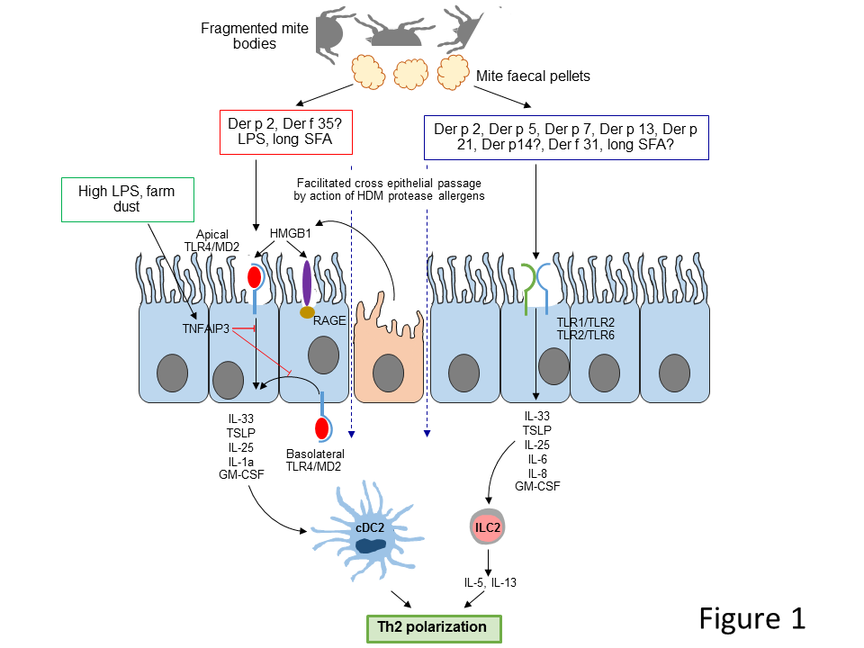

Figure 2. Sentinel IgE-independent interactions of HDM protease allergens with the airway epithelium and convergent signalling from innate sensing of RNA viruses by TLR3-, MDA-5- and RIG-I-dependent signalling routes lead to alarmin release, changes in gene expression and activation of ectodomain shedding pathways. HDM group 1 cysteine peptidase allergens and the serine peptidase allergens of groups 3, 6 and 9 are all able to disrupt interepithelial adhesion, especially through cleavage of a Leu-Leu dyad present in the extracellular domains of occludin and lung-expressed claudins. The reversible cleavage of epithelial tight junctions results in increased epithelial permeability. Group 1 HDM allergens act as prothrombinases enabling the activation of PAR-1 and PAR-4 and the initiation of a signalling cycle which, through the TLR4-dependent generation of ROS, regulates the release of IL-33 and the expression of pro-inflammatory genes. The pannexon-regulated release of ATP is a key intermediate in this process and also underlies ectodomain shedding activity responsible for the untethering of cells (eg ILC2, dendritic cells) from E-cadherin and the liberation of chemokines. HDM serine peptidase allergens activate PAR-2 and PAR-4 to produce a combination of pro-inflammatory or cytoprotective effects. Part of the signalling mechanism involves the operation of calcium channels comprising the calcium release-activated channel modulator protein, Orai 1. Solid lines depict events considered to have direct linkage to the next step indicated; broken lines indicate linkage via intermediate steps which are not shown. Der p 1 is an inhibitor of endogenous antiproteases found in the airways (49, 50), meaning that inhibition of Der p 1 by ADI compounds could leverage a collateral benefit of serine peptidase allergens being attenuated by endogenous inhibitors. Further details of these mechanisms have been described elsewhere (1, 2). GPCR = G protein-coupled receptor; RTK = receptor tyrosine kinase; P₂Y₂R and P₂X₇R = respectively, GPCR family and ligand-gated ion channel receptors for ATP. For further information on Der p 1-dependent pannexon gating and ATP release see (42).

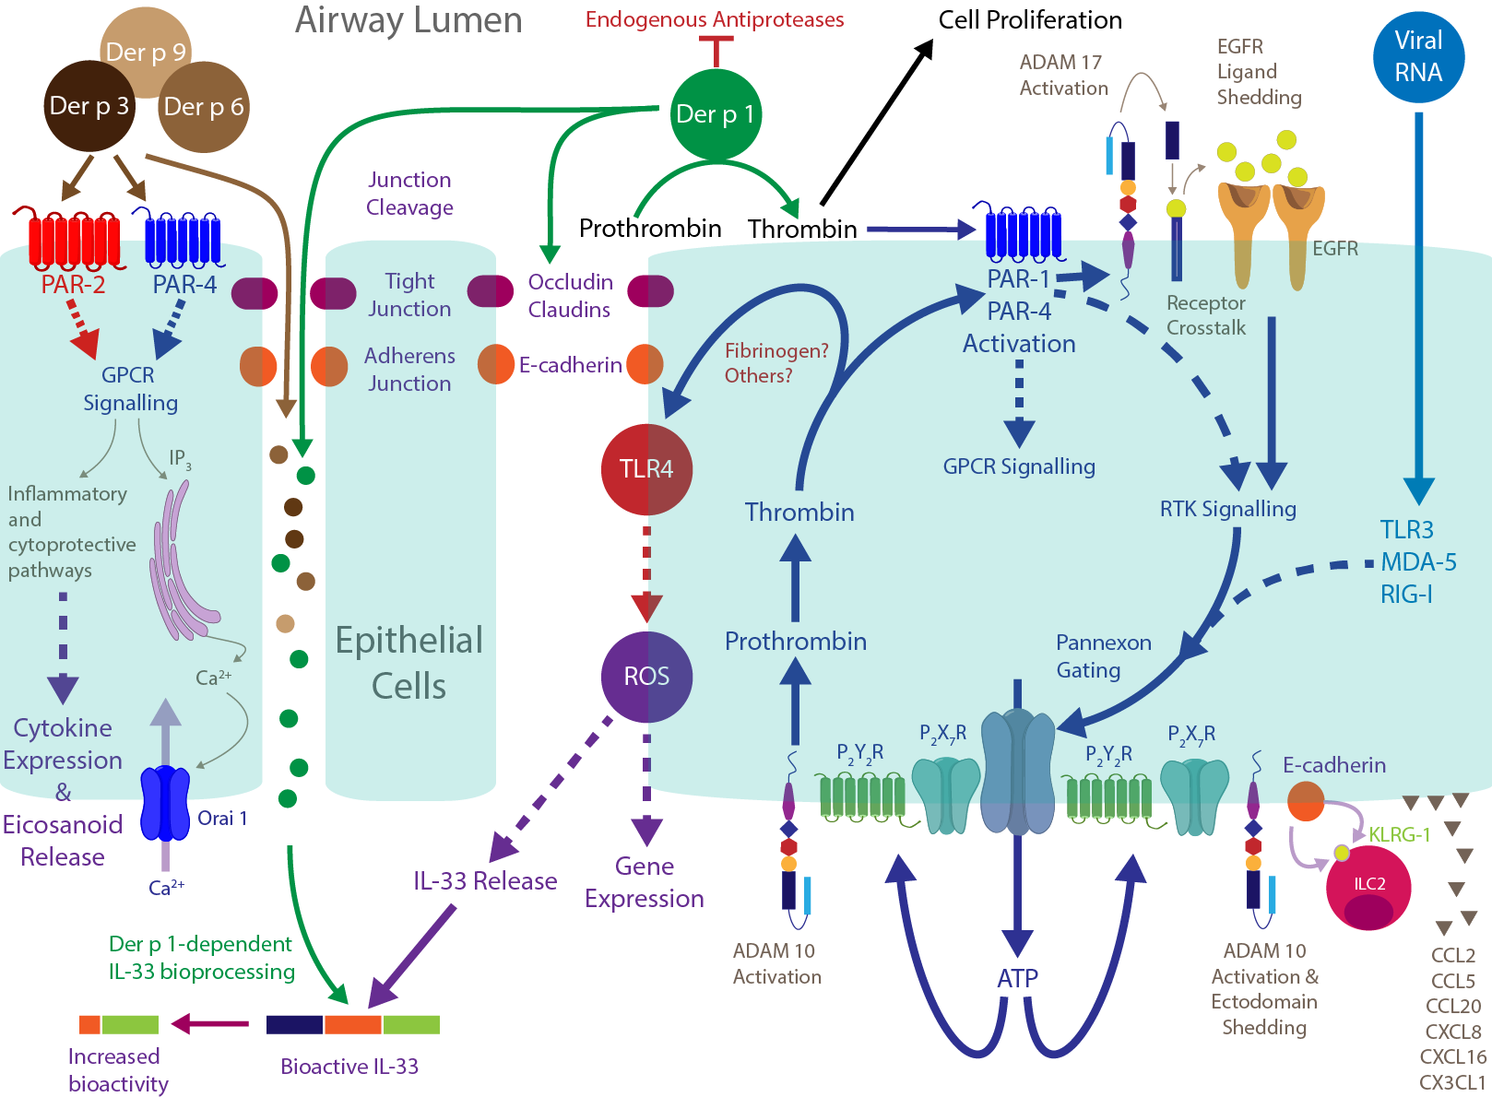

Figure 3. Cell activation by β-glucans/chitin during initiation of the HDM-induced allergic airway inflammation. Exposure of airway epithelium to β-glucans and particulate chitin associated or not with HDM allergens displaying similarities with chitin binding proteins can stimulate pro-Th2 cytokine release as IL-33, TSLP, IL-25 through putative TLR2/Dectin-1/MR signaling pathways. This pro-Th2 cytokine environment promotes the subsequent development of the typical Th2-biased allergic response. Whereas the pro-Th2 effect of chitin is negatively regulated by the expression and activity of secreted epithelial acidic mammalian chitinase (AMCase), the Th2 polarization mediated by β-glucans is dependent on down regulation of Dectin-1 expression and inappropriate Der p 10-Dectin-1 interactions.

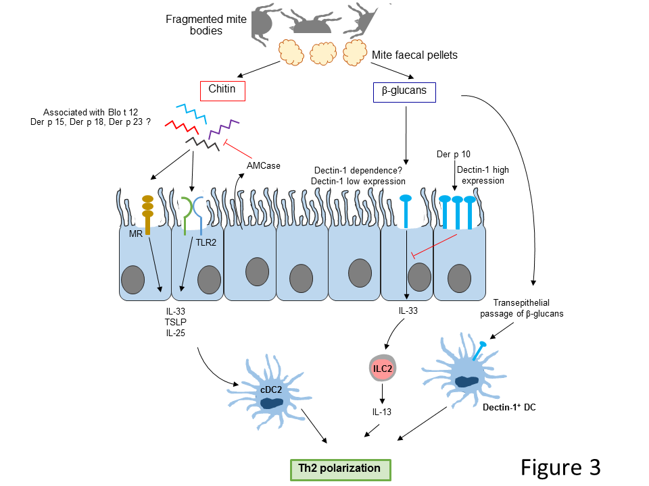

Figure 4. ADI compounds prevent the development of allergic sensitisation to HDM extracts in mice. Compound 1 ((S)-3-((S)-2-((S)-2-benzamido-3-methylbutanamido)propanamido)-2-oxoheptyl 2,6-bis(trifluoromethyl)benzoate) and compound 2 (N-{(S)-1-[(S)-1-((S)-1-cyclohexylaminooxalyl-2-methyl-propylcarbamoyl)-ethylcarbamoyl]-2,2-dimethyl-propyl}-isonicotinamide) are potent inhibitors of Der p 1. When administered intranasally with catalytically active HDM extract during the indicated immunisation protocol they prevented increases in total IgE and the development of HDM-specific IgE. Inclusion of a serine peptidase inhibitor with compound 1 produced no further benefit, consistent with the crucial role played by cysteine peptidase activity. Full experimental details and chemical syntheses are provided elsewhere (41, 161).

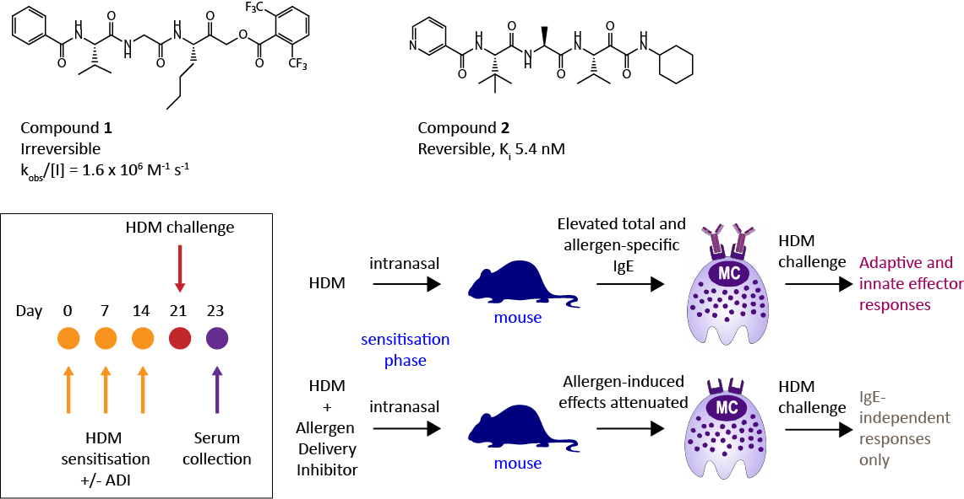
Figure 5. Mitigation of IgE-independent innate and IgE-dependent responses to HDM extract by an exemplar ADI. Mice were pre-treated with pyruvamide 2 by intratracheal aerosol prior to aerosol challenge with catalytically competent HDM extract. Full experimental details are provided elsewhere (41). In naïve mice, HDM extract challenge increased the numbers of eosinophils and neutrophils recoverable by BAL in a manner that was attenuated by prior protection from the ADI compound. In mice sensitised to HDM extract, allergen challenge evoked a larger response than in naïve mice and this was also susceptible to inhibition by a single inhaled dose of compound 2 given as prior protection.

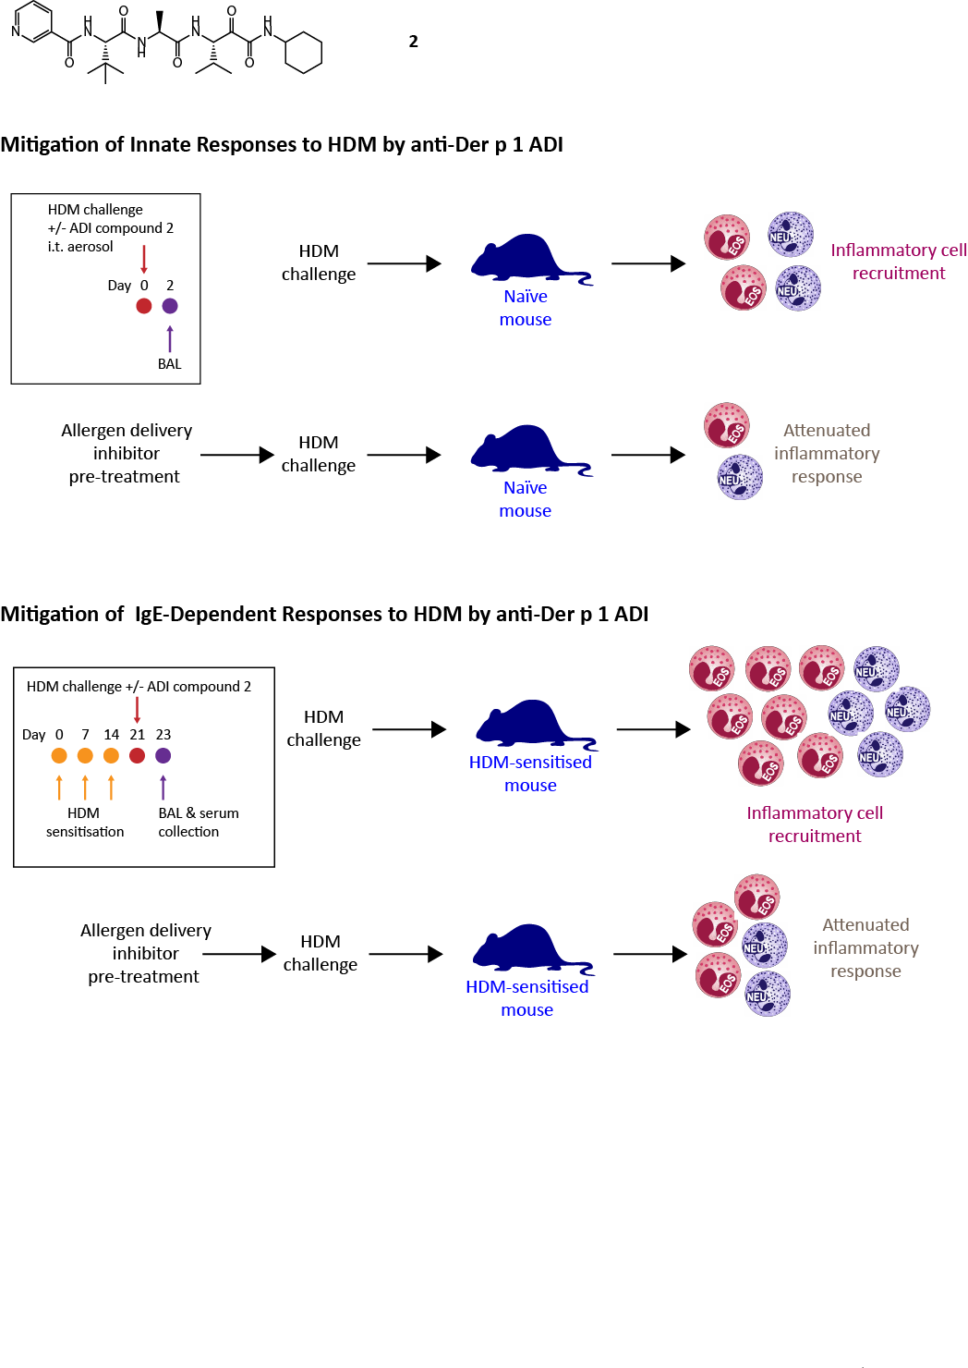

Figure 6. A Prior treatment with ADI compounds attenuates acute allergic bronchoconstriction following challenge of sensitised rats by HDM extract. Full experimental details are provided elsewhere (41). B Chemotypes, potency and mechanism of target inhibition of compounds associated with this effect. Compound 1 is (S)-3-((S)-2-((S)-2-benzamido-3-methylbutanamido)propanamido)-2-oxoheptyl 2,6-bis(trifluoromethyl)benzoate. Compound 3 is N-((2R)-1-(((2S)-1-((1-(dimethylamino)-2-oxoheptan-3-yl)amino)-1-oxopropan-2-yl)amino)-1-oxo-3-phenylpropan-2-yl)benzamide; compound 4 is N-((2S)-1-oxo-1-(((2S)-1-oxo-1-((2-oxo-1-(pyrrolidin-1-yl)heptan-3-yl)amino)propan-2-yl)amino)-3-phenylpropan-2-yl)benzamide; compound 5 is N-((S)-1-oxo-1-(((S)-1-oxo-1-(((S)-1-oxohexan-2-yl)amino)propan-2-yl)amino)-3-phenylpropan-2-yl)benzamide. Compounds were synthesised and potency tested as described (41, 161). C Principal oxidation states of the catalytic cysteine residue in group 1 HDM allergens.

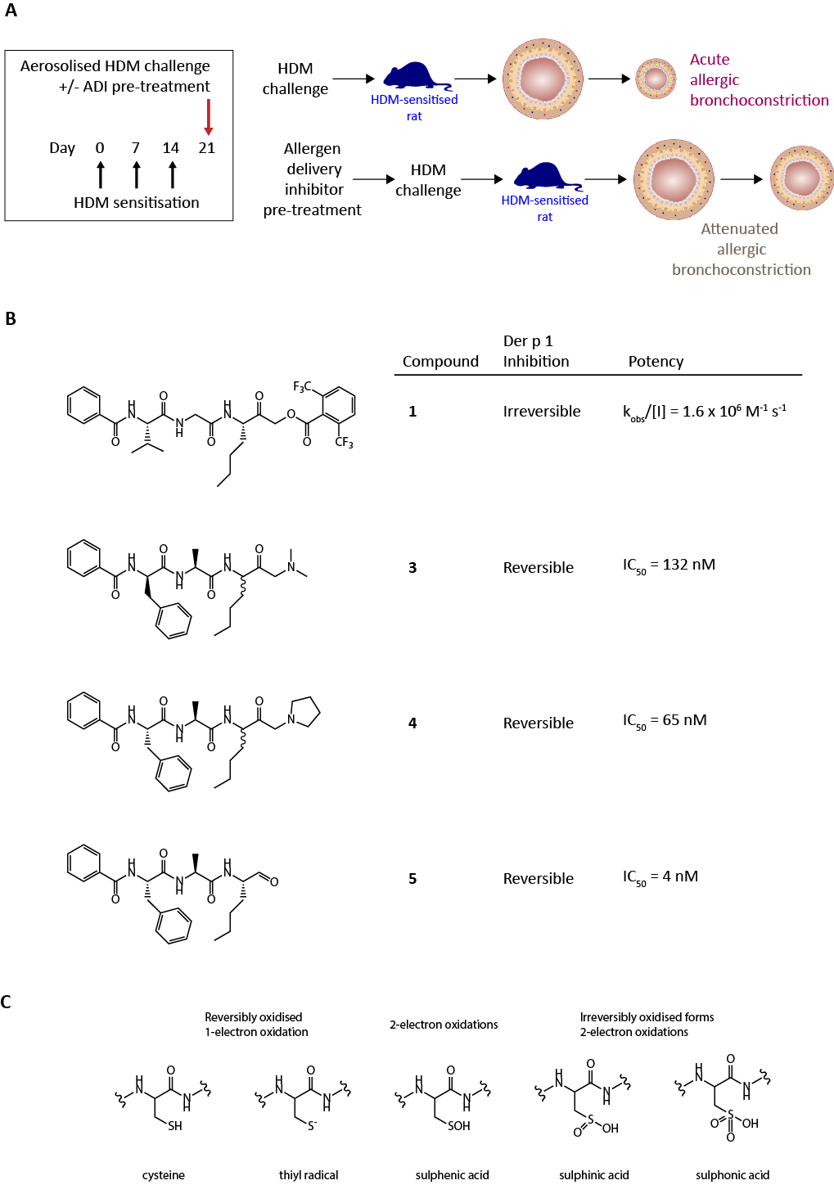

Table 1. HDM allergens referred to in this review, and their properties.
Allergen | Bioactivity | Bioactivity notes | PRR signalling | Signalling notes
Group 1 (eg Der p 1, Der f 1, Eur m 1, Blo t 1) | Cysteine proteases | Multiple cellular targets (1).  Facilitates contact with DCs and PRRs for unrelated allergens (41).  Releases and activates IL-33 (1, 125).  Pannexon gating and ATP release (42, 52).  Activates ADAM 10 (114).  Generates intracellular ROS (1, 2, 42, 52, 114).  Suppression of indoleamine 2,3-dioxygenase (176).  Maturation of Der p 3/6/9 (177) | PAR-1/PAR-4 (52); TLR4 (42); Mas-related G-protein coupled receptor X1 (159);  Others? | In rodent models, TLR4 is non-redundant for allergy initiation by HDM extracts, but partially redundant for leukocyte recruitment (21, 22, 25)  Transduction pathway to intracellular ROS generation is a nexus for pleiotropic signalling mechanisms (1, 2, 42).  Convergence with signalling from viral RNA sensors (TLR3, MDA-5, RIG-I) (42, 52)  TLR4 LPS hyporesponsive polymorphism associates with asthma risk (3)
Group 2  (eg Der p 2, Der f 2, Eur m 2, Blo t 2) | Homologous with MD-2 (37). Lipopeptide and lipopolysaccharide binding. | Binds LPS; substitutes for MD-2 deficiency (37, 67) | TLR4 (37);  TLR2? | In rodent models, TLR4 is non-redundant for allergy initiation by HDM extracts, but partially redundant for leukocyte recruitment (21, 22, 25). TLR2 implicated in nasal responses to HDM extract (34)  TLR4 LPS hyporesponsive and TLR2 polymorphisms associate with asthma risk (3)
Group 3  (eg Der p 3, Der f 3, Eur m 3, Blo t 3) | Trypsin-like serine proteases | Cleaves epithelial TJs to facilitate contact with DCs and PRRs (1).  Evokes cytokine release (1).  Kinin generation (178).  Anaphylatoxin generation (179)  Subsidiary to group 1 effects (41). | PAR-2 (52); PAR-4 (157);  Some connectivity to TLR4 and ROS generation? (42, 52) | PAR-2 upregulated in asthmatic airways (156)
Group 5  (eg Der p 5, Blo t 5) | Putative fatty acid binding proteins | Bind fatty acids (74, 76) | TLR2 (77) | In rodent models, TLR2 redundant for allergy? (22); TLR2 implicated in nasal responses to HDM extract (34)  TLR2 polymorphism associates with asthma risk (3)
Group 6  (eg Der p 6, Der f 6) | Chymotrypsin-like serine proteases | Cleaves epithelial TJs to facilitate contact with DCs and PRRs (1).  Evokes cytokine release (1).  Subsidiary to group 1 effects (1). | PAR-2; Some connectivity to TLR4 and ROS generation? (42, 52) | PAR-2 upregulated in asthmatic airways (156)
Group 7 (eg Der p 7, Der f 7, Blo t 7) | Putative lipid binding protein; binds polymyxin B | Bactericidal permeability-increasing-like protein (78, 79) | TLR2 > TLR4  (80, 81) | In rodent models, TLR2 redundant for allergy? (22); TLR2 implicated in nasal responses to HDM extract (34)  TLR2 polymorphism associates with asthma risk (3)
Group 10 (eg Der p 10, Der f 10, Blo t 10) | Tropomyosin |  | Dectin-1 (108) | Ligation inhibits IL-33 release and suppresses IL-13⁺ ILC2 cells.  Intronic dectin-1 poly-morphism associated with decreased lung function (108)
Group 12 (eg Blo t 12) | Homology with group 15 due to chitin-binding domain | Blo t 12-bound chitin augments allergic reactions (103) | TLR2? | In rodent models, TLR2 redundant for allergy? (22); TLR2 implicated in nasal responses to HDM extract (34)  TLR2 polymorphism associates with asthma risk (3)
Group 13 (Der p 13, Der f 13, Blo t 13) | Cytosolic fatty acid binding protein | Fatty acid binding (85) | TLR2,  ?CD14, ?CD36 | In rodent models, TLR2 redundant for allergy? (22); TLR2 implicated in nasal responses to HDM extract (34)  TLR2 polymorphism associates with asthma risk (3)
Group 14  (eg Der p 14, Der f 14, Eur m 14) | Apolipophorin-like lipid transport protein | LPS, lipoteichoic acid and β-glucans are ligands for apolipophorins | TLR2?  TLR4? (57) | In rodent models, TLR2 redundant for allergy? (22); TLR2 implicated in nasal responses to HDM extract (34)  TLR2 polymorphism associates with asthma risk (3)
Group 15  (eg Der p 15, Der f 15) | Putative glycosyl hydrolase family 18 chitinase | Homology with HDM group 18 and cockroach group 12.  Contains peritrophin-A domain (CBM-14). | ?
Group 18  (eg Der p 18, Der f 18) | Putative glycosyl hydrolase family 18 chitinase | Homology with group 15. Lacks catalytic residue for chitinase function (99) | ?
Group 21  (eg Der p 21, Der f 21, Blo t 21) | Putative fatty acid binding inferred from hydrophobic pocket. | Homology with group 5 (72). | TLR2 | In rodent models, TLR2 redundant for allergy? (22); TLR2 implicated in nasal responses to HDM extract (34)  TLR2 polymorphism associates with asthma risk (3)
Group 23  (eg Der p 23, Der f 23) | Shows homology with peritrophin-A domain (100).  Putative chitin-binding domain (101, 102) | Lacks functional chitin-binding activity (101, 102) | ?
Group 31  (eg Der f 31) | Cofilin analogue (86). Putative ADP-binding protein which depolymerises actin. | Putative regulator of PRRs. | TLR2 (89) | In rodent models, TLR2 redundant for allergy? (22); TLR2 implicated in nasal responses to HDM extract (34)  TLR2 polymorphism associates with asthma risk (3)
Group 35  (eg Der f 35) | Conserved MD-2 related lipid recognition domain (56) |  | Putative TLR4? | Functionally active?

Inferred for Blo t 1
Indicates uncertainty regarding contribution

