The underlying cause of type 2 respiratory failure affects NIV adherence
Sara Parsons, Emma Baker
Introduction: Domiciliary non-invasive ventilation (NIV) is used to treat type 2 respiratory failure. Although factors, including synchronisation, mask fitting and type are recognised to affect long term adherence (Boussaïd, G. et al. Neuromuscular Disorders, 2016; 26:666-674), the effect of underlying diagnosis on NIV adherence is poorly understood.
Method: We compared NIV adherence in 142 patients with type 2 respiratory failure, categorised by primary diagnosis. Adherence was assessed by percentage of days where NIV use was attempted (compliance >70%) and hours usage/night (>4 hours).
Results: Patients with neurological disorders were the most likely never to be compliant with therapy and used NIV for the least hours per night. Those with COPD were the most adherent to therapy.
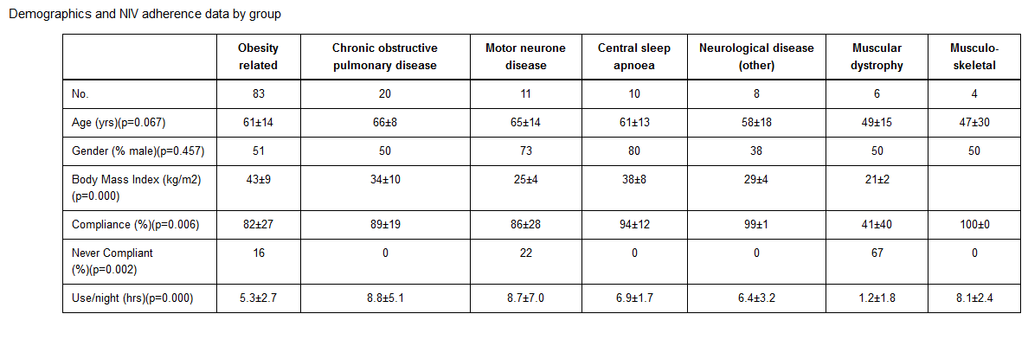
Conclusion: Patients with neurological disorders revealed poorest adherence to NIV, this may increase risk of respiratory complications. Reasons are unclear but may include psychological and physiological factors and the timing of the intervention. More work is needed to explore the reasons and develop disease-specific interventions to improve adherence.

