Diagnostic accuracy and Bayesian analysis of new international ECG Recommendations in Paediatric athletes
Gavin McClean^{1.2}, Nathan R Riding¹, Guido Pieles³, Victoria Watt⁴, Carmen Adamuz⁴, Sanjay Sharma⁵, Keith P. George², David Oxborough² and Mathew G Wilson^{1,2}

^{1.} Athlete Health and Performance Research Centre, Aspetar Orthopaedic and Sports Medicine Hospital, Qatar.
^{2.} Research Institute for Sport and Exercise Science, Liverpool John Moores University, UK.
^{3.} National Institute for Health Research (NIHR) Cardiovascular Biomedical Research Centre, Congenital Heart Unit, Bristol Royal Hospital for Children and Bristol Heart Institute, UK.
^{4.} Department of Sports Medicine, Aspetar Orthopaedic and Sports Medicine Hospital, Qatar.
^{5.} Department of Cardiovascular Sciences, St Georges University of London, UK

Correspondence to:

Professor Mathew G Wilson
Athlete Health and Performance Research Centre
ASPETAR Qatar Orthopaedic and Sports Medicine Hospital
PO BOX 29222, Doha, Qatar;
mathew.wilson@aspetar.com

Abstract: 259
Word Count: 2977

ABSTRACT
Objective: Historically, electrocardiographic (ECG) interpretation criteria for athletes were only applicable to adults. New international recommendations now account for athletes ≤16 years, but their clinical appropriateness is unknown. We sought to establish the diagnostic accuracy of new international ECG recommendations against the Seattle criteria and 2010 European Society of Cardiology (ESC) recommendations in paediatric athletes using receiver operator curve (ROC) analysis. Clinical context was calculated using Bayesian analysis.
Methods: 876 Arab and 428 black male pediatric athletes (11-18 years) were evaluated by medical questionnaire, physical examination, ECG and echocardiographic assessment. ECGs were retrospectively analyzed according to the 3 criteria.
Results: Thirteen (1.0%) athletes were diagnosed with cardiac pathology that may predispose to sudden cardiac arrest/death (SCA/D) [8 (0.9%) Arab and [5 (1.2%) black]. Diagnostic accuracy was poor [0.68, 95% CI 0.54-0.82] for 2010 ESC recommendations, fair [0.70, 95% CI 0.54-0.85] for Seattle criteria and fair [0.77, 95% CI 0.61-0.93] for international recommendations. False positive rates were 41.0% for 2010 ESC recommendations, 21.8% for Seattle criteria, and 6.8% for international recommendations. International recommendations provided a positive (+LR) and negative (-LR) post-test likelihood ratio of 9.0 (95% CI 5.1-13.1) and 0.4 (95% CI 0.2-0.7), respectively.
Conclusion: In Arab and black male paediatric athletes, new international recommendations outperform both the Seattle criteria and 2010 ESC recommendations, reducing false positive rates, whilst yielding a ‘fair’ diagnostic accuracy for cardiac pathology that may predispose to SCA/D. In clinical context, the ‘chance’ of detecting cardiac pathology within a paediatric male athlete with a positive ECG (+LR=9.0) was 8.3%, whereas a negative ECG (-LR=0.4) was 0.4%.
Key words: Paediatric, athlete’s heart, screening, electrocardiography, echocardiography.

What is already known about this subject?
- It has been proposed that electrocardiographic (ECG) screening of athletes is not effective due to outdated incidence data and flawed methodology.
- Recently, new international recommendations for ECG in athletes, have been demonstrated to reduce the number of abnormal ECGs, but in a primarily white adult athletic population.
- It has been proposed that T wave inversion V₁-V₃ in athletes ≤16 years is physiological, and should not prompt further evaluation in the absence of symptoms, signs or a family history of cardiac disease.
What does this study add?
- For the first time, new international recommendations for ECG interpretation in athletes were assessed by diagnostic accuracy and Bayesian analysis in a paediatric athletic cohort (aged 11-18 years) of 876 Arab and 428 black male athletes.
- New international recommendations for ECG interpretation in athletes significantly reduce false positive rates for pathology that may predispose to SCA/D (6.8%) irrespective of ethnicity and chronological age, compared with the 2010 ESC recommendations (41.0%) and Seattle criteria 21.8%), respectively).
- New international recommendations for ECG interpretation in athletes yield a ‘fair’ (0.77, 95% CI 0.61-0.93) diagnostic accuracy (area under the curve) for cardiac pathology that may predispose to SCD/A in sports.
How might this impact on clinical practice?
- The ‘chance’ of detecting cardiac pathology that may predispose to SCA/D in sports within a paediatric male athlete was approximately 1%.
- A positive ECG (+LR = 9.0) as per new international recommendations for ECG interpretation in athletes, means that the same athlete now has an 8.3% ‘chance’ of pathology, whereas a negative ECG (-LR = 0.4) a 0.4% ‘chance’.
- New international recommendations for ECG interpretation can be applied to paediatric (11-18 years) athletes of both Arab and black athletes for the detection of cardiac pathology that may predispose to SCD/A in sports, and outperform previous ECG recommendations.

INTRODUCTION
Studies based on high school populations in the United States reveal that paediatric athletes (14-18 years) are 3.6-times more likely to experience a sudden cardiac arrest than their non-athletic peers [1]. In the United Kingdom, 22% of all sudden cardiac deaths occur in athletes aged under 18 years [2]. The European Society of Cardiology (ESC) [3] and the Association of European Paediatric Cardiology [4], recommend initiating 12-Lead electrocardiography (ECG) screening to coincide with the onset of competitive athletic activity. Screening aims to identify underlying cardiac pathology predisposing to sudden cardiac arrest/death (SCA/D), and thereby reduce the incidence of such catastrophic events.

Until recently clinicians undertaking ECG screening in athletes applied interpretation criteria that were applicable only to adults [5,6]. In a recent systematic review with meta-analysis [7], we observed a high but similar prevalence of anterior (V₁-V₃) T-wave inversion (TWI) in ≥9000 paediatric athletes and ≥800 paediatric non-athletes (6.5% vs 5.7%), suggesting that this repolarization pattern is maturational and not abnormal within the paediatric athlete. New ECG interpretation recommendations now account for athletes aged ≤16 years, with particular focus on individuals displaying anterior (V₁-V₃) TWI (often called juvenile T-wave pattern) [8–10]. Whilst these new recommendations have been shown to significantly reduce the number of abnormal ECGs compared to previous ECG criteria [2010 ESC recommendations [5] and Seattle criteria [6]], this result was observed in a primarily white adult athletic population [11].

The past few decades have observed an exponential increase in the number of Arab and black athletes excelling in international competitive sport, with ethnicity now universally recognized as an important determinant of the electrical manifestations of an athlete’s heart [12]. Sports academies throughout the USA, Europe and Asia, who undertake ECG screening in paediatric athletes of Arab and Black ethnicity require knowledge of the clinical appropriateness of these new ECG recommendations to distinguish physiological cardiac adaptations from cardiac pathology predisposing to SCA/D. A second conundrum relates to ensuring that ECG screening results are interpreted in context, especially when there is no ‘gold standard’ test to identify cardiac pathology. Bayesian analysis allows for the quantification of ‘chance’ of having a disease as per examination methodology (in this case, ECG interpretation recommendations), based upon pre- and post-test odds [13].

Accordingly, the aim of this study was to establish the diagnostic accuracy of new international ECG interpretation recommendations for athletes against the Seattle criteria and 2010 ESC recommendations in a large cohort of Arab and black male paediatric athletes using receiver operator curve (ROC) analysis. Clinical context was calculated using Bayesian analysis.

METHODS

Ethics Approval
Ethics approval was provided by Anti-Doping Laboratory Qatar (IRB #E2013000003 and #E20140000012), with all parents or guardians providing informed consent.

Participants
Between 2009 and 2017, 876 Arab and 428 black male paediatric athletes registered with the Qatar Olympic Committee [exercising ≥6 hours/week, aged 11-18 years] presented at our institution for ECG screening. No athlete had been previously screened. Based on 2-year chronological age categories, athletes were distributed as per Table 1. Whilst we acknowledge ECG interpretation criteria were developed for application in athletes aged 12-35 years [8–10], a minority of athletes <12 years presented at the request of the Qatar Olympic Committee.

Preliminary Investigations
Health questionnaire and physical examination
Athletes completed a health questionnaire regarding family history of cardiovascular disease and personal symptoms, together with anthropometric (height and body mass; body surface area (BSA) [14]) and left brachial artery blood pressure assessment in collaboration with an Arabic, French, and/or English-speaking nurse. To ensure accurate medical history was taken, primary guardians were present where appropriate. Precordial auscultation in supine and standing positions, and assessment for any physical characteristics of underlying congenital or syndromal disorder were undertaken by a sports medicine physician.

Resting 12-lead ECG
ECG was recorded with standard 12-lead positions using a GE Mac 5500 (New York, USA), as described elsewhere [15]. All 1304 ECGs were retrospectively interpreted by GMC applying the 2010 ESC recommendations [5], the Seattle Criteria [6], and the new international recommendations (Figure 1) [8–10]. At the time of ECG interpretation, GMC was blinded to all pathological conditions that were subsequently diagnosed.

Echocardiography
2D transthoracic echocardiographic examination was performed using a IE33, (Philips, USA) and Artida (Toshiba Medical Systems, Japan) ultrasound systems. Standard views were obtained and analysed for left and right ventricular wall thickness, cavity dimension measurements, as well as the identification of the origins of the left and right coronary arteries in accordance with current guidelines [16,17].

Further Evaluation
Athletes presenting with an abnormal health questionnaire, physical examination, ECG or echocardiographic examination suggestive of underlying cardiovascular pathology were invited for further evaluation. Subsequent examinations included (but were not limited to) 24h ECG or ambulatory blood pressure monitoring, maximal cardiopulmonary exercise stress testing, electrophysiology study, computerized tomography and cardiac magnetic resonance imaging including contrast studies. Diagnosis of disease was established and managed in accordance to established guidelines [18–25].

Statistical Analysis
Data were expressed as mean ± SD or percentages as appropriate and analyzed with SPSS software (Version 21.0, Chicago, IL). Continuous variables were tested for normality using the Shapiro-Wilk test. Comparisons between groups were performed using a student t-test for continuous variables by ethnicity (Arab vs. black), and χ2 test or Fisher’s exact tests for categorical variables by ethnicity (Arab vs. black) and age, both within and between ECG interpretation criteria. A p value <0.05 was considered significant.

ROC analysis was used to describe the sensitivity and specificity of the 3 ECG interpretation criteria to identify cardiac pathology that may predispose to SCA/D in sports[2]. Area under the curve (AUC) represents diagnostic accuracy in differentiating athletes with cardiac pathology; interpreted as excellent (>0.90), good (0.80-0.90), fair (0.70-0.80), poor (0.60-0.70), or fail (<0.60) [26]. False positives were calculated from the specificity and sensitivity values of the 3 ECG interpretation criteria. Bayesian analysis was used to calculate the positive (+LR) and negative likelihood ratios (-LR) from the specificity and sensitivity values of the ECG interpretation criteria, allowing estimation of the chance of cardiac pathology after application of the 3 ECG interpretation criteria. Specifically, the base prevalence rate was determined from the pre-test odds, and the +LR and –LR was used to compute the post-test odds [13].

Inter-intra observer variability in ECG interpretation
Inter- and intra-observer reproducibility for ECG interpretation using the new international recommendations, Seattle Criteria and ESC 2010 recommendations were assessed using Cohen κ coefficient between two physiologists (GMC, NRR). Data were interpreted as poor (<0.20), fair (0.20-0.40), moderate (0.41-0.60), good (0.61-0.80) and very good (>0.80) [27]. A power calculation using R package CIBinary determined that 361 athletes were sufficient to detect a ‘good’ reliability (0.75 95% CI (0.60-0.85) when prevalence of abnormalities was 5.9%. Type 1 error was 5% and power was set 0.80. Inter- and intra-observer reliability was therefore conducted on 400 consecutive independent athletes. Inter-observer reliability for categorizing an ECG as abnormal was very good for ESC 2010 recommendations (k=0.85; 95% CI 0.71-0.99), very good for Seattle criteria (k=0.90; 95% CI 0.86-0.94), and very good for new international recommendations (k=0.90; 95% CI 0.88-0.92). Intra-observer reliability was very good for ESC 2010 recommendations (k=0.95; 95% CI 0.91-0.99), very good for Seattle criteria (k=0.91; 95% CI 0.78-1.00), and very good for new international recommendations (k=0.91; 95% CI 0.78-1.00).

RESULTS

Demographics
Arab athletes descended from West-Asia [836; 80.3%], Africa [171; 19.5%], and Europe [2; 0.2%]. Black athletes descended from Africa [275; 64.2%], West-Asia [139; 32.5%], Central America [7; 1.6%], South America [5; 1.2%], and Europe [2; 0.5%]. Athletes participated in 33 different sports with football (50%) dominating. Mean chronological age (15.9 ± 2.0 vs. 15.2 ± 1.9 years, p<0.001) was significantly greater in Arab than black athletes, whilst BSA (1.7 ± 0.3 vs 1.7 ± 0.3 m², p=0.68) was not different (Table 1).

Health questionnaire and physical examination

Overall, 242 (18.6%; 20.2% Arab and 15.2% black) athletes revealed cardiovascular abnormalities identified by health questionnaire and/or physical examination. Specifically, 216 (16.6%; 18.3% Arab and 13.1% black) athletes self-reported cardiovascular medical issues and 31 (2.4%; 2.1% Arab and 3.0% black) athletes demonstrated an abnormal physical examination.

ECG patterns between ethnicity using new international recommendations

Normal and borderline ECG findings

Normal ECG findings were significantly more frequent in black than arab athletes (93.0% vs. 89.0%; p≤0.001) (Figure 2). TWI in V₁-V₃ was observed in 69 (16.1%) black athletes compared to 56 (6.4%) Arab athletes aged <16 years old (p<0.0001). Borderline ECG findings, either in isolation or in association with a recognized training-related ECG finding, were significantly more frequent in black than Arab athletes (11.0% vs. 7.4%; p<0.05), with an increased prevalence of isolated right atrial enlargement (8.9% vs. 5.1%; p<0.01).

Abnormal ECGs findings

Abnormal ECGs that required further evaluation were more frequent in black than Arab athletes (10.5% vs. 6.1%; P<0.01). Specifically, abnormal TWIs were significantly more frequent in black than Arab athletes (7.0% vs. 2.1%, p<0.001); with an increased prevalence of both anterior (2.6% vs, 1.0%; P<0.05), and lateral (3.3% vs. 1.4%; p<0.05) TWI. Black athletes demonstrated a greater prevalence of pathological Q waves than Arab athletes (4.4% vs. 1.6%; p<0.01). Other abnormal ECG findings were rarely observed in paediatric athletes (≤1.3%), with no statistical difference observed between ethnicity.

Identification of cardiac pathology
Thirteen (1.0%, 95% CI 0.5-1.7) athletes were diagnosed with pathology that may predispose to SCA/D [8 (0.9%, 95% CI 0.4-1.8) Arab and 5 (1.2%, 95% CI 0.4-2.7) black] (Table 2). Of these 13, 6 (46.2%) demonstrated an abnormal health questionnaire and/or physical examination, 10 (76.9%) an abnormal ECG according to ESC 2010 recommendations, and 8 (61.5%) an abnormal ECG according to both the Seattle Criteria and the new international recommendations.

False positive rates per criteria
The false positive rate for pathology that may predispose to SCA/D was 41.0% for the 2010 ESC recommendations, 21.8% for the Seattle criteria, and 6.8% for the new international recommendations (specifically, 5.5% and 9.5% for Arab and black athletes).

Specific false positives per criteria
Ventricular pre-excitation was a false positive in 7.0% of athletes as per 2010 ESC recommendations (short PR interval with/without evidence of delta wave) compared to zero cases using the Seattle criteria and new International recommendations (PR interval <120 ms with a delta wave (slurred upstroke in the QRS complex) and wide QRS [≥120 ms]). Reclassifying axis deviation, atrial enlargement and complete right bundle branch block to be normal when observed in isolation or in association with a recognized training-related ECG finding, reduced false positive rates from 11.8% and 11.2% using the 2010 ESC recommendations and Seattle criteria, respectively, to 0.7% using the new international recommendations (Figure 3, Data Supplement 1-4). The false positive rate for anterior TWI was 12.8% for 2010 ESC recommendations, 3.0% for Seattle criteria and 1.2% for new international recommendations.

Impact of chronological age on false positive rates per criteria
New international ECG recommendations significantly (p<0.0001) reduced the false positive rate for pathology that may predispose to SCA/D compared to the Seattle Criteria and 2010 ESC recommendations in athletes aged ≤16 years (6.9% vs. 23.4% vs. 45.6%), ≤14 years (8.7% vs. 27.9% vs 52.7%), and ≤12 years (8.6% vs 29.3% vs 68.1%), respectively (Figure 4).

Diagnostic accuracy per criteria
For pathology that may predispose to SCA/D, diagnostic accuracy was poor [0.64, 95% CI 0.47-0.81] for health questionnaire and/or physical examination, poor [0.68, 95% CI 0.54-0.82] for the 2010 ESC recommendations, fair [0.70, 95% CI 0.54-0.85] for the Seattle criteria and fair [0.77, 95% CI 0.61-0.93] for new international recommendations (Figure 5, Table 3).

Clinical implication of using the new international recommendations
New international recommendations provided an overall +ve and -ve LR of 9.0 (95% CI 5.1-13.1) and 0.4 (95% CI 0.2-0.7), respectively. When split by ethnicity, 9.0 (95% CI 3.8-15.8) and 0.5 (95% CI 0.2-0.8) for Arab, and 8.5 (95% CI 3.8-12.5) and 0.2 (95% CI 0.04-0.7) for black athletes, respectively.

DISCUSSION
The correct differentiation of physiological cardiac adaptation owing to sustained and intensive exercise from an inherited cardiac pathology is paramount to correctly identify athletes at risk of SCA/D. In this study of 876 Arab and 428 black male paediatric athletes, it was observed that new international ECG recommendations significantly reduce false positive rates by 83.4% and 68.7% respectively when compared to the Seattle criteria and 2010 ESC recommendations, irrespective of chronological age, whilst yielding a ‘fair’ diagnostic accuracy for conditions that may predispose to SCA/D. To place new international recommendations into clinical context, the ‘chance’ of detecting cardiac pathology that predispose to SCA/D within a paediatric male athlete is approximately 1%. A positive ECG (+LR=9.0) as per new international recommendations, means that the same athlete now has an 8.3% ‘chance’ of pathology, whereas a negative ECG (-LR=0.4) has a 0.4% ‘chance’.

Diagnostic Accuracy of new international recommendations in paediatric Arab and Black athletes
When applying the 2010 ESC recommendations to our athletes, almost 1 in 3 Arab and 1 in 2 black athletes would warrant further evaluation, demonstrating a poor (0.68) AUC (diagnostic accuracy). The Seattle criteria improved these rates to 1 in 5 Arab and 1 in 4 black athletes, with a fair (0.70) overall diagnostic accuracy. While the 2010 ESC recommendations are based upon consensus rather than scientific evidence, the Seattle Criteria modified its interpretation criteria by applying evidence that 1) accounted for black ethnicity (J-point elevation and convex [‘domed’] ST-segment elevation followed by TWI in leads V₁–V₄), a false positive in 6.9% of our black paediatric athletes and 2), by adjusting ventricular pre-excitation criteria to require a concomitant delta wave (slurred upstroke in the QRS complex) and wide QRS (>120ms) in addition to a short PR (<120ms), a false positive in 7.0% of our paediatric athletes.

To further reduce false positive ECG rates and improve diagnostic accuracy, new international recommendations now categorize the presence of atrial enlargement (8.9% in our athletes), axis deviation (1.9% in our athletes), and complete right bundle branch block (0.4% in our athletes), as ‘borderline’ findings when observed in isolation or in association with a recognized training-related ECG change, as they correlate poorly with cardiac pathology predisposing to SCA/D in sport [28,29] (Figure 1). Our data supports these recommendations, by observing 112 athletes (8.6%) with isolated borderline ECG findings, and just 9 athletes (0.7%) with ≥2 borderline ECG findings that would trigger additional investigation; with none found to have pathology predisposing to SCA/D in sports (Figure 2 and 3). False positive rates were again further reduced by deeming the juvenile T-wave pattern to be physiological, a false positive in 121 (17.3%) athletes aged <16 years compared to 36 (6.1%) athletes ≥16 years. In real terms, when new international recommendations are applied to our athletes, 1 in 17 Arab and 1 in 10 black athletes would warrant further evaluation, with a fair (0.77) overall diagnostic accuracy [specifically, a fair (0.72) diagnostic accuracy for Arab but importantly, a good (0.85) diagnostic accuracy for black athletes].

Clinical application of new international recommendations in paediatric Arab and Black athletes
Our data confirm that like their adult counterparts (4.9%) [15], a comparable proportion of paediatric athletes demonstrate a false positive ECG (6.9%) when utilizing similar ECG criteria; a result observed irrespective of chronological age (≤16 years [7.6%] vs. ≤14 years [9.6%] vs. ≤12 years [8.6%]. This finding is important as the ESC state that ECG screening should start at the beginning of competitive athletic activity, which for the majority of sporting disciplines corresponds to an age of 12–14 years [30]. Whilst this low false positive rate is reassuring, care is warranted however, if considering the sensitivity of ECG screening. Dhutia et al. [11] diagnosed 15 athletes (from 4,925 screened; 0.3%) with cardiac pathology that may predispose to SCA/D, all of whom presented with an abnormal ECG according to new international recommendations (i.e. 100% sensitivity). We diagnosed 13 athletes with cardiac pathology that may predispose to SCA/D, of which just 8 (61.5% sensitivity) had an abnormal ECG according to new international recommendations (Table 2). However, the ECG is unable to detect anomalous coronary arteries (n=1), aortopathies (n=2) and valvular disease (=1) [8–10], and thus helps explain the reduced sensitivity observed. In line with previous literature [31], we confirm that medical questionnaires and/or physical examinations were associated with poor sensitivity (46.2%) for conditions predisposing to SCA/D.

Bayesian analysis allows for the quantification of ‘chance’ that a patient with an abnormal or normal ECG will have a cardiac pathology that may predispose them to SCA/D [13]. As the first study to apply Bayesian analysis in any young athletic population, our data demonstrates that baseline ‘chance’ of having cardiac pathology predisposing to SCA/D was 1% for the entire cohort. The findings presented here show that a positive ECG has a +LR=9.0 meaning that the same athlete with a positive test has an 8.3% ‘chance’ of cardiac pathology. Conversely, an athlete with a negative ECG (-LR=0.4) would have an 0.4% chance. Our analysis also demonstrate that the new international recommendations provide a greater positive likelihood (+LR=9.0) compared to the 2010 ESC recommendations (+LR=1.9) and the Seattle Criteria (+LR=2.7), respectively (Table 3).

Limitations
Our results are based on observational cross-sectional data, and thus we may have underestimated prevalence of cardiac pathology that may predispose to SCA/D in sport, since it is recognized that gene carriers of inherited cardiac pathology may not exhibit phenotype evidence until early adulthood. Secondly, our population were exclusively Arab and black male athletes, limiting application to other ethnicities and the female paediatric athlete. Finally, whilst we only recruited athletes who were registered with the Qatar Olympic Committee exercising ≥6 hours/week, we did not define fitness (such as aerobic capacity).

Conclusion
In conclusion, new international ECG interpretation recommendations for athletes outperform both the Seattle criteria and 2010 ESC recommendations by reducing false positive rates in Arab and black paediatric male athletes, whilst yielding a ‘fair’ diagnostic accuracy for conditions that may predispose to SCA/D in sports Interpretation of the paediatric athletes ECG by new international recommendations provides the best likelihood of triggering further evaluation in the attempt to detect cardiac pathology.

Acknowledgments
The authors acknowledge the sterling efforts of the Aspire Academy Sports Medicine Centre and Aspetar’s athlete screening team in the data collection: Roula Mattar, Christelle Mourad, Eleni Makri, Nelly Khalil, Pascal Tahtouh, Farah Demachkieh, Nisrine Sawaya, Ahmad Al Qasim, Mohammad Mustafa and Nancy Abdel Karim.

Disclosures
None.

Conflict of interest:
None declared.

Sources of Funding
This research received no specific grant from any funding agency in the public, commercial, or not-for-profit sectors.

REFERNCES

1 Toresdahl BG, Rao AL, Harmon KG, et al. Incidence of sudden cardiac arrest in high school student athletes on school campus. Hear Rhythm 2014;11:1190–4. doi:10.1016/j.hrthm.2014.04.017
2 Finocchiaro G, Papadakis M, Robertus J-L, et al. Etiology of Sudden Death in Sports. J Am Coll Cardiol 2016;67:2108–15. doi:10.1016/j.jacc.2016.02.062
3 Corrado D, Pelliccia A, Bjørnstad HH, et al. Cardiovascular pre-participation screening of young competitive athletes for prevention of sudden death: proposal for a common European protocol. Eur Heart J 2005;26:516–24. doi:10.1093/eurheartj/ehi108
4 Fritsch P, Dalla Pozza R, Ehringer-Schetitska D, et al. Cardiovascular pre-participation screening in young athletes: Recommendations of the Association of European Paediatric Cardiology. Cardiol Young 2017;:1–6. doi:10.1017/S1047951117001305
5 Corrado D, Pelliccia A, Heidbuchel H, et al. Recommendations for interpretation of 12-lead electrocardiogram in the athlete. Eur Heart J 2010;31:243–59. doi:10.1093/eurheartj/ehp473
6 Drezner J a, Ackerman MJ, Anderson J, et al. Electrocardiographic interpretation in athletes: the ‘Seattle criteria’. Br J Sports Med 2013;47:122–4. doi:10.1136/bjsports-2012-092067
7 McClean G, Riding NR, Ardern CL, et al. Electrical and structural adaptations of the paediatric athlete’s heart: a systematic review with meta-analysis. Br J Sports Med 2018;52:230–230. doi:10.1136/bjsports-2016-097052
8 Sharma S, Drezner JA, Baggish A, et al. International recommendations for electrocardiographic interpretation in athletes. Eur Heart J 2018;39:1466–80. doi:10.1093/eurheartj/ehw631
9 Sharma S, Drezner JA, Baggish A, et al. International Recommendations for Electrocardiographic Interpretation in Athletes. J Am Coll Cardiol 2017;69. doi:10.1016/j.jacc.2017.01.015
10 Drezner J, Sharma S, Baggish A, et al. International Criteria for Electrocardiographic Interpretation in Athletes. Br J Sports Med 2017.
11 Dhutia H, Malhotra A, Finocchiaro G, et al. Impact of the International Recommendations for Electrocardiographic Interpretation on Cardiovascular Screening in Young Athletes. J Am Coll Cardiol 2017;70:805–7. doi:10.1016/j.jacc.2017.06.018
12 Riding NR, Salah O, Sharma S, et al. ECG and morphologic adaptations in Arabic athletes: are the European Society of Cardiology’s recommendations for the interpretation of the 12-lead ECG appropriate for this ethnicity? Br J Sports Med 2014;48:1138–43. doi:10.1136/bjsports-2012-091871
13 Whiteley R. Screening and likelihood ratio infographic. Br J Sports Med 2016;50:837–8. doi:10.1136/bjsports-2015-095782
14 Haycock GB, Schwartz GJ, Wisotsky DH. Geometric method for measuring body surface area: A height-weight formula validated in infants, children, and adults. J Pediatr 1978;93:62–6. doi:10.1016/S0022-3476(78)80601-5
15 Riding NR, Sheikh N, Adamuz C, et al. Comparison of three current sets of electrocardiographic interpretation criteria for use in screening athletes. Heart 2014;101:384–90. doi:10.1136/heartjnl-2014-306437
16 Lopez L, Colan SD, Frommelt PC, et al. Recommendations for Quantification Methods During the Performance of a Pediatric Echocardiogram: A Report From the Pediatric Measurements Writing Group of the American Society of Echocardiography Pediatric and Congenital Heart Disease Council. J Am Soc Echocardiogr 2010;23:465–95. doi:10.1016/j.echo.2010.03.019
17 Lang RM, Badano LP, Mor-Avi V, et al. Recommendations for Cardiac Chamber Quantification by Echocardiography in Adults: An Update from the American Society of Echocardiography and the European Association of Cardiovascular Imaging. J Am Soc Echocardiogr 2015;28:1–39.e14. doi:10.1016/j.echo.2014.10.003
18 Marcus FI, McKenna WJ, Sherrill D, et al. Diagnosis of arrhythmogenic right ventricular cardiomyopathy/dysplasia: Proposed Modification of the Task Force Criteria. Eur Heart J 2010;31:806–14. doi:10.1093/eurheartj/ehq025
19 Elliott PM, Anastasakis A, Borger MA, et al. 2014 ESC guidelines on diagnosis and management of hypertrophic cardiomyopathy: The task force for the diagnosis and management of hypertrophic cardiomyopathy of the European Society of Cardiology (ESC). Eur Heart J 2014;35:2733–79. doi:10.1093/eurheartj/ehu284
20 Friedrich MG, Bucciarelli-Ducci C, White J a, et al. Simplifying cardiovascular magnetic resonance pulse sequence terminology. J Cardiovasc Magn Reson 2014;16:3960. doi:10.1186/s12968-014-0103-z
21 Jenni R. Echocardiographic and pathoanatomical characteristics of isolated left ventricular non-compaction: a step towards classification as a distinct cardiomyopathy. Heart 2001;86:666–71. doi:10.1136/heart.86.6.666
22 Cohen MI, Triedman JK, Cannon BC, et al. PACES/HRS Expert Consensus Statement on the Management of the Asymptomatic Young Patient with a Wolff-Parkinson-White (WPW, Ventricular Preexcitation) Electrocardiographic Pattern. Hear Rhythm 2012;9:1006–24. doi:10.1016/j.hrthm.2012.03.050
23 Nishimura RA, Otto CM, Bonow RO, et al. 2014 AHA/ACC Guideline for the Management of Patients With Valvular Heart Disease: Executive Summary. J Am Coll Cardiol 2014;63:2438–88. doi:10.1016/j.jacc.2014.02.537
24 Brothers J, Gaynor JW, Paridon S, et al. Anomalous aortic origin of a coronary artery with an interarterial course: Understanding current management strategies in children and young adults. Pediatr Cardiol 2009;30:911–21. doi:10.1007/s00246-009-9461-y
25 Flynn JT, Daniels SR, Hayman LL, et al. Update: Ambulatory Blood Pressure Monitoring in Children and Adolescents: A Scientific Statement From the American Heart Association. Hypertension 2014;63:1116–35. doi:10.1161/HYP.0000000000000007
26 Mehdi T, Ahmadi BN. Kernel Smoothing For ROC Curve And Estimation For Thyroid Stimulating Hormone. Int J Public Heal Res Spec Issue 2011;:239–42.
27 Altman DG. Practical statistics for medical research. New York, NY: 1999.
28 Gati S, Sheikh N, Ghani S, et al. Should axis deviation or atrial enlargement be categorised as abnormal in young athletes? the athlete’s electrocardiogram: Time for re-appraisal of markers of pathology. Eur Heart J 2013;34:3641–8. doi:10.1093/eurheartj/eht390
29 Zaidi A, Ghani S, Sheikh N, et al. Clinical significance of electrocardiographic right ventricular hypertrophy in athletes: comparison with arrhythmogenic right ventricular cardiomyopathy and pulmonary hypertension. Eur Heart J 2013;34:3649–56. doi:10.1093/eurheartj/eht391
30 Corrado D, Pelliccia A, Bjørnstad HH, et al. Cardiovascular pre-participation screening of young competitive athletes for prevention of sudden death: proposal for a common European protocol. Consensus Statement of the Study Group of Sport Cardiology of the Working Group of Cardiac Rehabilitation and. Eur Heart J 2005;26:516–24. doi:10.1093/eurheartj/ehi108
31 Harmon KG, Zigman M, Drezner J a. Sensitivity, specificity and positive predictive value of history, physical exam, and ECG to detect potentially lethal cardiac disorders in athletes: a systematic review. J Electrocardiol 2015;48:329–38. doi:10.1016/j.jelectrocard.2015.02.001

TABLES
Table 1. Anthropometric data of pediatric athletes
Age group (years.) | Group | n | % | Height (cm) | Body mass (kg) | BSA (m²)
11-12 | Total | 117 | 9.0 | 152.8 ± 9.4 | 45.2 ± 11.0 | 1.38 ± 0.20
 | Arab | 91 |  | 151.1 ± 8.5 | 44.3 ± 9.5 | 1.36 ± 0.17
 | Black | 26 |  | 158.5 ± 10.4** | 48.5 ± 15.1 | 1.45 ± 0.26†
13-14 | Total | 5410 | 31.4 | 167.9 ± 9.5 | 58.3 ± 13.8 | 1.6 ± 0.23
 | Arab | 204 |  | 166.6 ± 9.7 | 58.1 ± 15.9 | 1.63 ± 0.25
 | Black | 206 |  | 169.2 ± 9.1* | 58.6 ± 11.5 | 1.66 ± 0.19
15-16 | Total | 351 | 26.9 | 174.9 ± 9.6 | 67.3 ± 16.4 | 1.80 ± 0.25
 | Arab | 261 |  | 174.1 ± 8.6 | 66.7 ± 16.6 | 1.79 ± 0.25
 | Black | 90 |  | 177.2 ± 11.8** | 69.0 ± 15.9 | 1.83 ± 0.25
17-18 | Total | 426 | 32.7 | 177.2 ± 8.6 | 70.5 ± 14.3 | 1.86 ± 0.22
 | Arab | 320 |  | 176.7 ± 8.0 | 70.4 ± 14.0 | 1.86 ± 0.12
 | Black | 106 |  | 178.6 ± 10.3 | 70.8 ± 15.2 | 1.87 ± 0.23
Values are mean ± standard deviation.
* p≤0.01, significantly more prevalent or greater in black than Arab athletes
*** p≤0.001, significantly more prevalent or greater in black than Arab athletes
† p≤0.01, significantly more prevalent or greater in Arab than black athletes
BSA, Body surface area.

Table 2. Characteristics of athletes diagnosed with cardiac pathology that may predispose to sudden cardiac death in sports.
Pathology | Age | Ethnicity | Sport | H + P Abnormality | ECG Abnormality | ESC  2010 | Seattle | International | Diagnostics | Risk Stratification
Anomalous origin of left coronary artery | 15 | Arab | Football | Nil | Short PR interval | + | - | - | Echo, CMRI, CT | EST, Holter
ARVC | 18 | Black | Football | Family history of cardiomyopathy | TWI V₂-V₆ | + | + | + | Echo, CMRI | EST, Holter
Aneurysm with aortic root dilatation (Z score 4) | 12 | Arab | Football | Nil | Nil | - | - | - | Echo, CMRI, CT | Gene Test
Aortic coarctation with aortic root dilatation (moderate [Valsalva Sinus – Z Score 3.06] to mild [ascending aorta – Z score 2.98]), BAV and moderate PR | 18 | Arab | Football | Murmur | Nil | - | - | - | Echo, CMRI, Angiogram | EST
HCM | 13 | Black | Football | Nil | TWI  AVL, V₂-V₅  Q waves  II, III, AVF, V₅, V₆ | + | + | + | Echo, CMRI | EST, Holter, Gene Test
LVNC | 13 | Black | Football | Nil | TWI  II, III, AVF, V₁-V₆  Q waves  II, III, AVF,  V₄ -V₆ | + | + | + | Echo, CMRI | EST, Holter, Gene Test
MVP with severe MR, necessitating surgical repair | 18 | Black | 800m runner | Murmur  Chest Pain | Nil | - | - | - | Echo | -
Myocarditis, with anterolateral, lateral and inferolateral mid-wall fibrosis at basal level. | 14 | Arab | Football | Nil | TWI V₁-V₃ | + | + | - | Echo, CMRI | EST, Holter
Myocarditis, with anterolateral, lateral and inferolateral mid-wall fibrosis at basal and mid ventricular level. | 13 | Arab | Golf | Family history of cardiomyopathy | TWI AVL, V₁  V₄-V₅ | + | + | + | Echo, CMRI | EST, Holter
Myocarditis, with anterolateral and lateral mid-wall fibrosis at basal level. | 16 | Arab | Football | Syncope | TWI  III, AVF, V₁, V₄-V₆ | + | + | + | Echo, CMRI | EST, Holter
SVT with re-entry | 14 | Arab | Football | Nil | Short PR interval  PVCs | + | + | + | Echo, CMRI | EST, Holter, EPS
WPW | 13 | Arab | Swimmer | Nil | Short PR interval  Delta Wave  Wide QRS | + | + | + | Echo | EST, Holter, EPS
WPW | 13 | Black | Football | Family history of SCA/D | Short PR interval  Delta Wave  Wide QRS  TWI  AVL, V₁-V₄ | + | + | + | Echo, CMRI | EPS
ARVC; arrhythmogenic right ventricular cardiomyopathy; BAV; bicuspid aortic valve; CMRI; Cardiac Magnetic Resonance Imaging; ECG; 12-lead electrocardiogram; EST; Exercise Stress Testing; H + P = history and physical examination; HCM; hypertrophic cardiomyopathy; LVNC, left ventricular non-compaction; MVP; Mitral Valve Prolapse; MR; mitral regurgitation; PR; pulmonary regurgitation; SCA/D, sudden cardiac death; SVT, supraventricular tachycardia; TWI, T-wave inversion; WPW; Wolf-Parkinson-White syndrome.

Table 3: Positive and Negative likelihood ratios of three ECG interpretation criteria to detect cardiac pathology that may predispose to sudden cardiac death/arrest only
 | Combined Athletes (n=1304) |  |  | Arab Athletes (n=876) |  |  | Black Athletes (n=428)
 | ESC 2010 | Seattle Criteria | International Criteria | ESC 2010 | Seattle Criteria | International Criteria | ESC 2010 | Seattle Criteria | International Criteria
Sensitivity,% | 76.9  (46.2-95.0) | 61.5  (31.6-86.1) | 61.5  (31.6-86.1) | 75.0  (34.9-96.8) | 50.0  (15.7-84.3) | 50.0  (15.7-84.3) | 80.0  (28.4- 99.5) | 80.0  (28.4-99.5) | 80.0  (28.4-99.5)
Specificity, % | 59.0  (56.3-61.7) | 78.2  (75.9-80.5) | 93.2  (91.7-94.5) | 62.4  (59.1-65.7) | 79.7  (76.9-82.4) | 94.5  (92.7-95.9) | 52.0  (47.1-58.9) | 75.2  (70.8-79.2) | 90.5  (87.4-93.2)
AUC | 0.68  (0.54-0.82) | 0.70  (0.54-0.85) | 0.77  (0.61-0.93) | 0.69  (0.51-0.86) | 0.65  (0.44-0.86) | 0.72  (0.50-0.94) | 0.66  (0.44-0.88) | 0.77  (0.57-0.98) | 0.85  (0.65-1.00)
+ve likelihood ratio | 1.9  (1.2-2.3) | 2.7  (1.6-3.9) | 9.0  (5.1-13.1) | 2.0  (1.1- 2.5) | 2.5  (1.1-4.0) | 9.0  (3.8-15.8) | 1.7  (0.8-2.1) | 3.2  (1.5-4.3 | 8.5  (3.8-12.5)
-ve likelihood ratio | 0.4  (0.1-0.9) | 0.5  (0.2-0.8) | 0.4  (0.2-0.7) | 0.4  (0.1- 0.9) | 0.6  (0.3-1.0) | 0.5  (0.2-0.8) | 0.4  (0.07-1.2) | 0.3  (0.05-0.8) | 0.2  (0.04-0.7)
+ve post-test chance of pathology, % | 1.9  (0.9-3.4) | 2.7  (1.2-5.3) | 8.3  (3.3-14.3) | 1.8  (0.7- 3.9) | 2.3  (0.6-5.6) | 7.7  (2.1-18.2) | 2.0  (0.5-4.8) | 3.8  (1.0-8.8) | 8.1  (2.1-18.2)
-ve post-test chance of pathology, % | 0.4  (0.08-1.2) | 0.5  (0.2-1.2) | 0.4  (0.1-1.0) | 0.4  (0.04-1.3) | 0.5  (0.2-1.5) | 0.5  (0.1-1.2) | 0.5  (0.01-2.5) | 0.4  (0.0-1.8) | 0.2  (0.0-1.5)
Data are presented as % (95 % CI)
AUC, area under the curve; +ve, positive; -ve, negative.

FIGURES

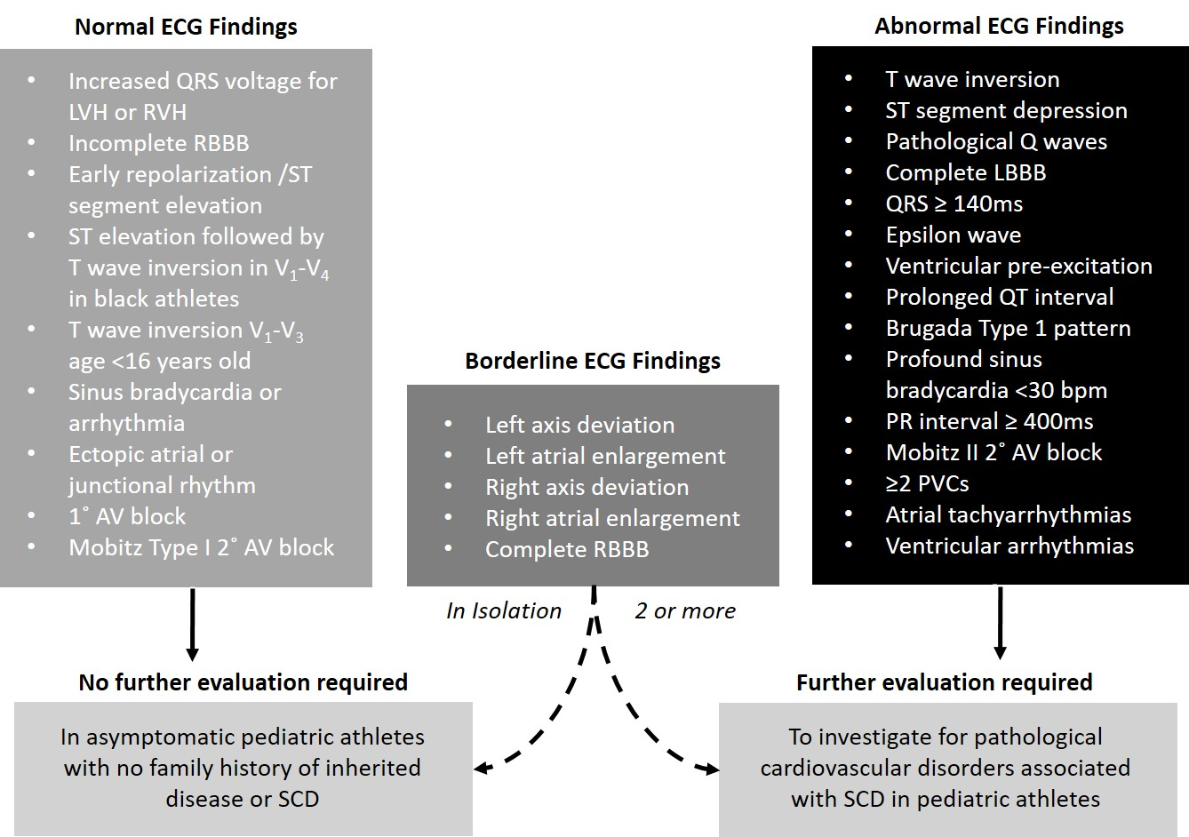
Figure 1. International recommendations for electrocardiographic interpretation in athletes
Key: AV; atrioventricular LBBB; left bundle branch block; LVH, left ventricular hypertrophy; ms; milliseconds; PVCs, premature ventricular contractions; RBBB; right bundle branch block; RVH; right ventricular hypertrophy; RBBB; right bundle branch block.

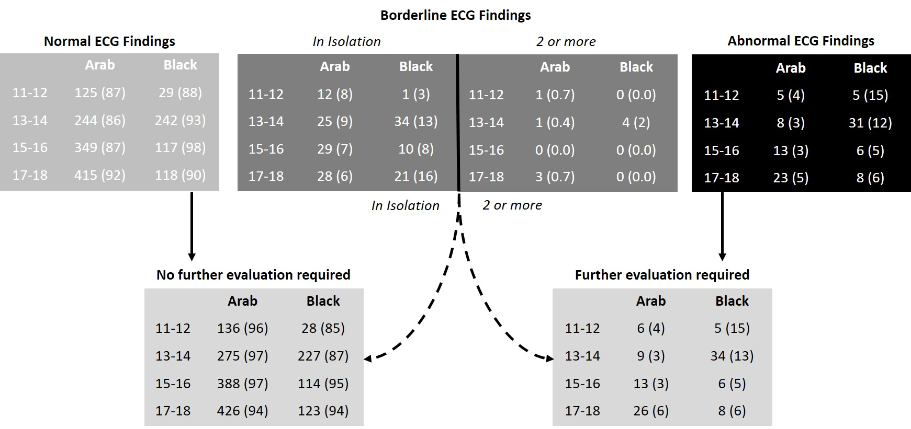
Figure 2. Prevalence of normal, borderline and abnormal ECG findings by chronological age group for Arab and black pediatric athletes according to International recommendations.
Key: Data are presented as n (%)
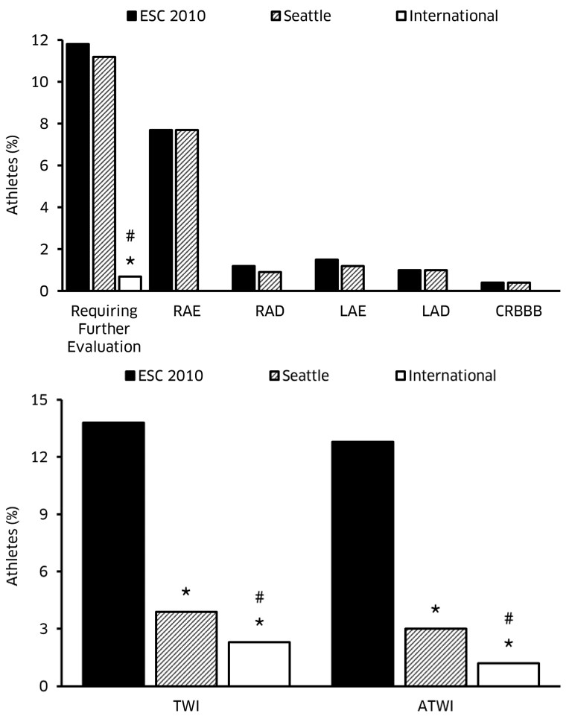
Figure 3. Bar chart shows specific ECG false positives rates with reference to to the 3 ECG interpretation criteria.
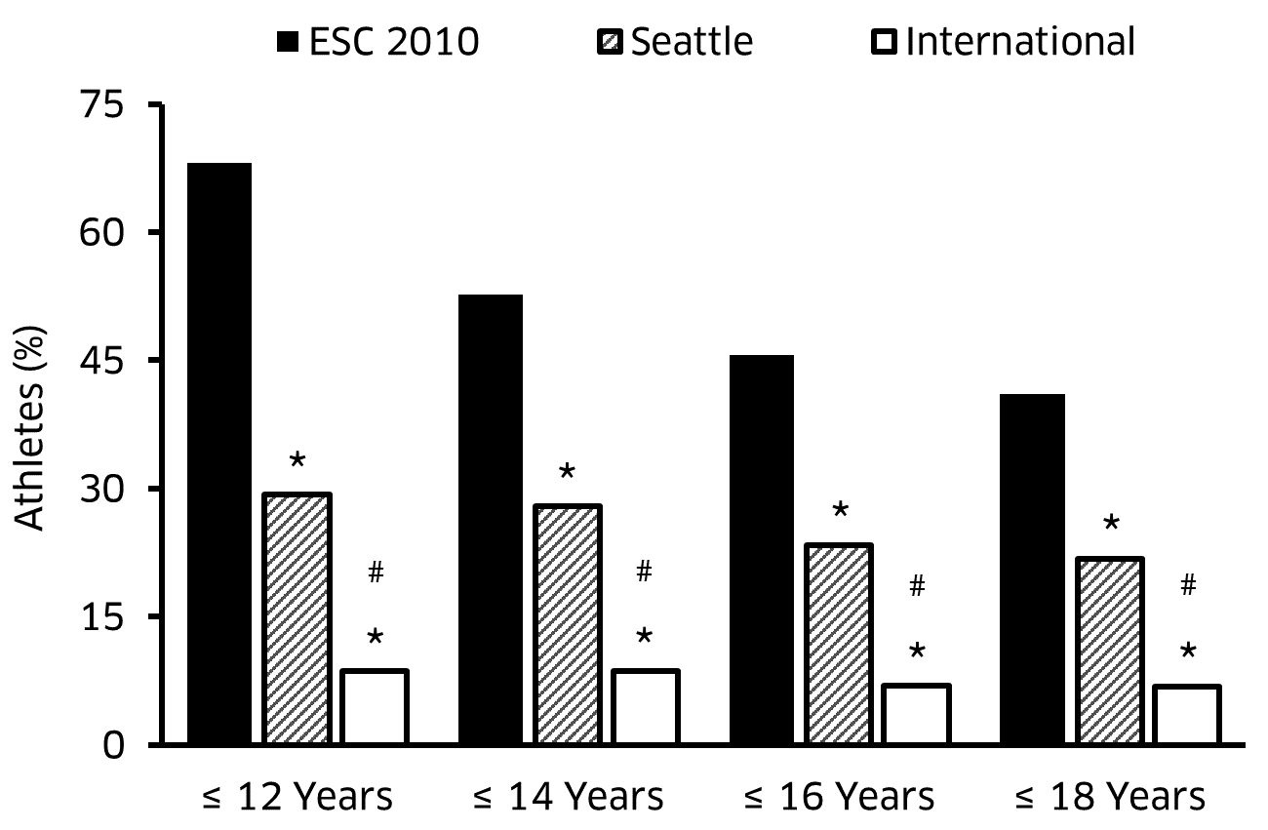
Figure 4. Bar chart shows percentage of false positive ECG findings according to the 3 ECG interpretation criteria by chronological age. *P <0.05, Significantly reduced prevalence to ESC 2010 recommendations. # P <0.05, Significantly reduced prevalence to Seattle Criteria.
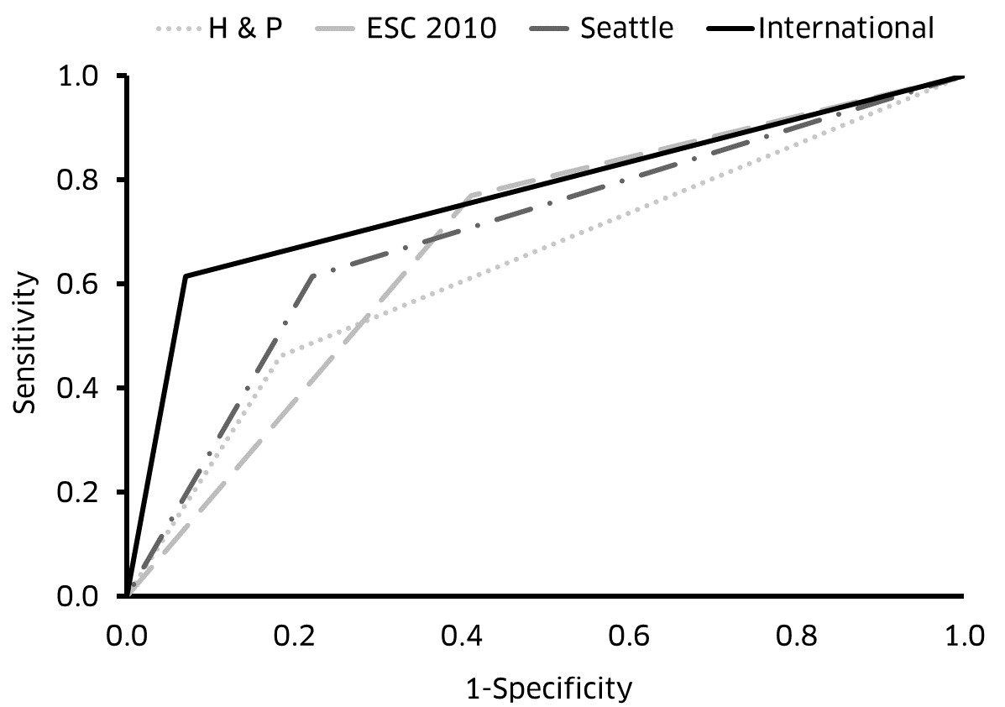

Figure 5. Receiver-operating curves according to health questionnaire and/or physical examination and the 3 ECG interpretation criteria to detect cardiac pathology that may predispose to sudden cardiac death/arrest.

