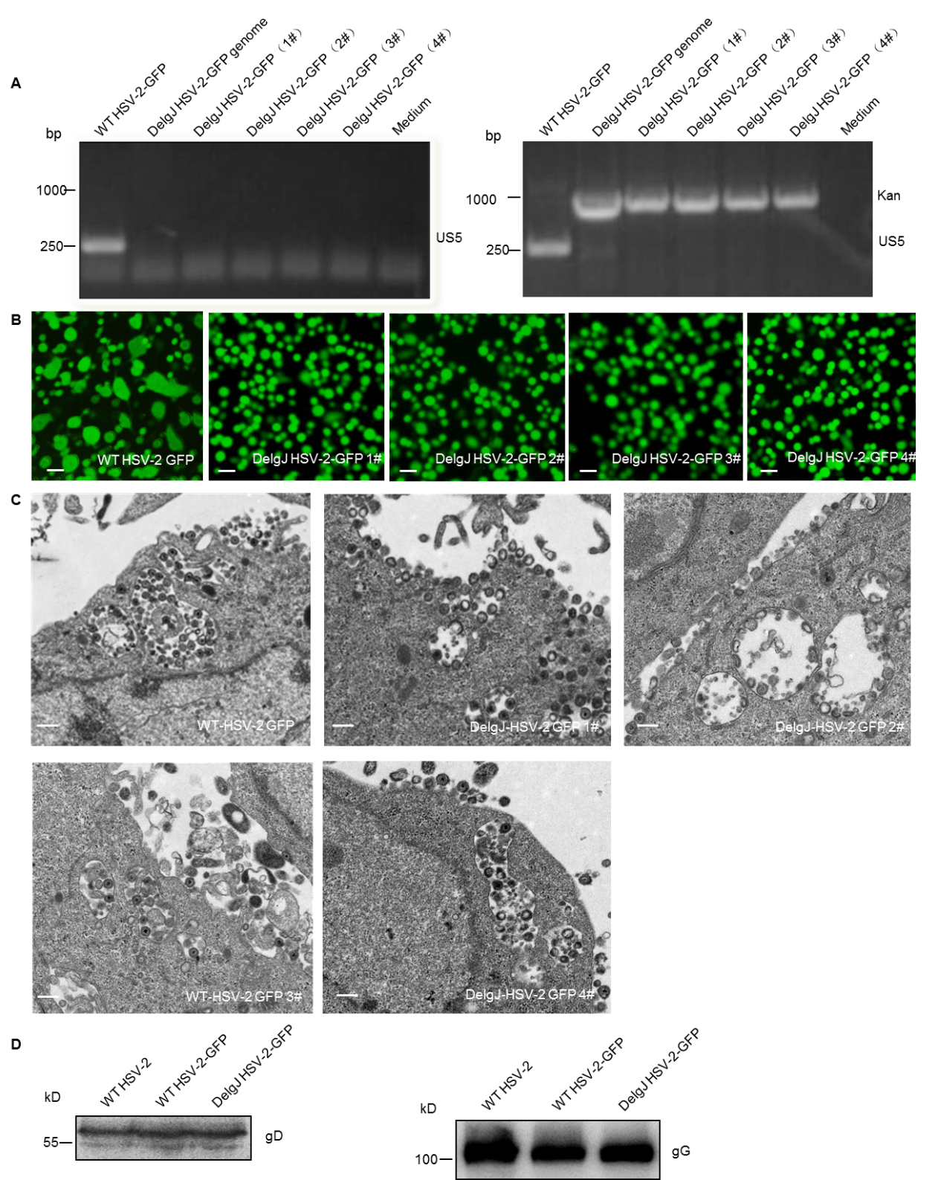
Fig. S1. Generation and characterization of DelgJ HSV-2-GFP. The BAC DNA was transfected into Vero cells to produce the mutant HSV-2 (DelgJ HSV-2-GFP) and the wild-type HSV-2 (WT HSV-2-GFP). (A) The genes of gJ and Kanamycin (kan) in medium containing WT HSV-2-GFP and the four single DelgJ HSV-2-GFP colonies were confirmed by PCR using corresponding primer pairs. (B) The fluorescence of GFP was detected in Vero cells infected with the four DelgJ HSV-2-GFP clones or WT HSV-2-GFP. Scale bar = 50 μm. (C) The virions were observed in Vero cells infected with the four DelgJ HSV-2-GFP clones or WT HSV-2-GFP by electron microscopy. Scale bar = 500 nm. One representative experiment out of three is shown. (D) The expression of gD and gG in supernatants containing the 4# DelgJ HSV-2-GFP or WT HSV-2-GFP was analyzed by western blot. Molecular weight standards in kilodaltons are shown on the left.

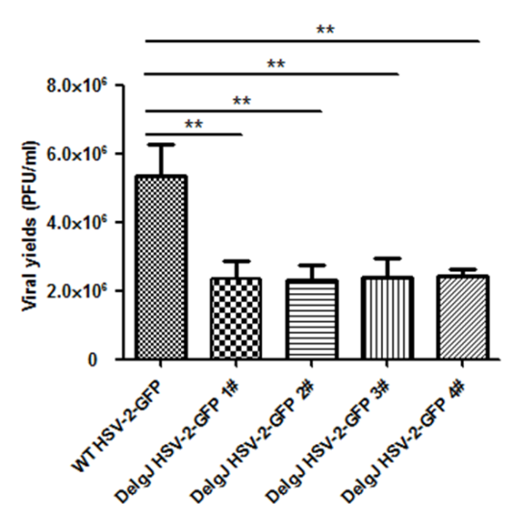
Fig S2. Virus production of DelgJ HSV-2-GFP clones. Vero cells were infected with the four DelgJ HSV-2-GFP clones or WT HSV-2-GFP at an MOI of 5 PFU/cell. The supernatants and cells were collected at 24 hours post infection (hpi) and the virus yields were measured by plaque assay. Data shown are mean ± SD of three independent experiments. ** represents P<0.01.
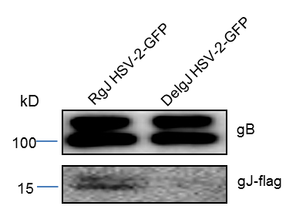
Fig. S3. Confirmation of gJ in RgJ HSV-2-GFP virions. A Vero cell line stably expressing gJ-flag (VgJ2) was constructed. VgJ2 cells were infected with DelgJ HSV-2-GFP at an MOI of 1 PFU/cell to produce the pseudovirus RgJ HSV-2-GFP. At 24hpi, pseudoviruses were harvested and concentrated through ultracentrifugation. A same amount of DelgJ HSV-2-GFP or RgJ HSV-2-GFP were lysed. The expression of gB and gJ-flag was detected by Western blot where actin was used as a loading control. Molecular weight standards in kilodaltons are shown on the left.

