Running head: Ashton-James et al.

Original Article

Can images of pain enhance patient-clinician rapport in pain consultations?

Claire E Ashton-James¹, Peter H Dekker², Judy Addai-Davis^{3,4}, Tom Chadwick ⁵, Joanna M Zakrzewska⁶, Deborah Padfield⁷ and Amanda CdeC Williams³

1. Pain Management and Research Institute, University of Sydney, Australia
2. Department of Experimental and Applied Psychology, Vrije Universiteit Amsterdam, Amsterdam, Netherlands
3. Research Department of Clinical, Educational & Health Psychology, University College London, London, United Kingdom
4. Tower Hamlets Early Intervention Service, London, United Kingdom
5. National Centre for Social Research, London, United Kingdom
6. Eastman Dental Hospital, UCLH NHS Foundation Trust, London, United Kingdom
7. Slade School of Fine Art, University College London, London, United Kingdom

Corresponding author:
Claire E. Ashton-James. Pain Management and Research Institute, University of Sydney, St. Leonards, Australia, 2065.
Email: Claire.ashton-james@sydney.edu.au

Abstract
A variety of treatment outcomes in chronic pain are influenced by patient-clinician rapport. Patients often report finding it difficult to explain their pain, and this potential obstacle to mutual understanding may impede patient-clinician rapport. Previous research has argued that the communication of both patients and clinicians is facilitated by the use of pain-related images in pain assessments. This study investigated whether introducing pain-related images into pain assessments would strengthen various components of patient-clinician rapport, including relative levels of affiliation and dominance, and interpersonal coordination between patient and clinician behaviour. Videos of 35 pain assessments in which pain images were present or absent were used to code behavioural displays of patient and clinician rapport at fixed intervals across the course of the assessment. Mixed modelling was used to examine patterns of patient and clinician affiliation and dominance with consultation type (Image vs. Control) as a moderator. When pain-images were present, clinicians showed more affiliation behaviour over the course of the consultation and there was greater correspondence between the affiliation behaviour of patient and clinician. However, relative levels of patient and clinician dominance were unaffected by the presence of pain images in consultations. Additional analyses revealed that clinicians responded directly to patients’ use of pain images with displays of affiliation. Based on the results of the current study, we recommend further investigation into the utility and feasibility of incorporating pain images into pain assessments to enhance patient-clinician communication.
Keywords
Patient-clinician rapport, pain assessments, communication, nonverbal behaviour
Introduction
Patient-clinician rapport plays a crucial role in treatment outcomes, enhancing treatment expectations, adherence, and satisfaction with treatment outcomes,¹⁻³ but pain consultations pose unique challenges. ⁴⁻⁷ Patients report difficulty conveying their personal experience of pain ^{6, 8-12} and clinicians can find chronic pain hard to understand.^{13, 14} Perhaps as a consequence, patients often report not feeling heard by clinicians, so their experience of pain is not legitimized or validated.⁶ The lack of association between pain and observable signs ¹⁵ further undermines shared understanding. Emerging research ¹⁶ suggests that patients’ use of visual images to describe their pain may facilitate patient-clinician rapport in pain consultations. To make patients’ private experiences of pain visible and more accessible to clinicians, Padfield ¹⁷ co-created abstract photographic representations of pain with people with chronic pain. A qualitative study of using the images in pain consultations found that both patients and clinicians reported that images facilitated communication about individual experience of pain and improved the patient-clinician relationship.¹⁶ Patient and clinician ratings of satisfaction with their communication were equally high in consultations with and without images, ^{16, 18} indicating that images were not found by clinicians to disrupt their pain assessment.
Beyond these accounts, little is known about the effects of using pain images on patient-clinician rapport. Although there is a moderately high correlation between subjectively reported and observed ratings of rapport, ¹⁹⁻²¹ observational measures of rapport – from spontaneous interpersonal patient and clinician behaviours - are more objective and reliable. ^{22, 23} We analysed observational measures of patient and clinician behaviour in pain consultations to ascertain whether pain images influenced patient-clinician rapport. In contrast to previous research into the question of whether pictorial images successfully communicate the quality of pain to clinicians, ²⁴ our goal was to evaluate whether pain images facilitate patient-clinician rapport.
What does patient-clinician rapport look like?
Patterns of nonverbal behaviour are the primary channel through which rapport – how well interaction partners get along - is communicated. ^{22, 25, 26} Decades of nonverbal communication research converge on three key indicators of interpersonal rapport: mutual affiliation, mutual dominance, and behavioural coordination. ²⁷⁻³⁰ Affiliation behaviours (such as forward-leaning posture, smiling, nodding, and a relatively high-pitched vocal tone) communicate warmth, empathy, and agreement. ^{25, 31} Dominance behaviours, such as speaking in a clear, firm, relatively loud voice, postural expansion, and asking questions or initiating discussion, signal assuredness, involvement, control, and agency. ^{32, 33} Coordinated interactions are achieved when affiliation behaviours are reciprocated (matched) and dominance behaviours are complemented (balanced). In this way, positivity develops over the course of an interaction (affiliation from one partner predicts affiliation from the other), and control is balanced (submissive behaviour from one partner predicts dominance from the other, and vice versa). These reciprocal and complementary patterns of affiliation and dominance characterize rapport not only between patients and clinicians, but also managers and employees, romantic partners, and acquaintances. ³⁴⁻³⁶
Hypotheses
Based on previous research using pain images to enhance patient-clinician communication, we predicted that using pain images would be associated with greater patient and clinician rapport in pain consultations. Specifically, we hypothesized that both patient and clinician would display more overall affiliation behaviour in pain consultations in which pain images were present versus absent. For dominance, we did not expect to see a change in clinician dominance in “image” compared to “control” consultations, since behaviours signalling dominance are integral to assessment (e.g. asking questions, leading discussion). ³⁷ However, since the pain images are intended to give patients’ pain a voice, we expected patients in “image” consultations to show higher levels of dominance (agency or control) compared to patients in standard consultations. Third, we expected greater interpersonal reciprocity in patient and clinician affiliation, and greater complementarity of patient and clinician dominance, in image compared to standard consultations.
Method
Design
Employing a quasi-experimental design, patient and clinician affiliation and dominance were measured repeatedly using fixed-interval sampling across the course of both “image” and “control” consultations, using the first minute of every five minutes. Independent coders rated affiliation and dominance behaviours of patients and clinicians.
Participants
Chronic pain patients awaiting an initial assessment for pain in a specialist pain clinic were invited to participate in the study if they were English-speaking, at least 18 years old, and able to consent. All participants were informed that they might be asked to select 4-5 images from a bank of photographs to take into the consultation, which would be video-recorded. Eleven clinicians from the pain clinic were invited to participate, including pain physicians, clinical psychologists, and specialist physiotherapists, and all agreed. Only one had previous experience of using the pain images in a consultation,
As the production of the images was incomplete at the start of recruitment, patients were not randomized to using images or not, but those in the first round (N = 21) had consultations without pain images, constituting the control group. The following year, an independent sample of 17 patients used pain images in their consultations, designated the image group.
Clinicians took part in both phases of the study, except for one who left her post after two control group consultations; these consultations were dropped from analyses, with one further consultation that was subject to technical failure. The analysis therefore contained 35 of the 38 patient-clinician dyads, 18 without and 17 with images. Ten pain clinicians (six pain specialists; one surgeon; one neurologist; one clinical psychologist; and one physiotherapist) completed two, three, or four consultations, at least one with and one without images. Of the 10 clinicians, five were female. Clinicians had been practicing for a mean 19 years (range 3 to 36 years).
Apparatus and materials
Pain images. Patients in Image consultations were provided with 54 laminated ‘pain cards’ approximately 20 minutes before the consultation and asked to select those that best represented their personal experience of pain. The ‘pain cards’ (142 x 105mm) were co-created by an artist in collaboration with chronic pain patients not involved in the current study ¹⁷. (See Padfield¹⁷ for details of the creation and validation of these images and Padfield et al ^{16, 18} for clinicians’ and patients’ evaluations of images). Some images were abstract and symbolic, while others could be interpreted literally, such as an image of sparking electrical wires (see Figures 1a and 1b, below). Patients in Image consultations were asked to take their selected images into the pain consultation to use at their discretion. Clinicians in Image consultations were also instructed that they could refer to the patients’ selected images at their discretion.
Figure 1a. Photograph of Pain. Deborah Padfield with Nell Keddie from the series Perceptions of Pain, 2001 -2006 © Deborah Padfield and Dewi Lewis.
Figure 1b. Photograph of Pain. Deborah Padfield with Chandrakant Khoda from the series face2face, 2008 – 2013, Digital Archival Print. © Deborah Padfield.
Video recording. All consultations were recorded by ceiling-mounted cameras that were adjusted remotely by technicians so that patients’ and clinicians’ faces and bodies were visible.
Observational coding protocol. The first minute of every 5 minutes in each consultation was sampled as an interaction segment. Consultation duration varied and medical examinations during consultations were not recorded. Coders familiarized themselves with nonverbal behaviours indicative of high and low affiliation and dominance (also termed agency, activation, control and status), using comprehensive reviews of nonverbal interpersonal behaviour ^{25, 31} and adopting a validated coding scheme. ^{26, 31}
Ratings of affiliation and dominance were recorded using an interpersonal grid developed and tested by Moskowitz and Zuroff ³⁸ that is correlated with self-reports of affiliation and dominance, has good inter-rater reliability, predictive validity, and discriminant validity.^{35, 38} The grid consists of an 11-point horizontal axis denoting affiliation (anchored by “cold-quarrelsome” at -5 and “warm-agreeable” at +5), and an 11-point vertical axis measuring dominance (anchored by “unassured-submissive” at -5 and “assured-dominant” at +5). The resulting grid serves for rating interpersonal behaviour, presenting affiliation and dominance as orthogonal dimensions so that behaviours that are low on affiliation are not necessarily high on dominance. In addition, the corners of the grid show the words “engaged” “deferring”, “withdrawn” and “critical”, to reflect the combinations of high and low affiliation and dominance. For each 1-minute interaction segment, coders independently followed the same observational protocol: first, they formed an overall impression of patient and clinician behaviour (how engaged, withdrawn, deferring, or critical were they?). Anchored by these impressions, coders then indicated the level of affiliation and dominance exhibited by patient and clinician by marking a cross at the intercept. For example, a cross at the intercept (3, 5) would indicate a moderately high level of affiliation and a very high level of dominance (see supplementary file). Observers also recorded whether they were coding an “Image” or “Control” consultation. For interaction segments in Image consultations, observers recorded whether or not the patient was referring to a pain image during the coded interaction segment. Each observer rated two-thirds of the consultations; the third (n = 13) coded by both was used to check inter-rater reliability.
Results
Inter-rater reliability
Inter-rater reliability between coders’ ratings was assessed by a two-way mixed intra-class correlation coefficient (ICC), showing high consistency between coders’ ratings for patient affiliation behaviours, ICC = .97, 95% CI [0.96, 0.98]; patient dominance behaviours, ICC = .96, with 95% CI [0.95, 0.97]; clinician affiliation behaviours, ICC = .95, CI [0.93, 0.97]; and clinician dominance behaviours, ICC = .98, CI [0.97, 0.98].
Descriptive statistics
Patient characteristics are compared in Table 1, below. No biases were found between Image and Control patients for gender, age, or pain duration (overall median 9 years; interquartile range 3-15 years: U = 115.00, p = .465). Details of ethnicity were not collected consistently and have not been included. Consultations varied in length (M = 61 min, SD = 18 min), with no difference between Image and Control: MImage = 65 min, SD = 19 min; MControl = 59 min, SD = 16 min (t = 1.01, p = .32). There was no difference in median number of one-minute clips, 12 for Control vs. 11 for Image: Mann-Whitney U = 144.5, p>0.5. Patients in the Image group selected from 2 to 14 images (median 6) to take into their consultations, using them from 1 to 3 times, with mean time of 4 minutes 45 seconds (SD = 2 minutes 28 seconds; range 1 minute 16 seconds to 10 minutes 22 seconds). No relationships were found between the number of images used and time spent (r = -.02, p = .936, n.s), nor between the number of images used and consultation length (r = .15, p = .579, n.s).
Table 1. Patient characteristics

 | Image  (n = 17) | Control  (n = 18)
 | n (%) | n (%) | X² | df | p
Gender
Male | 7 (41.20) | 7 (38.90) | .02 | 1 | .890
Female | 10 (58.80) | 11 (61.10)
Age
25-40 | 6 (35.30) | 5 (27.80) | 2.67ª | 2 | .291
41-60 | 5 (29.40) | 10 (55.60)
Over 60 | 6 (35.30) | 3 (16.70)
df = Degrees of Freedom
ª Indicates Fishers Exact test, other value is X

Patient and clinician affiliation behaviour
Mixed modelling was used to examine the hypothesis that both patients and clinicians in Image consultations would show higher overall levels of affiliation. First, linear, quadratic, and cubic trends in patient and clinician affiliation were examined with consultation type (Image vs. Control) as a moderator. An unstructured covariance matrix was specified for the repeated measurements. There was a significant, linear, downward trajectory in patient affiliation behaviour over both Image and Control consultations (see Figure 2), b = -.089, F(1, 19.9) = 66.4, p < .001), where coefficient b refers to the decrease in patient affiliation per consultation segment. Contrary to our hypothesis, overall levels of affiliation behaviour of patients in Image and Control did not differ: F(1, 27.5) = 2.7; p = .11.
As shown in Figure 3, affiliation behaviour of clinicians revealed a distinct cubic trend across the course of consultations in both Image and Control groups, F(1; 28.2) = 13.6; p = .001. To quantify the difference between clinicians’ levels of affiliation in the Image and Control consultations, we computed the Area Under the Curve (AUC); comparison with the mixed model procedure resulted in a difference of 7.41 (SE = 2.33); t(32) = 3.18; p = .003, also expressed as an average distance between the curves of .67, an effect size of .5. In sum, while we expected that both patient and clinician affiliation would be greater over the course of Image consultations, results revealed only an effect of pain images on the overall level of affiliation behaviour displayed by clinicians.
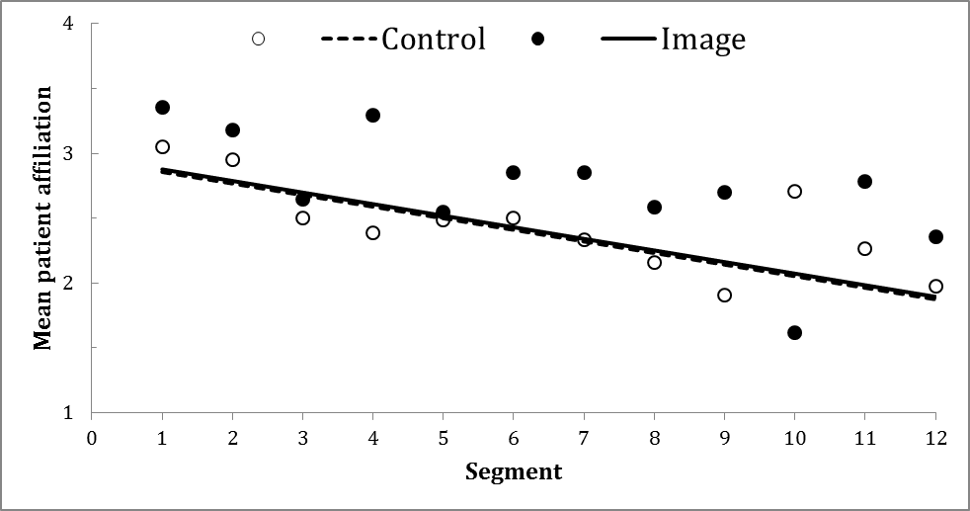
Figure 2. Mean patient affiliation as a function of observational segment and consultation type.

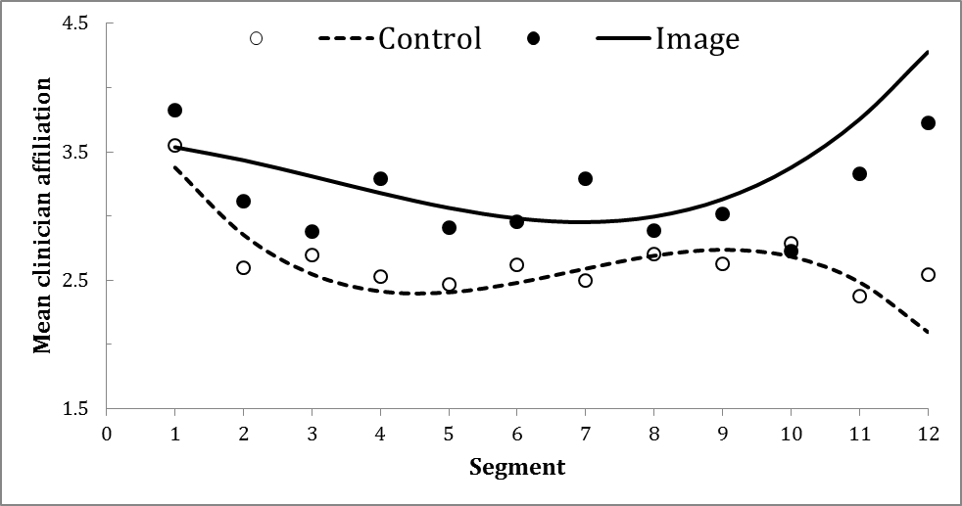
Figure 3. Mean clinician affiliation as a function of observational segment and consultation type (condition)
Patient and clinician dominance
Using the same statistical techniques described above, we tested the hypothesis that overall levels of patient dominance would be higher in Image compared to Control consultations. Contrary to our hypothesis, there was no main effect of consultation type on overall levels of patient dominance, F(1; 33.1) = .04; p = .84. There was, however, a significant (but not hypothesized) interaction between the (linear) pattern of patient dominance displayed by patients over the course of Image and Control consultations, F(1; 20.0) = 21.0; p < .001. As shown in Figure 4, there was a steady decrease in patient dominance over the course of Image consultations, ß = .061, t(22) = 2.33; p = .03, and an increase in patient dominance over the course of Control consultations, ß = . 099, t(18) = 4.29; p < .001.
As expected, there was no systematic pattern of change in the dominance behaviour of clinicians across the course of consultations, F(1; 30.7) =.07; p = .80, nor was their dominance influenced by consultation type (Image vs. Control), F(1; 25.6) = .90; p = .36. Further, there was no evidence of an interaction between clinician dominance over the course of consultations and consultation type, F(1; 30.7) = .30; p = .58 (see Figure 5).
In sum, consultation type influenced the pattern, but not the overall amount of dominance displayed by patients over the course of consultations: patients in Image consultations showed more dominance in the early compared to later segments of the consultation, while patients in Control consultations showed greater dominance in the later relative to the early segments of consultations. 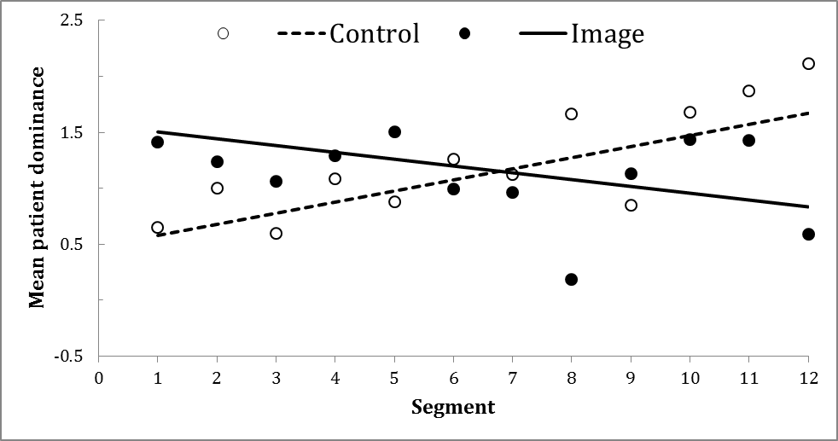
Figure 4. Mean patient dominance as a function of observational segment and consultation type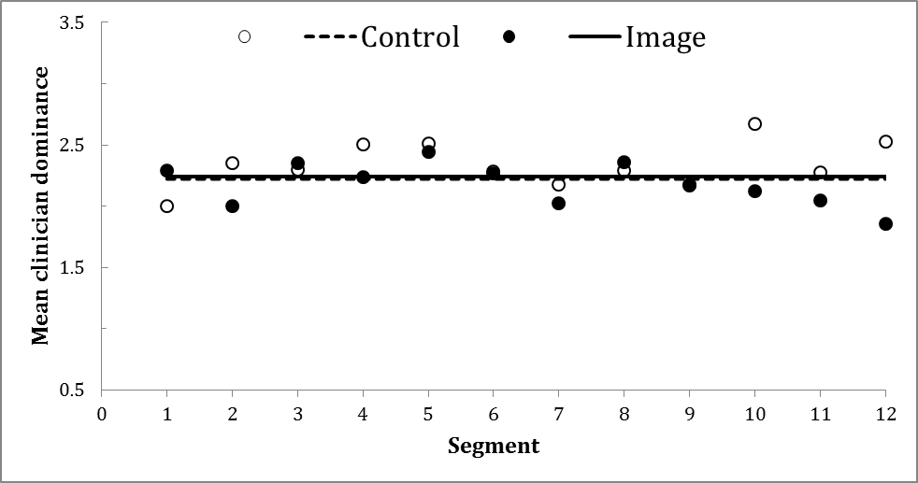
Figure 5. Mean clinician dominance as a function of observational segment and consultation type

Interpersonal coordination
Our final hypothesis concerned greater patient-clinician coordination in Image compared to Control consultations. Specifically, we expected positive changes in patient affiliation behaviour to predict positive changes in clinician affiliation behaviour (reciprocity), and positive changes in patient dominance behaviour to predict negative changes in clinician behaviour (complementarity). To test these, behavioural changes from one segment to the next were calculated and correlated for both affiliation and dominance. Thereafter, mixed modelling was used to assess the relationship between changes in patient and clinician affiliation and changes in patient and clinician dominance, specifying an unstructured covariance matrix for the repeated measurements. Analyses showed that positive changes in patient affiliation behaviour (from segment to segment) predicted positive changes in clinician affiliation behaviour in both consultation types, Control: b = .23; t(58) = 6.0; p < .001; Image: b = .61; t(142) = 10.8; p < .001. However, as predicted, correspondence between patient and clinician affiliation behaviour was significantly higher in Image than in Control consultations (consultation type x affiliation: F(1; 118.3) = 30.2; p < .001). Transformed into effect sizes, b corresponds to .26 and .70 respectively. Reversing the roles of patient and clinician in the analysis obtained similar results (Control: b = .36; t(61) = 6.8; p < .001, effect size = .31; Image: b = .51; t(32) = 9.9; p < .001, effect size = .45), but with only marginal difference between consultation types: F(1; 51.1) = 4.6; p = .04), indicating that clinicians’ affiliation behaviour was more likely to follow patient behaviour in the Image consultations. We found no evidence for association between patient and clinician dominance behaviour in either consultation type.
Additional analyses
We tested whether or not the use of images, as opposed to their mere presence or accessibility, had direct consequences for patient-clinician interaction. Actual image use was observed in 20 of the 177 Image consultation segments (11%). A within-group comparison of patient and clinician behaviour when images were actively used versus not revealed that patients’ active use of pain images during consultations did not significantly affect their display of affiliation or dominance (ps = .36 and .06 respectively). By contrast, clinicians were responsive to patients’ image use: the estimated mean of clinician affiliation when images were used was 4.5 vs 3.3 when they were idle, F(1; 45.8) = 38.6; p < .001; effect size = 1.0. The estimated mean of clinician dominance in segments where patients used images was 1.7 vs. 2.1 when images were idle, F(1; 39.4) = 4.6; p = .04; effect size = 0.3. These results indicate that when patients actively used images, clinicians showed more affiliation and less dominance than when the pain images lay idle.
Discussion
This study investigated whether the use of pain images in pain consultations increased patient-clinician rapport. We hypothesized that providing patients with pain-related images to use at their discretion would strengthen patient-clinician rapport, indicated by greater patient and clinician affiliation behaviour, patient dominance, and interpersonal coordination. Certain aspects of patient-clinician rapport, but not others, were affected: pain images were associated with increased overall levels of clinician (but not patient) affiliation, and increased reciprocity between patient and clinician affiliation, but pain images influenced neither patient nor clinician dominance. The most provocative result of the present study is that clinician rather than patient behaviour was sensitive to the presence of pain images, suggesting that pain images may facilitate patient-clinician rapport by enabling clinicians to better understand patients’ individual pain experience, in turn fostering clinician affiliation and clinician-patient rapport.³⁹ This interpretation implies that patient-clinician rapport depends less on patients’ communication of their pain than on clinicians’ understanding of and empathy with that communication.
Providing further evidence that pain images may facilitate patient-clinician rapport by activating clinician rather than patient affiliation behaviour, analyses revealed that patient-clinician reciprocity was driven by clinician responsiveness to patient affiliation behaviours more than by patient responsiveness to clinician affiliation behaviours. That is, clinician affiliation behaviour was predicted by patient behaviour to a greater extent than patient affiliation behaviour was predicted by clinician behaviour.
It is noteworthy that the presence of images in consultations did not influence clinicians’ overall dominance or control during consultations. Hence, while patients’ use of images increased their tendency to affiliate with patients, clinicians continued to show typical dominance behaviours required when completing a thorough pain assessment (e.g. asking questions, information-giving). It is also interesting that there was no evidence of correspondence between patient and clinician dominance: dominance behaviours were neither matched nor complemented by either party. It is possible that the consistency of clinicians’ dominance behaviours across consultation types reflects the standardization of clinical skills relevant to pain assessment.
Strengths and limitations
The reliability of our findings should be evaluated in light of the methodological strengths and limitations. On one hand, dyadic patterns of nonverbal behaviour offer the most accurate measurement of rapport: an individual’s subjective experience of rapport tends to reflect their attitudes towards an interaction partner and is only moderately correlated with the level of interpersonal coordination displayed in dyadic interaction. ^{22, 29, 40}
While there are clear benefits to conducting research on treatment process in a naturalistic clinical setting, there are also inherent limitations. For example, the ways in which clinicians and patients used the pain images, and the extent to which images were used, varied substantially. This variability in image use may be a significant source of error in the current study, although such error would more likely suppress than magnify the effects of pain images on consultation dynamics.
A common limitation of observational research is that coders cannot always be blind to experimental conditions. In the current study, images held by patients were visible and hence consultation type was evident to coders. While coders were not familiar with the specific research hypotheses, their intuitive expectations about the impact of pain images may have influenced their coding of patient-clinician rapport.
Finally, patient allocation to the image and control groups was not randomized; control consultations were recorded after image consultations. While no obvious demographic differences emerged between consultation groups, we cannot rule out the possible influence of other variables.
Conclusion
The results of the present study indicate that patient-clinician rapport may be enhanced by having pain-related images at patients’ disposal during pain assessments. Pain images appear to facilitate patient-clinician rapport by promoting greater affiliation behaviour and responsiveness from clinicians. The interpersonal behaviour of patients appears to be unaffected by their use of pain images to communicate about pain.
Clinical implications and future research directions
In view of the foregoing limitations, the results of the present study are considered preliminary, and clinical implications are tentative. The findings indicate that when patients are able to use visual cues to communicate about their pain, clinicians show greater affiliation with and responsiveness to patients – an indication that they are experiencing greater empathy.
Further research into the impact of pain images on patient-clinician rapport would ideally randomize patients to conditions, with adequate power to test for differences of the size found in this study. It would also be beneficial for follow-up to examine whether the use of pain images in consultations is associated with better treatment outcomes, including patient satisfaction, increased patient involvement in treatment decision-making, and treatment adherence.
Acknowledgements
We are grateful to participating patients and clinicians, and to Professor Sharon Morris, Helen Omand, and Professor Elena Semino who helped steer this project.
Funding
The work was funded by the Arts and Humanities Research Council UK, with contributions from Friends of University College London Hospitals, Grand Challenges UCL, Centre for Humanities Interdisciplinary Research Projects (CHIRP) UCL, and Arts Council England. Joanna Zakrzewska received funding from the NIHR Biomedical Research Centre.
Conflicting interests
The Authors declare that there are no conflicting interests.

References
1. Bertakis KD, Roter D and Putnam SM. The Relationship of Physician Medical Interview Style to Patient Satisfaction. J Fam Practice. 1991; 32: 175-81.
2. Hall JA, Roter DL and Katz NR. Meta-Analysis of Correlates of Provider Behavior in Medical Encounters. Medical Care. 1988; 26: 657-75.
3. Street RL, Jr., Makoul G, Arora NK and Epstein RM. How does communication heal? Pathways linking clinician-patient communication to health outcomes. Patient Educ Couns. 2009; 74: 295-301.
4. Bieber C, Müller KG, Blumenstiel K, et al. Long-term effects of a shared decision-making intervention on physician–patient interaction and outcome in fibromyalgia: A qualitative and quantitative 1 year follow-up of a randomized controlled trial. Patient education and counseling. 2006; 63: 357-66.
5. Eccleston C, Amanda CDC and Rogers WS. Patients' and professionals' understandings of the causes of chronic pain: blame, responsibility and identity protection. Social science & medicine. 1997; 45: 699-709.
6. Kenny DT. Constructions of chronic pain in doctor-patient relationships: bridging the communication chasm. Patient Educ Couns. 2004; 52: 297-305.
7. Eggly S and Tzelepis A. Relational control in difficult physician–patient encounters: negotiating treatment for pain. Journal of health communication. 2001; 6: 323-33.
8. Biro D. The Language of Pain: Findings Words, Compassion, and Relief. New York: WW Norton & Co, 2010.
9. Laerum E, Indahl A and Skouen JS. What is "the good back-consultation"? A combined qualitative and quantitative study of chronic low back pain patients' interaction with and perceptions of consultations with specialists. J Rehabil Med. 2006; 38: 255-62.
10. Dobkin PL, Sita A and Sewitch MJ. Predictors of adherence to treatment in women with fibromyalgia. Clinical Journal of Pain. 2006; 22: 286-94.
11. Sale JEM, Gignac M and Hawker G. How "Bad" does the pain have to be? A qualitative study examining adherence to pain medication in older adults with osteoarthritis. Arthrit Rheum-Arthr. 2006; 55: 272-8.
12. Buchman DZ, Ho A and Illes J. You Present like a Drug Addict: Patient and Clinician Perspectives on Trust and Trustworthiness in Chronic Pain Management. Pain Med. 2016; 17: 1394-406.
13. Kappesser J, Williams AC and Prkachin KM. Testing two accounts of pain underestimation. Pain. 2006; 124: 109-16.
14. Reynolds L, Broadbent E, Ellis CJ, Gamble G and Petrie KJ. Patients' drawings illustrate psychological and functional status in heart failure. J Psychosom Res. 2007; 63: 525-32.
15. Jensen MC, Brant-Zawadzki MN, Obuchowski N, Modic MT, Malkasian D and Ross JS. Magnetic resonance imaging of the lumbar spine in people without back pain. New England Journal of Medicine. 1994; 331: 69-73.
16. Padfield D, Janmohamed F, Zakrzewska JM, Pither C and Hurwitz B. A slippery surface... can photographic images of pain improve communication in pain consultations? Int J Surg. 2010; 8: 144-50.
17. Padfield D. Perceptions of Pain. 1 ed. Stockport: Dewi Lewis, 2003.
18. Padfield D, Zakrzewska JM and Williams AC. Do photographic images of pain improve communication during pain consultations? Pain Res Manag. 2015; 20: 123-8.
19. Lafrance M. Nonverbal Behavior and Communication - Siegman,Aw, Feldstein,S. J Commun. 1979; 29: 206-8.
20. Tiedens LZ and Fragale AR. Power moves: Complementarity in dominant and submissive nonverbal behavior. J Pers Soc Psychol. 2003; 84: 558-68.
21. Hall JA, Harrigan JA and Rosenthal R. Nonverbal Behavior in Clinician Patient Interaction. Appl Prev Psychol. 1995; 4: 21-37.
22. Grahe JE and Bernieri FJ. The importance of nonverbal cues in judging rapport. J Nonverbal Behav. 1999; 23: 253-69.
23. Harrigan JA, Oxman TE and Rosenthal R. Rapport Expressed through Nonverbal Behavior. J Nonverbal Behav. 1985; 9: 95-110.
24. Closs SJ, Knapp P, Morley S and Stones C. Can pictorial images communicate the quality of pain successfully? Br J Pain. 2015; 9: 173-80.
25. Kiesler DJ and Auerbach SM. Integrating measurement of control and affiliation in studies of physician-patient interaction: the interpersonal circumplex. Soc Sci Med. 2003; 57: 1707-22.
26. Moskowitz DS. Cross-Situational Generality and the Interpersonal Circumplex. J Pers Soc Psychol. 1994; 66: 921-33.
27. Mast MS. On the importance of nonverbal communication in the physician-patient interaction. Patient Education and Counseling. 2007; 67: 315-8.
28. Lafrance M and Broadbent E. Group Rapport: Posture Sharing as a Nonverbal Indicator. Group Organization Management. 1976; 1: 328-33.
29. Tickle-Degan L and Rosenthal R. The nature of rapport and its nonverbal correlates. Psychological Inquiry. 1990; 1: 285-93.
30. Lafrance M. Nonverbal synchrony and rapport: Analysis by the cross-lag panel technique. Social Psychology Quarterly. 1979; 42: 66-70.
31. Schermuly CC and Scholl W. The Discussion Coding System (DCS) - A New Instrument for Analyzing Communication Processes. Communication Methods and Measures. 2012; 6: 12-40.
32. Kiesler DJ. From communications to interpersonal theory: A personal odyssey. J Pers Assess. 1996; 66: 267-82.
33. Burgoon JK and Dunbar NE. An interactionist perspective on dominance-submission: Interpersonal dominance as a dynamic, situationally contingent social skill. Commun Monogr. 2000; 67: 96-121.
34. Markey PM, Funder DC and Ozer DJ. Complementarity of interpersonal behaviors in dyadic interactions. Pers Soc Psychol B. 2003; 29: 1082-90.
35. Moskowitz DS, Ho MHR and Turcotte-Tremblay AM. Contextual influences on interpersonal complementarily. Pers Soc Psychol B. 2007; 33: 1051-63.
36. Sadler P and Woody E. Is who you are who you're talking to? Interpersonal style and complementarity in mixed-sex interactions. J Pers Soc Psychol. 2003; 84: 80-96.
37. Street RL and Buller DB. Nonverbal Response Patterns in Physician-Patient Interactions - a Functional-Analysis. J Nonverbal Behav. 1987; 11: 234-53.
38. Moskowitz DS and Zuroff DC. Assessing interpersonal perceptions using the interpersonal grid. Psychol Assessment. 2005; 17: 218-30.
39. Leach MJ. Rapport: a key to treatment success. Complement Ther Clin Pract. 2005; 11: 262-5.
40. Tickle-Degnen L and Rosenthal R. The nature of rapport and its nonverbal correlates. Psychological Inquiry. 1990; 1: 285-93.

