Title: Reappraising the role of motor surround inhibition in dystonia
Authors: Panagiotis Kassavetis^{1,2}, Anna Sadnicka¹, Tabish A. Saifee¹, Isabel Pareés¹, Maja Kojovic^{1,3}, Kailash P. Bhatia¹, John C. Rothwell¹, Mark J. Edwards¹
Address: 1: Sobell Department of Motor Neuroscience and Movement Disorders, UCL Institute of Neurology, Queen Square, London, UK.
2: Boston University, Neurology Department, Boston, MA, USA.
3: Department of Neurology, University Clinical Centre Ljubljana, Slovenia.
Corresponding author: Panagiotis Kassavetis, MD, PhD
Boston University, Department of Neurology
UCL, Institute of Neurology
Email: p.kassavetis.09@ucl.ac.uk

Abbreviations ADDS, Arm Dystonia Disability Scale; ADM, abductor digiti minimi; ANOVA, analysis of variance; BT, botulinum toxin; CD, cervical dystonia; EMG, electromyography; FDI, first dorsal interosseus; FHD, focal hand dystonia; MD; Musician’s dystonia; MEP, motor evoked potential; SD, standard deviation; SEM, standard error of the mean; SI, surround inhibition; TMS, transcranial magnetic stimulation; TWSTRS, Toronto Western Spasmodic Torticollis Rating Scale; WC, Writer’s cramp;
ABSTRACT
Background: Surround inhibition (SI) in the motor system has been described to be decreased in patients with focal hand dystonia (FHD) but no evidence currently exists for patients with cervical dystonia (CD).
Objective: To characterise the SI profiles in three groups of participants: healthy volunteers, patients with FHD and patients with CD. To provide sample size calculations for future studies.
Methods: SI was assessed using Transcranial Magnetic Stimulation (TMS) in 31 right-handed healthy participants, 11 patients with CD and 12 patients with FHD. In addition data of SI in patients with FHD were extracted from previously published and analysed for sample size calculations and assessment of SI variability.
Results: No statistically significant difference in SI was found amongst the groups (healthy, FHD, CD). Analysis of combined current and previous data suggests that our study and all prior studies were underpowered. At least 26 participants in each group are required for a simple comparison of two groups. Analysis of published data indicated that SI is more variable in FHD patients compared to healthy controls.
Conclusions: The highly variable SI in patients with dystonia can confound statistical comparisons of mean differences. Larger studies are needed to assess SI in dystonia and to explore the origins of its variability.

INTRODUCTION

Surround inhibition (SI) is a neural process initially described in the visual system [1, 2] and later used to model the interaction between firing rates of adjacent neurons in several sensory systems and at different levels of the nervous system [3-5] . In the motor system, it has been hypothesised that a similar process assists in individuation of finger movements via suppression of activity in muscles adjacent to the active muscle. In 2004, Hallett et al. described reduction of corticospinal excitability in the abductor digiti minimi (ADM) during a brief index finger movement and hypothesized that this phenomenon indicated presence of SI in the motor system [6]. Similar observations had been made by other researchers [7] , but a direct link to SI at the cellular level has never been made.

A crucial assumption of the above studies is that SI must have a behavioural correlate and specifically that stronger SI should be associated with less activation of adjacent muscles during single finger movement. In line with this hypothesis, SI has been found to be stronger in the dominant hemisphere which may indicate possible relationship of SI with motor performance and dexterity. However it has been recently shown that SI does not correlate with EMG activity in adjacent muscles [8] and robust data to directly connect SI with performance is still lacking . The argument for the behavioural relevance of SI has instead largely been based on the observation that SI is decreased or absent in patients with focal hand dystonia, a condition characterised by loss of selectivity in activation of individual muscles and overflow of contraction to the muscles not engaged in the movement.

Following initial reports where SI was found to be abnormal in patients with dystonia [9] several studies have replicated the results. However, more than 10 years later there is still uncertainty on how SI relates to the pathophysiology and clinical manifestation of dystonia. Instead, the literature is generally limited to reporting between-group differences in SI, while failing to explore between group data and individual patient data.

With this study, SI was compared in three groups of participants: healthy volunteers, patients with focal hand dystonia (FHD) and patients with focal cervical dystonia (CD). We hypothesised that SI is decreased in the FHD group and explored SI in patients with CD . New data is presented and compared to published literature. We summarise the current evidence on SI and go one step further to perform power calculations for future studies.

METHODS

Participants

A total of 31 right-handed healthy adults (age 27.4 years, SD=7.2, 16 women), 11 patients with cervical dystonia (age 54.1 years, SD=10.6, 4 women) and 12 patients with task-specific focal hand dystonia (age 53.25 years, SD=12.9, 4 women) were recruited. The patients with dystonia were recruited in the movement disorders specialty clinics at the National Hospital for Neurology and Neurosurgery. None of the hand dystonia patients were receiving treatment. The CD patients were all chronically receiving botulinum toxin injects but the most recent were more than three months before the experiment. Written informed consent was obtained from all participants and the study was approved by the local ethics committee. The focal hand dystonia patients were rated with the Arm Dystonia Disability Scale (ADDS) (designed to quantify disability on a scale of 0-100%, with 100% indicating no disability) and the focal cervical dystonia patents with the Toronto Western Spasmodic Torticollis Rating Scale (TWSTRS) (used to assess the severity of cervical dystonia on a scale of 0 to 85, with 0 indicating no dystonia). Demographic and clinical data is presented in Tables 1 and 2.

Patient# | Gender | Age | Disease duration (y) | Last BT injection (months) | TWSTRS
1 | M | 43 | 8 | 4 | 28
2 | M | 55 | 18 | 3 | 30
3 | F | 72 | 25 | 4 | 26
4 | F | 54 | 14 | 6 | 18
5 | M | 46 | 16 | 4 | 15.5
6 | M | 46 | 16 | 4 | 22.25
7 | M | 49 | 6 | 3 | 32.25
8 | F | 70 | 18 | 4 | 26
9 | M | 41 | 20 | 3 | 22.25
10 | M | 55 | 40 | 4 | 25
11 | F | 64 | 14 | 3 | 28.5

Table 1: Demographic and clinical data of the CD patients.

Patient# | Gender | Age | Type of dystonia |  | Presentation | Duration of disease (y) | ADDS
1 | M | 86 |  | MD-clarinet | ring, middle and little finger flexion | 26 | 77
2 | F | 49 |  | WC | index and thumb flexion | 10 | 81
3 | M | 48 |  | MD-guitar | thumb flexion | 20 | 77
4 | M | 50 |  | WC | index and thumb flexion | 11 | 69
5 | F | 60 |  | WC | index and thumb flexion | 7 | 77
6 | M | 56 |  | MD-guitar | index finger flexion | 8 | 73
7 | M | 51 |  | MD-Clarinet | little and ring finger flexion | 5 | 81
8 | F | 38 |  | WC | index finger flexion | 17 | 69
9 | F | 51 |  | MD-guitar | middle and ring finger flexion | 3 | 73
10 | M | 51 |  | MD-saxophone | small finger flexion | 13 | 73
11 | M | 33 |  | MD-guitar | ring and little finger flexion | 3 | 81
12 | M | 66 |  | WC | index and thumb flexion | 8 | 77

Table 2: Demographics and clinical data of the FHD patients.

Motor task

The subjects were asked to briefly depress the button with a self-paced delay after a ‘go’ signal (an auditory tone), by flexing their index finger at the metacarpo-phalangeal joint. FDI is a synergist for this movement and previous studies have shown that this movement induces an increase in motor evoked potentials (MEPs) in FDI and reduction of MEPs in ADM [6, 10, 11]. EMG activity was recorded from both ADM and FDI muscles. Prior to the experimental session subjects were trained to perform the movement at 10% of their maximum EMG activity which was measured as the average EMG activity over three maximal isometric flexions of the index finger at the metacapro-phalangeal joint. The duration of the movement was aimed to be approximately 100ms.

Transcranial magnetic stimulation

A figure-of-eight shaped coil (external loop diameter of 9 cm) connected to a monophasic Magstim 200 stimulator (Magstim Co, UK) delivered transcranial magnetic stimulation (TMS). The intersection of the coil was positioned tangentially on the scalp over the left motor cortex at a 45⁰ angle to the sagittal plane in order to induce trans-synaptically a posterior–anterior directed current in the brain to activate the corticospinal tract [12, 13]. The “hot spot” was defined as the optimal scalp position for eliciting motor evoked potentials (MEPs) of maximal amplitude in the contralateral ADM. The intensity of the stimulation was set to evoke MEPs with average peak-to peak amplitude of approximately 1mV-1.5mV at rest in the ADM muscle. For the assessment of SI, single TMS pulses were delivered at rest and at the onset of the movement. Each trial started with a self-paced movement after the “go” signal and lasted for 10 seconds when the next “go” signal was presented. A total of 40 trials were collected and during each of them a single TMS pulse was delivered. In 20 out of the 40 trials we assessed the MEP amplitude size at the onset of the movement with the TMS being triggered by a closed loop circuit immediately when EMG activity in right FDI above 100 µV was detected. In the rest 20 trials we assessed the MEP amplitude size at rest by delivering the TMS pulse 5 seconds after the onset of the brief movement while the subjects were resting. Trials with root mean square (RMS) amplitude of the EMG signal above 20 µV, in an epoch 200ms prior the TMS pulse, were excluded. The ‘rest’ trials and ‘onset’ trials were randomised. The TMS artefact at the onset of the movement did not allow measurement of the force online or offline. The subjects received visual feedback about the force they applied during the “rest” trials.

Literature review

In order to compare our results with previously published studies on SI we reviewed the relevant literature. We searched PubMed with the terms (transcranial magnetic stimulation AND surround inhibition) for studies published until February 2014.

The inclusion criteria for the studies were: 1. Studies that used a similar paradigm/set up (peri-trigerred TMS pulse) 2. Studies that used 10% MVC as the target force for FDI.; 3. Studies that reported the ratio of the MEPs at the onset of the movement to the MEPs at rest either in the manuscript or in figures (data from figures were extracted after digitisation (Plot Digitiser V. 2.6.4.)). 4. Studies in healthy participants or patients with FHD.

Data analysis

Peak to peak MEP amplitudes were measured offline. Corticospinal excitability in the three groups at rest and at movement onset was assessed with rmANOVA [within subjects factors MOVEMENT (rest, onset) and MUSCLE (ADM, FDI) and between subjects factor Group (CD, FHD, Controls)]. SI in the AMD was explored with rmANOVA [within subjects factors MOVEMENT (rest, onset) and between subjects factor Group (CD, FHD, Controls)]. Bivariate correlations between the clinical scales scores and the SI ratios (ADM MEP at onset/ADM MEP at rest) were assessed with Pearson’s test for CD (parametric data) and Spearman’s Rho test for FHD (non-parametric data due to non-normal distribution).

In order to ensure similar performance of the task between groups, RMS amplitude of EMG activity was assessed during 100ms after the onset of the FDI contraction, in the trials when the MEPs were delivered at rest, so the EMG epoch was not “contaminated” with MEP or TMS artefact. RmANOVA was used to explore between groups differences.

We present all the SI ratios in FHD and healthy groups that that have been published in the past. We explore heterogeneity of SI differences between FHD and controls, in all previous studies with Cohran’s Q and I2 statistics. The effect sizes for SI differences between FHD and healthy groups were calculated and used for sample size calculations. Variability of SI in the FHD and healthy groups was also explored by comparing standard errors of the means (SEM) between the groups.

RESULTS

Corticospinal excitability

Mixed design rmANOVA of the MEP amplitudes in ADM and FDI muscles with within subjects factors MOVEMENT (rest, onset) and MUSCLE (ADM, FDI) and between subjects factor Group (CD, FHD, Controls) revealed a significant effect of the factor MOVEMENT F(1,51)=46.61, p<0.001, a significant effect of MUSCLE F(1,51)=338.68, p<0.001, and a significant interaction MUSCLE x MOVEMENT F(1,51)=123.39, p<0.001. The effect of GROUP (F(2,51)=1.24, p=0.30) and other main effects and interactions were non-significant.

Mixed design rmANOVA of the MEP amplitudes in ADM muscle with within subjects factors MOVEMENT (rest, onset) and between subjects factor Group (CD, FHD, Controls) revealed a significant effect of MOVEMENT F(1,51)=24.95, p<0.001due to the significant decrease in MEPs at the onset of the movement. The effect of GROUP and the interaction GROUPxMOVEMENT were not significant (F (2,51)=1.79, p=0.18 and F(2,51)=1.47, p=0.24 respectively) (Figure 2). Thus we were unable to confirm that there was a difference of SI between the groups.

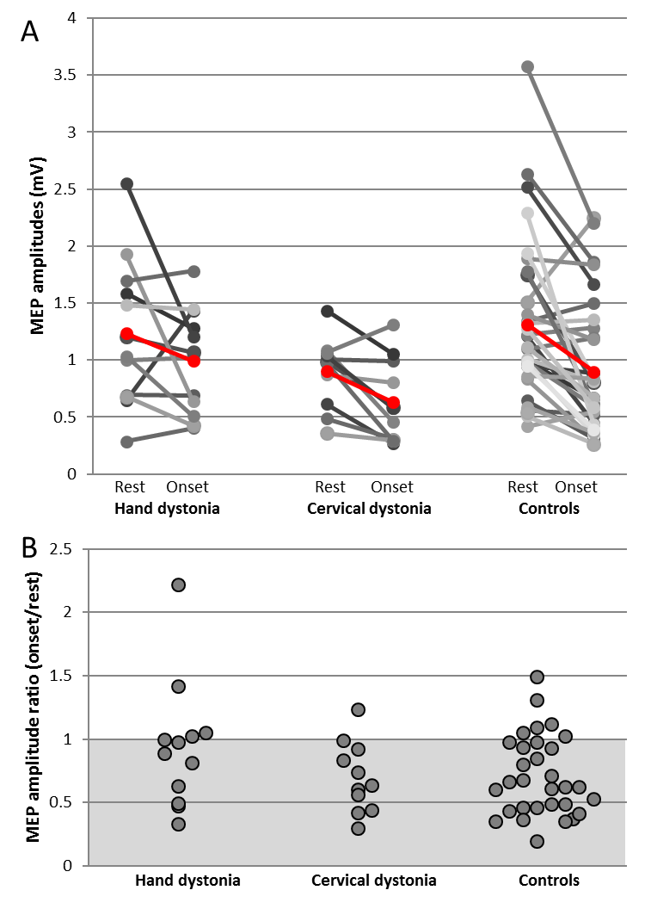

Figure 1 Α: MEPs at rest and onset of movement in the three groups. Red markers indicate the means Β: SI ratios in the three groups (individual subjects are plotted). Subjects are spread on the x-axis arbitrarily in order to minimize overlapping of subjects and to enhance visualisation. The grey area represents ratios below 1 (MEP at onset<MEP at rest).

No significant correlation was found between the ADDS scores and the SI ratios in the FHD group (p=0.26) or the TWSTRS scores and SI ratios in the CD group (p=0.91).

Differences in the RMS amplitude of EMG during FDI contraction were assessed with rmANOVA with the between group factor MUSCLE (2 levels: FDI and ADM) and between subjects factor GROUP (CD, FHD, Controls). We found significant effect of MUSCLE (F(1,51)=716.97, p<0.001) due to increased activation in the active FDI muscle (mean: 85.8µV, SD=49.5µV) in comparison to the surround ADM muscle (mean: 9.9µV, SD=6.6µV). There was no significant effect of GROUP (F(1,51)=0.323, p=0.73) or interaction MUSCLExGROUP (F(2,51)=0.125, p=0.88). Thus there was no significance difference in task execution between the groups which could account for the results.

In order to explore similarities and differences of our results compared to previously published data, we performed a review of previous studies which reported SI in FHD patients and healthy participants.

Review of studies on SI in healthy and FHD patients.

36 articles were identified but only 14 fulfilled the inclusion criteria. 4 of the included studies reported both a healthy control group and FHD group (Table 3). For the analysis we also included the newly collected data presented in this paper. Therefore, we used a total of 15 groups of healthy volunteers and 5 groups of patients with FHD (214 healthy volunteers and 64 FHD patients).
Healthy | Mean SI (%) | SEM | SD | N
Beck et al. 2009 Exp 2 | 65.8 | 6.3 | 28.2 | 20
Sohn et al. 2004 (AoN) | 75.9 | 11.8 | 31.1 | 7
Houdayer et al. 2012 | 88.9 | 6.5 | 27.4 | 18
Veugen et al. 2013 | 87.2 | 4.8 | 15 | 10
Present study | 70.6 | 5.7 | 31.6 | 31
Sohn et al. 2004 (EBR) | 69 | 4.9 | 17 | 12
Beck et al. 2010 | 84 | 5.2 | 17.2 | 11
Shin et al. 2009 | 67.2 | 5.1 | 16.2 | 10
Shin et al. 2010 | 91.8 | 8 | 25.5 | 10
Shin et al. 2007 | 84.5 | 16.4 | 46.5 | 8
Beck et al. 2009 Exp 1 | 76.9 | 4.4 | 19.2 | 19
Kang et al. 2012 | 82.5 | 5.6 | 21.7 | 15
Sadnicka et al. 2013 | 64.1 | 7.3 | 25.4 | 12
Kassavetis et al. 2012 | 74.5 | 6.7 | 26.6 | 16
Shin et al. 2012 | 85.2 | 6.3 | 24.4 | 15
Dystonia
Beck et al. 2009 Exp 2 | 105.9 | 8.7 | 34.8 | 16
Sohn et al. 2004 (AoN) | 177.8 | 40.2 | 106.3 | 7
Houdayer et al. 2012 | 115.7 | 26.8 | 113.6 | 18
Veugen et al. 2013 | 101 | 8.5 | 32.7 | 15
Present study | 94.1 | 14.5 | 50.4 | 12

Table 3: Studies included in the review of SI in healthy and FHD patients [6, 9, 11, 14-23]. Exp, experiment; AoN, Annals of Neurology; EBR, Experimental Brain Research.

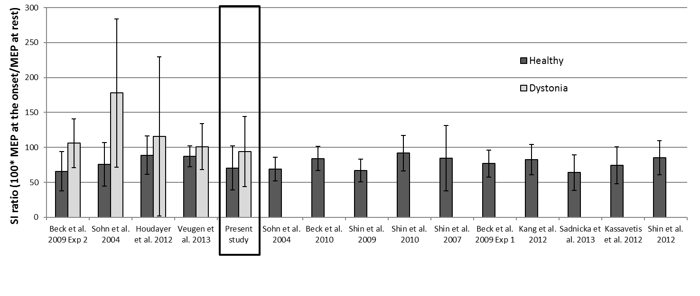
Figure 2: SI ratios in previous studies. Error bars indicate SD of the SI ratios as reported in the published papers. Within the black rectangular is the new data presented in this paper.

Figure 2 shows that our data visually fits within the range of SI generally found by others. Furthermore, we calculated the effect sizes in the 4 published studies that have compared SI in FHD and healthy participants and in our study (Table 4). Table 4 shows that the effect sizes vary significantly between studies and that our study is indeed within the previously published range. Heterogeneity of SI differences between FHD and controls, in the above studies was investigated with Cohran’s Q and I2 statistics [24] which showed non statistical significant, low heterogeneity (Table 5).

 | Effect size
Study | Cohen's d | r
Beck et al. 2009 Exp 2 | 1.26662107 | 0.535038
Sohn et al. 2004 | 1.30058769 | 0.545162
Houdayer et al. 2012 | 0.32452731 | 0.160169
Veugen et al. 2013 | 0.54005418 | 0.26069
Present study | 0.55823775 | 0.268843

Table 4: Effect sizes of differences of SI between FHD patients and healthy volunteers as reported in the literature

Q | 4.9527
df | 4
Significance level | p = 0.2922
I2 | 19.24%
95% CI for I2 | 0.00 to 84.19

Table 5: Cohran’s Q and I² statistics show low heterogeneity amongst studies.

Power calculations with the mean effect size of the 5 studies (d=0.80), alpha error probability of 0.05 and power of 0.80 (beta error =0.20) showed that a total number of 52 subjects (26 subjects in each group) is needed to investigate differences of SI between FHD and healthy participants. This is considerably higher than the sample size in all previous studies.

Comparison of the SI variability between healthy participants and FHD patients showed that there was significant difference between the two groups (SEM: t(18)=-3.93, p=0.001). FHD groups are more variable in regards to SI ratios (mean SEM=19.73) compared to groups of healthy controls (mean SEM=7.0) (Figure 3).

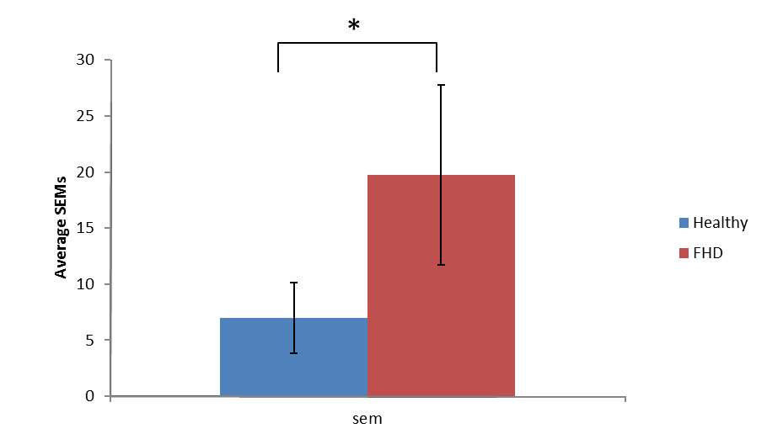
Figure 3: Average SEMs reported in the literature in groups of healthy volunteers (15 studies) and patients with FHD (5 studies).

DISCUSSION

In contrast to the general assumption that SI is abnormal in dystonia patients we failed to find a significant difference of the mean SI between FHD patients, CD patients and healthy controls. Sample size calculations showed that larger sample sizes are needed to provide adequate statistical power. Variability analysis of previous published data showed that FHD groups are more variable than healthy groups with regard to SI ratios. This study provides significant insight about published data and raises questions about our current understanding of SI in dystonia. SI is an exciting concept and has been well established in the sensory system. However, in the motor system the available data is still very limited especially in patient groups. Here, we provide evidence that low statistical power is an important confounding factor that may have influenced interpretation of prior studies. More specifically, the above results highlight the need to take into consideration differences in the baseline characteristics of healthy and patient groups when designing and interpreting studies of SI. In particular, increased variability of SI in the dystonia groups seems to be consistently present in the literature.

We acknowledge that TMS techniques are subject to high variability in general but the systematic differences between the groups may represents a true physiological difference. Variability of neurophysiological measures has been increasingly attracting significant interest in the scientific community and the assumption that variability does not simply represent noise but it is a true neurophysiological parameter has gained popularity recently[25, 26]. In the case of SI, we propose that variability might have common origins and perhaps represent a general instability of the motor system in patients with FHD. Previously published studies have presented findings of increased variability not only during movement but also at rest [27-31] which may be related to abnormalities in motor network connectivity in patient with FHD. Further studies on the spatial and temporal patterns of variability in these patients may provide valuable clues about its origins in the nervous system.

What are the implications of increased variability for statistical assessment of SI? Here we describe a systematic difference in variability of the MEP amplitudes between normal and dystonic groups which can potentially influence the statistical tests in group comparisons. Researchers commonly use normalisation methods to overcome this obstacle but with this study we highlight that normalisation is not always the right approach as it can mask systemic differences between the groups. Unfortunately, there is no consensus about the most appropriate statistical methods for analysis of TMS results and the design differences amongst neurophysiological studies does not allow exact replication of prior results. The TMS literature is flooded with studies of 10-15 subjects which can be appropriate when investigating large statistical effects. However, when multiple comparisons are employed or smaller effects are investigated the sample sizes may need to be increased as confirmed by the power calculations presented in this paper. A common assumption in the literature is that lack of significant statistical differences between MEPs measured in different conditions (conditioned vs unconditioned, rest vs movements etc) in patients, is usually interpreted as a “positive” result (impairment of the underlying inhibitory or excitatory network). However, as shown here, lack of difference in the patient group may be driven by increased variability of TMS measures in general. Therefore, although samples of 10-15 subjects may be appropriate for normal subject studies, this may not be the case for dystonic or other patient populations. In fact, the effect sizes as reported in previous studies are very variable (Table 4), which again highlights the possibility that underpowered studies may have caused inflation or underestimation of the real effect.

As a further question over the usefulness of FHD as a model for the hypothetical behavioural consequences of abnormal SI, we failed to find any correlation between clinical severity of dystonia and SI. Other electrophysiological parameters (i.e. SICI, response to PAS, SP) have been found to be ‘abnormal’ in dystonia but again no direct relation to clinical manifestation has been proven. SI in particular is commonly presented as a neurophysiological parameter that is causally linked to abnormal motor output in dystonia. The hypothesis that impaired SI in the dystonia groups would cause abnormal contractions of the non-active muscles is attractive but yet to be proven. Patients with focal hand dystonia have variable phenotypic presentations, therefore development of more detailed SI paradigms tailored specifically to the phenotypic expression of individual patients, would be more efficient to identify the abnormality without the “dilution effect” caused by phenotypic variability. In addition, more precise clinical or kinematic studies (able to capture the exact finger abnormalities) or experiments with clusters of patients with similar clinical symptoms could finally provide evidence for the association between SI and the motor performance.

With regards to the CD group, we found that these patients had SI comparable to the healthy group. This is an interesting finding given that other inhibitory networks within the motor cortex have also been found to be normal in those patients[32-34]. The significance of this finding is unclear as the sample size is small. This is the first time SI is described in CD therefore more studies are needed to draw firm conclusions. It is possible that in CD, the topography of abnormality within the CNS is spatially closer to the head/neck somatosensory representations compared to hand representations. Therefore, it is less likely to capture neurophysiological abnormalities when recording SI in the hand. At this stage we would defer more detailed pathophysiological speculations based on this finding.

This study, similarly to previous studies on SI, is limited mainly due to limitations of the TMS as a neurophysiological technique. The arbitrary choice of the TMS intensity as the intensity to evoke MEPs with average peak-to peak amplitude of approximately 1mV-1.5mV in the ADM muscle has been criticized in the past. While this method is extremely common in the literature, it is probably not optimal. The "1 mV standard" may have a variable position on an Input/Output curve and thus a variable response to a change in excitability. Other authors have suggested alternative techniques such as to set the test stimulus intensity to produce 50% of the maximal MEP amplitude at rest[35]. In this study, we followed the design of previous studies to group data from patients with WC and MD. We acknowledge that there is evidence of pathophysiological differences between the these two conditions[36] therefore future studies may need to further explore differences between MD and WC with regards to SI.

CONCLUSIONS

We studied SI in patients with two different types of focal dystonia (FHD and CD) and we found that their SI is similar to healthy participants. In addition, we found that patients with FHD have more variable SI, which is further confirmed by review and analysis of previously published studies. The most direct implication of this variability is that larger sample sizes are needed to power future studies in order confirm or reject the null hypothesis that SI is impaired in patients with FHD (significant different from healthy subjects).

REFERENCES
1. Ratliff, F., et al., Enhancement of flicker by lateral inhibition. Science, 1967. 158(3799): p. 392-3.
2. Ratliff, F., B.W. Knight, and N. Graham, On tuning and amplification by lateral inhibition. Proc Natl Acad Sci U S A, 1969. 62(3): p. 733-40.
3. Wehr, M. and A.M. Zador, Balanced inhibition underlies tuning and sharpens spike timing in auditory cortex. Nature, 2003. 426(6965): p. 442-6.
4. Olsen, S.R. and R.I. Wilson, Lateral presynaptic inhibition mediates gain control in an olfactory circuit. Nature, 2008. 452(7190): p. 956-60.
5. von Bekesy, G., Mach band type lateral inhibition in different sense organs. J Gen Physiol, 1967. 50(3): p. 519-32.
6. Sohn, Y.H. and M. Hallett, Surround inhibition in human motor system. Exp Brain Res, 2004. 158(4): p. 397-404.
7. Stinear, C.M. and W.D. Byblow, Impaired modulation of intracortical inhibition in focal hand dystonia. Cereb Cortex, 2004. 14(5): p. 555-61.
8. Kassavetis, P., et al., Motor 'surround inhibition' is not correlated with activity in surround muscles. Eur J Neurosci, 2014.
9. Sohn, Y.H. and M. Hallett, Disturbed surround inhibition in focal hand dystonia. Annals of Neurology, 2004. 56(4): p. 595-9.
10. Sadnicka, D.A., et al., Cerebellar transcranial direct current stimulation does not alter motor surround inhibition. Int J Neurosci, 2013.
11. Kassavetis, P., et al., Adaptation of surround inhibition in the human motor system. Exp Brain Res, 2012.
12. Di Lazzaro, V., et al., The physiological basis of transcranial motor cortex stimulation in conscious humans. Clin Neurophysiol, 2004. 115(2): p. 255-66.
13. Kaneko, K., et al., The effect of current direction induced by transcranial magnetic stimulation on the corticospinal excitability in human brain. Electroencephalogr Clin Neurophysiol, 1996. 101(6): p. 478-82.
14. Sadnicka, A., et al., Cerebellar transcranial direct current stimulation does not alter motor surround inhibition. Int J Neurosci, 2013. 123(6): p. 425-32.
15. Beck, S., et al., Surround inhibition depends on the force exerted and is abnormal in focal hand dystonia. J Appl Physiol, 2009. 107(5): p. 1513-8.
16. Houdayer, E., et al., The differential modulation of the ventral premotor-motor interaction during movement initiation is deficient in patients with focal hand dystonia. Eur J Neurosci, 2012. 35(3): p. 478-85.
17. Veugen, L.C., et al., Inhibition of the dorsal premotor cortex does not repair surround inhibition in writer's cramp patients. Exp Brain Res, 2013. 225(1): p. 85-92.
18. Beck, S. and M. Hallett, Surround inhibition is modulated by task difficulty. Clin Neurophysiol, 2010. 121(1): p. 98-103.
19. Shin, H.W., et al., Extended surround inhibition in idiopathic paroxysmal kinesigenic dyskinesia. Clin Neurophysiol, 2010. 121(7): p. 1138-41.
20. Shin, H.W., S.Y. Kang, and Y.H. Sohn, Disturbed surround inhibition in preclinical parkinsonism. Clinical Neurophysiology, 2007. 118(10): p. 2176-2179.
21. Kang, S.Y., M. Hallett, and Y.H. Sohn, Synchronized finger exercise reduces surround inhibition. Clin Neurophysiol, 2012. 123(11): p. 2227-31.
22. Shin, H.W., et al., Reduced surround inhibition in musicians. Exp Brain Res, 2012. 219(3): p. 403-8.
23. Shin, H.W., Y.H. Sohn, and M. Hallett, Hemispheric asymmetry of surround inhibition in the human motor system. Clin Neurophysiol, 2009. 120(4): p. 816-9.
24. Higgins, J.P., et al., Measuring inconsistency in meta-analyses. BMJ, 2003. 327(7414): p. 557-60.
25. Goris, R.L., J.A. Movshon, and E.P. Simoncelli, Partitioning neuronal variability. Nat Neurosci, 2014. 17(6): p. 858-65.
26. Stein, R.B., E.R. Gossen, and K.E. Jones, Neuronal variability: noise or part of the signal? Nat Rev Neurosci, 2005. 6(5): p. 389-97.
27. Mohammadi, B., et al., Changes in resting-state brain networks in writer's cramp. Hum Brain Mapp, 2012. 33(4): p. 840-8.
28. Hinkley, L.B., et al., Complex-value coherence mapping reveals novel abnormal resting-state functional connectivity networks in task-specific focal hand dystonia. Front Neurol, 2013. 4: p. 149.
29. Panizza, M., et al., H-Reflex Recovery Curve and Reciprocal Inhibition of H-Reflex in Different Kinds of Dystonia. Neurology, 1990. 40(5): p. 824-828.
30. Ridding, M.C., et al., Changes in the Balance between Motor Cortical Excitation and Inhibition in Focal, Task Specific Dystonia. Journal of Neurology Neurosurgery and Psychiatry, 1995. 59(5): p. 493-498.
31. Hanajima, R., et al., Difference in intracortical inhibition of the motor cortex between cortical myoclonus and focal hand dystonia. Clin Neurophysiol, 2008. 119(6): p. 1400-7.
32. Talelli, P., et al., A distinctive pattern of cortical excitability in patients with the syndrome of dystonia and cerebellar ataxia. Clin Neurophysiol, 2011. 122(9): p. 1816-9.
33. Kojovic, M., et al., Secondary and primary dystonia: pathophysiological differences. Brain, 2013. 136(Pt 7): p. 2038-49.
34. Hanajima, R., et al., Cortico-cortical inhibition of the motor cortical area projecting to sternocleidomastoid muscle in normals and patients with spasmodic torticollis or essential tremor. Electroencephalogr Clin Neurophysiol, 1998. 109(5): p. 391-6.
35. Lebon, F., et al., Task-dependent interaction between parietal and contralateral primary motor cortex during explicit versus implicit motor imagery. PLoS One, 2012. 7(5): p. e37850.
36. Rosenkranz, K., et al., Pathophysiological differences between musician's dystonia and writer's cramp. Brain, 2005. 128(Pt 4): p. 918-31.

ACKNOWLEDGEMENTS
Dr Kassavetis is funded by the Bachmann-Strauss Dystonia & Parkinson Foundation and has received financial support from Parkinson’s UK (Ref. number G-1009), the Dystonia Medical Research Foundation, the Movement Disorders Society and the Guarantors of Brain.
Dr Sadnicka is funded by the Guarantors of Brain with an Association of British Neurologists Clinical Training Fellowship and has received financial support from the Dystonia Medical Research Foundation and the Movement Disorders Society.
Dr Saifee has received funding by a fellowship awarded by the National Institute for Health Research.
Dr Pareés is funded by the Fundación Alfonso Martín Escudero and has received support from the Anglo-Spanish Society.
Dr Kojovic has nothing to declare.
Prof Bhatia received funding for travel from GlaxoSmithKline, Orion Corporation, Ipsen, and Merz Pharmaceuticals, LLC; serves on the editorial boards of Movement Disorders and TherapeuticAdvances in Neurological Disorders; receives royalties from the publication of Oxford Specialist Handbook of Parkinson’s Disease and Other Movement Disorders (Oxford University Press, 2008); received speaker honoraria from GlaxoSmithKline, Ipsen, Merz Pharmaceuticals, LLC, and Sun Pharmaceutical Industries Ltd.; personal compensation for scientific advisory board for GSK and Boehringer Ingelheim; received research support from Ipsen and from the Halley Stewart Trust through Dystonia Society UK , and the Wellcome Trust MRC strategic neurodegenerative disease initiative award ( Ref. number WT089698), a grant from the Dystonia Coalition and a grant from Parkinson’s UK ( Ref. number G-1009).
Prof Rothwell has current grant support from European Union FP7, Tourette Association, Dystonia Medical Research Foundation, The Stroke Association and The Royal Society.
Dr Edwards is funded by a fellowship awarded by the National Institute for Health Research and is supported by researchers at the National Institute for Health Research University College London Hospitals Biomedical Research Centre.

