Title: The Role of Cardiovascular Magnetic Resonance in the Assessment of Highly Trained Athletes

Running Title:
CMR in athletes

Sabiha Gati¹, PhD, MRCP; Sanjay Sharma², MD, FRCP FESC; Dudley Pennell¹, MD, FRCP, FMedSci

¹Royal Brompton & Harefield NHS Foundation Trust, London UK

²St. George’s Hospital, University of London, UK

Corresponding Author:
Dr Sabiha Gati
Royal Brompton Hospital
Sydney St, Chelsea, London SW3 6NP
Tel: 020 7352 8121 ext 2808
Email: sgati@rbht@nhs.uk

Conflicts of interest: None to declare
Key Words: Cardiovascular magnetic resonance, Athlete’s Heart

Abstract word count: 110.

Manuscript Word Count: 6611

Abstract
Exercise associated benefits on the cardiovascular systems are well established. Although exercise associated sudden cardiac death is rare, most deaths in young athletes are due to hereditary or congenital cardiac diseases. Athletic adaptation itself is associated with several structural changes that overlap those observed in individuals with cardiomyopathies, often leading to dilemmas for the clinician regarding life changing decisions including advice against competitive sports participation. Cardiovascular magnetic resonance (CMR) plays an increasingly important role in helping to establish an accurate diagnosis in these individuals. This review highlights the role of CMR in differentiating physiological adaptation in athletes from pathology.

Abbreviations:
ARVC – Arrythmogenic right ventricular cardiomyopathy
CMR- Cardiovascular magnetic resonance
DCM – Dilated cardiomyopathy
ECV – Extracellular volume
EF – Ejection fraction
HCM – Hypertrophic cardiomyopathy
LGE- Late gadolinium enhancement
LV – Left ventricle
LVNC – Left ventricular non-compaction
RV – Right ventricle
SCD – Sudden Cardiac Death

Introduction
The benefits of exercise on the cardiovascular system are well established.¹ Exercise curbs several risk factors for atherosclerosis and reduces the risk of an adverse event from coronary artery disease by 50% in the 5th and 6th decades of life. In this regard, young athletes symbolize the essence of good health. These individuals impress with their extraordinary physical skills and stamina. However, occasionally a young athlete may die suddenly during training or competition. Such events are catastrophic, not only because of the number of life years lost in an apparently healthy individual, but also because they frequently occur in the public domain.

Exercise associated sudden cardiac death (SCD) in the young is rare, affecting 1 in 50,000 athletes. The mean age of the athletes affected in Europe is 23 years old. Males are more vulnerable than females with a 9:1 ratio and black athletes are more susceptible than white athletes with an 8:1 ratio.² Almost 80% of athletes are asymptomatic prior to death. Most deaths occur during or just after exercise, suggesting that the multiple stresses of exercise including dehydration, electrolyte imbalance, adrenergic surge, and acid base disturbance may act as a trigger for arrhythmia in these predisposed athletes. The majority of deaths are due to electrical and structural diseases, which can be diagnosed during life and for which there are several interventions to modify the natural history of diseases, including prevention of sudden death.

Based on the aforementioned considerations, there are several initiatives to identify young athletes at risk. These range from mandatory cardiovascular screening in the highest echelons of sport, charitable organisations offering subsidised screening programmes, or investigation of a young person with symptoms suggestive of cardiovascular disease or a family history of inherited cardiovascular disease. However athletic adaptation itself is associated with a number of electrical and structural changes that overlap with commonly recognised features of several cardiomyopathies. Such issues usually affect athletes with a left ventricular wall thickness >12mm or athletes with large left or right ventricular cavities and reduced ejection fraction. Athletes of African or Afro-Caribbean origin (black) engaged in explosive sprint sports with a start-stop nature, such as soccer, and endurance athletes provide challenging clinical scenarios where an inaccurate diagnosis may result in unnecessary disqualification or potentially jeopardise a young life. Cardiovascular magnetic resonance (CMR) is an essential tool for facilitating an accurate diagnosis in these athletes and this review will address the role of CMR in differentiating athlete’s heart from structural heart disease.

Role of CMR
CMR has an important role in providing detailed characterisation of the myocardium with high temporal and spatial resolution. Functional cine CMR sequences (i.e. steady-state free precession) allow delineation of the epicardial and endocardial borders of the ventricles, accurate measurement of ventricular wall thickness, regional hypertrophy, and wall motion abnormalities. CMR also provides full ventricular coverage with no interslice gap for accurate assessment of ejection fraction and the ability to image in any plane, permits analysis of coronary origins. CMR also has the unique capability of detecting myocardial fibrosis with late gadolinium imaging which often provides clarification of a disease process in athletes with structural features overlapping with cardiomyopathy (“the grey zone”). Other CMR sequences of value include stress perfusion for ischaemia assessment, T2 STIR (or mapping) for myocardial oedema in acute myocarditis, and T1 mapping/extracellular volume assessment for interstitial fibrosis.

Differentiating Athlete’s Heart From Hypertrophic Cardiomyopathy.
Approximately 2% of white athletes and up to 13% of black athletes have a LV wall thickness of 13-16mm, which may be consistent with morphological mild hypertrophic cardiomyopathy (HCM). The differentiation between HCM and physiological LV hypertrophy is one of the commonest scenarios encountered in sports cardiology. Although there are echocardiography based algorithms to help differentiate physiological LV hypertrophy from HCM, the data available make comparisons between sedentary individuals with HCM and athletes with physiological LV hypertrophy.^{3, 4} In general, HCM is characterised by left ventricular hypertrophy with a non-dilated LV and abnormal diastolic function in 80%.⁵ Until recently the cardiovascular adaptation in athletes with HCM was unknown. In 2015, Sheikh et al. reported electrical and structural cardiac manifestations in 102 athletes diagnosed with HCM during pre-participation screening or family screening.⁶ The athletes were asymptomatic and competed in regular sport at regional, national or international level at the time of diagnosis. The study showed that most athletes with HCM have relatively mild LVH (15-16 mm), a larger LV cavity and normal indices of diastolic function compared with sedentary HCM patients. Among athletes with HCM, 85% showed an asymmetric pattern of LV hypertrophy, which was confined to the LV apex in 36% of cases. Only a very small proportion of athletes fulfilled the conventional ‘grey’ zone, i.e. concentric LVH with maximum LV wall thickness ranging between 13-15mm. In these individuals, an important minority (13%) had an LV cavity size≥ 54mm, and almost 100% had normal indices of diastolic function measured with mitral valve inflow Doppler and tissue Doppler at the level of the mitral annular ring. Another important point emphasised by this study was that almost all athletes (98%) showed lateral T-wave inversion on the electrocardiogram. If current echocardiographic criteria were applied to competitive athletes with HCM, then a significant proportion with apical HCM, those with a large LV cavity and those with entirely normal diastolic function, may not be detected. In this regard the 12-lead ECG may be the “tell-tale” feature and for this reason all athletes with deep T wave inversion, (other than T wave in leads V1-V4 in black athletes) should be investigated with CMR (Figure1).⁷ In a recent study, Schnell et al. assessed 155 athletes with deep T-wave inversion, of which 80% was confined to the lateral leads.⁸ Almost 40% of the athletes were subsequently diagnosed with cardiomyopathy. Echocardiography was diagnostic in 24% of athletes. CMR confirmed all of the echocardiographic diagnoses and revealed additional cases of cardiomyopathy or healed myocarditis in a further 24 athletes, demonstrating that CMR significantly increases the diagnostic yield of cardiomyopathy in athletes with marked repolarisation changes and a normal echocardiogram.

CMR with its high spatial resolution can better define wall thickness where echocardiographic images are ambiguous. In addition, CMR can define regions of subtle localised patterns of hypertrophy not clearly visualised on echocardiography, including apical and lateral wall hypertrophy (Figure 2). Tissue characterisation using LGE allows identification of macroscopic replacement fibrosis. In HCM, myocardial fibrosis is usually patchy occurring within maximally hypertrophied segments. In the presence of LV hypertrophy, the existence of fibrosis greatly helps to clarify the diagnosis of HCM. One study has shown that quantification of fibrosis may be relevant to arrhythmic risk and prognosis,⁹ however other studies have only been able to show an association between LGE in subsequent development of heart failure rather than sudden cardiac death.¹⁰ ¹¹ Macroscopic myocardial fibrosis is detected in just over 50% of HCM patients; therefore, the absence of LGE cannot be used to exclude HCM.⁹ In such cases, the novel technique of T1 mapping and extracellular volume assessment (ECV), which is still a research tool, may provide quantitative assessment of myocardial composition (i.e. total extent of expanded extracellular space) for athletes with a wall thickness between 12-15mm.

Swoboda et al. assessed 40 highly trained athletes with physiological LV hypertrophy with CMR and 1 mapping and demonstrated an inverse relationship between ECV and LV wall thickness.¹² These findings suggest that physiological LV hypertrophy is due to myocyte enlargement rather than increased extracellular matrix. In contrast, the pathological LV hypertrophy of HCM correlated directly with ECV indicating that a significant proportion of the LV mass is due to an increase in extracellular matrix. Among athletes with a LV wall thickness of 12-15mm, an ECV >22.5% showed sensitivity of 100% and specificity of 90% for diagnosing HCM. McDiarmid et al. compared the ECV in 30 endurance athletes and 15 healthy controls. ¹³ They found that athletes with very high peak VO₂ (>60mls/kg/min) had the largest compartmentalised mass i.e. mass constituted by myocyte enlargement, compared with untrained athletes and individuals with a peak VO₂ <60mL/kg/min. Despite its potential in differentiating between physiological LV hypertrophy and HCM, T1 mapping requires validation in a much larger cohort of athletes particularly those with HCM.

Differentiating Athlete’s Heart From Arrythmogenic Right Ventricular Cardiomyopathy
The distinction between physiological right ventricular (RV) enlargement and arrythmogenic right ventricular cardiomyopathy (ARVC), a genetic disease associated with fibro-fatty infiltration of the RV myocardium is increasingly important. Arrythmogenic right ventricular cardiomyopathy accounts for 4-22% of SCD in athletes.¹⁴ CMR is superior to echocardiography in providing detailed characterisation of the RV volume, function and regional wall motion abnormalities, given its high spatial resolution. It is well recognised that up to 14% of endurance athletes exhibit anterior T-wave inversion in V1-V2/V3¹⁵ and up to 40% of endurance athletes show a right ventricular out-flow dimensions within the range that would be consistent with a diagnosis of ARVC.¹⁶ Furthermore, a significant proportion of endurance athletes reveal a borderline low RV fractional area change¹⁷ and 2.5% of athletes have ventricular extra-systoles arising from the RV out-flow tract which are the commonest type of ventricular extra-systoles identified in patients with ARVC. The current imaging task force criteria for ARVC include RV dysfunction and RV akinesia before a diagnosis of ARVC can be considered. Echocardiography may fail to identify subtle RV wall motion abnormalities. Conversely, usual wall motion anomalies adjacent to the insertion of the moderator band may be potentially misinterpreted as pathology.

Zaidi et al.¹⁶ assessed the accuracy of the diagnostic criteria for ARVC when applied to athletes with T-wave inversion and attempted to identify discriminators between physiological adaptation and pathology. The authors comprehensively assessed 45 athletes with T-wave inversion, 35 athletes without T-wave inversion and 35 young patients with ARVC using 12-lead ECG, echocardiography, CMR, exercise treadmill test, 24-hour Holter ECG and signal average-ECG. The main findings were that balanced biventricular dilatation was likely to represent a benign manifestation of training in asymptomatic athletes without a relevant family history of cardiomyopathy or SCD. In contrast, a RV ejection fraction <45% on CMR, RV end-diastolic volume/LV end-diastolic volume>1.3:1, regional wall motion abnormalities in RV and presence of LGE were highly indicative of ARVC.

The thin walled RV poses challenges in the assessment of global RV LGE in ARVC, however, recent advances in 3D-LGE allow improved visualisation of fibrosis and should be considered where there is suspicion of subtle fibrosis (Figure 3). Furthermore, RV insertion point fibrosis appears to be common in athletes and may be observed in up to 40%. It is considered to be a benign feature from the mechanical pull of the thinned wall RV during exercise on the RV/LV septal insertion hinge point. ¹⁸

Advances in the molecular genetics of ARVC and pathology studies have revealed that the disease process may also affect the LV and occasionally be confined solely to the LV.¹⁹ ²⁰ In the latter case, the presence of a non-ischaemic pattern of LGE affecting an athlete with a high ventricular ectopic burden but otherwise preserved and synchronous ventricular contraction may signal a potentially serious cardiomyopathy which will not be detected with echocardiography.²¹ Indeed, all athletes with a high ectopic burden with normal cardiac structure and function on echocardiography should be referred for CMR (Figure).

Differentiating Athlete’s heart and Dilated Cardiomyopathy
Dilated cardiomyopathy (DCM) is defined as a dilated LV with reduced ejection fraction in the absence of significant ischaemic heart disease, hypertension or valvular disease and is a rare but recognised cause of SCD in athletes.²² In the majority of athletes with DCM, the inability to generate a satisfactory cardiac output during exercise selects them out for competitive sport.

Endurance athletes such as long-distance runners, swimmers, rowers and cyclists may develop significant chamber dilatation due to long-term volume and pressure overload, which overlaps with DCM. Pelliccia et al. assessed 1309 elite athletes and observed that the LV end-diastolic dimension exceeded the normal limits of >54mm in 584 (45%) athletes and 14% had an end-diastolic dimension >60mm.²³ Similarly, an echocardiographic study by Abergel et al. of 286 elite professional cyclists competing in the ‘Tour de France’ competition showed that 214 athletes (75%) had an LVEDD outside the normal range (cut-off of 57.4mm as the upper limit of normal), with 147 athletes (51%) having an LVEDD >60mm and 4 (1.4%) athletes with LVEDD>70mm.²⁴

Although there are echocardiographic values from many thousands of athletes of differing demographics and sporting practices, normal CMR values in athletes have been reported by few centers and from a less diverse sporting population. Prakken et al. provide the largest CMR data describing the normal range of cardiac morphology and function.^{25, 26} They compared biventricular volumes, masses and dimensions in 222 endurance athletes (79 elite and 143 recreational; 42% female) with 114 age and sex-matched non-athletes. Indexed LV end-diastolic volume and wall mass were higher in regular and elite athletes than in non-athletes. Male sex, BSA and training hours per week were associated with larger ventricular volumes and greater mass. Approximately 50% of elite male athletes revealed a short-axis LV diameter >60mm in and short-axis and a RV diameter exceeded 50mm. 16% of elite female athletes showed a LV diameter > 60 mm or a RV diameter > 50 mm.

A common misconception amongst physicians is that the resting LV ejection fraction (EF) should be normal in athletes. In reality, athletes with large LV volumes do not require a high EF to deliver a cardiac output of 5L/min at rest. Indeed, endurance athletes may show a low LV EF. Among Tour de France cyclists, 37% had LV EF ≤60%, 15% had an EF of 52-56% and 11% had an EF<52% but no less than 45%.²⁴ Similarly, CMR also underestimates overall cardiac function at rest. Prakken et al.²⁵ assessed the resting EF in 79 elite athletes and revealed a mean LV EF of 55 +/- 5.5% and mean RV EF 50 +/- 4.4%. Interestingly, in their cohort 22 (28%) athletes had a resting LV EF of 45-50% and 19 athletes (24%) had a lower EF of 40-45%. These observations have the potential of an erroneous diagnosis of DCM in an athlete. In such cases, the detection of LGE in the mid wall of the LV is almost pathognomonic of an underlying cardiomyopathy in a patient with an increased LV volume and reduced EF, but the absence of LGE does not necessarily exclude a DCM.²⁷

Perhaps differentiating physiological LV/RV enlargement from DCM requires a technique to enable comprehensive assessment of biventricular filling and emptying during exercise. Exercise echocardiography can be helpful in cases where athletes exhibit a combination of LV dilatation and suppressed or low-normal resting EF. Abernethy et al. demonstrated normalization of LV function with exercise in all their athletes with reduced resting systolic function. ²⁸ In contrast, patients with DCM rarely demonstrate the ability to augment cardiac output in response to increased metabolic demands.²⁹ Simultaneous measurement of gas exchange during a cardiopulmonary exercise testing may also prove useful in the diagnosis of DCM ³⁰ although an exercise CMR based study comparing athletes with physiological LV enlargement and athletes with DCM showed that the peak VO2 consumption values between the groups were not discriminative.(Ref)

La Gerche et al. described a novel technique of real-time-ungated CMR measuring biventricular volumes during high intensity exercise. ³¹ Electrocardiographic and respiratory movements were retrospectively synchronized enabling compensation for the cardiac cycle and respiratory phase. The real-time-ungated sequence was compared with standard exercise CMR with ECG gating and furthermore, the accuracy of this new sequence was substantiated with invasive direct Fick method of cardiac output assessment. The authors tested 34 active subjects of whom 4 were competitive athletes. A separate cohort of 19 subjects participated in the validation and reproducibility phase of the study. The technique was deemed feasible, reproducible and accurate in their cohort of subjects. Interestingly, athletes (n=10) demonstrated an increase in resting cardiac output from mean 8.4±2.6L/min to 25.4±4.5L/min with exercise. The same authors subsequently developed an in-scanner real-time CMR protocol to assess dynamic increases in ventricular function with exercise (Ref). More recently, Le et al.³² also described an in-scanner exercise real-time CMR protocol that was tested in 11 athletes and 11 non-athletes and showed that the technique was highly reproducible. Such techniques have to facilitate the differentiation between physiology and pathology in athletes with large ventricular volumes and mildly low ejection fractions.

Although still a research tool, T1 mapping and ECV may provide quantitative assessment of myocardial composition in athletes within the grey zone. In a recent study by Mordi et al. T1 and T2 mapping was assessed in 16 patients with non-ischaemic DCM with an EF between 45-55%, 21 healthy controls and 21 males with a history of aerobic exercise for at least 6 hours per week and an EF between 45-55%.³³ The authors reported higher native T1, ECV and T2 relaxation times in patients with DCM compared with controls and athletes. In their study, native T1 provided the best method of differentiation between individuals who exercised and patients with DCM. Importantly, a quarter of the patients with DCM had mid-wall fibrosis with the potential of falsely raising the native T1 value. Further studies in larger cohorts are necessary to establish the role of T1 mapping in differentiating physiological cardiac adaptation from DCM.

Left Ventricular Non-Compaction in Athletes
Left ventricular non-compaction (LVNC) is characterized by a double-layered LV myocardial wall architecture comprising of a thin compacted epicardial layer and a trabeculated inner endocardial layer. It is well recognized that a high proportion of athletes (8%) fulfill current echocardiographic criteria for LVNC criteria (Figure 4).³⁴ It is unlikely that such a high proportion of individuals have genuine cardiomyopathy.³⁵ Data from patients with chronic anaemia, and pregnant women suggest that increased LV trabeculations may occur due to a chronic increase in preload.^{35, 36} CMR with its superior spatial resolution provides a detailed assessment of the thin epicardial layer and can differentiate endocardial trabeculations from apical HCM and crypts within the epicardium, which are rarely detectable with echocardiography. Furthermore, CMR is more specific for regional wall motion abnormalities and quantifying impaired LV function as well as confirming pathology in the presence of fibrosis. There are currently several CMR criteria proposed for the diagnosis of LVNC. The first from Petersen et al. in 2005 proposed a ratio of >2.3 in diastole as a differentiating factor for LVNC.³⁷ The Multi-ethnic Study of Atherosclerosis (MESA) demonstrated that the Petersen criteria had low specificity for excluding people without LVNC.³⁸ Furthermore, the measurements in the long-axis views are variable due to difficulty excluding the papillary muscle structure. Jacquier et al. proposed a slightly different approach to the diagnosis of LVNC by calculating the LV trabecular mass and showing that a trabecular mass >20% of the total LV mass was predictive of LVNC.³⁹ Subsequent evaluation of the Jacquier criteria by others has demonstrated poor interobserver variability.⁴⁰ Captur et al. summarized global LV trabecular complexity as a continuous variable termed fractal dimension.⁴¹ A fractal dimension cut-off ≥ 1 provided the optimal prediction for patients with LVNC. The fractal approach was reproducible compared with LVNC analysis techniques proposed by Petersen and Jacquier. However, specific software is required and large-scale trials are necessary to validate this technique. Furthermore, a diagnosis of LVNC should not solely rely on imaging alone and should take in to account the clinical presentation, family history, 12-lead ECG and cardiac function to increase the sensitivity of diagnosis.

Myocarditis in Athletes
Myocarditis is an important cause of arrythmogenic SCD in young athletes. It is recommended that all athletes in whom myocarditis is suspected should be investigated with CMR. Grun et al. investigated 203 biopsy proven viral myocarditis patients and showed that LGE was the best predictor of mortality (HR 12.8) that was independent of symptoms, EF and LV end-diastolic volume. ⁴² Whereas asymptomatic athletes with myocarditis may return to sport if they have a normal echocardiogram, exercise capacity and no arrhythmias, the current European sports cardiology consensus is that the precise timing for return may be guided by the presence of LGE (Figure 5). Athletes with LGE should be advised to refrain for competition for 6 months. Formal prospective studies are required to determine whether LGE provides prognostic information about the management of athletes with myocarditis.

Congenital Coronary Artery Anomaly in Athletes
Congenital coronary artery anomalies may cause SCD in young athletes particularly if a coronary artery originates from the opposite sinus of Valsalva and has an inter-arterial course between the aorta and the pulmonary artery. The risk is greater if the left coronary artery originates from the right sinus of Valsalva.⁴³ The prevalence of anomalous coronary origins is ≤0.45%.⁴³ Anomalous coronary artery origin should be considered in any athlete presenting with unexplained chest pain or syncope. The origin of the coronary arteries is possible with echocardiography using the short axis views of the aorta.⁴⁴ Although visualisation of the left coronary artery is possible in up to 97% cases, identification of the origin of the right coronary artery may not be possible is as many as 20% of athletes.⁴⁵ The spatial resolution for imaging the coronary arteries with CMR angiography is inferior to CT coronary angiography although CMR angiography has the capability of visualising the origins and proximal course of the arteries (Figure 6).⁴⁶ Furthermore, CMR stress perfusion allows for assessment of inducible ischaemia, which has an important role in decisions relating to surgical intervention in asymptomatic right coronary origin from the left sinus of Valsalva.

Veteran Athletes
Over the past few decades, endurance events such as the marathon, triathlon and iron-man have become increasingly popular with individuals in their fifth decade onwards. Indeed, such veteran athletes comprise almost 40% of major marathons and many have exercised intensively for decades. In parallel, there have been several reports demonstrating high concentration of biomarkers of cardiac damage and transient reduction in ventricular function after exercise.
It has been postulated that such biochemical and functional profiles (albeit transient) may reflect a subclinical myocarditis that may ultimately result in a substrate for arrhythmogenesis. Animal studies in rats forced to exercise for an hour per day for 16 weeks have shown fibrosis in the atria and RV, impaired LV relaxation and ease of inducibility of both atrial fibrillation and ventricular tachycardia.⁴⁷ Although no study in humans who have exercised intensively have been able to link troponin leak with myocardial inflammation,⁴⁸ there are emerging reports that life long athletes reveal an increased prevalence of myocardial fibrosis compared to sedentary counterparts of similar age.⁴⁹

The initial studies in veteran athletes were conducted by Breuckmann et al.⁵⁰ The authors assessed 102 healthy asymptomatic veteran male marathon runners aged 50-72 years who had completed at least 5 marathons during the past 3 years and revealed a non-significant increase in prevalence of LGE between athletes and age-matched controls (12% vs 4%, p=0.07). Of the 12 athletes with LGE, 5 had a subendocardial distribution typical of coronary artery disease pattern infarction and 7 had non-specific mid-myocardial patchy pattern of LGE. An important limitation of this study was that over 50% of athletes were previous smokers and further 4.6% current smokers raising the possibility that the subendocardial LGE was the result of coronary disease and endothelial dysfunction. The 7 individuals with non-coronary artery disease LGE pattern raised the possibility that life long distance running may cause myocardial scarring. Wilson et al. also assessed 12 life-long veteran endurance athletes all of whom had run over 100 marathons with CMR and LGE and identified myocardial fibrosis in 6 (50%) athletes compared with 20 age matched veteran controls and 17 younger male endurance athletes.⁵¹ Four athletes had a non-specific LGE pattern, 1 had findings consistent with previous myocarditis and 1 with features of myocardial infarction. The authors demonstrated that LGE is associated with the number of years of training (p<0.001), and number of competitive marathons (p<0.001) completed.

A CMR study of 158 veteran athletes (28 young athletes, 71 veteran controls and 21 young controls) demonstrated that both young and veteran athletes have greater LV mass on CMR than their sedentary counterparts.^{49, 52} The myocardial native T1 signal, which is a measure of the interstitial space and its constitution and the ECV compartment, was lower in athletes than controls suggesting that the increased LV mass in athletes is due to cellular hypertrophy rather than expansion of interstitial space. Comparison of young athletes with older athletes showed that younger athletes were capable of developing a greater LV mass than older athletes, however, T1 mapping and extracellular volume measurements were no different between younger or older athletes. These findings suggest that life long exercise results in expansion in interstitial space or diffuse fibrosis. Furthermore, veteran athletes that ran long distance compared with those who participated in short distances had larger end-diastolic volumes, greater LV mass but smaller T1 signal and lower extracellular volume. The authors also identified minor fibrosis within RV insertion points, papillary muscles or RV trabeculae in 44% of athletes and 10% of controls. There were no differences in the prevalence of minor focal fibrosis between veteran athletes and young athletes; however, focal fibrosis was more common in male athletes compared with female athletes. Major fibrosis within the compacted myocardium was almost exclusively present in 11.4% of veteran male athletes with age being the only independent predictor. An ischaemic LGE pattern was identified in one third of veterans, 56% showed a non-ischaemic pattern and 11% demonstrated both patterns. This study was cross-sectional; therefore, the significance of myocardial fibrosis in veteran athletes is uncertain and larger prospective studies are required.

Conclusion
CMR has a pivotal role in evaluating cardiac structural changes in competitive athletes who often present with challenging and diagnostic dilemmas. CMR enables the detection of athletes at risk of SCD by providing precise assessment of the LV and RV function and tissue characterisation. Recent advances in T1 mapping provide a valuable opportunity to study the significance of life long exercise on the myocardium.

References:
1. Kokkinos P, Faselis C, Myers J, Sui X, Zhang J and Blair SN. Age-specific exercise capacity threshold for mortality risk assessment in male veterans. Circulation. 2014;130:653-8.
2. Papadakis M, Whyte G and Sharma S. Preparticipation screening for cardiovascular abnormalities in young competitive athletes. Bmj. 2008;337:a1596.
3. Maron BJ and Pelliccia A. The heart of trained athletes: cardiac remodeling and the risks of sports, including sudden death. Circulation. 2006;114:1633-44.
4. Maron BJ, Udelson JE, Bonow RO, Nishimura RA, Ackerman MJ, Estes NA, 3rd, Cooper LT, Jr., Link MS, Maron MS, American Heart Association E, Arrhythmias Committee of Council on Clinical Cardiology CoCDiYCoC, Stroke Nursing CoFG, Translational B and American College of C. Eligibility and Disqualification Recommendations for Competitive Athletes With Cardiovascular Abnormalities: Task Force 3: Hypertrophic Cardiomyopathy, Arrhythmogenic Right Ventricular Cardiomyopathy and Other Cardiomyopathies, and Myocarditis: A Scientific Statement From the American Heart Association and American College of Cardiology. Circulation. 2015;132:e273-80.
5. Maron BJ. Distinguishing hypertrophic cardiomyopathy from athlete's heart: a clinical problem of increasing magnitude and significance. Heart. 2005;91:1380-2.
6. Sheikh N, Papadakis M, Schnell F, Panoulas V, Malhotra A, Wilson M, Carre F and Sharma S. Clinical Profile of Athletes With Hypertrophic Cardiomyopathy. Circ Cardiovasc Imaging. 2015;8:e003454.
7. Sharma S, Drezner JA, Baggish A, Papadakis M, Wilson MG, Prutkin JM, La Gerche A, Ackerman MJ, Borjesson M, Salerno JC, Asif IM, Owens DS, Chung EH, Emery MS, Froelicher VF, Heidbuchel H, Adamuz C, Asplund CA, Cohen G, Harmon KG, Marek JC, Molossi S, Niebauer J, Pelto HF, Perez MV, Riding NR, Saarel T, Schmied CM, Shipon DM, Stein R, Vetter VL, Pelliccia A and Corrado D. International Recommendations for Electrocardiographic Interpretation in Athletes. J Am Coll Cardiol. 2017;69:1057-1075.
8. Schnell F, Riding N, O'Hanlon R, Axel Lentz P, Donal E, Kervio G, Matelot D, Leurent G, Doutreleau S, Chevalier L, Guerard S, Wilson MG and Carre F. Recognition and significance of pathological T-wave inversions in athletes. Circulation. 2015;131:165-73.
9. Chan RH, Maron BJ, Olivotto I, Pencina MJ, Assenza GE, Haas T, Lesser JR, Gruner C, Crean AM, Rakowski H, Udelson JE, Rowin E, Lombardi M, Cecchi F, Tomberli B, Spirito P, Formisano F, Biagini E, Rapezzi C, De Cecco CN, Autore C, Cook EF, Hong SN, Gibson CM, Manning WJ, Appelbaum E and Maron MS. Prognostic value of quantitative contrast-enhanced cardiovascular magnetic resonance for the evaluation of sudden death risk in patients with hypertrophic cardiomyopathy. Circulation. 2014;130:484-95.
10. O'Hanlon R, Grasso A, Roughton M, Moon JC, Clark S, Wage R, Webb J, Kulkarni M, Dawson D, Sulaibeekh L, Chandrasekaran B, Bucciarelli-Ducci C, Pasquale F, Cowie MR, McKenna WJ, Sheppard MN, Elliott PM, Pennell DJ and Prasad SK. Prognostic significance of myocardial fibrosis in hypertrophic cardiomyopathy. J Am Coll Cardiol. 2010;56:867-74.
11. Green JJ, Berger JS, Kramer CM and Salerno M. Prognostic value of late gadolinium enhancement in clinical outcomes for hypertrophic cardiomyopathy. JACC Cardiovasc Imaging. 2012;5:370-7.
12. Swoboda PP, McDiarmid AK, Erhayiem B, Broadbent DA, Dobson LE, Garg P, Ferguson C, Page SP, Greenwood JP and Plein S. Assessing Myocardial Extracellular Volume by T1 Mapping to Distinguish Hypertrophic Cardiomyopathy From Athlete's Heart. J Am Coll Cardiol. 2016;67:2189-90.
13. McDiarmid AK, Swoboda PP, Erhayiem B, Lancaster RE, Lyall GK, Broadbent DA, Dobson LE, Musa TA, Ripley DP, Garg P, Greenwood JP, Ferguson C and Plein S. Athletic Cardiac Adaptation in Males Is a Consequence of Elevated Myocyte Mass. Circ Cardiovasc Imaging. 2016;9:e003579.
14. Corrado D, Link MS and Calkins H. Arrhythmogenic Right Ventricular Cardiomyopathy. N Engl J Med. 2017;376:1489-90.
15. Brosnan M, La Gerche A, Kalman J, Lo W, Fallon K, MacIsaac A and Prior D. The Seattle Criteria increase the specificity of preparticipation ECG screening among elite athletes. Br J Sports Med. 2014;48:1144-50.
16. Zaidi A, Sheikh N, Jongman JK, Gati S, Panoulas VF, Carr-White G, Papadakis M, Sharma R, Behr ER and Sharma S. Clinical Differentiation Between Physiological Remodeling and Arrhythmogenic Right Ventricular Cardiomyopathy in Athletes With Marked Electrocardiographic Repolarization Anomalies. J Am Coll Cardiol. 2015;65:2702-11.
17. Teske AJ, Prakken NH, De Boeck BW, Velthuis BK, Martens EP, Doevendans PA and Cramer MJ. Echocardiographic tissue deformation imaging of right ventricular systolic function in endurance athletes. Eur Heart J. 2009;30:969-77.
18. La Gerche A, Claessen G, Dymarkowski S, Voigt JU, De Buck F, Vanhees L, Droogne W, Van Cleemput J, Claus P and Heidbuchel H. Exercise-induced right ventricular dysfunction is associated with ventricular arrhythmias in endurance athletes. Eur Heart J. 2015;36:1998-2010.
19. Corrado D and Zorzi A. Natural history of arrhythmogenic cardiomyopathy: Redefining the age range of clinical presentation. Heart Rhythm. 2017;14:892-893.
20. Sen-Chowdhry S, Syrris P, Prasad SK, Hughes SE, Merrifield R, Ward D, Pennell DJ and McKenna WJ. Left-dominant arrhythmogenic cardiomyopathy: an under-recognized clinical entity. J Am Coll Cardiol. 2008;52:2175-87.
21. Zorzi A, Migliore F, Elmaghawry M, Silvano M, Marra MP, Niero A, Nguyen K, Rigato I, Bauce B, Basso C, Thiene G, Iliceto S and Corrado D. Electrocardiographic predictors of electroanatomic scar size in arrhythmogenic right ventricular cardiomyopathy: implications for arrhythmic risk stratification. J Cardiovasc Electrophysiol. 2013;24:1321-7.
22. Maron BJ, Roberts WC, McAllister HA, Rosing DR and Epstein SE. Sudden death in young athletes. Circulation. 1980;62:218-29.
23. Pelliccia A, Culasso F, Di Paolo FM and Maron BJ. Physiologic left ventricular cavity dilatation in elite athletes. Ann Intern Med. 1999;130:23-31.
24. Abergel E, Chatellier G, Hagege AA, Oblak A, Linhart A, Ducardonnet A and Menard J. Serial left ventricular adaptations in world-class professional cyclists: implications for disease screening and follow-up. J Am Coll Cardiol. 2004;44:144-9.
25. Prakken NH, Velthuis BK, Teske AJ, Mosterd A, Mali WP and Cramer MJ. Cardiac MRI reference values for athletes and nonathletes corrected for body surface area, training hours/week and sex. Eur J Cardiovasc Prev Rehabil. 2010;17:198-203.
26. Prakken NH, Cramer MJ, Teske AJ, Arend M, Mali WP and Velthuis BK. The effect of age in the cardiac MRI evaluation of the athlete's heart. Int J Cardiol. 2011;149:68-73.
27. Gulati A, Jabbour A, Ismail TF, Guha K, Khwaja J, Raza S, Morarji K, Brown TD, Ismail NA, Dweck MR, Di Pietro E, Roughton M, Wage R, Daryani Y, O'Hanlon R, Sheppard MN, Alpendurada F, Lyon AR, Cook SA, Cowie MR, Assomull RG, Pennell DJ and Prasad SK. Association of fibrosis with mortality and sudden cardiac death in patients with nonischemic dilated cardiomyopathy. Jama. 2013;309:896-908.
28. Abernethy WB, Choo JK and Hutter AM, Jr. Echocardiographic characteristics of professional football players. J Am Coll Cardiol. 2003;41:280-4.
29. Wang ZV, Li DL and Hill JA. Heart failure and loss of metabolic control. J Cardiovasc Pharmacol. 2014;63:302-13.
30. Balady GJ, Arena R, Sietsema K, Myers J, Coke L, Fletcher GF, Forman D, Franklin B, Guazzi M, Gulati M, Keteyian SJ, Lavie CJ, Macko R, Mancini D, Milani RV, American Heart Association Exercise CR, Prevention Committee of the Council on Clinical C, Council on E, Prevention, Council on Peripheral Vascular D, Interdisciplinary Council on Quality of C and Outcomes R. Clinician's Guide to cardiopulmonary exercise testing in adults: a scientific statement from the American Heart Association. Circulation. 2010;122:191-225.
31. La Gerche A, Claessen G, Van de Bruaene A, Pattyn N, Van Cleemput J, Gewillig M, Bogaert J, Dymarkowski S, Claus P and Heidbuchel H. Cardiac MRI: a new gold standard for ventricular volume quantification during high-intensity exercise. Circ Cardiovasc Imaging. 2013;6:329-38.
32. Le TT, Bryant JA, Ting AE, Ho PY, Su B, Teo RC, Gan JS, Chung YC, O'Regan DP, Cook SA and Chin CW. Assessing exercise cardiac reserve using real-time cardiovascular magnetic resonance. J Cardiovasc Magn Reson. 2017;19:7.
33. Mordi I, Carrick D, Bezerra H and Tzemos N. T1 and T2 mapping for early diagnosis of dilated non-ischaemic cardiomyopathy in middle-aged patients and differentiation from normal physiological adaptation. Eur Heart J Cardiovasc Imaging. 2016;17:797-803.
34. Gati S, Chandra N, Bennett RL, Reed M, Kervio G, Panoulas VF, Ghani S, Sheikh N, Zaidi A, Wilson M, Papadakis M, Carre F and Sharma S. Increased left ventricular trabeculation in highly trained athletes: do we need more stringent criteria for the diagnosis of left ventricular non-compaction in athletes? Heart. 2013;99:401-8.
35. Gati S, Papadakis M, Papamichael ND, Zaidi A, Sheikh N, Reed M, Sharma R, Thilaganathan B and Sharma S. Reversible de novo left ventricular trabeculations in pregnant women: implications for the diagnosis of left ventricular noncompaction in low-risk populations. Circulation. 2014;130:475-83.
36. Gati S, Papadakis M, Van Niekerk N, Reed M, Yeghen T and Sharma S. Increased left ventricular trabeculation in individuals with sickle cell anaemia: physiology or pathology? Int J Cardiol. 2013;168:1658-60.
37. Petersen SE, Selvanayagam JB, Wiesmann F, Robson MD, Francis JM, Anderson RH, Watkins H and Neubauer S. Left ventricular non-compaction: insights from cardiovascular magnetic resonance imaging. J Am Coll Cardiol. 2005;46:101-5.
38. Kawel N, Nacif M, Arai AE, Gomes AS, Hundley WG, Johnson WC, Prince MR, Stacey RB, Lima JA and Bluemke DA. Trabeculated (noncompacted) and compact myocardium in adults: the multi-ethnic study of atherosclerosis. Circ Cardiovasc Imaging. 2012;5:357-66.
39. Jacquier A, Thuny F, Jop B, Giorgi R, Cohen F, Gaubert JY, Vidal V, Bartoli JM, Habib G and Moulin G. Measurement of trabeculated left ventricular mass using cardiac magnetic resonance imaging in the diagnosis of left ventricular non-compaction. Eur Heart J. 2010;31:1098-104.
40. Fernandez-Golfin C, Pachon M, Corros C, Bustos A, Cabeza B, Ferreiros J, de Isla LP, Macaya C and Zamorano J. Left ventricular trabeculae: quantification in different cardiac diseases and impact on left ventricular morphological and functional parameters assessed with cardiac magnetic resonance. J Cardiovasc Med (Hagerstown). 2009;10:827-33.
41. Captur G, Muthurangu V, Cook C, Flett AS, Wilson R, Barison A, Sado DM, Anderson S, McKenna WJ, Mohun TJ, Elliott PM and Moon JC. Quantification of left ventricular trabeculae using fractal analysis. J Cardiovasc Magn Reson. 2013;15:36.
42. Grun S, Schumm J, Greulich S, Wagner A, Schneider S, Bruder O, Kispert EM, Hill S, Ong P, Klingel K, Kandolf R, Sechtem U and Mahrholdt H. Long-term follow-up of biopsy-proven viral myocarditis: predictors of mortality and incomplete recovery. J Am Coll Cardiol. 2012;59:1604-15.
43. Angelini P. Coronary artery anomalies: an entity in search of an identity. Circulation. 2007;115:1296-305.
44. Zeppilli P, dello Russo A, Santini C, Palmieri V, Natale L, Giordano A and Frustaci A. In vivo detection of coronary artery anomalies in asymptomatic athletes by echocardiographic screening. Chest. 1998;114:89-93.
45. Pelliccia A, Spataro A and Maron BJ. Prospective echocardiographic screening for coronary artery anomalies in 1,360 elite competitive athletes. Am J Cardiol. 1993;72:978-9.
46. Bluemke DA, Achenbach S, Budoff M, Gerber TC, Gersh B, Hillis LD, Hundley WG, Manning WJ, Printz BF, Stuber M and Woodard PK. Noninvasive coronary artery imaging: magnetic resonance angiography and multidetector computed tomography angiography: a scientific statement from the american heart association committee on cardiovascular imaging and intervention of the council on cardiovascular radiology and intervention, and the councils on clinical cardiology and cardiovascular disease in the young. Circulation. 2008;118:586-606.
47. Benito B, Gay-Jordi G, Serrano-Mollar A, Guasch E, Shi Y, Tardif JC, Brugada J, Nattel S and Mont L. Cardiac arrhythmogenic remodeling in a rat model of long-term intensive exercise training. Circulation. 2011;123:13-22.
48. O'Hanlon R, Wilson M, Wage R, Smith G, Alpendurada FD, Wong J, Dahl A, Oxborough D, Godfrey R, Sharma S, Roughton M, George K, Pennell DJ, Whyte G and Prasad SK. Troponin release following endurance exercise: is inflammation the cause? a cardiovascular magnetic resonance study. J Cardiovasc Magn Reson. 2010;12:38.
49. Merghani A, Maestrini V, Rosmini S, Cox AT, Dhutia H, Bastiaenan R, David S, Yeo TJ, Narain R, Malhotra A, Papadakis M, Wilson MG, Tome M, AlFakih K, Moon JC and Sharma S. Prevalence of Subclinical Coronary Artery Disease in Masters Endurance Athletes With a Low Atherosclerotic Risk Profile. Circulation. 2017;136:126-137.
50. Breuckmann F, Mohlenkamp S, Nassenstein K, Lehmann N, Ladd S, Schmermund A, Sievers B, Schlosser T, Jockel KH, Heusch G, Erbel R and Barkhausen J. Myocardial late gadolinium enhancement: prevalence, pattern, and prognostic relevance in marathon runners. Radiology. 2009;251:50-7.
51. Wilson M, O'Hanlon R, Prasad S, Deighan A, Macmillan P, Oxborough D, Godfrey R, Smith G, Maceira A, Sharma S, George K and Whyte G. Diverse patterns of myocardial fibrosis in lifelong, veteran endurance athletes. J Appl Physiol (1985). 2011;110:1622-6.
52. Maestrini V, Merghani A, Rosmini S, Cox AT, Bulluck H, Culotta V, Cheang M, Fontana M, Treilel T, Abdel-Gadir A, Sharma S and Moon JC. CMR findings in high endurance veteran athetes - a 247 subject study. Journal of Cardiovascular magnetic resonance 2016;18:038.

Figure Legends

Figure 1: Step-wise approach to cardiovascular assessment of athletes.
Step 1: 12-lead ECG, to assess any training unrelated electrocardiographic changes; Step 2: Echocardiography to assess biventricular size, regional wall motion, function and valves.
Step 3: CMR is performed either in the presence of normal echocardiographic findings or for prognostic value.
In centres where advanced imaging is available the clinician may proceed directly to CMR following identification of abnormalities on the 12-lead ECG.

Figure 1: CMR demonstrating examples of LV hypertrophy and patterns of fibrosis in different clinical conditions.
Top and middle panel: Long and short axis of cardiac structure on cine still images demonstrating pattern of left ventricular hypertrophy; lower panel – myocardial fibrosis pattern on late gadolinium enhancement imaging.

Figure 2: Example of an athlete with arrythmogenic cardiomyopathy of the LV.
Images 1,2 & 3 exhibit left and right chambers and images 4-8 show extensive sub-epicardial and mid-myocardial fibrosis in an athlete with arrythmogenic cardiomyopathy.

Figure 3: Example of an athlete with increased LV trabeculation.
Panel A & B demonstrates echocardiographic and CMR visualisation of excess left and right ventricular trabeculation; panel C: late gadolinium enhancement imaging showed no myocardial fibrosis in this individual.

Figure 4: Assessment of an athlete with myocarditis
A: Flow diagram to aid assessment of an athlete with myocarditis. B: CMR example of an athlete with myocarditis (1 & 2: HLA and Mid-ventricular SAX cine still; 2 & 3: Positive T2-STIR of HLA and SAX demonstrating myocardial oedema/inflammation; 4 & 5: Late gadolinium enhancement showing sub-epicardial and mid-myocardial patchy fibrosis.

Figure 5: CMR demonstrating examples of coronary artery anomaly.
A: Normal left and right coronary origins. B: Anomalous left coronary artery arising from the right coronary origin with a malignant course between the aorta and pulmonary trunk. C: Anomalous right coronary artery arising from the left coronary origin and coursing between the aorta and pulmonary trunk.

Figure 1

Figure 2:

Figure 3:

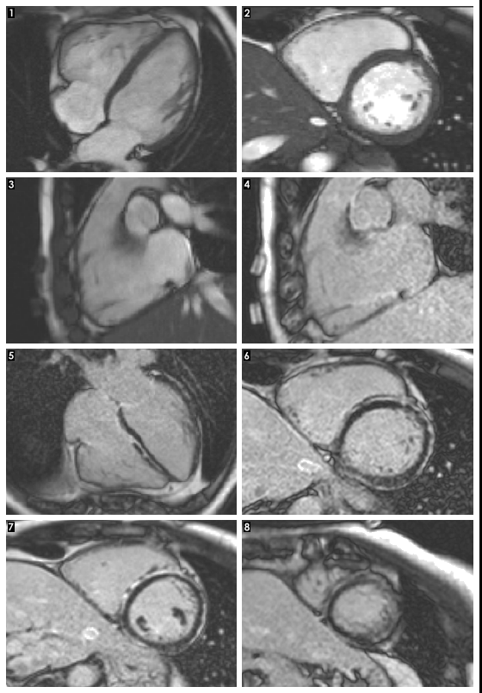

Figure 4:
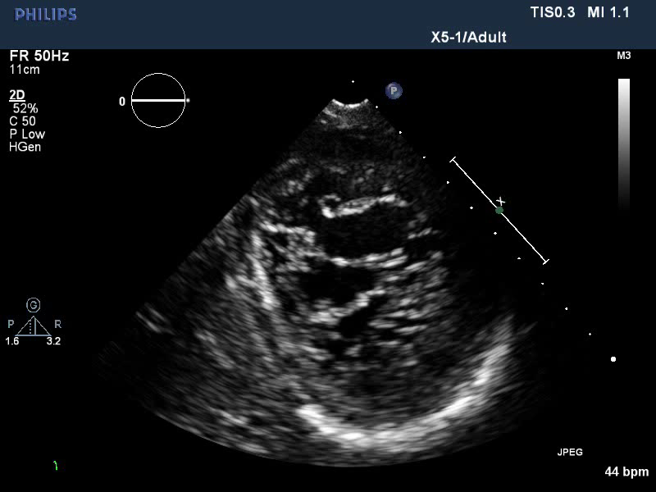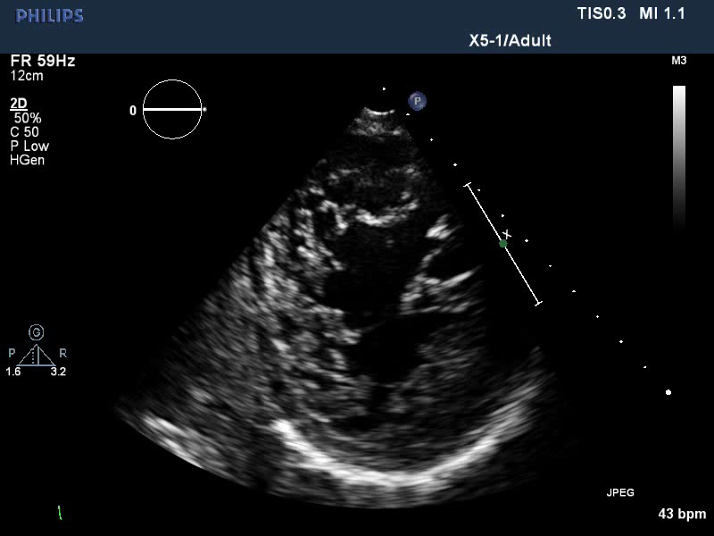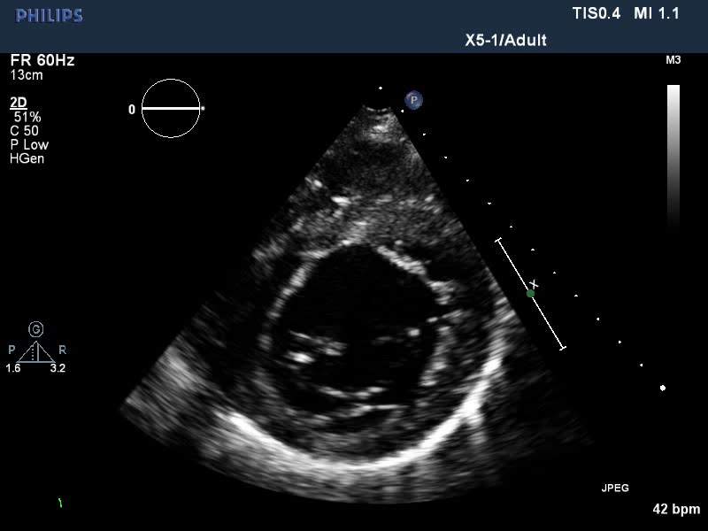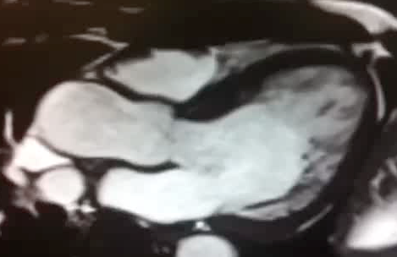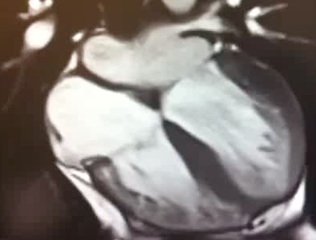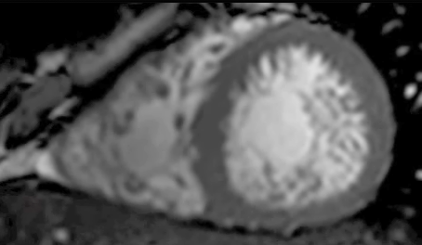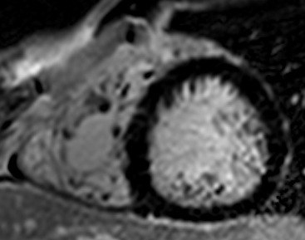
(A)
(B)
(C)

Figure 5:
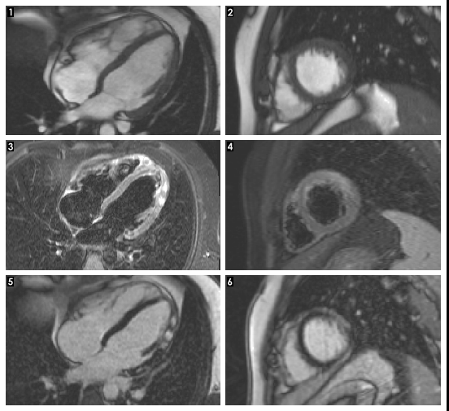
CMRI LGE
Yes
No
Repeat tests after 6 months rest
Repeat tests after 3 months rest
LGE -
LGE +
Annual review
Allow competition*
Allow competition*
*Normal biomarkers; Asymptomatic; Normal echo; Normal ETT; Normal Holter
(A)
(B)

Figure 6:
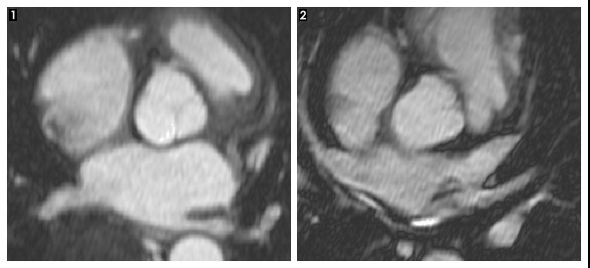
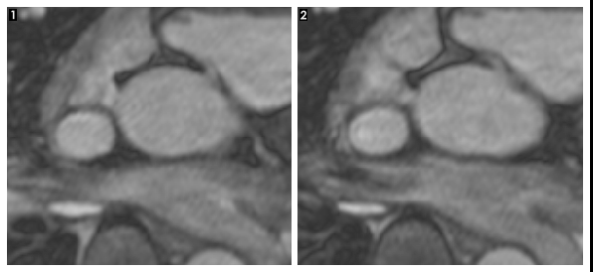
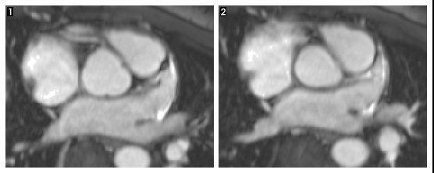
A
B
C

