**Pharmacokinetics and pharmacodynamics of antimicrobials in critically ill patients with lower respiratory tract infections. Are ‘one size fits all’ doses appropriate?**

**Authors** IO Oldfield, K Kipper, CI Barker, BJ Philips, A Johnston, JF Standing, EH Baker, M Sharland, DO Lonsdale *all at St George’s, University of London and St George’s University Hospitals NHS Foundation Trust*

**Introduction.** Respiratory infection is a common cause of severe sepsis1. Current therapeutic guidelines emphasise the importance of early initiation of antibiotic therapy, but make no recommendations on dose2. Recent studies have suggested that some critically ill patients fail to achieve sufficient plasma antibiotic concentrations to treat infection effectively3.

We determined whether critically-ill patients with respiratory infection achieved pharmacokinetic/pharmacodynamic (PK/PD) targets during antibiotic treatment and investigated factors associated with failure to meet these targets.

**Methods.** This was a subgroup, interim analysis of an ongoing study, ABDose. Participants were adults in intensive care receiving piperacillin-tazobactam or co-amoxiclav for respiratory infection. Demographics and measures of organ function were recorded. Antibiotic concentrations were measured in plasma at 50% and 100% of the dosing interval. Efficacy of beta-lactam antibiotics is dependent upon time above minimum inhibitory concentration (MIC). We chose PK/PD targets of antibiotic concentration >MIC and a more conservative >4xMIC of likely pathogen or microbiological isolate (if available). These targets have been used previously3. During 28-days follow up, need for additional antibiotics was recorded.

**Results.** 24 participants (median age 61, IQR [50-70] years), received co-amoxiclav (n=7), piperacillin-tazobactam (n=15) or both (n=2). At 100% of the dosing interval, 12 achieved plasma antibiotic concentrations >MIC and 8 achieved >4xMIC. Participants who did not achieve PK/PD targets were younger (48 [39-59] years vs 68 [61-80] years, p=0.002*) and had a higher eGFR (131±58 mls/min/1.73m2 vs 64±28 mls/min/1.73m2, p=0.004*) than those who did. Antibiotic concentrations were correlated with age and negatively correlated with eGFR (figure 1). All participants failing to achieve antibiotic concentrations >4xMIC at 100% of the dosing interval required further courses of antibiotics during follow-up compared to 50% of patients achieving this target (p=0.02*).

**Conclusion.** In critically-ill patients with respiratory infection, uniform dosing of beta lactam antibiotics does not consistently achieve PK/PD targets required for optimal antibiotic efficacy. Younger patients, with better renal function may be under-dosed. These interim findings identify a need for further work to determine whether personalised dynamic dosing regimens could improve outcomes for patients with severe respiratory infection.

1. Virulence. 2014;5(1):4-11.

2. NICE Guidelines, Sepsis. 2016

3. Clinical Infectious Diseases. 2014:ciu027.

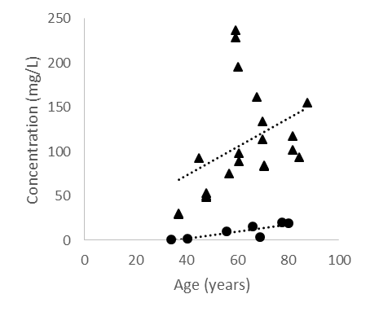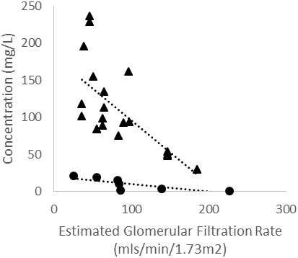

• Amoxicillin:

r=0.83, p=0.02*

⯅ Piperacillin:

r=0.43, p=0.04*

**Figure 1.** Antimicrobial concentration measured at 50% of the dosing interval plotted against age (left) and eGFR (right). Line of best fit and associated coefficients suggest correlation with age and negative correlation with eGFR.

• Amoxicillin:

r= -0.78, p=0.02*

⯅Piperacillin:

r= -0.70, p<0.001*