Test | Results | Units | Ref Range
Haemoglobin | 87 | g/L | 120 to 160
WBC | 8.9 | 10^9/L | 4.0 to 11.0
PLATELET | 678 | 10^9/L | 150 to 450
MCV | 85 | Fl | 78 to 97
NEUTROPHIL | 6.8 | 10^9/L | 1.7 to 8.0
LYMPHOCYTE | 1.6 | 10^9/L | 1.0 to 4.0
MONOCYTE | 0.3 | 10^9/L | 0.24 to 1.1
EOSINOPHIL | 0.1 | 10^9/L | 0.1 to 0.8
BASOPHIL | 0 | 10^9/L | 0.0 to 0.3
HCT | 0.28 |  | 0.37 to 0.47
INR | 1.4 | Ratio | 0.8 to 1.1
D-DIMER | 1071 | ng/ml | 21 to 300
SODIUM | 136 | mmol/L | 133 to 146
POTASSIUM | 4.5 | mmol/L | 3.5 to 5.3
CHLORIDE | 100 | mmol/L | 95 to 108
BICARBONATE | 24 | mmol/L | 22 to 29
UREA | 9.4 | mmol/L | 2.5 to 7.8
CREATININE | 85 | umol/L | 60 to 110
eGFR | >60 | mL/min/1.73m2
BILIRUBIN | 12 | umol/L | 0 to 21
ALANINE TRANSAMINASE | 33 | U/L | 0 to 40
ALKALINE PHOSPHATASE | 145 | U/L | 30 to 130
ALBUMIN | 28 | g/L | 35 to 50
GAMMA GT | 180 | U/L | 0 to 38
C REACTIVE PROTEIN | 294.1 | mg/L | 0.0 to 10.0
Arterial p H | 7.4 |  | 7.35-7.45
Arterial PO2 on air | 10.0 | kPa | 10.5-13.5
Arterial PCO2 on air | 3.78 | kPa | 4.7-6
Arterial Lactate | 2.0 | mmol / l | <1.6
Arterial HCO3 | 25.0 | mEq/ l | 22-26
Urine casts | Negative | - | -
Urine PCR | 51 | mg/mmol | <15
Urine WBC | 15 | /UL
Urine RBC | 2 | /UL
Epithelial Cells | 2 | /UL
Urine culture | No growth | -
Chest XRay | Patchy air space opacification in the left middle and lower zone and the right mid zone
Table 1: Investigations on presentation

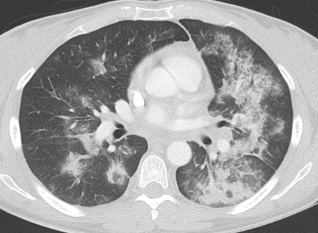
Figure 1: CT Thorax
Figure 1: Computed tomography of the thorax shows extensive bilateral patchy air space infiltrates and ground-glass changes.

Test | Results | Units | Ref Range
Influenza A, Influenza B, Parainfluenza, Rhinovirus, | Negative
Coronavirus, RSV, Metapneumovirus, Adenovirus, | Negative
Bocavirus, Enterovirus, Parechovirus and | Negative
Mycoplasma pneumoniae. | Negative
Total Protein | 59 | g/L | 60 to 80
Immunoglobulin G | 10.2 | g/L | 6.0 to 16.1
Immunoglobulin A | 3.1 | g/L | 0.8 to 2.8
Immunoglobulin M | 1.0 | g/l | 0.5 to 1.9
Complement C3 | 1.4 | g/l | 0.75 to 1.65
Complement C4 | 0.18 | g/l | 0.14 to 0.54
IgG anti citrullinated peptide | <1 | U/Ml | 0 to 7
IgG anti glomerular basement membrane | <3 | U/Ml | 0 to 10
Antinuclear antibody | NEGATIVE
ANCA staining pattern | C-ANCA pattern
IgG anti proteinase 3 | <2 | U/ml | Positive >3.0
IgG anti myeloperoxidase | <2 | U/ml | Positive >5.0
Rheumatoid Factor | 586 | iu/ml | 0 to 20
IgG anti SS-A | NEGATIVE
IgG anti SS-B | NEGATIVE
IgG anti Sm | NEGATIVE
IgG anti RNP | NEGATIVE
IgG anti dsDNA | <10 | IU/Ml | 0 to 30
IgG anti -cardiolipin | NEGATIVE
IgG anti beta-2 glycoprotein 1 | <4 | IU/Ml | 0 to 15
Table 2: Viral Serology & Immunology

Figure 3: Wedge Lung biopsy
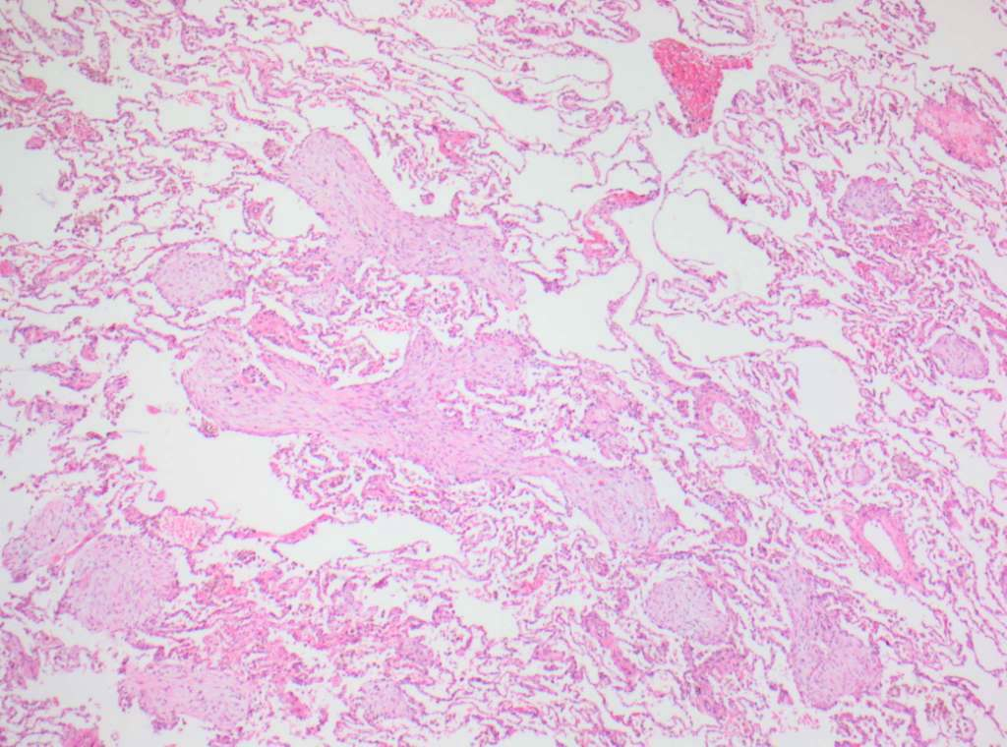
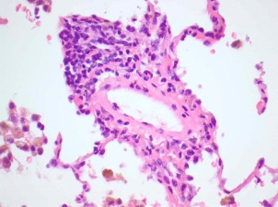

Figure 3a: Low power view of lung demonstrating focal organising pneumonia (arrow) and subtle perivascular inflammation (insert)(H&E stain).

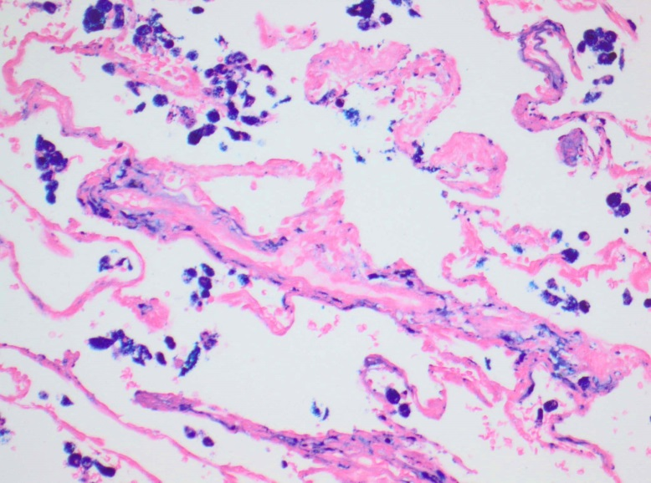

Figure 3b: Higher power view of lung showing coarse haemosiderin deposition within alveolar macrophages (solid arrow) and fine deposition within alveolar septa and the wall of a small blood vessel (open arrow - pulmonary haemosiderosis).

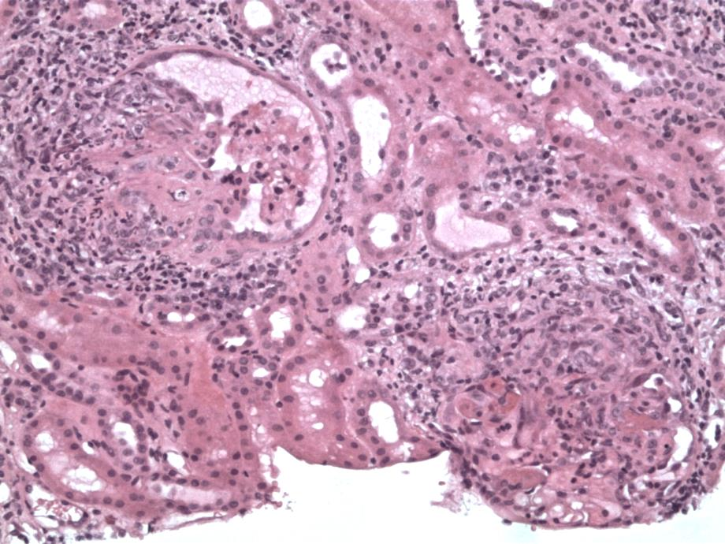
Figure 4: Renal Biopsy
Figure 4: The biopsy shows a kidney in which there is evidence of an acute necrotising glomerulopathy (solid arrow) with a relatively good background that appears to be pauci-immune. There is also some evidence of vasculitis.

