Cardiovascular Risk Prevention and All Cause Mortality in Primary Care Patients with Abdominal Aortic Aneurysms in the United Kingdom
Sandeep S Bahia, Alberto Vidal-Diez, Sreenivasa R K Seshasai, Ilya Shpitser, Jack R Brownrigg, Benjamin O Patterson, Kausik K Ray, Peter J Holt, Matthew M Thompson, Alan Karthikesalingam.
(1) Mr Sandeep S Bahia^{1, 2, 5}
Vascular Surgery Research Fellow (bahia_sandeep@yahoo.co.uk)
(2) Mr Alberto Vidal-Diez^{1, 4}
Research Statistician (avidal-d@sgul.ac.uk)
(3) Dr Sreenivasa R K Seshasai²
NIHR Academic Clinical Lecturer, Cardiology (rkondapa@sgul.ac.uk)
(4) Dr Ilya Shpitser³
Lecturer in Mathematics (i.shpitser@soton.ac.uk)
(5) Mr Jack R Brownrigg^{1, 2}
Vascular Surgery Research Fellow (jrwbrownrigg@gmail.com)
(6) Mr Benjamin O Patterson^{1, 2}
NIHR Academic Clinical Lecturer, Vascular Surgery (bop@doctors.org)
(7) Prof Kausik K Ray⁴
Professor of Public Health (koshray@gmail.com)
(8) Mr Peter J Holt^{1, 2}
Senior Lecturer and Consultant Vascular Surgeon (pholt@sgul.ac.uk)
(9) Professor Matthew M Thompson^{1, 2}
Professor of Vascular Surgery (matt.thompson@stgeorges.nhs.uk)
(10) Mr Alan Karthikesalingam^{1, 2}
NIHR Academic Clinical Lecturer, Vascular Surgery (alankarthi@gmail.com)
¹ St George’s Vascular Institute, St George’s University of London, Cranmer Terrace, London, SW170RE, UK
² Cardiovascular and Cell Sciences Institute, St George’s University of London, Cranmer Terrace, London, SW17 0RE UK
³ Department of Mathematical Sciences, University of Southampton, Highfield, Southampton, SO17 1BJ, UK
⁴ Department of Primary Care and Public Health, School of Public Health, Imperial College London, South Kensington Campus, London, SW7 2AZ, UK
⁵ Corresponding author: Mr Sandeep S Bahia
Telephone Number: 0044 (0)20 8226 6426
Fax Number: 0044 (0)20 8725 3495
E-mail: bahia_sandeep@yahoo.co.uk

Funding: None
Conflicts:
KKR has received honoraria for advisory boards, lectures or for serving on the steering committee for RCTs from Amgen, Sanofi, Pfizer, Regeneron, Aegerion, AZ, MSD, Kowa, Abbott, Takeda, Lilly, Boehringer Ingelheim, Novo Nordisk , Janssen, Roche.
All authors have completed the Unified Competing Interest form at www.icmje.org/coi_disclosure.pdf (available on request from the corresponding author) and declare: AK and PJEH have received research grants from the National Institute for Health Research (NIHR) and the Circulation Foundation. Neither funding organisation had any input into this study. AK, PH, BOP and MMT have provided consultancy for Medtronic Endovascular Ltd, MMT has provided expert guidance regarding Endovascular Aneurysm Repair for the National Institute for Health and Clinical Excellence (NICE). No funding body or commercial entity provided input into this study.
Copyright/License for Publication:
The Corresponding Author has the right to grant on behalf of all authors and does grant on behalf of all authors, a worldwide licence to the Publishers and its licensees in perpetuity, in all forms, formats and media (whether known now or created in the future), to i) publish, reproduce, distribute, display and store the Contribution, ii) translate the Contribution into other languages, create adaptations, reprints, include within collections and create summaries, extracts and/or, abstracts of the Contribution, iii) create any other derivative work(s) based on the Contribution, iv) to exploit all subsidiary rights in the Contribution, v) the inclusion of electronic links from the Contribution to third party material where-ever it may be located; and, vi) licence any third party to do any or all of the above.
Authorship:
AK, AVD, SB, SRKS, JRB and BOP designed the statistical analysis plan, cleaned data, drafted the paper and are guarantors. AVD, IS, SB, SRKS and AK wrote the statistical analysis plan, conducted internal validity data audit, conducted statistical analyses, and revised the draft paper. KKR, BOP, and PJH advised on analyses, drafted and revised the paper. KKR, PJH and MMT initiated the project, designed the study, drafted and revised the paper, and are guarantors. All authors, external and internal, had full access to all of the data (including statistical reports and tables) in the study and can take responsibility for the integrity of the data and the accuracy of the data analysis.

STRUCTURED ABSTRACT

Background

Peri-operative mortality is low for patients undergoing abdominal aortic aneurysm (AAA) repair, but long-term survival remains poor. Although patients diagnosed with AAA have a significant burden of cardiovascular disease and associated risk factors, there is limited understanding of the contribution of cardiovascular risk management to long-term survival.
Methods

General Practice Records within The Health Improvement Network (THIN) were examined. Patients with an AAA and >1 year of registered medical history were identified from 2000-2012. Medical therapies for cardiovascular risk were classified as “antiplatelet”, “statin”, or “anti-hypertensive” agents. Progression to death was investigated using the G-computation formula with time-dependent covariates to account for differences in exposure to cardiovascular risk–modifying treatments and the confounding between exposure, comorbidities and death.

Results

12,485 patients had a recorded diagnosis of AAA. From 2000-2012, prescription of medications that modify cardiovascular risk increased: from 27%-77% for statins, 57%-74% for antiplatelet agents and from 75%-84% for anti-hypertensives.
Adjusted Kaplan-Meier curves demonstrated better 5-year survival in patients receiving statins (68.4% vs. 42.2%), antiplatelet agents (63.6% vs. 39.7%) or anti-hypertensive agents (61.5% vs. 39.1%), compared to patients not receiving each therapy.
Conclusions

Appropriate risk factor modification could significantly reduce long-term mortality in patients with AAA. In the UK, up to 30% of patients are not currently receiving such medication, which will result in potentially avoidable reductions in life expectancy.

Introduction

Since the advent of endovascular technology and improvements to the provision of vascular services, peri-operative mortality has declined for patients undergoing abdominal aortic aneurysm (AAA) repair in England from 7.9%¹ to 1.8%² between 2006 and 2014. Despite these advances the longer-term fate of patients with AAA is poor, and life expectancy after AAA repair remains significantly worse than for otherwise equivalent individuals without an AAA^{3, 4}. In part this excess risk among AAA patients may be due to their greater burden of both clinical and subclinical cardiovascular diseases (CVD) and their associated risk factors; including a 2.78-fold increase in ischaemic heart disease and a 2.2-fold increase in cerebrovascular disease⁵.

In turn these findings may help explain the observation that patients with AAA have twice the rate (1.4% vs 2.78%/ year) of adverse cardiovascular events (including CVD death, non-fatal myocardial infarction and non-fatal stroke) compared to patients without AAA⁵. It would appear reasonable to assume that patients with AAA should receive evidence based treatments that reduce CVD risk, analogous to the secondary prevention of coronary heart disease (CHD). In the UK and elsewhere nearly 100% of patients who survive a myocardial infarction are discharged on aspirin, a P2Y12 inhibitor, a statin, a beta-blocker and an ACE inhibitor (if there is no contraindication). It is believed that a large proportion of the reduction in CHD deaths in the UK is attributed to this regimen. In contrast small local series suggest that as few as 40% of patients with AAA receive statin therapy⁶.

While statins⁷, antiplatelet agents⁸ and anti-hypertensive treatments⁹ have a well-established randomised trial evidence base for reducing cardiovascular risk among patients with clinically-manifest coronary disease, there are no comparable data among AAA patients. Nevertheless consensus guidelines for AAA recommend the importance of medications known to reduce CVD risk prevention in this high-risk group.¹⁰

Our goal was to provide real world observational data among AAA patients about the use of medications known to reduce CVD risk and to assess whether there was an association between their prescription and long-term survival. This was done by applying the G-computation formula, a technique developed under the causal inference framework to correctly adjust for potential confounding between time-varying treatments and time-varying covariates, where both are related to the outcome of interest¹¹.

Methods
General Practice Records within The Health Improvement Network (THIN) Database were examined. Patients with a recorded diagnosis of AAA were identified from 2000 to 2012 with at least 1 year of registered medical history before the diagnosis. The inclusion criteria required information regarding a known deprivation index and smoking status, and a minimum age of 50 years to exclude those with non-degenerative aortic pathology. Data were extracted regarding patients’ prescription medications, demographics, co-morbidity, smoking status and social deprivation index.

The primary outcome was 5-year survival, defined from first recorded diagnosis of AAA. Comorbidity was characterized according to a validated classification system for THIN data, and each diagnosis was extracted when first recorded in a patient’s record¹². Medical therapies known to reduce cardiovascular risk were classified as “antiplatelet” agents or “anticoagulation”, “statins and lipid modification therapy (LMT)”, or “anti-hypertensive” agents. Separate consideration was given to the most common antiplatelet therapies: aspirin, clopidogrel and dipyridamole and the grouped analysis included newer agents such as prasugrel and ticagrelor. Anticoagulants included heparin and its derivatives, warfarin and newer oral anticoagulants. Antihypertensive agents were further classified as angiotensin-converting enzyme inhibitors (ACE-i), angiotensin receptor antagonists (ARBs), beta-adrenoreceptor antagonists (BBs), calcium channel antagonists (CCBs), and diuretics. Patients were assumed to be receiving medications for the 90 days that followed each recorded prescription. Geographical variation in the rate of prescription of these medications was reported by strategic health authority, and visualized using open-source QGIS software (http://www.qgis.org).

Statistical analysis
The demographic characteristics of the overall cohort are reported using descriptive statistics, with further sub-classification into those with an additional history of CHD, cerebrovascular disease, peripheral vascular disease (PVD) and diabetes mellitus (DM). This was done to assess whether concomitant vascular disease or DM were associated with differences in medical prescribing as compared with those with AAA but no other prevalent vascular disease. Chi-squared tests or Mann-Whitney tests were used to compare the rate of prescription of each category of medical therapy (antiplatelet agent, statins, anti-hypertensive agents)

Adjusted survival curves were constructed using inverse probability weights¹³ with and without each category of medical therapy (antiplatelet agent, statins, anti-hypertensive agents), taking into account the time-dependency of the treatments¹⁴, to graphically represent the univariate impact of each medical therapy on 5-year survival.

Multivariate analysis was performed by applying the G-computation formula, a technique developed under the causal inference framework to correctly adjust for potential confounding between time-varying treatments and time-varying covariates, where both are related to the outcome of interest¹¹. A Directed Acyclic Graph (DAG) was constructed to describe the potential causal relations between the variables of the study^{15, 16} (Figure 4). The DAG was used to fit pooled logistic regression models with time introduced by splines or non-linear terms. Models were fitted for each time-dependent comorbidity, AAA surgery, each drug category, and death. Comorbidities, AAA surgery and death were modelled as time to the first event recorded, and baseline demographics and deprivation index were included in all models.

The g-formula approach was used to compare hypothetical drug interventions (scenarios) by simulating patient cohorts, modeled as described above. Survival comparisons were performed between a scenario in which all patients received the medical therapy of interest (statin/antiplatelet agent/antihypertensive agent or anticoagulant) versus a scenario in which no patients received that therapy (“all versus none”). Comparison was also made between a scenario in which all patients received drug therapy compared to a scenario in which the proportion receiving therapy matched that in current practice (all vs. current practice). Finally, current practice was compared to a scenario in which no patients received the therapy of interest (current practice vs. none). The data were split into 4-week periods for computational purposes after conducting sensitivity analyses using one-week periods in some scenarios. When a treatment was prescribed, it was assumed to last for the next 90 days (an approach commonly taken for THIN data¹⁷) and comorbidities (apart from smoking) were regarded as irreversible once acquired.
As a sensitivity analysis, effect estimates were also obtained for each medical therapy using a traditional Cox proportional hazards model with time-dependent covariates; to assess the potential for observational confounding in non-causal analysis of these epidemiological data. All analyses were performed using SAS version 9.3 (SAS Institute, Cary, NC, USA).

Results
Between January 2000 and December 2012 there were 12,485 patients with a recorded diagnosis of AAA which formed the cohort for this study, with a mean (S.D.) of 21.67 (16.7) years registered in their health centre prior to AAA diagnosis. The majority of patients were male (74.85%) with a mean (S.D.) age of 73.88 (8.54) years. Unsurprisingly many had a prior history of other vascular diseases such as ischaemic heart disease (32.03%), myocardial infarction (18.23%), cerebrovascular disease (16.57%) and PVD (24.26%) by the time they were diagnosed with a AAA, although 43.04% had no prior history of disease in any other vascular bed (Appendix)

The use of all major classes of cardioprotective medications was low (26.62 % for statins, 75.32% for anti-hypertensives and 56.49% for antiplatelets) in 2000 but increased over the decade such that by 2012, 76.74% of patients were receiving statins, 84% were receiving anti-hypertensive agents and 73.93% were prescribed antiplatelets agents (Figure 1) within a year of AAA diagnosis. The use of these medications were considerably higher where AAA was accompanied by ischaemic heart disease, diabetes mellitus, peripheral vascular disease, cerebrovascular disease compared to patients with AAA but without concomitant vascular comorbidities (p<0.001 for all comparisons) (Table 1).

There were considerable geographical variations in prescription rates between different Strategic Health Authorities for statins and antiplatelet agents, but not for anti-hypertensive medications (Appendix). The rate of prescription of antiplatelet agents varied by 5% between SHAs (Appendix), whilst that for statins varied by nearly 10% (Appendix).

Adjusted Survival and Medication for Cardiovascular Risk
Within 5 years after a diagnosis of AAA, 31.93% of the patients had died.
The risk of death was significantly associated with age, co-morbidity, social deprivation and strategic health authority (geographic region) [Appendix]. Adjusted Kaplan-Meier curves demonstrated better 5-year survival in patients receiving statins (68.4% vs. 42.2%, Figure 2), antiplatelet agents (63.6% vs. 39.7%, Figure 3) or anti-hypertensive agents (61.5% vs. 39.1%, Figure 4), compared to patients not receiving each therapy.

Intervention with Statins and Lipid Modification
Compared to current practice, the use of statins for all patients was associated with 21% lower risk of death (HR 0.798, 95% CI 0.766-0.832), and would potentially save 50 lives per 1000 patients per year (Figure 3, and Appendix Table 2). The addition of non-statin LMTs to this scenario was associated with a slightly greater benefit than statins alone (HR 0.787, 95% CI 0.756-0.820). The use of statins and LMTs in all patients was associated with 42% lower risk of death compared to none receiving these medications (HR 0.584, 95% CI 0.562-0.607). Statins alone were associated with 39% lower risk of death compared to no patients receiving therapy (HR 0.611, 95% CI 0.588-0.637). Compared to no therapy, current practice was associated with 26% lower risk of death (HR 0.742, 95% CI 0.714-0.771).

Intervention with antiplatelets and anticoagulants
Compared to current practice, the use of antiplatelets for all patients was associated with 10% lower risk of death (HR 0.901, 95% CI 0.866-0.937) and would potentially save 12 extra lives per 1000 patients per year (Figure 3, and Appendix Table 2). Antiplatelet agents were associated with 20% lower risk of death compared to a scenario in which no patients received antiplatelets (HR 0.799, 95% CI 0.77-0.83). Current practice was associated with 11% fewer deaths than a scenario with no patients receiving antiplatelets (HR 0.887, 95% CI 0.856 – 0.921). The use of anticoagulants for all patients was also associated with improved survival (all receiving anticoagulants versus current practice: HR 0.961, 95% CI 0.924-1.000; all versus none receiving anticoagulants: HR 0.849, 95% CI 0.818-0.882).

Interventions with antihypertensive agents
Prescription of ACEis, ARBs and CCBs were associated with better survival (HR 0.788, 95% CI 0.759-0.818; HR 0.672, 95% CI 0.648-0.699; HR 0.845, 95% CI 0.815-0.880 respectively) [Figure 3, and Appendix Table 2]. A lesser benefit was seen with BB prescriptions (HR 0.944, 95% CI 0.907-0.981). In contrast no benefit was observed with diuretic prescriptions (HR 1.177, 95% CI 1.136-1.222). Overall, any single antihypertensive agent was associated with 12% fewer deaths than a scenario where no antihypertensive agents were prescribed (HR 0.881, 95% CI 0.847 – 0.917), but the use of antihypertensive agents for all patients did not improve survival compared to current clinical practice (HR 0.966, 95% CI 0.931 – 1.01).

Discussion
The major finding of this study was that although medications to mitigate cardiovascular risk are associated with a clinically and statistically significant improvement in long-term survival in patients with a diagnosis of AAA, the proportion of these individuals receiving these medications remains quite poor in the UK. The data suggest that as few as 71.82% were on statins, 79.11% on antiplatelet agents and 87.21% on anti-hypertensive medication by 2012, with evidence of considerable geographical disparity in prescription rates. There was a considerable improvement in the rate of prescription of cardiovascular disease-modifying medications during the study period, and long-term survival improved over the study period. Overall life expectancy was better than in large studies of patients undergoing AAA repair¹⁸, reflecting the fact that the cohort for this study included small AAA below the threshold for surgical repair.

The interventions associated with greatest clinical benefit were statins and antiplatelet agents. Ensuring the universal use of these medications would save an additional 62 lives per 1000 patients per year, with the greatest benefit being derived from statins and lipid modification therapy. Antiplatelet agents and statins are considered mandatory for patients with AAA¹⁰ but, to our knowledge, this is the first large-scale investigation into the effects of these medications on long-term survival of these individuals. Patients with AAA have a substantial burden of baseline CVD and associated risk factors and have a reduced life expectancy compared to the wider population. The present study demonstrates that this risk may be modifiable⁵ through use of therapeutic interventions known to reduce CVD risk amongst those with vascular disease. The data illustrate that despite the importance of these therapies, physicians in England are more likely to recognise and treat cardiovascular risk when AAA patients present with cerebrovascular disease, peripheral vascular disease or coronary heart disease rather than AAA alone. This study highlights a clear need for better recognition of the cardiovascular risk associated with AAA, and greater attention to medical risk management.

The unequivocal benefit of statin therapy in preventing vascular events in patients with pre-existing CVD has been established in large-scale pooled analyses of randomized-controlled trials (RCTs)¹⁹. Further studies have demonstrated that the benefits are greater with more intensive treatment with these agents²⁰. In addition, patients deemed to be at relatively lower risk of future CVD events have also been shown to derive benefits from statin therapy²¹. Current guidelines for the treatment of blood cholesterol to reduce atherosclerotic vascular events among adults²² have not only expanded the scope of statin treatment for primary and secondary prevention of CVD, but have also emphasised the need for more intensive statin treatment among people with pre-existing atherosclerotic vascular disease. Measures that tend to improve statin prescription and/or adherence rates are also likely to be associated with an improvement in the long-term prognosis and survival of patients with AAA.

The benefit of aspirin treatment for the secondary prevention of CVD events has also been confirmed through similar large-scale collaborative meta-analyses of clinical trials²³ and aspirin treatment has been recommended as a class I indication in the joint ACC/ACCF guidelines²⁴. In the context of primary prevention, however, the overall benefit of this agent has been shown to be less robust and, moreover, offset by an increased risk of major bleeding⁸. Nevertheless, aspirin prophylaxis may still be appropriate for people deemed to be at a higher-than-average risk of future CVD events, and therefore may be relevant in primary prevention of CVD among people with AAA.

Antihypertensive medications have also been recommended as a class I indication for the secondary prevention of CVD events²⁴. It is well known from previous large-scale studies that incremental levels of both systolic and diastolic blood pressure are log-linearly associated with the risk of incident vascular events²⁵. As the majority of individuals with AAA have coexisting hypertension, optimised blood pressure control is likely to reduce the burden of future vascular events substantially in this population. The observation that ACEIs, ARBs and CCBs have mortality benefits whereas BBs/diuretics have a lesser impact is in keeping with many clinical guidelines, which advocate these first and second line in the treatment of hypertension whereas BBs have been relegated to fourth line²⁶. Part of these benefits may be related to the greater reduction in blood pressure variability of these agents compared with BBs or diuretics.²⁷ The findings of the present study are consistent with clinical guidelines and support the view that CCs and drugs acting on the renin angiotensin system are preferable for prognostic benefit in AAA patients.

Whilst it seems logical, based on our findings, that addressing treatment gaps (for CVD and its risk factors) in patients with AAA may considerably improve their long-term outcomes and survival, the findings of our study merit careful interpretation in the context of its limitations, especially those that relate to the quality and completeness of the available data. For instance, details regarding AAA morphology and size, factors that are known to predict long-term survival, were unavailable for analysis in the THIN dataset. Medications were considered to be current in patients for the 90 days that followed a prescription, but patients’ compliance with therapy was not known. Furthermore the dataset had information on all cause mortality rather than CV death. That said AAA patients are high vascular risk patients and among populations where CVD death rates are high treatments that reduce CVD death also reduce mortality²⁸. The present study is observational in nature and although we have attempted to adjust for biases and confounding, we cannot exclude residual confounding.

The present study adds considerably to existing literature, and its findings must be interpreted in the context of major improvements in short-term (operative) outcomes for patients with AAA. Elective thirty-day mortality for AAA repair has fallen from 7.4%²⁹ to 2.4% in the UK from 2000 to 2012, and mortality following endovascular repair was as low as 0.9% in 2012³⁰. Hence, although the challenge of perioperative survival has been largely overcome for patients undergoing AAA repair, their long-term outcome appears to be significantly worse compared to the wider population, raising important questions as to the long-term medical management of these individuals. By demonstrating that statins, antiplatelet agents and anti-hypertensive agents could potentially help improve long-term survival, as well as by providing detailed estimates as to their prescription levels nationally, the present study suggests an appraisal of the long-term treatment strategies of patients with AAA is required. Although all patients may not be able to tolerate some of these medications, this study demonstrates that even allowing for this there is potential room for improvement in their prescribing. It must be noted, however, that this study is unable to report on compliance rates for patients prescribed appropriate medications, and also cannot report on potential reasons such as patient choice for non-prescribing of these medications.
It is also important to recognise that many of these patients will have been seen by a vascular surgeon in a secondary care setting, and that this suggests a potential failing on a secondary care level.
Reducing geographical inequalities in prescribing and greater use of evidence based cardioprotective medications has the potential to save up to 50 person years per 1000 for patients with AAA. In particular, it emphasises the need for clinicians to effectively lower the long-term CVD risk of individuals with AAA, as failure to do so may annul both the medical and economic benefits of AAA repair. However, one must also bear in mind that regional variation in prescribing of risk-reducing medications can also reflect the level on engagement with primary care within a demographic or local population.

Conclusion
There is considerable room for improvement in the management of cardiovascular risk factors for patients with AAA across the UK. Statins in particular exert a considerable benefit on life expectancy in this cohort, and targeted efforts are needed to improve cardiovascular risk mitigation at a national level.

 |  | Patients with AAA +/- IHD  N= 4150 (31.04%)  (Y/N) | Patients with AAA +/- CVD  N=2230 (17.86%)  (Y/N) | Patients with AAA +/- DM  N=1516 (12.14%)  (Y/N) | Patients with AAA +/- PVD  N=5135  (41.43%)  (Y/N) | Patients with AAA +/- IHD, CVD, PVD or DM  N=3875 (31.04%)  (Y/N)
Median (interquartile Range) Age (years) | With comorbidity | 76 (11)*** | 78 (12)*** | 74 (12)*** | 75 (12)*** | 76(12)***
 | Without comorbidity | 75 (13) | 75 (13) | 75 (12) | 76 (13) | 75(14)
Male | With comorbidity | 78.46%*** | 73.36%*** | 81.2% *** | 77.53%*** | 76.84%***
 | Without comorbidity | 73.05% | 75.17% | 73.97% | 72.46% | 70.43%
Receiving Statin within 1 year after AAA diagnosis | With comorbidity | 79.57%*** | 71.39%*** | 81.07%*** | 67.63% | 70.21%***
 | Without comorbidity | 50.25% | 57.51% | 57.08% | 54.65% | 37.29%
Receving Statin or Lipid modifiers within 1 year after AAA diagnosis | With comorbidity | 77.78%*** | 69.96%*** | 78.83%*** | 66.17%*** | 68.7%***
 | Without comorbidity | 49.17% | 56.23% | 55.89% | 53.44% | 36.41%
Receiving Antihypertensives within 1 year after AAA diagnosis | With comorbidity | 91.88%*** | 86.1%*** | 89.91%*** | 80.16%*** | 83.26%***
 | Without comorbidity | 70.11% | 75.45% | 75.61% | 75.39% | 64.21%
Receiving Antiplatelets within 1 year after AAA diagnosis | With comorbidity | 87.61%*** | 87.4%*** | 77.51%*** | 72.78%*** | 76.56%***
 | Without comorbidity | 54.63% | 60.85% | 63.94% | 60.57% | 41.21%
Table 1: Use of Cardiovascular Risk-Reducing Medications within the first year following recorded diagnosis of AAA, in patients with AAA alone or addition to concomitant ischaemic heart disease (IHD), cerebrovascular disease (CVD), diabetes mellitus (DM), or peripheral vascular disease (PVD)

Chi-square tests (for frequencies) and Mann-Whitney tests (for Age) were calculated to compare patients with and without each cardiovascular comorbidity. *** p-value < 0.001

Figure 1: Rate of prescription of cardiovascular risk-preventing therapy over time. Graph highlights the publication of the Oxford Heart Study, recommending prescription of these therapies for patients with coronary heart disease; and introduction of the Quality Outcomes Framework (QOF) for primary care, in which general practitioners were incentivised to prescribe secondary prevention for cardiovascular risk.

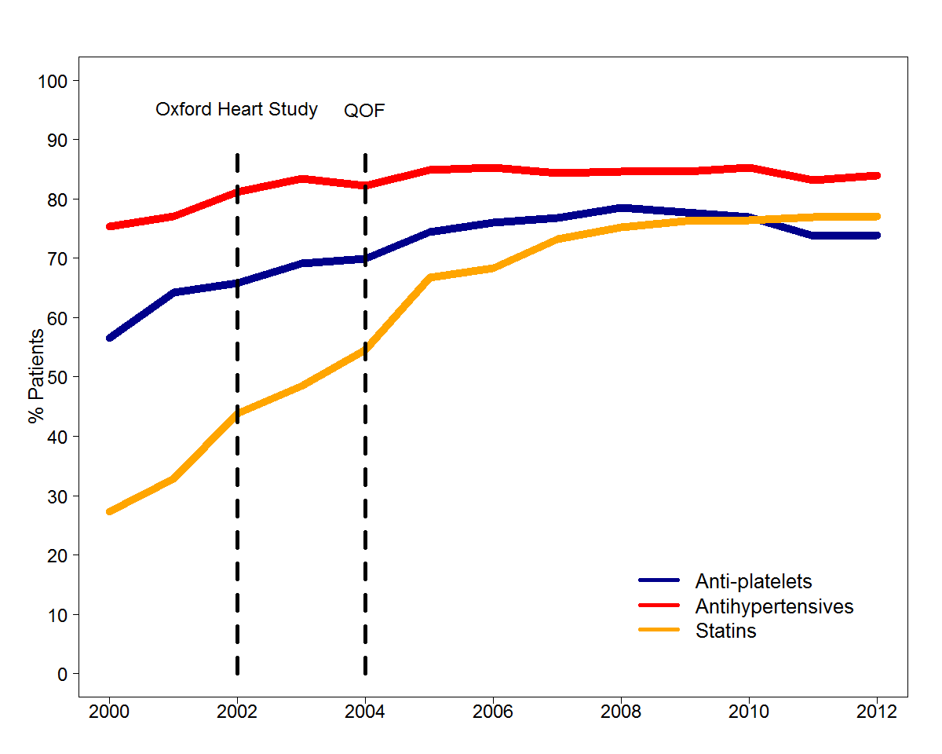

Figure 2A Weighted Adjusted Kaplan-Meier Curve demonstrating Survival with and without Statin Therapy
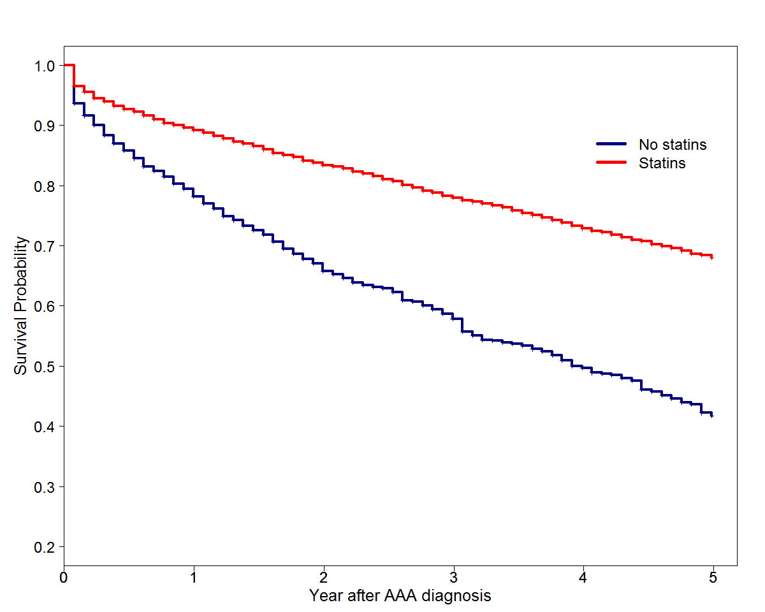

Year | 1 | 2 | 3 | 4 | 5
Survival without statin | 78.7% | 66.3% | 57.8% | 49.7% | 42.2%
N at risk (no statin) | 3905 | 2793 | 2270 | 1574 | 1207
Survival with statin | 89.2% | 83.4% | 77.9% | 72.8% | 68.4%
N at risk (statin) | 5208 | 4404 | 3606 | 2833 | 2205

Figure 2B Weighted Adjusted Kaplan-Meier Curve demonstrating Survival with and without Antiplatelet Therapy

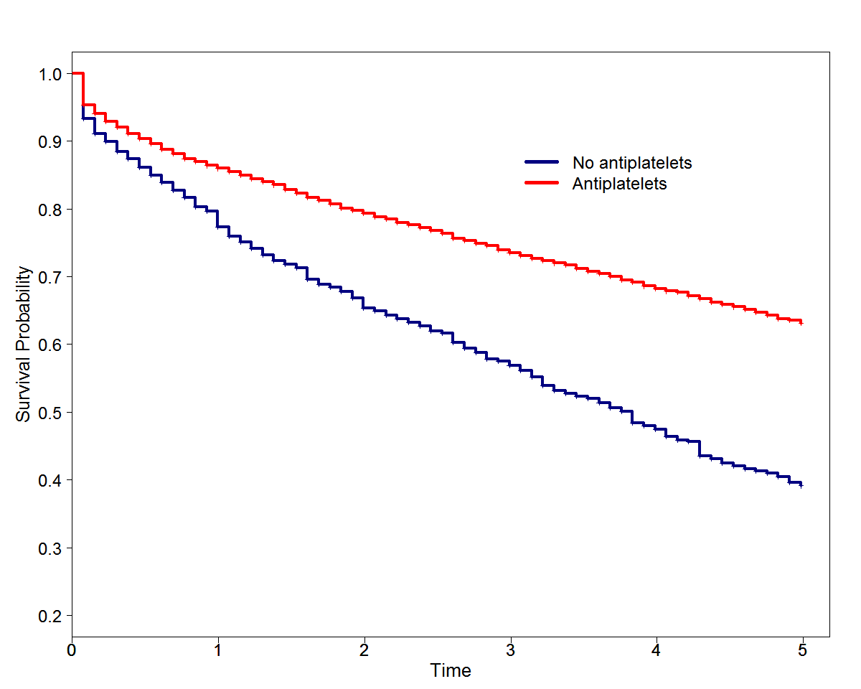

Year | 1 | 2 | 3 | 4 | 5
Survival without antiplatelets | 77.3% | 65.3% | 56.9% | 47.5% | 39.7%
N at risk | 4036 | 3067 | 2506 | 1687 | 1306
Survival with antiplatelets | 85.9% | 79.3% | 73.5% | 68.2% | 63.6%
N at risk | 5395 | 4374 | 3552 | 2739 | 2099

Figure 2C Weighted adjusted Kaplan-Meier Curve demonstrating Survival with and without Antihypertensive Therapy

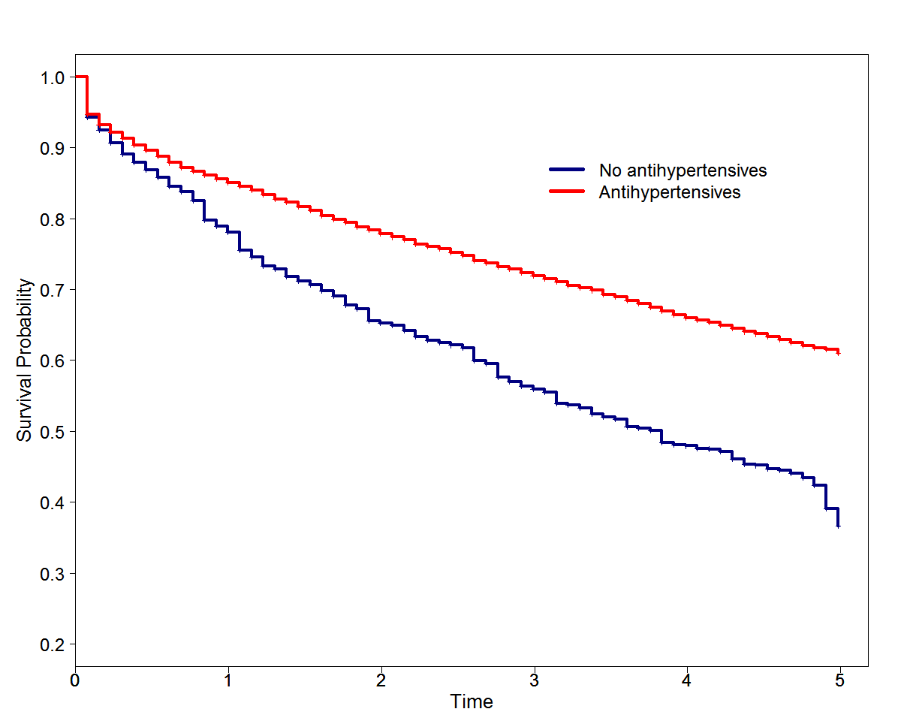

Year | 1 | 2 | 3 | 4 | 5
Survival without antihypertensive agent | 78% | 65.2% | 56% | 47.9% | 39.1%
N at risk | 2482 | 1709 | 1399 | 1012 | 746
Survival with antihypertensive agent | 85.1% | 77.8% | 71.9% | 66% | 61.5%
N at risk | 6737 | 5409 | 4282 | 3283 | 2549

Figure 3: Summary Results of the G-computation formula. Hazard Ratios and 95% confidence intervals for each treatment scenario displayed as a forest plot.
LMTs = Lipid Modification Therapy; CP = Current Practice; AP = Antiplatelets; AC = anticoagulants; AH = Antihypertensive agents

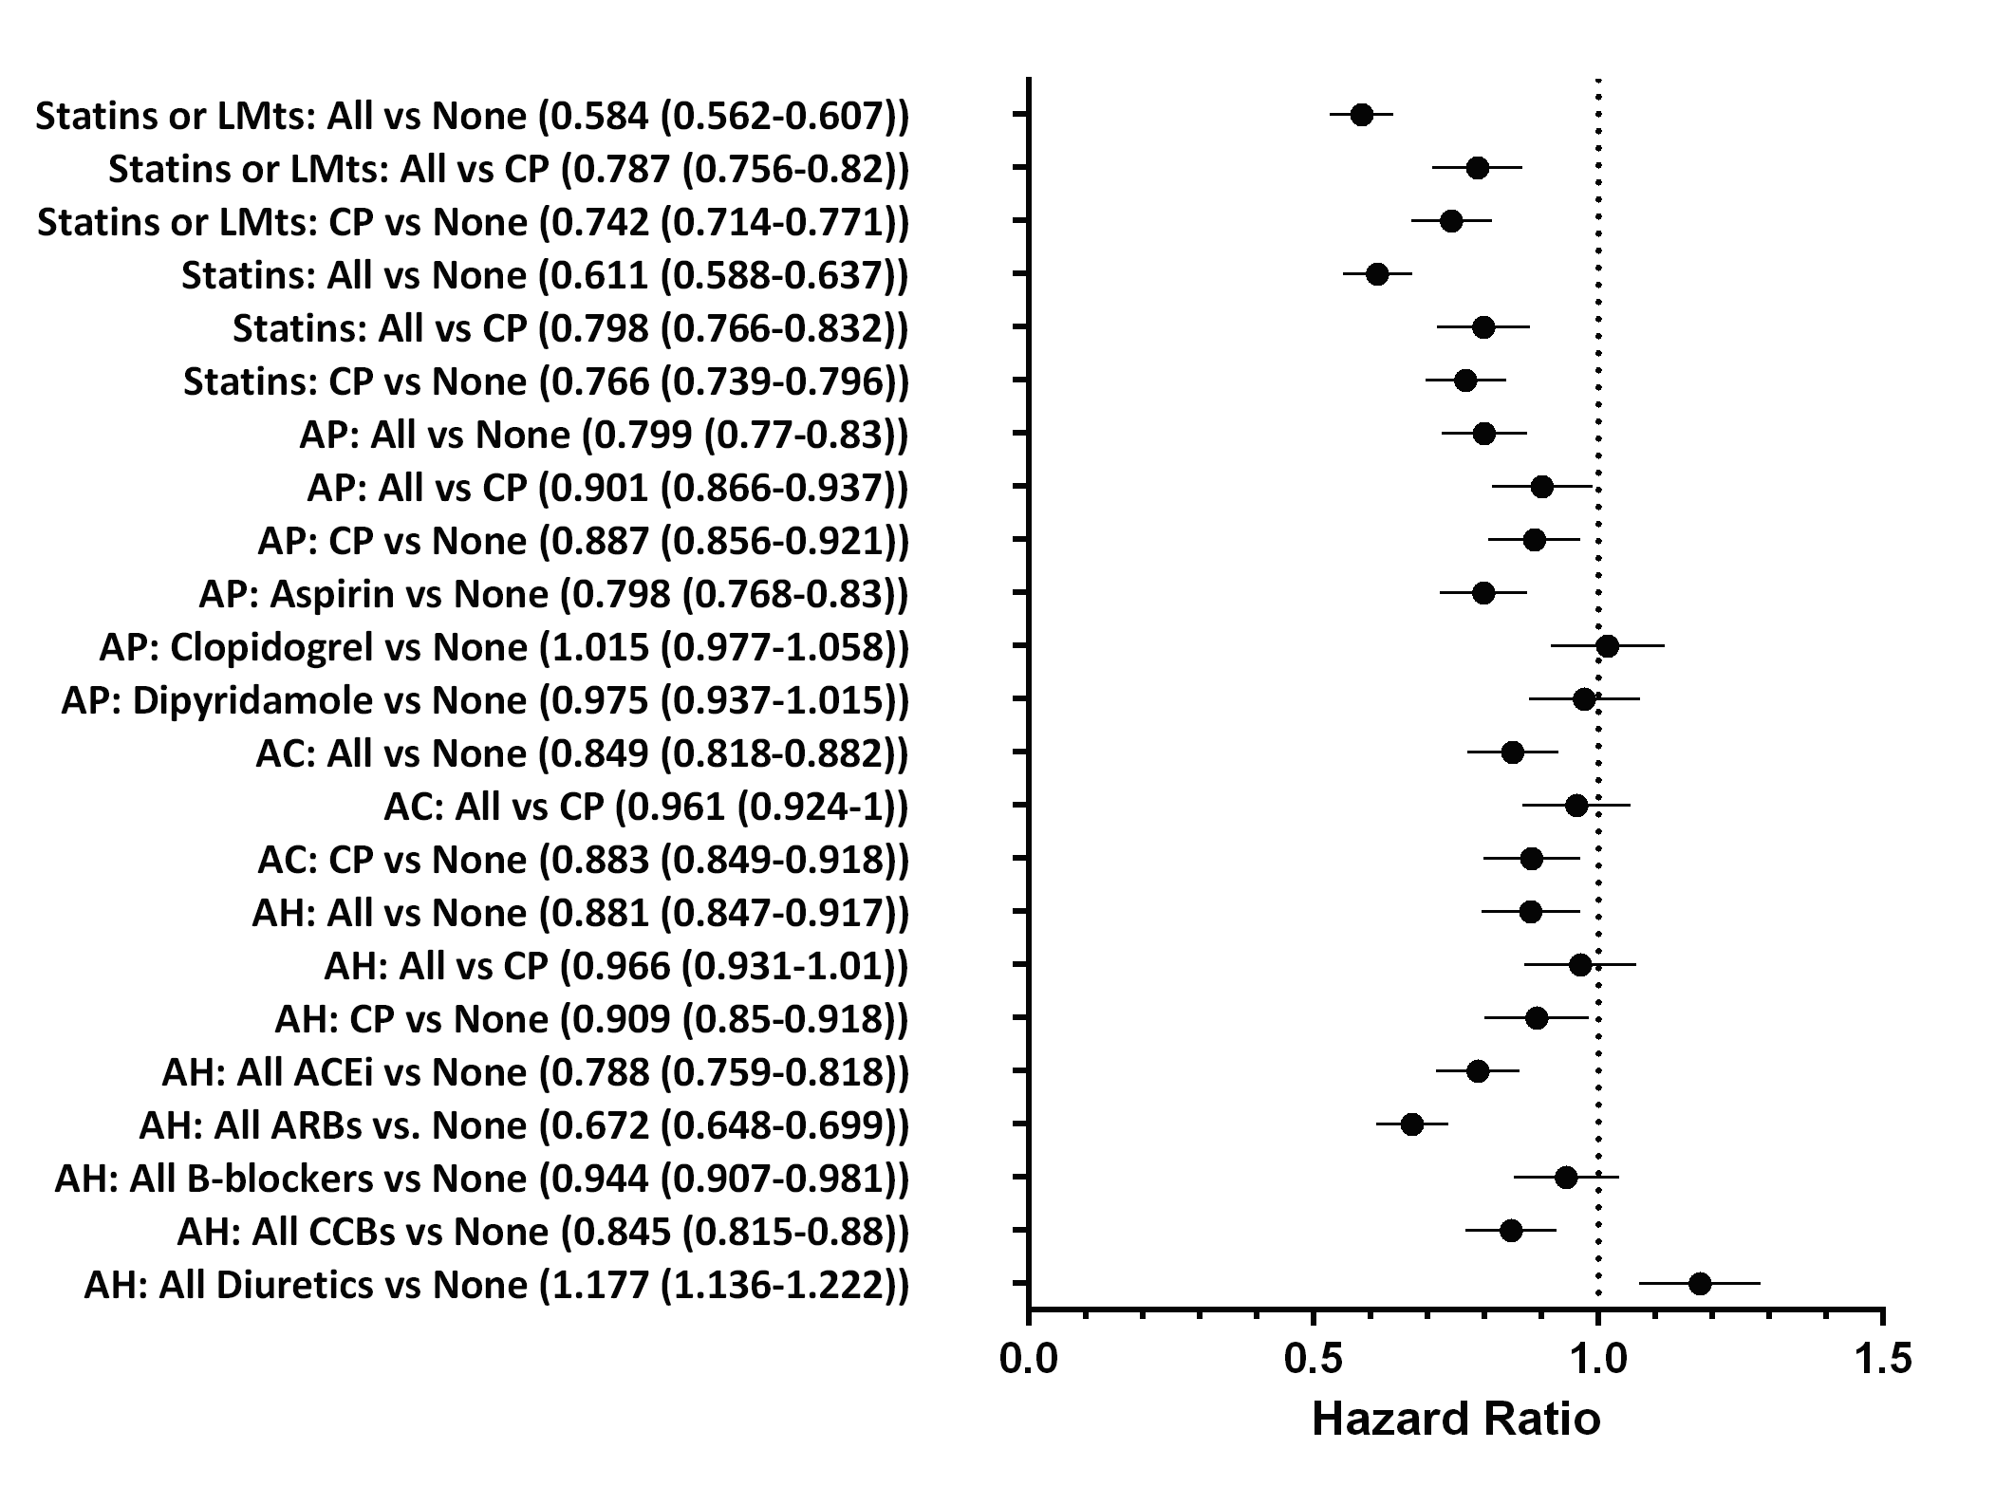

Figure 4: DAG (Directed Acylic Graph) for description of hypothesised or known causal links between variables used for this study

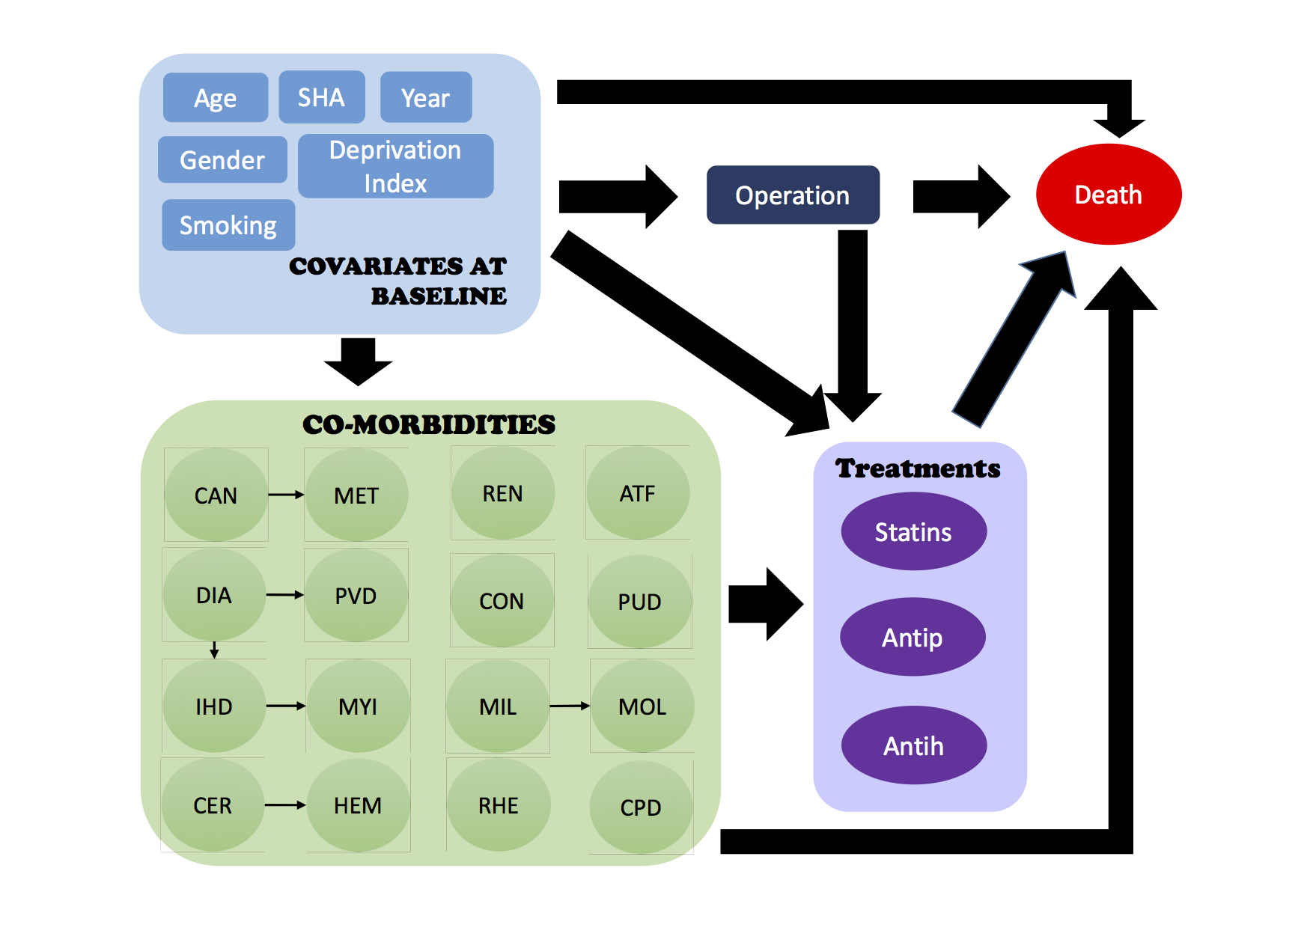
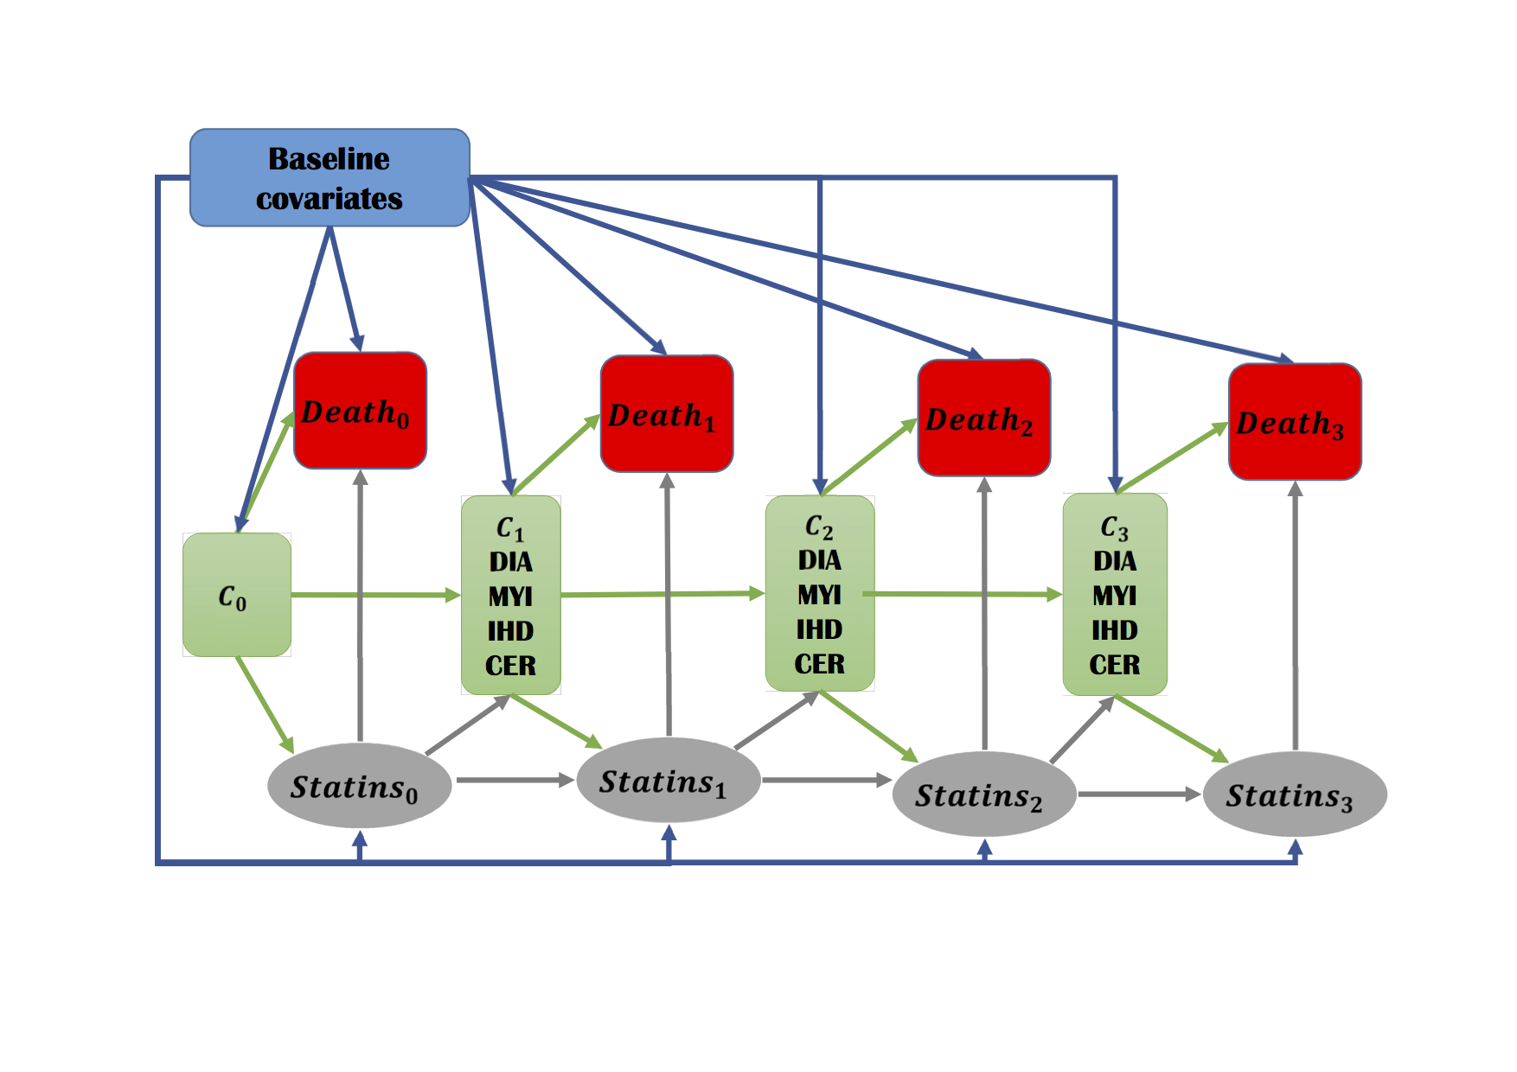
References

1. European Society for Vascular Surgery. 2nd vascunet report. 2008
2. Waton S JA, Groene O, Cromwell D, Mitchell D, Loftus IM. Outcomes after elective repair of infra-renal abdominal aortic aneurysm. . London: The Royal College of Surgeons of England,. October 2013:http://www.hqip.org.uk/assets/NCAPOP-Library/NCAPOP-2013-2014/Outcomes-after-Elective-Repair-of-Infra-renal-Abdominal-Aortic-Aneurysm.pdf accessed 2015 February 2015
3. Norman PE, Semmens JB, Lawrence-Brown MM, Holman CD. Long term relative survival after surgery for abdominal aortic aneurysm in western australia: Population based study. BMJ. 1998;317:852-856
4. Norman PE, Semmens JB, Lawrence-Brown MM. Long-term relative survival following surgery for abdominal aortic aneurysm: A review. Cardiovasc Surg. 2001;9:219-224
5. Karthikesalingam A, Bahia SS, Patterson BO, Peach G, Vidal-Diez A, Ray KK, Sharma R, Hinchliffe RJ, Holt PJ, Thompson MM. The shortfall in long-term survival of patients with repaired thoracic or abdominal aortic aneurysms: Retrospective case-control analysis of hospital episode statistics. European journal of vascular and endovascular surgery : the official journal of the European Society for Vascular Surgery. 2013;46:533-541
6. Lloyd GM, Newton JD, Norwood MG, Franks SC, Bown MJ, Sayers RD. Patients with abdominal aortic aneurysm: Are we missing the opportunity for cardiovascular risk reduction? Journal of vascular surgery. 2004;40:691-697
7. Baigent C, Keech A, Kearney PM, Blackwell L, Buck G, Pollicino C, Kirby A, Sourjina T, Peto R, Collins R, Simes R. Efficacy and safety of cholesterol-lowering treatment: Prospective meta-analysis of data from 90,056 participants in 14 randomised trials of statins. Lancet. 2005;366:1267-1278
8. Seshasai SR, Wijesuriya S, Sivakumaran R, Nethercott S, Erqou S, Sattar N, Ray KK. Effect of aspirin on vascular and nonvascular outcomes: Meta-analysis of randomized controlled trials. Archives of internal medicine. 2012;172:209-216
9. Bangalore S, Kumar S, Volodarskiy A, Messerli FH. Blood pressure targets in patients with coronary artery disease: Observations from traditional and bayesian random effects meta-analysis of randomised trials. Heart. 2013;99:601-613
10. Moll FL, Powell JT, Fraedrich G, Verzini F, Haulon S, Waltham M, van Herwaarden JA, Holt PJ, van Keulen JW, Rantner B, Schlosser FJ, Setacci F, Ricco JB. Management of abdominal aortic aneurysms clinical practice guidelines of the european society for vascular surgery. European journal of vascular and endovascular surgery : the official journal of the European Society for Vascular Surgery. 2011;41:S1-S58
11. Keil AP, Edwards JK, Richardson DB, Naimi AI, Cole SR. The parametric g-formula for time-to-event data: Intuition and a worked example. Epidemiology. 2014;25:889-897
12. Carey IM, Shah SM, Harris T, DeWilde S, Cook DG. A new simple primary care morbidity score predicted mortality and better explains between practice variations than the charlson index. Journal of clinical epidemiology. 2013;66:436-444
13. Cole SR, Hernan MA. Adjusted survival curves with inverse probability weights. Computer methods and programs in biomedicine. 2004;75:45-49
14. Simon R, Makuch RW. A non-parametric graphical representation of the relationship between survival and the occurrence of an event: Application to responder versus non-responder bias. Statistics in medicine. 1984;3:35-44
15. Robins JM, Greenland S. The role of model selection in causal inference from nonexperimental data. American journal of epidemiology. 1986;123:392-402
16. VanderWeele TJ, Hernan MA, Robins JM. Causal directed acyclic graphs and the direction of unmeasured confounding bias. Epidemiology. 2008;19:720-728
17. Moran GM, Calvert M, Feltham MG, Marshall T. Retrospective case review of missed opportunities for primary prevention of stroke and tia in primary care: Protocol paper. BMJ open. 2014;4:e006622
18. United Kingdom ETI, Greenhalgh RM, Brown LC, Powell JT, Thompson SG, Epstein D, Sculpher MJ. Endovascular versus open repair of abdominal aortic aneurysm. N Engl J Med. 2010;362:1863-1871
19. Baigent C, Keech A, Kearney PM, Blackwell L, Buck G, Pollicino C, Kirby A, Sourjina T, Peto R, Collins R, Simes R, Cholesterol Treatment Trialists C. Efficacy and safety of cholesterol-lowering treatment: Prospective meta-analysis of data from 90,056 participants in 14 randomised trials of statins. Lancet. 2005;366:1267-1278
20. Cannon CP, Steinberg BA, Murphy SA, Mega JL, Braunwald E. Meta-analysis of cardiovascular outcomes trials comparing intensive versus moderate statin therapy. Journal of the American College of Cardiology. 2006;48:438-445
21. Cholesterol Treatment Trialists C, Mihaylova B, Emberson J, Blackwell L, Keech A, Simes J, Barnes EH, Voysey M, Gray A, Collins R, Baigent C. The effects of lowering ldl cholesterol with statin therapy in people at low risk of vascular disease: Meta-analysis of individual data from 27 randomised trials. Lancet. 2012;380:581-590
22. Stone NJ, Robinson J, Lichtenstein AH, Merz CN, Blum CB, Eckel RH, Goldberg AC, Gordon D, Levy D, Lloyd-Jones DM, McBride P, Schwartz JS, Shero ST, Smith SC, Jr., Watson K, Wilson PW. 2013 acc/aha guideline on the treatment of blood cholesterol to reduce atherosclerotic cardiovascular risk in adults: A report of the american college of cardiology/american heart association task force on practice guidelines. Circulation. 2013
23. Antithrombotic Trialists C, Baigent C, Blackwell L, Collins R, Emberson J, Godwin J, Peto R, Buring J, Hennekens C, Kearney P, Meade T, Patrono C, Roncaglioni MC, Zanchetti A. Aspirin in the primary and secondary prevention of vascular disease: Collaborative meta-analysis of individual participant data from randomised trials. Lancet. 2009;373:1849-1860
24. Smith SC, Jr., Benjamin EJ, Bonow RO, Braun LT, Creager MA, Franklin BA, Gibbons RJ, Grundy SM, Hiratzka LF, Jones DW, Lloyd-Jones DM, Minissian M, Mosca L, Peterson ED, Sacco RL, Spertus J, Stein JH, Taubert KA, World Heart F, the Preventive Cardiovascular Nurses A. Aha/accf secondary prevention and risk reduction therapy for patients with coronary and other atherosclerotic vascular disease: 2011 update: A guideline from the american heart association and american college of cardiology foundation. Circulation. 2011;124:2458-2473
25. Lewington S, Clarke R, Qizilbash N, Peto R, Collins R, Prospective Studies C. Age-specific relevance of usual blood pressure to vascular mortality: A meta-analysis of individual data for one million adults in 61 prospective studies. Lancet. 2002;360:1903-1913
26. James PA, Oparil S, Carter BL, Cushman WC, Dennison-Himmelfarb C, Handler J, Lackland DT, LeFevre ML, MacKenzie TD, Ogedegbe O, Smith SC, Jr., Svetkey LP, Taler SJ, Townsend RR, Wright JT, Jr., Narva AS, Ortiz E. 2014 evidence-based guideline for the management of high blood pressure in adults: Report from the panel members appointed to the eighth joint national committee (jnc 8). JAMA : the journal of the American Medical Association. 2014;311:507-520
27. Rothwell PM, Howard SC, Dolan E, O'Brien E, Dobson JE, Dahlof B, Poulter NR, Sever PS, Ascot B, Investigators MRCT. Effects of beta blockers and calcium-channel blockers on within-individual variability in blood pressure and risk of stroke. The Lancet. Neurology. 2010;9:469-480
28. Randomised trial of cholesterol lowering in 4444 patients with coronary heart disease: The scandinavian simvastatin survival study (4s). Lancet. 1994;344:1383-1389
29. Holt PJ, Poloniecki JD, Loftus IM, Michaels JA, Thompson MM. Epidemiological study of the relationship between volume and outcome after abdominal aortic aneurysm surgery in the uk from 2000 to 2005. The British journal of surgery. 2007;94:441-448
30. The Vascular Society of Great Britain and Ireland. Outcomes after elective repair of infrarenal abdominal aortic aneurysm. A report from the vascular society. March 2012. http://www.vascularsociety.org.uk/vascular/wp-content/uploads/2012/11/VSGBI-Mortality-Report.pdf. 2012;Accessed November 2013

Acknowledgements:
Sunil Shah, Jan Poloniecki, Venediktos Kapetanakis and Iain Carey.
Appendix: Baseline Characteristics of Study Participants

All patients with AAA

N=12485
Showing n(%)
Median (interquartile Range) Age (years) | 75 (13)
Male | 9345 (74.85%)
Myocardial infarction | 2276 (18.23%)
Congestive Cardiac Failure | 1091 (8.74%)
Renal Disease | 748 (5.99%)
Cerebrovascular Disease | 2069 (16.57%)
Diabetes without complications | 1422 (11.39%)
Cancer | 1796 (14.39%)
Dementia | 235 (1.88%)
Chronic Pulmonary Disease | 2590 (20.74%)
Diabetes with complications | 224 (1.79%)
Hemiplegia/Paraplegia | 84 (0.67%)
Metastatic Tumour | 49 (0.39%)
Mild Liver Disease | 46 (0.37%)
Moderate Liver Disease | 10 (0.08%)
Peptic Ulcer Disease | 1058 (8.47%)
Peripheral Vascular Disease | 3029 (24.26%)
Rheumatological Disease | 656 (5.25%)
Atrial Fribilliation | 1424 (11.41%)
Ischaemic Heart Disease | 3999 (32.03%)
Hypertension | 6720 (53.82%)
Current Smoker | 2798 (22.41%)
Never Smoker | 2280 (18.26%)
Ex-Smoker | 7407 (59.33%)
Receiving Statin within 1 year after AAA diagnosis | 8250 (66.08%)
Receving Statin or Lipid modifiers within 1 year after AAA diagnosis | 8397 (67.26%)
Receiving Antihypertensives within 1 year after AAA diagnosis | 10235 (81.98%)
Receiving Antiplatelets within 1 year after AAA diagnosis | 9021 (72.25%)

Appendix:

Table 2: Summary results of the G-computation formula. Patients were assumed to be taking these agents for the 90 days that followed each recorded prescription.

Scenario |  | G-formula adjusted HR | Lives saved per 1000 person years (inferred from G-formula) | Cox model HR | P-value (from cox)
 | All Statins and LMTs
All vs. none |  | 0.584 (0.562-0.607) | 49.92 | 0.565 (0.523-0.609) | <0.0001
All vs current practice |  | 0.787 (0.756-0.820) | 25.56
Current practice vs none |  | 0.742 (0.714-0.771) | 30.96
 | Statins alone
All vs. none |  | 0.611 (0.588 – 0.637) | 46.68 | 0.589 (0.546-0.636) | <0.0001
All vs current practice |  | 0.798 (0.766-0.832) | 24.24
Current practice vs none |  | 0.766 (0.739-0.796) | 28.08
 | Antiplatelets
All vs. none |  | 0.799 (0.77-0.83) | 24.12 | 0.785 (0.729-0.845) | <0.0001
All vs current practice |  | 0.901 (0.866-0.937) | 11.88
Current practice vs none |  | 0.887 (0.856 – 0.921) | 13.56
Aspirin vs None |  | 0.798 (0.768-0.83) |  | 0.794 (0.739-0.853) | <0.0001
Clopidogrel vs None |  | 1.015 (0.977-1.058) |  | 1.013 (0.893-1.151) | 0.8345
Dipyridamole vs None |  | 0.975 (0.937-1.015) |  | 0.992 (0.826-1.192) | 0.9308
 | Anticoagulants
All vs. none |  | 0.849 (0.818-0.882) | 18.12 | 0.823 (0.726-0.932) | 0.0055
All vs current practice |  | 0.961 (0.924-1) | 4.68
Current practice vs none |  | 0.883 (0.849-0.918) | 14.04
 | Anti-hypertensives
All vs. none |  | 0.881 (0.847 – 0.917) | 14.28 | 0.872 (0.808-0.941) | 0.0004
All vs current practice |  | 0.966 (0.931 – 1.01) | 4.08
Current practice vs none |  | 0.909 (0.85 – 0.918) | 10.92
All ACEi vs none |  | 0.788 (0.759-0.818) |  | 0.775 (0.718-0.835) | < 0.0001
All ARBs vs. none |  | 0.672 (0.648-0.699) |  | 0.653 (0.579-0.737) | <0.0001
All B-blockers vs. none |  | 0.944 (0.907-0.981) |  | 0.942 (0.872-1.017) | 0.1282
All CCBs vs. none |  | 0.845 (0.815-0.880) |  | 0.835 (0.774-0.899) | <0.0001
All Diuretics vs. none |  | 1.177 (1.136-1.222) |  | 1.185 (1.105-1.271) | <0.0001

Appendix: Map to illustrate variation in prescription of antiplatelet agents for each Strategic Health Authority

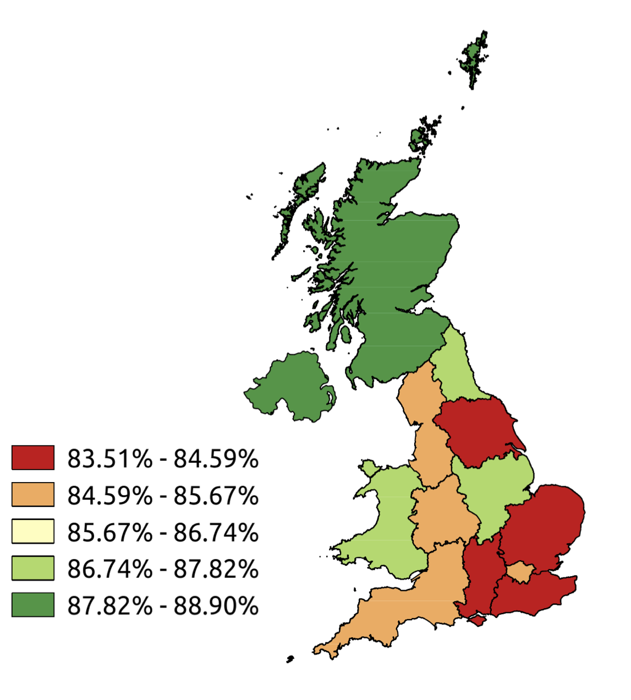
Appendix: Map to illustrate variation in prescription of statins for each Strategic Health Authority
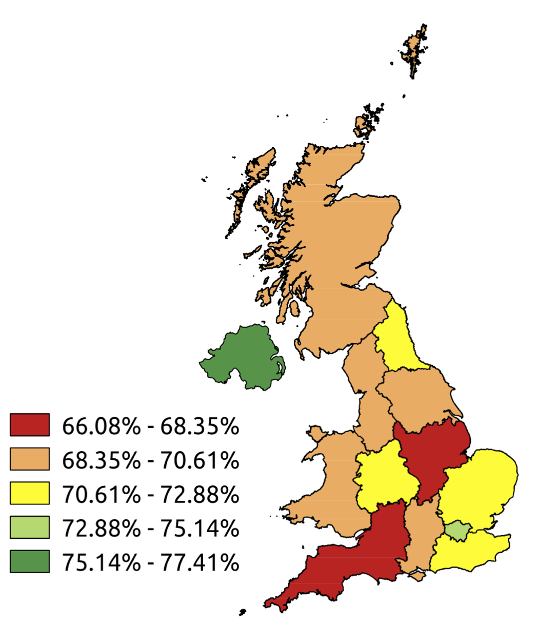

Appendix: Cox Proportional Hazards Model for 5-year survival. Antiplatelet agents, Anti-hypertensive agents, Statins, Operation and co-morbidities were modelled as time-dependent covariates. Patients were assumed to be taking these agents for the 90 days that followed each recorded prescription.

Parameter | Adjusted Hazard  Ratio | Lower 95% CI | Upper 95% CI |  | p-value
Age at AAA diagnosis | 1.060 | 1.055 | 1.065 |  | <.0001
Year at AAA diagnosis | *** |  |  |  | <.0001
Gender | 0.916 | 0.853 | 0.983 |  | 0.0144
Smoker (Never vs Current & Ex) | 0.571 | 0.53 | 0.615 |  | <.0001
Deprivation Categories | *** |  |  |  | 0.0082
Strategic Health Authority | *** |  |  |  | 0.0256
Operation (Yes vs No) | 0.688 | 0.618 | 0.765 |  | <.0001
Cancer (Yes vs No) | 1.709 | 1.59 | 1.837 |  | <.0001
Cerebrovascular disease (Yes vs No) | 1.405 | 1.301 | 1.518 |  | <.0001
Chronic Pulmonary Disease (Yes vs No) | 1.273 | 1.187 | 1.366 |  | <.0001
Congestive Cardiac Failure (Yes vs No) | 1.712 | 1.568 | 1.87 |  | <.0001
Dementia (Yes vs No) | 1.832 | 1.596 | 2.104 |  | <.0001
Diabetes (Yes vs No) | 1.160 | 1.054 | 1.278 |  | 0.0025
Hemiplegia/Paraplegia (Yes vs No) | 1.447 | 1.089 | 1.924 |  | 0.0109
Metastatic Tumour (Yes vs No) | 4.79 | 3.995 | 5.745 |  | <.0001
Moderate Liver Disease (Yes vs No) | 2.702 | 1.282 | 5.693 |  | 0.0091
Myocardial Infarction (Yes vs No) | 1.236 | 1.132 | 1.351 |  | <.0001
Peripheral Vascular Disease (Yes vs No) | 1.094 | 1.023 | 1.169 |  | 0.0084
Renal disease (Yes vs No) | 1.541 | 1.401 | 1.695 |  | <.0001
Rheumatological Disease (Yes vs No) | 1.208 | 1.069 | 1.365 |  | 0.0024
Atrial Fibrilliation (Yes vs No) | 1.195 | 1.088 | 1.311 |  | 0.0002
Ischaemic Heart Disease (Yes vs No) | 1.148 | 1.060 | 1.243 |  | 0.0007
Antiplatelet Therapy:
Antiplatelets (Yes vs No) | 0.785 | 0.73 | 0.845 |  | <.0001
Aspirin (Yes vs No) | 0.794 | 0.739 | 0.853 |  | <.0001
Clopidogrel | 1.013 | 0.893 | 1.151 |  | 0.835
Dipyridamole | 0.992 | 0.826 | 1.192 |  | 0.931
Anticoagulation Therapy:
Anticoagulation (Yes vs No) | 0.823 | 0.726 | 0.932 |  | 0.0022
Anti-hypertensive Therapy
Anti-hypertensive (Yes vs No) | 0.872 | 0.808 | 0.941 |  | 0.0004
ACEi (Yes vs No) | 0.775 | 0.718 | 0.835 |  | <.0001
B-Blockers (Yes vs No) | 0.942 | 0.872 | 1.017 |  | 0.1282
CCBs (Yes vs No) | 0.835 | 0.774 | 0.899 |  | <0.001
Diuretics (Yes/No) | 1.185 | 1.105 | 1.271 |  | <.0001
ARBs (Yes vs No) | 0.653 | 0.579 | 0.737 |  | <.0001
Statins Therapy
Statins + LMTs (Yes vs No) | 0.565 | 0.523 |  | 0.609 | <.0001
Only Statins (Yes/No) | 0.589 | 0.546 |  | 0.636 | <.0001

