SUPPLEMENTARY MATERIAL
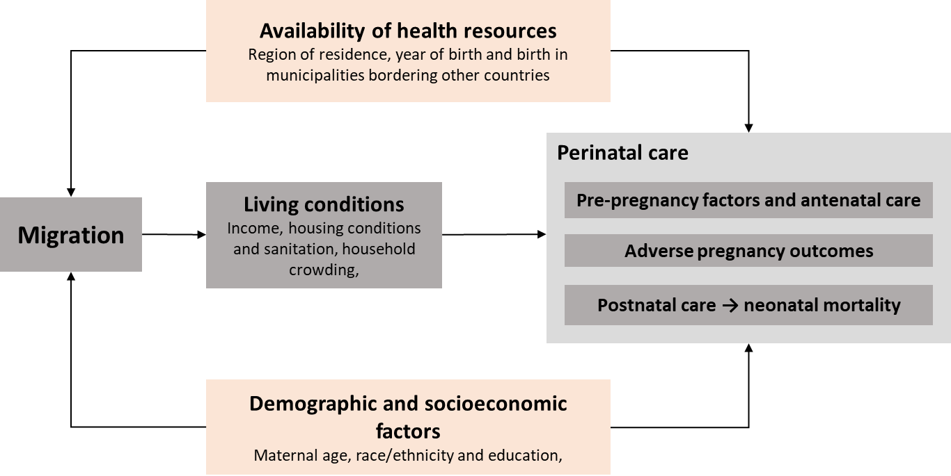
Figure S1. Logic model for the effect of migration on perinatal outcomes.

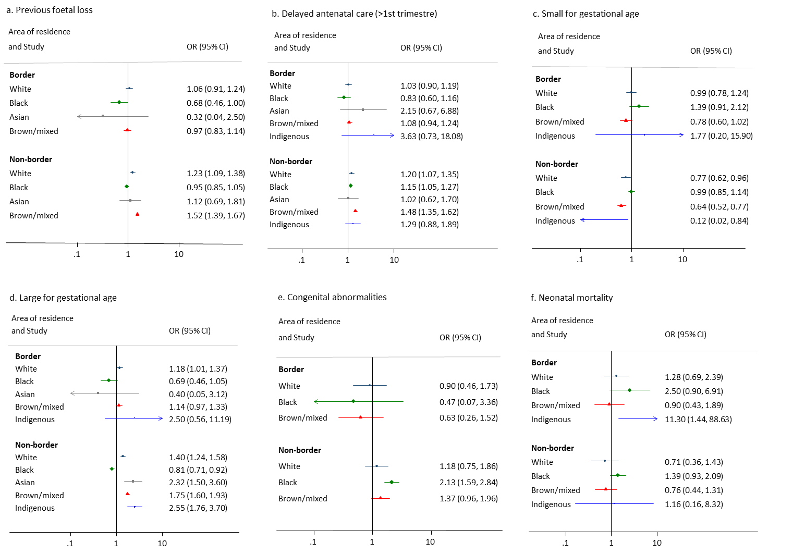
Figure S2. Adjusted odds ratio of perinatal outcomes of live births born to international migrants compared to those born to Brazilian-born mothers by race/ethnicity and place of residence for selected health outcomes. Odds ratio (OR) calculated by logistic regression adjusted for mother’s age, education, region of residence and year of birth.

Table S1. Characteristics of demographic and socioeconomic characteristics of live births born between 2011 and 2018 by place of birth of the mother.
 | Live births from international migrant mothers (N=9,469) |  | Live births from Brazilian-born mothers (N=10,269,542) |  | All live births  (N=10,279,011)
 | N | % | N | % | N | %
Mother’s demographic characteristics
Age
10-18 years | 628 | 6.6 | 1,820,058 | 17.7 | 1,820,686 | 17.7
19-39 years | 8,281 | 87.5 | 8,250,841 | 80.3 | 8,259,122 | 80.3
40-49 years | 560 | 5.9 | 198,643 | 1.9 | 199,203 | 1.9
Race/ethnicity
White | 3,011 | 31.8 | 3,103,283 | 30.2 | 3,106,294 | 30.2
Black | 2,634 | 27.8 | 818,398 | 8.0 | 821,032 | 8
Asian | 113 | 1.2 | 39,968 | 0.4 | 40,081 | 0.4
Brown/mixed | 3,572 | 37.7 | 6,205,110 | 60.4 | 6,208,682 | 60.4
Indigenous | 139 | 1.5 | 102,783 | 1.0 | 102,922 | 1
Civil status
Married | 5,182 | 54.7 | 5,048,155 | 49.2 | 5,053,337 | 49.2
Single | 4,203 | 44.4 | 5,117,160 | 49.8 | 5,121,363 | 49.8
Missing | 84 | 0.9 | 104,227 | 1.0 | 104,311 | 1
Literate
Yes | 9,041 | 95.5 | 9,525,172 | 92.8 | 9,534,213 | 92.8
No | 423 | 4.5 | 679,242 | 6.6 | 679,665 | 6.6
Missing | 5 | 0.1 | 65,128 | 0.6 | 65,133 | 0.6
Education
No | 126 | 1.3 | 90,762 | 0.9 | 90,888 | 0.9
1-3 years | 329 | 3.5 | 483,443 | 4.7 | 483,772 | 4.7
4-7 years | 1,959 | 20.7 | 2,753,401 | 26.8 | 2,755,360 | 26.8
8-11 years | 5,966 | 63 | 6,331,739 | 61.7 | 6,337,705 | 61.7
>12 years | 1,089 | 11.5 | 610,197 | 5.9 | 611,286 | 5.9
Region of residence
North | 656 | 6.9 | 1,300,066 | 12.7 | 1,300,722 | 12.7
Northeast | 368 | 3.9 | 3,953,245 | 38.5 | 3,953,613 | 38.5
Southeast | 4,121 | 43.5 | 3,169,972 | 30.9 | 3,174,093 | 30.9
South | 3,432 | 36.2 | 1,143,240 | 11.1 | 1,146,672 | 11.2
Central-west | 892 | 9.4 | 703,019 | 6.8 | 703,911 | 6.8
Area of residence
Urban | 8,693 | 91.8 | 7,593,967 | 73.9 | 7,602,660 | 74
Rural | 710 | 7.5 | 2,537,071 | 24.7 | 2,537,781 | 24.7
Missing | 66 | 0.7 | 138,504 | 1.3 | 138,570 | 1.3
Border municipality
Yes | 2,576 | 72.8 | 698,966 | 6.8 | 701,542 | 6.8
No | 6,893 | 27.2 | 9,570,576 | 93.2 | 9,577,469 | 93.2
Mothers socioeconomic characteristics
Household type
Private and permanent | 7,917 | 83.6 | 9,471,771 | 92.2 | 9,479,688 | 92.2
Private but improvised or collective | 866 | 9.1 | 388,517 | 3.8 | 389,383 | 3.8
Missing | 686 | 7.2 | 409,254 | 4.0 | 409,940 | 4
Material of the household
Masonry / brick | 7,015 | 74.1 | 7,141,091 | 69.5 | 7,148,106 | 69.5
Coated or Uncoated Taipa, wood, others | 252 | 2.7 | 1,412,932 | 13.8 | 1,413,184 | 13.7
Wood | 1,357 | 14.3 | 1,463,553 | 14.3 | 1,464,910 | 14.3
Missing | 845 | 8.9 | 251,966 | 2.5 | 252,811 | 2.5
Water supply
Public network | 7,703 | 81.3 | 6,883,419 | 67.0 | 6,891,122 | 67
Well, natural source from the ground | 720 | 7.6 | 2,269,475 | 22.1 | 2,270,195 | 22.1
Other (e.g., rivers) | 201 | 2.1 | 864,701 | 8.4 | 864,902 | 8.4
Missing | 845 | 8.9 | 251,947 | 2.5 | 252,792 | 2.5
Sewage disposal
Public network | 5,461 | 57.7 | 4,206,091 | 41.0 | 4,211,552 | 41
Septic tank | 1,094 | 11.6 | 1,494,210 | 14.5 | 1,495,304 | 14.5
Rudimentary Trench, open ditch, water or others | 1,735 | 18.3 | 2,553,596 | 24.9 | 2,555,331 | 24.9
Others (role, river, etc) | 248 | 2.6 | 1,660,776 | 16.2 | 1,661,024 | 16.2
Missing | 931 | 9.8 | 354,869 | 3.5 | 355,800 | 3.5
Waste disposal/ garbage collection
Collected directly/indirectly | 7,937 | 83.8 | 7,262,290 | 70.7 | 7,270,227 | 70.7
Burned or buried | 501 | 5.3 | 1,898,133 | 18.5 | 1,898,634 | 18.5
Other outdoor disposal | 186 | 2.0 | 857,182 | 8.3 | 857,368 | 8.3
Missing | 845 | 8.9 | 251,937 | 2.5 | 252,782 | 2.5
Electricity
Electric with meter | 6,930 | 73.2 | 7,589,833 | 73.9 | 7,596,763 | 73.9
Electric with community meter | 1,141 | 12.0 | 582,242 | 5.7 | 583,383 | 5.7
Informal electric lights or no electricity | 319 | 3.4 | 735,304 | 7.2 | 735,623 | 7.2
No electricity | 234 | 2.5 | 1,110,419 | 10.8 | 1,110,653 | 10.8
Missing | 845 | 8.9 | 251,744 | 2.5 | 252,589 | 2.5
Received Bolsa Familia benefit at any time
No | 2,856 | 30.2 | 872,459 | 8.5 | 875,315 | 8.5
Yes | 6,613 | 69.8 | 9,397,083 | 91.5 | 9,403,696 | 91.5

Table S2. Crude odds ratio of perinatal outcomes of live births born to international migrants compared to those born to Brazilian-born birth mothers.
 | Live births from international migrant mothers versus Brazilian-born mothers
 | White  OR (95%CI) | Black  OR (95%CI) | Asian  OR (95%CI) | Brown/mixed  OR (95%CI) | Indigenous  OR (95%CI)
Pre-pregnancy risk factors
Previous foetal loss
No | 1.00 | 1.00 | 1.00 | 1.00 | 1.00
Yes | 1.19 (1.09-1.30) | 0.90 (0.82-1.00) | 1.01 (0.64-1.59) | 1.41 (1.30-1.52) | 2.03 (1.41-2.92)
Antenatal care
Delayed antenatal care
No (started in first trimester) | 1.00 | 1.00 | 1.00 | 1.00 | 1.00
Yes (>1st trimester) | 1.05 (0.96-1.15) | 0.81 (0.74-0.89) | 0.86 (0.55-1.36) | 1.10 (1.02-1.19) | 0.70 (0.49-1.00)
Adverse pregnancy outcomes
Prematury
Term (>=37 weeks) | 1.00 | 1.00 | 1.00 | 1.00 | 1.00
Premature (<37 weeks) | 0.94 (0.83-1.06) | 0.81 (0.71-0.93) | 0.08 (0.01-0.56) | 0.82 (0.73-0.92) | 0.36 (0.18-0.73)
Birth weight
>=2500g | 1.00 | 1.00 | 1.00 | 1.00 | 1.00
<2500g | 0.86 (0.74-0.99) | 0.92 (0.80-1.07) | 0.24 (0.06-0.97) | 0.63 (0.54-0.74) | 0.21 (0.05-0.83)
Weight for gestational age (0 vs 1)
AGA | 1.00 | 1.00 | 1.00 | 1.00 | 1.00
SGA | 0.84 (0.72-0.99) | 0.91 (0.79-1.04) | 0.37 (0.12-1.19) | 0.64 (0.55-0.75) | 0.19 (0.05-0.77)
LGA | 1.29 (1.18-1.42) | 0.73 (0.65-0.82) | 1.75 (1.15-2.67) | 1.45 (1.34-1.57) | 2.05 (1.43-2.94)
APGAR at 5 minutes
>=7 | 1.00 | 1.00 | 1.00 | 1.00 | 1.00
<7 | 0.72 (0.47-1.10) | 1.44 (1.08-1.90) | 0.82 (0.11-5.90) | 0.71 (0.5-1.02) | 1.08 (0.27-4.36)
Congenital anomaly
No | 1.00 | 1.00 | 1.00 | 1.00 | 1.00
Yes | 1.11 (0.77-1.62) | 2.14 (1.6-2.84) | 1.13 (0.16-8.10) | 1.32 (0.95-1.83) | 0.99 (0.14-7.07)
Neonatal mortality
Neonatal mortality²
No | 1.00 | 1.00 | 1.00 | 1.00 | 1.00
Yes | 0.94 (0.59-1.50) | 1.18 (0.79-1.76) | - | 0.79 (0.51-1.22) | 1.75 (0.43-7.08)
² Not enough events among Asian category.
AGA: Adequate for gestational age, SGA: Small for gestational age, LGA: Large for gestational age

Table S3. Crude odds ratio of perinatal outcomes of live births born to international migrants compared to those born to Brazilian-born birth mothers for people living in border and non-border areas.
 | Live births from migrant versus Brazilian-born birth mothers
 | Non-border  OR (95%CI) | Non-border  OR_{adj}¹(95%CI) | Border  OR (95%CI) | Border  OR_{adj}¹(95%CI)
Pre-pregnancy risk factors
Previous foetal loss
No | 1.00 | 1.00 | 1.00 | 1.00
Yes | 1.31 (1.23-1.38) | 1.24 (1.17-1.31) | 1.03 (0.93-1.14) | 0.99 (0.89-1.09)
Antenatal care
Delayed antenatal care
No (started in first trimester) | 1.00 | 1.00 | 1.00 | 1.00
Yes (>1st trimester) | 1.01 (0.96-1.07) | 1.27 (1.21-1.35) | 0.83 (0.76-0.91) | 1.03 (0.94-1.14)
Adverse pregnancy outcomes
Prematurity
Term (>=37 weeks) | 1.00 | 1.00 | 1.00 | 1.00
Premature (<37 weeks) | 0.81 (0.75-0.88) | 0.86 (0.79-0.93) | 0.87 (0.76-0.88) | 0.93 (0.82-1.05)
Birth weight
>=2500g | 1.00 | 1.00 | 1.00 | 1.00
<2500g | 0.82 (0.74-0.91) | 0.74 (0.67-0.82) | 0.80 (0.68-0.95) | 0.76 (0.64-0.90)
Weight for gestational age
AGA | 1.00 | 1.00 | 1.00 | 1.00
SGA | 0.77 (0.70-0.86) | 0.80 (0.72-0.88) | 0.90 (0.76-1.05) | 0.93 (0.79-1.10)
LGA | 1.21 (1.14-1.29) | 1.33 (1.26-1.42) | 1.06 (0.95-1.17) | 1.12 (1.01-1.24)
APGAR at 5 minutes
>=7 | 1.00 | 1.00 | 1.00 | 1.00
<7 | 1.02 (0.82-1.27) | 1.11 (0.89-1.39) | 0.87 (0.58-1.30) | 0.90 (0.60-1.35)
Congenital anomaly
No | 1.00 | 1.00 | 1.00 | 1.00
Yes | 1.80 (1.47-2.19) | 1.57 (1.29-1.91) | 0.82 (0.50-1.37) | 0.74 (0.45-1.23)
Neonatal mortality
Child death within 28 days
No | 1.00 | 1.00 | 1.00 | 1.00
Yes | 0.96 (0.72-1.28) | 0.98 (0.73-1.31) | 0.99 (0.62-1.58) | 1.02 (0.64-1.63)
¹Adjusted for birth mother’s race/ethnicity, age, education, region of residence and year of birth.
AGA: Adequate for gestational age, SGA: Small for gestational age, LGA: Large for gestational age

Table S4. Adjusted odds ratio of perinatal outcomes of live births born to international migrants compared to those born to Brazilian-born mothers by race/ethnicity and place of residence.
 | White |  | Black |  | Asian |  | Brown/mixed |  | Indigenous
ORadj¹ (95%CI) | Non-border | Border | Non-border | Border | Non-border | Border | Non-border | Border | Non-border | Border
Pre-pregnancy risk factors
Previous foetal loss²
No | 1.00 | 1.00 | 1.00 | 1.00 | 1.00 | 1.00 | 1.00 | 1.00 | 1.00 | 1.00
Yes | 1.23 (1.09-1.38) | 1.06 (0.91-1.24) | 0.95 (0.85-1.05) | 0.68 (0.46-1.00) | 1.12 (0.69-1.81) | 0.32 (0.04-2.5) | 1.52 (1.39-1.67) | 0.97 (0.83-1.14) | - | -
Antenatal care
Delayed antenatal care
No (started in first trimester) | 1.00 | 1.00 | 1.00 | 1.00 | 1.00 | 1.00 | 1.00 | 1.00 | 1.00 | 1.00
Yes (>1st trimester) | 1.20 (1.07-1.35) | 1.03 (0.9-1.19) | 1.15 (1.05-1.27) | 0.83 (0.6-1.16) | 1.02 (0.62-1.7) | 2.15 (0.67-6.88) | 1.48 (1.35-1.62) | 1.08 (0.94-1.24) | 1.29 (0.88-1.89) | 3.63 (0.73-18.08)
Adverse pregnancy outcomes
Prematurity²
Term (>=37 weeks) | 1.00 | 1.00 | 1.00 | 1.00 | 1.00 | 1.00 | 1.00 | 1.00 | 1.00 | 1.00
Premature (<37 weeks) | 0.92 (0.79-1.08) | 1.00 (0.83-1.21) | 0.92 (0.8-1.06) | 0.73 (0.45-1.19) | - | - | 0.81 (0.70-0.93) | 0.95 (0.78-1.15) | 0.49 (0.23-1.05) | 0.55 (0.07-4.36)
Birth weight²
>=2500g | 1.00 | 1.00 | 1.00 | 1.00 | 1.00 | 1.00 | 1.00 | 1.00 | 1.00 | 1.00
<2500g | 0.85 (0.71-1.03) | 0.81 (0.64-1.02) | 0.91 (0.79-1.06) | 0.79 (0.46-1.36) | - | - | 0.54 (0.45-0.66) | 0.71 (0.54-0.94) | - | -
Weight for gestational age²
AGA | 1.00 | 1.00 | 1.00 | 1.00 | 1.00 | 1.00 | 1.00 | 1.00 | 1.00 | 1.00
SGA | 0.77 (0.62-0.96) | 0.99 (0.78-1.24) | 0.99 (0.85-1.14) | 1.39 (0.91-2.12) | - | - | 0.64 (0.52-0.77) | 0.78 (0.6-1.02) | 0.12 (0.02-0.84) | 1.77 (0.2-15.9)
LGA | 1.40 (1.24-1.58) | 1.18 (1.01-1.37) | 0.81 (0.71-0.92) | 0.69 (0.46-1.05) | 2.32 (1.5-3.6) | 0.40 (0.05-3.12) | 1.75 (1.6-1.93) | 1.14 (0.97-1.33) | 2.55 (1.76-3.7) | 2.50 (0.56-11.19)
APGAR at 5 minutes²
>=7 | 1.00 | 1.00 | 1.00 | 1.00 | 1.00 | 1.00 | 1.00 | 1.00 | 1.00 | 1.00
<7 | 0.58 (0.31-1.08) | 0.99 (0.56-1.76) | 1.77 (1.32-2.36) | 1.13 (0.36-3.56) | - | - | 0.79 (0.52-1.22) | 0.8 (0.42-1.55) | - | -
Congenital abnormalities²
No | 1.00 | 1.00 | 1.00 | 1.00 | 1.00 | 1.00 | 1.00 | 1.00 | 1.00 | 1.00
Yes | 1.18 (0.75-1.86) | 0.90 (0.46-1.73) | 2.13 (1.59-2.84) | 0.47 (0.07-3.36) | - | - | 1.37 (0.96-1.96) | 0.63 (0.26-1.52) | - | -
Neonatal mortality
Child death ≤28 days²
No | 1.00 | 1.00 | 1.00 | 1.00 | 1.00 | 1.00 | 1.00 | 1.00 | 1.00 | 1.00
Yes | 0.71 (0.36-1.43) | 1.28 (0.69-2.39) | 1.39 (0.93-2.09) | 2.50 (0.9-6.91) | - | - | 0.76 (0.44-1.31) | 0.90 (0.43-1.89) | 1.16 (0.16-8.32) | 11.30 (1.44-88.63)
¹Adjusted for birth mother’s race/ethnicity, age, education, region of residence and year of birth.
² Not enough events among Asian and/or Indigenous category.
AGA: Adequate for gestational age, SGA: Small for gestational age, LGA: Large for gestational age

