Supplementary Material

Contents:
Supplementary Figure 1
Supplementary Table 1

Supplementary Figure 2

Supplementary Table 2

Supplementary Table 3

Supplementary Table 4

Meta-Analysis

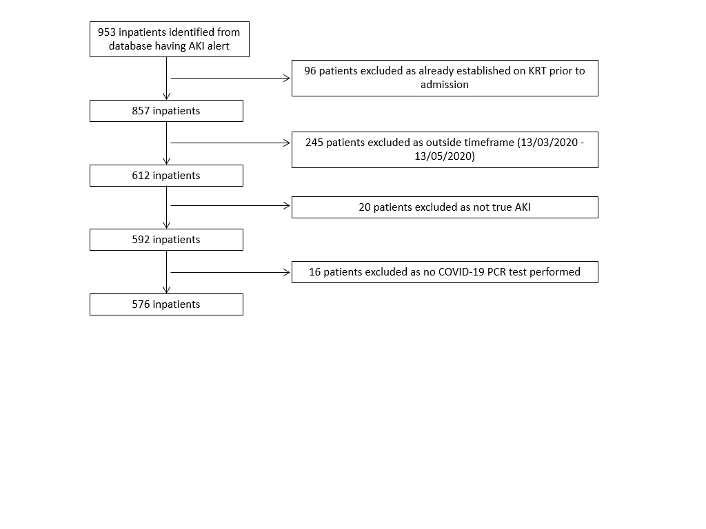
Supplementary Figure 1: Flow chart of eligible patients

 | ALL=576 |  |  |  | COVID 19- = 319 |  |  |  | COVID 19+ = 257
AKI stage | 1 | 2 | 3 | Died | 1 | 2 | 3 | Died | 1 | 2 | 3 | Died
1 (24hrs) | 297 (70.4%) | 54(12.8%) | 71(16.8%) | 117(27.7%) | 189(81.1%) | 32(13.7%) | 12(5.2%) | 27(11.6%) | 107(56.9%) | 22(11.7%) | 59(31.4%) | 90(47.9%)
2 (24hrs) | 0 | 55(59.1%) | 38(40.9%) | 44(47.3%) | 1 | 35(70.0%) | 14(28%) | 14 (28%) | 0 | 20(45.5%) | 24(54.6%) | 30(68.2%)
3 (24hrs) | 0 | 0 | 55 | 23(41.8%) | 0 | 0 | 30 | 9(30%) | 0 | 0 | 25 | 14(56%%)
Missing | 4 | 0 | 2 | 2 | 4 | 0 | 2 | 2 | 0 | 0 | 0 | 0

Supplementary Table 1: Descriptive table of AKI patient disease progression during hospital stay; overall and stratified by COVID status. A visual display of all possible transitions can be seen in Figure 2.
Overall, 12.8% of those diagnosed with AKI stage 1 within 24 hours progressed to stage 2 and 16.9% to stage 3 during their hospital/ICU stay. However, whilst progression to stage 2 was comparable in COVID- (13.7%) and COVID+ patients (11.7%), progression from AKI stage 1 to stage 3 was vastly different amongst the two groups; 5.2% in COVID- vs. 31.4% among COVID+ patients. Likewise, progression from AKI stage 2 diagnosis within 24 hours since admission to AKI stage 3 was different in the two groups; 28% in COVID- vs. 54.6% in COVID+ patients.
Overall, 9.5% patients were diagnosed with stage 3 AKI within 24 hours and remained so and the figure was not very different between the two groups defined by COVID status. However, in those diagnosed with AKI stage 3 within 24hours, 14/25 (56%) died amongst COVID+ compared to 9/30 (30%) in COVID- patients.

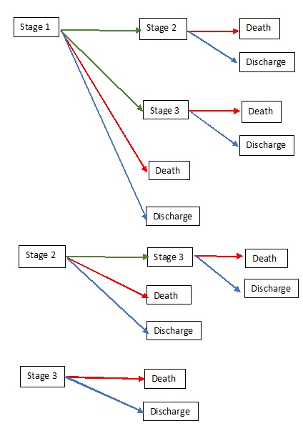

Supplementary Figure 2: Descriptive flow chart describing all possible transitions in AKI patients from 24 hours diagnosis throughout their hospital stay. Only the most severe AKI stage (referred to as peak AKI stage) ever recorded during hospital stay is considered a potential transition state. Final states are either death or discharge - considered a stable state in which the patient can leave the hospital.

 | COVID- |  |  |  | COVID+
 | DISCHARGE |  | DEATH |  | DISCHARGE |  | DEATH
 | DAY 7 | DAY 14 | DAY 7 | DAY 14 | DAY 7 | DAY 14 | DAY 7 | DAY 14
ALL | 44% (38%, 49%) | 66% (61%, 71%) | 8% (5%, 12%) | 19% (14%, 24%) | 10% (7%, 13%) | 13% (10%, 17%) | 19% (14%, 24%) | 33% (28%, 39%)
AKI 1 | 51% (43%, 57%) | 76% (70%, 82%) | 5% (2%, 8%) | 6% (3%, 10%) | 15% (9%, 22%) | 32% (23%, 41%) | 14% (8%, 21%) | 22% (15%, 31%)
AKI 2 | 37% (26%, 49%) | 63% (50%, 73%) | 18% (10%, 28%) | 21% (12%, 31%) | 10% (3%, 21%) | 19% (9%, 32%) | 21% (11%, 35%) | 33% (20%, 48%)
AKI 3 | 28% (17%, 39%) | 38% (26%, 50%) | 21% (11%, 32%) | 28% (17%, 39%) | 1% (0.8%, 5%) | 6% (2%, 11%) | 22% (15%, 30%) | 45% (36%, 54%)

Supplementary Table 2: The dynamics of discharge and death in AKI patients as estimated by the competing risk model. The figures represent the cumulative risk of death and discharge on day 7 and 14 stratified by COVID-19 status and further by AKI peak stage that patients reached during their hospital stay. A more detailed visual display can be seen in Figure 2.

 |  | COVID- |  |  |  | COVID+
FROM | TO | DAY 7 | DAY 14 | PEAK DAY | PEAK VALUE | DAY 7 | DAY 14 | PEAK DAY | PEAK VALUE
AKI 1 | AKI 2 | 3% (1%, 5%) | 2% (1%, 4%) | Day 2 | 9% (6%, 12%) | 3% (1%, 5%) | 4% (2%, 7%) | Day 2 | 5% (3%, 8%)
 | AKI 3 | 6% (3%, 9%) | 3% (1%, 5%) | Day 6 | 7% (4%, 10%) | 22% (17%, 27%) | 17% (12%, 22%) | Day 8 | 24% (19%, 30%)
 | DEATH | 8% (6%, 11%) | 11% (8%, 14%) | Day 33 | 13% (9%, 16%) | 22% (17%, 27%) | 36% (31%, 42%) | Day 33 | 50% (44%, 56%)
 | DISCHARGE | 71% (66%, 75%) | 80% (76%, 84%) | Day 36 | 86% (83%, 89%) | 27% (21%, 32%) | 35% (29%, 40%) | Day 40 | 47% (41%, 52%)
AKI 2 | AKI 3 | 16% (9%, 23%) | 8% (3%, 12%) | Day 4 | 19% (11%,27%) | 32% (22%, 42%) | 23% (15%, 30%) | Day 6 | 34% (24%, 45%)
 | DEATH | 22% (16%, 28%) | 25% (20%, 32%) | Day 31 | 29% (23%, 36%) | 30% (21%, 39%) | 44% (35%, 53%) | Day 28 | 63% (54%, 72%)
 | DISCHARGE | 56% (49%, 63%) | 63% (56%, 70%) | Day 33 | 69% (62%, 75%) | 19% (11%, 27%) | 23% (15%, 32%) | Day 40 | 33% (24%, 41%)
AKI 3 | DEATH | 28% (23%, 33%) | 30% (25%, 35%) | Day 31 | 32% (27%, 37%) | 42% (33%, 50%) | 50% (42%, 58%) | Day 33 | 59% (51%, 68%)
 | DISCHARGE | 62% (57%, 68%) | 65% (60%, 70%) | Day 28 | 67% (62%, 72%) | 33% (24%, 43%) | 35% (25%, 44%) | Day 40 | 38% (29%, 47%)

Supplementary Table 3: The estimated probabilities of all possible transitions and their 95%CIs from the initial 24 hours diagnosis on day 7 and 14 since admission stratified by COVID-19 status. The estimates are nonlinear with time since admission hence, to understand the AKI progression dynamics, we present the estimated peak probabilities and the first day these are achieved – potentially before their value saturate which is specific to death or discharge. A visual display of daily transition probabilities can be seen in Figure 4.
Time (days) | Percentiles | AUC | 95%CI for AUC
4 | 25% | 50.47 | (40.55, 60.39)
9 | 50% | 63.27 | (56.46, 70.09)
17 | 75% | 74.15 | (68.54, 79.76)
29 | 90% | 76.18 | (70.98, 81.37)
40 | 95% | 77.10 | (72.05, 82.15)
85 | 99% | 77.10 | (73.00, 81.16)
169 | 100% | 77.13 | (73.05,81.20)
Supplementary Table 4; Time-dependent ROC analysis indicating the discrimination power of the prognostic competing risk model developed in Table 2 by the analysis time centiles. The discrimination power starts to be meaningful after 40 days and, after the study ended, is consistent with a ROC analysis of an equivalent logistic regression with similar predictors which additionally explicitly accounts for the length to death/discharge in this cohort (~78%).

Supplementary Material – Meta Analysis
Methods

Data collection

Patient data
Data were collected for all adult patients aged over 18 years admitted to St George’s Hospital between 13/03/2020 and 13/05/2020, where AKI was detected by an algorithm, monitoring changes in measured serum creatinine during their hospital stay within this timeframe, and reported in the electronic patient record (EPR). All patients with AKI stages 1, 2 and 3 were identified by serum creatinine parameters, as defined by KDIGO AKI guidelines(1) – by an increase in serum creatinine to 1.5-1.9 times baseline value (AKI Stage-1), 2.0-2.9 times baseline value (AKI Stage-2) or 3.0 times baseline value (AKI Stage-3). AKI could not be categorized according to urine output, as this was not consistently documented. Electronic notes of all selected patients were reviewed by two senior renal trainees and one AKI clinical nurse specialist. All data including demographics, co-morbidities, laboratory parameters, requirement of KRT, admission to the ICU, complications during admission (e.g. thrombotic events) and patient outcome (discharge or death) were obtained from the EPR. Baseline serum creatinine was approximated by averaging as many historical creatinine values as were available.
All patients within the cohort had COVID-19 status determined by PCR of a throat swab sample. In total, 953 AKI cases were identified by the EPR. Of these, 347 cases were excluded, for example due to patients already being established on KRT, cases identified outside the specified timeframe, or who were not determined as true AKI on direct review; the latter was determined by clinical expertise. A total of 576 patients met the inclusion criteria, and were included in the final data analysis.
Systematic review
Studies published between 16/5/2020 and 2/3/2021 were identified by searching PubMed, Medline and EMBASE databases for articles using the following keywords: (1) COVID-19 OR SARS-CoV-2 OR 2019-nCoV, (2) Acute kidney injury OR Acute renal injury OR AKI OR Creatinine OR Urine output OR Laboratory characteristics, (3) (1) AND (2). Studies that assessed outcomes of AKI in COVID-19 patients, where population size was greater than 100 patients were included in the meta-analysis. Studies with fewer than 100 patient cases, case reports, those published in abstract form only, and those not published in English. In total, 48
articles met the inclusion criteria, and comparative analyses were performed (Supplementary Fig. 3).

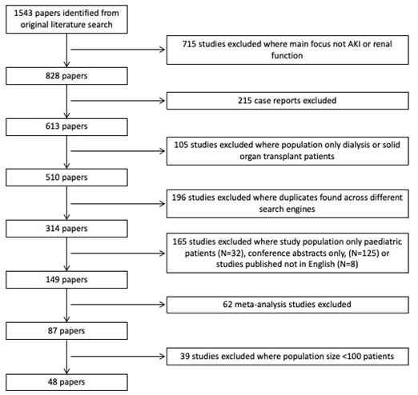
Supplementary Figure 3: The meta-analysis flow chart
Studies heterogeneity was explored, and the following questions investigated through meta-analyses of AKI in COVID data from the overall hospital, and ICU specific patients:
- the risk of AKI+ in COVID+ patients
- the case fatality ratio in AKI + COVID+ patients
- the relative risk of death for AKI+ vs AKI- in COVID+ patients
- the relative risk of death for COVID+ vs. COVID- patients where available.

The purpose of this systematic review and meta-analysis was to derive a potential pooled estimate for the risk of COVID-19 in AKI patients and/or to understand sources of heterogeneity which may arise between studies. Classical sources of heterogeneity include different populations and study designs, albeit addressing similar questions. Specific sources include the extent and size of the pandemic, and various contingency measures in the general population, the timing of hospital data collection (at the beginning or more recent), geographic location, lack of variability or changes in guidelines for disease diagnosis and management.
Study heterogeneity was explored, and estimates obtained for the overall hospital, and for ICU-specific patients for: the risk of AKI amongst COVID+ patients, the case fatality ratio for AKI in COVID+ patients, the relative risk of death for AKI vs no AKI in COVID+ patients, and the relative risk of death for COVID+ vs. COVID- patients where this was available.
Furthermore, meta-regression was applied to account for the effects of geographical region, age, gender, ethnicity and the length of study data collection, attempting to explain some of the variability between studies.
Studies were classified upon geographical location as from China (14 studies), US (15 studies), Europe (5 studies), Middle East/India (5 studies) and South America, South Korea and UK with 3 each. Age groups have been defined as mean age reported as follows: <=55, 55-60, 61-65, 66-70 and 71-80 years.
A gender group was defined as male- or female-dominated if the proportion of men or women was greater than 0.5, respectively. A group defined by the length of data collection (with no evidence of any correlation with study size) was also considered: <30 days, 31-45, 46-60, or 61-90 days.
The unprecedented nature of the SARS-COV-2 virus, and the variability in severity of the clinical manifestations of COVID-19, lack of guidelines for disease management and control during the first wave of the epidemic added an extra layer of complexity and may explain a great deal of heterogeneity between studies during this timeframe.
A random effects logistic model was employed, which allowed for both between and within-study variability to be modelled using the binomial distribution to binary outcomes. The uncertainty was computed as 95% confidence intervals using the score statistic and the exact binomial method and incorporated the Freeman-Tukey double arcsine transformation of proportions(2).
Heterogeneity has been assessed and discussed using I-squared values associated with the analyses. Further meta-regression using grouping based on geographical location and population structure (age, gender and ethnicity, hospital or intensive care units only patients) are discussed.
All analyses have been carried out in Stata 17 (StataCorp. 2019, Stata Statistical Software: Release 17; StataCorp LLC, College Station, TX) and R (R Core Team (2021). R: A language and environment for statistical computing. R Foundation for Statistical Computing, Vienna, Austria, URL https://www.R-project.org/.)

Statistical Methods

Patient data analysis

Data summary

All the available variables have been graphically explored and summarized according to their nature, i.e., means, SDs, medians, interquartile limits and ranges for continuous variables, and proportions for those that were categoric or binary. Log transformation has been performed for highly skewed variables, where appropriate, partly to reduce the variability of a measurement and partly to bring it closer to normal distribution.
Overall case fatality ratios – Logistic regression models
A simple binary logistic regression estimated the overall case fatality ratios in AKI patients, stratified by COVID status and AKI peak stage. This approach ignored the hospital dynamics of death and discharge as well as patients’ daily progression dynamics to more severe AKI stages or death.

Hospital outcomes and dynamics (death or discharge) - Competing risk models
The risk of death in AKI patients controlled by both COVID-19 status during hospital stay and AKI peak stage was investigated. A competing risk model was employed - an extension of survival analysis paradigm which, unlike the logistic regression above, intrinsically considers the length of time to hospital discharge or death. Namely, death is the primary statistical event of interest, and hospital discharge is assumed to be a competing event. The analyses modelled the time since admission to discharge or death during care using the Fine and Gray method for competing risk. Potential intermediate states such as AKI peag stage are ignored for this approach. Minimally adjusted competing risk models (accounted for COVID status and AKI peak stage), i.e. sub-distribution hazard ratio (SHR) models have been fitted to the data to quantify the additional effects of each available variable on the risk of death through SHR(3). An SHR value >1 indicates a harmful effect of the corresponding explanatory variable, <1 indicates a protective effect. Furthermore, a steep increase in the cumulative incidence functions with time since admission corresponding to death indicates a rapid deterioration in patients who died. A p-value <0.05 is interpreted as a statistically significant association. Predicted cumulative incidence functions are similar to the cumulative distribution functions in classic survival analysis and indicate the daily cumulative rate of death or discharge since admission overall and stratified by COVID status and AKI stage. The effect of the rest of the variables on death are also controlled by these two defining features of the patients. Also, although qualitatively similar, the advantage of using SHR over logistic regression models lies in the ability of the former to provide insights into the dynamics of death and hospital discharge in this population, i. e. inherently accounting for the time since admission to discharge or death.
Accounting for AKI stage at admission and AKI peak stage – Multi state models
A third approach benefited from the acquisition of the peak AKI diagnosis date, in addition to the diagnosis of AKI within 24-hours of admission. As such, a multi-state model has been fitted, in which the peak AKI stage is deemed a potential intermediate state between the initial AKI diagnosis, and the final so-called absorbing states, which can be either death or discharge from hospital. This is different from the previous competing-risk model approach, which does not allow for intermediate states, and provides extra insight into the dynamics of AKI disease progression, stratified by COVID status. The probabilities of progression from AKI Stage-1 to AKI Stage-2 or 3 have been derived, as well as those of discharge or death, from AKI Stage-2 to AKI Stage-3, discharge or death and from AKI Stage-3 to discharge or death(3).

A prognostic model for death
A multivariable prognostic models have also been built for death as binary outcomes, a competing-risk parsimonious model. The discrimination power of this prognostic model has been assessed by time-varying ROC (receiver operator characteristic) type analyses through area under the curve (AUC). The latter measures the discrimination power of a particular model - i. e. based on the information of its set of predictors the probability, that is the probability of correctly discriminate between a patient who will die or who will be discharged. Moreover, the competing risk model allows time varying ROC (AUC) evaluation which we did at different time points suggested by the centiles of the length of stay distribution. The theoretical statistical framework and procedure for time-varying circumstances and competing risks is described by Blanche et al 2013(4), and subsequently implemented within a comprehensive “timeROC”(5)package updated in 2022 which we have used for our results.

Model choice was based on the Akaike information criterion (AIC: the smaller the value, the better the model), used on a similar number of observations in the data. Sensitivity analyses on missing data have been conducted; these results are not shown or discussed, as they did not alter the qualitative or quantitative conclusions made based on complete observations.

Meta-analysis detailed results

The risk of AKI in COVID+ hospital patients (48 papers)
Overall, the risk of AKI in COVID+ hospital patients was estimated at 0.30(0.24, 0.37), but exhibited values between 0.005–0.99 in studies, and hence an I-squared (a measure of heterogeneity between studies) of 99.65%. Further analysis suggested differences in geographical regions (p<0.001), and by gender dominance (p<0.001), although variability within regions remains very high (I²>90%). These data are consistent with no difference between grouping defined mean age values (p=0.488), or length of data collection (p=0.06), but there was high within-group variability (6–58).

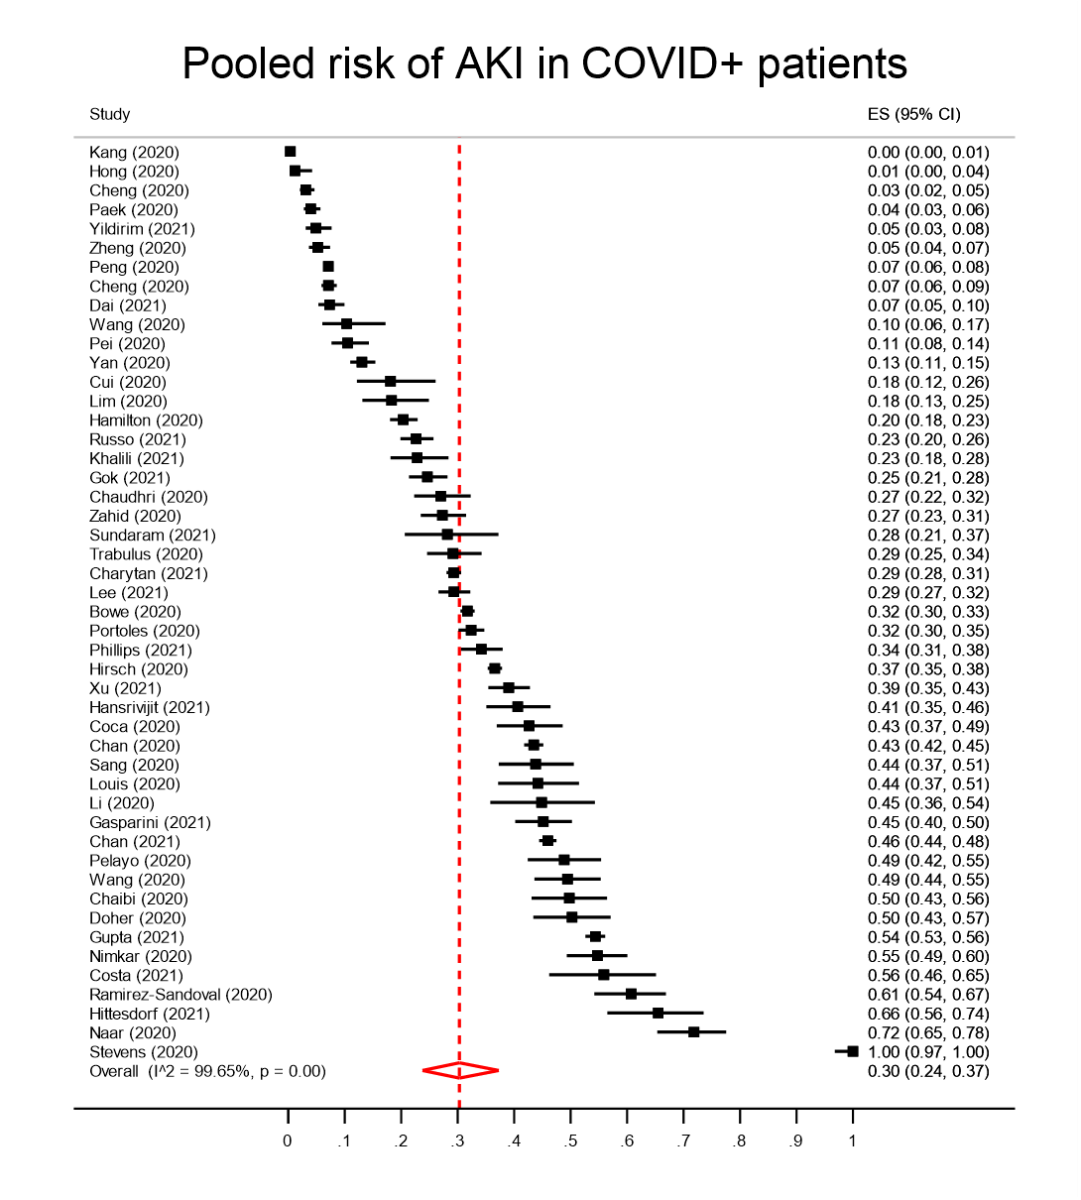
Meta-analysis Figure 1
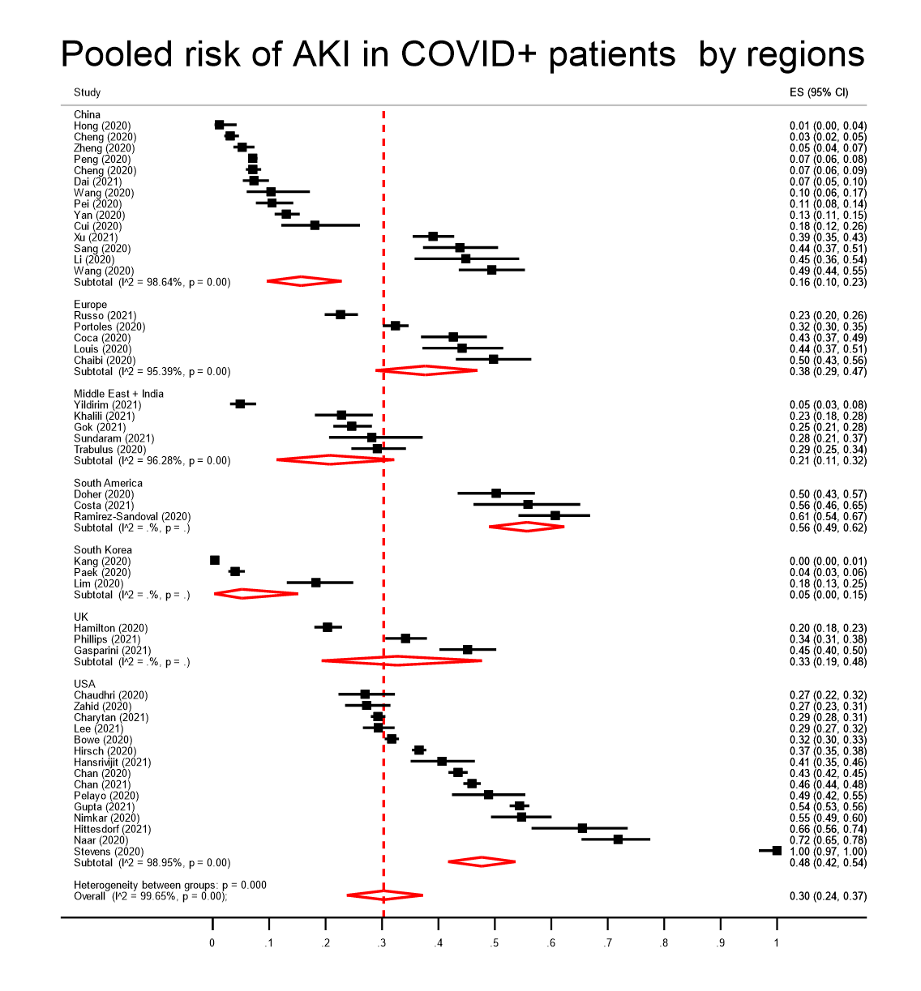
Meta-analysis Figure 2
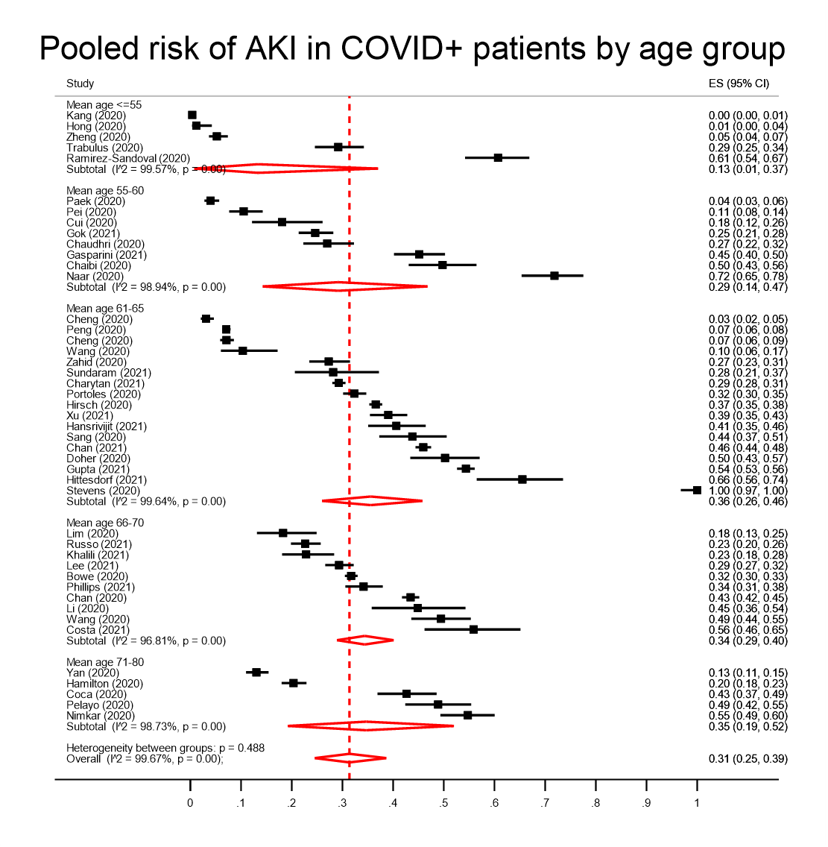
Meta-analysis Figure 3
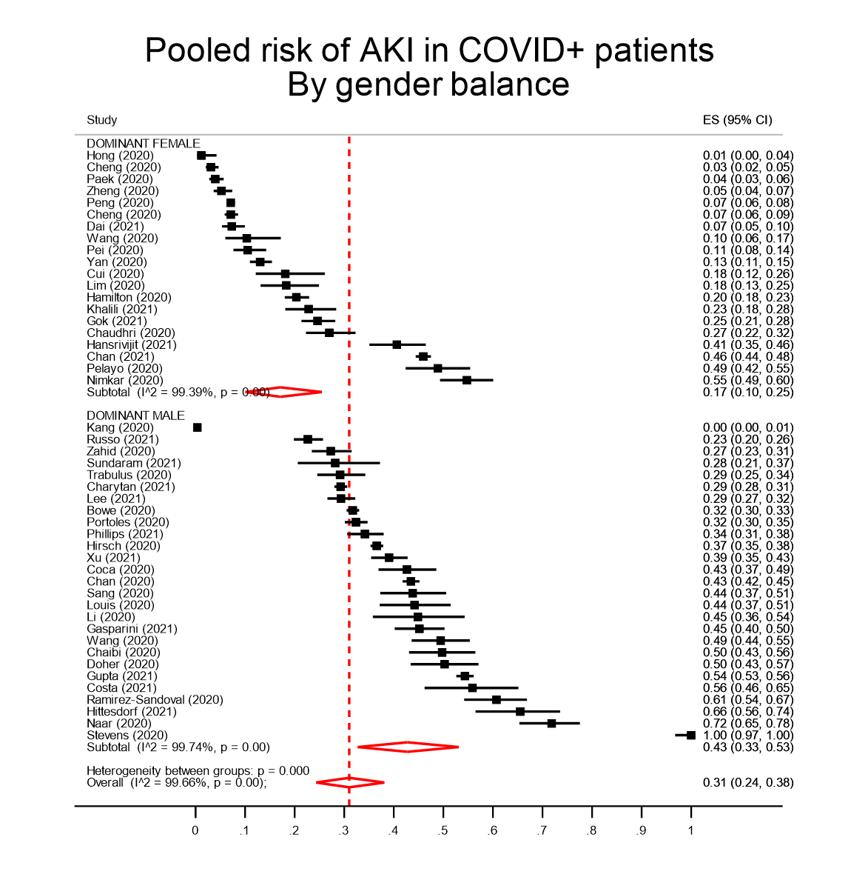
Meta-analysis Figure 4
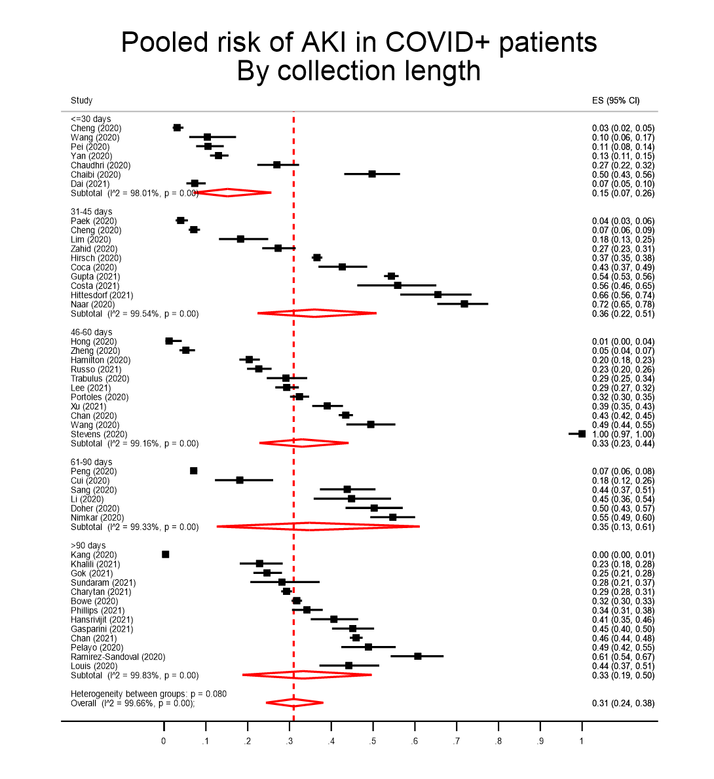
Meta-analysis Figure 5
Geography/Region
Broken down by region, some evidence of consistency in Europe can be seen after discarding Russo (2021) and Portoles (2020) from the list, which seems to be associated with high variability between studies. Therefore, based on 3 relatively homogeneous studies (I²=21.2%), the risk of AKI in COVID+ is 0.45(0.41-0.50), which differs from 0.38(0.29-0.47), based on all 5 heterogeneous studies found in Europe amongst all hospital patients.
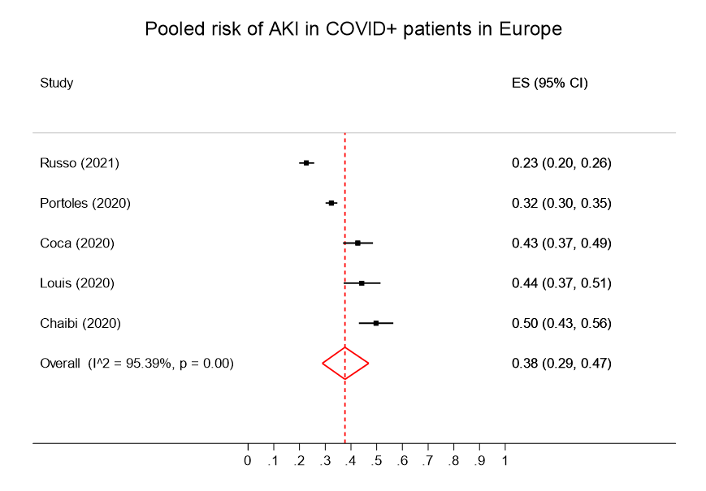
Meta-analysis Figure 6
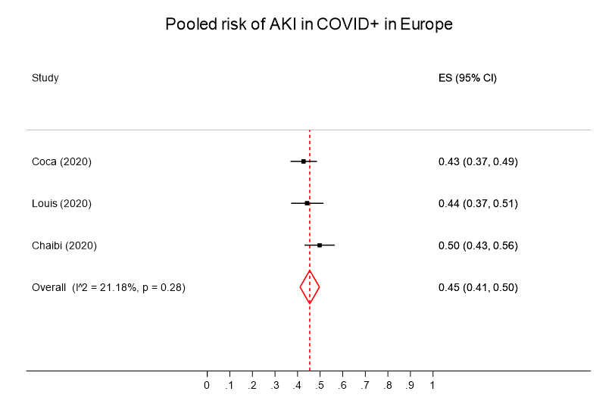
Meta-analysis Figure 7
Middle Eastern and Indian studies show a risk of 0.26(0.23, 0.29), after eliminating Yildirim (2021), which was associated with an increase of the I² value from 23% to 96.3%.
Amongst South American studies, the estimate is 0.56(0.49,0.62), accepting a moderate level of heterogeneity (57%).
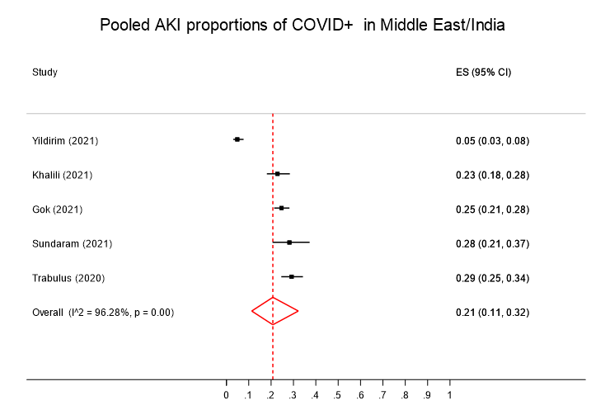
Meta-analysis Figure 8
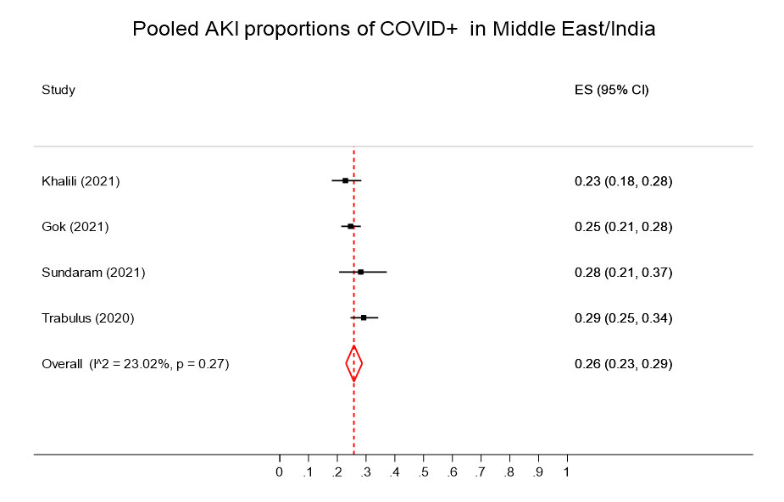
Meta-analysis Figure 9
The South Korean studies exhibit a high level of heterogeneity (I²= 98.6%), as do the UK studies (I²=97.8%) with an estimate of 0.33(0.19-0.48).

Heterogeneity amongst the Chinese studies seems to be associated with gender (p<0.001), the AKI risk is 0.44(0.39,0.49) based on male-dominated populations, in which the heterogeneity seems to have dropped to 67%, suggesting that female-dominated hospital populations exhibit greater heterogeneity. Grouping defined by age seems to be different in the female-dominated group, but still manifested much heterogeneity, leading to inconclusive results.
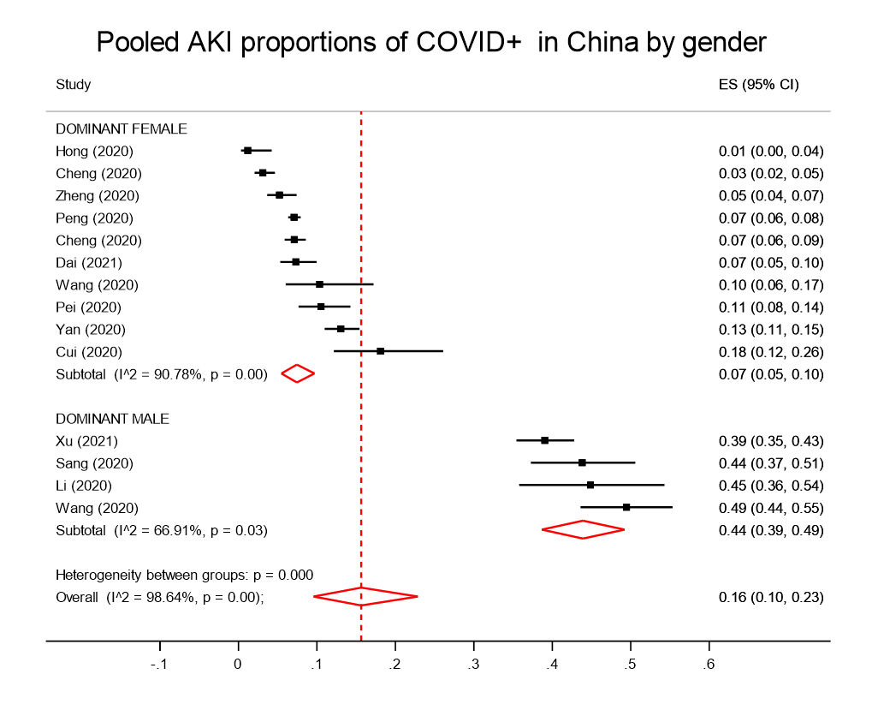
Meta-analysis Figure 10
American studies are consistent with similar levels of heterogeneity when grouping them by gender dominance (p=0.234), whilst ethnicity and study length seems to exhibit some differences (p<0.001), although the within group variability remains high (p<0.001). When split by gender × ethnicity, high heterogeneity is exhibited in non-white female- dominated studies, although the other three groups consist of 2-3 studies.

The risk of AKI in COVID+ patients on the ICU

Heterogeneity between studies remains high (96.4%). The ICU studies are all male- dominated, i.e., >50% of the patients are male. Differences between regions are assessed (p=0.009), and ICU studies from China seem to have some consistency (I²=67%), and an estimate of 0.44(0.39,0.49). The length of study collection grouping does not provide further insight either (p=0.06).

The case fatality ratio in all COVID+ hospital patients

Acknowledging a high level of heterogeneity between studies, the risk of death amongst COVID+ patients is estimated at 0.21(0.17,0.25).
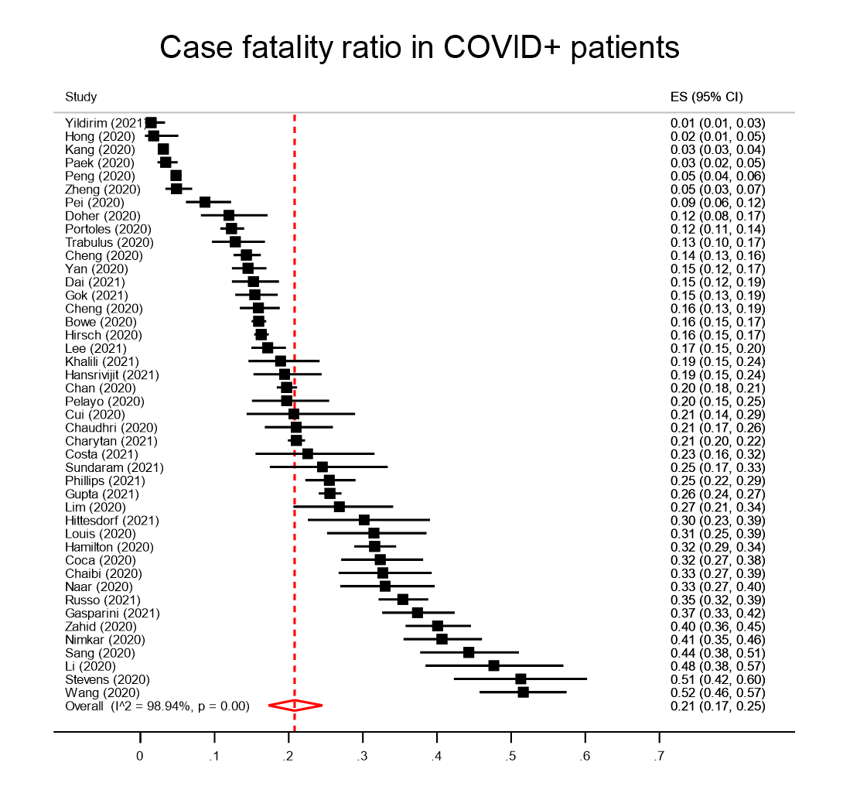
Meta-analysis Figure 11
Regions seem to be exhibit differences (p<0.001), but within regions, the heterogeneity remains high, or the number of studies is less than 3.
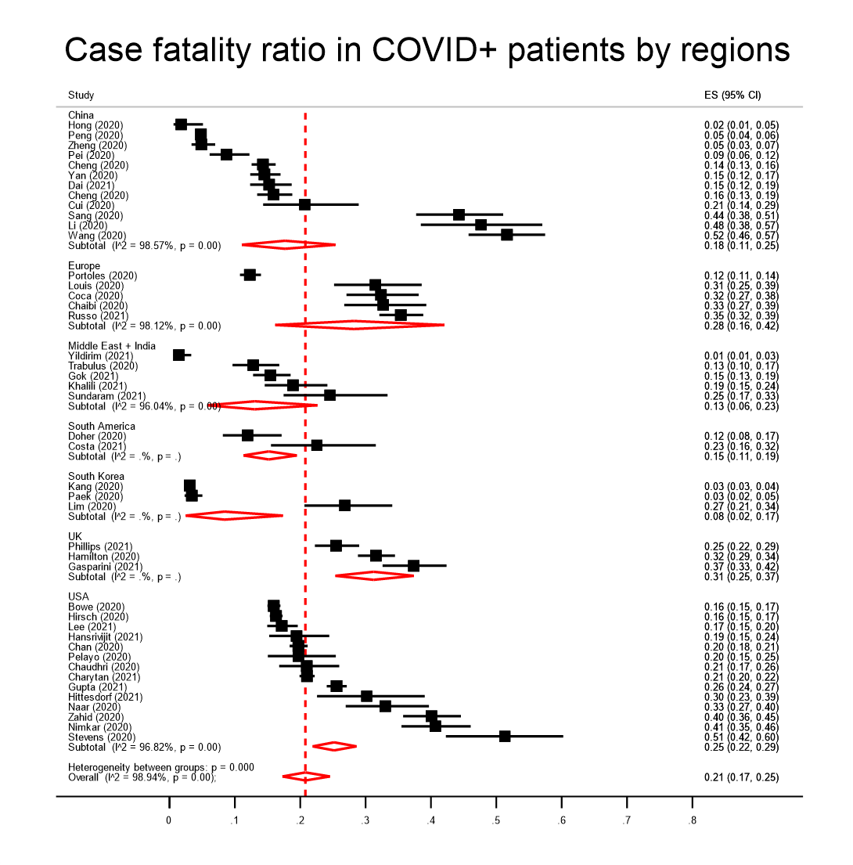
Meta-analyses Figure 12
Whilst age grouping seems to exhibit some differences (p<0.001), grouping by study duration does not seem to explain differences in the case fatality ratios (p=0.677). Four studies in Europe with little heterogeneity (p=0.66) between them suggests a case fatality ratio of 0.34 amongst COVID+ patients, and amongst studies from the Middle East/Indian region with an acceptable level of inter-study heterogeneity (I²=66%) suggests a case fatality ratio of 0.17 (0.13, 0.21).

The remaining 3 studies compared outcomes of patients with AKI in both COVID+ and COVID- patients, allowing more detailed comparisons to be made with these studies. All 3 studies identified male gender, non-Caucasian ethnicity, admission to ICU for mechanical ventilation and/or KRT as common factors amongst AKI patients who were COVID+, compared with COVID- patients, findings that were consistent with this study. Some other risk factors associated with COVID+ status amongst AKI patients included diabetes mellitus, obesity, CKD and older age(32,34,48).
All 3 studies also showed a higher mortality amongst COVID+ patients, compared with COVID- which was similarly consistent with this study(32,34,48). The case-fatality ratio of patients with AKI who were COVID+ in this dataset (52%), is comparable to Kolhe et al (60.5%), although elevated compared with Moledina (29.6%) and Fisher (33.7%). Interestingly, the two North American studies showed a similarly lower case- fatality. Differences might arise due to differences in patient management, (where there were at that time no standardised guidelines for the management of COVID-19). Neither Kolhe, Moledina nor Fisher outline patient management in great detail, so it is not possible to directly compare these. The COVID+ patients in this study were largely offered supportive management.
Limitations of this study included not utilizing urine output in classifying AKI Stage; this was not possible due to variable documentation of fluid balance. AKI stage was calculated using serum creatinine values compared with the baseline serum creatinine, approximated from historical creatinine results, as defined by KDIGO AKI guidelines(1).

REFERENCES
1. Kellum JA, Lameire N, Aspelin P, Barsoum RS, Burdmann EA, Goldstein SL, et al. Kidney disease: Improving global outcomes (KDIGO) acute kidney injury work group. KDIGO clinical practice guideline for acute kidney injury. Kidney Int Suppl. 2012;2(1):1–138.
2. Nyaga VN, Arbyn M, Aerts M. Metaprop: A Stata command to perform meta-analysis of binomial data. Arch Public Heal. 2014;72(39).
3. Putter H, Fiocco M, Gekus RB. Tutorial in biostatistics: Competing risk and multi-state models. Stat Med. 2007;26(11):2389–430.
4. Blanche P, Dartigues JF, Jacqmin-Gadda H. Estimating and comparing time-dependent areas under receiver operating characteristic curves for censored event times with competing risks. Stat Med. 2013;32(30).
5. Blanche P. Time-Dependent ROC Curve and AUC for Censored Survival Data [Internet]. 2022 [cited 2024 Feb 18]. Available from: https://cran.r-project.org/web/packages/timeROC/timeROC.pdf
6. Zheng X, Yang H, Li X, Li H, Xu L, Yu Q, et al. Prevalence of kidney injury and associations with critical illness and death in patients with COVID-19. Clin J Am Soc Nephrol. 2020;15(11):1549–56.
7. Xu J, Xie J, Du B, Tong Z, Qiu H, Bagshaw SM. Clinical Characteristics and Outcomes of Patients With Severe COVID-19 Induced Acute Kidney Injury. J Intensive Care Med. 2021;36(3):319–26.
8. Dai Y, Liu Z, Du X, Wei H, Wu Y, Li H, et al. Acute Kidney Injury in Hospitalized Patients Infected with COVID-19 from Wuhan, China: A Retrospective Study. Biomed Res Int. 2021;2021.
9. Pei G, Zhang Z, Peng J, Liu L, Zhang C, Yu C, et al. Renal involvement and early prognosis in patients with COVID-19 pneumonia. Vol. 31, Journal of the American Society of Nephrology. 2020. p. 1157–65.
10. Li Q, Hu P, Kang H, Zhou F. Clinical Characteristics and Short-Term Outcomes of Acute Kidney Injury Missed Diagnosis in Older Patients with Severe COVID-19 in Intensive Care Unit. J Nutr Heal Aging. 2021;25(4):492–500.
11. Portolés J, Marques M, López-Sánchez P, de Valdenebro M, Muñez E, Serrano ML, et al. Chronic kidney disease and acute kidney injury in the COVID-19 Spanish outbreak. Nephrol Dial Transplant. 2020;35(8):1353–61.
12. Louis G, Belveyre T, Goetz C, Gaci R, Dinot V. Acute kidney injury in severe SARS-CoV-2 infection: An experience report in Eastern France. Vol. 40, Anaesthesia Critical Care and Pain Medicine. 2021.
13. Coca A, Burballa C, Centellas-Pérez FJ, Pérez-Sáez MJ, Bustamante-Munguira E, Ortega A, et al. Outcomes of COVID-19 Among Hospitalized Patients With Non-dialysis CKD. Front Med. 2020;7.
14. Chaibi K, Dao M, Pham T, Gumucio-Sanguino VD, Di Paolo FA, Pavot A, et al. Severe acute kidney injury in patients with COVID-19 and acute respiratory distress syndrome. Vol. 202, American Journal of Respiratory and Critical Care Medicine. 2020. p. 1299–301.
15. Russo E, Esposito P, Taramasso L, Magnasco L, Saio M, Briano F, et al. Kidney disease and all-cause mortality in patients with COVID-19 hospitalized in Genoa, Northern Italy. J Nephrol. 2021;34(1):173–83.
16. Trabulus S, Karaca C, Balkan II, Dincer MT, Murt A, Ozcan SG, et al. Kidney function on admission predicts in-hospital mortality in COVID-19. PLoS One. 2020;15(9).
17. Khalili S, Sabaghian T, Sedaghat M, Soroureddin Z, Askari E, Khalili N. Prevalence, Risk Factors and Outcomes Associated with Acute Kidney Injury in Patients Hospitalized for COVID-19: A Comparative Study between Diabetic and Nondiabetic Patients. J Diabetes Res. 2021;2021.
18. Yan Q, Zuo P, Cheng L, Li Y, Song K, Chen Y, et al. Acute kidney injury is associated with in-hospital mortality in older patients with covid-19. Journals Gerontol - Ser A Biol Sci Med Sci. 2021;76(3):456–62.
19. Yildirim C, Ozger HS, Yasar E, Tombul N, Gulbahar O, Yildiz M, et al. Early predictors of acute kidney injury in COVID-19 patients. Nephrology. 2021;26(6):513–21.
20. Gok M, Cetinkaya H, Kandemir T, Karahan E, Tuncer İB, Bukrek C, et al. Chronic kidney disease predicts poor outcomes of COVID-19 patients. Int Urol Nephrol. 2021;53(9):1891–8.
21. Sundaram S, Soni M, Annigeri R. Urine abnormalities predict acute kidney injury in COVID-19 patients: An analysis of 110 cases in Chennai, South India. Diabetes Metab Syndr Clin Res Rev. 2021;15(1):187–91.
22. Öztürk S, Turgutalp K, Arici M, Çetinkaya H, Altiparmak MR, Aydin Z, et al. Impact of hospital-acquired acute kidney injury on covid-19 outcomes in patients with and without chronic kidney disease: A multicenter retrospective cohort study. Turkish J Med Sci. 2021;51(3):947–61.
23. Doher MP, Torres De Carvalho FR, Scherer PF, Matsui TN, Ammirati AL, Caldin Da Silva B, et al. Acute Kidney Injury and Renal Replacement Therapy in Critically Ill COVID-19 Patients: Risk Factors and Outcomes: A Single-Center Experience in Brazil. Blood Purif. 2021;50(5):520–30.
24. Ramirez-Sandoval JC, Gaytan-Arocha JE, Xolalpa-Chávez P, Mejia-Vilet JM, Arvizu-Hernandez M, Rivero-Sigarroa E, et al. Prolonged Intermittent Renal Replacement Therapy for Acute Kidney Injury in COVID-19 Patients with Acute Respiratory Distress Syndrome. Blood Purif. 2021;50(3):355–63.
25. Costa RL da, Sória TC, Salles EF, Gerecht AV, Corvisier MF, Menezes MA de M, et al. Acute kidney injury in patients with Covid-19 in a Brazilian ICU: incidence, predictors and in-hospital mortality. J Bras Nefrol. 2021;43(3):349–58.
26. Paek JH, Kim Y, Park WY, Jin K, Hyun M, Lee JY, et al. Severe acute kidney injury in COVID-19 patients is associated with in-hospital mortality. PLoS One. 2020;15(12).
27. Kang SH, Kim SW, Kim AY, Cho KH, Park JW, Do JY. Association between Chronic Kidney Disease or Acute Kidney Injury and Clinical Outcomes in COVID-19 Patients. J Korean Med Sci. 2020;35(50).
28. Lim JH, Park SH, Jeon Y, Cho JH, Jung HY, Choi JY, et al. Fatal outcomes of covid-19 in patients with severe acute kidney injury. J Clin Med. 2020;9(6):1718.
29. Wang J, Wang Z, Zhu Y, Li H, Yuan X, Wang X, et al. Identify the Risk Factors of COVID-19-Related Acute Kidney Injury: A Single-Center, Retrospective Cohort Study. Front Med. 2020;7(1):436.
30. Gasparini M, Khan S, Patel JM, Parekh D, Bangash MN, Stϋmpfle R, et al. Renal impairment and its impact on clinical outcomes in patients who are critically ill with COVID-19: a multicentre observational study. Anaesthesia. 2021;76(3):320–6.
31. Phillips T, Stammers M, Leggatt G, Bonfield B, Fraser S, Armstrong K, et al. Acute kidney injury in COVID-19: Identification of risk factors and potential biomarkers of disease in a large UK cohort. Nephrology. 2021;26(5).
32. Kolhe N V., Fluck RJ, Selby NM, Taal MW. Acute kidney injury associated with COVID-19: A retrospective cohort study. PLoS Med. 2020;17(10).
33. Hamilton P, Hanumapura P, Castelino L, Henney R, Parker K, Kumar M, et al. Characteristics and outcomes of hospitalised patients with acute kidney injury and COVID-19. PLoS One. 2020;15(11).
34. Fisher M, Neugarten J, Bellin E, Yunes M, Stahl L, Johns TS, et al. AKI in Hospitalized Patients with and without COVID-19: A Comparison Study. J Am Soc Nephrol. 2020;31(9):2145–57.
35. Charytan DM, Parnia S, Khatri M, Petrilli CM, Jones S, Benstein J, et al. Decreasing Incidence of Acute Kidney Injury in Patients with COVID-19 Critical Illness in New York City. Kidney Int Reports. 2021;6(4):916–27.
36. Chan L, Chaudhary K, Saha A, Chauhan K, Vaid A, Zhao S, et al. AKI in hospitalized patients with COVID-19. J Am Soc Nephrol. 2021;32(1):151–60.
37. Bowe B, Cai M, Xie Y, Gibson AK, Maddukuri G, Al-Aly Z. Acute kidney injury in a national cohort of hospitalized US veterans with COVID-19. Clin J Am Soc Nephrol. 2021;16(1):14–25.
38. Naar L, Langeveld K, El Moheb M, El Hechi MW, Alser O, Kapoen C, et al. Acute Kidney Injury in Critically-ill Patients With COVID-19: A Single-center Experience of 206 Consecutive Patients. Vol. 272, Annals of surgery. 2020.
39. Stevens JS, King KL, Robbins-Juarez SY, Khairallah P, Toma K, Verduzco HA, et al. High rate of renal recovery in survivors of COVID-19 associated acute renal failure requiring renal replacement therapy. PLoS One. 2020;
40. Wang F, Ran L, Qian C, Hua J, Luo Z, Ding M, et al. Epidemiology and Outcomes of Acute Kidney Injury in COVID-19 Patients with Acute Respiratory Distress Syndrome: A Multicenter Retrospective Study. Blood Purif. 2021;50(4–5).
41. Ng JH, Hirsch JS, Hazzan A, Wanchoo R, Shah HH, Malieckal DA, et al. Outcomes Among Patients Hospitalized With COVID-19 and Acute Kidney Injury. Am J Kidney Dis. 2021;77(2).
42. Pelayo J, Lo KB, Bhargav R, Gul F, Peterson E, Dejoy R, et al. Clinical Characteristics and Outcomes of Community- And Hospital-Acquired Acute Kidney Injury with COVID-19 in a US Inner City Hospital System. CardioRenal Med. 2020;10(4):223–31.
43. Lee JR, Silberzweig J, Akchurin O, Choi ME, Srivatana V, Lin J, et al. Characteristics of acute kidney injury in hospitalized COVID-19 patients in an urban academic medical center. Vol. 16, Clinical Journal of the American Society of Nephrology. 2021. p. 284–6.
44. Hansrivijit P, Gadhiya KP, Gangireddy M, Goldman JD. Risk Factors, Clinical Characteristics, and Prognosis of Acute Kidney Injury in Hospitalized COVID-19 Patients: A Retrospective Cohort Study. Medicines. 2021;8(1).
45. Zahid U, Ramachandran P, Spitalewitz S, Alasadi L, Chakraborti A, Azhar M, et al. Acute Kidney Injury in COVID-19 Patients: An Inner City Hospital Experience and Policy Implications. Am J Nephrol. 2020;51(10):786–96.
46. Chaudhri I, Moffitt R, Taub E, Annadi RR, Hoai M, Bolotova O, et al. Association of Proteinuria and Hematuria with Acute Kidney Injury and Mortality in Hospitalized Patients with COVID-19. Kidney Blood Press Res. 2020;45(6):1018–32.
47. Gupta S, Coca SG, Chan L, Melamed ML, Brenner SK, Hayek SS, et al. AKI treated with renal replacement therapy in critically ill patients with COVID-19. J Am Soc Nephrol. 2021;32(1):161–76.
48. Moledina DG, Simonov M, Yamamoto Y, Alausa J, Arora T, Biswas A, et al. The Association of COVID-19 With Acute Kidney Injury Independent of Severity of Illness: A Multicenter Cohort Study. Am J Kidney Dis. 2021;77(4):490–9.
49. Hirsch JS, Ng JH, Ross DW, Sharma P, Shah HH, Barnett RL, et al. Acute kidney injury in patients hospitalized with COVID-19. Kidney Int. 2020;98(1):209–18.
50. Nimkar A, Naaraayan A, Hasan A, Pant S, Durdevic M, Suarez CN, et al. Incidence and Risk Factors for Acute Kidney Injury and Its Effect on Mortality in Patients Hospitalized From COVID-19. Mayo Clin Proc Innov Qual Outcomes. 2020;4(6):687–95.
51. Cui X, Yu X, Wu X, Huang L, Tian Y, Huang X, et al. Acute Kidney Injury in Patients with the Coronavirus Disease 2019: A Multicenter Study. Kidney Blood Press Res. 2020;45(4):612–22.
52. Chan L, Chaudhary K, Saha A, Chauhan K, Vaid A, Murphy BT, et al. Incidence of AKI in hospitalized patients with COVID-19. J Am Soc Nephrol [Internet]. 2020;31:151–60. Available from: https://www.asn-online.org/api/download/?file=/education/kidneyweek/archives/KW20Abstracts.pdf
53. Sang L, Chen S, Zheng X, Guan W, Zhang Z, Liang W, et al. The incidence, risk factors and prognosis of acute kidney injury in severe and critically ill patients with COVID-19 in mainland China: a retrospective study. BMC Pulm Med. 2020;20(1):290.
54. Hittesdorf E, Panzer O, Wang D, Stevens JS, Hastie J, Jordan DA, et al. Mortality and renal outcomes of patients with severe COVID-19 treated in a provisional intensive care unit. J Crit Care. 2021;62:172–5.
55. Cheng Y, Luo R, Wang X, Wang K, Zhang N, Zhang M, et al. The incidence, risk factors, and prognosis of acute kidney injury in adult patients with coronavirus disease 2019. Clin J Am Soc Nephrol. 2020;15(10):1394–402.
56. Cheng Y, Luo R, Wang K, Zhang M, Wang Z, Dong L, et al. Kidney disease is associated with in-hospital death of patients with COVID-19. Vol. 97, Kidney International. 2020. p. 829–38.
57. Hong D, Long L, Wang AY, Lei Y, Tang Y, Zhao JW, et al. Kidney manifestations of mild, moderate and severe coronavirus disease 2019: A retrospective cohort study. Clin Kidney J. 2020;13(3):340–6.
58. Peng S, Wang HY, Sun X, Li P, Ye Z, Li Q, et al. Early versus late acute kidney injury among patients with COVID-19 — A multicenter study from Wuhan, China. Nephrol Dial Transplant. 2021;35(12):2095–102.

