Frailty Assessment in the Emergency Department

Abstract
The world population is aging rapidly leading to an increase in patients with comorbidities and age-related disorders, such as frailty, attending the Emergency Department. Frailty is a recognized disorder which brings about increased vulnerability in patients and increased demands on human resources and hospital services. Screening for frailty early in the care pathway of this specific population would ensure goal directed and timely care. This article aims to raise awareness of frailty assessment in the Emergency department and to increase knowledge on the most used tool - The Clinical Frailty Scale (Rockwood et al 2005).
Keywords: Frailty, Emergency Department, assessment tool, geriatric assessment, clinical frailty index

Why should you read this article:
- To increase awareness and strengthen knowledge on the importance of recognising and assessing frailty in the Emergency Department.
- To understand the concept of frailty as a disorder for older adults.
- To familiarise yourself with available frailty assessment tools focusing on the most common, the Clinical Frailty Scale (Rockwood et al 2005).

Introduction
The population in the UK is aging, with 18.6%, more than 12 million, adults over the age of 65 years (Office for National Statistics 2021). The Office for National Statistics (ONS) also states that there has been a shift in the proportion of age composition where the rate of population growth in over 65 years of age is faster than that of the under 65 years (ONS 2021).
Up to 15% of people who are 65 years and older are frail and this percentage increases to 25% in the group aged 85 years and older (Aplin 2021). Older patients can be high users of health services and 45% of all hospital admissions are frail patients with chronic diseases (Puig Campmany et al 2019). Frailty is associated with a number of poor outcomes including functional decline and lower quality of life (Cunha et al 2019). Although frailty is an accepted component of geriatric medicine, its consideration in the Emergency Department (ED) is still not yet fully understood or utilised (Brousseau et al 2018). Emergency Departments see and treat patients with any condition and from any age group but the focus on flow and single system illnesses is not necessarily suited to dealing with the older patients who have multi-morbidity problems on top of the acute presentations (Clegg et al 2013). Often frailty and the impact it has on the actual hospital presentation is overlooked (Turner and Clegg 2014).

Understanding Frailty
Frailty is a disorder defined as the increased vulnerability from age related or disease related insults in older adults due to diminishing physiological reserves (British Geriatric Society 2014, Kim Jung and Won 2020). Although frailty is more prevalent with age, they are two distinct concepts and frailty can also be present in younger adults with chronic conditions (Hanlon et al 2018). The vulnerability associated with frailty means that the impact of a relatively minor condition such as a simple urinary tract infection can have a more severe impact on patients who are frail than those who are not. This can lead to increasing dependency and further frailty (Figure 1).
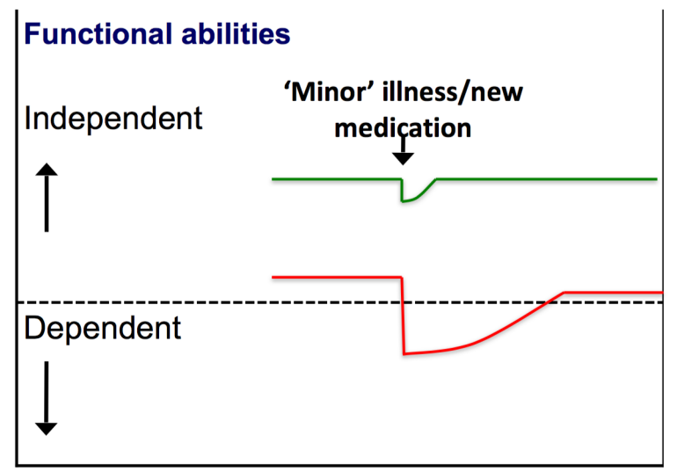

Figure 1:Vulnerability of frail elderly people to a sudden change in health status after minor illness. (Clegg et al 2013)

Two broad models of frailty exist, the phenotype model (Fried et al 2001) and the cumulative deficit model (Mitinski et al 2001). The phenotype model identifies frailty as being present if the patient has three or more of: exhaustion, weakness/loss of muscle strength, reduced gait speed, weight loss and reduced physical activity. If one or two of these conditions are present then the patient is classified as ‘pre-frail’ and if none are present, the patient is then classified as ‘robust’. Cesari et al (2014) argue that this model can be used in the ED to stratify the population under the three different profiles.
The cumulative deficit model takes the approach that “the more things somebody has wrong with them, the more likely they are to be frail” (Mitnitski et al 2001, p 722) so that people with more clinical illnesses and disabilities are considered frail. The deficits could be diseases such as dementia or symptoms like tremor which combine to increase the risk of patients suffering an adverse outcome such as longer hospital stay, or in-hospital complications such as delirium.
These two models are distinctive and should be seen as complimenting each other rather than substitutes (Cesari et al 2014). Both methods measure different things and can be applied at different stages of the patient’s journey through the Emergency Department (Finlay 2022) although both require knowledge of the patient which may not be immediately available.

To help clinicians to understand how patients can present with frailty the British Geriatric Society developed the concept of ‘frailty syndromes’ where they explain that a seemingly straight forward presentation might have serious underlying medical origins (British Geriatric Society 2014). They describe five symptoms that, although they can occur without frailty, clinicians should be aware of that could indicate the patient is frail (Table 1).
Frailty syndrome | Examples
- Falls | Possibly reported as ‘collapsed’, ‘legs gave way’ or ‘found lying on floor’
- Immobility | Sudden or more gradual deterioration in mobility; possibly reported as ‘gone off legs’ or ‘stuck in toilet’
- Delirium | Acute confusion, muddledness or sudden worsening of confusion in someone with dementia or memory loss
- Incontinence | New or worsening urinary or faecal incontinence
- Medication | Susceptibility to side effects of medicines- for example, confusion with codeine or hypotension with antidepressants

Table 1: the five frailty syndromes (British Geriatric Society 2014).

Frailty assessment in the Emergency Department
The importance of being able to measure frailty has been recognized for a long time and accurate identification of frailty can be used to anticipate patient needs (Rockwood et al 2005). Boreskie et al (2022) state that using frailty assessment in the ED can help put into context the acute illness alongside other pre-existing conditions and therefore not only assist in triage and decision making but also improve clinical decisions to better adapt to the needs of the individual. In UK, there is guidance that clinical frailty assessment should be completed within 30 minutes of arrival into the Emergency Department (NHS National Health Service 2019). Failing to assess properly for the degree of frailty can result in inappropriate interventions for example unnecessary invasive procedures or harmful medications being used but there is also a risk that treatment may be withheld in the non-frail patients who are judged solely by their physiological age (Clegg et al 2013). This is considered as a form of modern ageism (Elliot et al 2017). Such is the importance and impact of assessing frailty in the Emergency Department that it has even been dubbed as the ‘vital sign’ for older adults (Brousseau et al 2018).
Frailty assessment should happen as early as it is possible in the patients’ journey when seeking care in the ED since it can raise flags for possible serious underlying conditions as well as direct the goals of care.

Frailty assessment tools
There are many tools to measure frailty and a recent review identified 51 different measures applied across different settings (Faller et al 2019). Using a recognised tool allows clinicians to achieve a standard approach in measuring frailty and obtain an objective result (Ahmed et al 2016). An older patient presenting to the ED lying on an ambulance trolley with an oxygen mask covering his face and with eyes closed is easily judged as very ‘frail’ at that moment but that may not be a true reflection of the patient’s normal state.
The comprehensive geriatric assessment (CGA) is the gold standard assessment to identify the needs of the older population (British Geriatric Society 2014). It is performed by geriatricians and involves a holistic extensive assessment of patient’s medical, social, psychological and psychosocial and functional domains (James 2016). Through identifying patient issues early and targeting management it has been proven to increase patient’s independence and decrease mortality (BGS 2014). As it requires specific geriatric expertise across medicine and rehabilitation is not suitable for use by non-geriatric specialists in the ED (Clegg et al 2013).
Frailty screening tools in the ED need to be easily applied by ED staff, not rely heavily on patient documentation, use minimal equipment and be replicable (Lewis et al 2019). In a systematic review of frailty assessment studies in the ED there was low compliance to tool completion with only 52% of patients being screened, even in tools where the completion time was less than five minutes (Elliott et al 2017). This is perhaps understandable given the fast-paced environment, complexity of patients and lack of information that may be available in the ED to make an assessment. Other reasons for low compliance to frailty tools were “not wanting to force people into categories”, “using clinical judgement instead” and that it was “someone else’s role” (Elliot et al 2017).
A cohort study by Lewis et al (2019) tested three frailty tools to identify the most user friendly for routine use in the ED. They have simultaneously tested the Clinical Frailty Scale (Rockwood et al 2005), the Fried scale (Fried et al 2001) and the SUHB (Stable, unstable, help to walk, bedbound) scale (Kellett et al 2014). They conclude that the CFS was the less resource intensive, easy to use and understand scores and most comprehensive tool to use in a busy ED. It is found to predict outcomes in the context of urgent care where again higher frailty scores correlate with increased length of hospital stay, re-admission rate and in-patient mortality (Specialised Clinical Frailty Network, 2018). The CFS is the most widely reported tool used in the ED and has been shown to be reliable and accurate when used by nurses (O’Caoimh et al 2019, Jarman et al 2021).

The Clinical Frailty Scale
The Clinical Frailty Scale is based on the cumulative deficits model of frailty. The original version of the scale was calculated by using 70 variables (comprising of signs and symptoms, disease states, disability and abnormal laboratory results). Although proven and validated to predict outcome and mortality, having such a long assessment tool makes it difficult to manage in the clinical environment (Rockwood et al 2005). A shorter Clinical Frailty Scale was subsequently developed which was again revised to become a 9-point scale with the revision of level names and descriptions (Rockwood and Theou 2020) (Figure 2). A score is determined by the patient’s overall level of fitness, the presence or absence of disease, their level of dependency and their cognitive status (Davies et al 2018). The higher the patient’s score the higher the level of frailty. Patients who score between 1 and 3 have no active disease symptoms or well controlled medical conditions and are overall well. Patients scoring 4 are categorised as pre-frail and have symptoms caused by a condition that limits their daily activities. Scores of 5 to 8 indicate degrees of frailty and dependency. Terminally ill patients are scored a 9 irrespective of their baseline state (Dalhousie University, 2020).

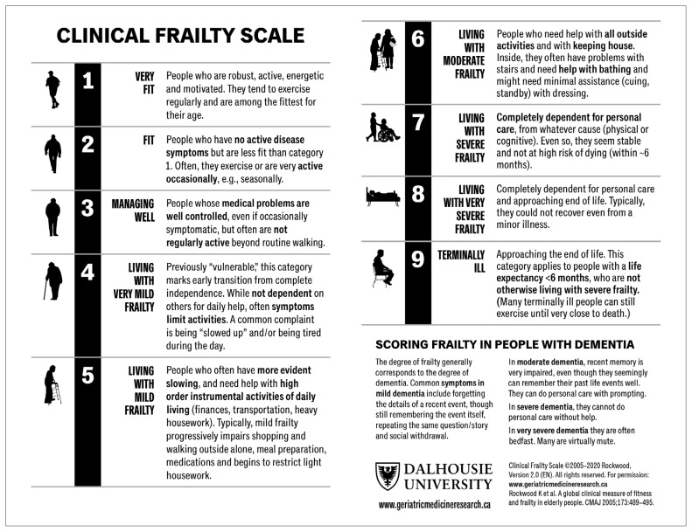
Figure 2: The clinical Frailty Scale (CFS) version 2.0. Available from: Clinical Frailty Scale - Geriatric Medicine Research - Dalhousie University (Rockwood and Theou 2020).

Tips on using the CFS (NHS Specialised Clinical Frailty Network 2018, Rockwood and Theou 2020)

The tool is only valid for use in people 65 years and older

Patients should be scored based on what they were like two weeks before they were ill

Do not base your assessment on how the patient is at the time you score them

If the patient cannot tell you how they were two weeks ago use information from carers, friends, or the GP

Don’t make assumptions about the patient, use prompting questions like “Do you have any problems with cooking, shopping or getting dressed?”

Check your score with colleagues if you are unsure

Possible disadvantages of screening tools
So far in this article we have identified the importance of frailty screening tools but as with every tool there are also some potential disadvantages. Firstly, the concept of being identified as ‘frail’ by the older population is not always well accepted as social stigma associates this word only with increased vulnerability and dependency (British Geriatric Society 2014). Most often than not older people are able to adapt and compensate well for the losses that frailty brings about and therefore don’t like to be labelled as vulnerable and frail when they can still lead a meaningful life. Not everyone has the same priorities or life expectations and therefore as healthcare professionals we need to be sensitive about this. It is always best to ask the individual, when possible, to discover what matters most to them before labelling them as just ‘frail’. However, it is also known that older adults might overestimate their abilities to cope whereas their families might underestimate their abilities (Nielsen et al 2016). Therefore, educating the older population and their relatives about frailty screening tools and ultimate care goals would help to have a better positive reception of this assessment.

Conclusion
This article aimed to increase awareness regarding the importance of understanding frailty as a condition in the vulnerable older patients. The aim of frailty assessment is to initiate the appropriate care to the most vulnerable and most importantly give individualised care to our patients. There is a need for emergency nurses to identify frailty because although it can’t be eliminated, early identification and frailty specific care can reduce complications and improve patient outcome. The Clinical Frailty Scale is appropriate for the use in the ED and predicts outcome. It is not a tool to be used in isolation of other clinical information but when done timely and appropriately it will help responsible healthcare professionals to make the correct decisions with regards to patient’s care.
Additional helpful resources:
NHS Specialised Clinical Frailty Network Specialised Clinical Frailty Network (scfn.org.uk)
British Geriatric Society Frailty | British Geriatrics Society (bgs.org.uk)
Royal College of Nursing Frailty | Older People

References
Ahmed A, Sorajja P, Pai A, et al (2016). Prospective evaluation of the eyeball test for assessing frailty in patients with valvular heart disease. Journal of the American College of Cardiology. 25, 2911-2912. https://doi.org/10.1016/j.jacc.2016.10.016
Aplin N (2021). Emergency Nurse. Looking out for signs of frailty in older people in emergency care is vital. 29, 1, 15-15. doi: 10.7748/en.29.1.15.s13
British Geriatric Society (2014). Fit for Frailty Part 1. https://www.bgs.org.uk/sites/default/files/content/resources/files/2018-05-23/fff_full.pdf (Last Accessed 13 November 2022.)
Boreskie KF, Hay JL, Boreskie PE, et al (2022). Frailty-aware care: giving value to frailty assessment across different healthcare settings. BMC Geriatrics. 22, 13. https://doi.org/10.1186/s12877-021-02722-9
Brousseau AA, Dent E, Hubbard R, et al (2018). Identification of older adults with frailty in the Emergency Department using a frailty index: results from a multinational study. Age and Ageing. 47,2, 242-248. https://doi.org/10.1093/ageing/afx168
Cesari M, Gambassi G, Abellan van Kan G, et al (2014). The frailty phenotype and the frailty index different instruments for different purposes. Age and Ageing. 43, 10-12. doi: 10.1093/ageing/aft160
Clegg A, Young J, Iliffe S, et al (2013). Frailty in elderly people. The Lancet. 381, 9868, 752-762. doi: 10.1016/S0140-6736(12)62167-9
Cunha A, Veronese N, de Melo Borges S, et al (2019) Frailty as a predictor of adverse outcomes in hospitalized older adults: a systematic review and meta-analysis. Ageing Research Reviews. 56, 100960. doi:10.1016/j.arr.2019.100960
Dalhousie University (2020). Using the Clinical Frailty Scale to rapidly assay grades of fitness and frailty. CFS Guidance Document: version 2020. https://cdn.dal.ca/content/dam/dalhousie/pdf/sites/gmr/CFS-Guidance-for-Use_2020Apr06_EN.pdf (Last accessed 12 November 2022.)
Davies J, Whitlock J, Gutmanis I, et al (2018). Inter-Rater Reliability of the Retrospectively Assigned Clinical Frailty Scale Score in a Geriatric Outreach Population. Canadian Geriatrics Journal. 21, 1, 1-5. doi: 10.5770/cgj.21.263.
Elliot A, Phelps K, Regen E, et al (2017). Identifying frailty in the Emergency Department-feasibility study. Age and Ageing. 46,5, 840-845. DOI: 10.1093/ageing/afx089
Finlay SL (2022). Frailty: An overview of concepts, risk factors, assessment tools and interventions. Nursing older People. 34,4, 35-42. doi: 10.7748/nop.2022.e1394
Faller JW, Pereira DdoN, de Souza S, et al (2019). Instruments for the detection of frailty syndrome in older adults: a systematic review. PLoS ONE. 14, 4: e0216166. doi:10.1371/journal.pone.0216166
Fried LP, Tangen CM, Walston J, et al (2001) Frailty in older adults: evidence for a phenotype. The Journals of Gerontology: Series A, Biological Sciences and Medical Sciences. 56, 3, 146–157. https://doi.org/10.1093/gerona/56.3.M146 (Last accessed: 10 November 2022.)
Hanlon P, Nicholl BI, Jani BD et al (2018) Frailty and pre-frailty in middle-aged and older adults and its association with multimorbidity and mortality: a prospective analysis of 493737 UK Biobank participants. The Lancet Public Health. 3, 7, e323-e332. doi: 10.1016/S2468-2667(18)30091-4
Jarman H, Crouch R, Baxter M, et al (2020). Frailty in major trauma study (FRAIL-T): a study protocol to determine the feasibility of nurse-led frailty assessment in elderly trauma and the impact on outcome in patients with major trauma. BMJ Open. 10,8: e038082. doi: 10.1136/bmjopen-2020-038082
James J (2016). Comprehensive geriatric assessment during emergency admission. Nursing Older People. 28, 2, 16-22. doi: 10.7748/nop.28.2.16.s20
Kellett J, Clifford M., Ridley A, et al (2014). A four item scale based on gait for the immediate global assessment of acutely ill medical patients – one look is more than 1000 words. European Geriatric Medicine. 5,2, 92-96. doi:https://doi.org/10.1016/j.eurger.2013.11.011
Kim S, Jung HW, Won CW (2020) What are the illnesses associated with frailty in community dwelling older adults: the Korean Frailty and Aging Cohort Study. Korean Journal of Internal Medicine. 35, 4, 1004-1013. doi: 10.3904/kjim.2019.097
Lewis ET, Dent T, Alkhouri H, et al (2019). Which frailty scale for patients admitted via Emergency Department? A cohort study. Archives of Gerontology and Geriatrics. 80, 104-114. https://doi.org/10.1016/j.archger.2018.11.002
Mitnitski AB, Mogilner AJ, Rockwood K (2001) Accumulation of deficits as a proxy measure of aging. Scientific World Journal. 1, 323–336. doi:10.1100/tsw.2001.58
NHS National Health Service. The NHS long term plan. 2019. https://www. longtermplan.nhs.uk/ (Accessed 05 Dec 2022)
Nielsen LM, Kirkegaard H, Ostergaard LG, et al (2016). Comparison of self-reported and performance-based measures of functional ability in elderly patients in an emergency department: Implications for selection of clinical outcome measures. BMC Geriatrics. 16, 1, 199. https://doi.org/10.1186%2Fs12877-016-0376-1
Rockwood K, Song X, MacKnight C, et al (2005) A global clinical measure of fitness and frailty in elderly people. Canadian Medical Association Journal. 173,5, 489-95. doi: 10.1503/cmaj.050051
Rockwood K, Theou O (2020). Using the Clinical Frailty Scale in allocating scarce healthcare resources. Canadian Geriatrics Journal. 23,3, 210-215. https://doi.org/10.5770%2Fcgj.23.463
O'Caoimh R, Costello M, Small C, et al (2019). Comparison of Frailty Screening Instruments in the Emergency Department. International Journey of Environmental Research and Public Health. 16,19,3626. doi: 10.3390/ijerph16193626
Office for National Statistics (2021). Population and household estimates, England and Wales: Census 2021. https://www.ons.gov.uk/peoplepopulationandcommunity/populationandmigration/populationestimates/bulletins/populationandhouseholdestimatesenglandandwales/census2021 (Last accessed 13 November.)
Puig Campmany M, Ris Romeu J, Blazquez Andion M, et al (2019). Development of a comprehensive, multidisciplinary programme of care for frailty in an Emergency Department. European Geriatric Medicine. 10, 37-46. https://doi.org/10.1007/s41999-018-0151-2
Turner G, Clegg A (2014). Best practice guideline for the management of frailty: a British Geriatric Society, Age UK and Royal College of General Practitioners report. Age and Ageing. 43,6, 744-747. doi: 10.1093/ageing/afu138

Specialised Clinical Frailty Network (2018). Clinical Frailty scale. https://www.scfn.org.uk/ clinical-frailty-scale (Last accessed 13 November 2022.)

