Supplemental Digital Content
Figure S1: Model schematic for the phenotype-specific HF models (HF LVEF>40% and HFrEF)
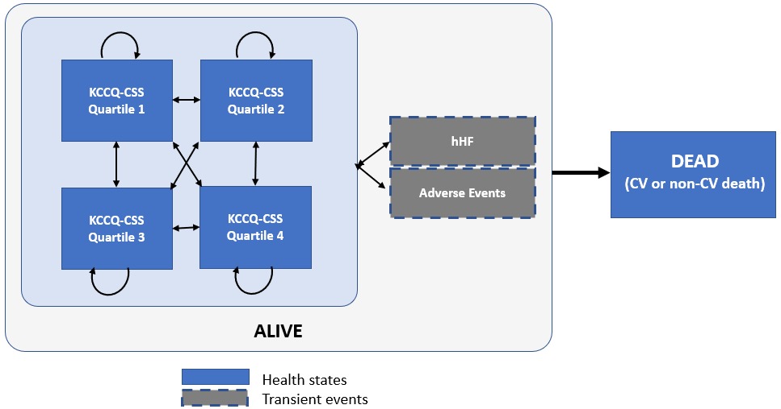
Abbreviations: CSS = clinical summary score; CV = cardiovascular; HFrEF, heart failure with reduced ejection fraction; HF LVEF >40%, heart failure with >40% ejection fraction; hHF = hospitalisation due to heart failure; KCCQ = Kansas City Cardiomyopathy Questionnaire
Figure S2. Overview of the approach used to combine the PSA results of the phenotype-specific HF models
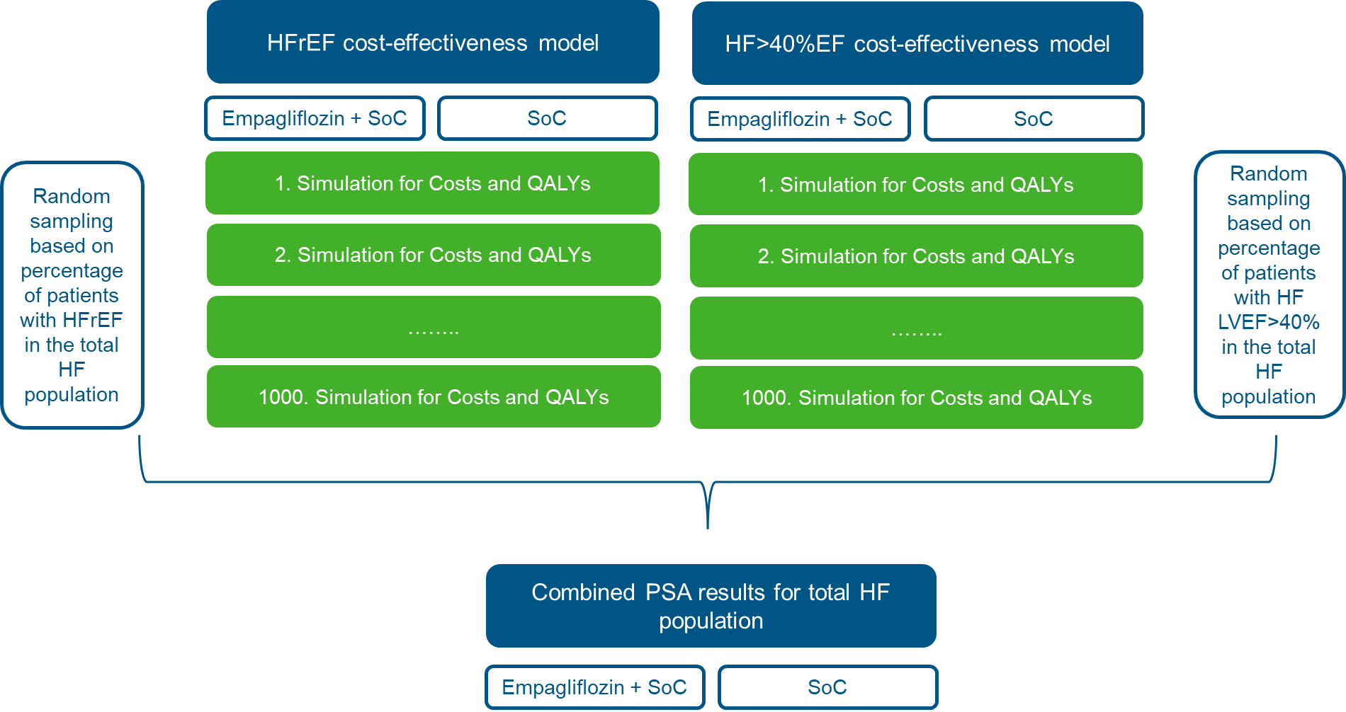
Abbreviations: CEM, cost-effectiveness model; HF, heart failure; HFrEF, heart failure with reduced ejection fraction; HF LVEF >40%, heart failure with >40% ejection fraction; PSA, probabilistic sensitivity analysis; QALY, quality-adjusted life-year; SoC, standard of care.
Table S1. Details of the subgroup analyses
Subgroup | Description
T2DM at baseline | Adjust mean patient characteristics to reflect subset of EMPEROR-Reduced and EMPEROR-Preserved population with T2DM at trial entry.
No T2DM at baseline | Adjust mean patient characteristics to reflect subset of EMPEROR-Reduced and EMPEROR-Preserved population without T2DM at trial entry.
Baseline age < 65 years | Adjust mean patient characteristics to reflect subset of EMPEROR-Reduced and EMPEROR-Preserved population younger than 65 years of age.
Baseline age ≥ 65 years | Adjust mean patient characteristics to reflect subset of EMPEROR-Reduced and EMPEROR-Preserved population at least 65 years of age.
Baseline eGFR < 60 mL/min/1.73m2 | Adjust mean patient characteristics to reflect subset of EMPEROR-Reduced and EMPEROR-Preserved population with an eGFR less than 60 mL/min/1.73m2.
Baseline eGFR ≥ 60 mL/min/1.73m2 | Adjust mean patient characteristics to reflect subset of EMPEROR-Reduced and EMPEROR-Preserved population with an eGFR of at least 60 mL/min/1.73m2.
Abbreviations: eGFR, estimated glomerular filtration rate; T2DM, Type II Diabetes Mellitus
Table S2. Breakdown of deterministic average costs per patient for the overall HF population
Disaggregated costs | Empagliflozin + SoC | SoC | Incremental
Drug acquisition | £3,998 | £2,382 | £1,616
hHF management | £2,686 | £3,108 | -£422
CV death management | £2,072 | £2,121 | -£49
AE management | £1,698 | £1,708 | -£11
Disease management | £4,792 | £4,663 | £130
Total | £15,246 | £13,982 | £1,264
Note: sums may not add due to rounding
Abbreviations: AE, adverse events; CV, cardiovascular; HF, heart failure; hHF, hospitalization for heart failure; SoC, standard of care
Table S3. PSA outcomes for the overall HF population
Cost-effectiveness measures | Mean | Lower 95% CI | Upper 95% CI
Incremental LYs | 0.15 | -0.24 | 0.60
Incremental QALYs | 0.16 | -0.16 | 0.52
Incremental costs | £1,262 | £201 | £2,148
ICER (cost/LY gained) | £8,395
ICER (cost/QALY gained) | £7,657
Note: sums may not add due to rounding
Abbreviations: CI, confidence interval; LY, life-year; HF, heart failure; QALY, quality-adjusted life-year; PSA, probabilistic sensitivity analysis
Table S4. Scenario analysis (equal split [50%] between the HFrEF and HF LVEF>40%) cost-effectiveness results for the overall HF population
Outcome (per patient) | Empagliflozin + SoC | SoC | Incremental
Total discounted LYs | 6.34 | 6.21 | 0.13
Total discounted QALYs | 4.03 | 3.88 | 0.14
Total discounted costs | £14,191 | £12,887 | £1,304
ICER (cost/LY gained) | £10,208
ICER (cost/QALY gained) | £9,074
Note: sums may not add due to rounding
Abbreviations: ICER, incremental cost-effectiveness ratio; LY, life-years; QALY, quality-adjusted life-year
Table S5. Scenario analysis (equal split between the HFrEF and HF LVEF>40%) breakdown of average costs per patient for the overall HF population
Disaggregated costs | Empagliflozin + SoC | SoC | Incremental
Drug acquisition | £3,806 | £2,171 | £1,635
hHF management | £2,389 | £2,755 | -£366
CV death management | £1,897 | £1,950 | -£53
AE management | £1,737 | £1,752 | -£15
Disease management | £4,362 | £4,259 | £103
Total | £14,191 | £12,887 | £1,304
Note: sums may not add due to rounding
Abbreviations: AE, ad

