Supplementary Material
Guideline directed medical therapy in advanced heart failure with reduced ejection fraction: an analysis of the HELP-HF Registry
Daniela Tomasoni,^{1,2}* Matteo Pagnesi,¹* Giada Colombo,¹ Mauro Chiarito,^{3,4} Davide Stolfo,⁵ Luca Baldetti,⁶ Carlo Mario Lombardi,¹ Marianna Adamo,¹ Giuseppe Maggi,¹ Riccardo Maria Inciardi,¹ Ferdinando Loiacono,³ Marta Maccallini,^{3,4} Alessandro Villaschi,^{3,4} Gaia Gasparini,^{3,4} Marco Montella,^{3,4} Stefano Contessi,⁵ Daniele Cocianni,⁵ Maria Perotto,⁵ Giuseppe Barone,⁶ Marco Merlo,⁵ Alberto Maria Cappelletti,⁶ Giuseppe Rosano,⁷ Gianfranco Sinagra,⁵ Daniela Pini,³ Gianluigi Savarese,² Marco Metra¹

¹ Institute of Cardiology, ASST Spedali Civili, Department of Medical and Surgical specialties, Radiological sciences and Public Health, University of Brescia, Brescia, Italy
² Division of Cardiology, Department of Medicine, Karolinska Institutet, and Heart and Vascular and Neuro Theme, Karolinska University Hospital, Stockholm, Sweden
³ Humanitas Research Hospital IRCCS, Rozzano-Milan, Italy
⁴ Department of Biomedical Sciences, Humanitas University, Pieve Emanuele-Milan, Italy
⁵ Cardiovascular Department, Azienda Sanitaria Universitaria Giuliano Isontina (ASUGI), University of Trieste, Trieste, Italy
⁶ Cardiac Intensive Care Unit, IRCCS San Raffaele Scientific Institute, Milan, Italy
⁷ Department of Medical Sciences, Centre for Clinical and Basic Research, IRCCS San Raffaele Pisana, Rome

*D. Tomasoni and M. Pagnesi equally contributed as first authors of this manuscript

Short Title: GDMT in advanced HFrEF.

Corresponding author:
Prof. Marco Metra, MD
Institute of Cardiology, Department of Medical and Surgical Specialties, Radiological Sciences, and Public Health, University of Brescia, Brescia, Italy
Email: metramarco@libero.it
Phone: +393356460581
Supplementary Table 1. Evidence-based doses of disease-modifying drugs in key randomized trials in patients with heart failure with reduced ejection fraction (from 2021 ESC guidelines for the management of acute and chronic HF(1))
ACE-I
Captopril, 50 mg t.i.d.
Enalapril, 10-20 mg b.i.d.
Lisinopril, 20-35 mg o.d.
Ramipril, 5 mg b.i.d.
Trandolapril, 4 mg o.d.

ARNI
Sacubitril/valsartan, 97/103 mg b.i.d.

Beta-blockers
Bisoprolol, 10 mg o.d.
Carvedilol, 25 mg b.i.d.e
Metoprolol succinate (CR/XL), 200 mg o.d.
Nebivolol, 10 mg o.d.

MRA
Eplerenone, 50 mg o.d.
Spironolactone, 50 mg o.d.

Supplementary Table 2. Use of GDMT in the subgroup of patients fulfilling the 2018 HFA-ESC criteria for advanced HF (n = 152)
 | Beta blockers | ACEi/ARB/ARNI | MRA
Treated patients | 116 (76.8) | 76 (50.3) | 101 (66.9)
Dose ≥50% of the target dose | 50 (33.1) | 34 (22.5) | 98 (64.9)
Fractional dose, % | 43.6 ± 33.6 | 48.9 ± 31.0 | 97.8 ± 72.9
Reasons for lack of treatment
Low blood pressure | 14 (40.0) | 24 (32.0) | 3 (6.0)
Bradycardia | 3 (8.6) | - | -
Chronic kidney disease | 1 (2.7) | 22 (29.3) | 12 (24.0)
Hyperkalaemia | - | 2 (2.7) | 8 (16.0)
Other side effects | 3 (8.6) | 2 (2.7) | -
Unknown reasons | 13 (37.1) | 25 (33.3) | 27 (54.0)
Reason for underdosing (<50% target dose)
Low blood pressure | 42 (41.6) | 51 (43.6) | 3 (5.7)
Bradycardia | 5 (5.0) | - | -
Chronic kidney disease | 3 (3.0) | 23 (19.7) | 12 (22.6)
Hyperkalaemia | - | 2 (1.7) | 9 (17.0)
Other side effects | 8 (7.9) | 3 (2.6) | -
Unknown reasons | 42 (41.6) | 38 (32.5) | 29 (54.7)

Supplementary Table 3 Univariable and Multivariable Models for All-cause Death
 | Univariate |  | Multivariate*
 | HR (95% CI) | p-value | HR (95% CI) | p-value
Beta-blocker use (any dose) | 0.42 (0.30-0.58) | <0.001 | 0.50 (0.36-0.71) | <0.001
Fractional dose beta blocker (%) | 0.34 (0.21-0.55) | <0.001 | 0.52 (0.31-0.88) | 0.015
Beta-blockers dose ≥50% target dose vs. no therapy or <50% target dose | 0.54 (0.39-0.74) | <0.001 | 0.73 (0.51-1.03) | 0.073
Beta-blockers dose categories  ≥50% target dose vs. no therapy  1-49% target dose vs. no therapy | 0.34 (0.23-0.50)  0.50 (0.35-0.72) | <0.001  <0.001 | 0.48 (0.32-0.72)  0.52 (0.36-0.76) | <0.001  0.001
ACE-I/ARB/ARNI use (any dose) | 0.45 (0.33-0.61) | <0.001 | 0.66 (0.47-0.93) | 0.016
Fractional dose ACE-I/ARB/ARNI (%) | 0.34 (0.19-0.62) | <0.001 | 0.62 (0.35-1.12) | 0.114
ACE-I/ARB/ARNI dose ≥50% target dose vs. no therapy or <50% target dose | 0.60 (0.39-0.90) | 0.015 | 0.79 (0.50-1.24) | 0.301
ACE-I/ARB/ARNI dose categories  ≥50% target dose vs. no therapy  1-49% target dose vs. no therapy | 0.45 (0.29-0.69)  0.45 (0.31-0.65) | <0.001  <0.001 | 0.68 (0.42-1.08)  0.65 (0.43-0.96) | 0.106  0.032
MRA use (any dose) | 0.76 (0.56-1.02) | 0.070 | 0.80 (0.59-1.10) | 0.168
Fractional dose MRA (%) | 0.97 (0.75-1.24) | 0.795 | 1.06 (0.81-1.38) | 0.677
MRA dose ≥50% target dose vs. no therapy or <50% target dose | 0.81 (0.60-1.09) | 0.161 | 0.83 (0.61-1.14) | 0.246
MRA dose categories  ≥50% target dose vs. no therapy  1-49% target dose vs. no therapy | 0.77 (0.57-1.04)  0.52 (0.19-1.43) | 0.097  0.208 | 0.81 (0.59-1.12)  0.66 (0.24-1.83) | 0.199  0.426
ACEi, angiotensin-converting enzyme inhibitor; ARB, angiotensin II receptor blocker; ARNI, angiotensin receptor neprilysin inhibitor; CI, confidence interval; HR, hazard ratio; MRA, mineralocorticoid receptor antagonist

*Adjusted for age, sex, inpatient versus outpatient status, peripheral artery disease, prior stroke or transient ischaemic attack, history of atrial fibrillation, prior myocardial infarction, chronic obstructive pulmonary disease, New York Heart Association class III–IV, systolic blood pressure, heart rate and estimated glomerular filtration rate (as in the previously published model of the original HELP-HF study)

Supplementary Table 4 Multivariable Models for the primary endpoint and for all-cause death including natriuretic peptides among covariates.
 | All-cause death or HF hospitalization* |  | All-cause death#
 | HR (95% CI) | p-value | HR (95% CI) | p-value
Beta-blocker use (any dose) | 0.72 (0.53-0.99) | 0.046 | 0.62 (0.42-0.92) | 0.017
Beta-blockers dose ≥50% target dose vs. no therapy or <50% target dose | 0.69 (0.52-0.91) | 0.008 | 0.77 (0.53-1.11) | 0.158
Beta-blockers dose categories  ≥50% target dose vs. no therapy  1-49% target dose vs. no therapy | 0.60 (0.42-0.86)  0.83 (0.59-1.16) | 0.006  0.273 | 0.58 (0.37-0.91)  0.66 (0.43-1.01) | 0.019  0.053
ACE-I/ARB/ARNI use (any dose) | 0.79 (0.61-1.04) | 0.094 | 0.76 (0.52-1.10) | 0.145
ACE-I/ARB/ARNI dose ≥50% target dose vs. no therapy or <50% target dose | 0.80 (0.57-1.12) | 0.200 | 0.85 (0.53-1.36) | 0.493
ACE-I/ARB/ARNI dose categories  ≥50% target dose vs. no therapy  1-49% target dose vs. no therapy | 0.75 (0.52-1.07)  0.83 (0.61-1.13) | 0.107  0.241 | 0.77 (0.47-1.26)  0.75 (0.48-1.17) | 0.293  0.203
MRA use (any dose) | 0.92 (0.70-1.19) | 0.516 | 0.80 (0.56-1.12) | 0.191
MRA dose ≥50% target dose vs. no therapy or <50% target dose | 0.93 (0.71-1.20) | 0.563 | 0.80 (0.57-1.13) | 0.209
MRA dose categories  ≥50% target dose vs. no therapy  1-49% target dose vs. no therapy | 0.92 (0.70-1.20)  0.89 (0.41-1.93) | 0.763 | 0.79 (0.56-1.13)  0.83 (0.30-2.32) | 0.194  0.724
ACEi, angiotensin-converting enzyme inhibitor; ARB, angiotensin II receptor blocker; ARNI, angiotensin receptor neprilysin inhibitor; CI, confidence interval; HR, hazard ratio; MRA, mineralocorticoid receptor antagonist

*Adjusted for age, sex, inpatient versus outpatient status, peripheral artery disease, prior stroke or transient ischaemic attack, history of atrial fibrillation, prior myocardial infarction, chronic obstructive pulmonary disease, New York Heart Association class III–IV, systolic blood pressure, estimated glomerular filtration rate and natriuretic peptides (< vs >= median value)
# Adjusted for age, sex, inpatient versus outpatient status, peripheral artery disease, prior stroke or transient ischaemic attack, history of atrial fibrillation, prior myocardial infarction, chronic obstructive pulmonary disease, New York Heart Association class III–IV, systolic blood pressure, heart rate, estimated glomerular filtration rate and natriuretic peptides (< vs >= median value)

Supplementary Figure 1. Kaplan Meier curves for 1-year all-cause death according to beta-blockers use and dose (not prescribed vs prescribed at <50% of the target dose vs prescribed at ≥50% of the target dose).

Supplementary Figure 2. Kaplan Meier curves for 1-year all-cause death according to ACEi/ARB/ARNI use and dose (not prescribed vs prescribed at <50% of the target dose vs prescribed at ≥50% of the target dose).
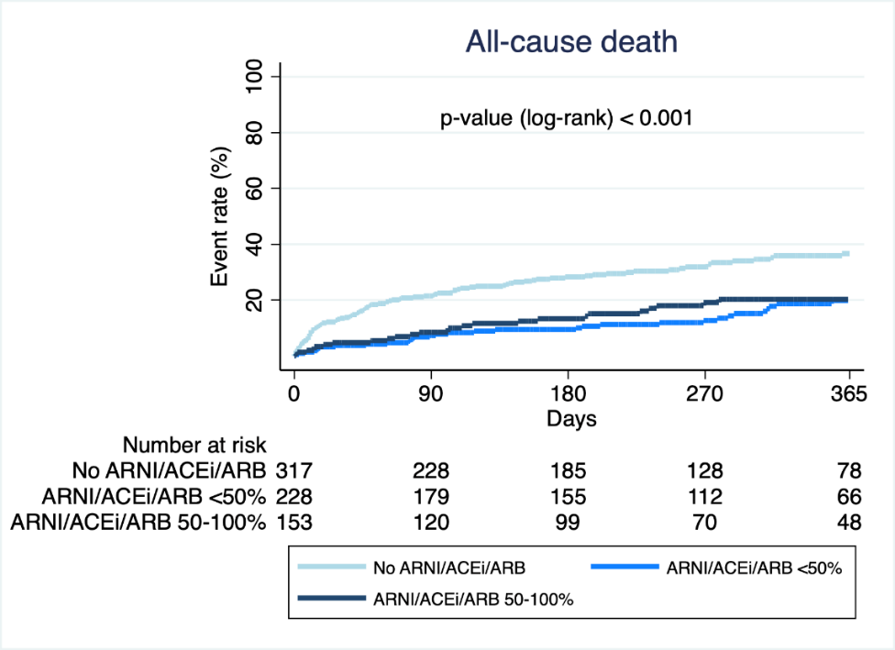

Supplementary Figure 3. Kaplan Meier curves for 1-year all-cause death according to MRA use and dose (not prescribed vs prescribed at <50% of the target dose vs prescribed at ≥50% of the target dose)

References
1. Authors/Task Force M, McDonagh TA, Metra M, Adamo M, Gardner RS, Baumbach A, et al. 2021 ESC Guidelines for the diagnosis and treatment of acute and chronic heart failure: Developed by the Task Force for the diagnosis and treatment of acute and chronic heart failure of the European Society of Cardiology (ESC). With the special contribution of the Heart Failure Association (HFA) of the ESC. Eur J Heart Fail. 2022;24(1):4-131.

