Seasonal Variation in Sudden Cardiac Death: Insights from a Large United Kingdom Registry

Ioannis Panayiotides¹ MD, Joseph Westaby¹ BMBS, PhD, FRCPath, Elijah R. Behr¹ MA, MBBS, FRCP, Michael Papadakis¹ MBBS, MRCP, MD, MRCP, Sanjay Sharma¹ BSc, MBChB, FRCP, MD, Gherardo Finocchiaro¹ MD, PhD*, Mary N. Sheppard¹ MBBCH, BAO, BSc, MD, FRCPath, FRCPI*

Institutions:
1. Cardiovascular Sciences Research Centre, St George's, University of London, London, United Kingdom

* Equally contributed as senior authors

Author for correspondence:
Mary N. Sheppard MB, BCH, BAO, BSc, MD, FRCPath, FRCPI
Professor of Cardiac Pathology,
Cardiovascular Sciences,
St. George’s University of London, Cranmer Terrace,
London. SW17 0RE. UK.
E-mail: msheppar@sgul.ac.uk
ABSTRACT

Background: Sudden cardiac death (SCD) is relatively common and may occur in apparently healthy individuals. The role of seasonal variation as a risk factor for SCD is poorly understood. The aim of this study was to investigate whether SCD exhibits a predilection for specific seasons.
Methods: We reviewed a database of 4751 cases of SCD (mean age 38 ± 17 years) referred to our center for cardiac pathology at St George’s University of London between 2000 and 2018. Clinical information was obtained from referring coroners who were asked to complete a detailed questionnaire. All cases underwent macroscopic and histological evaluation of the heart, by expert cardiac pathologists.
Results: SCD was more common during winter (26%) and rarer during summer (24%), p= 0.161. Significant seasonal variation was not observed among cases of sudden arrhythmic death syndrome (SADS, 2910 cases) in which the heart is structurally normal. In contrast, a significant difference in seasonal distribution among decedents exhibiting cardiac structural abnormalities at the post-mortem examination (n=1841) was observed. In this subgroup, SCDs occurred more frequently during winter (27 %) compared to summer (22%) (p=0.007). In cases diagnosed with a myocardial disease (n=1399), SCD was most common during the winter (27%) and least common during the summer (22%) (p=0.027).
Conclusions: While SADS occurs throughout the year with no seasonal variation, SCD due to structural heart disease appears to be more common during the winter. Bio-meteorological factors may be potential triggers of SCD in individuals with an underlying structural cardiac abnormality.
Keywords: sudden cardiac death, seasonal variation
INTRODUCTION

Sudden cardiac death (SCD) is a tragic event that occasionally affects apparently healthy individuals. While cardiomyopathies and primary arrhythmic syndromes are considered the most common causes of SCD in young individuals, coronary artery disease (CAD) predominates in older (> 35 years) individuals (1, 2)​.
The elucidation of the causes of SCD relies heavily on the post-mortem examination. This should be performed utilizing a systematic methodology, which includes macroscopic evaluation and histological analysis of the heart.
It is poorly understood, whether seasonal variation, and concomitant climatological fluctuation may be environmental triggers of SCD (3). While a correlation between cold weather and myocardial infarction has been shown in previous studies, a possible association between seasonal variation and SCD has not been explored yet (4,5). Limited data on arrhythmogenic cardiomyopathy (AC) show an increased incidence of ventricular tachyarrhythmias and SCD during the summer, and particularly at higher temperatures (6)​. There is no evidence to support any seasonal effect of SCD in individuals with primary arrhythmic syndromes (7–9).
The acknowledgement of a possible seasonal variation of SCD may be useful to formulate preventive lifestyle recommendations. Counselling on the safety of exposure to various climatological environments may be crucial in individuals with specific cardiac conditions.

The aim of this study was to investigate seasonal variation in SCD, in cases where the post-mortem diagnosis was ascertained by expert cardiac pathologists following a standardized protocol.
METHODS

Setting
The Cardiac Risk in the Young (CRY) center for cardiac pathology is established at St. George’s University of London. The center receives over 400 whole hearts of cases of SCD across the United Kingdom each year. General pathologists are likely to refer when the clinical history is suggestive of a cardiac cause which could be inherited, especially when the death affects a young or athletic individual or when the cause of death is uncertain after the initial autopsy.

Study population
We reviewed a database of 4751 cases of SCD which were referred to the CRY center for cardiac pathology between January 2000 and December 2018, alongside their available demographic characteristics, clinical information and date of the events. SCD was defined as death occurring within 12 hours of apparent wellbeing.

Autopsy examination
All SCD cases underwent a full autopsy evaluation by the local pathologist who excluded extra-cardiac and toxicological causes. Comprehensive macroscopic examination of the whole heart and histological analysis were performed by expert cardiac pathologists (MNS, JW) in accordance with the guidelines on “Autopsy practice for sudden death with likely cardiac pathology” of the Royal College of Pathologists and the Association for European Cardiovascular Pathology (10). All cardiac structures were systematically examined. The heart weight was recorded in grams and ventricular wall thickness excluding the papillary muscles and fat and internal cavity dimensions including the trabeculae were measured at a mid-ventricular level. A minimum of 10 blocks of tissue were taken for histological analysis. Sections of myocardium were fixed in formalin, embedded in paraffin and stained with hematoxylin and eosin. If required a picrosirius red was used to highlight collagen.
The criteria for defining specific cardiac pathologies are summarized in Table 1. Sudden arrhythmic death syndrome (SADS) was a diagnosis of exclusion, defined as a structurally normal heart with no evident abnormality on macroscopic and histological evaluation, and a negative toxicology screen (10).

Clinical information
The referring coroner and pathologist were asked to complete a questionnaire enquiring about the demographics of the deceased, past medical history, family history, cardiac symptoms, the nature and level of physical activity and exact circumstances of death. The data were derived from several sources including interviews with the family of the deceased, potential witnesses of the SCD and reports from the deceased’s family physician. Circumstances of death were subdivided broadly into death related to exercise, at rest or during sleep. Data was collected prospectively and stored on our electronic database.

Statistical Analysis
The chi-squared test was used to examine whether there was an even seasonal distribution of SCD events (25% in each season). To assess seasonal variations, we considered all cases from March to May (spring), June to August (summer), September to November (autumn) and December to February (winter). Moreover, the monthly occurrence of SCD events was examined while adjusting for the different number of days in each month (28 to 31 days) by dividing the number of cases by the number of days in the related month and multiplying by 30. The average number of events per month has been used. The statistical test implemented is the Chi-Square test of homogeneity to investigate whether there is an equal distribution of number of events across the 4 seasons. Finally, Poisson regression was used to quantify the effect of season on the number of SCD events via the Incident Rate Ratio (IRR). IRR quantifies the risk of the incident of a season relative to another season. The Poisson models accounted for the time variable and the number of days in the month. All models were compared to the NULL model (i.e., no effect of the season or month to the monthly or seasonal number of incidents) via the ANOVA procedure to assess whether the inclusion on a seasonal effect significantly improves the model goodness of fit. The analysis was performed in R v.3.5.1 [R Core Team (2018). R: A language and environment for statistical computing. R Foundation for Statistical Computing, Vienna, Austria. URL https://www.R-project.org/].

RESULTS

The database included 4751 deceased (65% males) with recorded date of death between the 1st of January 2000 and 31st of December 2018.
Most decedents were white (n=3855, 81%), 171 (4%) were black and 240 (5%) were of other ethnic groups (predominantly Chinese, Indian and Pakistani). Table 2 shows the main demographic characteristics of the sample and the causes of SCD.

Causes of death
A structurally normal heart suggestive of SADS was found in 2910 (61%) of cases. The remaining 1841 (39%) cases were diagnosed with cardiomyopathies (n=1399, 29%), CAD (n=128, 2%), congenital heart disease (n=118, 2%), valvular heart disease (n=99, 2%), aortic dissection (n=81, 2%) and cardiac tumor (n=16, 0.5%). In the subgroup of individuals diagnosed with CAD, congenital coronary artery anomalies accounted for 72 cases (the remaining 56 cases were found to have obstructive atherosclerotic disease). A comparison between male and female decedents showed a similar distribution of underlying etiologies.

Seasonal variation
Sudden cardiac events occurred more commonly during the winter (26%) and less frequently during the summer (24%), however this difference in the distribution was not statistically significant (p = 0.161). A similar non-seasonal distribution was demonstrated when male and female decedents were analyzed separately. Figure 1 and Table 2 demonstrate the distribution of analyzed events during the year.
No differences in terms of seasonal distribution were found in decedents with a structurally normal heart (p=0.953). In contrast, a seasonal variability with events occurring more frequently during the winter (27%) and less frequently during the summer (22%) (p=0.007) was observed in cases with cardiac structural abnormalities at the post-mortem examination (n=1841). In individuals with structural cardiac disease, SCDs were 18% less likely to occur during the summer, compared to winter (IRR=0.819, p=0.003) and the seasonal effect was statistically significant (p=0.005). In cases where the post-mortem examination revealed a cardiomyopathy (n=1399), SCD was most common during the winter (27%) and least common during the summer (22%) (p=0.027). In cases where the cause of death was coronary artery disease, SCDs were most frequent during the autumn (34%) and the least during the summer (21%) (p=0.047). Cases of myocarditis (n = 102) exhibited a seasonal preference, being more frequent in spring (36%) and least frequent in autumn (18%) (p= 0.0034).

Circumstances of death
SCDs occurred at rest in 3700 cases (78%) and during exercise in 544 (12%). A seasonal effect was noted in fatal events occurring at rest, with a predominance in winter (n = 983, 27%) (P=0.014). A statistically significant seasonal predilection was also noted in SCDs related to exercise with a predominance of summer (n = 166, 31%) (p=0.09) (Figure 2, Table 3).

DISCUSSION

Our study investigates the seasonal variation of sudden cardiac death in a large cohort where the post-mortem examination was performed by expert cardiac pathologists. While in individuals who had a structurally normal heart at autopsy, suggestive of SADS, fatal events were recorded to be approximately equal among seasons (~25%), significant seasonal variation was observed among decedents with structural cardiac abnormalities where events were more common during the winter (27%) and the least common during the summer (22%).

Seasonal variation in sudden cardiac death
Previous studies focused on epidemiology of myocardial infarction showed some degree of seasonal variation (11). Acute events in the context of atherosclerotic coronary pathology are documented to have a predilection for cold weather conditions (12, 13). A higher incidence of mortality attributed to CAD, including SCD, is generally demonstrated in a low temperature environment, according to most published registries (14). In a slightly dissimilar pattern, our study showed that autumn was the season when most of SCDs due to CAD occurred.
According to our findings, SCDs in individuals with cardiac structural abnormalities were less likely to occur during the summer. Previous studies have also identified a predilection of winter and low temperature in SCD among individuals with known heart disease (15). This is also in agreement with a study that investigated the annual periodic trend of sustained ventricular arrhythmias derived from intracardiac electrograms of patients with an implanted defibrillator (16).
Seasonal distribution of SCD may be explained by how extrinsic meteorological factors interfere with various biological parameters, and certain behavioral elements, which may contribute to the development of fatal arrhythmias in individuals with a predisposing electrical or structural substrate. The meteorological conditions in winter may result in an unfavorable hormonal equilibrium with a negative repercussion on endothelial function and coagulation response (17, 18). Both fibrinogen and factor VII clotting activity (FVIIc) plasma values appear greater in winter-time, something that may potentially increase the susceptibility for thrombotic cardiovascular events. The activation of sympathetic nervous system by the cold weather has a heavy catecholamine-mediated impact on blood pressure and heart rate. Vitamin D levels are reduced due to less sunlight exposure (19-21). These variables may result in a state of increased oxidative stress and endothelial dysfunction. Several behavioral components, such as nutritional habits and physical inactivity, tend to vary significantly during different seasons of the year and weather conditions, and this may have an impact on the arrhythmic risk (22). Viral and bacterial infections are more common during the winter (23, 24). Our study showed also a seasonal predilection of fatal events at rest during the winter. In contrast, SCD during exercise was more common during the summer. This may be explained simply by the tendency to engage in outdoor sport activities during the summer, rather than during the winter. Perhaps future studies looking closely at the types of exercise along with the specific environment of athletic activities (indoor or outdoor) can shed light on this finding,

Clinical implications
A full understanding of seasonal distribution of SCDs may have clinical implications on lifestyle recommendations and preventive strategies. Although in most of our cases SCD was the first manifestation of a silent cardiac disease, we speculate that individuals with an underlying structural substrate may be at risk especially when exposed to a cold environment. With genetic testing gradually evolving and becoming an integral component in the investigation and prevention of SCD, any such evidence regarding predisposing seasonal or climatological conditions may be proved useful for additional research.

Limitations
General pathologists are likely to refer to the CRY center of cardiac pathology when the clinical history is suggestive of an inherited cardiac condition, especially when the death affects a young or athletic individual or when the cause of death is uncertain after the initial autopsy. These facts introduce a potential referral bias: it is probable that pathologies such as coronary artery atherosclerosis, aortic dissection, and HCM may be under-represented in this cohort. Instead, normal heart suggestive of SADS may be over-represented in our cohort.

CONCLUSION
Sudden cardiac death in individuals with an underlying structural cardiac condition are more common during the winter. In contrast, no seasonal variation is observed in cases of SADS. Meteorological factors may act as potential triggers of SCD in individuals with an underlying structural or electrical substrate. The complex interaction of seasonal and climatological circumstances with the propensity for potentially fatal arrhythmias, should be further investigated with the aim of preventing these tragic events.

Disclosures: none.
Funding: Cardiac Risk In The Young funds the Database from which this paper information is obtained

REFERENCES

​​1. Hayashi M, Shimizu W, Albert CM. The spectrum of epidemiology underlying sudden cardiac death. Circ Res. 2015 Jun 5;116(12):1887–906.
​2. Finocchiaro G, Papadakis M, Robertus JL, Dhutia H, Steriotis AK, Tome M, et al. Etiology of Sudden Death in Sports: Insights From a United Kingdom Regional Registry. J Am Coll Cardiol. 2016 May 10;67(18):2108–15.
​3. Chugh SS, Jui J, Gunson K, Stecker EC, John BT, Thompson B, et al. Current burden of sudden cardiac death: multiple source surveillance versus retrospective death certificate-based review in a large U.S. community. J Am Coll Cardiol. 2004 Sep 15;44(6):1268–75.
​4. Spencer FA, Goldberg RJ, Becker RC, Gore JM. Seasonal distribution of acute myocardial infarction in the second National Registry of Myocardial Infarction. J Am Coll Cardiol. 1998 May;31(6):1226–33.
​5. Myerburg RJ, Junttila MJ. Sudden cardiac death caused by coronary heart disease. Circulation. 2012 Feb 28;125(8):1043–52.
​6. Chung FP, Li HR, Chong E, Pan CH, Lin YJ, Chang SL, et al. Seasonal variation in the frequency of sudden cardiac death and ventricular tachyarrhythmia in patients with arrhythmogenic right ventricular dysplasia/cardiomyopathy: the effect of meteorological factors. Heart Rhythm. 2013 Dec;10(12):1859–66.
​7. Aizawa Y, Takatsuki S, Kaneko Y, Noda T, Katsumata Y, Nishiyama T, et al. Comparison of circadian, weekly, and seasonal variations of electrical storms and single events of ventricular fibrillation in patients with Brugada syndrome. Int J Cardiol Heart Vasc. 2016 Jun;11:104–10.
​8. Takigawa M, Noda T, Shimizu W, Miyamoto K, Okamura H, Satomi K, et al. Seasonal and circadian distributions of ventricular fibrillation in patients with Brugada syndrome. Heart Rhythm. 2008 Nov;5(11):1523–7.
​9. Kim SH, Nam GB, Baek S, Choi HO, Kim KH, Choi KJ, et al. Circadian and seasonal variations of ventricular tachyarrhythmias in patients with early repolarization syndrome and Brugada syndrome: analysis of patients with implantable cardioverter defibrillator. J Cardiovasc Electrophysiol. 2012 Jul;23(7):757–63.
10. Basso C, Aguilera B, Banner J, Cohle S, d’Amati G, de Gouveia RH, et al. Guidelines for autopsy investigation of sudden cardiac death: 2017 update from the Association for European Cardiovascular Pathology. Virchows Arch. 2017 Dec;471(6):691–705
​11. Gyllerup S. Cold climate and coronary mortality in Sweden. Int J Circumpolar Health. 2000 Oct;59(3–4):160–3.
​12. Cagle A, Hubbard R. Cold-related cardiac mortality in King County, Washington, USA 1980-2001. Ann Hum Biol. 2005;32(4):525–37.
​13. Deo R, Albert CM. Epidemiology and genetics of sudden cardiac death. Circulation. 2012 Jan 31;125(4):620–37.
​14. Deo R, Norby FL, Katz R, Sotoodehnia N, Adabag S, DeFilippi CR, et al. Development and Validation of a Sudden Cardiac Death Prediction Model for the General Population. Circulation. 2016 Sep 13;134(11):806–16.
15. Katz A, Biron A, Ovsyshcher E, Porath A. Seasonal variation in sudden death in the Negev desert region of Israel. Isr Med Assoc J. 2000 Jan;2(1):17-21. PMID: 10892365.
​16. Russo V, Solimene F, Zanotto G, Pisanò EC, Della Bella P, Iacopino S, et al. Seasonal trend of ventricular arrhythmias in a nationwide remote monitoring database of implantable defibrillators and cardiac resynchronization devices. Int J Cardiol. 2019 Jan 15;275:104–6.
​17. Zhu Z, Zhu S, Zhu J, van der Giet M, Tepel M. Endothelial dysfunction in cold-induced hypertensive rats. Am J Hypertens. 2002 Feb;15(2 Pt 1):176–80.
​18. Woodhouse PR, Khaw KT, Plummer M, Foley A, Meade TW. Seasonal variations of plasma fibrinogen and factor VII activity in the elderly: winter infections and death from cardiovascular disease. Lancet. 1994 Feb 19;343(8895):435–9.
​19. Radke KJ, Izzo JL. Seasonal variation in haemodynamics and blood pressure-regulating hormones. J Hum Hypertens. 2010 Jun;24(6):410–6.
​20. Wilkinson IB, Prasad K, Hall IR, Thomas A, MacCallum H, Webb DJ, et al. Increased central pulse pressure and augmentation index in subjects with hypercholesterolemia. J Am Coll Cardiol. 2002 Mar 20;39(6):1005–11.
​21. Gouni-Berthold I, Krone W, Berthold HK. Vitamin D and cardiovascular disease. Curr Vasc Pharmacol. 2009 Jul;7(3):414–22.
​22. Aro AL, Reinier K, Rusinaru C, Uy-Evanado A, Darouian N, Phan D, et al. Electrical risk score beyond the left ventricular ejection fraction: prediction of sudden cardiac death in the Oregon Sudden Unexpected Death Study and the Atherosclerosis Risk in Communities Study. Eur Heart J. 2017 Oct 21;38(40):3017–25.
​23. Warren-Gash C, Smeeth L, Hayward AC. Influenza as a trigger for acute myocardial infarction or death from cardiovascular disease: a systematic review. Lancet Infect Dis. 2009 Oct;9(10):601–10.
​24. Rezkalla SH, Kloner RA. Viral myocarditis: 1917-2020: From the Influenza A to the COVID-19 pandemics. Trends Cardiovasc Med. 2021 Apr;31(3):163–9.
​
Figure legends:

Figure 1. Seasonal variation of SCDs according to the underlying autopsy diagnosis.
n : average number of events per year distributed in months.
p value: Chi-square test of homogeneity for the frequency of SCDs across the seasons, which investigates whether the frequency of events is statistically similar in every season. There is an unequal frequency of SCDs with cardiac structural abnormalities (p=0.007) across the four seasons, indicating a predilection of winter.
Figure 2. Seasonal distribution of SCDs according to circumstances of death.
p value: Chi-square test of homogeneity for the frequency of SCDs at rest across the seasons demonstrate a predominance of events in winter (p=0.014), while SCDs during exercise demonstrate a predominance of events in summer (p=0.009).

Table 1. Pathological Criteria for Defining Cardiac Pathology

 | Macroscopic | Microscopic
Hypertrophic cardiomyopathy | Left ventricular wall thickness, increased wall thickness or focally and/or heart weight, increased heart weight | Myocyte hypertrophy, myocyte disarray (> 20% of myocardial disarray in at least two tissue blocks of 4 cm2) and interstitial fibrosis
Idiopathic left ventricular hypertrophy | Left ventricular wall thickness, increased and heart weight | Myocyte hypertrophy +/-fibrosis in the absence of myocyte disarray
Idiopathic left ventricular fibrosis | Normal heart weight and wall thickness with/without scarring macroscopically | Fibrosis (> 20% in at least two tissue blocks of 4 cm2) with no myocyte disarray
Arrhythmogenic cardiomyopathy | Right or left ventricular thinning, fatty replacement, fibrosis on the epicardial surface or outer wall | Fat and fibrosis (> 20% in at least two tissue blocks of 4 cm2) in the wall of the right and/or left ventricle, particularly in outer wall, with degenerative changes in the myocytes
Myocarditis | Normal or dilated ventricles | Inflammation (> 20% in at least two tissue blocks of 4 cm2) with myocyte necrosis
Anomalous coronary artery | Anomalous origin of the coronary artery, coronary artery atresia, stenosis | Fibrosis/acute/chronic infarction in the left ventricle
Coronary atherosclerosis | Atherosclerosis with estimated luminal narrowing >75% | Acute or chronic infarction in  the left ventricle
Dilated cardiomyopathy | Increase in heart weight with dilated left ventricle (> 4cm) and thin wall (<10mm). Absence of coronary artery disease. | Diffuse interstitial and replacement fibrosis (> 20% in at least two tissue blocks of 4 cm2) in the left ventricle with degenerative changes in the myocytes
Mitral valve prolapse | Prolapse of mitral valve above the atrio-ventricular junction with ballooning between chordae in one or both leaflets | Myxoid degeneration with expansion in spongiosa of leaflets and destruction of fibrosa layer
Bicuspid aortic valve | Fusion of two aortic cusps, with or without presence of a raphe often with significant valve stenosis
Morphologically normal heart | Normal | Normal

Table 2. Seasonal distribution of SCD.
 | N | WINTER | SPRING | SUMMER | AUTUMN | p-value
OVERALL DEATHS | 4751 | 1244 (26) | 1174 (25) | 1136 (24) | 1197 (25) | 0.161
Autopsy Negative | 2910 | 738 (25) | 719 (25) | 732 (25) | 721 (25) | 0.953
Autopsy Positive | 1841 | 506 (27) | 455 (25) | 404 (22) | 476 (26) | 0.007 *
Coronary artery disease | 128 | 34 (27) | 23 (18) | 27 (21) | 44 (34) | 0.05
Cardiomyopathies | 1399 | 381 (27) | 360 (26) | 304 (22) | 354 (25) | 0.03
Valvular heart disease | 99 | 29 (29.3) | 23 (23) | 19 (19) | 28 (28) | 0.45
Aortic dissection | 81 | 24 (30) | 17 (21) | 21 (26) | 19 (24) | 0.72
Congenital heart disease | 118 | 36 (31) | 27 (23) | 29 (25) | 26 (22) | 0.56
Cardiac Tumor | 16 | 4 (25) | 4 (25) | 4 (25) | 4 (25) | 0.99
Age
Under 18 | 485 | 140 (29) | 116 (24) | 121 (25) | 108 (22) | 0.21
18-35 | 2073 | 522 (25) | 501 (24) | 506 (24) | 544 (26) | 0.54
36-45 | 1065 | 271 (25) | 266 (25) | 257 (23) | 271 (26) | 0.92
46-55 | 610 | 155 (25) | 161 (26) | 137 (22.5) | 157 (26) | 0.53
Over 55 | 518 | 156 (30) | 130 (25) | 115 (22) | 117 (23) | 0.04
Gender
Female | 1659 | 436 (26) | 418 (25) | 375 (23) | 430 (26) | 0.79
Male | 3092 | 809 (26) | 756 (24) | 760 (25) | 767 (25) | 0.87

* p value : Chi-square test of homogeneity for the frequency of SCDs across the seasons, demonstrating a predilection of events in winter in decedents with a cardiac structural abnormality (p=0.007).

Table 3. Sample characteristics of circumstances of death (N=4751).

Circumstances of Death | N | Winter | Spring | Autumn | Summer | p value
Rest | 3700 (78) | 983 (27) | 924 (24) | 875 (23) | 918 (26) | 0.014*
Exercise | 544 (12) | 111(20) | 130(24) | 137(25) | 166(31) | 0.009^

* p value : Chi-square test of homogeneity for the frequency of SCDs at rest across the seasons demonstrating a predominance of events in winter (p=0.014).
^ p value : Chi-square test of homogeneity for the frequency of SCDs during exercise across the seasons, demonstrating a predominance of events in summer (p=0.009).

Figure 1.
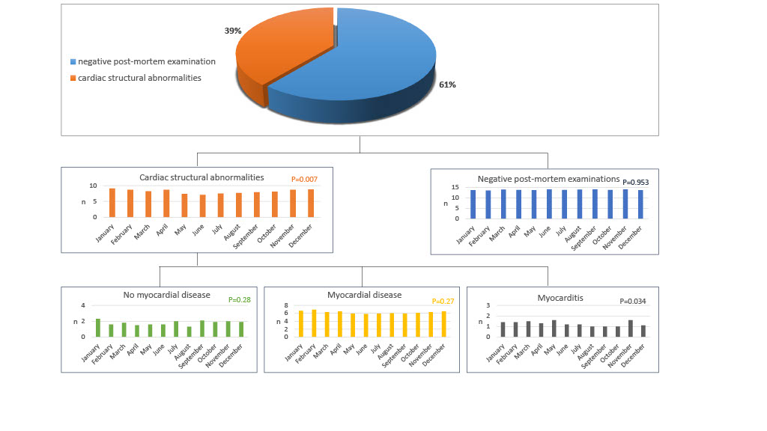

Figure 2.
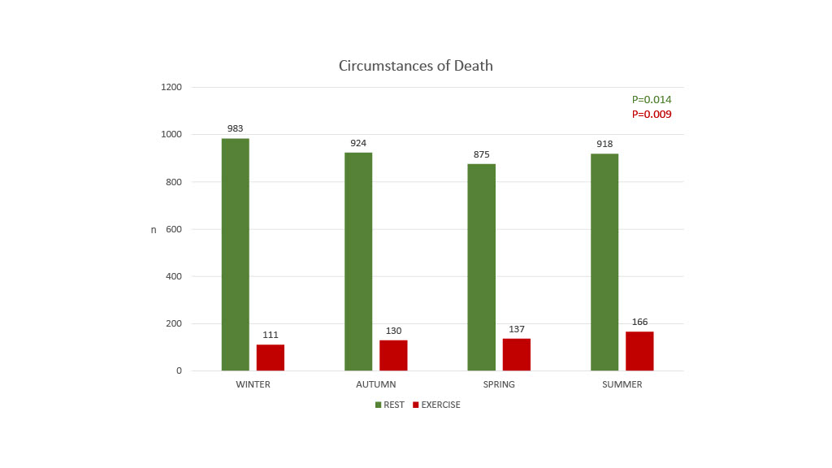

Graphical Abstract.
