Online Supplemental Material

Cardiac Assessment and Inflammatory Markers in Children with Paediatric Inflammatory Multisystem Syndrome Temporally associated with SARS-CoV2 (PIMS-TS) treated with Methylprednisolone Versus Intravenous Immunoglobulins: Longitudinal follow-up of the randomized controlled Swissped RECOVERY Trial.

Andre Maya C.^{1,2*}, MD, Sanchez Carlos³, M.Sc., Bressieux-Degueldre Sabrina⁴, MD, Perez Marie-Helene⁵, MD, Wütz Daniela⁶, MD, Blanchard-Rohner Geraldine⁷, MD, Grazioli Serge⁸, MD, Schöbi Nina⁹, MD, Trück Johannes¹⁰, DPhil, Welzel Tatjana^{3,11}, MD, Atkinson Andrew^{3,12}, PhD, Schlapbach Luregn J.^{13,14°}, PhD, and Bielicki Julia^{3,15°}, MD, for the Swissped RECOVERY Trial Group.

¹ Division of Respiratory and Critical Care Medicine, University Children`s Hospital Basel, University of Basel, Basel, Switzerland
² Department of Pediatric Haematology and Oncology, University Children´s Hospital, Eberhard Karls University, Tuebingen, Germany
³ Paediatric Research Centre, University Children`s Hospital Basel, University of Basel, Basel, Switzerland
⁴ Paediatric Cardiology Unit, Department of Women-Mother-Child, University Hospital of Lausanne and Lausanne University, Lausanne, Switzerland
⁵ Paediatric Intensive and Intermediate Care Units, Department of Women-Mother-Child University Hospital of Lausanne and Lausanne University, Lausanne, Switzerland
⁶ Division of Pediatric Cardiology, Pediatric Heart Center, University Children's Hospital Zurich, Zurich, Switzerland
⁷ Pediatric Immunology and Vaccinology Unit, Division of General Pediatrics, Department of Child, Woman and Adolescent Medicine, Geneva University Hospitals and Faculty of Medicine, Geneva, Switzerland
⁸ Division of Neonatal and Pediatric Intensive Care, Department of Child, Woman and Adolescent Medicine, Geneva University Hospitals and Faculty of Medicine, Geneva, Switzerland
⁹ Department of Pediatrics, Division of Pediatric Infectious Diseases, Inselspital, Bern University Hospital, University of Bern, Bern, Switzerland
¹⁰ Divisions of Allergy and Immunology and Children`s Research Center, University Children's Hospital Zurich, University of Zurich (UZH), Zurich, Switzerland
¹¹ Pediatric Rheumatology, University Children`s Hospital Basel, University of Basel, Basel, Switzerland
¹² Division of Infectious Diseases, Washington University in St. Louis School of Medicine, St. Louis, MO, US
¹³ Department of Intensive Care and Neonatology, and Children`s Research Center, University Children's Hospital Zurich, Zurich, Switzerland
¹⁴ Child Health Research Centre, The University of Queensland, and Paediatric Intensive Care Unit, Queensland Children`s Hospital, Brisbane, Australia
¹⁵ Centre for Neonatal and Paediatric Infection, St George’s University, London, United Kingdom
° contributed equally

Swissped RECOVERY group:
Kantonsspital Aarau, Aarau, Switzerland: Henrik Koehler, MD; Spyridoula Gysi, MD; Indra Janz, MD; Andreas Bieri, MD.
University Children`s Hospital Basel (UKBB), University of Basel, Basel, Switzerland: Birgit Donner, MD; Jürg Hammer, MD; Ulrich Heininger, MD; Clemens von Kalckreuth, MD; Malte Kohns, MD; Nicole Mettauer, MD; Alexandra Meyer; Diana Reppucci; Chloé Schlaeppi, MD; Daniel Trachsel, MD; Nina Vaezipour, MD; Andreas Woerner, MD; Andreas Zutter, MD.
Clinic of Pediatrics, Pediatric Institute of Southern Switzerland, EOC, Bellinzona, Switzerland: Federica Vanoni, MD; Lisa Kottanattu, MD; Calogero Mazzara, MD; Alessia Severi Conti, MD.
Inselspital, Bern University Hospital, University of Bern, Bern, Switzerland: Christoph Aebi, MD; Philipp Agyeman, MD; Andrea Duppenthaler, MD; Martin Glöckler, MD; Sabine Pallivathukal, MD; Thomas Riedel, MD.
University of Fribourg, Fribourg Hospital, Fribourg, Switzerland: Petra Zimmermann, MD, PhD; Hong-Phuc Cudré-Cung, MD PhD; Mladen Pavlovic, MD.
Children’s Hospital, Geneva University Hospitals and Faculty of Medicine, Geneva, Switzerland: Alice Bordessoule, MD; Anne-Laure Martin, MD; Angelo Polito, MD; Noemie Wagner, MD; Marie Rohr, MD; Arnaud L'Huillier.
University Hospital Lausanne, Lausanne, Switzerland: Vivianne Amiet, MD; Thomas Ferry, MD; David Longchamp, MD; Julia Natterer, MD; Rebecca Oppenheim, PhD; Michael Hofer, MD.
Children`s Hospital, Hospital Lucerne, Lucerne, Switzerland: Michael Buettcher, MD; Katharina Wechselberger, MD; Alex Donas, MD; Sara Germann, MD; Michaela Lütolf Erni, MD; Daniela Kaiser, MD; Katharina Schwendener Scholl, MD; Hans Peter Kuen, MD; Katja Hrup, MD; Janine Stritt, MD.
Children’s Hospital of Eastern Switzerland St. Gallen, St. Gallen, Switzerland: Douggl G N Bailey, MD; Tanja Wachinger, BSc; Ingrid Beck, MD; André Birkenmaier, MD; Bjarte Rogdo, MD; Philip Lorenz, MD; Ivo Iglowstein, MD; Konstanze Zöhrer, MD; Martin Flade, MD.
Children`s Research Center, University Children’s Hospital Zurich, University of Zurich (UZH), Switzerland: Seraina Prader, MD; Jana Pachlopnik Schmid, MD, PhD; Michelle Seiler, MD; Patrick Meyer Sauteur, MD, PhD; Barbara Brotschi, MD; Kathrin Weber.
Section of Paediatric Infectious Diseases, Imperial College London, London, United Kingdom: Elizabeth Whittaker, MD, PhD.
NIHR Southampton Clinical Research Facility and Biomedical Research Centre, University Hospital Southampton NHS Foundation Trust; and Faculty of Medicine and Institute for Life Sciences, University of Southampton, Southampton, UK: Saul N. Faust, MD, PhD.

Supplemental Table Legends

Supplemental Table 1. Follow-up protocol of the Swissped Recovery Trial. Note, that echocardiographic and electrocardiographic, haematological, and biochemical examinations were ordered at the discretion of the treating physician and not per protocol.

Supplemental Table 2. Follow-up data: Cardiac assessment on the early, intermediate, and late Follow-up (FU) in the IVIG and MPS group. Interquartile range (IQR) displaying Q1-Q3, i.e., the 25th to 75th percentile. Note, that children in apparently good health were not examined by repeated echocardiographic examinations and have correspondingly been marked with N.A. CAA: Coronary artery aneurysm. N.A. not applicable.

Supplemental Table 3. Follow-up data: Laboratory parameters during early, intermediate, and late FU in the IVIG and MPS group. Note, that children in apparently good health did not receive serial blood tests and have correspondingly been marked with N.A.
ALT: Alanine-aminotransferase, CRP: C-reactive protein, N-terminal pro-B-type natriuretic peptide: NT-proBNP. N.A. not applicable.

Supplemental Figure Legends

Suppl. Figure 1. Cardiac FU examinations: Biochemical assessment. Results of laboratory analyses during the FU in children with PIMS-TS treated with IVIG or MPS as per protocol. (A, B) Box Whisker Plots displaying the serum concentrations of (A) NT-proBNP, and (B) Troponin at the indicated time points. Note, that we omitted the Whisker Box Plots in cases where ≤ 5 measurements were available.

Suppl. Figure 2. Haematological FU examinations: Resolution of inflammation. Results of laboratory analyses during FU in children with PIMS-TS treated with IVIG or MPS as per protocol. (A-C) Box Whisker Plots displaying the serum concentrations of (A) neutrophil count, (B) lymphocyte and (C) thrombocyte count at the indicated time points.

Suppl. Figure 3. Biochemical FU examinations: Resolution of inflammation. Results of laboratory analyses during FU in children with PIMS-TS treated with IVIG or MPS as per protocol. (A-C) Box Whisker Plots displaying the serum concentrations of (A) C-reactive protein (CRP), (B) D-Dimer and (C) ferritin at the indicated time points.

Suppl. Figure 4. Biochemical FU examinations: Liver function test. Results of laboratory analyses during the FU in children with PIMS-TS treated with IVIG or MPS as per protocol. (A, B) Box Whisker Plots displaying the serum concentrations of (A) albumin and (B) Alanin-Aminotransferase (ALT) at the indicated time points.

Supplemental Table 1.

 | Early FU (week 1-3) | Intermediate FU (week 4 - 8) | Late FU (week 9 - month 6 ) | Any FU
Days in trial | After discharge
Clinical Assessment
Acute and past medical history | ü | ü | ü
Vital signs | ü | ü | ü
Disposition / outcome | ü | ü | ü
Quality of Life Assessments |  |  | ü
Vaccine questionnaire |  |  | ü
Laboratory Assessment
Haematology | (ü) | (ü) | (ü)
Biochemistry | (ü) | (ü) | (ü)
Cardiac Assessment
Echocardiography | (ü) | (ü) | (ü)
Electrocardiogram (ECG) | (ü) | (ü) | (ü)
FU Completed IVIG group (n=38) | 29  Missing = 9 | 33  Missing = 5 | 29  Missing = 9 | 37  Missing = 1
FU Completed MPS group (n=37) | 34  Missing = 3 | 31  Missing = 6 | 28  Missing = 9 | 37 Missing = 0

Supplemental Table 2.
 | Early FU
 | IVIG | Methylprednisolone | p
No. of patients | 38 | 37
No. of records | 29 | 34
Echocardiography (%): no | 2 (5∙2) | 10 (27∙0) | 0∙05
Echocardiography (%): yes | 27 (71∙1) | 24 (64∙9)
Echocardiography (%): N.A. | 9 (23∙7) | 3 (8∙1)
Abnormal contractility (%): no | 3 (7∙9) | 6 (16∙2) | N.A.
Abnormal contractility (%): yes | 0 (0∙0) | 0 (0∙0)
Abnormal contractility (%): N.A. | 35 (92∙1) | 31 (83∙8)
Lowest EF (median [IQR]) | 0 | 0 | N.A.
Lowest FS (median [IQR]) | 0 | 0 | N.A.
CAA (%): no | 2 (5∙3) | 4 (10∙8) | 0∙99
CAA (%): yes | 1 (2∙6) | 3 (8∙1)
CAA (%): N.A. | 35 (92∙1) | 30 (81∙1)
Z score (median [IQR]) | 2∙94 [2∙94, 2∙94] | 6∙36 [4∙88, 7∙85] | 0∙221
ECG (%): no | 7 (18∙4) | 11 (29∙7) | 0∙66
ECG (%): yes | 22 (57∙9) | 23 (62∙2)
ECG (%): N.A. | 9 (23∙7) | 3 (8∙1)
Prolonged PR (%): no | 5 (13∙2) | 2 (5∙4) | N.A.
Prolonged PR (%): N.A. | 33 (86∙8) | 35 (94∙6)
Prolonged QT (%): no | 5 (13∙2) | 2 (5∙4) | N.A.
Prolonged QT (%): N.A. | 33 (86∙8) | 35 (94∙6)
Arrythmia (%): no | 5 (13∙2) | 2 (5∙4) | N.A.
Arrythmia (%): N.A. | 33 (86∙8) | 35 (94∙6)
Low voltage (%): no | 5 (13∙2) | 2 (5∙4) | N.A.
Low voltage (%): N.A. | 33 (86∙8) | 35 (94∙6)
ST elevation (%): no | 5 (13∙2) | 2 (5∙4) | N.A.
ST elevation (%): N.A. | 33 (86∙8) | 35 (94∙6)
Pericardial effusion (%): no | 3 (7∙9) | 6 (16∙2) | 0∙99
Pericardial effusion (%): yes | 0 (0∙0) | 1 (2∙7)
Pericardial effusion (%): N.A. | 35 (92∙1) | 30 (81∙1)

Supplemental Table 2, cont.
 | intermediate FU
 | IVIG | Methylprednisolone | p
No. of patients | 38 | 37
No. of records | 33 | 31
Echocardiography (%): no | 6 (15∙8) | 2 (5∙4) | 0∙3
Echocardiography (%): yes | 27 (71∙1) | 29 (78∙4)
Echocardiography (%): N.A. | 5 (13∙1) | 6 (16∙2)
Abnormal contractility (%): no | 4 (10∙5) | 5 (13∙5) | N.A.
Abnormal contractility (%): yes | 0 (0∙0) | 0 (0∙0)
Abnormal contractility (%): N.A. | 34 (89∙5) | 32 (86∙5)
Lowest EF (median [IQR]) | 0 | 0 | N.A.
Lowest FS (median [IQR]) | 0 | 0 | N.A.
CAA (%): no | 3 (7∙9) | 4 (10∙8) | 0∙99
CAA (%): yes | 1 (2∙6) | 2 (5∙4)
CAA (%): N.A. | 34 (89∙5) | 31 (83∙8)
Z score (median [IQR]) | 3∙50 [3∙50, 3∙50] | 5∙26 [3∙88, 6∙63] | 0∙99
ECG (%): no | 5 (13∙2) | 5 (13∙5) | 0∙99
ECG (%): yes | 28 (73∙7) | 26 (70∙3)
ECG (%): N.A. | 5 (13∙2) | 6 (16∙2)
Prolonged PR (%): no | 2 (5∙3) | 2 (5∙4) | N.A.
Prolonged PR (%): N.A. | 36 (94∙7) | 35 (94∙6)
Prolonged QT (%): no | 2 (5∙3) | 2 (5∙4) | N.A.
Prolonged QT (%): N.A. | 36 (94∙7) | 35 (94∙6)
Arrythmia (%): no | 2 (5∙3) | 2 (5∙4) | N.A.
Arrythmia (%): N.A. | 36 (94∙7) | 35 (94∙6)
Low voltage (%): no | 2 (5∙3) | 2 (5∙4) | N.A.
Low voltage (%): N.A. | 36 (94∙7) | 35 (94∙6)
ST elevation (%): no | 2 (5∙3) | 2 (5∙4) | N.A.
ST elevation (%): N.A. | 36 (94∙7) | 35 (94∙6)
Pericardial effusion (%): no | 4 (10∙5) | 6 (16∙2) | N.A.
Pericardial effusion (%): yes | 0 | 0
Pericardial effusion (%): N.A. | 34 (89∙5) | 31 (83∙8)

Supplemental Table 2, cont..
 | Late FU
 | IVIG | Methylprednisolone | p
No. of patients | 38 | 37
No. of records | 29 | 28
Echocardiography (%): no | 4 (10∙5) | 5 (13∙5) | 0∙95
Echocardiography (%): yes | 25 (65∙8) | 23 (62∙2)
Echocardiography (%): N.A. | 9 (23∙7) | 9 (24∙3)
Abnormal contractility (%): no | 2 (5∙3) | 4 (10∙8) | N.A.
Abnormal contractility (%): yes | 0 (0∙0) | 0 (0∙0)
Abnormal contractility (%): N.A. | 36 (94∙7) | 33 (89∙2)
Lowest EF (median [IQR]) | 0 | 0 | N.A.
Lowest FS (median [IQR]) | 0 | 0 | N.A.
CAA (%): no | 0 (0∙0) | 3 (8∙1) | 0∙39
CAA (%): yes | 2 (5∙3) | 1 (2∙7)
CAA (%): N.A. | 36 (94∙7) | 33 (89∙2)
Z score (median [IQR]) | 4∙40 [4∙35, 4∙45] | 10∙90 [10∙90, 10∙90] | 0∙221
ECG (%): no | 4 (10∙5) | 5 (13∙5) | 0∙95
ECG (%): yes | 25 (65∙8) | 23 (62∙2)
ECG (%): N.A. | 9 (23∙7) | 9 (24∙3)
Prolonged PR (%): no | 1 (2∙6) | 3 (8∙1) | N.A.
Prolonged PR (%): N.A. | 37 (97∙4) | 34 (91∙9)
Prolonged QT (%): no | 1 (2∙6) | 3 (8∙1) | N.A.
Prolonged QT (%): N.A. | 37 (97∙4) | 34 (91∙9)
Arrythmia (%): no | 1 (2∙6) | 3 (8∙1) | N.A.
Arrythmia (%): N.A. | 37 (97∙4) | 34 (91∙9)
Low voltage (%): no | 1 (2∙6) | 3 (8∙1) | N.A.
Low voltage (%): N.A. | 37 (97∙4) | 34 (91∙9)
ST elevation (%): no | 1 (2∙6) | 3 (8∙1) | N.A.
ST elevation (%): N.A. | 37 (97∙4) | 34 (91∙9)
Pericardial effusion (%): no | 2 (5∙3) | 4 (10∙8) | N.A.
Pericardial effusion (%): yes | 0 | 0
Pericardial effusion (%): N.A. | 36 (94∙7) | 33 (89∙2)

Supplemental Table 3.

 | Early FU
 | IVIG | Methylprednisolone | p
No. of patients | 38 | 37
Neutrophils (x10*9/L) (median [IQR]) | 3∙5 [2∙2, 5∙2] | 4∙0 [3∙1, 6∙7] | 0∙21
Lymphocytes (x10*9/L) (median [IQR]) | 2∙5 [2∙0, 3∙3] | 2∙8 [1∙7, 3∙6] | 0∙9
Thrombocytes (x10*9/L) (median [IQR]) | 382∙0 [326∙2, 471∙5] | 335∙5 [301∙0, 476∙2] | 0∙53
ALT (U/L) (median [IQR]) | 29∙0 [19∙0, 46∙2] | 25∙5 [16∙8, 37∙8] | 0∙51
Albumin (g/L) (median [IQR]) | 36∙5 [33∙0, 39∙0] | 37∙5 [34∙0, 40∙8] | 0∙38
Ferritin (ug/L) (median [IQR]) | 193∙0 [61∙0, 218∙0] | 167∙5 [84∙5, 194∙0] | 0∙61
D-dimer (ug/L) (median [IQR]) | 631∙0 [543∙2, 671∙5] | 564∙0 [401∙0, 800∙0] | 0∙92
NT pro-BNP (ng/L) (median [IQR]) | 77∙0 [50∙0, 173∙5] | 66∙0 [49∙2, 109∙5] | 0∙31
Troponin (ng/L) (median [IQR]) | 4∙0 [3∙0, 7∙8] | 5∙0 [3∙0, 5∙0] | 0∙77
CRP (mg/L) (median [IQR]) | 1∙2 [0∙7, 5∙0] | 4∙5 [1∙9, 5∙0] | 0∙09
 | intermediate FU
 | IVIG | Methylprednisolone | p
No. of patients | 38 | 37
Neutrophils (x10*9/L) (median [IQR]) | 2∙7 [2∙4, 3∙1] | 2∙8 [2∙3, 3∙6] | 0∙81
Lymphocytes (x10*9/L) (median [IQR]) | 2∙7 [2∙1, 3∙4] | 2∙4 [1∙9, 2∙8] | 0∙31
Thrombocytes (x10*9/L) (median [IQR]) | 294∙0 [268∙0, 355∙0] | 309∙5 [291∙5, 386∙0] | 0∙28
ALT (U/L) (median [IQR]) | 17∙5 [13∙5, 25∙8] | 15∙0 [14∙0, 18∙0] | 0∙52
Albumin (g/L) (median [IQR]) | 44∙0 [36∙0, 46∙0] | 39∙5 [39∙2, 39∙8] | 0∙7
Ferritin (ug/L) (median [IQR]) | 54∙0 [38∙8, 61∙0] | 36∙5 [29∙0, 43∙0] | 0∙2
D-dimer (ug/L) (median [IQR]) | 330∙0 [246∙1, 451∙8] | 302∙0 [251∙0, 351∙0] | 0∙72
NT pro-BNP (ng/L) (median [IQR]) | 45∙8 [33∙5, 81∙8] | 50∙0 [24∙2, 72∙2] | 0∙83
Troponin (ng/L) (median [IQR]) | 3∙0 [3∙0, 3∙2] | 5∙0 [3∙0, 5∙0] | 0∙18
CRP (mg/L) (median [IQR]) | 1∙0 [0∙7, 5∙0] | 2∙4 [0∙4, 5∙0] | 0∙96
 | Late FU
 | IVIG | Methylprednisolone | p
No. of patients | 38 | 37
Neutrophils (x10*9/L) (median [IQR]) | 2∙8 [2∙5, 3∙2] | 3∙9 [3∙5, 4∙3] | 0∙14
Lymphocytes (x10*9/L) (median [IQR]) | 3∙4 [2∙4, 4∙4] | 2∙5 [2∙3, 3∙3] | 0∙31
Thrombocytes (x10*9/L) (median [IQR]) | 288∙0 [276∙0, 326∙0] | 310∙0 [296∙8, 339∙0] | 0∙22
ALT (U/L) (median [IQR]) | 19∙0 [18∙0, 23∙0] | 21∙0 [17∙0, 24∙0] | 0∙92
Albumin (g/L) (median [IQR]) | N.A. | N.A.
Ferritin (ug/L) (median [IQR]) | 26∙5 [21∙2, 31∙8] | 33∙0 [33∙0, 33∙0] | 1
D-dimer (ug/L) (median [IQR]) | 400∙0 [400∙0, 400∙0] | N.A. [N.A., N.A.] | N.A.
NT pro-BNP (ng/L) (median [IQR]) | 67∙0 [60∙5, 73∙5] | 287∙0 [287∙0, 287∙0] | 0∙22
Troponin (ng/L) (median [IQR]) | 4∙5 [3∙8, 5∙2] | 6∙0 [6∙0, 6∙0] | 0∙48
CRP (mg/L) (median [IQR]) | 0∙4 [0∙4, 1∙7] | 0∙4 [0∙4, 0∙4] | 0∙49

Supplemental Figures

Suppl. Fig. 1.

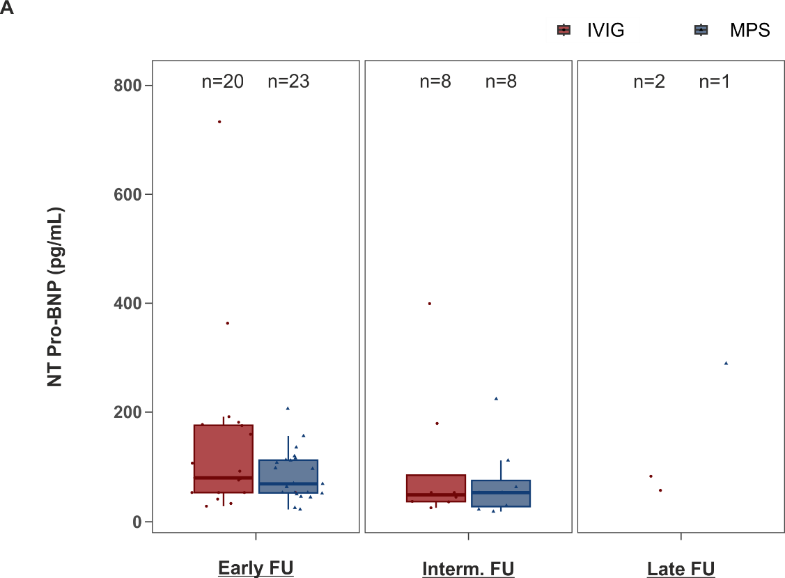
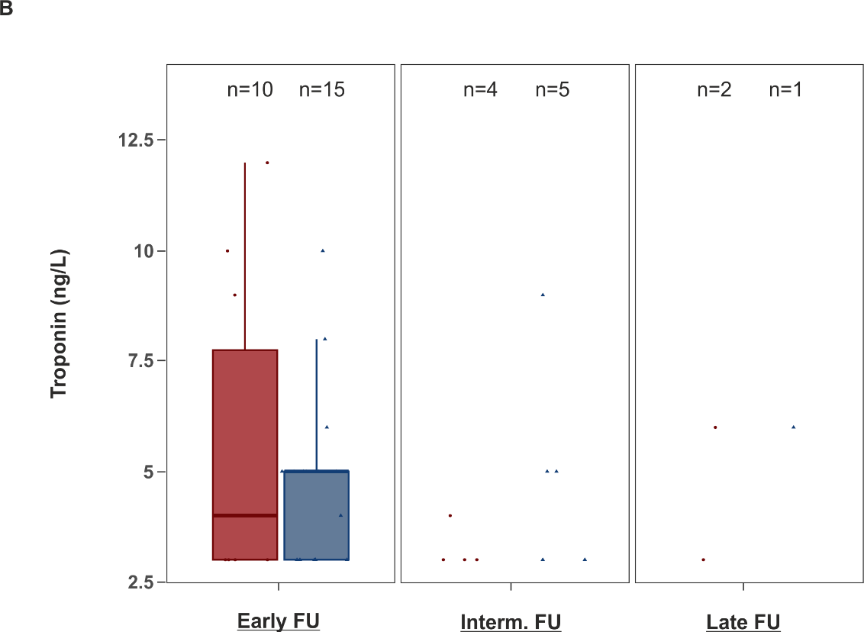

Suppl. Fig. 2.

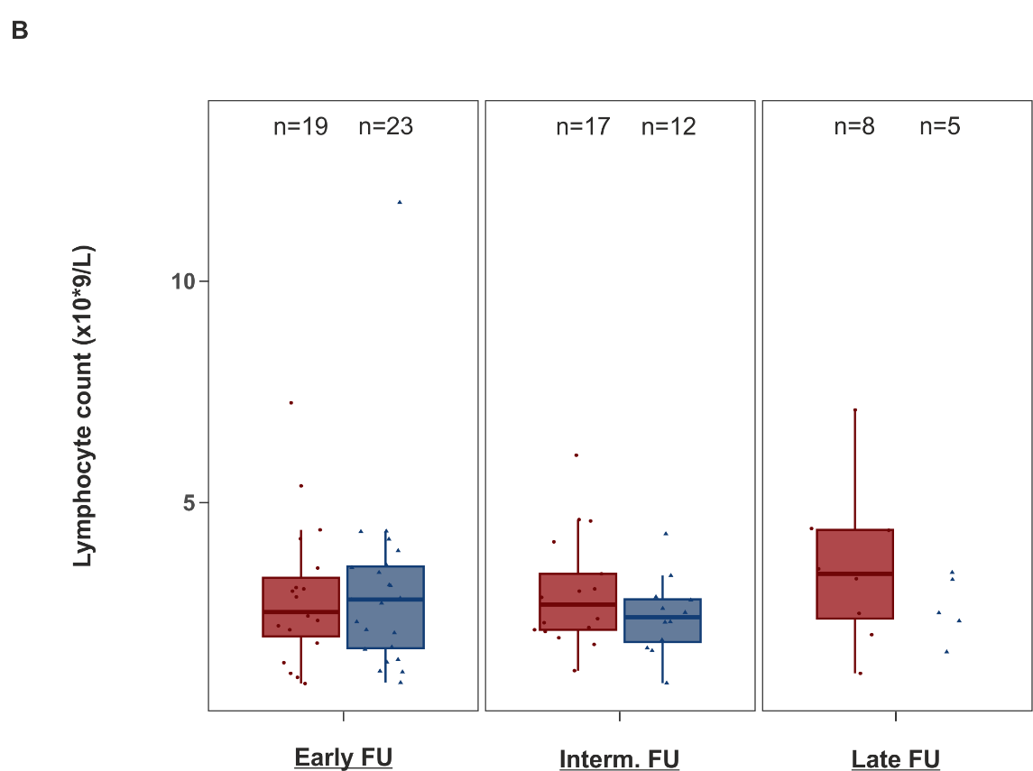
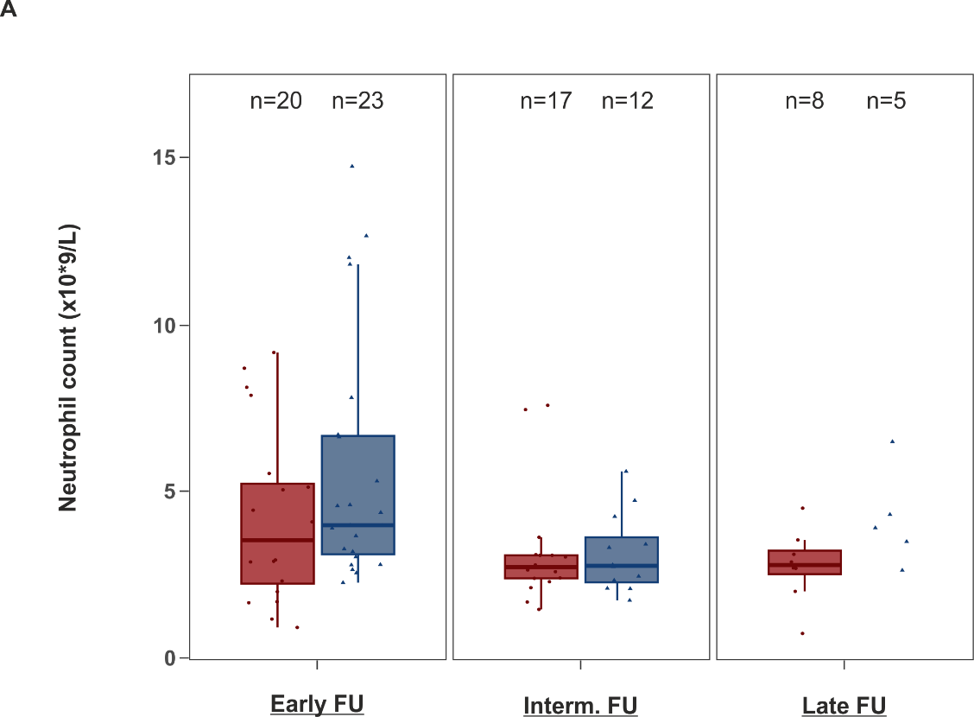

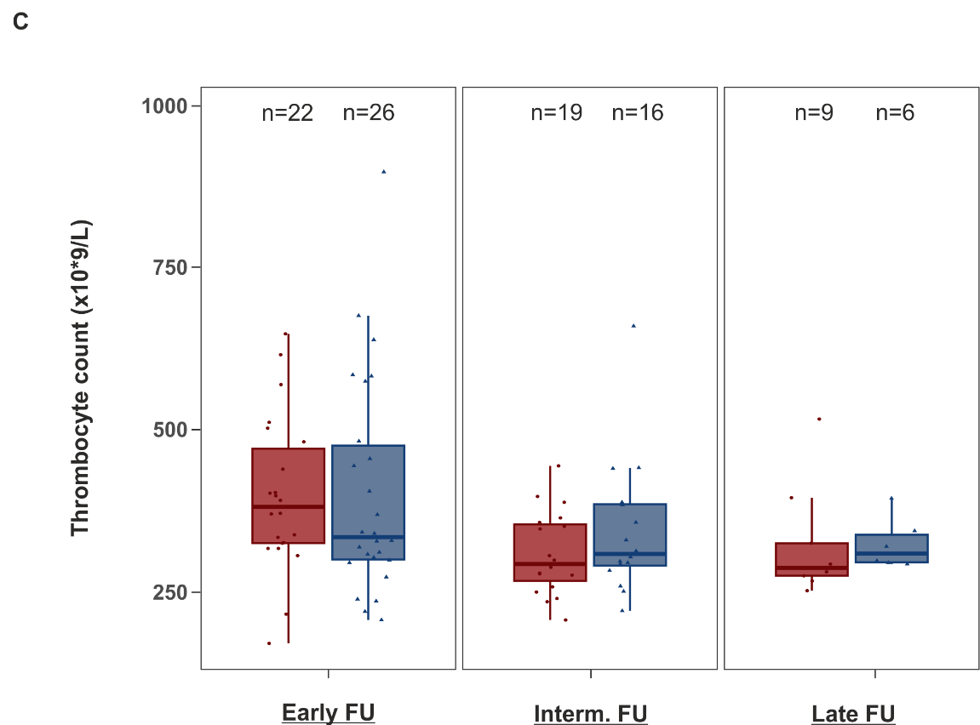

Suppl. Fig. 3.
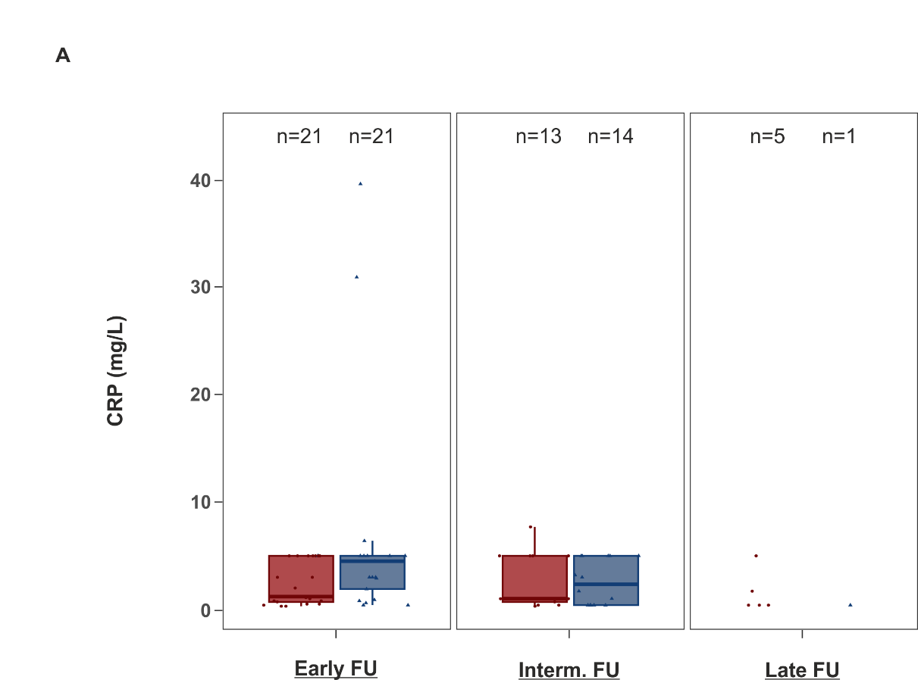
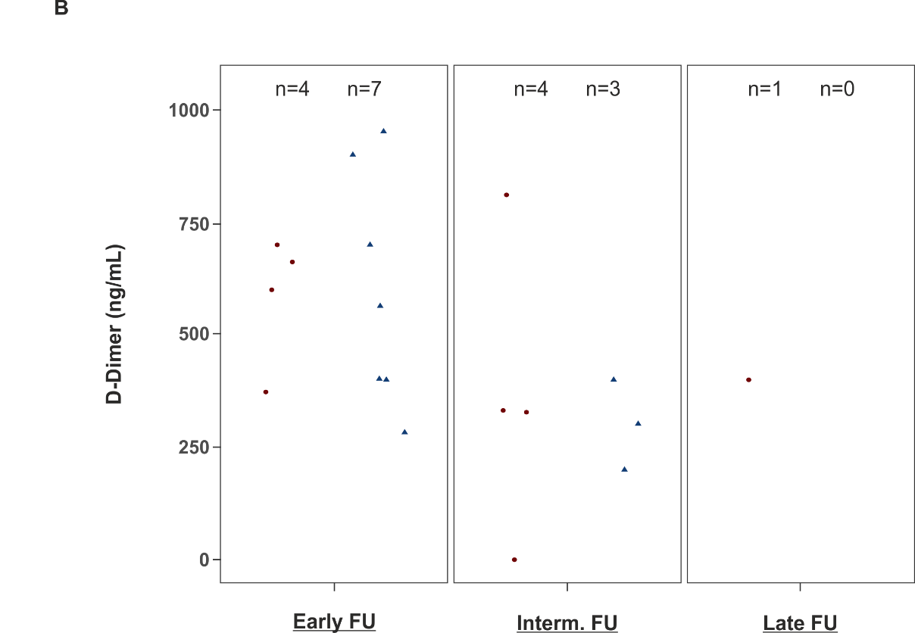

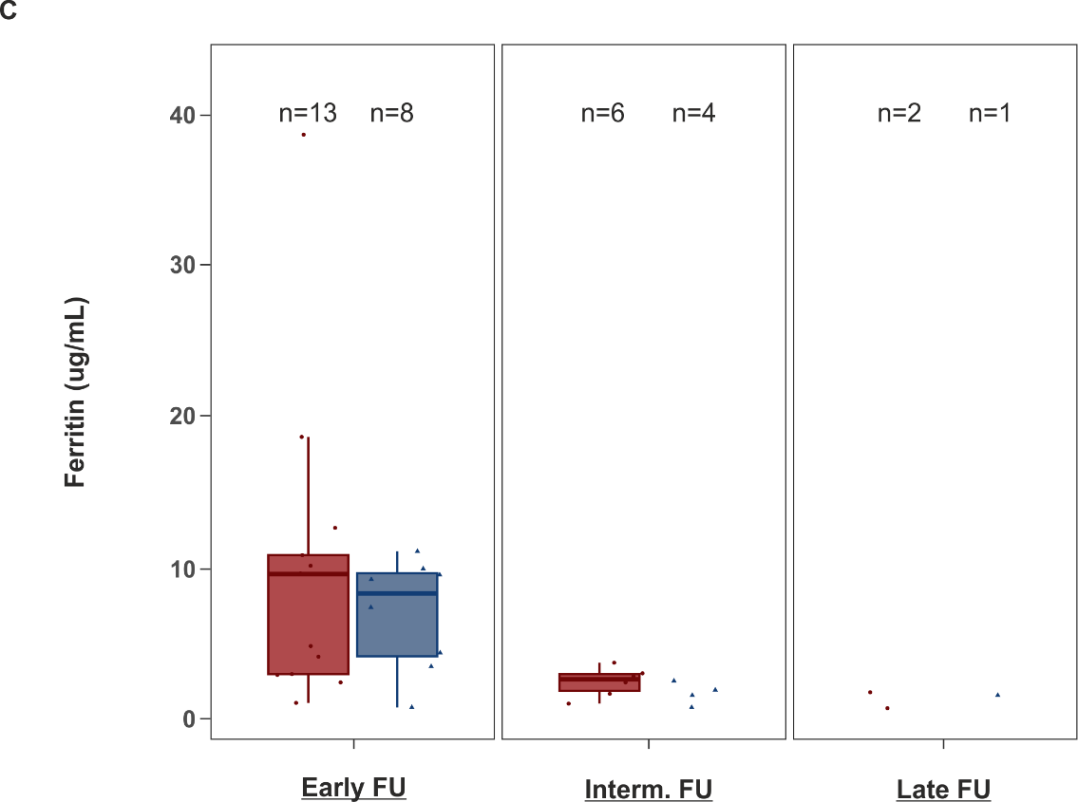

Suppl. Fig. 4.

