Supplementary Data:
S1: List of Antimicrobials and Immunosuppressants included in search
Antimicrobials
Amikacin  Amoxicillin  Amphotericin  Anidulafungin  Azithromycin  Benzylpenicillin  Caspofungin  Cefalexin  Ceftazidime  Ceftriaxone  Cefuroxime  Ciprofloxacin  Clarithromycin | Clindamycin  Co-amoxiclav  Colistin  Co-trimoxazole  Doxycycline  Ertapenem  Erythromycin  Fidaxomicin  Flucloxacillin  Fluconazole  Fosfomycin  Gentamicin  Levofloxacin | Linezolid  Meropenem  Metronidazole  Moxifloxacin  Nitrofurantoin  Piperacillin  Pivmecillinam  Posaconazole  Teicoplanin  Temocillin  Tigecycline  Trimethoprim  Vancomycin  Voriconazole
Immunosuppressants
Dexamethasone
Hydrocortisone
Prednisolone
Methylprednisolone
Tocilizumab

*exposure to immunosuppressant defined as any single dose of tocilizumab or >1 dose of ≥30mg prednisolone or equivalent (≥4.5mg dexamethasone, 120mg hydrocortisone, 24mg methylprednisolone)

S2: Automatic Exclusions for non-significant microbiological cultures according to culture site
Respiratory:
- All Candida spp.
- Coagulase-negative staphylococci
- “Upper respiratory tract flora” where not otherwise specified

Urine:
- “Mixed growth” without a predominant species
- Coagulase-negative staphylococci, except for Staphylococcus saprophyticus

Wound swabs:
- Any isolate other than Staphylococcus aureus, Staphylococcus lugdunensis or beta-haemolytic streptococci, e.g. Group A streptococcus

The above results were automatically deemed non-significant without need for further review. All other positive cultures were included for detailed clinical review to assess for true infection.

S3: Data Collection Methods
Variables of interest | Data source | Method of assessment
COVID-related infections | Laboratory information management system (LIMS); electronic patient records (including clinical notes, laboratory data and radiological images) | Medical review
Other infection variables (species, site) | As above | As above
Antimicrobial Days of Therapy | Electronic prescribing record | Automatic extraction and calculation
Other antimicrobial variables (class, number of courses) | As above | As above
Receipt of high-dose immunosuppression | Electronic prescribing record | Medical review
Demographics (age, gender) and observations (serial oxygen saturations, receipt of supplementary oxygen) | Electronic patient record | Automatic extraction
Clinical data (comorbidities, ICU admission, need for organ support, days of hospital stay, days of follow-up, in-hospital mortality) | Electronic patient record | Manual extraction

S4: Identification of true co- and secondary infections.
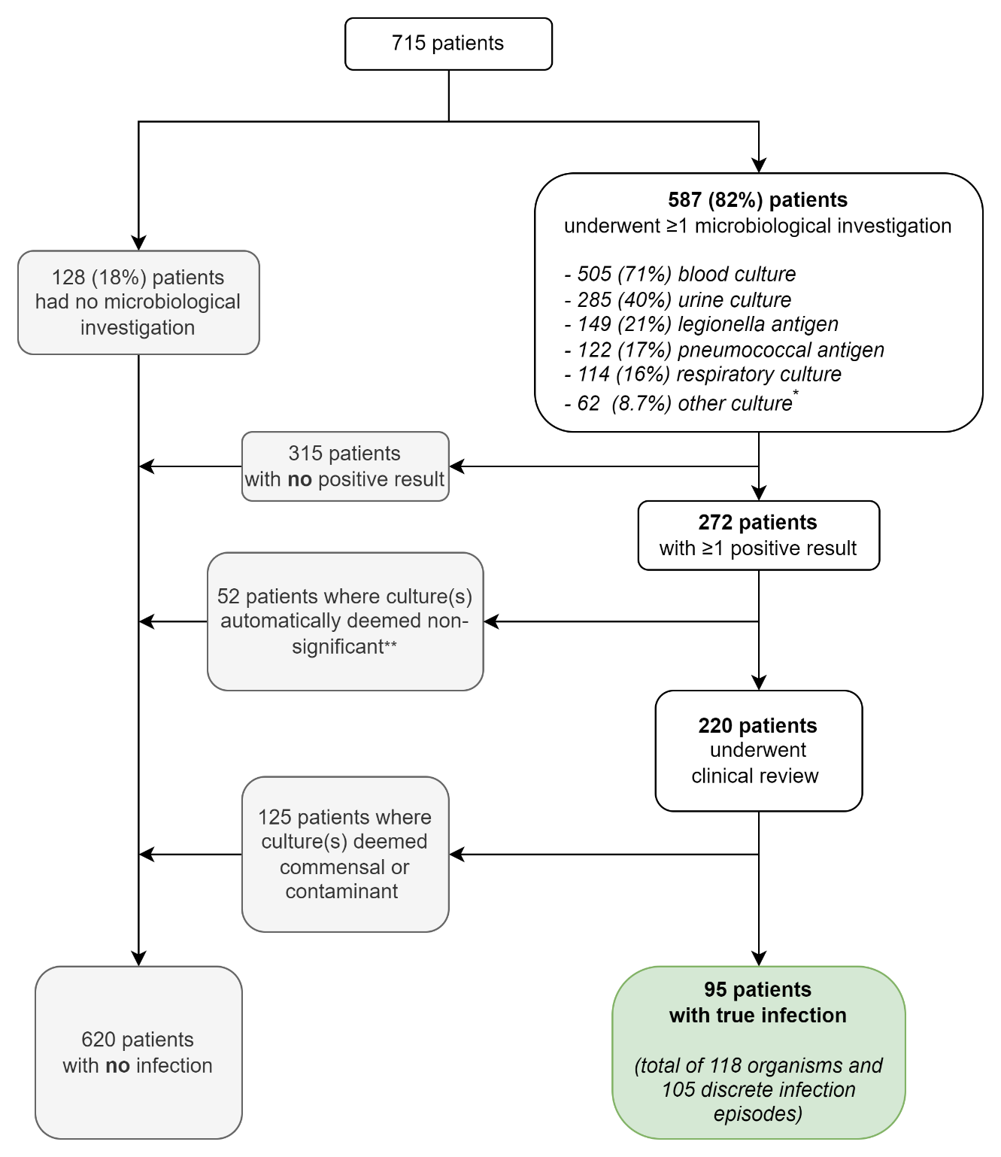
*other cultures (wound swabs, fluid/pus culture, line tip culture) were only recorded where positive so this may be an under-estimate
** see Supplementary Table 3 (S3) for list

