Chronic Abdominal Pain in Inflammatory Bowel Disease; a practical guide

Authors:
Samantha Baillie¹, Christine Norton², Sonia Saxena³ and Richard Pollok¹

(Corresponding authors SB and RP)

Affiliations:
- Department of Gastroenterology, St George's University Hospitals NHS Foundation Trust, London, United Kingdom
- Florence Nightingale Faculty of Nursing, Midwifery and Palliative Care, King’s College London, London, UK
- School of Public Health, Imperial College London, London, UK

Funding Information:
SS is funded by the National Institute for Health Research (NIHR) School for Public Health Research (SPHR) (PD-SPH-2015), NIHR Northwest London Applied Research. Collaboration (ARC) and Imperial NIHR Biomedical Research Centre. The SPHR is a partnership between the Universities of Sheffield, Bristol, Cambridge, Imperial, University College London and the London School for Hygiene and Tropical Medicine (LSHTM); LiLaC—a collaboration between the Universities of Liverpool and Lancaster; and Fuse—the Centre for Translational Research in Public Health a collaboration between Newcastle, Durham, Northumbria, Sunderland and Teesside Universities.
CN received support from a UK National Institute for Health Research programme grant for applied research (grant reference RP-PG-0216-20001)
The views expressed in this publication are those of the authors and not necessarily those of the NHS, the NIHR or Department of Health and Social Care.

Competing Interests:
SB has had speaker arrangements with Takeda and Dr Falk, has received a travel grant from Galapagos and has provided consultancy to Galapagos.
RP has provided consultancy to Galapagos.
CN has received speaker fees from Ferring, AbbVie, Takeda and Tillotts

Abstract:

Pain is common in inflammatory bowel disease (IBD), yet many patients feel their pain is not addressed by health care professionals. Listening to a patient’s concerns about pain, assessing symptoms and acknowledging the impact these have on daily life remain crucial steps in addressing pain in IBD. While acute pain may be effectively controlled by pain medication, chronic pain is more complex and often pharmacological therapies, particularly opioids, are ineffective. Low dose tricyclic antidepressants and psychological approaches, including cognitive behavioural therapy, have shown some promise in offering effective pain management while lifestyle changes such as a trial of low-FODMAP diet in those with overlapping irritable bowel syndrome may also reduce pain. Patients benefit from a long-term, trusting relationship with their health care professional to allow a holistic approach combining pharmacological, psychological, lifestyle and dietary approaches to chronic pain. We present a practical review to facilitate management of chronic abdominal pain in IBD.

Title: Chronic Pain in Inflammatory Bowel Disease; a practical guide

“it’s all about the bowel movements. It’s all about how often you go to the loo. … I don’t think they focus on the pain so much.” (1)

Introduction
The majority of individuals with IBD experience pain regularly(2,3) and this has a negative impact on daily activities(4) whilst being associated with a poorer quality of life.(3,5) Pain management approaches frequently focus on reducing inflammation yet, a third of individuals continue to experience pain despite mucosal healing(6,7) and pain often persists despite “clinical remission”.(8) Furthermore, many pain medications such as opioids are ineffective for pain arising from the gut and for chronic pain lasting more than 3 months. Qualitative studies indicate that individuals with IBD pain can feel discredited, misunderstood and/or frustrated that lack of knowledge amongst clinicians leads to pain being insufficiently managed(1,9) while long-term, trusting patient-clinician relationships with regular review of pain were valued by patients.(10) In this practical guide, we describe the pathophysiology of chronic abdominal pain in IBD, outline pharmacological, psychological, dietary and lifestyle approaches to management.

Key points:

Aim to create a long-term, trusting relationship with patients to allow an individualised, patient-specific, holistic approach to chronic pain management

Ensure that modifiable causes for pain have been assessed, investigated and treated

Treating co-existing IBS may help to manage chronic IBD pain. This includes antispasmodics, FODMAP diet and tricyclic antidepressant medication

Avoid opioid medication as this has no proven benefit and is associated with poorer outcomes

Psychological therapies including cognitive behavioural therapy can improve pain as well as improving quality of life
Pathophysiology of Chronic Pain in IBD
A recent international consensus defines pain as “an unpleasant sensory and emotional experience associated with, or resembling that associated with, actual or potential tissue damage”.(11) Acute pain may prevent harm by initiating withdrawal from danger however, this definition acknowledges that pain often exists in the absence of tissue damage and in the presence of normal investigations. Chronic pain is a subjective experience unique to each individual and influenced by peripheral, central, environmental and psychosocial factors, all of which must be considered to understand and improve the individual’s experience (Figure 1).
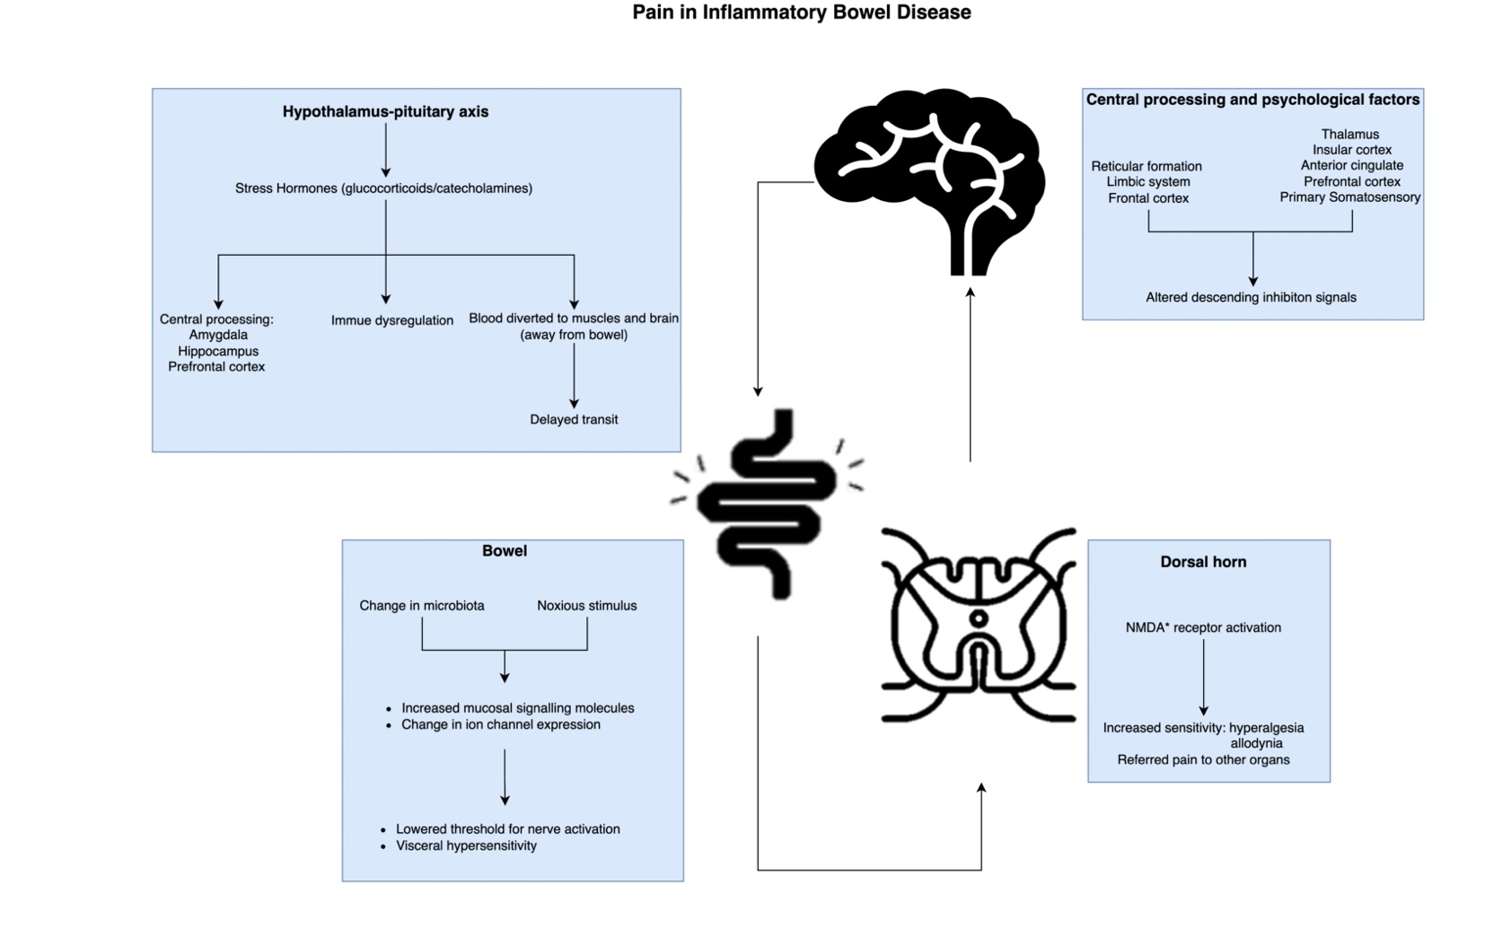
Pathophysiology: Viscera
Noxious stimuli in the intestine activate pain receptors; chemoreceptors are triggered by inflammatory mediators while mechanoreceptors are triggered by bowel distention. Bowel distention may occur because of strictures, adhesions, or luminal gas. Chronic inflammation results in visceral hypersensitivity by increasing mucosal signalling molecules, changing ion channel expression and lowering the threshold for nerve activation.(12,13)

Pathophysiology: Dorsal Horn
Impulses are transmitted via nerves to the spinal cord where they synapse on second order nerves in the dorsal horn ganglia. Visceral inflammation has been shown to increase nerve excitability at this level via changes to the N-methyl-D-aspartate (NMDA) receptor and this is associated with hypersensitivity.(13,14)

Pathophysiology: Hypothalamus Pituitary Axis (HPA)
Pain can result in activation of the HPA stress pathway, leading to glucocorticoid and catecholamine hormone production. These hormones act centrally to determine the emotional response to pain by integrating past experiences. Previous or current stress results in a heightened perception of pain, as shown on functional brain imaging.(15) Stress also activates the autonomic nervous system which increases blood pressure and diverts blood away from the gastrointestinal (GI) tract towards the brain and muscles. This can result in delayed gut transit and abdominal discomfort.(16) Finally, stress hormones modify immune function through cytokine production, which can lead to painful disease flares.(13)

Pathophysiology: Central Processing
Pain signals travel via nerves in the spinal cord to the thalamus and reticular formation before being processed in the cerebral cortex. This processing may be affected by IBD, even in remission, Crohn’s disease (CD) patients had decreased grey matter volumes in areas of the brain involved with processing pain sensation when compared to controls, a finding also noted in other chronic pain syndromes.(17)

Pathophysiology: Psychological factors
Emotional and cognitive processes can reduce pain inhibition signals travelling from the brain to the gut, resulting in gut hypersensitivity and persistent abdominal pain.(12,18) Additionally, psychological stress has been associated with altered gut microbiota(19) which leads to pain via altered intestinal cytokines and bowel distention. Inflammation and physical processes often initiate pain, but chronic pain may be maintained by psychological factors such as mood disorders, “perceived stress” and “pain-catastrophising”, all of which were associated with increased IBD pain in a systematic review.(20)

Co-existent Irritable Bowel Syndrome (IBS)
A common source of pain in IBD is co-existent IBS, a disorder of gut-brain interaction, which affects around a third of individuals with IBD(21) and is 2-3 times more common in IBD patients in remission than in the general population.(22) Chronic IBD pain and IBS share common pathophysiological features, and it is likely that there is an overlap between the two processes including low grade mucosal inflammation, neuro-immune interactions,(22,23) and alterations in the gut microbiota.(13,23) Additionally, there is a high prevalence of anxiety and depression in individuals with IBD(24) and those with anxiety and depression are more likely to experience IBS symptoms.(22)
Thus IBS-IBD overlap may explain why many past, current and proposed treatments for chronic IBD pain are those that may also improve IBS symptoms. It should however, be noted that a qualitative study reported that many IBD patients find the label of IBS unhelpful.(25)

Managing chronic abdominal pain in IBD
Cochrane reviews of randomised pain intervention studies for UC and CD had very low certainty of evidence due to small numbers as well as heterogeneity amongst studies and risk of bias(26,27) and further high-quality research is needed to improve both pharmacological and non-pharmacological approaches.(28) Here we present a summary of the data available for managing chronic IBD-related abdominal pain interventions, as well as a checklist for assessing chronic pain in IBD (Supplementary Information 1). In this review we discuss CD and UC together under the umbrella of “IBD”, firstly because IBD chronic pain literature does not differentiate between the diseases (or has similar outcomes for both CD and UC) and secondly, because a similar prevalence of pain is reported in 4176 CD and 4255 UC individuals in the IBD BOOST study (17% UC vs 25% CD) and in quiescent CD and UC (60.2% vs. 62.5% respectively).(29,30) Holistic management of chronic pain is paramount, addressing pharmacological, psychological and lifestyle approaches (Figure 2).
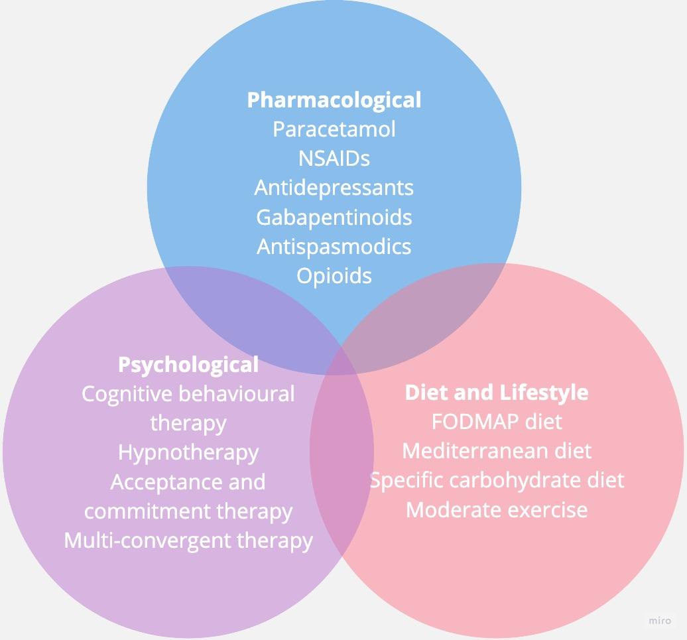
Managing chronic abdominal pain in IBD: modifiable causes for abdominal pain
To manage pain, modifiable causes should be identified and treated (see Figure 3). If an individual reports feeling pain despite having no evidence of a disease flare it is important to rule out the causes below.(31)
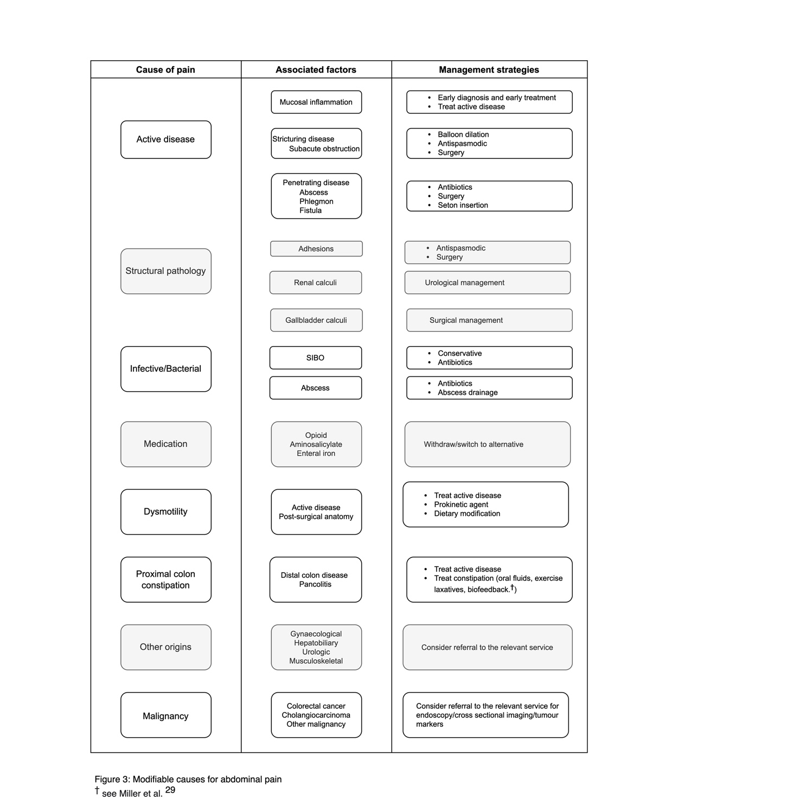
Managing chronic abdominal pain in IBD: pharmacological approaches
Non-Steroidal Anti-Inflammatory Drugs (NSAIDs)
Non visceral inflammatory pain typically responds well to NSAIDs and NSAID use can alleviate pain associated with axial and peripheral arthropathies that occur in IBD. However, many clinicians are wary of NSAIDs due to perceived risk of IBD flares(32), although a recent systematic review including 2 RCTs demonstrated no statistically significant increase in the risk of disease flares(33) and, where increased risk has been demonstrated, it appears to be highest in ileal CD,(33) with frequent use (more than 5 times per month)(34) and with COX-1 inhibitors.(33)
Key message: NSAIDs have a role in pain control in select IBD patients, particularly in the context of extraintestinal musculoskeletal symptoms however, caution should be exercised regarding the risk of disease flares; selective COX-2 inhibitors may be preferable to minimise this risk.

Antispasmodics
There are no studies directly reviewing the use of antispasmodics in IBD and most data relate to their use in IBS. As outlined above, IBS commonly coexists alongside IBD and the American Gastroenterological Association advise antispasmodics for IBD patients with IBS/functional symptoms.(35) Systematic reviews, including a network meta-analysis of IBS RCTs, have demonstrated that antispasmodic drugs and peppermint oil are significantly more efficacious than placebo at 4 to 12 weeks.(36) Caution must be exercised in patients with risk of obstruction as anticholinergic effects may mask or exacerbate symptoms.
Key message: Antispasmodics provide symptom control for IBS, however, consider the risk of side effects, including constipation, prior to use in IBD.

Opioids
Opioids are very effective in treating acute pain, or pain caused by cancer. However, for chronic pain there is limited evidence of any benefit and for IBD patients, opioids do not improve pain or quality-of-life scores and reduced hospital opioid prescribing does not worsen pain scores.(37–39),
Instead, long term opioid use may be associated with increased pain and side effects including constipation, nausea, vomiting, immunosuppression, sexual dysfunction, addiction, sedation and respiratory depression.(40–44) Regular use of strong opioids in IBD has been associated with a 2-fold increase in premature mortality(45) and is a predictor for serious infection.(46)
Opioids are frequently prescribed to manage co-existing musculoskeletal and rheumatological complaints,(47) despite there being no proven benefit of chronic opioid use above simple analgesia in these conditions(48) and The National Institute for Health and Care Excellence (NICE) guidelines do not recommend the use of opioids in musculoskeletal symptom control.(49–51) Likewise, the British Society of Gastroenterology (BSG) guidelines discourage opioid use in IBD(52) and the Faculty of Pain Medicine advises against the use of opioids for chronic pain beyond 2-4 weeks of modest doses.(41)

Atypical Opioids
Partial opioid receptor agonists such as buprenorphine offer analgesic effects with reduced withdrawal effects, less dysphoria and an improved safety profile compared to regular opioids. However, there remain long term side effect and dependence risks.(53) Naltrexone antagonises opioid receptors, yet at low doses it has paradoxical analgesic effects. Small studies have shown benefit in pain control in IBD with a favourable side effect profile compared to regular opioids, but this requires further evaluation.(54) Loperamide and diphenoxylate, which do not readily cross the blood-brain barrier, exploit the anti-diarrhoeal and anti-secretory effects of opioids and animal models have indicated that loperamide may also reduce pain via blockade of sodium channels.(55) Significant improvement in IBD abdominal pain was seen in individuals treated with loperamide for 1 week compared to placebo.(56)
Key message: Avoid opioid prescribing for chronic pain in IBD. Where opioid prescribing is unavoidable this should be a joint decision with the patient to trial a modest dose over 2-4 weeks with counselling that those who do not achieve useful pain relief within this period are unlikely to gain benefit in the long term.²⁶ See Opioid Aware https://www.fpm.ac.uk/opioids-aware for further guidance.

Antidepressant medications (ADM)
Antidepressant medications, such as tricyclic antidepressants, selective serotonin reuptake inhibitors and selective noradrenaline reuptake inhibitors regulate the neurotransmitters serotonin, norepinephrine and corticotropin-releasing factor to alter gut motility and modulate signals between the gut and the brain resulting in an overall reduction in pain.(57) These medications may also improve pain by treating co-existent IBS and it has been suggested that ADMs could modify IBD activity, but a systematic review found the evidence inconclusive in this regard.(58)
Tricyclic antidepressants (TCAs)
Certain TCAs, including Amitriptyline and Nortriptyline, are licensed in the UK to treat neuropathic pain and are used off-licence for abdominal pain not responding to first line treatment.(59) TCAs are also used to treat depression but the dosage for pain is much lower. In a retrospective cohort study of TCA use in patients with mild or inactive IBD, 85.2% of whom had abdominal pain, there was a moderate improvement in global well-being scores. The Improvement was similar to that seen in IBS treated with TCAs and pain scores were not recorded.(60) A systematic review of IBS treatment showed that low dose TCA treatment had a lower relative risk of abdominal pain compared to placebo.(61) Side effects of TCAs include sedation, overdose toxicity, cardiotoxic effects and anticholinergic effects. Constipation may be beneficial in individuals for whom diarrhoea is an issue, while taking doses at night can utilise TCA’s sedative effect.

Selective serotonin reuptake inhibitors (SSRIs) and selective noradrenaline reuptake inhibitors (SNRIs).

Few studies have examined the effect of SSRIs/SNRIs on pain in IBD and those that have generally show little benefit.(62–64)

Two systematic reviews of ADMs in IBS showed no significant effect of SSRIs on abdominal pain. (36,61) The side effects of SSRIs and SNRIs include agitation, insomnia, sexual dysfunction, nausea and diarrhoea and these must be taken into account when considering their use, particularly in individuals troubled by increased stool frequency.(57)
Key message: Low dose TCAs may help manage pain in IBD and co-existent IBS. There is little evidence for the benefit of SSRIs or SNRIs.

Gabapentinoids
The gabapentinoids Gabapentin and Pregabalin are analogues of gamma-aminobutyric acid (GABA) with anticonvulsant, central, and possibly peripheral, analgesic actions. Anti-inflammatory properties of gabapentinoids have been demonstrated in animal models and may represent another mode of action by which pain in IBD can be altered.(65)
The impact of gabapentinoids on IBD pain has not been directly studied, instead benefit has been extrapolated from trials in chronic pancreatitis, oesophageal hyperalgesia and rectal sensitivity.
For IBS patients with rectal hypersensitivity, pregabalin increased distension sensory thresholds to normal levels(66) and gabapentin significantly increased threshold pressures for bloating, discomfort and pain in IBS with diarrhoea.(66,67) For chronic pancreatitis, pregabalin treatment significantly improved pain relief when compared to placebo(68) and pregabalin prevented proximal oesophageal hyperalgesia following oesophageal acidification.(69)
The substantial side effect profile includes somnolence, GI upset and risk of dependency. Somewhat controversially, NICE do not recommend their use for the treatment of chronic pain. (70)
Key message: Gabapentinoids may improve chronic visceral pain however more evidence is required in IBD. Their side effects and the risk of dependency need to be considered carefully.

Cannabinoids
The human endocannabinoid system (ECS) is a neuromodulatory system which responds to both endogenous and exogenous cannabinoids, such as Δ⁹-tetrahydrocannbinol (THC) and cannabidiol (CBD). Cannabinoid receptors are found in the GI tract as well as the central nervous system and the ECS has a role in modulating pain sensation. Observational cohort data indicates that 17.6% of IBD patients regularly use cannabis and 83.9% of users felt cannabis improved their abdominal pain.(71) Two small studies have shown improved IBD clinical scores in individuals smoking or inhaling cannabis (72,73) however, follow up was short and abdominal pain was not specifically evaluated.
Regression analysis linked prolonged cannabis use with an increased risk of surgery after adjusting for tobacco smoking and demographic status.(71)
Key message: Medical cannabis is not approved for use in IBD and there is currently no evidence of its benefit in treating IBD-related abdominal pain.

Managing chronic abdominal pain in IBD: psychological approaches
A recent systematic review reported six studies using behavioural therapies to manage IBD-related pain and included individuals who were predominantly in remission.(74) The review concluded that relaxation techniques and changing cognitions show promise but in view of the scarcity of evidence, further research is warranted. The IBD-BOOST study explores a tailored, online, facilitated cognitive behavioural intervention for symptom control.(29) Of all 8486 patients included in the initial survey, 42% report wanting support for pain management and the results of the randomised controlled trial (RCT) of a facilitated online behavioural therapy intervention are keenly awaited; potentially offering a pragmatic approach to chronic pain management in IBD. A small cohort study demonstrated a significant reduction in abdominal pain in stress management groups compared to those without stress management although there was no adjustment for IBD activity.(75) A study of 20 patients allocated to relaxation training had significantly lower pain scores than a group of 20 allocated to attention control(76) and relaxation techniques improved pain in IBD patients randomised to intervention compared to waiting list controls.(77) Studies of adolescent and paediatric participants have shown improved pain scores through cognitive behavioural therapy (CBT) and coping skills however the results are not widely representative with two studies including only adolescent females, another only those with anxiety disorder, and the effect of high attrition rates were noted.(78–81) IBD-specific CBT improved quality of life and decreased anxiety and depression in IBD patients with poor quality of life.(82) Acceptance and commitment therapy (ACT) and multi-convergent therapy improve several outcomes in IBD including quality of life but the impact on pain has not been specifically assessed.(83,84)
With regards to the impact of behavioural therapies on IBS, a recent systematic review demonstrated that CBT and gut-directed hypnotherapy had the most evidence for efficacy however, there was a high risk of bias.(85) An RCT of 431 adults with functional bowel disorders showed that CBT was significantly more effective than education in improving quality of life despite having little effect on pain, and may enable an improved ability to live with pain.(86)
A systematic review of the use of mindfulness for pain control concluded that existing evidence was limited and inconclusive(87). An IBD specific review showed no effect on symptoms, although mindfulness did improve quality of life.(88) While overall IBS symptoms can be significantly improved long term with hypnotherapy, no studies in IBD-related pain have been conducted.(89) One study has shown that individuals with UC in remission randomised to gut directed hypnotherapy had clinical relapse 78 days later than those randomised to attention control alone, however pain was not directly assessed and there was no difference in quality of life.(90)
Key message: There is some limited evidence regarding psychological approaches in IBD-related pain with CBT improving overall quality of life, coping mechanisms and pain.

Diet and lifestyle approaches
The low-FODMAP diet contains low levels of fermentable oligosaccharides, disaccharides, monosaccharides, and polyols. These carbohydrates are poorly absorbed in the small intestine, are highly osmotic, and are rapidly fermented by bacteria in the gut. This leads to fluid and gas distention of the bowel which may result in symptoms such as bloating, flatulence, cramping, and diarrhoea. A diet reduced in FODMAPs, followed by FODMAP reintroduction, is well-recognised as an effective approach to managing abdominal pain in IBS (91) and its role in reducing abdominal pain in IBD was supported in a recent systematic review.(92,93) An additional 2 studies indicate significantly more patients with IBS symptoms and quiescent IBD had resolved or improved abdominal pain, after 6-8 weeks of low-FODMAP diet.(94,95) Low-FODMAP diets are low in fibre and may lead to constipation; compliance may be challenging due to the diet’s restrictive nature and it has been linked to a reduction in total bacteria and butyrate-producing bacteria, which are important for anti-inflammatory and immune regulatory functions.(92) It is therefore important that the food reintroduction phase of the diet is followed, under the supervision of a dietician.
A comparison of the specific carbohydrate diet (SCD) and Mediterranean diet (MD) in IBD found that both improved abdominal pain at week 6 but, while the SCD may lead to deficiencies in key vitamins, a MD is generally easy to follow.(96) Many individuals with IBD follow a gluten free diet (GFD) in the absence of coeliac disease. A recent systematic review and meta-analysis of dietary interventions for induction and maintenance of remission in IBD reported mixed findings; one study showed that symptoms, including pain, improved in two-thirds of individuals while a prospective study found no variation in hospitalisations or flares but a poorer quality of life in those with GFD.(97) Further research is needed in this area.(98)
Moderate exercise can improve quality of life in IBD and improve GI symptoms in IBS however, the effect on pain in IBD has not been studied.(35)
Key message: The FODMAP diet offers short term benefit to those with co-existent IBS and is best carried out for a time limited period, under the supervision of a dietician.

Conclusion
Managing chronic pain in IBD continues to be a challenge for clinicians and patients alike. By listening to patients, acknowledging their symptoms and assessing pain with pain severity scales we can begin to manage chronic pain effectively. Few research studies focus specifically on pain in IBD and assessment of specific interventions to improve pain outcomes are badly needed. A collaborative approach between clinician and patient, reviewing disease activity, psychosocial factors, current medications and comorbidities must be undertaken to achieve optimal symptom control.
Early diagnosis and suppression of inflammation may prevent irreversible central and peripheral changes that contribute to chronic pain. Considering the poor efficacy and side effect profile of many pharmacological agents, notably opioids, the management of chronic pain in IBD should largely comprise non-pharmacological approaches. Psychological approaches have shown promise and further research is needed. In the future, integrated psychological and pain services need to be part of a holistic approach to caring for individuals with IBD (Figure 2).
Contributor Statement:
SB researched, drafted and revised the article. RP researched and edited the draft article. SS and CN reviewed and edited the draft article.
Ethics:
No ethics approval required.

References

1. Sweeney L, Moss-Morris R, Czuber-Dochan W, Belotti L, Kabeli Z, Norton C. ‘It’s about willpower in the end. You’ve got to keep going’: a qualitative study exploring the experience of pain in inflammatory bowel disease. Br J Pain. 2019 Nov 1;13(4):201–13.
2. Schirbel A, Reichert A, Roll S, Baumgart DC, Büning C, Wittig B, et al. Impact of pain on health-related quality of life in patients with inflammatory bowel disease. World J Gastroenterol. 2010 Jul 7;16(25):3168–77.
3. Zeitz J, Ak M, Müller-Mottet S, Scharl S, Biedermann L, Fournier N, et al. Pain in IBD Patients: Very Frequent and Frequently Insufficiently Taken into Account. PLOS ONE. 2016 Jun 22;11(6):e0156666.
4. Devlen J, Beusterien K, Yen L, Ahmed A, Cheifetz AS, Moss AC. The Burden of Inflammatory Bowel Disease: A Patient-reported Qualitative Analysis and Development of a Conceptual Model. Inflamm Bowel Dis. 2014 Mar 1;20(3):545–52.
5. Lönnfors S, Vermeire S, Avedano L. IBD and health-related quality of life — Discovering the true impact ✩. J Crohns Colitis. 2014 Oct 1;8(10):1281–6.
6. Shah SC, Colombel JF, Sands BE, Narula N. Systematic review with meta-analysis: mucosal healing is associated with improved long-term outcomes in Crohn’s disease. Aliment Pharmacol Ther. 2016 Feb 1;43(3):317–33.
7. Shah SC, Colombel JF, Sands BE, Narula N. Mucosal Healing Is Associated With Improved Long-term Outcomes of Patients With Ulcerative Colitis: A Systematic Review and Meta-analysis. Clin Gastroenterol Hepatol. 2016 Sep 1;14(9):1245-1255.e8.
8. Colombel JF, Sandborn WJ, Reinisch W, Mantzaris GJ, Kornbluth A, Rachmilewitz D, et al. Infliximab, Azathioprine, or Combination Therapy for Crohn’s Disease. N Engl J Med. 2010 Apr 15;362(15):1383–95.
9. Bernhofer EI, Masina VM, Sorrell J, Modic MB. The Pain Experience of Patients Hospitalized With Inflammatory Bowel Disease: A Phenomenological Study. Gastroenterol Nurs [Internet]. 2017;40(3). Available from: https://journals.lww.com/gastroenterologynursing/Fulltext/2017/05000/The_Pain_Experience_of_Patients_Hospitalized_With.2.aspx
10. Balbale SN, Iroz CB, Schäfer WLA, Johnson JK, Stulberg JJ. A Missing Piece of the Puzzle: Patient and Provider Perspectives on Pain Management Needs and Opioid Prescribing in Inflammatory Bowel Disease Care. Crohns Colitis 360. 2022 Jul 1;4(3):otac033.
11. Raja SN, Carr DB, Cohen M, Finnerup NB, Flor H, Gibson S, et al. The revised International Association for the Study of Pain definition of pain: concepts, challenges, and compromises. PAIN [Internet]. 2020;161(9). Available from: https://journals.lww.com/pain/Fulltext/2020/09000/The_revised_International_Association_for_the.6.aspx
12. Zielińska A, Sałaga M, Włodarczyk M, Fichna J. Focus on current and future management possibilities in inflammatory bowel disease-related chronic pain. Int J Colorectal Dis. 2018/12/19 ed. 2019 Feb;34(2):217–27.
13. Srinath A, Young E, Szigethy E. Pain Management in Patients with Inflammatory Bowel Disease: Translational Approaches from Bench to Bedside. Inflamm Bowel Dis. 2014 Dec 1;20(12):2433–49.
14. Willert RP, Woolf CJ, Hobson AR, Delaney C, Thompson DG, Aziz Q. The development and maintenance of human visceral pain hypersensitivity is dependent on the N-methyl-d-aspartate receptor. Gastroenterology. 2004 Mar 1;126(3):683–92.
15. Wong RK, Van Oudenhove L, Li X, Cao Y, Ho KY, Wilder-Smith CH. Visceral pain perception in patients with irritable bowel syndrome and healthy volunteers is affected by the MRI scanner environment. United Eur Gastroenterol J. 2015/04/09 ed. 2016 Feb;4(1):132–41.
16. Abdallah CG, Geha P. Chronic Pain and Chronic Stress: Two Sides of the Same Coin? Chronic Stress Thousand Oaks Calif. 2017/06/08 ed. 2017 Feb;1:2470547017704763.
17. Agostini A, Benuzzi F, Filippini N, Bertani A, Scarcelli A, Farinelli V, et al. New insights into the brain involvement in patients with Crohn’s disease: a voxel-based morphometry study. Neurogastroenterol Motil. 2013 Feb 1;25(2):147-e82.
18. Hurtado-Lorenzo A, Honig G, Weaver SA, Larkin PB, Heller C. Chronic Abdominal Pain in IBD Research Initiative: Unraveling Biological Mechanisms and Patient Heterogeneity to Personalize Treatment and Improve Clinical Outcomes. Crohns Colitis 360. 2021 Jul 1;3(3):otab034.
19. Simpson CA, Diaz-Arteche C, Eliby D, Schwartz OS, Simmons JG, Cowan CSM. The gut microbiota in anxiety and depression – A systematic review. Clin Psychol Rev. 2021 Feb 1;83:101943.
20. Sweeney L, Moss-Morris R, Czuber-Dochan W, Meade L, Chumbley G, Norton C. Systematic review: psychosocial factors associated with pain in inflammatory bowel disease. Aliment Pharmacol Ther. 2018 Mar;47(6):715–29.
21. Fairbrass KM, Costantino SJ, Gracie DJ, Ford AC. Prevalence of irritable bowel syndrome-type symptoms in patients with inflammatory bowel disease in remission: a systematic review and meta-analysis. Lancet Gastroenterol Hepatol. 2020 Dec;5(12):1053–62.
22. Simrén M, Axelsson J, Gillberg R, Abrahamsson H, Svedlund J, Björnsson ES. Quality of life in inflammatory bowel disease in remission: the impact of IBS-like symptoms and associated psychological factors. Am J Gastroenterol. 2002 Feb;97(2):389–96.
23. Ohman L, Simrén M. Pathogenesis of IBS: role of inflammation, immunity and neuroimmune interactions. Nat Rev Gastroenterol Hepatol. 2010 Mar;7(3):163–73.
24. Jayasooriya N, Blackwell J, Saxena S, Bottle A, Petersen I, Creese H, et al. Antidepressant medication use in Inflammatory Bowel Disease: a nationally representative population-based study. Aliment Pharmacol Ther [Internet]. 2022 Mar 4 [cited 2022 Mar 16];n/a(n/a). Available from: https://doi.org/10.1111/apt.16820
25. Huisman D, Sweeney L, Bannister K, Moss-Morris R. Irritable bowel syndrome in inflammatory bowel disease: Distinct, intertwined, or unhelpful? Views and experiences of patients. Cogent Psychol. 2022 Dec 31;9(1):2050063.
26. Sinopoulou V, Gordon M, Akobeng A, Gasparetto M, Sammaan M, Vasiliou J, et al. Interventions for the management of abdominal pain in Crohn’s disease and inflammatory bowel disease. Cochrane Database Syst Rev [Internet]. 2021;(11). Available from: https://doi.org//10.1002/14651858.CD013531.pub2
27. Sinopoulou V, Gordon M, Dovey TM, Akobeng AK. Interventions for the management of abdominal pain in ulcerative colitis. Cochrane Database Syst Rev. 2021 Jul 22;7(7):CD013589.
28. Inflammatory Bowel Disease Priority Setting Partnership. Inflammatory Bowel Disease Top Ten [Internet]. James Lind Alliance; 2015 Feb [cited 2022 Oct 24]. (James Lind Alliance Priority Setting Partnerships). Available from: https://www.jla.nihr.ac.uk/priority-setting-partnerships/inflammatory-bowel-disease/top-10-priorities/
29. Hart A, Miller L, Hamborg T, Stagg I, McGuinness S, Wileman V, et al. DOP59 What is the relationship between fatigue, pain and urgency in people with inflammatory bowel disease? Results of the IBD-BOOST survey in 8486 participants. J Crohns Colitis. 2023 Jan 30;17(Supplement_1):i130–2.
30. Coates MD, Johri A, Gorrepati VS, Maheshwari P, Dalessio S, Walter V, et al. Abdominal pain in quiescent inflammatory bowel disease. Int J Colorectal Dis. 2021 Jan;36(1):93–102.
31. Charles Miller, Anton Emmanuel, Natalia Zarate-Lopez, Stuart Taylor, Stuart Bloom. Constipation in ulcerative colitis: pathophysiology and practical management. Frontline Gastroenterol. 2021 Nov 1;12(6):493.
32. Takeuchi K, Smale S, Premchand P, Maiden L, Sherwood R, Thjodleifsson B, et al. Prevalence and Mechanism of Nonsteroidal Anti-Inflammatory Drug–Induced Clinical Relapse in Patients With Inflammatory Bowel Disease. Clin Gastroenterol Hepatol. 2006 Feb 1;4(2):196–202.
33. Moninuola OO, Milligan W, Lochhead P, Khalili H. Systematic review with meta-analysis: association between acetaminophen and nonsteroidal anti-inflammatory drugs (NSAIDs) and risk of Crohn’s disease and ulcerative colitis exacerbation. Aliment Pharmacol Ther. 2018/04/05 ed. 2018 Jun;47(11):1428–39.
34. Long MD, Kappelman MD, Martin CF, Chen W, Anton K, Sandler RS. Role of Nonsteroidal Anti-Inflammatory Drugs in Exacerbations of Inflammatory Bowel Disease. J Clin Gastroenterol. 2016 Feb;50(2):152–6.
35. Colombel JF, Shin A, Gibson PR. AGA Clinical Practice Update on Functional Gastrointestinal Symptoms in Patients With Inflammatory Bowel Disease: Expert Review. Clin Gastroenterol Hepatol. 2019 Feb 1;17(3):380-390.e1.
36. Black CJ, Yuan Y, Selinger CP, Camilleri M, Quigley EMM, Moayyedi P, et al. Efficacy of soluble fibre, antispasmodic drugs, and gut–brain neuromodulators in irritable bowel syndrome: a systematic review and network meta-analysis. Lancet Gastroenterol Hepatol. 2020 Feb 1;5(2):117–31.
37. Coates MD, Seth N, Clarke K, Abdul-Baki H, Mahoney N, Walter V, et al. Opioid Analgesics Do Not Improve Abdominal Pain or Quality of Life in Crohn’s Disease. Dig Dis Sci. 2019/11/22 ed. 2020 Aug;65(8):2379–87.
38. Berry SK, Takakura W, Bresee C, Melmed GY. Pain in Inflammatory Bowel Disease Is Not Improved During Hospitalization: The Impact of Opioids on Pain and Healthcare Utilization. Dig Dis Sci. 2020 Jun 1;65(6):1777–83.
39. Kaimakliotis P, Ramadugu A, Kang J, McGorisk T, Polick A, Votta-Velis E, et al. Targeted housestaff intervention reduces opioid use without worsening patient-reported pain scores and improves outcomes among patients with IBD: the “IBD pain ladder”. Int J Colorectal Dis. 2021 Jun 1;36(6):1193–200.
40. Chou R, Gordon DB, de Leon-Casasola OA, Rosenberg JM, Bickler S, Brennan T, et al. Management of Postoperative Pain: A Clinical Practice Guideline From the American Pain Society, the American Society of Regional Anesthesia and Pain Medicine, and the American Society of Anesthesiologists’ Committee on Regional Anesthesia, Executive Committee, and Administrative Council. J Pain. 2016 Feb 1;17(2):131–57.
41. Faculty of Pain Medicine. The effectiveness of opioids for long term pain. Opioids Aware. [Internet]. [cited 2022 Aug 5]. Available from: https://www.fpm.ac.uk/opioids-aware-clinical-use-opioids/opioids-long-term-pain
42. Poole DP, Pelayo J, Scherrer G, Evans CJ, Kieffer BL, Bunnett NW. Localization and Regulation of Fluorescently Labeled Delta Opioid Receptor, Expressed in Enteric Neurons of Mice. Gastroenterology. 2011 Sep 1;141(3):982-991.e8.
43. Sobczak M, Sałaga M, Storr MA, Fichna J. Physiology, signaling, and pharmacology of opioid receptors and their ligands in the gastrointestinal tract: current concepts and future perspectives. J Gastroenterol. 2013/02/09 ed. 2014 Jan;49(1):24–45.
44. Reja M, Hajela N, Makar M, Marino D, Bhurwal A, Rustgi V. One-year risk of opioid use disorder after index hospitalization for inflammatory bowel disease. Int J Colorectal Dis. 2020 Nov 1;35(11):2081–7.
45. Burr NE, Smith C, West R, Hull MA, Subramanian V. Increasing Prescription of Opiates and Mortality in Patients With Inflammatory Bowel Diseases in England. Clin Gastroenterol Hepatol. 2018 Apr 1;16(4):534-541.e6.
46. Lichtenstein GR, Feagan BG, Cohen RD, Salzberg BA, Diamond RH, Chen DM, et al. Serious Infections and Mortality in Association With Therapies for Crohn’s Disease: TREAT Registry. Clin Gastroenterol Hepatol. 2006 May 1;4(5):621–30.
47. Samantha Baillie, Jimmy K Limdi, Ash Bassi, Aileen Fraser, Gareth Parkes, Glyn Scott, et al. Opioid use and associated factors in 1676 patients with inflammatory bowel disease: a multicentre quality improvement project. Frontline Gastroenterol. 2023 Jun 14;flgastro-2023-102423.
48. Lin I, Wiles L, Waller R, Goucke R, Nagree Y, Gibberd M, et al. What does best practice care for musculoskeletal pain look like? Eleven consistent recommendations from high-quality clinical practice guidelines: systematic review. Br J Sports Med. 2020 Jan;54(2):79–86.
49. National Institute for Health and Care Excellence. Rheumatoid arthritis in adults: management [Internet]. 2018 Jul [cited 2022 Aug 9]. Report No.: NG100. Available from: www.nice.org.uk/guidance/ng100
50. National Institute for Health and Care Excellence. Osteoarthritis in over 16s: diagnosis and management [Internet]. National Institute for Health and Care Excellence; 2022 Oct [cited 2023 Feb 4]. Report No.: NICE guideline [NG226]. Available from: https://www.nice.org.uk/guidance/ng226
51. National Institute for Health and Care Excellence. Low back pain and sciatica in over 16s: assessment and management [Internet]. 2020 Dec [cited 2023 Feb 4]. Report No.: NICE guideline [NG59]. Available from: https://www.nice.org.uk/guidance/NG59
52. Lamb CA, Kennedy NA, Raine T, Hendy PA, Smith PJ, Limdi JK, et al. British Society of Gastroenterology consensus guidelines on the management of inflammatory bowel disease in adults. Gut. 2019 Dec 1;68(Suppl 3):s1.
53. Johnson RE, Fudala PJ, Payne R. Buprenorphine: Considerations for Pain Management. J Pain Symptom Manage. 2005 Mar 1;29(3):297–326.
54. Kim PS, Fishman MA. Low-Dose Naltrexone for Chronic Pain: Update and Systemic Review. Curr Pain Headache Rep. 2020 Aug 26;24(10):64.
55. Wu Y, Zou B, Liang L, Li M, Tao YX, Yu H, et al. Loperamide inhibits sodium channels to alleviate inflammatory hyperalgesia. Neuropharmacology. 2017 May 1;117:282–91.
56. van Outryve M, Toussaint J. Loperamide Oxide for the Treatment of Chronic Diarrhoea in Crohn’s Disease. J Int Med Res. 1995 Sep 1;23(5):335–41.
57. Mikocka-Walus A, Ford AC, Drossman DA. Antidepressants in inflammatory bowel disease. Nat Rev Gastroenterol Hepatol. 2020 Mar 1;17(3):184–92.
58. Mikocka-Walus AA, Turnbull DA, Moulding NT, Wilson IG, Andrews JM, Holtmann GJ. Antidepressants and inflammatory bowel disease: a systematic review. Clin Pract Epidemiol Ment Health CP EMH. 2006 Sep 20;2:24.
59. Joint Formulary Comittee. Amitriptyline Hydrochloride:Indications and dose. In: British National Formulary. 82nd ed.
60. Iskandar HN, Cassell B, Kanuri N, Gyawali CP, Gutierrez A, Dassopoulos T, et al. Tricyclic antidepressants for management of residual symptoms in inflammatory bowel disease. J Clin Gastroenterol. 2014;48(5):423–9.
61. Ford AC, Lacy BE, Harris LA, Quigley EMM, Moayyedi P. Effect of Antidepressants and Psychological Therapies in Irritable Bowel Syndrome: An Updated Systematic Review and Meta-Analysis. Off J Am Coll Gastroenterol ACG [Internet]. 2019;114(1). Available from: https://journals.lww.com/ajg/Fulltext/2019/01000/Effect_of_Antidepressants_and_Psychological.11.aspx
62. Mikocka-Walus A, Hughes PA, Bampton P, Gordon A, Campaniello MA, Mavrangelos C, et al. Fluoxetine for Maintenance of Remission and to Improve Quality of Life in Patients with Crohn’s Disease: a Pilot Randomized Placebo-Controlled Trial. J Crohns Colitis. 2017 Apr 1;11(4):509–14.
63. Walker EA, Gelfand MD, Gelfand AN, Creed F, Katon WJ. The relationship of current psychiatric disorder to functional disability and distress in patients with inflammatory bowel disease. Gen Hosp Psychiatry. 1996 Jul 1;18(4):220–9.
64. Daghaghzadeh H, Naji F, Afshar H, Sharbafchi MR, Feizi A, Maroufi M, et al. Efficacy of duloxetine add on in treatment of inflammatory bowel disease patients: A double-blind controlled study. J Res Med Sci Off J Isfahan Univ Med Sci. 2015 Jun;20(6):595–601.
65. de Brito TV, Júnior GJD, da Cruz Júnior JS, Silva RO, da Silva Monteiro CE, Franco AX, et al. Gabapentin attenuates intestinal inflammation: Role of PPAR-gamma receptor. Eur J Pharmacol. 2020 Apr 15;873:172974.
66. Docherty MJ, Jones RCW 3rd, Wallace MS. Managing pain in inflammatory bowel disease. Gastroenterol Hepatol. 2011 Sep;7(9):592–601.
67. LEE KJ, KIM JH, CHO SW. Gabapentin reduces rectal mechanosensitivity and increases rectal compliance in patients with diarrhoea-predominant irritable bowel syndrome. Aliment Pharmacol Ther. 2005 Nov 1;22(10):981–8.
68. Farrokhyar F, Marshall JK, Easterbrook B, Irvine JE. Functional Gastrointestinal Disorders and Mood Disorders in Patients with Inactive Inflammatory Bowel Disease: Prevalence and Impact on Health. Inflamm Bowel Dis. 2006 Jan 1;12(1):38–46.
69. Srinath AI, Walter C, Newara MC, Szigethy EM. Pain management in patients with inflammatory bowel disease: insights for the clinician. Ther Adv Gastroenterol. 2012 Sep 1;5(5):339–57.
70. Chronic pain (primary and secondary) in over sixteens: assessment of all chronic pain and management of chronic primary pain [Internet]. National Institute for Health and Care Excellence; 2021 Apr. Available from: https://www.nice.org.uk/guidance/ng193
71. Storr M, Devlin S, Kaplan GG, Panaccione R, Andrews CN. Cannabis Use Provides Symptom Relief in Patients with Inflammatory Bowel Disease but Is Associated with Worse Disease Prognosis in Patients with Crohn’s Disease. Inflamm Bowel Dis. 2014 Mar 1;20(3):472–80.
72. Lahat A, Lang A, Ben-Horin S. Impact of Cannabis Treatment on the Quality of Life, Weight and Clinical Disease Activity in Inflammatory Bowel Disease Patients: A Pilot Prospective Study. Digestion. 2012;85(1):1–8.
73. Naftali T, Bar-Lev Schleider L, Dotan I, Lansky EP, Sklerovsky Benjaminov F, Konikoff FM. Cannabis Induces a Clinical Response in Patients With Crohn’s Disease: A Prospective Placebo-Controlled Study. Clin Gastroenterol Hepatol. 2013 Oct 1;11(10):1276-1280.e1.
74. Norton C, Czuber-Dochan W, Artom M, Sweeney L, Hart A. Systematic review: interventions for abdominal pain management in inflammatory bowel disease. Aliment Pharmacol Ther. 2017 Jul 1;46(2):115–25.
75. García-Vega E, Fernandez-Rodriguez C. A stress management programme for Crohn’s disease. Behav Res Ther. 2004 Apr 1;42(4):367–83.
76. Shaw L, Ehrlich A. Relaxation training as a treatment for chronic pain caused by ulcerative colitis. PAIN [Internet]. 1987;29(3). Available from: https://journals.lww.com/pain/Fulltext/1987/06000/Relaxation_training_as_a_treatment_for_chronic.2.aspx
77. Mizrahi MC, Reicher-Atir R, Levy S, Haramati S, Wengrower D, Israeli E, et al. Effects of guided imagery with relaxation training on anxiety and quality of life among patients with inflammatory bowel disease. Psychol Health. 2012 Dec 1;27(12):1463–79.
78. Reed-Knight B, McCormick M, Lewis JD, Blount RL. Participation and Attrition in a Coping Skills Intervention for Adolescent Girls with Inflammatory Bowel Disease. J Clin Psychol Med Settings. 2012 Jun 1;19(2):188–96.
79. McCormick M, Reed-Knight B, Lewis JD, Gold BD, Blount RL. Coping skills for reducing pain and somatic symptoms in adolescents with IBD. Inflamm Bowel Dis. 2010 Dec 1;16(12):2148–57.
80. Reigada LC, Benkov KJ, Bruzzese JM, Hoogendoorn C, Szigethy E, Briggie A, et al. Integrating illness concerns into cognitive behavioral therapy for children and adolescents with inflammatory bowel disease and co-occurring anxiety. J Spec Pediatr Nurs. 2013 Apr 1;18(2):133–43.
81. Hayutin LG, Blount RL, Lewis JD, Simons LE, McCormick ML. Skills-Based Group Intervention for Adolescent Girls With Inflammatory Bowel Disease. Clin Case Stud. 2009 Oct 1;8(5):355–65.
82. Bennebroek Evertsz’ F, Sprangers MAG, Sitnikova K, Stokkers PCF, Ponsioen CY, Bartelsman JFWM, et al. Effectiveness of cognitive–behavioral therapy on quality of life, anxiety, and depressive symptoms among patients with inflammatory bowel disease: A multicenter randomized controlled trial. J Consult Clin Psychol. 2017;85(9):918–25.
83. Bernabeu P, van-der Hofstadt C, Rodríguez-Marín J, Gutierrez A, Alonso MR, Zapater P, et al. Effectiveness of a Multicomponent Group Psychological Intervention Program in Patients with Inflammatory Bowel Disease: A Randomized Trial. Int J Environ Res Public Health. 2021;18(10).
84. Hughes LS, Clark J, Colclough JA, Dale E, McMillan D. Acceptance and Commitment Therapy (ACT) for Chronic Pain: A Systematic Review and Meta-Analyses. Clin J Pain [Internet]. 2017;33(6). Available from: https://journals.lww.com/clinicalpain/Fulltext/2017/06000/Acceptance_and_Commitment_Therapy__ACT__for.10.aspx
85. Black CJ, Thakur ER, Houghton LA, Quigley EMM, Moayyedi P, Ford AC. Efficacy of psychological therapies for irritable bowel syndrome: systematic review and network meta-analysis. Gut. 2020 Aug 1;69(8):1441.
86. Drossman DA, Toner BB, Whitehead WE, Diamant NE, Dalton CB, Duncan S, et al. Cognitive-behavioral therapy versus education and desipramine versus placebo for moderate to severe functional bowel disorders 1. Gastroenterology. 2003 Jul 1;125(1):19–31.
87. McClintock AS, McCarrick SM, Garland EL, Zeidan F, Zgierska AE. Brief Mindfulness-Based Interventions for Acute and Chronic Pain: A Systematic Review. J Altern Complement Med N Y N. 2018/12/05 ed. 2019 Mar;25(3):265–78.
88. Ewais T, Begun J, Kenny M, Rickett K, Hay K, Ajilchi B, et al. A systematic review and meta-analysis of mindfulness based interventions and yoga in inflammatory bowel disease. J Psychosom Res. 2019 Jan 1;116:44–53.
89. Peters SL, Muir JG, Gibson PR. Review article: gut-directed hypnotherapy in the management of irritable bowel syndrome and inflammatory bowel disease. Aliment Pharmacol Ther. 2015 Jun 1;41(11):1104–15.
90. Keefer L, Taft TH, Kiebles JL, Martinovich Z, Barrett TA, Palsson OS. Gut-directed hypnotherapy significantly augments clinical remission in quiescent ulcerative colitis. Aliment Pharmacol Ther. 2013 Oct 1;38(7):761–71.
91. Black CJ, Staudacher HM, Ford AC. Efficacy of a low FODMAP diet in irritable bowel syndrome: systematic review and network meta-analysis. Gut. 2022 Jun 1;71(6):1117.
92. Zhan Y le, Zhan Y an, Dai S xue. Is a low FODMAP diet beneficial for patients with inflammatory bowel disease? A meta-analysis and systematic review. Clin Nutr. 2018 Feb 1;37(1):123–9.
93. Peng Z, Yi J, Liu X. A Low-FODMAP Diet Provides Benefits for Functional Gastrointestinal Symptoms but Not for Improving Stool Consistency and Mucosal Inflammation in IBD: A Systematic Review and Meta-Analysis. Nutrients. 2022 May 15;14(10):2072.
94. Tapete G, De Bortoli N, Ceccarelli L, Mumolo M, Vinci E, Albano E, et al. Low-FODMAPs diet improves intestinal symptoms in IBD patients with disease remission: randomized case-control study. Dig Liver Dis. 2018;50(2):e195.
95. Więcek M, Panufnik P, Kaniewska M, Lewandowski K, Rydzewska G. Low-FODMAP Diet for the Management of Irritable Bowel Syndrome in Remission of IBD. Nutrients. 2022 Oct 29;14(21):4562.
96. Lewis JD, Sandler RS, Brotherton C, Brensinger C, Li H, Kappelman MD, et al. A Randomized Trial Comparing the Specific Carbohydrate Diet to a Mediterranean Diet in Adults With Crohn’s Disease. Gastroenterology. 2021 Sep 1;161(3):837-852.e9.
97. Schreiner P, Yilmaz B, Rossel JB, Franc Y, Misselwitz B, Scharl M, et al. Vegetarian or gluten-free diets in patients with inflammatory bowel disease are associated with lower psychological well-being and a different gut microbiota, but no beneficial effects on the course of the disease. United Eur Gastroenterol J. 2019 Jul 1;7(6):767–81.
98. Weaver KN, Herfarth H. Gluten-Free Diet in IBD: Time for a Recommendation? Mol Nutr Food Res. 2021 Mar 1;65(5):1901274.

Supplementary Material 1: Checklist for assessing pain

Setting:
- Ensure factors that limit communication are addressed, including but not limited to:
  - Language barriers, speech or hearing disabilities, neurodivergence and learning disabilities¹
- Understand the patient as an individual:
  - Acknowledge the unique way each person experiences a condition and its impact on their life¹
- Assess impact on domestic, social, sexual and work situations¹
- Build trust and rapport
- Show empathy
- Acknowledge distress

History:
- Severity of pain (see below)
- Location of pain
- Frequency and duration of pain
- Mode of onset and location
- Associated symptoms e.g. nausea and or/vomiting, increased stool frequency, anxiety
- Nature of pain e.g. colicky, burning etc
- Provocative and relieving factors e.g. relation to eating and bowel movements

Severity of pain:
- No specific pain scale exists for inflammatory bowel disease
- Use of numerical rating scales for pain intensity, pain-related distress, and interference with activity help to assess pain and track changes in pain over time.
- Ideally pain scales should include current pain intensity and average pain intensity over a speciﬁed period, for example, last 1 week or 4 weeks.
E.g.
- Numeric rating scale (0-10)
- Visual analogue scale (0-10)
- Brief Pain Inventory (short or long form)
- The Patient-Reported Outcomes Measurement Information System (PROMIS) Pain Interference

Medication:
- Previous pain killer use:
  - Dosage
  - Frequency of use
  - Duration of use
  - Perceived effect
  - Side effects
- Over the counter medications
- Ensure that you ask about all pain killers including for other indications e.g. musculoskeletal pain
- All other non-pain killer medications
- Allergies/intolerances

Assessment:
- Clinical examination where possible

Management:
- Collaborative creation of a pain management approach plan.
- Discuss the acceptability and availability of the pain management approach.
- Set a date for reassessment, particularly where pharmacological therapies are included to assess side effects.
- Written confirmation of the plan shared with the patient, primary care practitioner and other involved specialties and/or pain services.

1. Patient Experience in Adult NHS Services: Improving the Experience of Care for People Using Adult NHS Services. The National Institute for Health and Care Excellence; 2021. Accessed May 25, 2023. https://www.nice.org.uk/guidance/cg138/chapter/1-Guidance

