**RESEARCH LETTER - Clinical & Experimental Allergy**

**Routine infant skincare advice in the UK: a cross-sectional survey**

**AUTHORS**

**Lucy P. Goldsmith1* Amanda Roberts,2 Carsten Flohr,3 Robert J. Boyle,4 Michael Ussher,1,5**† **Michael R. Perkin1**†

**1** Population Health Research Institute, St. George's University of London, London, UK

**2** Nottingham Support Group for Carers of Children with Eczema, Nottingham, UK

**3** Unit for Paediatric and Population-Based Dermatology Research, St John's Institute of Dermatology, Guy's & St Thomas' NHS Foundation Trust and King's College London, London, UK

**4** National Heart and Lung Institute, Imperial College London, London, UK

**5** Institute of Social Marketing and Health, University of Stirling, Stirling, UK

†Joint senior authors

*Corresponding author: Lucy P. Goldsmith

To the Editor,

Eczema has the highest burden of all skin disease, affecting 15% of infants and 6% of older children worldwide.1 Gene-environment interactions are implicated in eczema development. Impaired skin barrier function is observed in infants preceding the development of clinical eczema, suggesting that preventing skin barrier function impairment may support primary prevention of eczema.2 In infancy the skin undergoes a maturation process including changes in the lipid lamellae structure and stratum corneum. The stratum corneum becomes less permeable, reflected in reduced transepidermal water loss rates as maturation occurs. The impact of infant skincare routines on short or long term skin barrier function and skin health is unknown.

A systematic review published in 2018 sought to identify what skin practices are important for the protection of baby skin in healthy term babies (0–6 months) and generate evidence-based conclusions to inform health professionals and parents.3 The review divided infant skincare into five facets: baby skin care for bathing and cleansing, nappy care, hair and scalp care, management of dry skin and baby massage. The review noted that there had been few studies with a follow-up time-point to assess any correlation between skin products used from birth and the development of atopic eczema.

Skincare studies tend to compare an intervention with routine advice. However, routine skincare advice varies between settings. The World Health Organization (WHO) recommends delaying bathing for 24 hours after birth and that If this is not possible for cultural reasons, bathing should be delayed for at least six hours. The WHO makes no specific recommendations for infant skincare beyond this point.4 In the UK, National Institute for Health and Care Excellence (NICE) guidelines recommend that healthcare providers provide parents with information about how to bathe their baby and care for their skin, but do not state what this information should be.5 6

No systematic assessment of what constitutes routine skincare advice in antenatal and postnatal services has been undertaken. To ascertain the infant skincare advice given to the UK general public, we made a freedom of information (FOI) request to the 149 NHS providers of maternity services in England, Scotland, Wales and Northern Ireland. The two questions asked were: ‘What antenatal advice does the trust routinely give to mothers about infant skincare including the bathing of babies?’ and ‘What postpartum advice does the trust routinely give to mothers about infant skincare including the bathing of babies?’ The survey was conducted between 27/07/22 and 01/12/22.

The results are summarised in Table 1 divided into the five facets of skincare identified in the systematic review and Figure 1. 129 (86.6%) healthcare providers completed the survey. Of the responding providers, 18 (14.0%) gave no routine advice; 1 (0.8%) only gave antenatal advice; 30 (23.3%) only gave postpartum advice and 80 (62.0%) gave antenatal and postpartum advice. One-hundred-and-seventeen of 129 (90.7%) made time-limited recommendations about skincare (Table 1 Section A). Thirty-six (27.9%) recommended delaying the first bath. Ten (7.8%) advised delaying the first bath for 24 hours (aligned with WHO guidelines). Of these, four advised a 24 hour delay for thermoregulation and six did not supply a reason. Five (3.9%) advised not to bathe for the first ‘few’, 2 or 3 days. Of these, one stated that the delay was for thermoregulation and development of the acid mantle; four didn’t state why. Two (1.6%) advised to delay bathing for 5-7 days – one did not state a reason and the other stated that high levels of limescale in the area could increase risk of eczema and psoriasis. Six (4.7%) advised to delay bathing for seven days. Of these, two didn’t supply a rationale, one cited thermoregulation, one cited both thermoregulation and to support build-up of the acid mantle, one cited umbilical cord care, and one cited cord care, addition to the skin flora and vernix preservation. Two (1.6%) advised not bathing for 7-10 days; one did not give a reason, the other stated this was to establish the microbiome. Two (1.6%) providers recommended delaying the first bath for 1-2 weeks; one stated this was to help establish the microbiome and the other gave no reason. Six (4.7%) advised to delay bathing until the umbilical cord falls off. A further three providers gave more ambiguous advice about the delay. Sixty-two (48.1%) providers recommended that the use of cleansing products should be delayed - the most frequently stated delay was for 4 weeks (33 (25.6%) providers) and proposed delays ranged from 2 weeks to 3 months. Three (2.3%) advised to use a comb rather than shampoo in the first few weeks. Twenty-three (17.8%) providers recommended not removing the vernix.

Around a third of providers (50, 38.8%) made recommendations about bathing frequency (Table 1 Section B). Suggested bathing frequencies ranged from daily to once per week. Regarding use of products, 104 (80.5%) advised bathing babies in plain water only – no soap, bubble bath or wash product and 65 (50.4%) recommended not using skincare products. Eleven (8.5%) advised that if wishing to use a cleansing agent (e.g. soap), then to use mild, non-perfumed soap. Seventeen (13.2%) advised using baby shampoo and four (3.1%) advised using baby bath liquid. Sixty-two (48.1%) advised using cotton wool, a sponge or wash cloth. Thirty (23.3%) provided more specific recommendations, often conflicting between providers, about which skincare products to use or what to avoid (Table 1). Many product categories that were suggested included baby oil and ‘natural’ oils. Aqueous cream, scented products and olive oil-based products were most frequently suggested to be avoided. Notably sunflower oil is recommended by two providers but recommended against by another provider; two recommend olive oil and five recommend against it. Vegetable oil is recommended by three providers and advised against by one.

In summary, UK health providers’ routine advice about infant skincare varies considerably; often conflicting between providers. This reflects the lack of research about the optimum skincare regimen, leading to a lack of clear and consistent guidelines from UK and international bodies.

One specific area of infant skincare for which there is a paucity of evidence is the optimal frequency of bathing. Frequent bathing is dissociated from our evolutionary history7 and negatively impacts on skin physiology (even when bathing in water alone), may reduce skin barrier function and could potentially predispose infants to skin conditions such as eczema. Tap water (pH 7.9-8.2) increases naturally acidic skin pH by 0.19, decreases skin fat content by 0.93 µg/cm2 and changes enzymatic activity in the upper epidermis.8

The UK National Health Service (NHS) recommends bathing in plain water, not using oils or lotions for the first month, and advises that there is no reason to not bathe the baby daily if the baby enjoys it.6 The UK Royal College of Midwives (RCM) website previously reported an expert recommendation from the systematic review 3 within the “Bathing and cleansing” domain, that an infant only be bathed 2-3 times per week up to six months of age. However, this page was removed and the only document on the RCM website pertaining to bathing is a Johnson’s document “Science of the Senses – Making the most of bath time (Johnson’s)”. The document does not include the word “frequency” or the term “per week” but states that a “regular multisensory stimulation has been shown to have a number of benefits for babies”, with the clear inference that doing this daily is optimal. It finishes with a link to a webpage on the Johnson’s website itself, if readers require more information.

There has been no high-quality clinical trial examining the impact of infant bathing on the development of eczema.9 Bathing is a complex multifactorial behaviour, involving multiple potential aspects including water temperature, water hardness, bathing duration, use of wash products, associated potential application of moisturisers after the bath. A UK National Institute for Health Research (NIHR) Research for Patient Benefit (RfPB) funded randomised controlled feasibility trial (BabyBathe) has designed a simple intervention based on asking intervention families to reduce the frequency of bathing their infant and is now testing this in a feasibility trial (NIHR Research for Patient Benefit programme (NIHR203170).

## Summary box

* We surveyed over 85% of UK public health system maternity care providers in 2022.
* Routine UK infant skincare advice is very heterogeneous, often conflicting and not evidence based.

**Author contributions**: MRP contributed the original idea. LG, MU, BB, MRP AR, contributed to the study design. LG conducted the survey, analysed the data, prepared study results and drafted the manuscript. All co-authors contributed to revising the manuscript and approved the final version.

**Funding Information:** No funding was received for this survey.

**Conflict of interest:** The authors are undertaking an NIHR RfPB feasibility trial of reducing potentially harmful bathing practices in infants for the prevention of eczema.

**Data availability statement:** The data that support the findings of this survey are available from the corresponding author upon reasonable request.

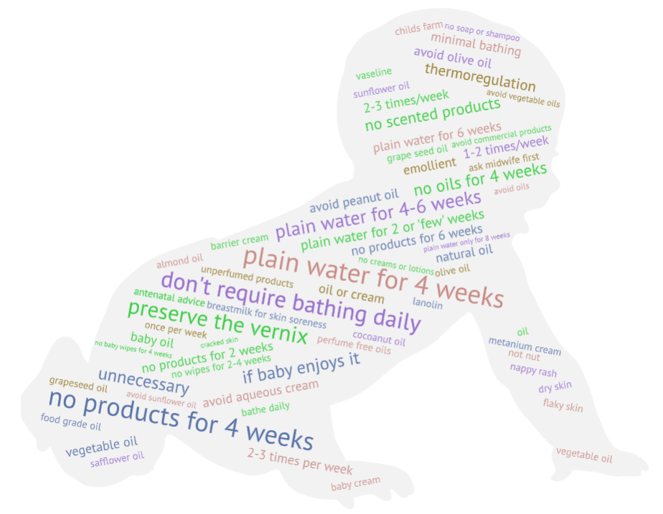

Figure 1: Word cloud showing current UK healthcare provider recommendations for newborn infant skincare

Table 1: Results of a survey of UK healthcare providers regarding antenatal and postnatal recommendations for routine infant skincare

|  |  |  |  |  |  |
| --- | --- | --- | --- | --- | --- |
|  | |  | | | **Healthcare providers  n=129; (%)** |
|  | |  | | |
| **A. Time Limited Advice** | | | | |
| ***Advice about the vernix*** | |  | | |  |
| Preserve the vernix (don’t wipe it off) | | | | | 23 (17.8) |
| ***Recommended delay for the first bath*** | | | | |  |
| 24 hours | |  | | | 10 (7.8) |
| ‘We recommend that babies aren't bathed straight away to avoid the skin drying out’* | | | | | 1 (0.8) |
| First ‘few’, 2 or 3 days | | | | | 5 (3.9) |
| 'Bathe as little as possible in the early days’* | | | | | 1 (0.8) |
| ‘Do not bathe the baby for several days to help the microbiome to establish’* | | | | | 1 (0.8) |
| 5-7 days | |  | | | 2 (1.6) |
| 7 days* | |  | | | 6 (4.7) |
| 7-10 days* | | | | | 2 (1.6) |
| 1-2 weeks* | | | | | 2 (1.6) |
| Delay until chord falls off | | | | | 6 (4.7) |
| ***Any delay*** | | | | | **36 (27.9)** |
| ***Recommendations for delayed use of soap or cleansing product*** | | | | |  |
| Plain water for 2-4 weeks | | | | | 6 (4.7) |
| Plain water for 4 weeks* | | | | | 33 (25.6) |
| Plain water for 4-6 weeks* | | | | | 13 (10.1) |
| Plain water for 6 weeks* | | | | | 8 (6.2) |
| Plain water for 8 weeks | | | | | 1 (0.8) |
| Plain water for 3 months | | | | | 1 (0.8) |
| ***Delayed use of soap or cleansing product*** | | | | | **62 (48.1** **)** |
| ***Other time-limited recommendations involving bathing*** | | | | |  |
| Bathe approximately 1-2 times per week in first few weeks | | | | | 1 (0.8) |
| ***Recommendations about nappy care*** | | | | |  |
| No baby wipes for 2-4 weeks | | | | | 3 (2.3) |
| No baby wipes for 4 weeks | | | | | 1 (0.8) |
| ***Recommendations for delayed introduction of products for dry skin or baby massage*** | | | | |  |
| No skincare products (e.g. lotions) for 2 or 'few' weeks | | | | | 4 (3.1) |
| No skincare products (e.g. lotions) for 4 weeks | | | | | 20 (15.5) |
| No oils for 4 weeks | | | | | 10 (7.8) |
| No creams or lotions for 4-6 weeks | | | | | 1 (0.8) |
| No products (e.g. lotions) for 6 weeks | | | | | 5 (3.9) |
| Avoid commercial products for 3 months | | | | | 1 (0.8) |
| ***Any delayed introduction of other products*a** | | | | | **33 (25.6)** |
| ***Recommendations about hair and scalp care*** | | | | |  |
| No soap or shampoo for 3 months | | | | | 1 (0.8) |
| Use a comb rather than shampoo in the first few weeks | | | | | 3 (2.3) |
| **B. Non Time Limited Advice** | |  | | |  |
| ***Recommended bathing frequency*** | | | | |  |
| Daily | |  | | | 2 (1.6) |
| Every day is unnecessary but fine if your baby enjoys it | | | | | 11 (8.5) |
| 2-3 times per week, but every day is fine if they enjoy it | | | | | 5 (3.9) |
| Babies don't require bathing daily* | | | | | 19 (14.7) |
| 2-3 times/week | | | | | 4 (3.1) |
| 1-2 times/week* | | | | | 5 (3.9) |
| Once per week* | | | | | 1 (0.8) |
| Keep baths to a minimum* | | | | | 3 (2.3) |
| ***Any recommendation about bathing frequency*** | | | | | **50 (38.8)** |
| ***Recommendations about bathing and cleansing*** | |  | | |  |
| Bathe babies in plain water only* | | | | | 104 (80.5) |
| Avoid using skincare products* | | | | | 65 (50.4) |
| Use mild, non-perfumed soap if you wish to use soap | | | | | 11 (8.5) |
| Do use baby bath liquid | | | | | 4 (3.1) |
| Use cotton wool, a sponge or a wash cloth | | | | | 62 (48.1) |
| ***Recommendations about nappy care*** | | | | |  |
| Barrier cream to prevent nappy rash | | | | | 1 |
| Metanium cream for nappy rash | | | | | 1 |
| ***Recommendations about hair and scalp care*** | |  | | |  |
| Do use baby shampoo | | | | | 17 (13.2) |
| ***Recommendations about hair and scalp care*** | |  | | | **17 (13.2)** |
| ***Recommended skincare products to use*b** | | | | |  |
| Emollient based cream free from sodium dodecyl sulphate | | | | | 1 |
| Emollient based cream free from alcohol, colour and perfume | | | | | 2 |
| Childs farm | | | | | 1 |
| Baby cream | | | | | 1 |
| Baby oil | |  | | | 5 |
| Vegetable oil | | | | | 3 |
| Rapeseed oil | | | | | 2 |
| Coconut oil | | | | | 1 |
| Almond oil | | | | | 1 |
| Natural oil | | | | | 4 |
| Grapeseed oil | | | | | 1 |
| Food grade oil | | | | | 1 |
| Safflower oil | | | | | 1 |
| Sunflower oil | | | | | 2 |
| Grape seed oil | | | | | 1 |
| Vaseline | |  | | | 1 |
| Olive oil is recommended | | | | | 2 |
| Oil (unspecified) | | | | | 1 |
| Oil, but ask midwife first | | | | | 1 |
| Vegetable (not nut) based and free from mineral oils, perfume and colours | | | | | 1 |
| Unperfumed products | | | | | 1 |
| Breastmilk for skin soreness | | | | | 1 |
| Oil or cream (no specific oil or cream suggested) | | | | | 3 |
| Perfume free oils | | | | | 1 |
| Cream (unspecified type) only for dry/cracked skin; not for dry flaky skin | | | | | 1 |
| Lanolin - if skin appears cracked | | | | | 1 |
| ***Recommendations for skincare products to avoid*b** | | | | |  |
| Aqueous cream | | | | | 5 |
| Olive oil | |  | | | 5 |
| Vegetable oils | | | | | 1 |
| Oils, especially nut based oils | | | | | 1 |
| Sunflower oil | | | | | 1 |
| Peanut oil | | | | | 3 |
| Scented products | | | | | 9 |
|  | |  | | |  |
| **Key** | |  | | |  |
| **Colour** | **Skincare advice facet** | |  |
|  | Advice about bathing and cleansing | |  |
|  | Nappy care | |  |
|  | Hair and scalp care | |  |
|  | Recommendations for management of dry skin or baby massage | |  |
|  | |  | | |  |
| **Notes:** | |  | | |  |
| *Quantification of responses is based on the verbatim response; some of these categories overlap. | | | | | |
| **a** The same providers often advise about both delayed introduction of wipes and moisturiser/oil so the box total is not the algebraic sum of the preceding categories. | | | | | |
| **b**Some healthcare providers recommend multiple products to use and/or avoid; percentages not supplied for these categories as the raw numbers are low. | | | | | |

References

1. Langan SM, Mulick AR, Rutter CE, et al. Trends in eczema prevalence in children and adolescents: A Global Asthma Network Phase One Study. *Clinical and Experimental Allergy* 2023;53(3):337-52.

2. Flohr C, England K, Radulovic S, et al. Filaggrin loss-of-function mutations are associated with early-onset eczema, eczema severity and transepidermal water loss at 3 months of age. *Br J Dermatol* 2010;163(6):1333-36.

3. Cooke A, Bedwell C, Campbell M, et al. Skin care for healthy babies at term: A systematic review of the evidence. *Midwifery* 2018;56:29-43. doi: S0266-6138(17)30354-6 [pii];10.1016/j.midw.2017.10.001 [doi]

4. World Health Organisation. WHO recommendations on Newborn Health: guidelines approved by the WHO Guidelines Review Committee, 2017.

5. National Institute of Clinical Excellence. Postnatal care (NG194), 2021.

6. National Health Service. Washing and bathing your baby 2021 [Available from: <https://www.nhs.uk/conditions/baby/caring-for-a-newborn/washing-and-bathing-your-baby/>.

7. Ashenburg K. Clean: An unsanitised history of washing: Profile Books 2011.

8. Hanifin JM, Tofte SJ. Update on therapy of atopic dermatitis. *Journal of Allergy and Clinical Immunology* 1999;104(3, Supplement):S123-S25. doi: <https://doi.org/10.1016/S0091-6749(99)70054-0>

9. Kelleher MM, Cro S, Van Vogt E, et al. Skincare interventions in infants for preventing eczema and food allergy: A cochrane systematic review and individual participant data meta-analysis. *Clinical & Experimental Allergy* 2021;51(3):402-18. doi: <https://doi.org/10.1111/cea.13847>