APPENDIX I – Supplemental Methods

High-Sensitivity Troponin in the Evaluation of Patients With Acute Coronary Syndrome (High-STEACS)

Adjudication according to the Fourth Universal Definition of Myocardial Infarction
All patients with high-sensitivity cardiac troponin I (hs-cTnI) concentrations above the sex-specific 99th centile were classified according to the Third Universal Definition of Myocardial Infarction in use at the time of the trial. For a pre-specified secondary analysis, we updated this classification in accordance with the Fourth Universal Definition of Myocardial Infarction (ref). Two physicians independently reviewed all clinical information, blinded to study phase, with discordant diagnoses resolved by a third reviewer. Clinical information included the dates and times of presentation and final discharge, the initial emergency department assessment and final discharge letter as documented in the electronic care record, with summaries of all investigations undertaken during the index presentation including the electrocardiogram. The adjudication panel had access to raw clinical information including haemoglobin, creatinine and high-sensitivity cardiac troponin I concentrations, and the reports from invasive coronary angiography. Type 1 myocardial infarction was defined as myocardial necrosis (any hs-cTnI concentration above the 99th centile with a rise and/or fall in hs-cTnI concentration where serial testing was performed) in the context of a presentation with suspected acute coronary syndrome with symptoms or signs of myocardial ischemia on the electrocardiogram. Patients with symptoms or signs of myocardial ischemia and evidence of increased oxygen demand or decreased supply (for example, tachyarrhythmia, hypotension, or anaemia) secondary to an alternative pathology and myocardial necrosis were defined as type 2 myocardial infarction. The classification of type 2 myocardial infarction also includes patients with coronary vasospasm, embolism or spontaneous dissection without evidence of atherothrombosis related to coronary artery disease. Type 4a myocardial infarction was defined in patients with symptoms or signs of myocardial ischemia following percutaneous coronary intervention where hs-cTnI concentrations were 5-fold greater than the 99th centile, or increased further if elevated prior to the procedure. Type 4b myocardial infarction was defined where myocardial ischemia and myocardial necrosis were associated with stent thrombosis documented at angiography. Myocardial injury was defined if hs-cTnI concentrations were above the 99th centile in the absence of any clinical features of myocardial ischemia. All non-ischemic myocardial injury was classified as acute, unless a change of <20% was observed on serial testing or the final adjudicated diagnosis was chronic heart failure or chronic renal failure, where the classification was chronic myocardial injury.

Advantageous Predictors of Acute Coronary Syndromes Evaluation (APACE)

Study design and population
Advantageous Predictors of Acute Coronary Syndromes Evaluation (APACE) was a prospective international multicentre study with 12 centres in 5 countries aiming to advance the early diagnosis of myocardial infarction (ClinicalTrials.gov registry, number NCT00470587). Adult patients (≥ 18 years) presenting to the Emergency Department with symptoms suggestive of myocardial infarction were recruited. While enrolment was independent of renal function, we excluded patients with terminal kidney failure on chronic dialysis. The study was carried out according to the principles of the Declaration of Helsinki and approved by the local ethics committees. Written informed consent was obtained from all patients.

Cardiac troponin measurement
Cardiac troponin testing was performed at presentation and repeated at 1, 2, 3 and 6 hours from presentation. Serial sampling was discontinued when a patient was discharged or transferred to the catheterization laboratory. Samples were collected in plasma or serum tubes, underwent centrifugation before being frozen at −80°C until assayed in a blinded fashion in a dedicated core laboratory.

Cardiac troponin assays
The Abbott ARCHITECT_{STAT} high-sensitivity troponin I assay (Abbott Laboratories, Illinois, USA) is a chemiluminescent microparticle immunoassay with a manufacturer reported inter-assay coefficient of variation of less than 10% at 4.7 ng/L, a limit of detection of 1.9 ng/L and a 99th centile upper reference limit of 34 ng/L in men and 16 ng/L in women.

The Beckman Coulter Access high-sensitivity troponin I assay (Beckman Coulter, California, USA) is a sequential two–step immunoenzymatic assay with a manufacturer reported inter-assay coefficient of variation of less than 10% at 5.6 ng/L, a limit of detection of 2.3 ng/L, a universal 99th centile upper reference limit of 17.5 ng/L with a 99th centile upper reference limit of 19.8 ng/L in men and 11.6 ng/L in women.

The LSI Medience PATHFAST high-sensitivity troponin I assay (LSI Medience Corporation, Tokyo, Japan) is a point-of-care chemiluminescent enzyme immunoassay with a manufacturer reported inter-assay coefficient of variation of less than 10% at 15 ng/L, a limit of detection of 2.3 ng/L, and a universal 99th centile upper reference limit of 29.0 ng/L.

The Ortho Clinical Diagnostics VITROS high-sensitivity troponin I assay (Ortho Clinical Diagnostics, New Jersey, USA) is a chemiluminescent enzyme immunoassay with a manufacturer reported inter-assay coefficient of variation of less than 10% at 1.99 ng/L, a limit of detection of 0.86 ng/L, a universal 99th centile upper reference limit of 11.0 ng/L with a 99th centile upper reference limit of 12.0 ng/L in men and 9.0 ng/L in women.

The Siemens ADVIA Centaur high-sensitivity troponin I assay (Siemens Healthiners, Erlangen, Germany) is a chemiluminescent enzyme immunoassay with a manufacturer reported inter-assay coefficient of variation of less than 10% at 6.0 ng/L, a limit of detection of 1.6 ng/L, a universal 99th centile upper reference limit of 47.34 ng/L with a 99th centile upper reference limit of 57.3 ng/L in men and 37 ng/L in women.

The Siemens Dimension EXL high-sensitivity troponin I assay (Siemens Healthiners, Erlangen, Germany) is a chemiluminescent enzyme immunoassay with a manufacturer reported inter-assay coefficient of variation of less than 10% at 12.0 ng/L, a limit of detection of 2.7 ng/L, a universal 99th centile upper reference limit of 60.4 ng/L with a 99th centile upper reference limit of 76.2 ng/L in men and 51.4 ng/L in women.

The Siemens Dimension Vista high-sensitivity troponin I assay (Siemens Healthiners, Erlangen, Germany) is a chemiluminescent enzyme immunoassay with a manufacturer reported inter-assay coefficient of variation of less than 10% at 10.0 ng/L, a limit of detection of 2.0 ng/L, a universal 99th centile upper reference limit of 58.9 ng/L with a 99th centile upper reference limit of 78.5 ng/L in men and 53.7 ng/L in women.

The Singulex Clarity high-sensitivity troponin I assay (Singulex Clarity, Alameda, United States) is a microparticle-based immunoassay with a manufacturer reported inter-assay coefficient of variation of less than 10% at 0.53ng/L, a limit of detection of 0.08ng/L, and a universal 99th centile upper reference limit of 8.67 ng/L.

Adjudicated final diagnosis
Myocardial infarction was defined and cardiac troponin levels interpreted as recommended in current guidelines.^{1–3} In brief, myocardial infarction was diagnosed when there was evidence of myocardial injury with a significant rise and/or fall in a clinical setting consistent with myocardial ischemia. Patients with myocardial infarction were further subdivided into type 1 myocardial infarction (primary coronary events) and type 2 myocardial infarction (ischemia due to increased demand or decreased supply, for example tachyarrhythmia or hypertensive urgency).^{1,4} All other patients were classified in the categories of unstable angina, non-cardiac chest pain, cardiac but non-coronary disease (e.g., tachyarrhythmia, myopericarditis), and symptoms of unknown origin with normal high-sensitivity cardiac tropoini concentrations.

The adjudication of final diagnoses was performed centrally in the core lab (University Hospital Basel) for all patients incorporating sex-specific high-sensitivity cardiac troponin I concentrations. More specifically, two independent cardiologists not directly involved in patient care reviewed all available medical records (including patient history, physical examination, results of laboratory testing including high-sensitivity cardiac troponin I levels, radiologic testing, electrocardiography, echocardiography, cardiac exercise test, lesion severity and morphology in coronary angiography, discharge summary) pertaining to the patient from the time of Emergency Department presentation to 90-day follow-up. In situations of diagnostic disagreement, cases were reviewed and adjudicated in conjunction with a third cardiologist.

Sex-specific 99th centile upper reference limits of ARCHITECT_{STAT} high-sensitivity troponin I assay (women: 16 ng/L, men 34 ng/L) were used to identify those with myocardial injury. Absolute changes in cardiac tropoinin were used to determine significant changes based on the diagnostic superiority of absolute over relative changes.^{5–10} Based on studies of the biological variation of cTn^{11,12} as well as on data from previous chest pain cohort studies,^{5,13} a significant absolute change was defined as a rise or fall of at least 10 ng/L within six hours, or, in an assumption of linearity, as an absolute change of 6 ng/L within three hours.

Routine clinical assessment
Patients underwent clinical assessment that included medical history, physical examination, standard blood test including serial measurements of local cardiac troponin, 12-lead ECG, chest radiography, continuous ECG-rhythm monitoring and pulse oximetry. Management of patients was left to discretion of the attending physician.

Follow-up and clinical endpoints
Patients were contacted 3, 12 and 24 months after discharge by telephone calls or in written form. Information regarding death during follow up was furthermore obtained from the patient’s hospital notes, the family physician’s records and the national registry on mortality.

References

1. Thygesen K, Alpert JS, Jaffe AS, et al. Fourth universal definition of myocardial infarction (2018). Eur Heart J. Published online 2019. doi:10.1093/eurheartj/ehy462
2. Thygesen K, Mair J, Giannitsis E, et al. How to use high-sensitivity cardiac troponins in acute cardiac care. Eur Heart J. 2012;33(18):2252-2257. doi:10.1093/eurheartj/ehs154
3. Apple FS, Jesse RL, Newby LK, Wu AHB, Christenson RH. National Academy of Clinical Biochemistry and IFCC Committee for Standardization of Markers of Cardiac Damage Laboratory Medicine Practice Guidelines: Analytical issues for biochemical markers of acute coronary syndromes. Circulation. 2007;115(13):e352-5. doi:10.1161/CIRCULATIONAHA.107.182881
4. Collet J-P, Thiele H, Barbato E, et al. 2020 ESC Guidelines for the management of acute coronary syndromes in patients presenting without persistent ST-segment elevation: The Task Force for the management of acute coronary syndromes in patients presenting without persistent ST-segment elevation. Eur Heart J. Published online August 2020. doi:10.1093/eurheartj/ehaa575
5. Reichlin T, Irfan A, Twerenbold R, et al. Utility of absolute and relative changes in cardiac troponin concentrations in the early diagnosis of acute myocardial infarction. Circulation. 2011;124(2):136-145. doi:10.1161/CIRCULATIONAHA.111.023937
6. Wildi K, Reichlin T, Twerenbold R, et al. Serial changes in high-sensitivity cardiac troponin I in the early diagnosis of acute myocardial infarction. Int J Cardiol. 2013;168(4):4103-4110. doi:10.1016/j.ijcard.2013.07.078
7. Irfan A, Reichlin T, Twerenbold R, et al. Early diagnosis of myocardial infarction using absolute and relative changes in cardiac troponin concentrations. Am J Med. 2013;126(9):781-788.e2. doi:10.1016/j.amjmed.2013.02.031
8. Mueller M, Biener M, Vafaie M, et al. Absolute and relative kinetic changes of high-sensitivity cardiac troponin T in acute coronary syndrome and in patients with increased troponin in the absence of acute coronary syndrome. Clin Chem. 2012;58(1):209-218. doi:10.1373/clinchem.2011.171827
9. Biener M, Mueller M, Vafaie M, et al. Comparison of a 3-hour versus a 6-hour sampling-protocol using high-sensitivity cardiac troponin T for rule-out and rule-in of non-STEMI in an unselected emergency department population. Int J Cardiol. 2013;167(4):1134-1140. doi:10.1016/j.ijcard.2012.09.122
10. Biener M, Giannitsis E, Lamerz J, Mueller-Hennessen M, Vafaie M, Katus HA. Prognostic value of elevated high-sensitivity cardiac troponin T levels in a low risk outpatient population with cardiovascular disease. Eur Hear journal Acute Cardiovasc care. 2016;5(6):409-418. doi:10.1177/2048872615610869
11. Vasile VC, Saenger AK, Kroning JM, Jaffe AS. Biological and analytical variability of a novel high-sensitivity cardiac troponin T assay. Clin Chem. 2010;56(7):1086-1090. doi:10.1373/clinchem.2009.140616
12. Wu AHB, Lu QA, Todd J, Moecks J, Wians F. Short- and long-term biological variation in cardiac troponin I measured with a high-sensitivity assay: implications for clinical practice. Clin Chem. 2009;55(1):52-58. doi:10.1373/clinchem.2008.107391
13. Hammarsten O, Fu MLX, Sigurjonsdottir R, et al. Troponin T percentiles from a random population sample, emergency room patients and patients with myocardial infarction. Clin Chem. 2012;58(3):628-637. doi:10.1373/clinchem.2011.171496

Appendix II – Supplemental Figures & Tables

- Supplementary Table 1: Baseline characteristics of patients presenting early after symptom onset.

- Supplementary Table 2: Diagnostic performance of rule out thresholds by time from symptom onset in patients presenting very early after symptom onset.

- Supplemental Table 3. Diagnostic performance of rule out thresholds for type 1 or 4b myocardial infarction or cardiovascular death within 30 days of index presentation by time from symptom onset

- Supplementary Table 4: Baseline characteristics of the external validation cohort stratified by time from maximal symptom severity to troponin sampling.

- Supplementary Table 5: External validation of performance of rule out thresholds for a diagnosis of type 1 or 4 b myocardial infarction by time from maximal symptom onset.

- Supplementary Table 6: External validation of performance of rule out thresholds by time from maximal symptom onset in patients presenting very early after symptom onset.

- Supplementary Table 7: External validation of performance of rule out thresholds for a diagnosis of type 1 or 4 b myocardial infarction or cardiovascular death within 30 days of index presentation by time from maximal symptom onset.

- Supplementary Table 8: Baseline characteristics of the external validation cohort stratified by time from maximal symptom severity to troponin sampling.

- Supplementary Table 9: Validation of the performance of rule out thresholds for a diagnosis of type 1 or 4 b myocardial infarction by time from initial symptom onset.

- Supplementary Table 10: Validation of the performance of rule out thresholds by time from initial symptom onset in patients presenting within 3 hours of initial symptom onset.

- Supplementary Table 11: Baseline characteristics of patients in the external validation cohort who underwent additional cardiac assay troponin sampling.

- Supplemental Table 12: Assessment of the limit of detection of additional cardiac troponin I assays to rule out type 1 or 4b myocardial infarction by time from maximal symptom severity to troponin sampling in the external validation cohort.

- Supplementary Table 13: Diagnostic performance of rule out thresholds for a diagnosis of type 1 or 4b myocardial infarction by time from symptom onset in patients without evidence of ischaemia on 12-lead electrocardiogram.

Supplementary Table 14: Rule-out performance by time from symptom onset to troponin sampling restricted to patients with serial cardiac troponin measurements at 6-12 hours from presentation (n=9,362)

Supplementary Table 15: Diagnostic performance of rule out thresholds for a diagnosis of type 1 or 4b myocardial infarction by time from symptom onset excluding patients with a GRACE score >140.

Supplementary Table 16: Diagnostic performance of a 2ng/L threshold for the rule-out of type 1 or 4b myocardial infarction by time from symptom onset and GRACE risk category.

- Supplementary Table 17: Diagnostic performance of rule out thresholds for a diagnosis of type 1 or 4b myocardial infarction by time from symptom onset stratified by age.

Supplementary Table 18: Diagnostic performance of rule out thresholds for a diagnosis of type 1, type 2 or type 4b myocardial infarction by time from symptom onset.

Supplementary Table 1: Baseline characteristics of patients with suspected myocardial infarction presenting early stratified by the number of hours since symptom onset (n=12,595)

 | Time from symptom onset to troponin testing
 | 1 hour | 2 hours | 3 hours | p-value
Number of participants | 2,469 | 5,303 | 4,823
Age, years | 62 (17) | 62 (17) | 62 (17) | <0.001
Sex |  |  |  | <0.001
Women | 965 (39%) | 2,294 (43%) | 2,221 (46%)
Men | 1,504 (61%) | 3,009 (57%) | 2,602 (54%)
Presenting complaint
Chest pain | 1,679 (68%) | 4,154 (78%) | 3,914 (81%) | <0.001
Previous medical conditions
Ischaemic heart disease | 630 (26%) | 1,385 (26%) | 1,368 (28%) | 0.010
Myocardial infarction | 232 (9.4%) | 508 (9.6%) | 502 (10%) | 0.26
Heart Failure | 254 (10%) | 517 (9.7%) | 423 (8.8%) | 0.076
Cerebrovascular disease | 165 (6.7%) | 328 (6.2%) | 324 (6.7%) | 0.50
Diabetes mellitus | 187 (7.6%) | 410 (7.7%) | 376 (7.8%) | 0.94
Chronic renal disease | 562 (23%) | 993 (19%) | 1,013 (21%) | <0.001
Previous revascularisation
Percutaneous coronary intervention | 198 (8.0%) | 455 (8.6%) | 445 (9.2%) | 0.20
Coronary artery bypass grafting | 50 (2.0%) | 79 (1.5%) | 101 (2.1%) | 0.054
Medications at presentation
Aspirin | 737 (30%) | 1,523 (29%) | 1,453 (30%) | 0.27
P2Y12 inhibitor | 252 (10%) | 530 (10.0%) | 531 (11%) | 0.23
Dual anti-platelet therapy† | 79 (3.2%) | 188 (3.5%) | 189 (3.9%) | 0.28
Statin | 1,092 (44%) | 2,230 (42%) | 2,085 (43%) | 0.17
ACE inhibitor or ARB | 909 (37%) | 1,824 (34%) | 1,658 (34%) | 0.076
Beta-blocker | 752 (30%) | 1,518 (29%) | 1,440 (30%) | 0.19
Oral anticoagulant‡ | 180 (7.3%) | 360 (6.8%) | 319 (6.6%) | 0.55
Physiological parameters on presentation§
Heart rate, beats per minute | 90 (30) | 86 (29) | 85 (27) | 0.003
Systolic blood pressure, mmHg | 136 (34) | 136 (29) | 140 (29) | 0.025
GRACE score | 152 (42) | 145 (39) | 141 (36) | 0.002
Ischaemia on ECG | 141 (27%) | 311 (32%) | 234 (27%) | 0.038
Haematology and clinical chemistry measurements
Haemoglobin, g/L | 136 (25) | 137 (21) | 135 (23) | <0.001
Estimated glomerular filtration mL/min | 77 (26) | 80 (24) | 81 (24) | <0.001
Presentation high-sensitivity cardiac troponin I, ng/L | 4 [2-16] | 4 [1-12] | 4 [2-12] | <0.001
Serial troponin¶ measurement | 1,354 (55%) | 3,288 (62%) | 3,062 (63%) | <0.001
Adjudicated diagnosis
Type 1 myocardial infarction | 269 (11%) | 589 (11%) | 560 (12%) | 0.59
Type 2 myocardial infarction | 98 (4.0%) | 175 (3.3%) | 135 (2.8%) | 0.027
Type 4b myocardial infarction | <5 (<0.1%) | 9 (0.2%) | 10 (0.2%) | 0.51
Acute myocardial injury | 204 (8.3%) | 196 (3.7%) | 145 (3.0%) | <0.001
Chronic myocardial injury | 67 (2.7%) | 133 (2.5%) | 138 (2.9%) | 0.54
No myocardial injury | 1,829 (74%) | 4,199 (79%) | 3,835 (80%) | <0.001
Outcomes at 30 days
Type 1 or 4b myocardial infarction | 17 (0.7%) | 38 (0.7%) | 29 (0.6%) | 0.8
Cardiovascular death | 107 (4.3%) | 117 (2.2%) | 75 (1.6%) | <0.001
Values are mean (SD) and median [25th – 75th centile]; n (%).
¹Wilcoxon rank sum test; Pearson’s Chi-squared test
†Two medications from aspirin, clopidogrel, prasugrel, or ticagrelor.
‡Includes warfarin or novel oral anticoagulants.
ACE, angiotensin converting enzyme; ARB, angiotensin receptor blockers
¶Serial testing defined as two or more tests within 24 hours of presentation.

Supplementary Table 2: Diagnostic performance of rule out thresholds by time from symptom onset in patients presenting very early after symptom onset
Hours from  symptom onset | Presentation high-sensitivity cardiac troponin I
 | TN | FN | Sensitivity  (95% CI) | NPV  (95% CI) | Proportion  ruled out (%)
 | 2 ng/L
1 hour | 567 | 1 | 99.6%  (99.3-99.8%) | 99.8%  (99.6-99.9%) | 23%
2 hours | 1,323 | 4 | 99.3%  (99.1-99.5%) | 99.7%  (99.5-99.8%) | 25%
3 hours | 1,130 | 4 | 99.3%  (99.0-99.5%) | 99.6%  (99.4-99.8%) | 24%
 | 5 ng/L
1 hour | 1,222 | 20 | 92.6%  (91.5-93.6%) | 98.4%  (97.8-98.8%) | 50%
2 hours | 2,866 | 18 | 97.0%  (96.5-97.4%) | 99.4%  (99.1-99.6%) | 54%
3 hours | 2,580 | 12 | 97.9%  (97.4-98.3%) | 99.5%  (99.3-99.7%) | 54%
 | Sex-specific 99th centile
1 hour | 1,906 | 102 | 62.4%  (60.4-64.3%) | 94.9%  (94.0-95.7%) | 81%
2 hours | 4,305 | 181 | 69.7%  (68.5-71.0%) | 96.0%  (95.4-96.5%) | 85%
3 hours | 3,896 | 128 | 77.5%  (76.3-78.7%) | 96.8%  (96.3-97.3%) | 83%
Presented as number or % (95% confidence intervals) as appropriate.
High-sensitivity cardiac troponin I assay = ARCHITECT_{STAT}
*Sex-specific 99th centile = 34 ng/L men, 16 ng/L women.
Number of patients in each time group: 1 hour = 2,469; 2 hours = 5,299; 3 hours = 4,913
Abbreviations: TN = true negatives, FN = false negatives, NPV = negative predictive value

Supplementary Table 3: Diagnostic performance of rule out thresholds for type 1 or 4b myocardial infarction or cardiovascular death within 30 days of index presentation by time from symptom onset
Hours from  symptom onset | Presentation high-sensitivity cardiac troponin I
 | TN | FN | Sensitivity  (95% CI) | NPV  (95% CI) | Proportion  ruled out (%)
 | 2 ng/L
≤3 hours | 3,016 | 13 | 99.2%  (99.0 - 99.3%) | 99.6%  (99.4 - 99.7%) | 24%
4-12 hours | 4,761 | 9 | 99.5%  (99.3 - 99.6%) | 99.8%  (99.7 - 99.9%) | 27%
>12 hours | 3,551 | 2 | 99.8%  (99.6 - 99.8%) | 99.9%  (99.9 - 100.0%) | 32%
Overall | 11,328 | 24 | 99.4%  (99.3 - 99.5%) | 99.8%  (99.7 - 99.8%) | 28%
 | 5 ng/L
≤3 hours | 6,653 | 65 | 95.9%  (95.6 - 96.3%) | 99.0%  (98.8 - 99.2%) | 53%
4-12 hours | 10,138 | 30 | 98.2%  (98.0 - 98.4%) | 99.7%  (99.6 - 99.8%) | 58%
>12 hours | 6,900 | 13 | 98.4%  (98.1 - 98.6%) | 99.8%  (99.7 - 99.9%) | 63%
Overall | 23,691 | 108 | 97.3%  (97.2 - 97.5%) | 99.5%  (99.5 - 99.6%) | 58%
 | Sex-specific 99th centile
≤3 hours | 10,105 | 503 | 68.6%  (67.7 - 69.4%) | 95.2%  (94.8 - 95.6%) | 84%
4-12 hours | 14,555 | 293 | 82.3%  (81.8 - 82.9%) | 98.0%  (97.8 - 98.2%) | 85%
>12 hours | 9,386 | 85 | 89.4%  (88.8 - 89.9%) | 99.1%  (98.9 - 99.3%) | 86%
Overall | 33,956 | 881 | 78.3%  (77.9 - 78.7%) | 97.5%  (97.3 - 97.6%) | 85%
Presented as number or % (95% confidence intervals) as appropriate.
High-sensitivity cardiac troponin I assay = ARCHITECT_{STAT}
*Sex-specific 99th centile = 34 ng/L men, 16 ng/L women.
Number of patients in each time group: ≤3 hours = 12,595; 4-12 hours = 17,468;
>12 hours = 11,040; Overall = 41,103
Abbreviations: TN = true negatives, FN = false negatives, NPV = negative predictive value
Supplementary Table 4: Baseline characteristics of the external validation cohort stratified by time from maximal symptom severity to troponin sampling (n=7,088).

 |  | Time from symptom onset to troponin testing
 | Overall |  | ≤3 hours | 4-12 hours | >12 hours |  | p-value
Number of participants | 7,088 | 2,927 |  | 3,203 | 958
Age, years | 60 (17) | 58 (16) |  | 62 (16) |  | 60 (17) | <0.001
Sex
Women | 2,420 (34%) | 968  (33%) |  | 1,145 (36%) |  | 307 (32%) | 0.073
Men | 4,668 (66%) | 1,959 (67%) |  | 2,058 (64%) |  | 651 (68%)
Time from symptom onset to troponin sampling (hours) | 9 (±15) | 2 (±1) |  | 7 (±2) |  | 38 (±25) | <0.001
Previous medical conditions
Ischaemic heart disease | 2,262 (32%) | 903 (31%) |  | 1,076 (34%) |  | 283 (30%) | 0.017
Myocardial infarction | 1,607 (23%) | 667 (23%) |  | 746 (23%) |  | 194 (20%) | 0.14
Cerebrovascular disease | 365 (5.1%) | 145 (5.0%) |  | 173 (5.4%) |  | 47 (4.9%) | 0.68
Diabetes mellitus | 1,238 (17%) | 497 (17%) |  | 583 (18%) |  | 158 (16%) | 0.30
Chronic renal disease | 665 (9.4%) | 235 (8.0%) |  | 333 (10%) |  | 97 (10%) | 0.005
Previous revascularisation
Percutaneous coronary intervention | 1,677 (24%) | 699 (24%) |  | 764 (24%) |  | 214 (22%) | 0.59
Coronary artery bypass grafting | 546 (7.7%) | 190 (6.5%) |  | 288 (9.0%) |  | 68 (7.1%) | <0.001
Medications at presentation
Aspirin | 2,503 (35%) | 994 (34%) |  | 1,177 (37%) |  | 332 (35%) | 0.067
P2Y12 inhibitor | 748 (11%) | 331 (11%) |  | 327 (10%) |  | 90 (9.4%) | 0.17
Dual anti-platelet therapy† | 583 (8.2%) | 258 (8.8%) |  | 257 (8.0%) |  | 68 (7.1%) | 0.21
Statin | 2,453 (35%) | 996 (34%) |  | 1,162 (36%) |  | 295 (31%) | 0.005
ACE inhibitor or ARB | 2,774 (39%) | 1,121 (38%) |  | 1,305 (41%) |  | 348 (36%) | 0.023
Beta-blocker | 2,360 (33%) | 935 (32%) |  | 1,124 (35%) |  | 301 (31%) | 0.014
Oral anticoagulant‡ | 716 (10%) | 266 (9.1%) |  | 369 (12%) |  | 81 (8.5%) | 0.001
Physiological parameters on presentation§
Heart rate, beats per minute | 79 (19) | 79 (20) |  | 79 (19) |  | 79 (20) | 0.75
Systolic blood pressure, mmHg | 141 (23) | 140 (24) |  | 142 (24) |  | 141 (22) | 0.005
GRACE score | 98 [75-126] | 94 [72-121] |  | 103 [80-130] |  | 98 [75-125] | <0.001
Ischaemia on ECG | 1,314 (19%) | 461 (16%) |  | 670 (21%) |  | 183 (19%) | <0.001
Haematology and clinical chemistry measurements
Haemoglobin, g/L | 141 (17) | 142 (17) |  | 140 (17) |  | 142 (17) | 0.001
Estimated glomerular filtration mL/min | 85 (23) | 86 (23) |  | 83 (23) |  | 84 (24) | <0.001
Presentation high-sensitivity cardiac troponin I, ng/L | 4 [2-14] | 4 [2-11] |  | 5 [2-21] |  | 4 [2-14] | <0.001
Adjudicated diagnosis
Type 1 myocardial infarction | 975 (14%) | 360 (12%) |  | 486 (15%) |  | 129 (13%) | 0.005
Outcome at 30 days
Type 1 or 4b myocardial infarction | 40 (0.6%) | 15 (0.5%) |  | 22 (0.7%) |  | 3 (0.3%) | 0.35
Cardiovascular death | 39 (0.6%) | 7 (0.2%) |  | 26 (0.8%) |  | 6 (0.6%) | 0.010
Values are mean (SD) and median [25th – 75th centile]; n (%).
¹Wilcoxon rank sum test; Pearson's Chi-squared test
†Two medications from aspirin, clopidogrel, prasugrel, or ticagrelor.
‡Includes warfarin or novel oral anticoagulants.
§Physiological data missing in the following number of patients: heart rate = 12, blood pressure = 10, presentation ECG = 81, GRACE score = 669
ACE, angiotensin converting enzyme; ARB, angiotensin receptor blockers; ECG, electrocardiogram

Supplementary Table 5: External validation of performance of rule out thresholds for a diagnosis of type 1 or 4 b myocardial infarction by time from maximal symptom onset (n=7,088)
Hours from  symptom onset | Presentation high-sensitivity cardiac troponin I
 | TN | FN | Sensitivity  (95% CI) | NPV  (95% CI) | Proportion  ruled out (%)
 | 2 ng/L
≤3 hours | 697 | 0 | 100%  (99.9-100%) | 100%  (99.9-100%) | 24%
4-12 hours | 610 | 0 | 100%  (99.9-100%) | 100%  (99.9-100%) | 19%
>12 hours | 243 | 0 | 100%  (99.6-100%) | 100%  (99.6-100%) | 25%
Overall | 1,550 | 0 | 100%  (99.9-100%) | 100%  (99.9-100%) | 22%
 | 5 ng/L
≤3 hours | 1,713 | 5 | 98.6%  (98.1-99.0%) | 99.7%  (99.4-99.8%) | 59%
4-12 hours | 1,571 | 0 | 100%  (99.9-100%) | 100%  (99.9-100%) | 49%
>12 hours | 534 | 1 | 99.2%  (98.4-99.6%) | 99.8%  (99.3-100%) | 56%
Overall | 3,818 | 6 | 99.4%  (99.2-99.5%) | 99.8%  (99.7-99.9%) | 54%
 | Sex-specific 99th centile
≤3 hours | 2,386 | 128 | 64.4%  (62.7-66.2%) | 94.9%  (94.1-95.6%) | 86%
4-12 hours | 2,430 | 55 | 88.7%  (87.5-89.7%) | 97.8%  (97.2-98.2%) | 78%
>12 hours | 754 | 6 | 95.3%  (93.8-96.5%) | 99.2%  (98.4-99.6%) | 79%
Overall | 5,570 | 189 | 80.6%  (79.7-81.5%) | 96.7%  (96.3-97.1%) | 81%
Presented as number or % (95% confidence intervals) as appropriate.
High-sensitivity cardiac troponin I assay = ARCHITECT_{STAT}
*Sex-specific 99th centile = 34 ng/L men, 16 ng/L women.
Number of patients in each time group: ≤3 hours = 2,927; 4-12 hours = 3,203;
>12 hours = 958; Overall = 7,088
Abbreviations: TN = true negatives, FN = false negatives, NPV = negative predictive value
Supplementary Table 6: External validation of performance of rule out thresholds by time from maximal symptom onset in patients presenting very early after symptom onset (n=2,927)

Hours from  symptom onset | Presentation high-sensitivity cardiac troponin I
 | TN | FN | Sensitivity  (95% CI) | NPV  (95% CI) | Proportion  ruled out (%)
 | 2 ng/L
1 hour | 153 | 0 | 100%  (99.6 – 100%) | 100%  (99.4 - 100%) | 24%
2 hours | 313 | 0 | 100%  (99.7 – 100%) | 100%  (99.7 - 100%) | 25%
3 hours | 231 | 0 | 100%  (99.6 – 100%) | 100%  (99.6 - 100%) | 22%
 | 5 ng/L
1 hour | 377 | 1 | 98.6%  (97.4-99.3%) | 99.7%  (98.9-99.9%) | 60%
2 hours | 750 | 1 | 99.3%  (98.6-99.6%) | 99.9%  (99.5-100%) | 61%
3 hours | 586 | 3 | 98.0%  (96.9-98.7) | 99.5%  (98.8-99.8%) | 56%
 | Sex-specific 99th centile
1 hour | 526 | 33 | 54.8%  (50.9-58.6%) | 94.1%  (92.0-95.7%) | 88%
2 hours | 1031 | 51 | 63.3%  (60.6-65.9%) | 95.3%  (94.0-96.3%) | 87%
3 hours | 829 | 44 | 70.3%  (67.4-73.0%) | 95.0%  (93.5-96.1%) | 83%
Presented as number or % (95% confidence intervals) as appropriate.
High-sensitivity cardiac troponin I assay = ARCHITECT_{STAT}
*Sex-specific 99th centile = 34 ng/L men, 16 ng/L women.
Number of patients in each time group: 1 hour = 634; 2 hours = 1,240; 3 hours = 1,053
Abbreviations: TN = true negatives, FN = false negatives, NPV = negative predictive value

Supplementary Table 7: External validation of performance of rule out thresholds for a diagnosis of type 1 or 4 b myocardial infarction or cardiovascular death within 30 days of index presentation by time from maximal symptom onset (n=7,088)

Hours from  symptom onset | Presentation high-sensitivity cardiac troponin I
 | TN | FN | Sensitivity  (95% CI) | NPV  (95% CI) | Proportion  ruled out (%)
 | 2 ng/L
≤3 hours | 696 | 1 | 99.7%  (99.5-99.9%) | 99.9%  (99.6-99.9%) | 24%
4-12 hours | 608 | 2 | 99.6%  (99.3-99.8%) | 99.7%  (99.4-99.8%) | 19%
>12 hours | 243 | 0 | 100%  (99.6-100%) | 100%  (99.6-100%) | 26%
Overall | 1,547 | 3 | 99.7%  (99.5-99.8%) | 99.8%  (99.7-99.9%) | 22%
 | 5 ng/L
≤3 hours | 1,711 | 7 | 98.1%  (97.5-98.5%) | 99.6%  (99.3-99.8%) | 59%
4-12 hours | 1,566 | 5 | 99.0%  (98.6-99 3%) | 99.7 %  (99.4-99.8%) | 49%
>12 hours | 533 | 2 | 98.5%  (97.5-99.1%) | 99.6%  (99.0-99 9%) | 56%
Overall | 3,810 | 14 | 98.6%  (98.3-98.9%) | 99.6%  (99.5-99.8%) | 54%
 | Sex-specific 99th centile
≤3 hours | 2,378 | 136 | 63.1%  (61.4-64.9%) | 94.6%  (93.7-95.4%) | 86%
4-12 hours | 2,416 | 69 | 86.3%  (85.1-87.5%) | 97.2%  (96.6-97.7%) | 78%
>12 hours | 751 | 9 | 93.2%  (91.4-94.6%) | 98.8%  (97.9-99.3%) | 79%
Overall | 5,545 | 214 | 78.7%  (77.8-79.7) | 96.3%  (95.8-96.7%) | 81%
Presented as number or % (95% confidence intervals) as appropriate.
High-sensitivity cardiac troponin I assay = ARCHITECT_{STAT}
*Sex-specific 99th centile = 34 ng/L men, 16 ng/L women.
Number of patients in each time group: ≤3 hours = 2,927; 4-12 hours = 3,203;
>12 hours = 958; Overall = 7,088
Abbreviations: TN = true negatives, FN = false negatives, NPV = negative predictive value
Supplementary Table 8: Baseline characteristics of the external validation cohort stratified by time from maximal symptom severity to troponin sampling (n=7,088).

 |  | Time from symptom onset to troponin testing
 | Overall | ≤3 hours | 4-12 hours | >12 hours | p-value
Number of participants | 7,088 | 1,880 | 2,964 | 2,244 | <0.01
Age, years | 60 (17) | 58 (16) | 63 (16) | 59 (17) | <0.001
Sex |  |  |  |  | 0.036
Women | 4,668 (66%) | 1,280 (68%) | 1,945 (66%) | 1,443 (64%)
Men | 2,420 (34%) | 600 (32%) | 1,019 (34%) | 801 (36%)
Time from symptom onset to troponin sampling (hours) | 19 (27) | 2 (1) | 7 (2) | 48 (31) | <0.001
Previous medical conditions
Ischaemic heart disease | 2,262 (32%) | 566 (30%) | 1,058 (36%) | 638 (28%) | <0.001
Myocardial infarction | 1,607 (23%) | 418 (22%) | 732 (25%) | 457 (20%) | <0.001
Cerebrovascular disease | 365 (5.1%) | 95 (5.1%) | 164 (5.5%) | 106 (4.7%) | 0.41
Diabetes mellitus | 1,238 (17%) | 322 (17%) | 557 (19%) | 359 (16%) | 0.030
Chronic renal disease | 665 (9.4%) | 137 (7.3%) | 308 (10%) | 220 (9.8%) | 0.001
Previous revascularisation
Percutaneous coronary intervention | 1,677 (24%) | 429 (23%) | 765 (26%) | 483 (22%) | <0.001
Coronary artery bypass grafting | 546 (7.7%) | 114 (6.1%) | 260 (8.8%) | 172 (7.7%) | 0.003
Medications at presentation
Aspirin | 2,503 (35%) | 639 (34%) | 1,122 (38%) | 742 (33%) | <0.001
P2Y12 inhibitor | 748 (11%) | 208 (11%) | 328 (11%) | 212 (9.4%) | 0.12
Dual anti-platelet therapy† | 583 (8.2%) | 160 (8.5%) | 253 (8.5%) | 170 (7.6%) | 0.40
Statin | 2,453 (35%) | 639 (34%) | 1,114 (38%) | 700 (31%) | <0.001
ACE inhibitor or ARB | 2,774 (39%) | 718 (38%) | 1,237 (42%) | 819 (36%) | <0.001
Beta-blocker | 2,360 (33%) | 604 (32%) | 1,071 (36%) | 685 (31%) | <0.001
Oral anticoagulant‡ | 716 (10%) | 166 (8.8%) | 322 (11%) | 228 (10%) | 0.072
Physiological parameters on presentation§
Heart rate, beats per minute | 79 (19) | 78 (20) | 79 (19) | 79 (19) | 0.048
Systolic blood pressure, mmHg | 141 (23) | 139 (24) | 142 (24) | 142 (23) | <0.001
GRACE score | 98 [75-126] | 94 [72-122] | 104 [80-130] | 96 [74- 124] | <0.001
Ischaemia on ECG | 1,314 (19%) | 298 (16%) | 596 (20%) | 420 (19%) | <0.001
Haematology and clinical chemistry measurements
Haemoglobin, g/L | 141 (17) | 142 (16) | 140 (17) | 142 (17) | <0.001
Estimated glomerular filtration mL/min | 85 (23) | 86 (23) | 83 (23) | 85 (24) | <0.001
Presentation high-sensitivity cardiac troponin I, ng/L | 4 [2-14] | 4 [2-10] | 5 [2-20] | 4 [2-14] | <0.001
Adjudicated diagnosis
Type 1 myocardial infarction | 975 (14%) | 246 (13%) | 449 (15%) | 280 (12%) | 0.013
Outcome at 30 days
Type 1 or 4b myocardial infarction | 40 (0.6%) | 9 (0.5%) | 16 (0.5%) | 15 (0.7%) | 0.70
Cardiovascular death | 39 (0.6%) | 6 (0.3%) | 19 (0.6%) | 14 (0.6%) | 0.29
Values are mean (SD) and median [25th – 75th centile]; n (%).
¹Wilcoxon rank sum test; Pearson's Chi-squared test
†Two medications from aspirin, clopidogrel, prasugrel, or ticagrelor.
‡Includes warfarin or novel oral anticoagulants.
§Physiological data missing in the following number of patients: heart rate = 12, blood pressure = 10, presentation ECG = 81, GRACE score = 669
ACE, angiotensin converting enzyme; ARB, angiotensin receptor blockers; ECG, electrocardiogram

Supplementary Table 9: Validation of the performance of rule out thresholds for a diagnosis of type 1 or 4 b myocardial infarction by time from initial symptom onset (n=7,088)
Hours from  symptom onset | Presentation high-sensitivity cardiac troponin I
 | TN | FN | Sensitivity  (95% CI) | NPV  (95% CI) | Proportion  ruled out (%)
 | 2 ng/L
≤3 hours | 449 | 0 | 100%  (99.8-100%) | 100%  (99.8-100%) | 24%
4-12 hours | 526 | 0 | 100%  (99.9-100%) | 100%  (99.9-100%) | 18%
>12 hours | 575 | 0 | 100%  (99.8-100%) | 100%  (99.8-100%) | 26%
Overall | 1550 | 0 | 100%  (99.9-100%) | 100%  (99.9-100%) | 22%
 | 5 ng/L
≤3 hours | 1092 | 4 | 98.4%  (97.7-98.9%) | 99.6%  (99.2-99.8%) | 58%
4-12 hours | 1454 | 1 | 99.8%  (99.5-99.9%) | 99.9%  (99.8-100%) | 50%
>12 hours | 1272 | 1 | 99.6%  (99.3-99.8%) | 99.9%  (99.7-100%) | 57%
Overall | 3818 | 6 | 99.4%  (99.2-99.5%) | 99.8%  (99.7-99.9%) | 54%
 | Sex-specific 99th centile
≤3 hours | 1532 | 104 | 57.7%  (55.5-59.9%) | 93.6%  (92.4-94.7%) | 87%
4-12 hours | 2254 | 59 | 86.9%  (85.6-88.0%) | 97.4%  (96.8-98.0%) | 78%
>12 hours | 1784 | 26 | 90.7%  (89.4-91.8%) | 98.6%  (98.0-99.0%) | 81%
Overall | 5570 | 189 | 80.6%  (79.7-81.5%) | 96.7%  (96.3-97.1%) | 81%
Presented as number or % (95% confidence intervals) as appropriate.
High-sensitivity cardiac troponin I assay = ARCHITECT_{STAT}
*Sex-specific 99th centile = 34 ng/L men, 16 ng/L women.
Number of patients in each time group: ≤3 hours = 1,880; 4-12 hours = 2,964;
>12 hours = 2,244; Overall = 7,088
Abbreviations: TN = true negatives, FN = false negatives, NPV = negative predictive value

Supplementary Table 10: Validation of the performance of rule out thresholds by time from initial symptom onset in patients presenting within 3 hours of initial symptom onset (n=2,420)

Hours from  symptom onset | Presentation high-sensitivity cardiac troponin I
 | TN | FN | Sensitivity  (95% CI) | NPV  (95% CI) | Proportion  ruled out (%)
 | 2 ng/L
1 hour | 153 | 0 | 100%  (99.4-100%) | 100%  (99.4-100%) | 24%
2 hours | 313 | 0 | 100%  (99.7-100%) | 100%  (99.7-100%) | 25%
3 hours | 231 | 0 | 100%  (99.6-100%) | 100%  (99.6-100%) | 22%
 | 5 ng/L
1 hour | 377 | 1 | 98.6%  (97.4-99.3%) | 99.7%  (98.9-99.9%) | 60%
2 hours | 750 | 1 | 99.3%  (98.6-99.6%) | 99.9%  (99.5-100%) | 61%
3 hours | 586 | 3 | 98.0%  (96.9-98.7%) | 99.5%  (98.8-99.8%) | 56%
 | Sex-specific 99th centile
1 hour | 526 | 33 | 54.8%  (50.9-58.6%) | 94.1%  (92.0-95.7%) | 88%
2 hours | 1031 | 51 | 63.3%  (60.6-65.9%) | 95.3%  (94.0-96.3%) | 87%
3 hours | 829 | 44 | 70.3%  (67.4-73.0%) | 95.0%  (93.5-96.1%) | 83%
Presented as number or % (95% confidence intervals) as appropriate.
High-sensitivity cardiac troponin I assay = ARCHITECT_{STAT}
*Sex-specific 99th centile = 34 ng/L men, 16 ng/L women.
Number of patients in each time group: 1 hour = 687; 2 hours = 1,027; 3 hours = 706
Abbreviations: TN = true negatives, FN = false negatives, NPV = negative predictive value

Supplementary Table 11: Baseline characteristics of patients in the external validation cohort who underwent additional cardiac assay troponin sampling.

 | Cardiac troponin assay
 | Beckman Coulter Access | LSI Medicine PATHFAST | Ortho Clinical Diagnostics VITROS | Siemens ADVIA Centaur | Siemens Dimension Vista | Siemens Dimension EXL | Singulex Clarity
Number of participants | 1,895 | 1,534 | 3,197 | 2,908 | 2,120 | 1,438 | 2,787
Age, years | 60 (17) | 60 (17) | 60 (17) | 61 (16) | 61 (16) | 60 (17) | 61 (16)
Sex
Women | 626 (33%) | 530 (35%) | 1,141 (36%) | 1,958 (67%) | 712 (34%) | 499 (35%) | 910 (33%)
Men | 1,269 (67%) | 1,004 (65%) | 2,056 (64%) | 950 (33%) | 1,408 (66%) | 939 (65%) | 1,877 (67%)
Time from symptom onset to troponin sampling (hours) | 17 (30) | 18 (32) | 18 (29) | 17 (27) | 18 (29) | 18 (32) | 17 (23)
Previous medical conditions
Ischaemic heart disease | 614 (32%) | 481 (31%) | 979 (31%) | 1,003 (34%) | 727 (34%) | 436 (30%) | 973 (35%)
Myocardial infarction | 440 (23%) | 367 (24%) | 717 (22%) | 689 (24%) | 503 (24%) | 326 (23%) | 662 (24%)
Cerebrovascular disease | 124 (6.5%) | 82 (5.3%) | 171 (5.3%) | 157 (5.4%) | 128 (6.0%) | 77 (5.4%) | 159 (5.7%)
Diabetes mellitus | 325 (17%) | 265 (17%) | 550 (17%) | 523 (18%) | 364 (17%) | 259 (18%) | 477 (17%)
Chronic renal disease | 168 (8.9%) | 132 (8.6%) | 304 (9.5%) | 277 (9.5%) | 206 (9.7%) | 123 (8.6%) | 261 (9.4%)
Previous revascularisation
Percutaneous coronary intervention | 471 (25%) | 376 (25%) | 766 (24%) | 706 (24%) | 521 (25%) | 342 (24%) | 673 (24%)
Coronary artery bypass grafting | 146 (7.7%) | 113 (7.4%) | 217 (6.8%) | 249 (8.6%) | 201 (9.5%) | 108 (7.5%) | 262 (9.4%)
Medications at presentation
Aspirin | 651 (34%) | 525 (34%) | 1,101 (34%) | 1,048 (36%) | 789 (37%) | 480 (33%) | 1,027 (37%)
P2Y12 inhibitor | 212 (11%) | 169 (11%) | 350 (11%) | 334 (11%) | 244 (12%) | 155 (11%) | 329 (12%)
Dual anti-platelet therapy† | 154 (8.1%) | 138 (9.0%) | 288 (9.0%) | 243 (8.4%) | 182 (8.6%) | 124 (8.6%) | 233 (8.4%)
Statin | 669 (35%) | 531 (35%) | 1,108 (35%) | 1,038 (36%) | 753 (36%) | 480 (33%) | 995 (36%)
ACE inhibitor or ARB | 726 (38%) | 624 (41%) | 1,306 (41%) | 1,121 (39%) | 828 (39%) | 572 (40%) | 1,054 (38%)
Beta-blocker | 619 (33%) | 503 (33%) | 1,066 (33%) | 985 (34%) | 750 (35%) | 466 (32%) | 971 (35%)
Oral anticoagulant‡ | 211 (11%) | 205 (13%) | 370 (12%) | 288 (9.9%) | 192 (9.1%) | 190 (13%) | 247 (8.9%)
Physiological parameters on presentation§
Heart rate, beats per minute | 80 (20) | 79 (19) | 79 (19) | 80 (20) | 80 (20) | 79 (18) | 80 (20)
Systolic blood pressure, mmHg | 142 (23) | 141 (23) | 140 (23) | 143 (24) | 143 (24) | 140 (23) | 143 (24)
GRACE score | 97 [74-126] | 98 [75-125] | 98 [75-125] | 98  [74-127] | 98  [74-126] | 96  [73-126] | 99  [74- 127]
Ischaemia on ECG | 328 (18%) | 560 (18%) | 560 (18%) | 564 (20%) | 401 (19%) | 220 (16%) | 551 (20%)
Haematology and clinical chemistry measurements
Haemoglobin, g/L | 142 (17) | 141 (17) | 141 (17) | 141 (17) | 142 (17) | 141 (17) | 141 (17)
Estimated glomerular filtration mL/min | 86 (23) | 84 (23) | 84 (23) | 85 (24) | 85 (23) | 86 (23) | 85 (23)
Presentation high-sensitivity cardiac troponin I, ng/L | 4 [2-11] | 2 [1-8] | 2 [1-8] | 6 [3-20] | 4 [1-17] | 7 [4-21] | 2 [1-6]
Adjudicated diagnosis
Type 1 myocardial infarction | 245 (13%) | 423 (13%) | 423 (13%) | 414 (14%) | 309 (15%) | 165 (11%) | 408 (15%)
Outcome at 30 days
Type 1 or 4b myocardial infarction | 7 (0.4%) | 19 (0.6%) | 19 (0.6%) | 15 (0.5%) | 8 (0.4%) | 6 (0.4%) | 11 (0.4%)
Cardiovascular death | 8 (0.4%) | 13 (0.4%) | 13 (0.4%) | 16 (0.6%) | 13 (0.6%) | 10 (0.7%) | 17 (0.6%)
Values are mean (SD) and median [25th – 75th centile]; n (%).
¹Wilcoxon rank sum test; Pearson's Chi-squared test
†Two medications from aspirin, clopidogrel, prasugrel, or ticagrelor.
‡Includes warfarin or novel oral anticoagulants.
ACE, angiotensin converting enzyme; ARB, angiotensin receptor blockers

Supplemental Table 12: Assessment of the limit of detection of additional cardiac troponin I assays to rule out type 1 or 4b myocardial infarction by time from maximal symptom severity to troponin sampling in the external validation cohort.

Presentation high-sensitivity cardiac troponin I assay (limit of detection)
Hours from  symptom onset | Number of  patients | TN | FN | Sensitivity  (95% CI) | NPV  (95% CI) | Proportion  ruled out (%)
Beckman Coulter Access (3 ng/L)
≤3 hours | 525 | 339 | 0 | 100 (99.6-100) | 100 (99.6-100) | 40
4-12 hours | 831 | 361 | 0 | 100 (99.6-100) | 100 (99.6-100) | 39
>12 hours | 539 | 37 | 0 | 100 (96.7-100) | 100 (96.7-100) | 33
Overall | 1,895 | 737 | 0 | 100 (99.8-100) | 100 (99.8-100) | 39
LSI Medicine PATHFAST (3 ng/L)
≤3 hours | 478 | 389 | 1 | 98.9 (97.9-99.4) | 99.7 (99.1-99.9) | 48
4-12 hours | 595 | 276 | 1 | 98.9 (97.8-99.5) | 99.6 (98.8-99.9) | 42
>12 hours | 461 | 25 | 0 | 100 (94.3-100) | 100.0 (94.3-100) | 39
Overall | 1,534 | 690 | 2 | 98.9 (98.3-99.3) | 99.7 (99.3-99.9) | 45
Ortho Clinical Diagnostics VITROS (1 ng/L)
≤3 hours | 947 | 469 | 0 | 100 (99.7-100) | 100.0 (99.7-100) | 31
4-12 hours | 1,271 | 353 | 1 | 99.5 (99.0-99.8) | 99.7 (99.3-99.9) | 25
>12 hours | 979 | 73 | 0 | 100 (98.7-100) | 100.0 (98.7-100) | 26
Overall | 3,197 | 895 | 1 | 99.8 (99.5-99.9) | 99.9 (99.7-100) | 28
Siemens ADVIA Centaur (2 ng/L)
≤3 hours | 250 | 222 | 0 | 100 (99.7-100) | 100 (99.7-100) | 19
4-12 hours | 1,244 | 191 | 0 | 100 (99.7-100) | 100 (99.7-100) | 13
>12 hours | 814 | 35 | 0 | 100 (98.7-100) | 100 (98.7-100) | 12
Overall | 2,908 | 448 | 0 | 100 (99.9-100) | 100 (99.9-100) | 15
Siemens Dimension EXL (3 ng/L)
≤3 hours | 460 | 81 | 0 | 100 (99.5-100) | 100 (99.5-100) | 11
4-12 hours | 550 | 67 | 0 | 100 (99.4-100) | 100 (99.4-100) | 11
>12 hours | 428 | 2 | 0 | 100 (93.4-100) | 100 (93.4-100) | 4
Overall | 1,438 | 150 | 0 | 100 (99.7-100) | 100 (99.7-100) | 10
Siemens Dimension Vista (2 ng/L)
≤3 hours | 534 | 271 | 0 | 100 (99.5-100) | 100 (99.5-100) | 33
4-12 hours | 911 | 295 | 0 | 100 (99.6-100) | 100 (99.6-100) | 31
>12 hours | 675 | 97 | 0 | 100 (98.9-100) | 100 (98.9-100) | 28
Overall | 2,120 | 663 | 0 | 100 (99.8-100) | 100 (99.8-100) | 31
Singulex Clarity (1ng/L)
≤3 hours | 668 | 396 | 2 | 98.7 (97.7-99.2) | 99.5 (98.8-99.8) | 39
4-12 hours | 1,317 | 484 | 0 | 100 (99.7-100) | 100 (99.7-100) | 35
>12 hours | 802 | 127 | 0 | 100 (99.0-100) | 100 (99.0-100) | 32
Overall | 2,787 | 1007 | 2 | 99.5 (99.2-99.7) | 99.8 (99.6-99.9) | 36
Presented as number or % (95% confidence intervals) as appropriate.
Abbreviations: TN = true negatives, FN = false negatives, NPV = negative predictive value

Supplementary Table 13: Diagnostic performance of rule out thresholds for a diagnosis of type 1 or 4b myocardial infarction by time from symptom onset in patients without evidence of ischaemia on 12-lead electrocardiogram (n=39,457)

Hours from  symptom onset | Presentation high-sensitivity cardiac troponin I
 | TN | FN | Sensitivity  (95% CI) | NPV  (95% CI) | Proportion  ruled out (%)
 | 2 ng/L
≤3 hours | 3,019 | 7 | 99.3%  (99.1 - 99.4%) | 99.8%  (99.7 - 99.8%) | 25%
4-12 hours | 4,764 | 5 | 99.6%  (99.5 - 99.7%) | 99.9%  (99.8 - 99.9%) | 28%
>12 hours | 3,552 | 1 | 99.8%  (99.7 - 99.9%) | 100.0%  (99.9 - 100.0%) | 33%
Overall | 11,335 | 13 | 99.5%  (99.4 - 99.6%) | 99.9%  (99.8 - 99.9%) | 29%
 | 5 ng/L
≤3 hours | 6,657 | 36 | 96.3%  (95.9 - 96.6) | 99.5%  (99.3 - 99.6%) | 56%
4-12 hours | 10,145 | 17 | 98.5%  (98.3 - 98.7%) | 99.8%  (99.8 - 99.9%) | 60%
>12 hours | 6,907 | 6 | 98.8%  (98.6 - 99.0%) | 99.9%  (99.8 - 100.0%) | 65%
Overall | 23,709 | 59 | 97.8%  (97.6 - 97.9%) | 99.8%  (99.7 - 99.8%) | 60%
 | Sex-specific 99th centile
≤3 hours | 10,046 | 305 | 68.7%  (67.8 - 69.5%) | 97.1%  (96.7 - 97.3%) | 87%
4-12 hours | 14,587 | 176 | 84.6%  (84.0 - 85.1%) | 98.8%  (98.6 - 99.0%) | 88%
>12 hours | 9,407 | 44 | 91.3%  (90.8 - 91.9%) | 99.5%  (99.4 - 99.6%) | 88%
Overall | 34,040 | 525 | 80.0%  (79.6 - 80.4%) | 98.5%  (98.4 - 98.6%) | 88%
Presented as number or % (95% confidence intervals) as appropriate.
High-sensitivity cardiac troponin I assay = ARCHITECT_{STAT}
*Sex-specific 99th centile = 34 ng/L men, 16 ng/L women.
Number of patients in each time group: ≤3 hours = 11,909; 4-12 hours = 16,854;
>12 hours = 10,689; Overall = 39,457
Abbreviations: TN = true negatives, FN = false negatives, NPV = negative predictive value

Supplementary Table 14: Rule-out performance by time from symptom onset to troponin sampling restricted to patients with serial cardiac troponin measurements at 6-12 hours from presentation (n=9,362)
Hours from  symptom onset | Presentation high-sensitivity cardiac troponin I
 | TN | FN | Sensitivity  (95% CI) | NPV  (95% CI) | Proportion  ruled out (%)
 | 2 ng/L
≤3 hours | 744 | 7 | 99.1%  (98.5-99.5%) | 99.1%  (98.7-99.3%) | 18%
4-12 hours | 163 | 3 | 99.6%  (99.3-99.7%) | 99.6%  (99.3-99.7%) | 17%
>12 hours | 163 | 1 | 99.5%  (98.9-99.8%) | 99.4%  (98.7-99.7%) | 16%
Overall | 744 | 7 | 99.1%  (98.5-99.5%) | 99.1%  (98.7-99.3%) | 18%
 | 5 ng/L
≤3 hours | 1,934 | 24 | 97.0%  (96.5-97.5%) | 98.8%  (98.4-99.1%) | 46%
4-12 hours | 1,871 | 11 | 98.4%  (97.9-98.7%) | 99.4%  (99.1-99.6%) | 46%
>12 hours | 399 | 2 | 99.0%  (98.2-99.5%) | 99.5%  (98.9-99.8%) | 39%
Overall | 1,934 | 24 | 97.0%  (96.5-97.5%) | 98.8%  (98.4-99.1%) | 46%
 | Sex-specific 99th centile
≤3 hours | 3,082 | 253 | 68.5%  (67.1-69.9%) | 92.4%  (91.6-93.2%) | 78%
4-12 hours | 2,989 | 122 | 82.1%  (80.8-83.2%) | 96.1%  (95.4-96.6%) | 77%
>12 hours | 640 | 30 | 85.2%  (82.9-87.2%) | 95.5%  (94.1-96.6%) | 64%
Overall | 3,082 | 253 | 68.5%  (67.1-69.9%) | 92.4%  (91.6-93.2%) | 78%
Presented as number or % (95% confidence intervals) as appropriate.
High-sensitivity cardiac troponin I assay = ARCHITECT_{STAT}
*Sex-specific 99th centile = 34 ng/L men, 16 ng/L women.
Number of patients in each time group: ≤3 hours = 12,595; 4-12 hours = 17,468;
>12 hours = 11,040; Overall = 41,103
Abbreviations: TN = true negatives, FN = false negatives, NPV = negative predictive value
Supplementary Table 15: Diagnostic performance of rule out thresholds for a diagnosis of type 1 or 4b myocardial infarction by time from symptom onset excluding patients with a GRACE score >140 (n=39,076)
Hours from  symptom onset | Presentation high-sensitivity cardiac troponin I
 | TN | FN | Sensitivity  (95% CI) | NPV  (95% CI) | Proportion  ruled out (%)
 | 2 ng/L
≤3 hours | 3,019 | 7 | 99.4%  (99.2 - 99.5%) | 99.8%  (99.7 - 99.8%) | 26%
4-12 hours | 4,764 | 6 | 99.5%  (99.4 - 99.6%) | 99.9%  (99.8 - 99.9%) | 29%
>12 hours | 3,552 | 1 | 99.8%  (99.7 - 99.9%) | 100.0%  (99.9 - 100.0%) | 34%
Overall | 11,335 | 14 | 99.5%  (99.5 - 99.6%) | 99.9%  (99.8 - 99.9%) | 29%
 | 5 ng/L
≤3 hours | 6,658 | 41 | 96.3%  (95.9 - 96.6%) | 99.4%  (99.2 - 99.5%) | 57%
4-12 hours | 10,145 | 20 | 98.4%  (98.2 - 98.5%) | 99.8%  (99.7 - 99.9%) | 61%
>12 hours | 6,907 | 5 | 99.2%  (99.0 - 99.3%) | 99.9%  (99.9 - 100.0%) | 65%
Overall | 23,710 | 66 | 97.8%  (97.6 - 97.9%) | 99.7%  (99.7 - 99.8%) | 88%
 | Sex-specific 99th centile
≤3 hours | 10,016 | 315 | 71.4%  (70.6 - 72.2%) | 97.0%  (96.6 - 97.2%) | 88%
4-12 hours | 14,556 | 190 | 84.5%  (83.9 - 85.0%) | 98.7%  (98.5 - 98.9%) | 89%
>12 hours | 9,408 | 44 | 92.8%  (92.3 - 93.3%) | 99.5%  (99.4 - 99.6%) | 89%
Overall | 33,980 | 549 | 81.3%  (80.9 - 81.7%) | 98.4%  (98.3 - 98.5%) | 88%
Presented as number or % (95% confidence intervals) as appropriate.
High-sensitivity cardiac troponin I assay = ARCHITECT_{STAT}
*Sex-specific 99th centile = 34 ng/L men, 16 ng/L women.
Number of patients in each time group: ≤3 hours = 11,804; 4-12 hours = 16,652;
>12 hours = 10,620; Overall = 39,076
Abbreviations: TN = true negatives, FN = false negatives, NPV = negative predictive value
Supplementary Table 16: Diagnostic performance of a 2ng/L threshold for the rule-out of type 1 or 4b myocardial infarction by time from symptom onset and GRACE risk category.
Hours from  symptom onset | TN | FN | Sensitivity  (95% CI) | NPV  (95% CI) | Proportion  ruled out (%)
GRACE score <104
≤3 hours | 564 | 0 | 100%  (99.8-100%) | 100%  (99.8-100%) | 33%
4-12 hours | 496 | 0 | 100%  (99.8-100%) | 100% (99.8-100%) | 31%
>12 hours | 202 | 0 | 100%  (99.3-100%) | 100% (99.3-100%) | 38%
Overall | 1,262 | 0 | 100%  (99.9-100%) | 100% (99.9-100%) | 33%
GRACE score 104-140
≤3 hours | 53 | 0 | 100% (99.3-100%) | 100%  (99.3-100%) | 10%
4-12 hours | 47 | 0 | 100% (99.5-100%) | 100%  (99.5-100%) | 6%
>12 hours | 19 | 0 | 100% (98.2-100%) | 100%  (98.2-100%) | 9%
Overall | 119 | 0 | 100% (99.7-100%) | 100%  (99.7-100%) | 8%
GRACE score >140
≤3 hours | 10 | 0 | 100%  (98.9-100%) | 100%  (98.9-100%) | 3%
4-12 hours | 6 | 0 | 100%  (99.3-100%) | 100%  (99.3-100%) | 1%
>12 hours | 2 | 0 | 100%  (97.4-100%) | 100%  (97.4-100%) | 1%
Overall | 18 | 0 | 100%  (99.6-100%) | 100%  (99.6-100%) | 2%
Presented as number or % (95% confidence intervals) as appropriate.
High-sensitivity cardiac troponin I assay = ARCHITECT_{STAT}
Number of patients in each group: GRACE Score <104 = 3,860, GRACE Score 104-140 = 1,518, GRACE Score >140 = 1,040, Overall = 6,418
Abbreviations: TN = true negatives, FN = false negatives, NPV = negative predictive value, GRACE = global registry of acute coronary events

Supplementary Table 17: Diagnostic performance of rule out thresholds for a diagnosis of type 1 or 4b myocardial infarction by time from symptom onset stratified by age (n=41,103).

Hours from  symptom onset | Presentation high-sensitivity cardiac troponin I
 | Age group | TP | FP | TN | FN | Sensitivity  (95% CI) | NPV  (95% CI) | Proportion  ruled out (%)
2 ng/L
≤3 hours | <75 years | 913 | 5,332 | 2,953 | 9 | 99.0% (98.8-99.2%) | 99.7% (99.6-99.8%) | 32%
 | $≥$75 years | 517 | 2,804 | 67 | 0 | 100% (99.9-100%) | 100% (99.9-100%) | 2%
4-12 hours | <75 years | 921 | 7,340 | 4,675 | 5 | 99.5% (99.3-99.6%) | 99.9% (99.8-99.9%) | 36%
 | $≥$75 years | 626 | 3,811 | 89 | 1 | 99.8% (99.7-99.9%) | 98.9% (98.5-99.2) | 2%
>12 hours | <75 years | 492 | 4,796 | 3,499 | 1 | 99.8% (99.7-99.9%) | 100% (99.9-99.8%) | 40%
 | $≥$75 years | 243 | 1,956 | 53 | 0 | 100% (99.8-100%) | 100% (99.8-100%) | 2%
Overall | <75 years | 2,326 | 17,468 | 11,127 | 15 | 99.4% (99.3-99.4%) | 99.9% (99.8-99.9%) | 36%
 | $≥$75 years | 1,386 | 8,571 | 209 | 1 | 99.9% (99.9-100%) | 99.5% (99.4-99.6%) | 2%
5 ng/L
≤3 hours | <75 years | 876 | 2,336 | 5,949 | 46 | 95.0% (94.5-95.4%) | 99.2% (99.0-99.4%) | 65%
 | $≥$75 years | 513 | 2,152 | 719 | 4 | 99.2% (98.9-99.5%) | 99.4% (99.1-99.6%) | 21%
4-12 hours | <75 years | 910 | 2,896 | 9,119 | 16 | 98.3 (98.0-98.5%) | 99.8% (99.7-99.9%) | 71%
 | $≥$75 years | 623 | 2,871 | 1,029 | 4 | 99.4% (99.1-99.6%) | 99.6% (99.2-99.8%) | 23%
>12 hours | <75 years | 489 | 1,890 | 6,405 | 4 | 99.2% (99.0-99.4%) | 99.9% (99.9-100%) | 73%
 | $≥$75 years | 241 | 1,507 | 502 | 2 | 99.2% (98.7-99.5%) | 99.6% (99.4-99.7%) | 22%
Overall | <75 years | 2,275 | 7,122 | 21,473 | 66 | 97.2% (97.0-97.4%) | 99.7% (99.6-99.7%) | 70%
 | $≥$75 years | 1,377 | 6,530 | 2,250 | 10 | 99.3% (99.1-99.4%) | 99.6% (99.4-99.7%) | 22%
Sex-specific 99th centile
≤3 hours | <75 years | 793 | 517 | 7,844 | 283 | 69.3% (68.4-70.2%) | 96.5% (96.1-96.9%) | 88%
 | $≥$75 years | 389 | 608 | 2,263 | 128 | 75.2% (73.8-76.7%) | 94.6% (96.4-97.4%) | 71%
4-12 hours | <75 years | 793 | 517 | 11,498 | 133 | 85.6% (85.0-86.2%) | 98.9% (98.7-99.0%) | 90%
 | $≥$75 years | 528 | 782 | 3,118 | 99 | 84.2% (83.1-85.2%) | 96.9% (96.4-97.4%) | 71%
>12 hours | <75 years | 459 | 344 | 7,951 | 34 | 93.1% (92.6-93.6%) | 99.6% (99.4-99.7%) | 91%
 | $≥$75 years | 222 | 544 | 1,465 | 21 | 91.4% (90.1-92.4%) | 98.6% (98.0-99.0%) | 66%
Overall | <75 years | 1,891 | 1,302 | 27,293 | 450 | 80.8% (80.3-81.2%) | 98.4% (98.2-98.5%) | 90%
 | $≥$75 years | 1,139 | 1,934 | 6,846 | 248 | 82.1% (81.4-82.9%) | 96.5% (96.1-96.8%) | 70%
Presented as number or % (95% confidence intervals) as appropriate.
High-sensitivity cardiac troponin I assay = ARCHITECT_{STAT}
*Sex-specific 99th centile = 34 ng/L men, 16 ng/L women.
Number of patients in each time group:
- Age <75 years: ≤3 hours = 9,207; 4-12 hours = 12,941; >12 hours = 8,788; Overall = 30,936
- Age ≥75 years: ≤3 hours = 3,388; 4-12 hours = 4,527; >12 hours = 2,252; Overall = 10,167
Abbreviations: TP = true positive, FP = false positive, TN = true negatives, FN = false negatives, NPV = negative predictive value

Supplementary Table 18: Diagnostic performance of rule out thresholds for a diagnosis of type 1, type 2 or type 4b myocardial infarction by time from symptom onset (n=41,103)
Hours from  symptom onset | Presentation high-sensitivity cardiac troponin I
 | TN | FN | Sensitivity  (95% CI) | NPV  (95% CI) | Proportion  ruled out (%)
 | 2 ng/L
≤3 hours | 3,019 | 10 | 99.5%  (99.3 - 99.6%) | 99.6%  (99.4 – 99.7%) | 24%
4-12 hours | 4,764 | 6 | 99.7%  (99.6 - 99.8%) | 99.8%  (99.7 - 99.9%) | 27%
>12 hours | 3,552 | 1 | 99.9%  (99.8 - 99.9%) | 99.9%  (99.9 – 100%) | 32%
Overall | 11,335 | 17 | 99.6%  (99.6 - 99.7%) | 99.8%  (99.7 – 99.8%) | 28%
 | 5 ng/L
≤3 hours | 6,653 | 65 | 96.5%  (96.1 - 96.8%) | 99.0%  (98.8 - 99.2%) | 53%
4-12 hours | 10,145 | 23 | 98.8%  (98.7 - 99.0%) | 99.8%  (99.7 - 99.8%) | 58%
>12 hours | 6,907 | 6 | 99.4%  (99.2 - 99.5%) | 99.9%  (99.8 - 100.0%) | 63%
Overall | 23,705 | 94 | 98.0%  (97.9 - 98.2%) | 99.6%  (99.5 - 99.7%) | 58%
 | Sex-specific 99th centile
≤3 hours | 9,979 | 539 | 70.8%  (70.0 - 71.6%) | 99.7%  (99.6 - 99.8%) | 84%
4-12 hours | 14,538 | 310 | 84.3%  (83.7 - 84.8%) | 99.9%  (99.8 - 99.9%) | 85%
>12 hours | 9,404 | 67 | 92.8%  (92.4 - 93.3%) | 100.0% (99.9 - 100.0%) | 86%
Overall | 33,921 | 916 | 80.7%  (80.3 - 81.1%) | 99.9%  (99.8 - 99.9%) | 85%
Presented as number or % (95% confidence intervals) as appropriate.
High-sensitivity cardiac troponin I assay = ARCHITECT_{STAT}
*Sex-specific 99th centile = 34 ng/L men, 16 ng/L women.
Number of patients in each time group: ≤3 hours = 12,595; 4-12 hours = 17,468;
>12 hours = 11,040; Overall = 41,103
Abbreviations: TN = true negatives, FN = false negatives, NPV = negative predictive value

FIGURE LEGENDS

Supplementary Figure 1: Distribution of time from symptom onset to troponin sampling across cohorts and definitions of symptom onset.

Supplementary Figure 2: Fourth Universal Definition of Myocardial Infarction by time of symptom onset. Abbreviations: MI = myocardial infarction.

Supplementary Figure 3. Density estimtate of troponin concentrations by time from symptom onset

Supplementary Figure 4. Scatter plot with 95% confidence intervals (CI) showing the sensitivity and negative predictive value (A) and sensitivity (B) for patients with cardiac troponin concentrations below 2 ng/L (red), 5 ng/L (blue) and the sex-specific 99th centile (grey) at presentation by time from symptom onset for an outcome of type 1 or 4b myocardial infarction or cardiovascular death within 30 days from the index presentation.

Supplemental Figure 5: Combined scatter and bar plot showing the sensitivity, negative predictive value and proportion of patients with cardiac troponin concentrations below 2 ng/L (red), 5 ng/L (blue) and the sex-specific 99th centile (grey) at presentation in the external validation cohort stratified by time from maximal symptom severity to troponin sampling.

Supplementary Figure 1: Distribution of time from symptom onset the to troponin sampling and the diagnosis of myocardial infarction across cohorts and definitions of symptom onset.

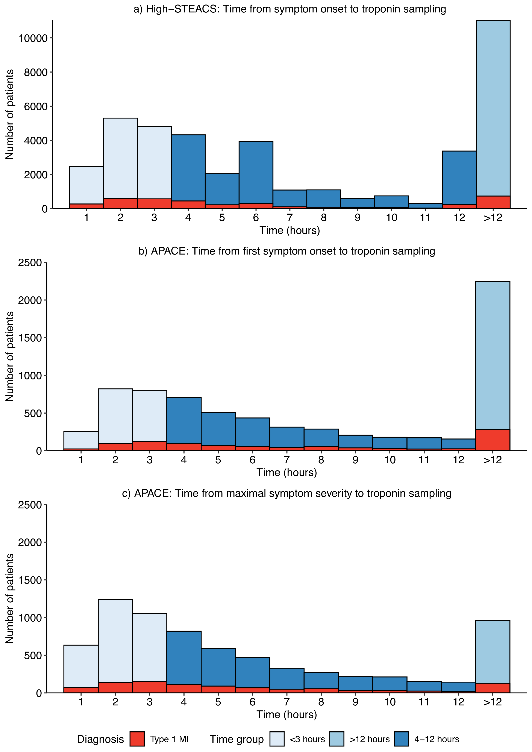

Supplementary Figure 2: Fourth Universal Definition of Myocardial infarction by time of symptom onset.
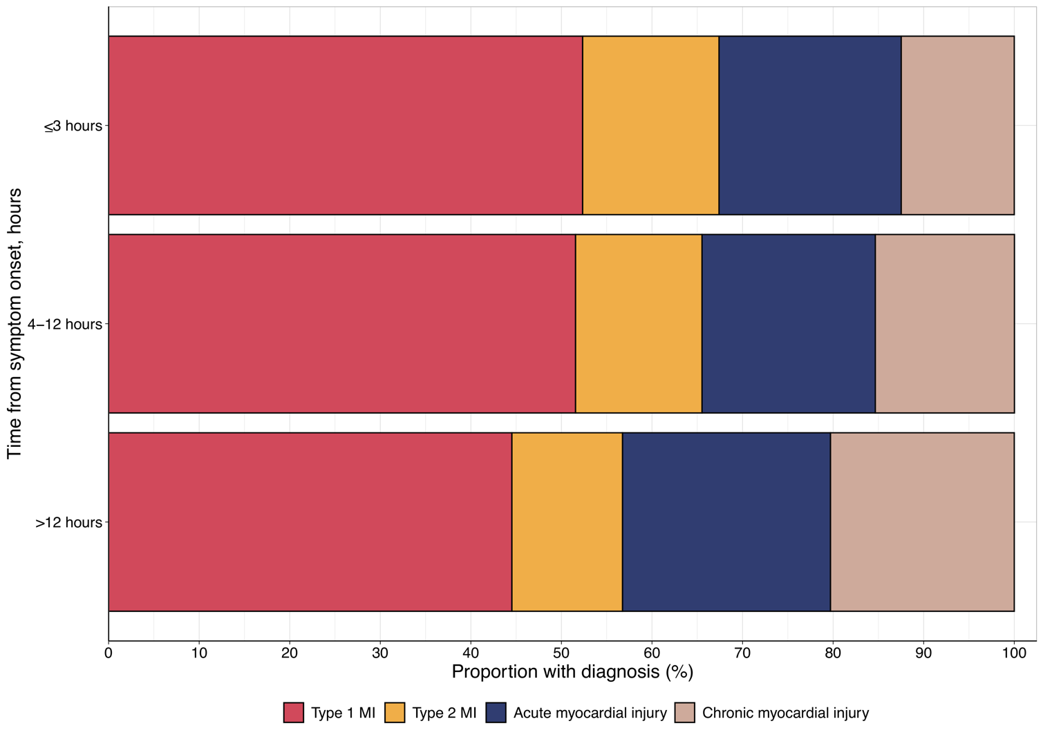

Supplementary Figure 3. Density estimtate of troponin concentrations by time from symptom onset
Density plot of the maximal cardiac troponin I concentration at presentation and following serial testing in patients with type 1 or type 4b myocardial infarction stratified by the time from symptom onset to the first troponin measurement.
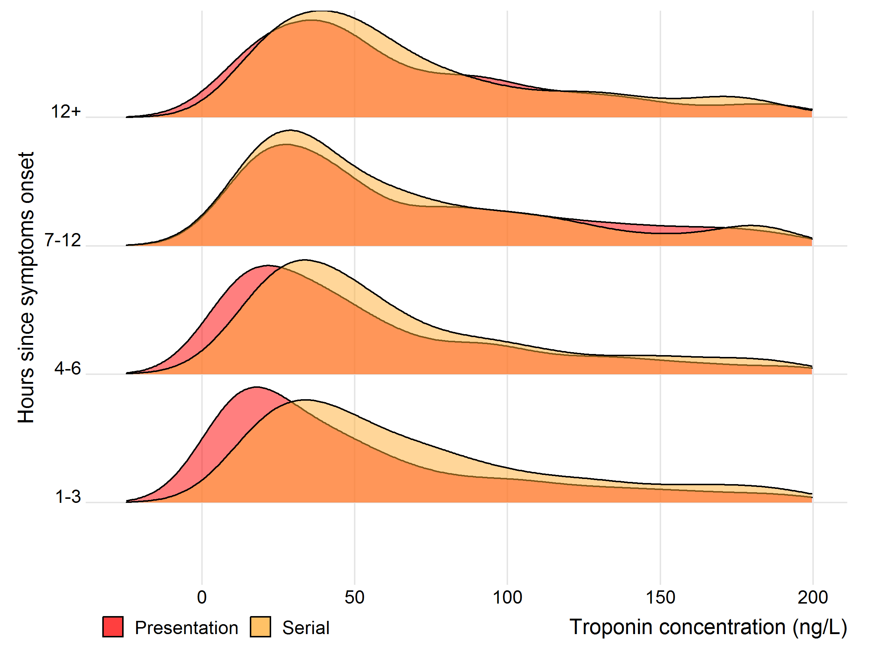
Supplementary Figure 4. Scatter plot with 95% confidence intervals showing the sensitivity (A) and negative predictive value (B) for patients with cardiac troponin concentrations below 2 ng/L (red), 5 ng/L (blue) and the sex-specific 99th centile (grey) at presentation by time from symptom onset for an outcome of type 1 or 4b myocardial infarction or cardiovascular death within 30 days of the index presentation (n=41,103).
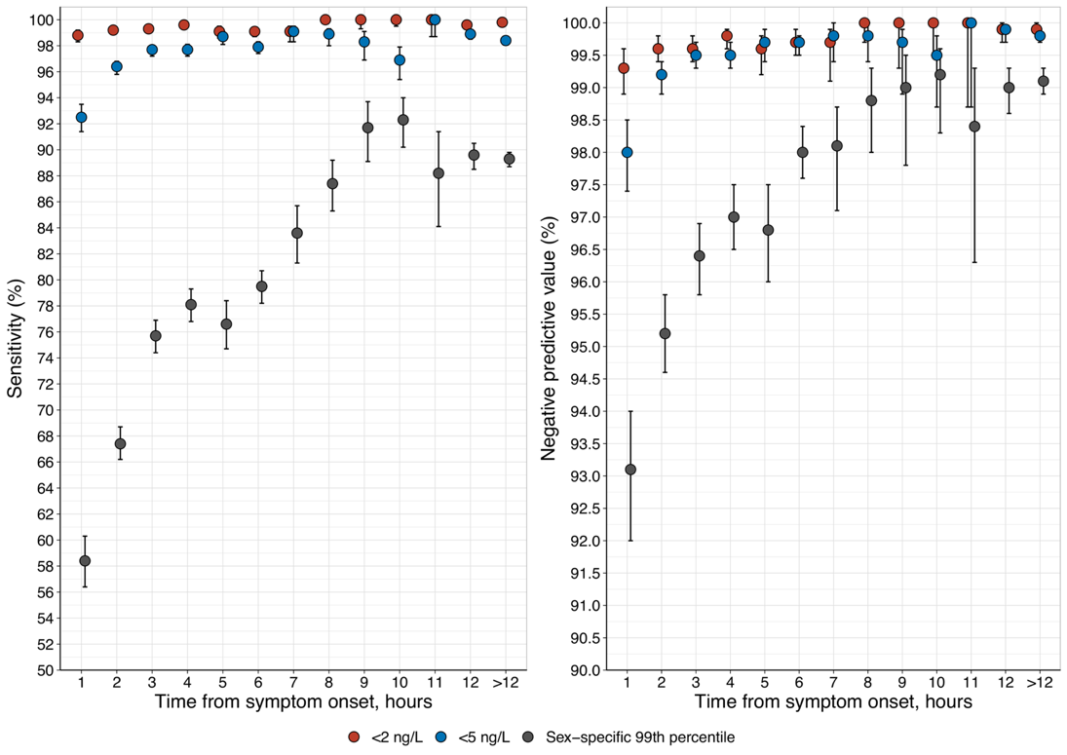
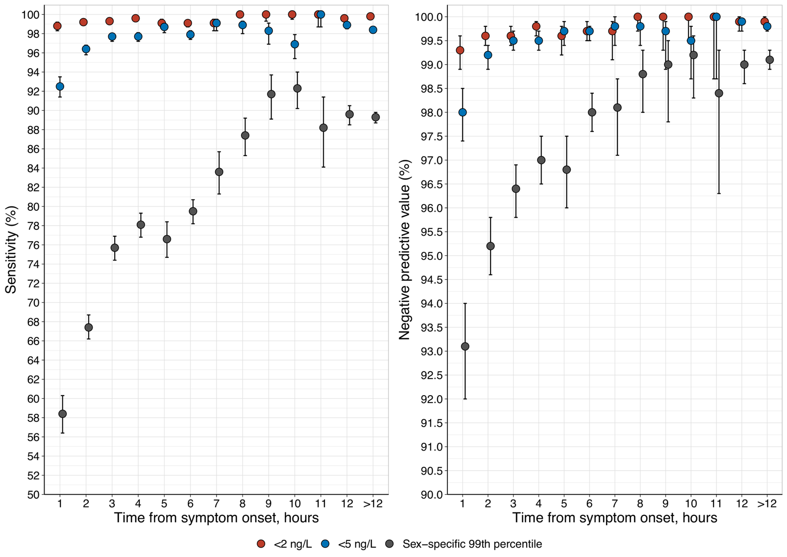
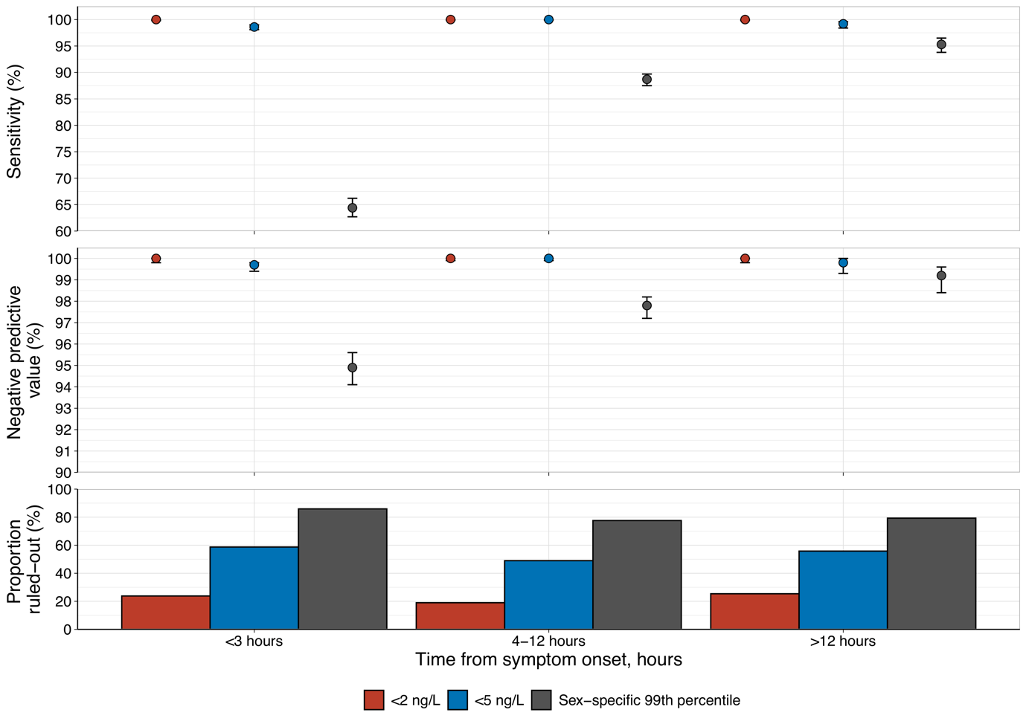
Supplemental Figure 5: Combined scatter and bar plot showing the sensitivity, negative predictive value and proportion of patients with cardiac troponin concentrations below 2 ng/L (red), 5 ng/L (blue) and the sex-specific 99th centile (grey) at presentation in the external validation cohort stratified by time from maximal symptom onset (n=7,088).

