Supplementary Figure 1. Solicited local and systemic adverse events reported after primary vaccination in Study 2019nCoV-501 in (A) HIV-negative participants, (B) People living with HIV (PLWH) [24,31]. SARS-CoV-2, severe acute respiratory syndrome coronavirus 2.
(A) Study 2019nCoV-501 – HIV-negative participants
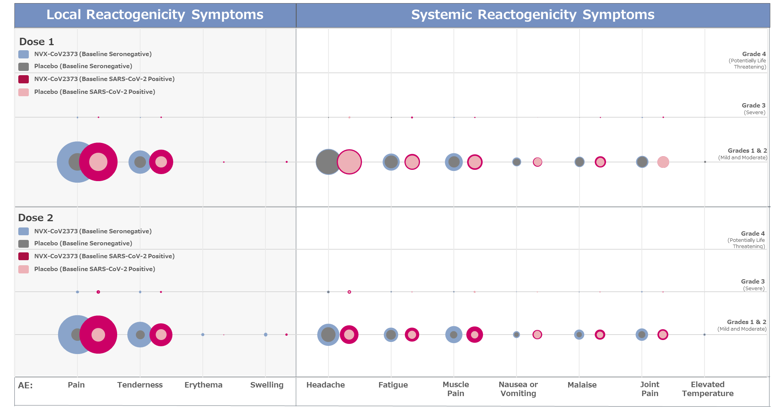
(B) Study 2019nCoV-501 – PLWH
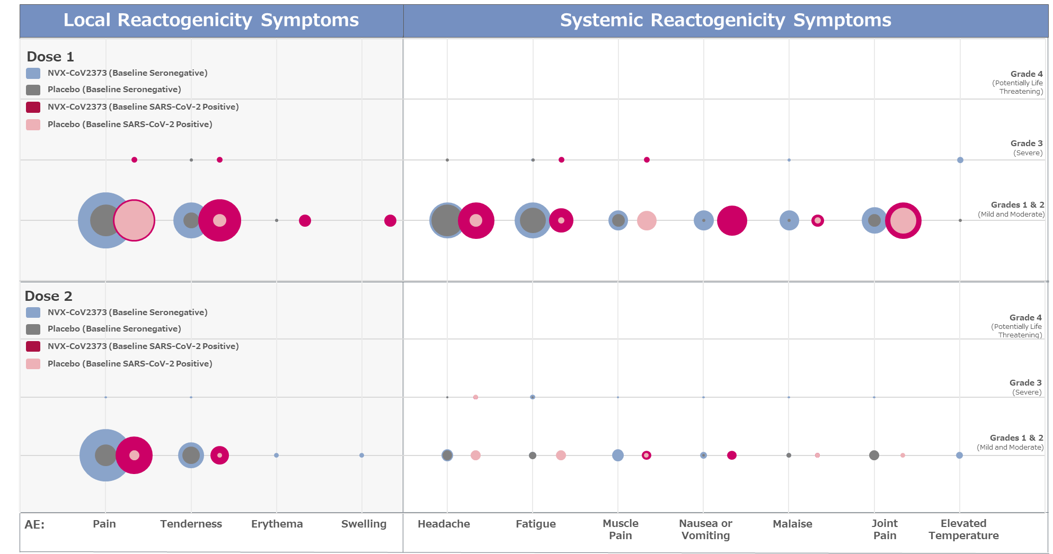
Supplementary Figure 2. Study 2019nCoV-101 immunogenicity of NVX-CoV2373 over time and relative to patients infected with SARS-CoV-2 stratified by clinical presentation [18]. (A) Geometric mean titer IgG response. (B) Geometric mean titer neutralizing antibody response.
(A)
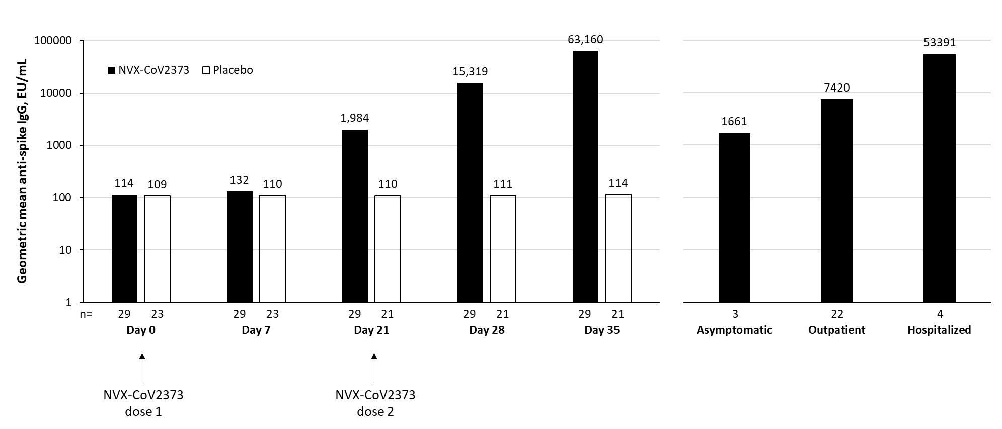
(B)
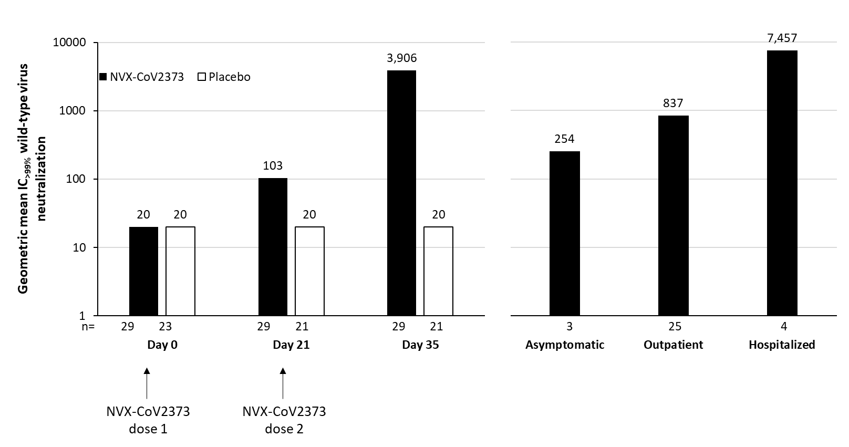
EU, enzyme-linked immunosorbent assay units; IC_{>99%}, inhibitory concentration >99%; IgG, immunoglobulin G; SARS-CoV-2, severe acute respiratory syndrome coronavirus 2.

