Figures

Figure 1:
Histogram showing age distribution of respondents to the survey. y axis – n (respondents), x axis - age banding.

Figure 2:
Overlap between the various measures of psychological morbidity: Figure illustrates extent and overlap of high scoring staff for each of the three types of work-related distress surveyed (n=1656)
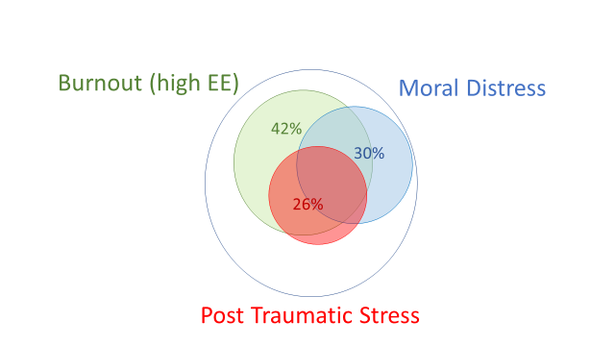

Moral distress defined as Moral Distress Scale-Revised ≥ 90; Burnout defined as abbreviated Maslach Burnout Inventory Emotional Exhaustion subscale ≥ 9 (equivalent to ≥27 on the full MBI); Post Traumatic Stress defined as Trauma Screening Questionnaire ≥ 6;

