Antibiotic prescription audit and feedback to reduce antibiotic consumption in primary care: A nationwide pragmatic randomized controlled trial
Soheila Aghlmandi¹, Florian S. Halbeisen¹, Ramon Saccilotto², Pascal Godet³, Andri Signorell⁴, Simon Sigrist⁵, Dominik Glinz¹, Giusi Moffa⁶, Andreas Zeller⁷, Andreas F. Widmer⁸, Andreas Kronenberg⁹, Julia Bielicki^{10,11}, Heiner C. Bucher¹
¹ Basel Institute for Clinical Epidemiology and Biostatistics, Department of Clinical Research, University Hospital Basel and University of Basel, Basel, Switzerland
² Department of Clinical Research, University Hospital Basel and University of Basel, Basel, Switzerland
³ Sanitas Insurance Zurich, Switzerland
⁴ Helsana Insurance Zurich, Switzerland
⁵ CSS Insurance Lucerne, Switzerland
⁶ Department of Mathematics and Computer Science, University of Basel, Basel, Switzerland
⁷ Centre for Primary Health Care, University of Basel, Basel, Switzerland
⁸ Division of Infectious Diseases and Hospital Hygiene, University Hospital Basel and University of Basel, Basel, Switzerland
⁹ Institute for Infectious Diseases, University of Bern, Bern, Switzerland
¹⁰ Infectious Diseases and Paediatric Pharmacology University Children’s Hospital Basel and University of Basel, Basel, Switzerland
¹¹ Centre for Neonatal and Paediatric Infection, St. George’s University London, London, UK

Correspondence to:
Heiner C. Bucher, MD MPH
Basel Institute for Clinical Epidemiology and Biostatistics, Department of Clinical Research, University Hospital Basel, CH-4031 Basel, Switzerland, Phone +41-79-542 98 60, Email: heiner.bucher@usb.ch, (http://www.ceb-institue.org)
Key points
Question Does automated quarterly antibiotic prescribing feedback with peer benchmarking over two years reduce antibiotic prescribing in the second year of the intervention in primary care physicians who are the top 75% prescribers of antibiotics (i.e. medium to high prescribers)?
Findings In this randomized trial of 3426 Swiss primary care physicians a 4.2% (95% confidence interval 3.9, 4.6) relative increase in antibiotic prescribing was noted in the cohort during the second year of the intervention (2019) compared to the baseline year in 2017. The median annual antibiotic prescribing rate per 100 consultations was 8.2 (Interquartile range IQR 6.1; 11.4) in the feedback and audit group (n = 1713) and 8.4 (IQR 6.0; 11.8) in the control group (n = 1713) in the second year of the intervention. Relative to the background increase, a statistically not significant -0.11% (-1.17, 0.97) reduction in antibiotic prescribing was found between the intervention and control groups.
Meanings Among medium to high prescribing primary care physicians, antibiotic prescribing audit and feedback did not reduce antibiotic prescribing.

Abstract
Importance Antibiotics are commonly prescribed in primary care, increasing the risk of antimicrobial resistance in the population.
Objective To investigate the impact of quarterly audit and feedback on antibiotic prescribing in medium to high antibiotic prescribing Swiss primary care physicians.
Design, Setting, and Participants Pragmatic randomized controlled trial in registered primary care physicians and paediatricians in single or small practices.
Intervention Primary care physicians were randomized in a 1:1 fashion to quarterly antibiotic prescribing audit and feedback with peer benchmarking versus no intervention for an intervention period of 2 years (2018-2019). Anonymized patient-level claims data from three health insurers serving roughly 50% of insures in Switzerland were used for audit and feedback. The intervention group also received evidence-based guidelines for respiratory and urinary tract infection management and community antibiotic resistance information. Physicians in the intervention group were blinded regarding the trial nature and physicians in the control group were not informed of the trial.
Main Outcomes and Measures The same claims data as used for audit and feedback were analysed to assess outcomes. The primary outcome was the antibiotic prescribing rate per 100 consultations during the second year of the intervention. There were eight secondary endpoints. Intention-to-treat analysis was performed using ANCOVA models.
Results
3426 physicians were randomised to intervention (n= 1713) and control groups (n= 1713) serving 629 825 and 622 344 patients, respectively, with a total of 4 790 525 consultations in the 2017 baseline year. In the entire cohort, a 4.22% (95% confidence interval 3.86, 4.58) relative increase in the antibiotic prescribing rate was noted during the second year of the intervention compared to the 2017 baseline year. In the intervention group, the median annual antibiotic prescribing rate per 100 consultations in the second year of the intervention was 8.16 (Interquartile range IQR 6.09; 11.43) and in the control group 8.41 (IQR 5.98; 11.78). Relative to the overall increase, a -0.11% (95%CI -1.17, 0.97) lower antibiotic prescribing per 100 consultations was found in the intervention compared to the control group. No relevant reductions in specific antibiotic prescribing rates were noted between groups except for quinolones in the second year of the intervention (-0.94% [95%CI -1.47, -0.41]).
Conclusion and Relevance Quarterly personalised antibiotic prescribing audit and feedback with peer benchmarking did not reduce antibiotic prescribing in medium to high-prescribing Swiss primary care physicians.
Trial Registration ClinicalTrial.gov Identifier: NCT03379194

Keywords
Antibiotics, antimicrobial resistance, prescription feedback, primary care, routinely collected patient data
Word count: Manuscript (abstract): 3163 (385), Tables: 4, 2 Figures: 2, References: 35.
Introduction
Most antibiotics in human medicine are prescribed in primary care for respiratory and urinary tract infections¹⁻⁴ contributing to increased population level antibiotic resistance. ⁵⁻⁷
Effective strategies to reduce antibiotic prescribing in primary care, like face-to-face education or communication training of primary care physicians, are resource-intense, costly, challenging to apply on a large scale and may not reach high prescribers not motivated to participate in such interventions.^{8,9} Therefore, system-wide strategies to improve antibiotic use in primary care are needed. Peer comparison audit and feedback can be an effective tool to modify physician behavior and be applied on a health system level at low-cost intervention for reducing antibiotic prescribing in primary care.¹⁰⁻¹² Only a few randomized controlled trials (RCTs) have evaluated audit and feedback interventions for antibiotic prescribing in primary care at the health system level. These trials have produced inconsistent results^{10,12-14}, which may be related to the intensity and type of feedback interventions, different settings and baseline level of prescribing.
In a nationwide pilot trial in Switzerland, we investigated the feasibility and the effectiveness of quarterly personalized prescription feedback to primary care physicians based on aggregated practice-based claims data¹¹ and did not observe a reduction in antibiotic prescribing in the intervention group. Feedback in our previous trial was based on aggregated information and did not allow ascribing antibiotic prescriptions to individual patients. Thus, patient factors, such as comorbidities, that may influence prescribing behavior and adverse consequences of the intervention could not be adequately considered.
The main objective of the current trial was to investigate the effect of patient-level claims data audit and feedback with peer benchmarking provided to physicians compared with no intervention on antibiotic prescribing in primary care. Adverse health outcomes (all-cause and infection-related hospitalizations) were a key secondary endpoint. An additional goal was to explore the feasibility to develop a nationwide antibiotic prescribing monitoring program using claims data.
Methods
Study design
This pragmatic randomized controlled trial targeted primary care physicians in Switzerland with medium to high antibiotic prescription rates and is based on routinely collected individual claims data of the large Swiss health insurers (Sanitas, CSS, and Helsana) providing health care coverage for approximately 50% of Swiss residents of all ages. We used pseudonymized physician and anonymized patient identifiers that were created by data managers of the insurance companies to ensure confidentiality. Claims data were formatted by data managers of health insurers according to a standard protocol that allowed for data import and the identification of the relevant physician population, the generation of the antibiotic prescribing feedback, and the generation of the full claims data set for the final analysis (Figure S2 Appendix). The study protocol was approved by all ethics committees in Switzerland (Leitethikkommission Nordwest- und Zentralschweiz, Project-ID 2017-00888). Details of the trial protocol have been previously published.¹⁵
Participants
We included board-certified primary care physicians and pediatricians with an individual practicing license number “Zentralregisternummer” (ZSR) identified under a unique address who were in top 75% prescribers of antibiotic (i.e. medium to high prescribers) with at least 100 patient contacts per year and identified 3426 from 4888 physicians assessed for eligibility in the claims data set of 2016. License numbers of large group practices and hospital-based ambulatory facilities were excluded but we included practices where more than one physician was working under one license number (Table S10 Appendix). Due to the delayed administrative processing of claims data the 2016 data set was taken for identification of physicians and sample size calculation.
Physicians in the intervention groups were unaware of the fact of being included in an intervention trial, and physicians in the control group were not informed that their antibiotic prescriptions were monitored for the duration of the trial.
Randomization and masking
Eligible physicians were randomized to the intervention and control group in a 1:1 ratio using a computer generated algorithm in R (R Core Team 2017).¹⁶ Physicians in the intervention groups were formally blinded regarding the fact of being included in an intervention trial, and physicians in the control group were not informed that their antibiotic prescription was monitored for the duration of the trial. As all trial-relevant data were collected by automated processes for claims data by health insurances, the outcome assessment may also be considered formally blinded.
Procedures
Continuously updated quarterly antibiotic prescription feedbacks contained (i) the personal overall prescription rates and (ii) antibiotic type per 100 consultations and year, (iii) the personal prescription rates for the three months of the same period of the preceding year, each category compared with the prescription rates of peer-physicians. (iv) In addition, each mailing contained a message for action (Details in appendix and reference¹⁵). The first mailing was sent on the 22nd of December 2017 and was followed by seven additional quarterly mailings, with the last mailing sent in late September 2019.
As there is a six months delay in the health insurance billing records, processing the yearly prescription feedbacks were based on the data from the period of nine months before the respective mailing. The first feedback mailing was based on antibiotic prescription rates between April 2016 to March 2017. Quarterly prescription feedbacks were prepared by one trial statistician with no further involvement in the analysis, and printed, packaged and mailed by staff not otherwise involved in the trial.¹⁵
With the first postal mailing, all primary care physicians in the intervention group received an accompanying letter explaining the intervention, a response card for physicians wishing to opt out, and evidence-based guidelines in German and French on antibiotic prescribing for respiratory and urinary tract infections.^{11,15,17} With the second feedback mailing, information on antibiotic resistance data and its regional distribution from the Swiss Centre for Antibiotic Resistance¹⁸ was provided. By the end of the study, 65 practices had closed down and 53 had withdrawn consent to participate further in the study (Figure S3 Appendix). All information material and guidelines were also made available to physicians in the intervention group on a password-protected trial website.
Outcomes
The primary outcome was the overall antibiotic prescription rate per 100 consultations in the second year of intervention (long-term intervention effect). The secondary outcomes were (1) overall antibiotic use per 100 patient consultations in the first year (short-term intervention effect) (2) and over two years while considering two repeated measurements, over the first and the second year of intervention; (3) use of broad-spectrum antibiotics (quinolones and oral cephalosporines) per 100 patient consultations; (4) all-cause and infection-related hospitalizations¹⁵; (5) antibiotic use in three specific patient age groups i) 0 to ≤5 years, ii) 6 to 64 years, iii) ≥65 years. Secondary outcomes (3) to (5) were to be evaluated separately over the second and first years of the intervention. The detail of the calculation of prescription rates are provided in the Appendix.

Statistical analysis
Details of the sample size calculation are provided elsewhere.¹⁵ We calculated monthly and annual medians for the number of antibiotic prescriptions per 100 consultations with associated interquartile ranges per physician license number (the unit of analysis) for the baseline year (2017) and the intervention periods (2018-2019). The primary and secondary outcomes were modeled using ANCOVA¹⁹, with the intervention as a factor of interest, baseline antibiotic prescription rates in 2017 and comorbidities (immunosuppression like conditions, metabolic disorders, cardiovascular disease, neurological disorders, respiratory diseases, and other conditions) as covariates, and an interaction term for the intervention with time. We report the coefficient estimates in percentage change in prescriptions per 100 consultations with the respective 95% CI.
Effects for an overall time of intervention (twenty-four months) period was assessed with a linear mixed model including the intervention, time (baseline, twenty-four months), and an interaction term for the intervention with time. From the model including the same covariates as the primary analysis and randomized physicians as random effects, we derived mean percentage changes from baseline for the intervention and control groups. Due to the skewed nature of antibiotic prescription rates, we log-transformed rates and back-transformed model estimates with log-log model formulations.
The number of hospitalizations (overall and infection-related) were modeled using Poisson regressions including the intervention as a factor of interest and all covariates from the primary analysis. Finally, we conducted stratified analyses by age groups as for the primary analysis over the respective periods (details are provided in the appendix). To report some of the baseline characteristics (Table 1), we used patient-level data but for modelling the data were aggregated on the physician ZSR license number.
All analyses followed CONSORT guidelines using intention-to-treat principles based on the final dataset, which became available in fall 2020.²⁰⁻²² We also conducted a per-protocol analysis and three post-hoc sensitivity analyses by excluding physicians who were identified as outliers for antibiotic-related endpoints at baseline, first year and second year of the intervention, by excluding practices of one to three or more than three physicians working under the same license number. Statistical analyses were performed using R (R Core Team 2017).¹⁶ The trial is registered at clinicalTrial.gov (NCT03379194).
Role of the funding resource
The study was funded by National Research Program 72 on Antimicrobial Resistance of the Swiss National Science Foundation. The funder of the study had no role in study design, data collection, data analysis, data interpretation, or writing of the report.

Results
Of 4888 physicians assessed for eligibility 3426 were randomised to the intervention (n=1713) and control groups (n=1713), with 1591 and 1579 physicians being available for analysis for the second year of the intervention (Figure 1). Physicians in the intervention and control groups at baseline in 2017 served 629 825 and 622 344 patients and prescribed 212 933 and 211 825 antibiotics for a total of 2 402 119 and 2 388 406 consultations. 55 physicians opted out of the intervention (Figure S3 Appendix). Patients’ characteristics were well balanced between study groups (Table 1).
Median annual antibiotic prescription rates per 100 consultations in the year preceding the trial were 8.41 (IQR 6.30; 11.46) in the intervention group and 8.35 (IQR 6.35; 11.64) in the control group. Prescription rates per 100 consultations, in the second and first year, were in the intervention group 8.16 (IQR 6.09; 11.43) and 8.32 (IQR 6.17; 11.69) and in the control group 8.41 (IQR 5.98; 11.78) and 8.51 (IQR 6.27; 11.99). Monthly median prescription rates are provided in Figure 2.
In comparison to the year 2017 prior to the intervention, a 4.22% (3.86, 4.58) increase in the antibiotic prescription rate was noted during the intervention phase in the entire cohort (Table S1 Appendix). Relative to these increased prescription rates in 2017 a small statistically non-significant -0.11% (-1.17, 0.97) reduction in antibiotic prescriptions per 100 consultations was found in the feedback group compared to the control group in the second year of the intervention (primary endpoint). During the first year and the entire trial period, antibiotic prescription rates in the intervention group slightly and additionally increased by 0.54% (-0.12, 1.21) and 0.50% (-0.22, 1.29) when compared with the control group (Figure 3). Findings were similar when restricting the analysis to practices with less than three physicians working under one license number (Table S8 Appendix).
Prescription rates for specific antibiotics were also increased during the intervention period when compared to the baseline year (Table S2 Appendix). Relative to these increased rates small relative reductions in antibiotic prescriptions were noted in the feedback compared to the control group during both years of the intervention, these reductions were all not statistically significant with the exception of quinolone prescriptions during the second year of the intervention (-0.94% (-1.47, -0.41)) (Figure 4). No statistically significant differences in antibiotic prescription rates were noted between the feedback and control groups for all pre-specified age-related subgroup analyses (Table S2 Appendix). Estimates from the per-protocol analysis likewise showed no reductions in antibiotic prescriptions between both groups (Table S9 Appendix). Also, no differences in infection-related and overall hospitalization rates were found between both groups during all observation periods (Table S7 Appendix).
Discussion
In this nationwide claims data-based pragmatic trial primary care physicians and paediatricians with the highest prescription rates in Switzerland were randomized to regular prescribing feedback, the provision of community-based antibiotic resistance data and evidence-based guidelines for respiratory and urinary tract infections, or controls not receiving any information. For the primary endpoint, the overall antibiotic prescription rate in the second year of the intervention, a very small - from a public health perspective not relevant - reduction of antibiotic prescription rates was noted. All pre-specified subgroup analyses showed also no difference between the two groups with the exception of a roughly 1% difference in quinolone prescriptions between the intervention and the control groups during the second year of the intervention.
Several smaller trials that were conducted in selected general practices used antibiotic prescription feedback in combination with personalized expert feedback²³, academic detailing²⁴, a practice accreditation programme²⁵ or in combination with decision support systems^{12,26,27}, and found a relative reduction in antibiotic prescriptions of about 5%. Some of these trials recruited motivated primary care physicians already engaged in education programs to reduce antibiotic prescriptions or were offered financial incentives for trial participation²⁶. Only a few trials used routine prescription feedback for high antibiotic prescribers in primary care on the health system level addressing the entire primary care physician community. In a trial in the UK, a 3.3% reduction in antibiotic prescriptions over 6 months was found when a single letter from England’s Chief Medical Officer with information on high prescription rates was sent to the top 20% of antibiotic prescribers.¹⁰ In a Canadian trial, the same intervention approach was used in the 25% top prescribers in Ontario and a 3.4% reduction over 12 months was found which was not statistically significant. ¹⁴ In a trial from New Zealand, a single letter providing peer antibiotic comparison found only reduced antibiotic use in high but not in low prescribers.²⁸ Another trial from Australia provided antibiotic prescription feedback twice over 6 months in unselected rural practices and found no difference in antibiotic prescribing.¹³
The negative findings from this trial are in contrast with results from the UK and Canadian trials which both included practices system-wide. First, antibiotic prescription rates in the UK trial were about 30% higher than in the present trial. ^{10,14} The Canadian trial was based on drug sales data with no denominator information. The present trial included - for reasons of sample size - about 80% of eligible practices and represents a more heterogeneous group of practices in terms of antibiotic prescribing patterns. Switzerland has one of the lowest antibiotic consumption rates among European countries. ²⁹⁻³¹ Thus, it seems difficult to further reduce antibiotic prescribing with our chosen approach in a setting with already low prescription rates, although we know that prescriptions of antibiotics in primary care for upper respiratory and urinary tract infections are still too high³² and the spread of multidrug resistance remains a problem in particular for gram-negative bacteria expressing extended-spectrum betalactamases.^{18, 33} Our trial has several limitations. Due to the long processing time of claims data by health insurer’s prescription feedback was sent to physicians with a delay of 6 months making it likely less relevant or more difficult to interpret in the actual clinical situation. ³⁴ Swiss claims data does not contain any diagnostic information from primary care, and therefore it was not possible to provide feedback on the appropriateness of antibiotic prescriptions. Legal issues in regard to the privacy of health data are major obstacles to overcome this data deficit in Switzerland. Social scientists emphasize the social normative aspects when aiming at behavior change in antibiotic stewardship interventions and the necessity to link peer comparisons to ‘appropriately top-prescribers’. ³⁴ We chose an average prescription benchmark rather than top prescribing practices as a reference to acknowledge prescribing variations due to differences in the case mix and the lack of diagnostic data for the reason of antibiotic prescriptions. Other investigators have advocated the use of top prescribers as a reference standard. ³⁴ Finally, our trial does not cover the entire Swiss population.
A relative increase in antibiotic prescriptions of 4% was noted in both years of the intervention concerning the baseline in 2017. The Swiss Ministry of Health also reported higher rates of influenza-like illnesses and invasive H. influenzae infections during the intervention period 2018/19 when compared to 2017.³⁵ This illustrates the importance to evaluate feedback interventions for antibiotic prescribing over sufficiently long periods to accurately account for seasonality effects.
Strengths of this trial are the formal blinding of physicians and data analysis, the conduct of an ITT and per-protocol analysis, the completeness and external validity of our data, and the use of non-aggregated patient-level claims data for certain endpoints. In our statistical approach - contrary to previous trials ^{10,14} - we integrated baseline prescription data, abstained from excluding practices with extreme prescription data, and included co-variates to address the patient case mix. Due to the large sample, all our estimates include small confidence intervals. Finally, we were able to explore the theoretical harm from the intervention by the analysis of hospitalization data.
In conclusion, quarterly detailed claims data-based prescription feedback to primary care physicians did not reduce antibiotic prescriptions during a two years intervention in the Swiss primary health care setting with already low antibiotic use when compared to other European countries. Whether health system-wide antibiotic stewardship programs with more individually tailored information on the appropriateness of antibiotic prescriptions, eventually combined with individual physician targeted incentives, might achieve further antibiotic use reductions has to be evaluated in future trials. Such trials, however, will need much more detailed routinely collected diagnostic and laboratory patient data.

Data sharing
Fully anonymized trial data and a data dictionary may be available with the publication of this study for purposes to be specified by applicants and with approval from the Research Committee of the programme ‘Antimicrobial Resistance’ from the Swiss National Science Foundation and with additional approval from the health insurers Helsana, CSS and Sanitas.
Competing interests
SA, FH, RS, GM, DG, AZ, AFW, JB, AK, and HCB declare no conflict of interest. PG is employed by Sanitas Health Insurance, AS is employed by Helsana Health Insurance, SS is employed by CSS Health Insurance. DG is currently employed with Roche Pharma Switzerland. His current employment has no role in any aspect that relates to trial conduct, analysis, or interpretation of data. The Basel Institute for Clinical Epidemiology and Biostatistics, University Hospital Basel, Basel, Switzerland was until December 2020 supported by Stiftung Institut für klinische Epidemiologie.
Author contributions
AW, AZ, RS and HCB conceived the study and developed the protocol. GM and HCB created the personalized feedback system. AW, AZ and HCB wrote the clinical guidelines. SA, FH, GM, RS managed the data. DG, GM, RS and SA coordinated the set-up of the postal feedback intervention. SA and FH analyzed the data. SA and HCB wrote the first draft and all authors made revisions on the manuscript. All authors read and approved the final version of the manuscript. HCB is the guarantor. All authors had full access to all the analyses data in the study and had final responsibility for the decision to submit for publication. SA, FH and HCB had accessed and verified the data.
Acknowledgements
We thank Diana Grauwiler for administrative assistance.
References
1. Akkerman AE, Kuyvenhoven MM, Verheij TJ, van Dijk L. Antibiotics in Dutch general practice: nationwide electronic GP database and national reimbursement rates. Pharmacoepidemiol Drug Saf. 2008;17(4):378-383.
2. Hawker JI, Smith S, Smith GE, et al. Trends in antibiotic prescribing in primary care for clinical syndromes subject to national recommendations to reduce antibiotic resistance, UK 1995-2011: analysis of a large database of primary care consultations. J Antimicrob Chemother. 2014;69(12):3423-3430.
3. Petersen I, Hayward AC. Antibacterial prescribing in primary care. J Antimicrob Chemother. 2007;60 Suppl 1:i43-47.
4. Smucny J, Fahey T, Becker L, Glazier R. Antibiotics for acute bronchitis. Cochrane Database Syst Rev. 2004(4):CD000245.
5. Costelloe C, Metcalfe C, Lovering A, Mant D, Hay AD. Effect of antibiotic prescribing in primary care on antimicrobial resistance in individual patients: systematic review and meta-analysis. BMJ. 2010;340:c2096.
6. Goossens H, Ferech M, Vander Stichele R, Elseviers M. Outpatient antibiotic use in Europe and association with resistance: a cross-national database study. Lancet. 2005;365(9459):579-587.
7. Hillier S, Roberts Z, Dunstan F, Butler C, Howard A, Palmer S. Prior antibiotics and risk of antibiotic-resistant community-acquired urinary tract infection: a case-control study. J Antimicrob Chemother. 2007;60(1):92-99.
8. Butler CC, Simpson SA, Dunstan F, et al. Effectiveness of multifaceted educational programme to reduce antibiotic dispensing in primary care: practice based randomised controlled trial. BMJ. 2012;344:d8173.
9. Gjelstad S, Hoye S, Straand J, Brekke M, Dalen I, Lindbaek M. Improving antibiotic prescribing in acute respiratory tract infections: cluster randomised trial from Norwegian general practice (prescription peer academic detailing (Rx-PAD) study). BMJ. 2013;347:f4403.
10. Hallsworth M, Chadborn T, Sallis A, et al. Provision of social norm feedback to high prescribers of antibiotics in general practice: a pragmatic national randomised controlled trial. Lancet. 2016;387(10029):1743-1752.
11. Hemkens LG, Saccilotto R, Reyes SL, et al. Personalized prescription feedback using routinely collected data to reduce antibtiotic use in primary care: a nationwide pragmatic randomized trial. JAMA Intern Med. 2016;177:176-183.
12. Gulliford MC, Prevost AT, Charlton J, et al. Effectiveness and safety of electronically delivered prescribing feedback and decision support on antibiotic use for respiratory illness in primary care: REDUCE cluster randomised trial. Bmj-Brit Med J. 2019;364.
13. O'Connell DL, Henry D, Tomlins R. Randomised controlled trial of effect of feedback on general practitioners' prescribing in Australia. Bmj-Brit Med J. 1999;318(7182):507-+.
14. Schwartz KL, Ivers N, Langford BJ, et al. Effect of Antibiotic-Prescribing Feedback to High-Volume Primary Care Physicians on Number of Antibiotic Prescriptions A Randomized Clinical Trial. Jama Internal Medicine. 2021;181(9):1165-1173.
15. Glinz D, Mc Cord KA, Moffa G, et al. Antibiotic prescription monitoring and feedback in primary care in Switzerland: Design and rationale of a nationwide pragmatic randomized controlled trial. Cont Clin Trial Comm. 2021;21.
16. R Core Team 2017. R: A language and environment for statistical computing. R Foundation for Statistical Computing, Vienna, Austria. URL https://www.R-project.org/.
17. Hemkens LG, Saccilotto R, Reyes SL, et al. Personalized prescription feedback to reduce antibiotic overuse in primary care: rationale and design of a nationwide pragmatic randomized trial. BMC Infect Dis. 2016;16:421.
18. Institut für Infektionskrankheiten. Swiss Centre for Antibiotic resistance. www.anresis.ch.
19. Wang B, Ogburn EL, Rosenblum M. Analysis of covariance in randomized trials: More precision and valid confidence intervals, without model assumptions. Biometrics. 2019;75(4):1391-1400.
20. Schulz KF, Altman DG, Moher D, Group C. CONSORT 2010 statement: updated guidelines for reporting parallel group randomized trials. Ann Intern Med. 2010;152(11):726-732.
21. Juszczak E, Altman DG, Hopewell S, Schulz K. Reporting of Multi-Arm Parallel-Group Randomized Trials: Extension of the CONSORT 2010 Statement. JAMA. 2019;321(16):1610-1620.
22. Piaggio G, Elbourne DR, Pocock SJ, Evans SJ, Altman DG, Group C. Reporting of noninferiority and equivalence randomized trials: extension of the CONSORT 2010 statement. JAMA. 2012;308(24):2594-2604.
23. Eilermann K, Halstenberg K, Kuntz L, Martakis K, Roth B, Wiesen D. The Effect of Expert Feedback on Antibiotic Prescribing in Pediatrics: Experimental Evidence. Med Decis Making. 2019;39(7):781-795.
24. Gjelstad S, Hoye S, Straand J, Brekke M, Dalen I, Lindbaek M. Improving antibiotic prescribing in acute respiratory tract infections: cluster randomised trial from Norwegian general practice (prescription peer academic detailing (Rx-PAD) study). Bmj-Brit Med J. 2013;347.
25. van der Velden AW, Kuyvenhoven MM, Verheij TJM. Improving antibiotic prescribing quality by an intervention embedded in the primary care practice accreditation: the ARTI4 randomized trial. J Antimicrob Chemoth. 2016;71(1):257-263.
26. Meeker D, Linder JA, Fox CR, et al. Effect of Behavioral Interventions on Inappropriate Antibiotic Prescribing Among Primary Care Practices A Randomized Clinical Trial. Jama-J Am Med Assoc. 2016;315(6):562-570.
27. Linder JA, Meeker D, Fox CR, et al. Effects of Behavioral Interventions on Inappropriate Antibiotic Prescribing in Primary Care 12 Months After Stopping Interventions. Jama-J Am Med Assoc. 2017;318(14):1391-1392.
28. Chappell N, Gerard C, Gyani A, et al. Using a randomised controlled trial to test the effectiveness of social norms feedback to reduce antibiotic prescribing without increasing inequities. New Zeal Med J. 2021;134(1544):13-34.
29. Adriaenssens N, Coenen S, Versporten A, et al. European Surveillance of Antimicrobial Consumption (ESAC): outpatient quinolone use in Europe (1997-2009). J Antimicrob Chemother. 2011;66 Suppl 6:vi47-56.
30. European Centre for Disease Prevention and Control. Summary of the latest data on antibiotic consumption in the European Union. ESAC-Net surveillance data November 2016. http://ecdc.europa.eu/en/eaad/antibiotics-get-informed/antibiotics-resistance-consumption/Pages/data-reports.aspx.
31. Federal Office of Public Health and Federal Food Safety and Veterinary Office. Swiss Antibiotic Resistance Report 2016. Usage of Antibiotics and Occurrence of Antibiotic Resistance in Bacteria from Humans and Animals in Switzerland. FOPH publication number: 2016-OEG-30 http://www.anresis.ch/files/pdf/BAG_Swiss_Antibiotic_Resistance_Report_2016_WEB.pdf.
32. Glinz D, Leon Reyes S, Saccilotto R, et al. Quality of antibiotic prescribing of Swiss primary care physicians with high prescription rates: a nationwide survey. J Antimicrob Chemother. 2017;72(11):3205-3212.
33. Murray CJL, Ikuta KS, Sharara F, et al. Global burden of bacterial antimicrobial resistance in 2019: a systematic analysis. Lancet. 2022;399(10325):629-655.
34. Fox CR, Doctor JN, Goldstein NJ, Meeker D, Persel SD, Linder JA. Details matter: predicting when nudging clinicians will succeed or fail. Bmj-Brit Med J. 2020;370.
35. Office FOoPHaFFSaV. Informationsmagazin für medizinische Fachpersonen und Medienschaffende. BAG-Bulletin. 2020;Ausgabe vom 10. Februar 2020.

Figures and Tables
Figure 1 Flow diagram of primary care physicians and pediatrician’s disposition (ITT)
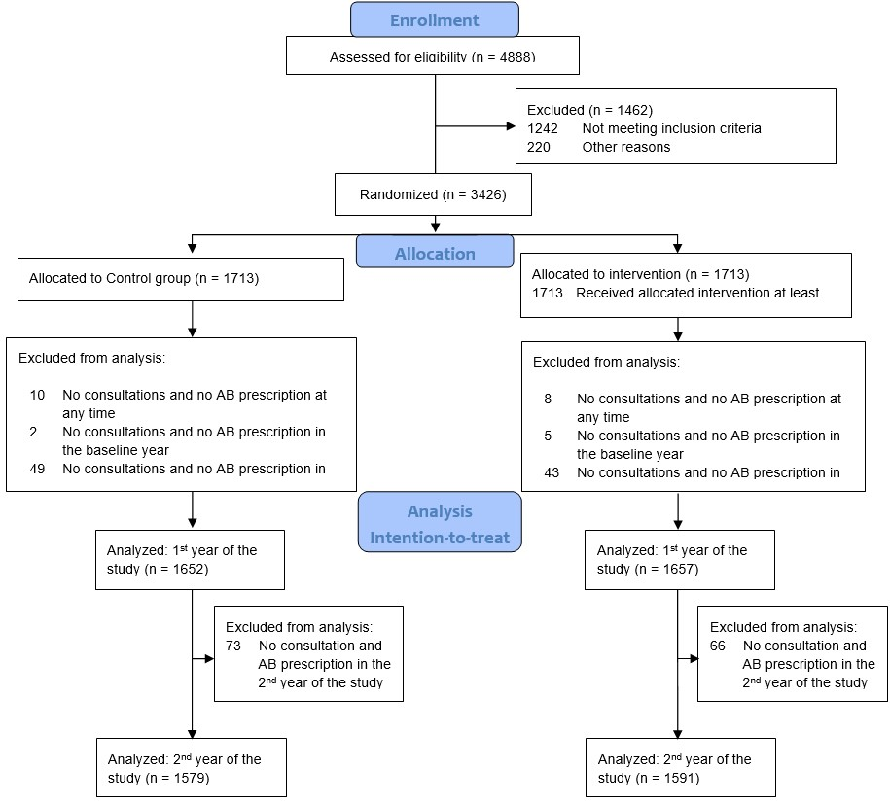

Figure 2 Median (IQR) of antibiotic prescription rates per month
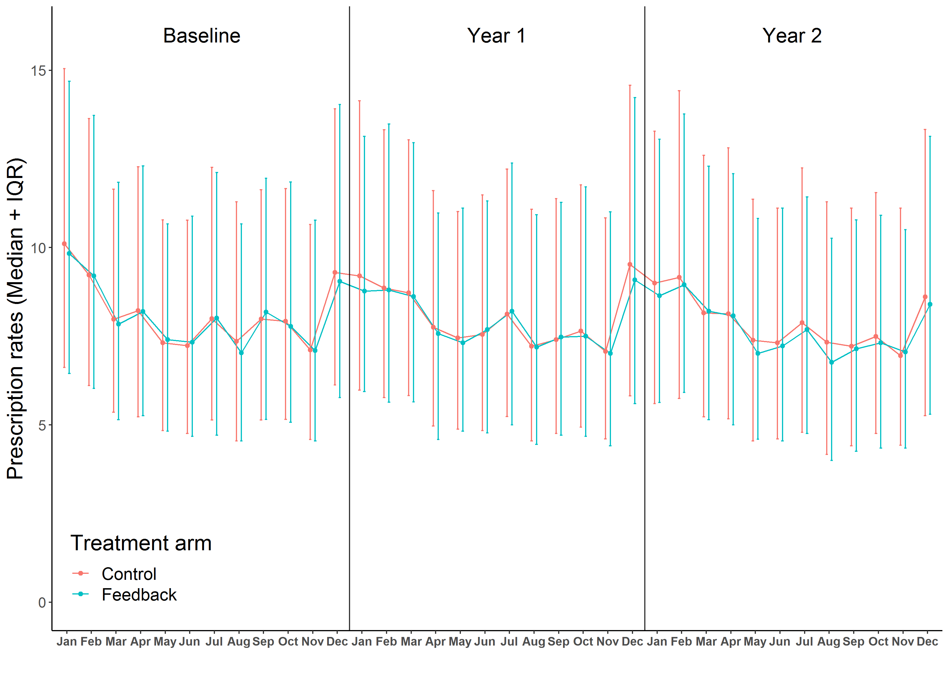

Figure 3 Change of prescription rates per 100 consultations by physicians in the intervention vs. the control group in the second year of the intervention (ITT) relative to the baseline year 2017

Prescribing for specific populations or specific antibiotics | % (95 CI) | Feedback Control
All patients*
 | -0.11 (-1.17, 0.97)
 | -0.14 (-1.20, 0.94)
0-5 years
 | -0.75 (-1.98, 0.50)
 | -0.64 (-1.85, 0.59)
6-65 years
 | <0.01 (-1.01, 1.02)
 | 0.01 (-1.00, 1.03)
>65 years
 | 0.39 (-0.60, 1.40)
 | 0.46 (-0.53, 1.46)
Macrolides
 | 0.04 (-0.53, 0.60)
 | 0.03 (-0.53, 0.59)
Other β-Lactams
 | -0.71 (-1.93, 0.53)
 | -0.74 (-1.95, 0.50)
Quinolones
 | -0.94 (-1.47, -0.41)
 | -1.04 (-1.57, -0.52)
Between-group differences, %
*For each category the first line is the base model (treatment variable adjusted to baseline prescription rate) and the second is the multivariable model adjusted to the predefined comorbidities

Figure 4 Change of prescription rate per 100 consultations by physicians in the intervention vs. the control group in the first year of the intervention (ITT) relative to the baseline year 2017

Prescribing for specific populations or specific antibiotics | % (95 CI) | Feedback Control
All patients*
 | 0.54 (-0.12, 1.21)
 | 0.53 (-0.13, 1.20)
0-5 years
 | -0.30 (-1.47, 0.88)
 | -0.22 (-1.38, 0.96)
6-65 years
 | -0.21 (-0.91, 0.50)
 | -0.21 (-0.90, 0.52)
>65 years
 | -0.56 (-1.24, 0.13)
 | -0.53 (-1.22, 0.16)
Macrolides
 | -0.12 (-0.61, 0.37)
 | -0.14 (-0.62, 0.35)
Other β-Lactams
 | -0.56 (-1.73, 0.63)
 | -0.62 (-1.79, 0.56)
Quinolones
 | 0.04 (-0.43, 0.53)
 | -0.03 (-0.5, 0.45)
Between-group differences, %
* For each category the first line is the base model (treatment variable adjusted to baseline prescription rate) and the second is the multivariable model adjusted to the predefined comorbidities

Table 1 Baseline characteristics (using data from Baseline year 2017)

 | Statistic | Total | Intervention | Control
Number of patients | n (%) | 1252169 (100%) | 629825 (50.30%) | 622344 (49.70%)
 | Median (Q1, Q3) | 337 (236, 480) | 338 (233, 482.25) | 336 (238, 475)
Patients’ age
Ages <=5 years | n (%) | 187557 (14.98%) | 95468 (7.63%) | 92089 (7.35%)
Ages 6 – 64 years | n (%) | 711234 (56.8%) | 358622 (28.63%) | 352612 (28.16%)
Ages >= 65 years | n (%) | 353378 (28.22%) | 175735 (14.04%) | 177643 (14.19%)
Gender
Females | n (%) | 686633 (54.84%) | 344098 (27.48%) | 342535 (55.04%)
Patients with comorbidities*
Immunsuppression like conditions¹ | n (%) | 1400627 (100%) | 699822 (49.96%) | 700805 (50.04%)
Metabolic disorders | n (%) | 1270058 (100%) | 635431 (50.03%) | 634627 (49.97%)
Cardiovascular disease, and  Neurological disorders | n (%) | 2523931 (100%) | 1260454 (49.94%) | 1263477 (50.06%)
Respiratory disease | n (%) | 834878 (100%) | 417552 (50.01%) | 417326 (49.99%)
Other² | n (%) | 2836897 (100%) | 1419263 (50.3%) | 1417634 (49.97%)
Number of consultations  (Baseline year 2017) | n (%) | 4790525 (100%) | 2402119 (50.14%) | 2388406 (49.86%)
 | Mean (SD) | 1447.73 (805.88) | 1454.07 (817.13) | 1441.4 (794.71)
 | Median (Q1, Q3) | 1283 (869, 1861) | 1301 (872.5, 1859.25) | 1271 (865, 1862)
¹ Classification according to pharmacy cost groups
² Psychiatric disorders, gastric acid-related disorders, and iron deficiency anaemia
* Multiple comorbidities per patient are possible

