Supplementary Materials to

Methylprednisolone Versus Intravenous Immunoglobulins in Children with Paediatric Inflammatory Multisystem Syndrome Temporally Associated with SARS-CoV-2: A Randomized Multicentre Trial

Corresponding author:
Prof. Luregn Schlapbach, MD, PhD, FCICM
Department of Intensive Care and Neonatology
University Children's Hospital Zurich – Eleonore Foundation
Steinwiesstrasse 75
CH-8032 Zurich Switzerland
phone +41 44 266 71 11
email: luregn.schlapbach@kispi.uzh.ch

Supplementary Appendix Table of Contents

eMethods
1. List of ethics approval numbers and approved protocol modifications
2. Data monitoring plan
3. Swiss PIMS-TS case definition
4. Bayesian Analysis

eTables

eTable S1: Enrollment statistics by site
eTable S2: Laboratory characteristics and echocardiographic findings at baseline
eTable S3: Baseline risk factors for time to discharge from the fitted Cox PH models
eTable S4: Baseline risk factors for the need for “any respiratory support” (post-randomisation)
eTable S5: Subgroup and posthoc analyses
eTable S6: Overview severe adverse events during study period

eFigures

eFigure S1: Time from admission to discharge in PIMS-TS patients
eFigure S2: Kaplan-Meier plot for time from admission to discharge
eFigure S3: Biomarker trajectories, stratified by arm; LOESS smoothers shown as thick lines

eMethods

- List of ethics approval numbers and approved protocol modifications

Version Nr. | Version Date | Comments | Approval Date
1∙0 | 10.03.2021 | With conditions
1∙1 | 23.03.2021 | Answering the condition | 30.03.2021
1∙2 | 16.06.2021 | Change measurements and procedure/study duration | 13.07.2021
1∙3 | 18.01.2022 | Change measurements and procedures/study duration | 10.02.2022

- Data monitoring plan

Action |  | Extent | Timeframe | Comment
Site initiation visit |  | All sites | After Ethic approval and prior of inclusion of the first patient by site
Regular communication |  | All sites | Every 14 to 21 days during recruitment by video conferences
Central data monitoring | Protocol compliance | 100% | Every 3 months for all patients enrolled at least 42 days prior to agreed monitoring date | Documentation of eligibility criteria, evaluation of recorded treatments in relation to randomization
 | Primary outcome | 100% |  | Data collection and documentation. Differences in collection and documentation by site
 | Data completeness | 100% |  | All data requested for 28-day follow-up proceeded and recorded in database. Differences in collection and documentation by site
 | Data consistency | 100% |  | Inconsistencies/error in data entry revised and addressed

- Swiss PIMS-TS case definition

List of diagnostic criteria for PIMS-TS
General | Criteria
Clinical features
Required | Fever
Organ systems | Single or multi-organ involvement
Gastrointestinal | Abdominal pain, diarrhea, vomiting  Abnormal liver function test  Colitis, ileitis, ascites
Cardiovascular | Hypotension, shock, oliguria  Myocardial dysfunction, pericardial effusion  Coronary artery abnormalities
Respiratory | Cough, sore throat  Oxygen requirement  Patchy infiltrates, pleural effusions
Dermatologic | Conjunctivitis, periorbital swelling/redness  Mucus membrane changes  Rash  Lymphadenopathy  Swollen hands and feet
Neurologic | Headache, confusion, irritability, reduced level of consciousness  Syncope
Abnormal laboratory findings indicating inflammation (any combination)
Inflammatory markers | Elevated CRP/fibrinogen/D-Dimers/ferritin, hypoalbuminemia, lymphopenia, neutrophilia
Cardiac biomarkers | Elevated Troponin T/NT-pro-BNP
COVID-19 contact | Either confirmed or putative
Confirmed | Positive for current or recent SARS-CoV-2 infection by PCR, serology, or antigen test
Putative | COVID-19 exposure within 4 weeks prior to the onset of symptoms
No alternative plausible diagnosis (microbial or inflammatory)
Patients must be below 18 years and meet at least one criterion for each group, including (i) presence of fever, (ii) organ involvement, (iii) laboratory evidence of inflammation, (iv) microbiologically proven or putative COVID-19 contact, and (v) exclusion of other causes.

Reference: Schlapbach LJ, Andre MC, Grazioli S, et al. Best Practice Recommendations for the Diagnosis and Management of Children With Pediatric Inflammatory Multisystem Syndrome Temporally Associated With SARS-CoV-2 (PIMS-TS; Multisystem Inflammatory Syndrome in Children, MIS-C) in Switzerland. Front Pediatr 2021; 9: 667507.

- Bayesian Analysis
We fitted a negative binomial (NB) model for the time to discharge (y), adjusting for treatment arm (trt = 0, 1) and baseline age, assuming non-informative priors such that:
$$y |{ β}_{0}, { β}_{1}, { β}_{2},{ β}_{3}, r \sim NB\left(μ, r\right), with$$
$$μ={ β}_{0}+ \sum_{i=1}^{2}{{ β}_{i} trt+ }β_{3}age, where$$
$$β_{i}\sim N\left(0, 100\right) for i=0,..,3, and a discrete prior for r on \left[0, 100\right].$$

The model was run for a total of 50’000 cycles with a 25’000 burn-in period (single chain, no thinning). Visual checking of the diagnostics indicated parameter convergence.

OpenBUGs code used for the Bayesian analysis:

library(R2OpenBUGS)
library(coda)
library(data.table)
library(matlab)
library(MASS)

## PRIMARY ANALYSIS MODEL
mymodel <- function() {
for (i in 1:N) {
# negative binomial
Y[i] ~ dnegbin(p[i], r) #%_% C(0, 28) # NOTE size (r) is discrete in openbugs / in JAGS can be cts
# censoring at 28 days as in the primary analysis
# %_% allows to save model in R due to syntax errors otherwise, removed in BUGs.

p[i] <- r/(r+lambda[i])

#negative binomial - uk recovery ped. sap incl. treatment contrasts and age
log(lambda[i]) <- beta0
+beta[x[i]]
+beta4*(age[i]-mean(age[i])) # centred
}

#Priors

# Poisson/negbin
beta0 ~ dnorm(0, 0.01)
# prior used in the UK recovery ped. SAP
#beta0~dt(log(10.0), 1/2.5, 3) # dt(mu, tau, k), tau=1/k is the degrees of freedom
#beta1 ~ dnorm(0, 0.01)

# negbin
# discrete prior on 1 to 100
for(j in 1:100){ prob[j]<-1/100}
r ~ dcat(prob[])

#theta<-pow(1/mean(p[1:N]), 2)
#sp<-p[1:N]
#scaleparam<-(1-sp)/sp

# anova
for (j in 1:2) {
beta[j] ~ dnorm(0,0.01) # from UK ped. SAP - Beta_i~N(0, 10^2)
}
beta4 ~ dnorm(0, 0.01) # estimate for age

#Other Derived parameters
# Group means (note, beta is a vector)
Group.means1 <-exp(beta0+beta[1])
Group.means2 <-exp(beta0+beta[2])
tr.diff<-Group.means2-Group.means1
p.diff<-step(-tr.diff) # Pr(diff>=0) # definition says strictly negative, but Pr(diff=0)=0 effectively.
}

eTables

eTable S1: Enrollment statistics by site
Study site location | Eligible patients (n) | Enrolled patients (n)
A | 1 | 1
B | 11 | 9
C | 0 | 0
D | 24 | 7
E | 1 | 1
F | 14 | 9
G | 10 | 7
H | 20 | 12
I | 12 | 6
J | 34 | 24
total | 127 | 76

eTable S2: Laboratory characteristics and echocardiographic findings at baseline
(N (%) for categorical variables, median [IQR] for continuous variables | Methylprednisolone | IVIG | Total | Reference
 | N=37 | N=38 | N=75 | values
Whole blood count
Haemoglobin (g/L) | 118 [106, 128] | 118 [106, 125] | 118 [106, 126]  4 (5%) | 115-155
White blood cells  missing | 8∙3 [6∙3, 11∙3] | 10∙9 [7∙4, 13∙6] | 9∙4 [6∙5, 12∙6]  5 (7%) | 4∙5-13∙5
Neutrophil count (*10⁹/L)  missing | 6∙7 [4∙9, 9∙6] | 8∙7 [5∙2, 11∙9] | 7∙2 [4∙9, 10∙9]  7 (9%) | 1∙5-8
Lymphocyte count (*10⁹/L)  missing | 0∙7 [0∙5, 1∙2] | 0∙8 [0∙6, 1∙3] | 0∙7 [0∙5, 1∙3]  8 (11%) | 1∙5-6∙8
Platelet count (*10⁹/L)  missing | 135 [99, 191] | 156 [118, 256] | 146 [106, 216]  7 (9%) | 150-450
Coagulation/Inflammation
D-dimers (ng/ml)  missing | 2800 [1513, 5000] | 2485 [1630, 5627] | 2650[1613, 5470]  17 (23%) | 190-500
Fibrinogen (g/L)  missing | 5∙9 [4∙9, 7∙7] | 5∙3 [4∙6, 6∙4] | 5∙6 [4∙8, 7∙1]  15 (20%) | 1∙7-4∙1
Ferritin (µg/mL)  missing | 445 [217, 594] | 704 [306, 1068] | 549 [243, 851]  16 (21%) | 14-124
C-reactive protein (mg/L)  missing | 142 [98, 200] | 171 [114, 242] | 162 [101, 228]  7 (9%) | < 10
Chemistry
Albumin (g/L)  missing | 31 [29, 36] | 31 [27, 33] | 31 [28, 34]  15 (20%) | 35-49
Creatinine (µmol/L)  missing | 48 [34, 58] | 46 [38, 63] | 47 [37, 60]  11 (15%) | 25-55
Bilirubin (mmol/L)  missing | 10∙0 [8∙0, 18∙0] | 7∙9 [3∙0, 15∙3] | 9∙5 [5∙0, 18∙0]  26 (35%) | < 21
pH  missing | 7∙41 [7∙37, 7∙44] | 7∙41 [7∙37, 7∙44] | 7∙41 [7∙38, 7∙44]  14 (19%) | 7∙35-7∙40
Base excess (mmol/L)  missing | -1∙8 [-4∙8, 0∙10] | -1∙2 [-2∙3, -0∙1] | -1∙5 [-3∙6, 0∙1]  18 (24%) | -3 to +3
LDH (U/L)  missing | 251∙5 [220∙8, 302∙5] | 285∙0 [222∙0, 397∙0] | 258∙0 [221∙0, 322∙5]  24 (32%) | < 307
NTpro-BNP (pg/ml)  missing | 2394 [5, 25735] | 4191 [77, 64982] | 3104 [906, 7382]  10 (13%) | < 125
Troponin T (ng/L)  missing | 13 [6, 32] | 24 [6, 61] | 19 [6, 37]  11 (15%) | < 14
ALT (U/L)  missing | 22 [14, 57] | 30 [19, 42] | 27 [15, 48]  8 (11%) | 9-25
AST (U/L)  missing | 32 [26, 57] | 35 [22, 49] | 32 [24, 53]  10 (13%) | 22-41
GGT (U/L)  missing | 37 [16, 78] | 27 [15, 55] | 27 [15, 66]  26 (35%) | 6-16
Legend: ¹echocardiography was performed in 16 patients at baseline, Abbreviation: IVIG intravenous immunoglobulin G, ALT Alanine transaminase, AST Aspartate transaminase, GGT Gamma-glutamyl transferase, LDH Lactate acid dehydrogenase, NT-proBNP N-terminal prohormone of brain natriuretic peptide, IQR Inter-quartile ranges, g gram, L liter, mg milligram, mmol millimole, ng nanogram, pg picogram, U unit, µg microgram, µmol micromole.

eTable S3: Baseline risk factors for time from randomisation to discharge from the fitted Cox Proportional Hazards models; multivariable models adjusted for demographic factors only (sex, age, BMI); HR<1 indicates a reduced risk of discharge (ie longer length of stay).
Dependent variable  “time to discharge from randomization” | Univariable |  |  | Multivariable  (N=74)
Risk factor | HR | 95% CI | p value | aOR | 95% CI | p value
Intervention  Methylprednisolone  IVIG | 1 (reference)  0.9 | (0.6, 1.2) | 0.4 | 1 (reference)  0.9 | (0.7, 1.2) | 0.5
Sex  Male  Female | 1 (reference)  0.7 | (0.5, 0.9) | 0.008 | 1 (reference)  0.7 | (0.5, 0.9) | 0.002
Age (per year) | 1.0 | (1.0, 1.0) | 0.8 | 1.0 | (1.0, 1.0) | 0.6
Body mass index | 1.0 | (1.0, 1.1) | 0.5 | 1.0 | (1.0, 1.0) | 0.7
Ethnicity  Caucasian  Other | 1 (reference)  0.7 | (0.5, 1.0) | 0.06
Fever | 0.8 | (0.4, 1.4) | 0.4
Heart rate | 1.0 | (1.0, 1.0) | 0.9
Respiratory rate | 1.0 | (1.0, 1.0) | 0.09
Systolic blood pressure | 1.0 | (1.0, 1.0) | 0.6
SpO2 | 1.0 | (1.0, 1.1) | 0∙09
Central capillary refill time | 0.9 | (0.8, 1.1) | 0.4
Arterial hypotension | 1.0 | (0.7, 1.2) | 0.7
Shock | 0.6 | (0.5, 0.8) | <0∙001
Tachycardia | 0.9 | (0.6, 1.1) | 0.3
Left ventricular ejection fraction <55% | 0.9 | (0.7, 1.1) | 0.3
Coronary artery enlargement | 0.6 | (0.2, 1.3) | 0.2
Pericardial effusion | 1.5 | (0.9, 2.5) | 0∙1
Diarrhea | 0.9 | (0.7, 1.1) | 0.3
Nausea/vomiting | 0.8 | (0.6. 1.2) | 0.3
Significant abdominal pain | 1.3 | (1.0, 1.8) | 0.05
Bilateral conjunctival injection | 0.9 | (0.8, 1.1) | 0.4
Palmoplantar erythema, hand/foot swelling | 1.1 | (0.9, 1.5) | 0.2
Rash | 1.1 | (0.8, 1.5) | 0.5
Oral erythema/strawberry tongue | 1.5 | (1.0, 2.1) | 0.03
Lymphadenopathy | 0.9 | (0.6, 1.4) | 0.7
Altered mental status | 0.5 | (0.3, 0.8) | 0.002
Focal neurological deficits | - |  | nE
Headache | 0.9 | (0.5, 1.7) | 0.8
Meningism | 0.7 | (0.5, 1.0) | 0.04
Cough | 0.9 | (0.6, 1.3) | 0.6
Respiratory distress / work of breathing | 1.1 | (0.4, 3.1) | 0.8
Hypoxia (need for supplemental oxygen) | 0.5 | (0.3, 0.8) | 0.004
Haemoglobin | 1.0 | (1.0, 1.0) | 0.4
Neutrophils | 1.0 | (0.9, 1.0) | 0.01
Lymphocyte | 1.1 | (0.8, 1.4) | 0.6
Platelets | 1.0 | (1.0, 1.0) | 0.4
D-dimers | 1.0 | (1.0, 1.0) | 0.1
Fibrinogen | 1.0 | (1.0, 1.0) | 0.5
Ferritin (500 unit steps) | 0.9 | (0.9, 0.9) | <0.001
CRP (per 20 mg/L) | 0.9 | (0.9, 1∙0) | 0∙08
Albumin | 1.0 | (1.0, 1.0) | 0.2
Bilirubin | 1.0 | (1.0, 1.0) | 0.4
pH categories (0.1 steps)  (7.2, 7.3]  (7.3, 7.4]  (7.4, 7.5]  (7.5, 7.6] | 1 (reference)  0.7  1.1  3.0 | (0.3, 1.8)  (0.4, 2.9)  (0.4, 21.4) | 0.4  0.8  0.3
Base excess (5 steps) | 1.3 | (1.0, 1.6) | 0.03
LDH (100 steps) | 0.9 | (0.8, 1.0) | 0.004
NTpro-BNP | 1.0 | (1.0, 1.0) | 0.3
Troponin | 1.0 | (1.0, 1.0) | 0.1
AST (50 steps) | 0.9 | (0.8, 0.9) | <0.001
ALT (50 steps) | 0.9 | (0.9, 1.0) | 0.01
GGT | 1.0 | (1.0, 1.0) | 0.4
WBC (10 steps) | 0.7 | (0.5, 0.8) | <0.001
Abbreviations: **posthoc variable definition; IVIG intravenous immunoglobulin G, HR hazard ratio, CI confidence interval, aOR adjusted odds ratio; PIMS-TS Paediatric Inflammatory Multisystem Syndrome temporally associated withSARS-CoV-2, KD Kawasaki Disease, NS not significant at the 10%, nE not estimable, CRP c-reactive protein, ALT Alanine transaminase, AST Aspartate transaminase, GGT Gamma-glutamyl transferase, LDH Lactate acid dehydrogenase, NT-proBNP N-terminal prohormone of brain natriuretic peptide, WBC white blood cells

eTable S4: Baseline risk factors for the need for “any respiratory support” at any time; multivariable models adjusted for demographic factors only (sex, age, BMI); OR>1 increases risk of requiring any respiratory support.
Dependent variable  “any respiratory support” | Univariable |  |  | Multivariable  (N=74)
Risk factor | OR | 95% CI | p value | aOR | 95% CI | p value
Intervention  Methylprednisolone  IVIG | 1 (reference)  3.3 | (1.4, 8.0) | 0.03 | 1 (reference)  5.0 | (1.9, 13.0) | 0.03
Sex  Male  Female | 1 (reference)  2.5 | (0.8, 8-0.4) | 0.2 | 1 (reference)  3.0 | (0.9, 10.3) | 0.2
Age (years) | 1.1 | (1.0, 1.3) | 0.2 | 1.0 | (0.9, 1.2) | 0.7
Body mass index (BMI) | 1.2 | (1.1, 1.4) | 0.006 | 1.3 | (1.1, 1.5) | 0.02
Weight (per 5 kg) | 1.2 | (1.1, 1.4) | 0.03
Ethnicity  Caucasian  Other | 1 (reference)  2.1 | (1.0, 4.9) | 0.11
Fever | 0.7 | (0.1, 8.9) | 0.8
Heart rate | 1.0 | (1.0, 1.0) | 0.8
Respiratory rate | 1.0 | (1.0, 1.1) | 0.4
Systolic blood pressure | 1.0 | (1.0, 1.0) | 0.4
SpO2 | 0.9- | (0.8, 1.1) | 0.3
Central capillary refill time | 1.1 | (0.5, 2.5) | 0.9
Arterial hypotension | 2.2 | (0.5, 9.3) | 0.3
Shock | 1.5 | (0.3, 7.7) | 0.6
Tachycardia | 2.5 | (1.4, 4.6) | 0∙02
Left ventricular ejection fraction <55% | 2.2 | (1.4, 3.4)- | 0.01
Coronary artery enlargement | 0.9 | (0.1, 8.7) | 0.9
Pericardial effusion | 0.5 | (0.1, 5.3) | 0.5
Diarrhea | 0.7 | (0.2, 1.9) | 0.5
Nausea/vomiting | 0.9 | (0.6, 1.5) | 0.7
Significant abdominal pain | 0.7 | (0.3, 1.6) | 0.5
Bilateral conjunctival injection | 0.4 | (0.2, 0.9) | 0∙05
Palmoplantar erythema, hand/foot swelling | 1.1 | (0.5, 2.4) | 0.8
Rash | 0.6 | (0.1, 2.5) | 0.5
Enoral erythema/strawberry tongue | 0.6 | (0.2, 1.8) | 0.4
Lymphadenopathy | 0.5 | (0.2, 1.1) | 0.1
Altered mental status | 4.0 | (0.8, 21.7) | 0.2
Focal neurological deficits | - |  | nE
Headache | 0.6 | (0.2, 1.6) | 0.3
Meningism | 0.5 | (0.1, 4.0) | 0.6
Cough | 3∙0 | (1.1, 8∙5) | 0∙08
Respiratory distress / work of breathing | 2.9 | (0.6, 15.6) | 0.3
Hypoxia (need for supplemental oxygen) | - | - | nE
Haemoglobin | 1.0 | (1.0, 1.0) | 0.8
Neutrophils | 1.1 | (1.0, 1.1) | 0.1
Lymphocyte | 1.3 | (0.7, 2.5) | 0.5
Platelets | 1.0 | (1.0, 1.0) | 0.5
D-dimers | 1.0 | (1.0, 1.0) | 0.5
Fibrinogen | 0.9 | (0.7, 1.0) | 0.1
Ferritin | 1.0 | (1.0, 1.0) | 0.2
CRP (per 20 mg/L) | 1.2 | (1.0, 1.3) | 0.03
Albumin | 0.9 | (0.8, 1.0) | 0.1
Bilirubin | 1.0 | (1.0, 1.1) | 0.2
pH categories (0.1 steps)  (7.2, 7.3]  (7.3, 7.4]  (7.4, 7.5]  (7.5, 7.6] | 1 (reference)  1.1  0.5  1.0 | (0.1, 17.4)  (0.0, 8.7)  (0.1, 18.9) | 0.9  0.6  0.9
Base excess | 1.0 | (0.9, 1.1) | 0.6
LDH | 1.0 | (1.0, 1.0) | 0.9
NTpro-BNP | 1.0 | (1.0, 1.0) | 0.1
Troponin | 1.0 | (1.0, 1.0) | 0.9
AST | 1.0 | (1.0, 1.0) | 0.6
ALT | 1.0 | (1.0, 1.0) | 0.2
GGT | 1.0 | (1.0, 1.0) | 0∙03
WBC | 1.1 | (1.0, 1.2) | 0∙07
Abbreviations: NS not significant at the 10% level; IVIG intravenous immunoglobulin G, OR Odds ratio, CI confidence interval, aOR adjusted odds ratio, PIMS-TS Paediatric Inflammatory Multisystem Syndrome temporally associated with SARS-CoV-2, KD Kawasaki Disease, nE not estimable due to perfect prediction and/or colinearity, CRP c-reactive protein, ALT Alanine transaminase, AST Aspartate transaminase, GGT Gamma-glutamyl transferase, LDH Lactate acid dehydrogenase, NT-proBNP N-terminal prohormone of brain natriuretic peptide, WBC white blood cells

eTable S5: Subgroup and posthoc analyses
 |  | Methylprednisolone (n=37) | IVIG  (n=38) | Effect size with 95%-CI, p-value
Subgroup analyses of time from admission to discharge (days)
Age categories | 0-5 years, n=12 | 7∙0 [4∙3, 9∙0] | 6∙0 [5∙3, 8∙3] | -0∙027 [-0∙26, 0∙21], p 0∙80
 | 6-10 years, n=30 | 6∙0 [5∙0, 8∙0] | 6∙0 [4∙5, 7∙0] | -0∙0011 [-0∙16, 0∙16], p 0∙99
 | >10 years, n=33 | 5∙5 [4∙0, 7∙3] | 7∙0 [5∙0, 10∙0] | -0∙076 [-0∙22, 0∙072], p 0∙30
Caucasian, n=59 |  | 6∙0 [4∙5, 8∙0] | 6∙0 [4∙8, 8∙3] | -0∙034 [-0∙13, 0∙065], p 0∙49
Sex  male, n=56  female, n=19 |  | 5∙0 [4∙0, 7∙0]  8∙0 [6∙0, 9∙0] | 6∙0 [5∙0, 8∙0]  6∙0 [5∙0, 11∙0] | -0∙040 [-0∙15, 0∙068], p 0∙46  -0∙0026 [-0∙19, 0∙18], p 0∙98
Duration of stay in paediatric intensive care unit, days (N=46) |  | 3∙5 [1∙0, 4∙3] | 4∙0 [2∙0, 4∙8] | 0∙59ª
Posthoc subgroup analysis of time from admission to discharge (days)
PIMS-TS Phenotype | Shock (N=20) | 7∙5 [5∙3, 8∙8] | 7∙0 [6∙3, 7∙8] | 0∙99ª
 | Kawasaki Disease (KD)-like (N=31) | 5∙0 [4∙0, 6∙0] | 6∙5 [5∙8, 9∙3] | 0∙035ª
 | Undifferentiated (N=24) | 6∙0 [5∙0, 8∙3] | 5∙0 [4∙0, 6∙3] | 0∙28ª
Intercurrent Events (ICEs)
Patients having one or more intercurrent events, n (%) |  | 24 (64∙9) | 17 (44∙7) | 0.45^{b}
Patients discharged without any intercurrent event, n (%) |  | 13 (35∙1) | 21 (55∙3) | 0∙38^{b}
“While on Treatment” strategy (per protocol analysis)  Time from admission to discharge (days, median [IQR]  Time to event (Kaplan-Meier) |  | 5∙0 [4∙0, 5∙0]  - | 5∙0 [4∙0, 6∙0]  - | 0.4^{c}  0.9^{d}

ªWilcoxon rank-sum test (p-value not corrected for multiple testing); ^{b}chi-square test with Yate’s continuity correction; ^{c}t-test of log transformed times (primary analysis); ^{d}log rank test.
Abbreviations: CI confidence interval PIMS-TS Paediatric Inflammatory Multisystem Syndrome temporally associated withSARS-CoV-2

eTable S6: Overview of severe adverse events during study period
Description severe adverse event |  | Methylprednisolone (n=37) | IVIG  (n=38) | Outcome | Causality
Re-Admission after discharge | Fever, vomiting and abdominal pain | 0 | 1 | Resolved | Not related with IMP
 | Knee pain, abdominal pain, subfebrile temperature | 1 | 0 | Resolved | Not related with IMP
 | Fever, Headache, body ache, rash | 1 | 0 | Resolved | Not related with IMP
Inpatient treatment not envisaged in the protocol/prolonged hospital stay | Hyperglycaemia | 1 | 0 | Resolved | Expected, possible related to IMP
 | Agitation, Lethargy | 1 | 0 | Resolved | Expected, possible related to IMP
 | Hypotensive shock | 0 | 1 | Resolved | Possible related to IMP
 | Intracardial thrombi | 0 | 1 | Resolved | Expected, but not related in this case with the IMP
Abbreviation: IVIG intravenous immunoglobulin G, IMP Investigational Medical Product

eFigures

eFigure S1: Time from admission to discharge in PIMS-TS patients

- B)
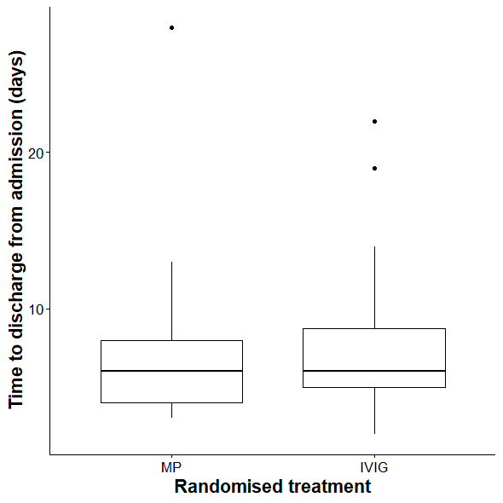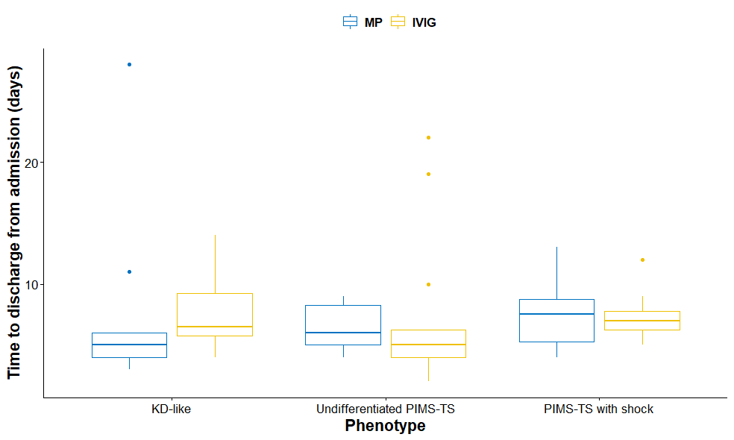

Legend: Time to discharge stratified by A) randomised treatment for intravenous methylprednisolone (MP) and intravenous immunoglobulin G (IVIG) and B) in respect to clinical PIMS-TS phenotype and randomised treatment. Abbreviations: MP intravenous methylprednisolone, IVIG intravenous immunoglobulin G, KD-like Kawasaki Disease-like, PIMS-TS Paediatric Inflammatory Multisystem Syndrome Temporally Associated with SARS-CoV-2

eFigure S2: Kaplan-Meier plot for time from admission to discharge, stratified by treatment (log rank test, p=0∙42). Legend: (+) denoting the patient censored at 28 days; dashed lines indicate the median time to discharge for both arms with shaded areas indicating 95% confidence intervals.
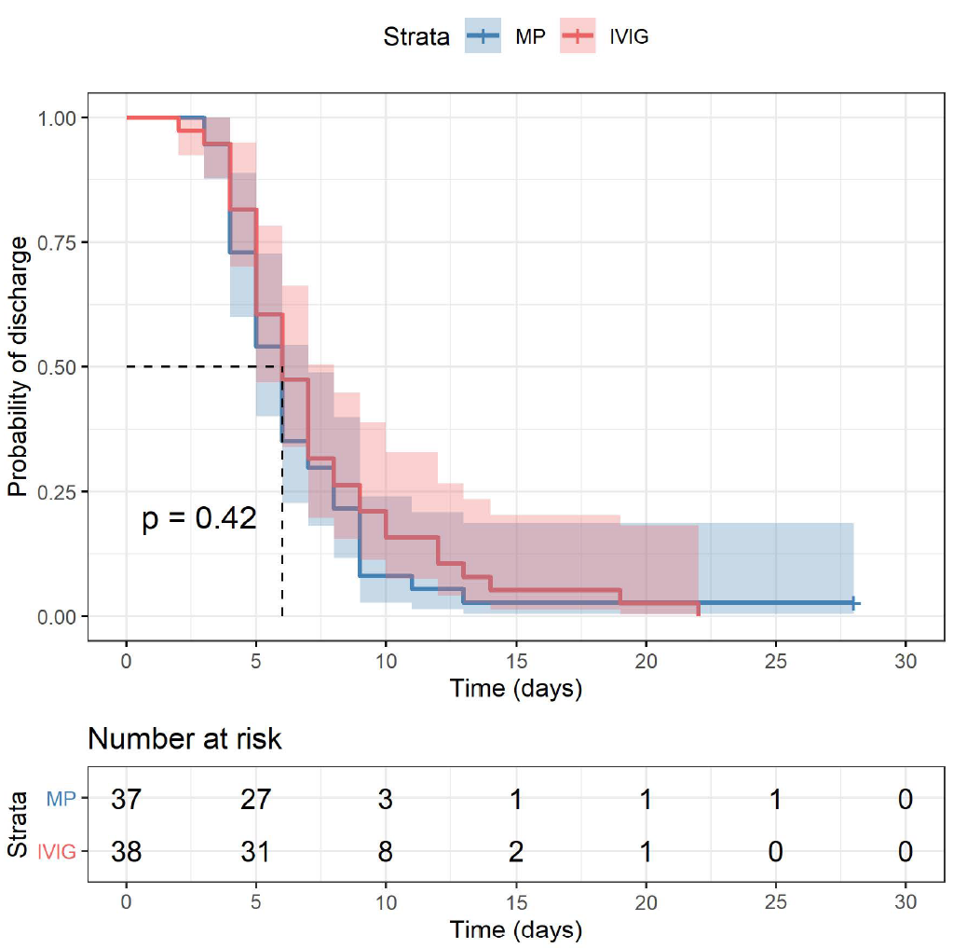
Abbreviation: MP intravenous methylprednisolone, IVIG intravenous immunoglobulin G

Figure S3: Biomarker trajectories, stratified by arm; LOESS smoothers shown as thick lines. MP intravenous methylprednisolone, IVIG intravenous immunoglobulin G; hb, haemoglobin; crp, C-reactive protein.