Figure S1. Change in largest external anal sphincter (EAS) defect size over time on four-dimensional transperineal ultrasound (4D TPUS).
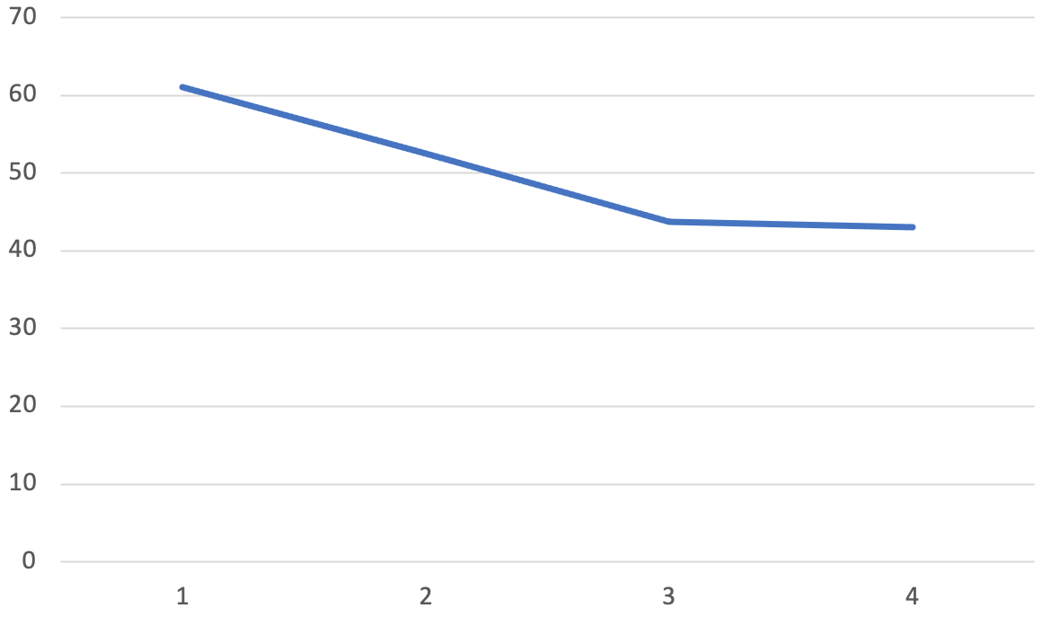
Median= 48.1⁰ (IQR-43.2⁰-59.0⁰)
Time (weeks)
EAS defect angle (degrees)

*Only one woman had an anal sphincter defect noted on 4D TPUS (EAS defect alone)

