Supplementary material
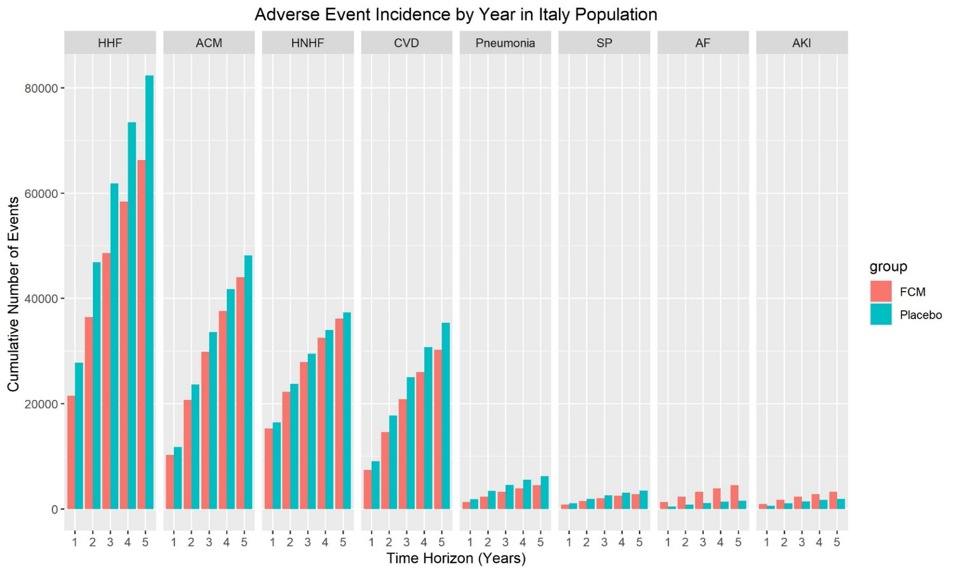
Figure S1. Projected cumulative incidence of adverse events associated with FCM versus placebo in Italy

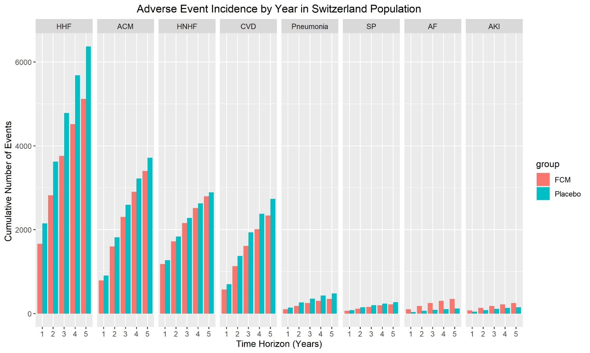
Figure S2. Projected cumulative incidence of adverse events associated with FCM versus placebo in Switzerland

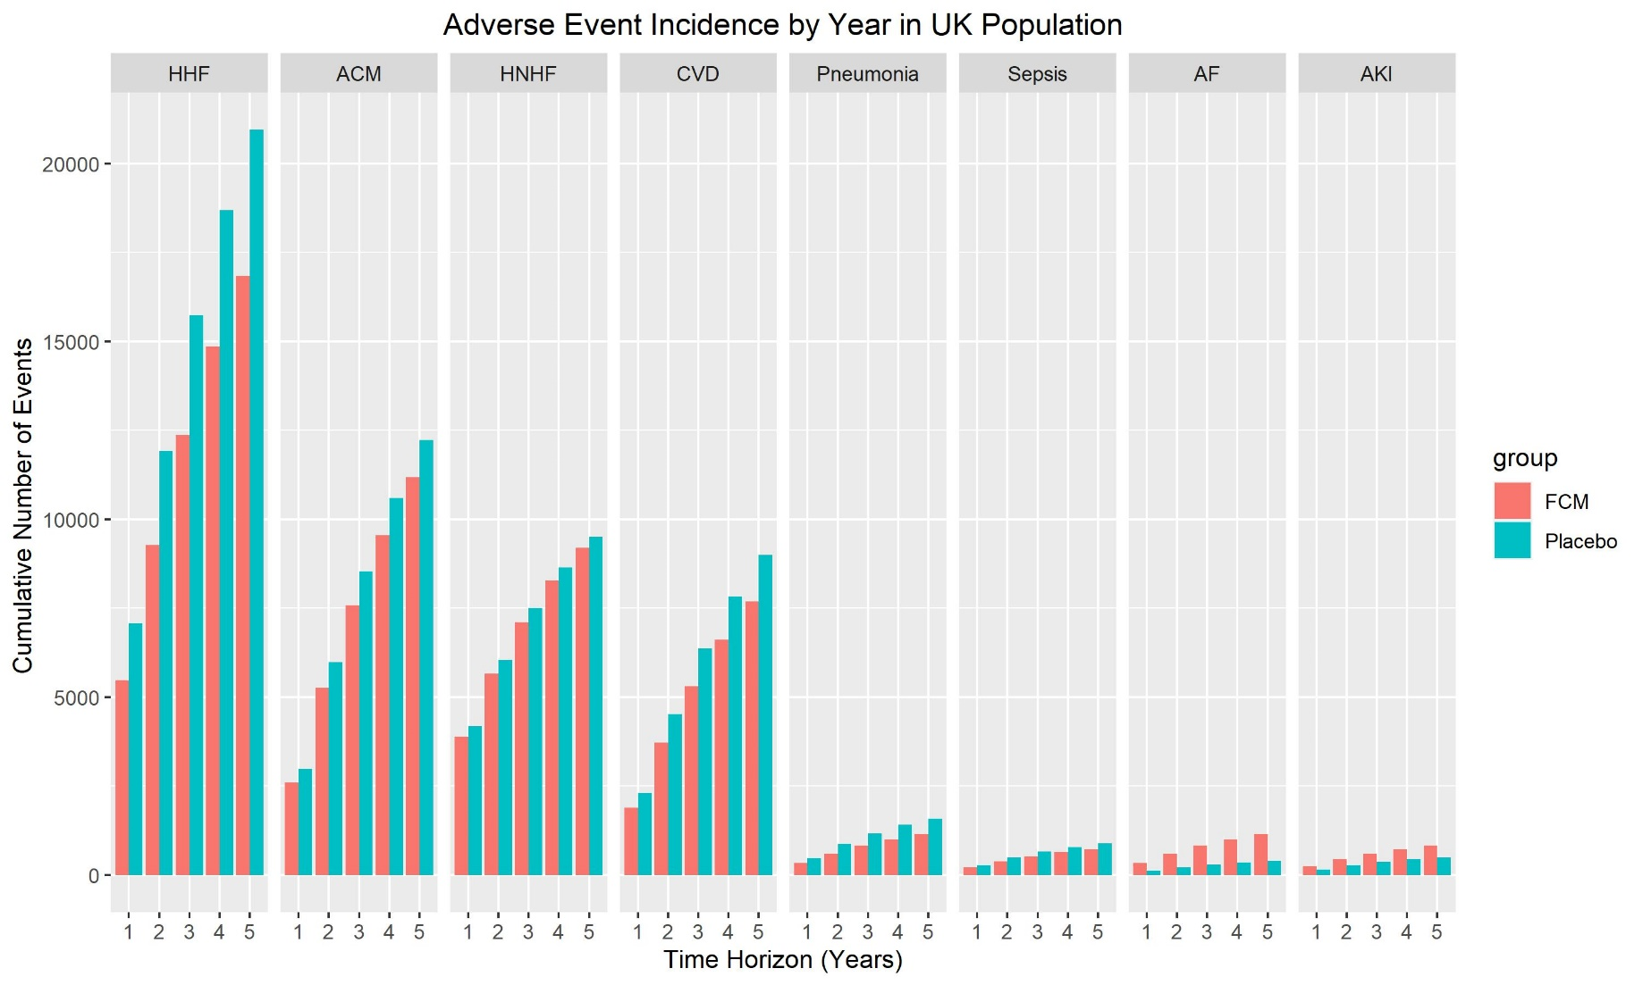
Figure S3. Projected cumulative incidence of adverse events associated with FCM versus placebo in the UK
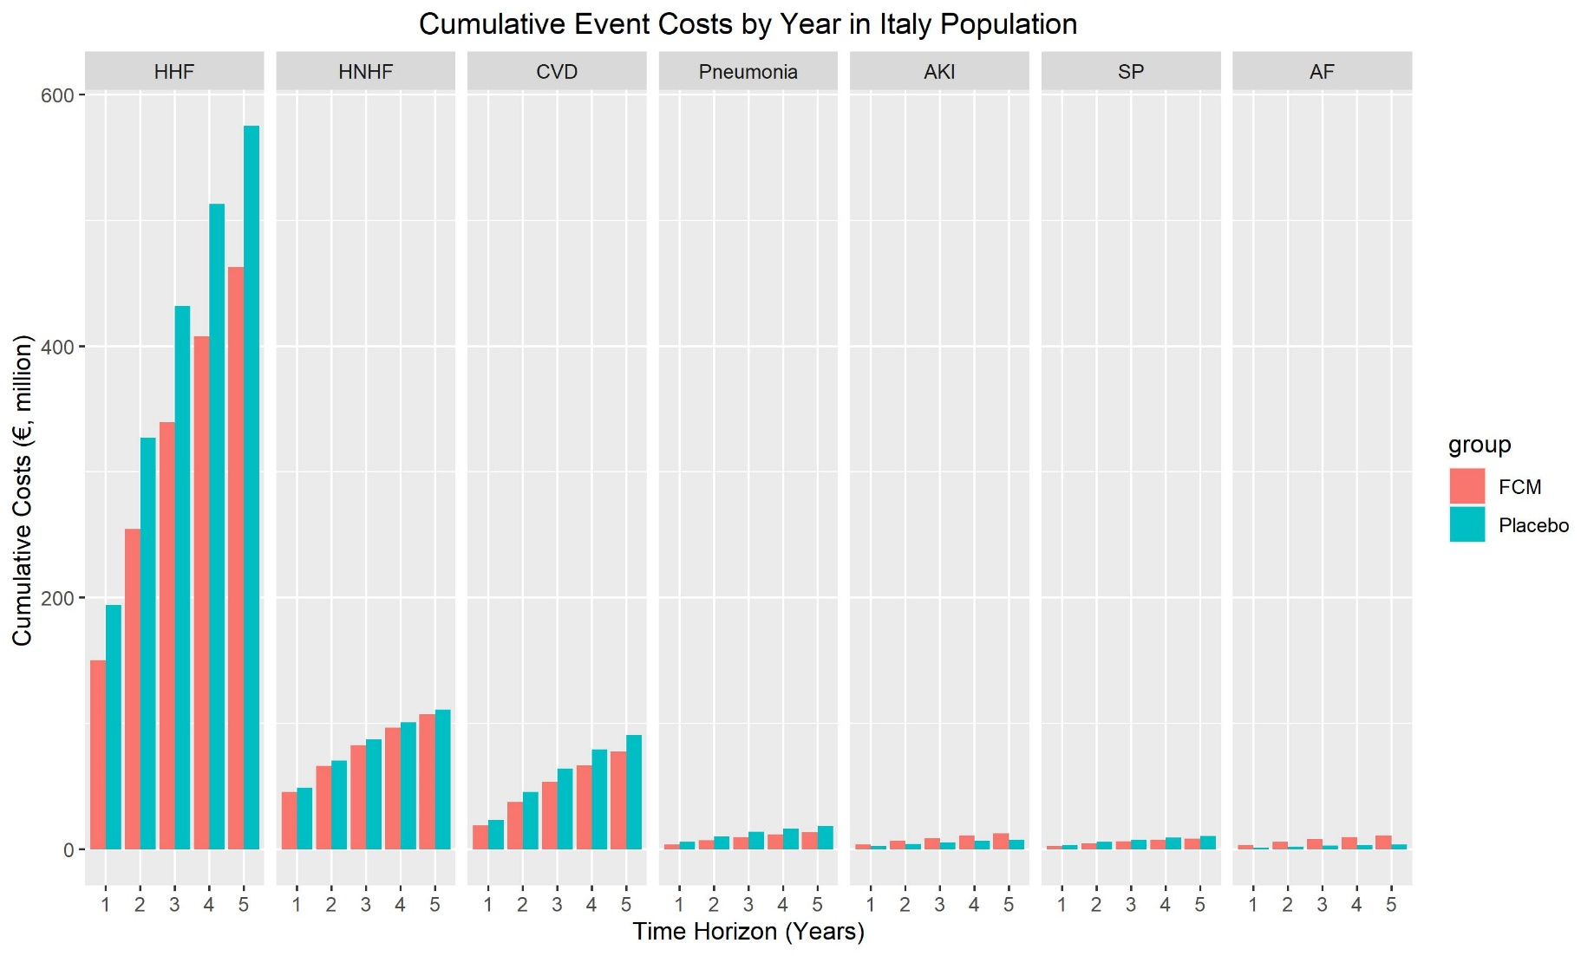
Figure S4. Projected cumulative event costs associated with FCM versus placebo in Italy
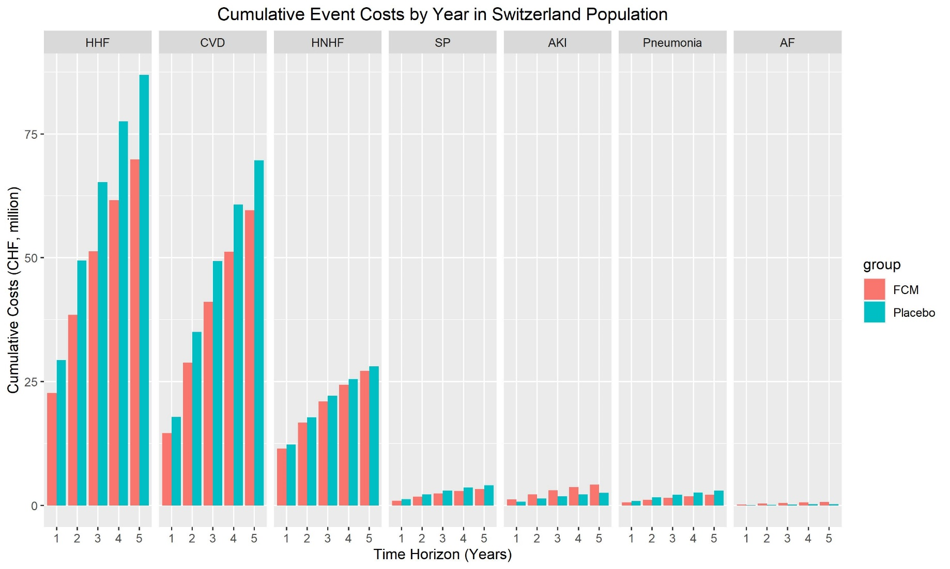
Figure S5. Projected cumulative event costs associated with FCM versus placebo in Switzerland

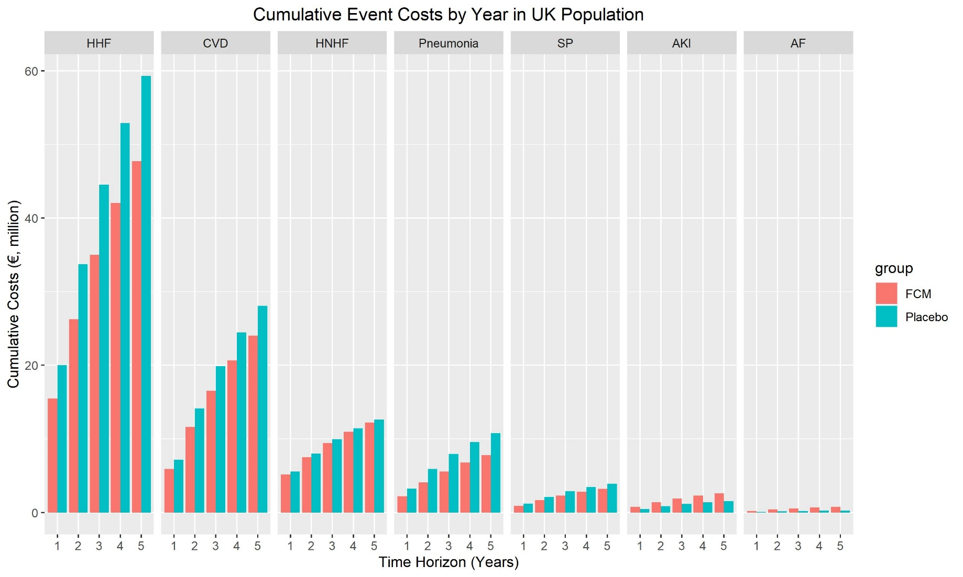
Figure S6. Projected cumulative event costs associated with FCM versus placebo in the UK

Table S1.
Coefficients derived from adjusted covariates predicting heart failure and non-heart failure hospitalization events through generalized estimating equations.

Covariate | Hospitalization for heart failure | Hospitalization not for heart failure
 | Coefficient | Coefficient
Intercept | -2.3827 | -2.8267
FCM | -0.2220 | -0.0621
LVEF (centered) | -0.0229 | -0.0114
Ischemic HF | 0.1360 | 0.2863
de novo HF | -0.8082 | 0.0377
eGFR (centered) | -0.0082 | -0.0109
Anemia | 0.0579 | -0.1008
Age (centered) | -0.0041 | -0.0014
KCCQ: 0-<25 | Ref | Ref
KCCQ: 25-<39 | -0.1796 | -0.0960
KCCQ: 39-<54 | -0.4488 | -0.3191
KCCQ: 54-100 | -1.0908 | -0.4805
Female | -0.1766 | -0.7550
Time | -0.0011 | -0.0032
eGFR: estimated glomerular filtration rate; FCM: ferric carboxymaltose; HF: heart failure; KCCQ: Kansas City Cardiomyopathy Questionnaire; LVEF: left ventricular ejection fraction
Negative coefficients denote a lower probability of the predicted outcome according to time.

Table S2. Incidence of treatment-emergent adverse events per patient within 52 weeks
Adverse event | FCM |  | Standard care
 | Mean | SE | Mean | SE
AF | 0.02 | 0.01 | 0.01 | 0.004
Pneumonia | 0.02 | 0.01 | 0.03 | 0.01
AKI | 0.01 | 0.01 | 0.01 | 0.004
Sepsis | 0.01 | 0.005 | 0.02 | 0.01
AF: atrial fibrillation; AKI: acute kidney injury; FCM: ferric carboxymaltose; SE: standard error.
Data from AFFIRM-AHF, Vifor Pharma (data on file).

Table S3. Cost inputs for FCM treatment, adverse events and hospitalizations
Component | UK | Switzerland | Italy
Treatment costs
First month | £178.58 (£4.45) | CHF280.25 (CHF6.99) | €199.82 (€4.98)
Second month | £64.41 (£10.21) | CHF99.51 (CHF16.03) | €70.95 (€11.43)
Adverse event costs
AF | £674.71 (67.47)[63] | CHF1,941.24 (CHF194.12) ┼ | €2,424.69 (242.47)[55]
Pneumonia | £6,810.06 (681.01)[64] | CHF6,123.94 (CHF612.39)[65] | €2,964.87 (296.49)^
AKI | £3,161.37 (316.14)[66],[67] | CHF16,733.64(CHF1,673.36)[68] | €3,812.13 (381.21)[55]
Sepsis | £4,423.56 (442.36 [66] | CHF15,054.06(CHF1,505.41)[69] | €2,964.87 (296.49)^
Hospitalizations and CV death costs
HHF | £2,832(283.20)[66],[70] | CHF13,645.00(CHF1,364.50)[68] | €6,983.91(698.39)[71]**
HnHF | £1,327.07(132.71)[66],[70] | CHF9,705.13 (CHF970.51)[65] | €2,964.87(296.49)[71]**
CV death | £3,126(312.60)[70],[72] | CHF25,500.00(CHF2,550.00)[73]* | €2,568.63 (256.86)[74]
Costs are presented as mean (standard error).
┼ mean cost across other countries
^ non-HF hospitalization cost used as surrogate
#Vifor Pharma data on file: Unit drug cost reported by Vifor Pharma, data on file and adjusted according to mean dose at first and subsequent (if indicated) infusion as calculated from the AFFIRM-AHF trial data. Standard errors are given in parenthesis.
UK costs were applied as reported by McEwan et al.^{[70]} with original sources indicated for traceability. Please see original publication for derivation details.
*The cited reference is a link to the publication; the CV death specific cost was determined from a supplementary presentation of the data in a thesis of an article co-author (C. Berlin), found in Table 5, page 120, PhD thesis, “Cardiovascular disease in Switzerland – health care, mortality and geographical pattern,” Claudia Berlin, Graduate School for Health Sciences, University of Bern
**calculated from total expenditure during follow-up period (1 year) divided into patients hospitalized for HF and those for non-HF reasons. These totals were divided by the split in number of patients experiencing each type of hospitalization to determine mean cost per event.
AF: atrial fibrillation; AKI: acute kidney injury; CV: cardiovascular; HHF: hospitalization for heart failure; HnHF: hospitalization for non-heart failure

Table S4. Parameterization of adjusted all-cause and CV-specific mortality parametric survival equations (Weibull)
Covariate | All-cause mortality | CV-specific mortality
 | Coefficient | Coefficient
Shape | 1.1364 | 1.0983
Scale | 907.7787 | 1,293.7577
FCM | 0.0669 | 0.1271
Female | 0.2282 | 0.1532
Anemia | 0.0946 | -0.0762
de novo HF | -0.0442 | 0.1414
Ischemic HF | -0.3430 | -0.4127
LVEF (centered) | 0.0182 | 0.0204
KCCQ: 0-<25 | Ref | Ref
KCCQ: 25-<39 | 0.2442 | 0.2867
KCCQ: 39-<54 | 0.6173 | 0.6766
KCCQ: 54-100 | 1.3537 | 1.4138
eGFR (centered) | 0.0092 | 0.0095
Age (centered) | -0.0135 | -0.0128
CV: cardiovascular; eGFR: estimated glomerular filtration rate; FCM: ferric carboxymaltose; HF: heart failure; KCCQ: Kansas City Cardiomyopathy Questionnaire; LVEF: left ventricular ejection fraction

Table S5. Deterministic sensitivity analysis. The impact of parameter changes on cost-savings after 5 years.
Parameter | Variation made | UK |  | Switzerland |  | Italy
 |  | Parameter value | Cost-savings | Parameter value | Cost-savings | Parameter value | Cost-savings
Base case |  |  | -£14,008,237.80 |  | -CHF25,456,456.43 |  | -€105,295,147.10
Increase in target population | 73.3% with LVEF <50% and ID | 57764 | -£46,162,834.00 | 16079 | -CHF76,792,152.00 | 122445 | -€186,839,451.00
Drug costs | upper (first month) | £187.30 | -£13,504,887.59 | CHF293.95 | -CHF25,216,324.92 | €209.58 | -€103,076,268.66
 | upper (second month) | £84.42 |  | CHF130.93 |  | €93.35
 | lower (first month) | £169.86 | -£14,511,588.01 | CHF266.55 | -CHF25,696,587.94 | €190.06 | -€107,514,025.50
 | lower (second month) | £44.40 |  | CHF68.09 |  | €48.55
Hospitalization for heart failure costs | upper | £3,387.07 | -£16,283,772.88 | CHF16,319.42 | -CHF28,794,024.27 | €8,352.76 | -€127,326,554.88
 | lower | £2,276.93 | -£11,732,702.72 | CHF10,970.58 | -CHF22,118,888.59 | €5,615.06 | -€83,258,219.04
Hospitalization for non-heart failure costs | upper | £1,587.18 | -£14,088,558.12 | CHF11,607.34 | -CHF25,636,001.12 | €3,545.98 | -€105,990,936.60
 | lower | £1,066.96 | -£13,927,917.47 | CHF7,802.92 | -CHF25,276,911.74 | €2,383.76 | -€104,593,837.33
CV death costs | upper | £3,738.70 | -£14,806,506.14 | CHF30,498.00 | -CHF27,439,482.16 | €3,072.08 | -€107,865,131.21
 | lower | £2,513.30 | -£13,209,969.46 | CHF20,502.00 | -CHF23,473,430.70 | €2,065.18 | -€102,719,642.71
Atrial fibrillation costs | upper | £806.95 | -£13,909,261.58 | CHF2,321.72 | -CHF25,369,852.79 | €2,899.93 | -€103,892,625.91
 | lower | £542.47 | -£14,107,214.02 | CHF1,560.76 | -CHF25,543,060.07 | €1,949.45 | -€106,692,148.01
Pneumonia costs | upper | £8,144.83 | -£14,601,017.63 | CHF7,324.23 | -CHF25,618,686.38 | €3,545.98 | -€106,306,222.19
 | lower | £5,475.29 | -£13,415,457.96 | CHF4,923.65 | -CHF25,294,226.48 | €2,383.76 | -€104,278,551.74
Acute kidney injury costs | upper | £3,781.00 | -£13,799,505.31 | CHF20,013.43 | -CHF25,120,512.63 | €4,559.31 | -€104,301,494.28
 | lower | £2,541.74 | -£14,216,970.28 | CHF13,453.85 | -CHF25,792,400.22 | €3,064.95 | -€106,283,279.64
Sepsis costs | upper | £5,290.58 | -£14,149,301.92 | CHF18,004.66 | -CHF25,602,607.88 | €3,545.98 | -€105,663,514.22
 | lower | £3,556.54 | -£13,867,173.68 | CHF12,103.46 | -CHF25,310,304.97 | €2,383.76 | -€104,921,259.70
Life tables | Life tables excluded | Yes | -£14,043,693.33 | Yes | -CHF25,475,258.91 | Yes | -€105,935,839.65
Survival curves | Unadjusted curves | Yes | -£22,083,238.22 | Yes | -CHF31,356,066.67 | Yes | -€199,528,811.19
ID: iron deficiency; CV: cardiovascular; LVEF: left ventricular ejection fraction

