SUPPLEMENTAL INFORMATION
SUPPLEMENTAL CASE REPORTS
Family 1
In family 1, two affected sisters were born to consanguineous Arab parents. F1-II:1 was born without any complications and showed normal early development until age of 9 months being able to sit and stand without support and to walk with help. At 9 months old she suffered a febrile seizure. From then, she developed lower and upper limb spasticity, regression of speech and language skills and lost the ability to stand and walk unsupported. Electroencephalogram (EEG) was mildly abnormal and seizures were controlled with phenobarbital until 11 months later, when she had another seizure. After the second seizure her condition deteriorated further and was associated with truncal hypotonia, poor neck control, severe progressive limb contractures, strabismus (exotropia), progressive visual loss and finally she became bedridden. Metabolic screen was normal.
Her condition improved with occupational therapy, and at the age of two years she achieved neck control and sitting, but she never achieved independent walking. Her language skills improved after speech therapy. She began to speak from four years of age. the electromyography (EMG) results at the age of 9 years were normal. At the most recent examination, at 17 years old, the affected individual had severe spastic paraplegia and was wheelchair dependent. Additional clinical features included supranuclear gaze palsy, external ophthalmoplegia, slow saccades, and stuttering speech. Brain MRI showed mild T2 hyperintense signal involving the bilateral posterior centrum semiovale, corona radiata, periatrial regions, bilateral globi pallidi, thalami, and dorsal pons, mildly hypoplastic corpus callosum posterior body and isthmus, mega cisterna magna, and mild retroflexion of the odontoid process of the C2 vertebra.
In her younger affected sibling, F1-II:2, the pregnancy was complicated by premature placental separation. She was born via uncomplicated vaginal delivery and had normal neonatal and early development, including head control, sitting age (around 6 months old), speech development and standing. Progressive spasticity of lower and upper limbs developed gradually around 7-9 months with contracture and ataxic assisted gait. She never achieved independent walking, even after occupational therapy, and required Achilles tendon repair surgery at 2 years for severe contractures. Metabolic testing by tandem mass spectrometry and EMG studies at the age of 2 years were normal. Brain MRI showed mild bilateral cerebral white matter volume loss and T2 hyperintense signal involving the bilateral posterior centrum semiovale, corona radiata, and periatrial regions, T2 hyperintense signal involving the bilateral globi pallidi, thalami, dorsal pons, and cerebellar nuclei, hypoplastic corpus callosum posterior body and isthmus, and mega cisterna magna. At the age of 6 years, she was diagnosed with diabetes mellitus and started insulin therapy. She has normal cognition, hearing and vision.

Family 2
In the second family, a 25-year-old man (F2-II:1) with non-consanguineous parents and negative family history presented for evaluation of lower extremity weakness and gait disturbances. Symptoms were first noted when he started walking at one year of age. Symptoms worsened during intercurrent illnesses during which time he describes that his gait became more ataxic. Although this was more pronounced when he was younger, he still notices a decline in his status when he is unwell. However, the person’s condition returns to baseline after the illness. His upper extremity strength is intact, and he has not had any worsening of symptoms or neurological decline /neurocognitive regression. His growth and development were normal, and he is doing very well academically.
Metabolic studies were normal. Brain and spine MRIs were reported as normal (not independently reviewed). Muscle biopsy, EMG and nerve conduction studies showed non-specific changes suggestive of myopathic changes with no evidence of neuropathy.
On examination, he has no dysmorphic features. The cranial nerves and upper extremity motor examinations are normal. In the lower limbs, he has symmetrical minimal wasting, hypertonia, hyperreflexia, bilateral ankle clonus and a positive Babinski sign on the left. Restriction of hip abduction and knee extension noted with mild fixed flexion contraction deformity at the knees. Vibration and position sense are normal. Romberg is negative. He is unable to tandem walk and has a spastic gait. There were no other cerebellar signs.

Family 3
In Family 3, two siblings from unaffected consanguineous parents presented in the first year of life. Both affected individuals were delivered by Caesarean section after uneventful pregnancies.
Individual F3-II:1 had good initial development achieving normal head control and sitting milestones. However, at the age of one year she had delayed crawling and inability to take first steps. With the introduction of physiotherapy input, she started to crawl around the age of 2 years and able to walk supported at the age of 3 years. She developed spasticity in the lower limbs requiring tendon repairs and was never able to walk independently. The tone and muscle strength from the upper limbs were normal. She presented mild learning disability not needing special education. On the last examination at the age of 12 years, no dysmorphic features were noted and she was generally well except for being below average growth parameters for her age (weight 20.5kg (-2SD), height 137cm (-2.1SD) and head circumference 50cm (-2.4SD)). Neurological examination showed generalized muscle wasting, normal cranial nerves and upper limbs examination and no signs of incoordination. In the lower limbs she presented with hypertonia, brisk deep tendon reflexes, positive patellar clonus, absent ankle clonus and positive Babiniski sign. She had a spastic gait and was able to walk using two crouches. Investigations revealed normal metabolic studies, reportedly normal MRIs of the spine and brain (not independently reviewed), and normal EMG and nerve conduction velocity, funduscopic examination, and ABR.
Individual F3- II:2 had a very similar onset at around one-year-old presenting similar clinical signs and progression. He never achieved independent walking in spite of extensive occupational therapy. On last examination, age 9, his growth parameters were also below average: weight 16kg (-2.1SD), height 118cm (-2.1SD) and head circumference 49.2cm (-2.3SD). He was able to walk only supported with limited hip adduction, flexed knees and tip-toe walking. He had hypertonia and brisk deep tendon reflexes of lower limbs, bilateral ankle and patellar clonus and positive Babiniski sign. He had normal coordination, cranial nerves, and sensation. The upper limbs tone was normal with brisk tendon reflexes. He had normal speech and his learning abilities were below his peers in school. Normal MRI brain, EMG and NC were also recorded (not independently reviewed).

Family 4
Three affected female siblings from healthy consanguineous Egyptian parents were identified in family 4. All were delivered full term vaginally after uneventful pregnancy. There was a family history of 3 deceased older siblings during early neonatal life, two of them were owed to prematurity and the third was a part of twin with less viability than his alive twin.
Individual F4-II:4 was part of a non-identical twins’ pair (the other male twin died after birth). Neonatal and infancy periods were unremarkable, she was able to support the head at the age of 4 months, sit at the age of 7 months, crawl and able to say double syllable words at the age of 1 year. She had not achieved independent walking; however, she could walk with support at the age of 2 years presenting spastic gait with tip-toe walking. She used the hands independently. At the age of 33 months, she had a febrile illness not associated with epilepsy that was followed by deterioration of her general condition with severe weakness, inability to sit or stand with loss of acquired skills. She was admitted to hospital for 21 days and died with unexplained etiology at the time.
Individual F4-II:5 from the same family had normal neonatal and early development, including head control (3 months), sitting age (7 months), speech development and standing. Progressive spasticity of lower limbs was started at the age of 11 months, with inability to achieve walking at age. After intensive physiotherapy, the affected individual was able to walk alone around the age of 4 with abnormal, unsteady spastic gait. On examination at the age of 6 years old, she was alert, very cooperative, average cognitive function and normal speech. Growth parameters were also below average birth weight 14kg (-1.8SD), height 100cm (-2.7SD) and head circumference 47.5cm (-3.1SD). Neurological assessment revealed symmetrical wasting, increased tone in in lower limbs with brisk deep tendon reflexes, ankle clonus, patellar clonus and positive Babiniski. The upper limbs had normal tone with brisk reflexes. Sensation was normal in both upper and lower limbs. She had normal coordination and normal cranial nerve exam. However, mild ptosis on fatigue was recorded. Investigations revealed normal metabolic work up, fundoscopic examination, ABR, spine MRI, EMG and NCS. Brain MRI showed mild bilateral cerebral white matter volume loss and T2 hyperintense signal involving the bilateral posterior centrum semiovale, corona radiata, and periatrial regions, T2 hyperintense signal involving the bilateral globi pallidi, thalami, dorsal pons, and middle cerebellar peduncles, mild prominence of the lateral ventricles and frontoparietal sulci, hypoplastic corpus callosum posterior body and isthmus, and mega cisterna magna.
Affected individual F4-II:6 had a similar normal neonatal and infancy period with good head control, sitting and crawling. Similarly, delayed walking was noted after the age of 1 year with remarkable increase of tone in lower limbs. She was able to stand and walk supported. She had mild delay in speech development, she could say single words but no sentences until the age of 2. Anthropometric measurement identified were below average, the weight was 8kg (-3.1SD), height 75cm (-2.7SD) and head circumference 46cm (-1.4SD). Neurological examination showed generalized wasting, hypertonia of lower limbs, brisk reflexes, ankle clonus, patellar clonus and positive Babiniski sign. Cranial nerves were normal. Tone, power, reflexes, sensation and coordination in the upper limbs were normal. Investigations including metabolic studies, MRI spine and EMG and NCS were normal. Brain MRI showed mild bilateral cerebral white matter volume loss and T2 hyperintense signal involving the bilateral posterior centrum semiovale, corona radiata, and periatrial regions, T2 hyperintense signal involving the bilateral globi pallidi and thalami, mild prominence of the lateral ventricles, frontoparietal sulci, and sylvian fissures, hypoplastic corpus callosum body and isthmus, and mega cisterna magna. At the age of 30 months she suffered from a febrile illness lasting for more than 15 days accompanied with the same scenario as her older deceased sister with severe hypotonia and loss of acquired skills followed by death within a month. Both siblings failed to recovered from their unexplained febrile illness.

Family 5
Family 5 included female and male siblings born to first cousin healthy parents. Their first child was the female individual F5-II:1, delivered by Caesarean section with normal neonatal and early infancy periods. She achieved head control near 3 months and had average cognitive functions. At the age of 5 months she developed fever, followed by severe hypotonia, admitted to a pediatric intensive care unit (PICU) because of chest secretion. Investigations showed acidosis, mild elevated ammonia and lactate, normal metabolic screening, acylcarnitine profile and organic acid in urine. Brain CT revealed mild bilateral cerebral white matter volume loss and mild prominence of the lateral ventricles, frontoparietal sulci, and sylvian fissures. She died at the age of 6 months with respiratory failure.
F5-II-2 is a male sibling aged 4 years and 7 months, the second child in family 5. He had normal neonatal and infancy periods with achieving milestones, was able to sat at 8 months, walk supported until the age of 1 year and 2 months. He had febrile illness at that age and developed hypotonia then he recovered and improved but still unable to walk alone. He had another attack of febrile illness at 1 year and 8 months with skin rash, he was admitted to the hospital and took acyclovir injection. He was discharged in good condition and then after he developed progressive spasticity of the lower limbs. On examination, his weight was 15kg (-1SD), height 93cm (-2.85SD) and head circumference 51cm (+0.2SD). He was alert and cooperative and could talk and understand, and had sphincteric control. His upper limbs had normal tone and reflexes, while the lower limbs were spastic, brisk reflexes and pathological reflexes including positive patellar and Babiniski sign. No extrapyramidal manifestations were noted. Investigations showed normal metabolic screening, acylcarnitine profile, organic acid in urine, creatine kinase, ammonia and lactate in blood was 18mg/dl (normal up to 19mg/dl). MRI spine, EMG and NCV, fundus examination and auditory brain response were normal. Brain MRI showed mild bilateral cerebral white matter volume loss and T2 hyperintense signal involving the bilateral posterior centrum semiovale, corona radiata, and periatrial regions, T2 hyperintense signal involving the bilateral globi pallidi and thalami, mild prominence of the lateral ventricles, frontoparietal sulci, and sylvian fissures, hypoplastic corpus callosum posterior body and isthmus, vermian hypoplasia, and mega cisterna magna.

Family 6
This family presents with 2 affected siblings born to unaffected consanguineous Egyptian parents. The older sibling manifested at the age of 1 year with difficulty walking due to lower limb spasticity. His cognitive development was unremarkable. He had several episodes of reversible deterioration of his symptoms after febrile illness. On examination by the age of 3 years he had increased tone with brisk reflexes, ankle and patellar clonus, and positive Babinski sign. Lactate was 68mg/dl and extended metabolic screening, organic acid in urine, and ammonia were normal. His electromyography and nerve conduction studies were normal. He was reported to succumb to one of the episodes of deterioration after febrile illness. Brain MRI showed mild bilateral cerebral white matter volume loss and T2 hyperintense signal involving the bilateral posterior centrum semiovale, corona radiata, and periatrial regions, T2 hyperintense signal involving the bilateral globi pallidi, thalami, pons, and dentate nuclei, mild prominence of the lateral ventricles, frontoparietal sulci, and sylvian fissures, mildly hypoplastic corpus callosum, and mega cisterna magna.
His affected brother manifested at 10 months of age with regression in sitting and increasing spasticity in lower limbs. His cognitive development was unremarkable. Similar to his affected brother he had several episodes of reversible deterioration of his symptoms after febrile illness. On examination at age 2 year and 3 months he had increased tone with brisk reflexes, ankle and patellar clonus, and positive Babinski sign. Lactate was 50 mg/dl and extended metabolic screening, organic acid in urine normal, and ammonia were normal. His electromyography and nerve conduction studies were normal.

Family 7
Family 7 presented with two affected siblings (F7-II:1 and F7-II:2) currently aged 10 and 6 years old. The siblings are boys born full-term after unremarkable pregnancy to non-consanguineous Kazakh parents. Both are the products of uneventful vaginal delivery with normal birth weight and height. By the ages of 3-4 months, parents noticed stiff legs with impaired stepping reflex when the boys were held upright with their feet touching the ground. The stiffness in the lower limbs had gradually progressed impeding independent ambulation. No deterioration with intercurrent infections has been noticed. They had a normal cognitive performance at school and have expressed no other symptoms. Upon examination, they had a bilateral symmetrically increased tone in the lower limbs, reduced muscle power (MRC grade 3) with brisk tendon reflexes and upgoing plantar reflexes. Gait was spastic and they could walk with walking frames. Lumbar hyperlordosis and equinus feet were also shared signs between the siblings. The EEG and EMG were unremarkable. Brain MRI of individual F7-II1 showed mild T2 hyperintense signal involving the bilateral posterior centrum semiovale, corona radiata, and periatrial regions, mild T2 hyperintense signal involving the bilateral thalami, dorsal pons, and middle cerebellar peduncles, hypoplastic corpus callosum posterior body and isthmus, and mega cisterna magna.
Family 8
This family presents two affected siblings born to first cousin healthy Turkish parents. First two siblings are healthy, third and fourth siblings are affected. The proband did not have any health problem until 18th month. When he was 18 months old, he had a flu infection, and his walking was impaired, and he started to fall and get tired. After infection, the affected individual started to have difficulty walking, getting tired and he started walking on his toes. When the index proband was at 3 years old, his affected brother was evaluated by pediatric neurology department due to unachieved walking. Cranial MRI findings were normal. When they had an infection, gait disturbance and lower extremity spasticity worsens in both siblings. In both siblings, progression of gait disturbance is described over time. Neither brother had a history of seizures. The proband now walks on his toes and he has frequent falls. He got Dysport® injections two times 2 years ago, but it was ineffective. they are now waiting for tendon ligament release operation. The affected brother can not walk now and uses rollator walker. Both of affected brothers have increased deep tendon reflex and decreased muscle strength in lower limbs, they have positive Babinski sign.

Family 9
This individual is a 12-year-old male, only child between his parents, with spastic gait, upper motor neuron signs, peripheral neuropathy, and behavioral concerns including attention deficit hyperactivity disorder but, otherwise his cognition fairly is intact. His prior records indicate a history of leg pain, fatigue, problems with sleep (hypersomnolence, mild obstructive sleep apnoea, maintained on CPAP), precocious puberty (onset 8 years), occasional ptosis, frequent ear infections, poor appetite, and eczema. He met his early developmental milestones on time and his initial onset of symptoms was ~2 years with difficulty walking following a febrile illness. His muscle biopsy (5 years, right vastus lateralis) revealed a mild increase in lipid droplets between muscle fibers on Oil red O stain, mainly in type 1 fibers, but was otherwise negative for findings suggestive of myopathy or muscular dystrophy. His cervical and thoracic spine MRI (4 years old) revealed incidental bilateral posterior lower lobe pulmonary infiltrates of uncertain significance. His spine MRI at 9-year-old was reported as negative. His brain MRI at 9 years old was reported as normal (not independently reviewed). His disease course has been episodic by family report and has had worsening of symptoms following periods of febrile illness.

Family 10

This family presented with 2 siblings, a boy and a girl of European-American descent. The boy manifested new onset generalized seizures (status epilepticus) after febrile illness, mild global developmental delay, and hypotonia at 6 months of age. His brain MRI showed mild bilateral cerebral white matter volume loss and T2 hyperintense signal involving the bilateral posterior centrum semiovale, corona radiata, periatrial regions, bilateral basal ganglia, thalami, cerebral peduncles, pons, and cerebellar hemispheres. Some of these areas had associated restricted diffusion and enhancement, which may represent active demyelination, metabolic encephalopathy, or acute/subacute ischemia. Mild prominence of the lateral ventricles, frontoparietal sulci, and sylvian fissures, mildly hypoplastic corpus callosum, and mega cisterna magna. No lactate peak was identified on magnetic resonance spectroscopy. Severely abnormal EEG due to the presence of high voltage poorly modulated background during sleep with frequent epileptiform discharges (bifrontal and generalized) (Hypsarrhythmia), and bursts concerning for electrographic seizures were found. He died after another episode of febrile illness at age 13 months old. Prior to the critical illness metabolic work up was negative.
His affected sister manifested hypotonia and global developmental delay at the age of 3 months. Later she developed right leg spasticity, nystagmus, and bilateral optic atrophy. She had elevated urinary tiglyglycine and non-specific elevations of several amino acids, Growth Differentiation Factor 15 (GDF15) at 1 mo = 715 pg/mL; 25 mo (during critical illness with RSV) = 4437 pg/mL (normal <750 pg/mL). Her brain MRI showed multiple T2 hyperintense lesions with peripheral restricted diffusion involving the deep and subcortical white matter of the frontal lobes and cerebral peduncles suggestive of actively demyelinating lesions, areas of cystic degeneration/leukomalacia in the white matter of the bilateral frontal lobes, mild bilateral cerebral white matter volume loss and T2 hyperintense signal involving the bilateral posterior centrum semiovale, corona radiata, periatrial regions, pons, and middle cerebellar peduncles, mild T2 hyperintense signal involving the bilateral thalami, mild prominence of the lateral ventricles, frontoparietal sulci, and sylvian fissures, mildly hypoplastic corpus callosum, and mega cisterna magna. She died at the age of 24 months after a febrile illness.

SUPPLEMENTAL METHODS
SDS-PAGE and Western blot analysis
Human fibroblasts from an affected individual (F1-II:1) were lysed and samples subjected to SDS-PAGE and western blotting using primary antibodies against Porin/VDAC1 (abcam ab14734), UQCRC2 (abcam ab14745), NDUFB8 (abcam ab110242), ATP5A (abcam ab14748), SDHB (abcam, ab14714), COXII (ab110258), and GAPDH (abcam ab8245).

Recombinant Protein Preparation of Native and Substituted Proteins
Site-directed mutagenesis, and protein expression and purification were performed using standard procedures ¹⁻⁴. Site-directed mutagenesis was performed to prepare pET28b (+) plasmid-encoded V241L variant of full-length human NFU1. Polymerase chain reaction (PCR) amplification was performed with a pair of complementary primers for V241L substitution using Phusion polymerase from Fisher Scientific. The protocol involved initial denaturation at 95 ºC for 1 min, 25 cycles comprising denaturation at 95 ºC for 30 sec, annealing at 55 ºC for 1 min and primer extension for 6 min at 72 ºC. Dpn1 enzyme was added to the mixture upon completion of PCR and incubated for 1 h at 37 ºC to digest parent plasmid. Heat-shock method was used to transform the reaction mix into BL21-DE3 E. coli cells, which were then plated on kanamycin plates. Positive clones were identified by isolating plasmid DNA from the colonies and sending them for sequencing.
Native NFU1 and its V241L variant were expressed and purified from E. coli using published protocols¹. Plasmid for human FDX1 was kindly gifted by Dr. J. Markley and the protein was purified as reported previously². FDX1 was purified in cluster-bound holo form and the cluster was subsequently removed³ to prepare apo FDX1. Purification of human ISCU was performed as described before⁴.
Native and V241L NFU1 were reconstituted anaerobically following an in-vitro protocol, by use of L-Cys, FeCl₃ and Tm NifS¹, as was ISCU with FeCl₃ and Na₂S⁵. Reconstitution was confirmed by recording the circular dichroism (CD) and ultraviolet-visible (UV) electronic spectra, characteristic of cluster-bound holo proteins.
Protein Characterization by Variable Temperature Circular Dichroism (CD) and Analytical Ultracentrifugation
The effect of the amino acid substitution on overall protein stability was probed by performing thermal melt experiment⁶. Temperature-dependent CD spectra were acquired from a 10 μM solution of protein (native or p.(Val241Leu) NFU1) in 50 mM phosphate buffer (pH 7.5) using a 0.1 cm quartz cell on a JASCO J-815 CD Spectrometer. The intensity of the CD signal at 222 nm was recorded between 20 ºC and 65 ºC at a rate of 0.4 ºC min⁻¹. The oligomeric state of the NFU1 protein was determined by use of analytical ultracentrifugation (AUC) and monitoring the absorbance at 280 nm for 50 μM of apo native or p.(Val241Leu) NFU1. The obtained sedimentation profiles were fit to the Lamm equation⁷ using Sedfit software.
Fe-S cluster transfer monitored by Circular Dichroism
Cluster transfer between proteins was monitored by measuring the change in CD signal intensity over a 300-600 nm range by use of a JASCO J-815 CD Spectrometer, as reported previously ^{1,8,9} . Cluster transfer from reconstituted holo native or p.(Val241Leu) NFU1 to apo acceptors FDX1 and Grx3 were investigated by introducing the degassed holo protein and scanning from 300-600 nm at rate of 200 nm/min. For cluster delivery to apo native or p.(Val241Leu) NFU, both reconstituted holo ISCU and a glutathione-complexed [2Fe-2S] cluster, [2Fe-2S] (GS)₄, were used, where the latter complex was synthesized according to a previously reported protocol¹⁰. CD data were converted to % cluster transfer based on the concentration of [2Fe-2S] cluster and fitted by DYNAFIT software to extract second-order rate constants for cluster-transfer reactions.
Pyruvate Dehydrogenase Activity Assay
PDH activity was measured in cultured fibroblasts from the affected individual F1-II:1 using [1-¹⁴C]-pyruvate as substrate, after maximal activation with dichloroacetate as described previously¹¹.
α-Ketoglutarate Dehydrogenase Activity Assay
KGDHC lysate buffer (50 mM Tri-HCl pH7.2, 1mM DTT, 50 um leupeptin, 0.2 mM EGTA, 0.4 % TritonX-100) was added to fibroblast pellets of the affected individual F1-II:1, her healthy mother and a control. Protein concentration was measured using Bio-Rad’s protein assay. To 25 μl of blank (lysis buffer), standards or samples was added to wells of a 96-well plate followed by addition of 100 μl of KGDHC reaction buffer, 50 μl of KGDHC assay buffer (NAD, CoA), and 25 μl of a KG. The activity of KGDHC was measured reading the plate at 340-460 nm (cut off 455 nm) at 30ºC for 30 min. Each sample was measured in triplicate.

SUPPLEMENTAL RESULTS
Functional study of the single amino acid mutant p.(Val241Leu) of NFU1
The three-dimensional structures of the N-and C-terminal domains of human NFU1 have been previously published and the structural models for full-length monomeric apo-NFU1, dimeric apo-NFU1 and holo-NFUI, consisting of a complex of three apo-NFU1 dimers have been determined¹². These models show that two apo-NFU1 subunits coordinate one [4Fe-4S] cluster to form a cluster-linked dimer through the C-terminal domains, while the N-terminal domain on the other end of the dimer forms the interface for the trimer formation. Only one single amino acid variant p.(Val241Leu) among the newly identified ones involves a residue from the C-terminal [Fe-S] cluster binding domain of NFU1. The other four variants, p.(Leu99Val), p.(Ala100Pro), p.(Arg101Gly) and p.(Val121Ala) lie on the separate N-terminal domain of NFU1. Thus, p.(Val241Leu) could have significant impact on [Fe-S] binding and transfer ability as has been documented before for two other variants from the C-terminal domain (p.(Gly189Arg) and p.(Gly208Cys))^{13,14,27}, while the mutations on the N-terminal domain could affect the trimer formation. We performed in vitro [Fe-S] cluster reconstitution experiments with p.(Val241Leu) mutant.
Recombinant apo p.(Val241Leu)-substituted NFU1, when investigated by analytical ultracentrifugation (AUC), revealed a similar monomer-dimer distribution to that observed for the native protein (Supplementary Figure 2A). Variable temperature circular dichroism (CD) melting profiles of the native and p.(Val241Leu) were identical, indicating that there is no significant change in secondary structure of the mutant protein (Supplementary Figure 2B). UV and CD signatures of the [Fe-S] cluster bound holo forms of Arg182Gln native and p.(Val241Leu) NFU1 are identical (Supplementary Figure 2C and 1D) and the reconstituted p.(Val241Leu) protein transfers cluster to a physiological downstream targets such as FDX1 at a similar rate in comparison to the native protein (Supplementary Figure 2E). Moreover, p.(Val241Leu) substitution does not impact the ability of NFU1 to accept [Fe-S] cluster from physiologically relevant donors as the rates of cluster uptake by p.(Val241Leu) are similar to the native form (Supplementary Figure 2F).
PDH activity was low, while KGDHC activity was normal in homozygous p.(Val241Leu) fibroblasts
Since patient fibroblasts were available only for the p.(Val241Leu) variant, the impact of variant on the enzymatic activities of PDH and KGDHC were measured only for this variant. PDH activity assays performed from cultured fibroblasts of the F1-II:1 homozygous for p.(Val241Leu) variant and her healthy heterozygous mother, showed that the mean activity of the enzyme in the affected individual was low (0.50 nmol/mg protein/min), while the mean activity in the mother was normal (0.82 nmol/mg protein/min, normal range 0.6-0.9 nmol/mg protein/min). The KGDHC activity assay performed from the fibroblasts of the F1-II:1, her healthy heterozygous mother (F1-I:1), and a control, showed no deficiency of the activity of the enzyme in the cells of the affected individual (Supplementary Figure 3).

Supplemental Figures
Supplementary Figure 1. Western blot band quantification relative to GAPDH, setting F1-I1 sample as 1
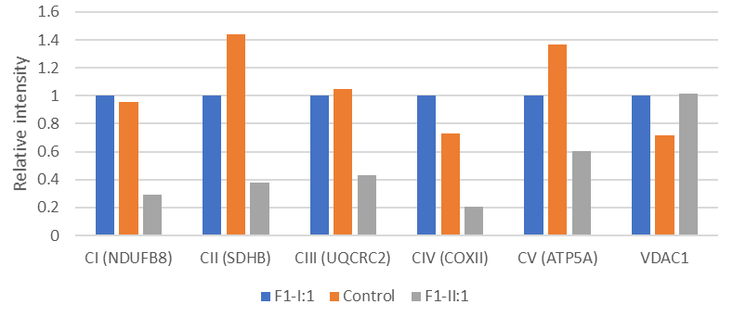

Supplementary Figure 2. Investigation of recombinant apo p.(Val241Leu)-substituted NFU1, by analytical ultracentrifugation (AUC) and variable temperature circular dichroism (CD) melting profiles of the native and p.(Val241Leu)
(A) VTCD for thermal melting of apo native and p.(Val241Leu) NFU1 in 40 mM phosphate, pH 7.5 (B) AUC profile for apo native and p.(Val241Leu) with sedimentation monitored at 280 nm (C) UV spectra of cluster-bound native and p.(Val241Leu) NFU1 and (D) CD spectra of cluster-bound native and p.(Val241Leu) NFU1 where the holo protein was obtained by NifS-mediated chemical reconstitution. The extinction coefficients are based on cluster concentrations. (E) Time course measurements for cluster transfer from holo p.(Val241Leu) to apo FDX1 under anaerobic conditions. The second order rate constant was determined to be 4060±430 M⁻¹ min⁻¹ (4695±823 M-1 min-1 for native). (F) [2Fe–2S](GS)₄ cluster uptake by apo p.(Val241Leu). The second order rate constant was determined to be 1764±132 M⁻¹ min⁻¹ (1930±212 M-1 min-1 for native).
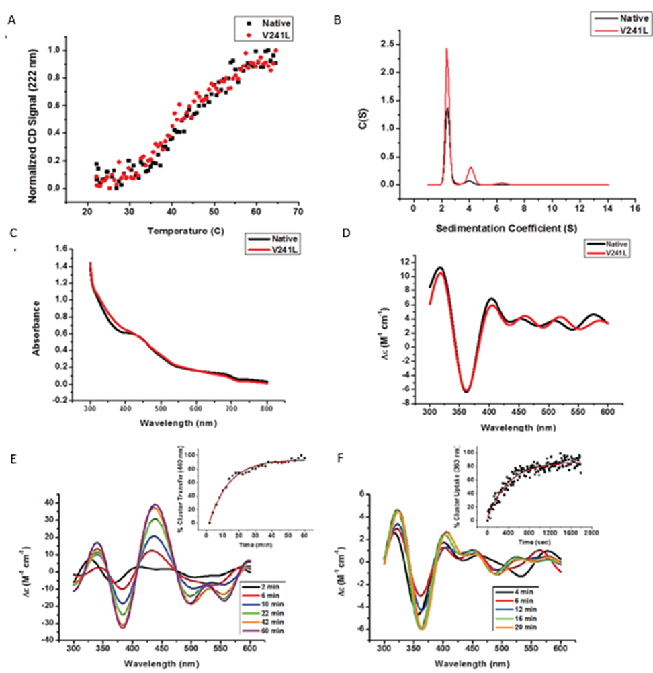
Supplementary Figure 3. KGDHC activity in the fibroblasts of F1-II:1, her healthy heterozygous mother (F1-I:1) and a control.
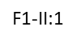
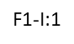
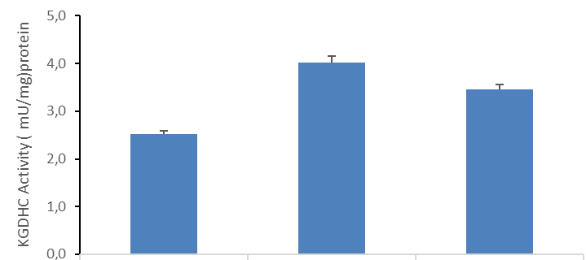

SUPPLEMENTAL DISCUSSION
Remarkable interfamilial and intrafamilial phenotypic variability was observed in the present cohort even within the affected individuals with the same homozygous recurrent NFU1 c.362T>C, p.(Val121Ala) variant. Individuals from F3 had a mild course of HSP with no episodic neurological decompensation. Two siblings from F4 and F6:S1 with pure HSP had a fatal response to their febrile illness. And F5:S1, who was healthy until the age of 5 months, manifested by severe hypotonia after a febrile illness resulting in early death. Affected individuals from F2 and F7 who was carrying compound heterozygous NFU1 variants, and the siblings from F6 had the mildest disease course. Overall, these findings indicate that the NFU1-assosiated HSP could present as a spectrum. Our WES results revealed altogether five variants of NFU1-gene in our cohort. One variant, p.(Val241Leu) lays in the C-terminal domain, while four of the variants p.(Leu99Val), p.(Ala100Pro), p.(Arg101Gly) and p.(Val121Ala), lie in the N-terminal domain of NFU1. The published NMR structure of the C-terminal domain of human NFU1 (Figure 1F) shows the p.(Val241) residue to lie far from the cluster binding site. Experimentally we find the substitution to have no significant influence on the protein aggregation or cluster binding or exchange reactivity and does not change global protein structure or stability (as evidenced by AUC and variable temperature CD). However, it does appear likely that even minor structural perturbations could have a significant impact on partner protein recognition and the binding of physiologically-relevant partner proteins that are revealed in downstream metabolic processes, as documented herein.
Interestingly, a substitution to phenylalanine at the same p.(Val241) position, that was combined with a compound heterozygous deletion in exon 4 of NFU1, was found in two persons with severe early onset MMDS1¹⁵. The deletion in exon 4 leads to a loss of 10 amino acids and thus to a loss of two β-sheets in the N-domain of NFU1 protein, disrupting the whole function of the protein. The more severe phenotype of this individual could be explained by the combined effect of the deletion and the variant, in which a change of a small amino acid p.(Val241) into the much bulkier phenylalanine could lead to greater disruption of the function of the C-terminal domain.
Of the genetic mutations summarized in Figure 2, amino acid substitutions in positions that lie on beta sheets (such as p.(Phe88Ser) and p.(Val121Ala)) or alpha helices (such as p.(Leu99Val), p.(Ala100Pro), p.(Arg101Gly), p.(Leu133Pro), (p.(Arg182??), p.(Pro183Arg), and p.(Gly189Arg)) are likely to destabilize protein secondary and consequently tertiary structure. This is particularly the case for substitutions involving addition or loss of proline residues, including Ala100Pro and Pro183Arg. Other mutations lie in loops around the cluster binding domain, with Gly208 appearing to serve a critical role in defining the aggregation state for NFU1, which is also modulated by Cys210.
Six variants reported here (p.(Phe88Ser), p.(Leu99Val), p.(Ala100Pro), p.(Arg101Gly), p.(Val121Ala) and p.(Leu133Pro)) reside on a separate N-terminal domain of NFU1, which is highly ordered. The other variants are found in the C-terminal cluster binding domain (p.(Arg182Gln), p.(Pro183Arg), p.(Gly189Arg), p.(Gly190Arg), p.(Gly208Cys), p.(Cys210Phe) and p.(Val241Leu)), which has some characteristics of a molten globule16 (Figure 1F). When the two domains come together, the protein is well-folded, suggesting a need for the N-terminal domain for structural stabilization. Thus, minor structural perturbation induced by any of these substitutions could have broader impact on the structure, holo-NFU1 formation or for example on partner binding. A variant p.(Ala100Gly) was recently published as compound heterozygous with p. (Leu133Pro) in an affected individualpresenting with MMDS1. This time, however, the p.(Ala100) is substituted with structurally smaller amino acid glycine compared to the bulkier proline, found in the individual from the present report. The second variant in the C-terminal domain might cause more severe combinatory effect with the p.(Ala100Gly) variant in the person with MMDS1, however. The Gly189Arg substitution has previously been described in some detail14. This position lies at the end of a helix and in close proximity to the cluster binding site and results in structural perturbations that influence the stability of the protein and change the monomer–dimer equilibrium toward the monomeric species. Consequently, the modified NFU1 cannot maintain a bound [2Fe-2S] cluster. Those mutations that lie in loops around the cluster binding domain, Gly208 and Cys210, also appearing to serve a critical role in defining the aggregation state for NFU113,27. Certain derivatives of these sites have previously been shown to stabilize the dimeric species to such an extent that the apo dimer is unable to accept cluster from physiological partners and is therefore unable to engage in downstream trafficking of cluster, while Cys210 itself is likely to be involved in mechanisms of cluster binding and transfer.
As a conclusion, we thus suspect that the variants observed in the present cohort are causing milder defects for the NFU1 structure and function compared to the MMDS1 connected variants. The different variants might affect for example partner protein binding in a distinct way leading to high phenotypic variability connected to NFU1 mutations. This is in contradiction, however, with the phenotype of two of our persons, F4-II:4 and F4-II:6, who died relatively early, at 33 and 30 months respectively. Intrafamilial phenotypic variability has been observed also previously in the second family reported with NFU1 variants and HSP-like phenotype¹⁷. In this family a sibling of the HSP-like person developed normally until the age of 13 months when she began to deteriorate, eventually developing difficulty in breathing after which she was hospitalised and died at the age of 16 months. The phenotype of these affected individuals might be affected, however, by other genetic or non-genetic reasons, about the combinatory effects of which we are not aware of. Pathogenic variants in NFU1 have been previously associated with deficiencies of PDH and KGDHC activity, as well as the stability and activities of OXPHOS complexes I, II and III and occasionally complex IV. The residual activity of PDH in the affected individual F1-II:1 fibroblasts homozygous for p.(Val241Leu) was almost normal and considerably greater than the levels reported in MMDS1. Severely affected MMDS1 individuals tend to have a significant reduction in PDH activity in both fibroblasts and muscle. However, also normal activity has been reported, even with early onset and fatal disease¹⁸. Also, the activity of KGDHC in the F1-II:1fibroblasts was normal. The activity of KGDHC has not been reported in all the previous individuals with MMDS, but has been shown to be normal in one previously published individual with MMDS1with homozygous p.(Phe60Cys) variant¹⁹. The residual PDH activity and the normal KGDHC activity in our affected individual is consistent with a less severe form of disease with prolonged survival.
The steady-state levels of the tested OXPHOS complex I, II, III and IV subunits were all decreased in the F1-II:1 fibroblasts compared to healthy controls, whereas the level of the complex V subunit (ATP5A) remained unchanged. NDUFB8 (subunit of complex I), SDHB (subunit of complex II) and Rieske (subunit of complex III) all contain an [Fe-S] cluster, while the subunits of complexes IV and V lack one²⁰. The synthesis of heme A in complex IV, however, requires the function of a mitochondrial [Fe-S] cluster containing protein ferredoxin-2 (FDX2)²¹. NFU1 has been reported to transfer [Fe-S] clusters into FDX2 in vitro¹, but surprisingly not to Rieske-type protein. Similar to our results however, the level or activity of complex III and IV are also lower in some of the NFU1 patients fibroblasts ²²⁻²⁶. The decreased OXPHOS protein levels and the only slightly affected PDH and normal KGDHC activity results in thefibroblasts of the affected individual from our report, might be explained by changed affinity of the mutated NFU1 for the different partner proteins. This would need further investigation, however, since the exact residues of NFU1 binding the partner proteins are not clearly defined yet. The reliability of the PDH and KGDHC activity and OXPHOS complex protein level results in fibroblasts reported here and elsewhere is hindered, however, by the lack of sufficient number of controls.

SUPPLEMENTARY REFERENCES
- Wachnowsky C, Fidai I, Cowan JA. Iron-sulfur cluster exchange reactions mediated by the human nfu protein. J Biol Inorg Chem 2016;21(7):825-836.
- Xia B, Cheng H, Bandarian V, et al. Human ferredoxin: Overproduction in escherichia coli, reconstitution in vitro, and spectroscopic studies of iron-sulfur cluster ligand cysteine-to-serine mutants. Biochemistry 1996;35(29):9488-9495.
- Sen S, Bonfio C, Mansy SS, Cowan JA. Investigation of glutathione-derived electrostatic and hydrogen-bonding interactions and their role in defining Grx5 [2Fe-2S] cluster optical spectra and transfer chemistry. J Biol Inorg Chem 2018;23(2):241-252.
- Wu SP, Wu G, Surerus KK, Cowan JA. Iron-sulfur cluster biosynthesis. kinetic analysis of [2Fe-2S] cluster transfer from holo ISU to apo Fd: Role of redox chemistry and a conserved aspartate. Biochemistry 2002;41(28):8876-8885.
- Sen S, Rao B, Wachnowsky C, Cowan JA. Cluster exchange reactivity of [2Fe-2S] cluster-bridged complexes of BOLA3 with monothiol glutaredoxins. Metallomics 2018;10(9):1282-1290.
6. Sen S, Cowan JA. Role of protein-glutathione contacts in defining glutaredoxin-3 [2Fe-2S] cluster chirality, ligand exchange and transfer chemistry. J Biol Inorg Chem 2017;22(7):1075-1087.
7. Schuck P. Size-distribution analysis of macromolecules by sedimentation velocity ultracentrifugation and lamm equation modeling. Biophys J 2000;78(3):1606-1619.
8. Fidai I, Wachnowsky C, Cowan JA. Glutathione-complexed [2Fe-2S] clusters function in fe-S cluster storage and trafficking. J Biol Inorg Chem 2016;21(7):887-901.
9. Wachnowsky C, Fidai I, Cowan JA. Cytosolic iron-sulfur cluster transfer-a proposed kinetic pathway for reconstitution of glutaredoxin 3. FEBS Lett 2016;590(24):4531-4540.
10. Qi W, Li J, Chain CY, et al. Glutathione complexed Fe-S centers. J Am Chem Soc 2012;134(26):10745-10748.
11. Wicking CA, Scholem RD, Hunt SM, Brown GK. Immunochemical analysis of normal and mutant forms of human pyruvate dehydrogenase. Biochem J 1986;239(1):89-96.1
12. Cai K, Liu G, Frederick RO, et al. Structural/functional properties of human NFU1, an intermediate [4Fe-4S] carrier in human mitochondrial iron-sulfur cluster biogenesis. Structure 2016;24(12):2080-2091.
13. Wachnowsky C, Wesley NA, Fidai I, Cowan JA. Understanding the molecular basis of multiple mitochondrial dysfunctions syndrome 1 (MMDS1)-impact of a disease-causing Gly208Cys substitution on structure and activity of NFU1 in the Fe/S cluster biosynthetic pathway. J Mol Biol 2017;429(6):790-807.
14. Wesley NA, Wachnowsky C, Fidai I, Cowan JA. Understanding the molecular basis for multiple mitochondrial dysfunctions syndrome 1 (MMDS1): Impact of a disease-causing Gly189Arg substitution on NFU1. FEBS J 2017;284(22):3838-3848.
15. Jin D, Yu T, Zhang L et al. Novel NFU1 variants induced MMDS behaved as special leukodystrophy in Chinese sufferers. J Mol Neurosci 2017;62(2):255-261.
16. Li J, Ding S, Cowan JA. Thermodynamic and structural analysis of human NFU conformational chemistry. Biochemistry 2013;52(29):4904-4913.
17. Uzunhan TA, Cakar NE, Seyhan S, Aydin K. A genetic mimic of cerebral palsy: Homozygous NFU1 mutation with marked intrafamilial phenotypic variation. Brain Dev 2020;42(10):756-761.
18. Thompson K, Majd H, Dallabona C et al. Recurrent de novo dominant mutations in SLC25A4 cause severe early-onset mitochondrial disease and loss of mitochondrial DNA copy number. Am J Hum Genet 2016;99(4):860-876.
19. Hartman TG, Yosovich K, Michaeli HG et al. Expanding the genotype-phenotype spectrum of ISCA2-related multiple mitochondrial dysfunction syndrome-cavitating leukoencephalopathy and prolonged survival. Neurogenetics 2020.
20. Stiban J, So M, Kaguni LS. Iron-sulfur clusters in mitochondrial metabolism: Multifaceted roles of a simple cofactor. Biochemistry (Mosc) 2016;81(10):1066-1080.
21. Sheftel AD, Stehling O, Pierik AJ et al. Humans possess two mitochondrial ferredoxins, Fdx1 and Fdx2, with distinct roles in steroidogenesis, heme, and Fe/S cluster biosynthesis. Proc Natl Acad Sci U S A 2010;107(26):11775-11780.
22. Cameron JM, Janer A, Levandovskiy V et al. Mutations in iron-sulfur cluster scaffold genes NFU1 and BOLA3 cause a fatal deficiency of multiple respiratory chain and 2-oxoacid dehydrogenase enzymes. Am J Hum Genet 2011;89(4):486-495.
23. Invernizzi F, Ardissone A, Lamantea E et al. Cavitating leukoencephalopathy with multiple mitochondrial dysfunction syndrome and NFU1 mutations. Front Genet 2014;5:412.
24. Lebigot E, Gaignard P, Dorboz I et al. Impact of mutations within the [Fe-S] cluster or the lipoic acid biosynthesis pathways on mitochondrial protein expression profiles in fibroblasts from patients. Mol Genet Metab 2017;122(3):85-94.
25. Navarro-Sastre A, Tort F, Stehling O et al. A fatal mitochondrial disease is associated with defective NFU1 function in the maturation of a subset of mitochondrial Fe-S proteins. Am J Hum Genet 2011;89(5):656-667.
26. Tonduti D, Dorboz I, Imbard A et al. New spastic paraplegia phenotype associated to mutation of NFU1. Orphanet J Rare Dis 2015;10:13-015-0237-6.
27. Wesley N A et al. Analysis of NFU-1 metallocofactor binding-site substitutions-impacts on iron-sulfur cluster coordination and protein structure and function, FEBS J. 2017;284:3817-3837, 2017.

