Supplemental file for “Implications for sequencing of biologic therapy and choice of second anti-TNF in patients with inflammatory bowel disease: results from the Immunogenicity to Second Anti-TNF Therapy (IMSAT) therapeutic drug monitoring study”

Table of Contents
Supplementary Table 1: IMSAT study investigators banner 2
Supplemental Table 2: Variables associated with development of immunogenicity to first anti-TNF, stratified by biologic drug (infliximab as first anti-TNF) 7
Supplemental Table 3: Variables associated with development of immunogenicity to first anti-TNF, stratified by biologic drug (adalimumab as first anti-TNF) 8
Supplemental Table 4: Antibody concentration and drug level profiles, of patients who developed immunogenic-pharmacokinetic and immunogenic-pharmacodynamic failure to first anti-TNF, stratified by anti-TNF 9
Supplemental Table 5: Risk of developing immunogenicity and immunogenic-pharmacokinetic failure (undetectable drug level) to second anti-TNF, stratified by condition 10
Supplemental Table 6: Adverse Events leading to drug cessation 11
Supplemental Table 7: Therapies following cessation to second anti-TNF 12
Supplemental Figure 1: Forest plot showing the coefficients from a multivariable logistic regression model of associations with immunogenicity first anti-TNF, stratified by condition (Crohn’s disease) 13
Supplemental Figure 2: Forest plot showing the coefficients from a multivariable logistic regression model of associations with immunogenicity first anti-TNF, stratified by condition (ulcerative colitis) 14
Supplemental Figure 3: Drug persistence to second anti-TNF, including stricter definition of immunogenic, pharmacokinetic failure (antibody present, undetectable drug level), stratified by first anti-TNF and type of failure to first anti-TNF 15
Supplemental Figure 4: Drug persistence to second anti-TNF, comparing patients who developed immunogenic-pharmacokinetic failure (antibody present, undetectable drug level) to patients who developed treatment failure for other reasons 16

Supplementary Table 1: IMSAT study investigators banner

1) First two authors on banner:
Neil Chanchlani¹ (first author, principle investigator)
Simeng Lin¹ (second author)
2) Collaborator list
3) Last three authors on banner:
Nicholas A Kennedy¹#
James R Goodhand¹#
Tariq Ahmad¹# (overall guarantor, chief investigator)
# denotes shared authorship
¹Royal Devon University Healthcare NHS Foundation Trust, Exeter, UK
Collaborator list
* denotes principal investigator at collaborating site
Trust name | First name | Middle Initial | Surname | Title | Patients recruited
Alder Hey Children’s NHS Foundation Trust |  |  |  |  | 33
 | *Marcus | K | Auth | Consultant paediatric gastroenterologist
 | Chai Leng |  | Lee | Specialist registrar in paediatric gastroenterology
Ashford and St Peter's Hospitals NHS Foundation Trust |  |  |  |  | 89
 | *Helena |  | Robbins | Consultant gastroenterologist
 | Shi |  | Looi | Specialist registrar in gastroenterology
Blackpool Teaching Hospitals NHS Foundation Trust |  |  |  |  | 18
 | *Senthil | V | Murugesan | Consultant gastroenterologist
 | Tom |  | Riley | Specialist registrar in gastroenterology
Bradford Teaching Hospitals NHS Foundation Trust |  |  |  |  | 8
 | *Cathryn |  | Preston | Consultant gastroenterologist
 | Sophie |  | Stephenson | Gastroenterology research nurse
 | Wendy |  | Cardozo | Gastroenterology research nurse
Calderdale and Huddersfield Royal Infirmary |  |  |  |  | 21
 | *Sunil | A | Sonwalkar | Consultant gastroenterologist
 | Mohammed |  | Allah-Ditta | Specialist pharmacist in gastroenterology
 | Lynne |  | Mansfield | IBD clinical nurse specialist
Cardiff and Value University Health Board |  |  |  |  | 32
 | *Dharmaraj |  | Durai | Consultant gastroenterologist
 | Mark |  | Baker | Research nurse
Countess of Chester Hospital NHS Foundation Trust |  |  |  |  | 55
 | *Ian |  | London | Consultant gastroenterologist
 | Emily |  | London | Clinical research fellow
Croydon Health Services NHS Trust |  |  |  |  | 14
 | *Sanjay |  | Gupta | Consultant gastroenterologist
Gloucestershire Hospitals NHS Foundation Trust |  |  |  |  | 19
 | *Alex |  | Di Mambro | Consultant gastroenterologist
 | Aisling |  | Murphy | Clinical fellow in gastroenterology
Great Ormond Street Hospital |  |  |  |  | 33
 | *Edward |  | Gaynor | Consultant paediatric gastroenterologist
 | Kelsey | DJ | Jones | Consultant paediatric gastroenterologist
Great Western Hospitals NHS Foundation Trust |  |  |  |  | 12
 | *Andrew |  | Claridge | Consultant gastroenterologist
Hull University Teaching Hospitals NHS Trust |  |  |  |  | 77
 | *Shaji |  | Sebastian | Professor of gastroenterology
 | Sankaranarayanan |  | Ramachandran | Specialty doctor in gastroenterology
Leeds Teaching Hospitals NHS Trust |  |  |  |  | 24
 | *Christian | P | Selinger | Consultant gastroenterologist
Manchester University NHS Foundation Trust |  |  |  |  | 13
 | *Simon | P | Borg-Bartolo | Consultant gastroenterologist
 | Paul |  | Knight | Consultant gastroenterologist
Mid Yorkshire Hospitals NHS Trust |  |  |  |  | 39
 | *Michael | B | Sprakes | Consultant gastroenterologist
 | Julie |  | Burton | Research nurse
 | Patricia |  | Kane | Research nurse
 | Stephanie |  | Lupton | Research nurse
 | Aimee |  | Fletcher | Clinical trials assistant
NHS Greater Glasgow and Clyde – Glasgow Royal Infirmary |  |  |  |  | 35
 | *Daniel | R | Gaya | Consultant gastroenterologist
 | Roghan |  | Colbert | Senior clinical fellow in gastroenterology
NHS Greater Glasgow and Clyde – Queen Elizabeth University Hospital |  |  |  |  | 60
 | *John Paul |  | Seenan | Consultant gastroenterologist
 | Jonathan |  | MacDonald | Consultant gastroenterologist
 | Lucy |  | Lynch | Specialist registrar in gastroenterology
 | Iain |  | McLachlan | Clinical development fellow
 | Stephanie |  | Shields | Clinical research fellow
NHS Greater Glasgow and Clyde – Royal Hospital for Sick Children |  |  |  |  | 10
 | *Richard |  | Hansen | Consultant paediatric gastroenterologist
 | Lisa |  | Gervais | Inflammatory bowel disease/research nurse specialist
 | Mwansa |  | Jere | Clinical research fellow
NHS Lanarkshire - University Hospital Wishaw |  |  |  |  | 4
 | *Muhammad |  | Akhtar | Consultant gastroenterologist
 | Karen |  | Black | Senior research nurse
NHS Lothian - Royal Hospital For Sick Children |  |  |  |  | 5
 | *Paul |  | Henderson | Consultant paediatric gastroenterologist
 | Richard | K | Russell | Professor of paediatric gastroenterology
NHS Lothian - Western General Hospital |  |  |  |  | 47
 | *Charlie | W | Lees | Professor of gastroenterology
 | Lauranne | AAP | Derikx | Senior clinical fellow in gastroenterology
North Bristol NHS Trust |  |  |  |  | 43
 | *Melanie |  | Lockett | Consultant gastroenterologist
 | Frederica |  | Betteridge | Specialist registrar in gastroenterology
Royal Berkshire NHS Foundation Trust |  |  |  |  | 14
 | *Aminda |  | De Silva | Consultant gastroenterologist
 | Arif |  | Hussenbux | Specialist registrar in gastroenterology
Royal Cornwall Hospitals NHS Trust |  |  |  |  | 51
 | *John |  | Beckly | Consultant gastroenterologist
 | Oliver |  | Bendall | Specialist registrar in gastroenterology
Royal Devon and Exeter NHS Foundation Trust |  |  |  |  | 106
 | James | W | Hart | Consultant paediatrician
 | Amanda |  | Thomas | Senior clinical fellow in gastroenterology
 | Ben |  | Hamilton | Specialist registrar in gastroenterology
 | Claire |  | Gordon | Senior clinical fellow in gastroenterology
 | Desmond |  | Chee | Senior clinical fellow in gastroenterology
 | Marian |  | Parkinson | Research administrator
 | Helen |  | Gardner Thorpe | Research administrator
Shrewsbury and Telford Hospital NHS Trust |  |  |  |  | 49
 | *Jeff | R | Butterworth | Consultant gastroenterologist
 | Asima |  | Javed | Specialty registrar in gastroenterology
 | Sarah |  | Al-Shakhshir | Specialist registrar in gastroenterology
 | Rekha |  | Yadagiri | Specialty doctor in gastroenterology
 | Sebrene |  | Maher | Medical student
St George's University Hospitals NHS Foundation Trust |  |  |  |  | 46
 | *Richard | CG | Pollok | Professor of gastroenterology
 | Tze |  | Ng | Clinical fellow in gastroenterology
 | Priscilla |  | Appiahene | Physician associate
 | Fiona |  | Donovan | Inflammatory bowel disease nurse specialist
 | James |  | Lok | Specialist registrar in gastroenterology
St Helens and Knowsley Teaching Hospitals NHS Trust |  |  |  |  | 56
 | *Rajiv |  | Chandy | Consultant gastroenterologist
 | *Reema |  | Jagdish | Specialty doctor in gastroenterology
 | Daniyal |  | Baig | Specialist registrar in gastroenterology
Stockport NHS Foundation Trust |  |  |  |  | 15
 | *Zahid |  | Mahmood | Consultant gastroenterologist
 | Liane |  | Marsh | Clinical research practitioner
Taunton and Somerset NHS Foundation Trust |  |  |  |  | 22
 | *Alison |  | Moss | Research nurse
 | Amin |  | Abdulgader | Clinical fellow in gastroenterology
 | Angus |  | Kitchin | Clinical fellow in gastroenterology
Torbay and South Devon NHS Foundation Trust |  |  |  |  | 39
 | *Gareth | J | Walker | Consultant gastroenterologist
 | Becky |  | George | Inflammatory bowel disease clinical nurse specialist
 | Yuen-Hui |  | Lim | Specialist registrar in gastroenterology
 | James |  | Gulliver | Specialist registrar in gastroenterology
University College London Hospitals NHS Foundation Trust |  |  |  |  | 157
 | *Stuart |  | Bloom | Professor of gastroenterology
 | Holly |  | Theaker | Clinical fellow in gastroenterology
 | Sean |  | Carlson | Internal medical trainee
University Hospital Southampton NHS Foundation Trust |  |  |  |  | 24
 | *JR | Fraser | Cummings | Consultant gastroenterologist
 | Robert |  | Livingstone | Clinical fellow in gastroenterology
University Hospitals Bristol and Weston NHS Foundation Trust - Bristol |  |  |  |  | 45
 | *Amanda |  | Beale | Consultant gastroenterologist
 | Josiah | O | Carter | Specialist registrar in gastroenterology
University Hospitals Bristol and Weston NHS Foundation Trust - Weston |  |  |  |  | 14
 | *Andrew |  | Bell | Consultant gastroenterologist
 | Archibald |  | Coulter | Specialist registrar in gastroenterology
University Hospitals Dorset NHS Foundation Trust |  |  |  |  | 72
 | *Jonathon |  | Snook | Consultant gastroenterologist
 | Helen |  | Stone | Specialist registrar in gastroenterology

 |  | Immunogenicity to first anti-TNF
Variable | Level | Yes  (n = 704) | No  (n = 142) | P-value
Gender | Male | 82.8% (357/431) | 17.2% (74/431) | 0.783
 | Female | 83.6% (347/415) | 16.4% (68/415)
Age (years) | At first anti-TNF | 28.6 (17.8 - 45.6) | 26.2 (18.1 - 42.7) | 0.432
 | Paediatric  (<18 years old) | 83.9% (182/217) | 16.1% (35/217) | 0.833
Ethnicity | White: British | 83.0% (571/688) | 17.0% (117/688) | 0.071
 | Black: Caribbean | 80.0% (4/5) | 20.0% (1/5)
 | Asian: Indian | 76.2% (16/21) | 23.8% (5/21)
Smoking | Current Smoker | 87.1% (101/116) | 12.9% (15/116) | 0.284
Disease | Crohn’s disease | 83.1% (493/593) | 16.9% (100/593) | 0.818
 | Ulcerative colitis | 83.9% (183/218) | 16.1% (35/218)
 | IBD-U | 80.0% (28/35) | 20.0% (7/35)
Location | L1 | 81.9% (118/144) | 18.1% (26/144) | 0.194
 | L2 | 87.9% (131/149) | 12.1% (18/149)
 | L3 | 81.9% (240/293) | 18.1% (53/293)
 | L4 | 66.7% (4/6) | 33.3% (2/6)
L4 modifier | True | 80.2% (105/131) | 19.8% (26/131) | 0.286
Behaviour | B1 | 88.2% (321/364) | 11.8% (43/364) | <0.001
 | B2 | 76.2% (93/122) | 23.8% (29/122)
 | B3 | 73.8% (79/107) | 26.2% (28/107)
Perianal disease | True | 81.1% (163/201) | 18.9% (38/201) | 0.355
Extent | E1 | 86.4% (19/22) | 13.6% (3/22) | 0.829
 | E2 | 81.7% (85/104) | 18.3% (19/104)
 | E3 | 84.3% (107/127) | 15.7% (20/127)
First anti-TNF indication | Luminal disease | 83.0% (679/818) | 17.0% (139/818) | 0.605
 | Extraintestinal | 78.9% (15/19) | 21.1% (4/19) | 0.543
 | Co-existing non-IBD diagnosis | 100.0% (5/5) | 0.0% (0/5) | 0.596
Immunomodulator | Start TNF1 | 78.8% (364/462) | 21.2% (98/462) | <0.001
Immunomodulator type | Azathioprine | 78.1% (235/301) | 21.9% (66/301) | 0.796
 | Mercaptopurine | 83.8% (62/74) | 16.2% (12/74)
 | Tioguanine | (0/0) | (0/0)
 | Methotrexate | 81.1% (43/53) | 18.9% (10/53)
Duration (years) | TNF1 | 1.3 (0.7 - 2.7) | 1.9 (0.8 - 4.3) | 0.001
Drug level | TNF1 | 0.7 (0.7 - 3.2) | 4.2 (2.6 - 7.6) | <0.001
Dosing regimen | Escalated | 83.0% (338/407) | 17.0% (69/407) | 0.927
 | Standard | 83.4% (366/439) | 16.6% (73/439)
Treatment outcome | Treatment failure | 83.8% (550/656) | 16.2% (106/656) | 0.619
 | Adverse event | 81.4% (48/59) | 18.6% (11/59)
 | Non-treatment failure | 80.9% (106/131) | 19.1% (25/131)

Supplemental Table 2: Variables associated with development of immunogenicity to first anti-TNF, stratified by biologic drug (infliximab as first anti-TNF)

 |  | Immunogenicity to first anti-TNF
Variable | Level | Yes  (n = 99) | No  (n = 113) | P-value
Gender | Male | 50.5% (51/101) | 49.5% (50/101) | 0.335
 | Female | 43.2% (48/111) | 56.8% (63/111)
Age (years) | At first anti-TNF | 33.8 (22.7 - 47.3) | 32.9 (24.1 - 43.6) | 0.894
 | Pediatric  (<18 years old) | 65.0% (13/20) | 35.0% (7/20) | 0.102
Ethnicity | White: British | 42.5% (76/179) | 57.5% (103/179) | 0.059
 | Black: Caribbean | 0.0% (0/1) | 100.0% (1/1)
 | Asian: Indian | 75.0% (3/4) | 25.0% (1/4)
Smoking | Current | 70.3% (26/37) | 29.7% (11/37) | 0.002
Weight (kg) | Start TNF1 | 77.6 (66.0 - 90.5) | 72.0 (63.8 - 87.0) | 0.164
Disease | Crohn’s disease | 48.8% (79/162) | 51.2% (83/162) | 0.435
 | Ulcerative colitis | 42.5% (17/40) | 57.5% (23/40)
 | IBD-U | 30.0% (3/10) | 70.0% (7/10)
Location | L1 | 45.1% (23/51) | 54.9% (28/51) | 0.643
 | L2 | 45.0% (18/40) | 55.0% (22/40)
 | L3 | 54.4% (37/68) | 45.6% (31/68)
 | L4 | 33.3% (1/3) | 66.7% (2/3)
L4 modifier | True | 50.0% (16/32) | 50.0% (16/32) | 1.000
Behaviour | B1 | 53.8% (49/91) | 46.2% (42/91) | 0.350
 | B2 | 44.1% (15/34) | 55.9% (19/34)
 | B3 | 59.5% (22/37) | 40.5% (15/37)
Perianal disease | True | 48.5% (16/33) | 51.5% (17/33) | 1.000
Extent | E1 | 50.0% (2/4) | 50.0% (2/4) | 0.501
 | E2 | 32.0% (8/25) | 68.0% (17/25)
 | E3 | 47.6% (10/21) | 52.4% (11/21)
First anti-TNF indication | Luminal disease | 45.8% (92/201) | 54.2% (109/201) | 0.354
 | Extraintestinal | 75.0% (9/12) | 25.0% (3/12) | 0.070
 | Co-existing non-IBD diagnosis | 38.5% (5/13) | 61.5% (8/13) | 0.580
Immunomodulator | Start TNF1 | 42.9% (36/84) | 57.1% (48/84) | 0.402
Immunomodulator type | Azathioprine | 37.3% (22/59) | 62.7% (37/59) | 0.339
 | Mercaptopurine | 50.0% (7/14) | 50.0% (7/14)
 | Tioguanine | (0/0) | (0/0)
 | Methotrexate | 60.0% (6/10) | 40.0% (4/10)
Duration (years) | TNF1 | 1.4 (0.7 - 2.5) | 1.2 (0.6 - 2.7) | 0.455
Drug level | TNF1 | 1.1 (0.7 - 3.9) | 9.0 (6.5 - 11.9) | <0.001
Dosing regimen | Escalated | 42.3% (33/78) | 57.7% (45/78) | 0.392
 | Standard | 49.3% (66/134) | 50.7% (68/134)
Treatment outcome | Treatment failure | 47.9% (91/190) | 52.1% (99/190) | 0.015
 | Adverse event | 9.1% (1/11) | 90.9% (10/11)
 | Non-treatment failure | 63.6% (7/11) | 36.4% (4/11)

Supplemental Table 3: Variables associated with development of immunogenicity to first anti-TNF, stratified by biologic drug (adalimumab as first anti-TNF)

Infliximab as first anti-TNF
Treatment failure to first anti-TNF |  | Immunogenic - pharmacokinetic  Antibody present, low drug level  (n = 414) | Immunogenic - pharmacodynamic  Antibody present, adequate drug level  (n = 136) | P-value
Antibody concentration (AU/mL) (IQR) |  | 102.0 (42.0 – 336.8) | 45.5 (16.0 – 72.8) | <0.001
Antibody concentration quartiles | 1 | 2.7% (11/414) | 5.9% (8/136) | <0.001
 | 2 | 26.1% (108/414) | 52.2% (71/136)
 | 3 | 36.2% (150/414) | 31.6% (43/136)
 | 4 | 35.0% (145/414) | 10.3% 9 (14/136)
Drug level (mg/L) (IQR) |  | 0.7 (0.7 – 0.7) | 5.5 (4.0 – 9.1) | <0.001
Drug level quartiles (mg/L) | 1 | 43.2% (179/414) | 0 (0/136) | <0.001
 | 2 | 40.3% (167/414) | 0 (0/136)
 | 3 | 16.4% (68/414) | 48.5% (66/136)
 | 4 | 0 (0/414) | 51.5% (70/136)
Adalimumab as first anti-TNF
Treatment failure to first anti-TNF |  | Immunogenic - pharmacokinetic  Antibody present, low drug level  (n = 73) | Immunogenic - pharmacodynamic  Antibody present, adequate drug level  (n = 18) | P-value
Antibody concentration (AU/mL) (IQR) |  | 201.0 (98.0 – 201.0) | 15.5 (11.2 – 62.8) | <0.001
Antibody concentration (AU/mL) quartiles | 1 | 1.4% (1/73) | 11.1% (2/18) | <0.001
 | 2 | 15.1% (11/73) | 61.1% (11/18)
 | 3 | 23.3% (17/73) | 22.2% (4/18)
 | 4 | 60.3% (44/73) | 5.6% (1/18)
Drug level (mg/L) (IQR) |  | 0.7 (0.7 – 1.8) | 6.5 (5.9 – 11.4) | <0.001
Drug level quartiles (mg/L) | 1 | 35.6% (26/73) | 0 (0/18) | <0.001
 | 2 | 43.8% (32/73) | 0 (0/18)
 | 3 | 20.5% (15/73) | 5.6% (1/18)
 | 4 | 0 (0/73) | 94.4% (17/18)

Supplemental Table 4: Antibody concentration and drug level profiles, of patients who developed immunogenic-pharmacokinetic and immunogenic-pharmacodynamic failure to first anti-TNF, stratified by anti-TNF

 | Crohn’s disease
 | Infliximab-first, adalimumab-second  (n = 593) | Adalimumab-first,  Infliximab-second  (n = 162)
Risk of developing immunogenicity | OR 2.52  (95% CI 1.43 - 4.68) | OR 2.94  (95% CI 1.48 – 5.94)
Risk of developing immunogenic-pharmacokinetic failure (undetectable drug level) | OR 2.61  (95% CI 1.35 – 5.27) | OR 1.65  (95% CI 0.70 – 3.78)
 | Ulcerative colitis
 | Infliximab-first, adalimumab-second  (n = 218) | Adalimumab-first,  Infliximab-second  (n = 40)
Risk of developing immunogenicity | OR 1.16  (95% CI 0.50 – 2.89) | OR 0.85  (95% CI 0.18 – 3.71)
Risk of developing immunogenic-pharmacokinetic failure (undetectable drug level) | OR 2.26  (95% CI 0.80 – 7.34) | OR 4.14  (95% CI 0.59 – 30.06)

Supplemental Table 5: Risk of developing immunogenicity and immunogenic-pharmacokinetic failure (undetectable drug level) to second anti-TNF, stratified by condition

 | First anti-TNF |  | Second anti-TNF |  | Total
 | Adalimumab  (n = 12) | Infliximab  (n = 58) | Adalimumab  (n = 33) | Infliximab  (n = 12)
Adverse event
Infusion reaction | 0.0% (0/12) | 69.0% (40/58) | 0.0% (0/33) | 66.7% (8/12) | 41.7% (48/115)
Psoriasiform dermatitis | 0.0% (0/12) | 8.6% (5/58) | 24.2% (8/33) | 8.3% (1/12) | 12.2% (14/115)
Rash (not otherwise specified) | 25.0% (3/12) | 6.9% (4/58) | 15.2% (5/33) | 8.3% (1/12) | 11.3% (13/115)
Injection site reaction | 50.0% (6/12) | 0.0% (0/58) | 18.2% (6/33) | 0.0% (0/12) | 10.4% (12/115)
Arthritis | 16.7% (2/12) | 0.0% (0/58) | 3.0% (1/33) | 8.3% (1/12) | 3.5% (4/115)
Viral infection | 0.0% (0/12) | 1.7% (1/58) | 9.1% (3/33) | 0.0% (0/12) | 3.5% (4/115)
Deranged liver function tests | 0.0% (0/12) | 3.4% (2/58) | 3.0% (1/33) | 0.0% (0/12) | 2.6% (3/115)
Lupus-like syndrome | 0.0% (0/12) | 1.7% (1/58) | 3.0% (1/33) | 8.3% (1/12) | 2.6% (3/115)
Headache | 0.0% (0/12) | 1.7% (1/58) | 3.0% (1/33) | 0.0% (0/12) | 1.7% (2/115)
Leukocytoclastic vasculitis | 0.0% (0/12) | 1.7% (1/58) | 3.0% (1/33) | 0.0% (0/12) | 1.7% (2/115)
Clinically isolated syndrome | 0.0% (0/12) | 0.0% (0/58) | 3.0% (1/33) | 0.0% (0/12) | 0.9% (1/115)
Deranged renal function | 0.0% (0/12) | 0.0% (0/58) | 3.0% (1/33) | 0.0% (0/12) | 0.9% (1/115)
Interstitial lung disease | 0.0% (0/12) | 0.0% (0/58) | 3.0% (1/33) | 0.0% (0/12) | 0.9% (1/115)
Night sweats | 0.0% (0/12) | 1.7% (1/58) | 0.0% (0/33) | 0.0% (0/12) | 0.9% (1/115)
Oral granulomatosis | 8.3% (1/12) | 0.0% (0/58) | 0.0% (0/33) | 0.0% (0/12) | 0.9% (1/115)
Peripheral neuropathy | 0.0% (0/12) | 0.0% (0/58) | 3.0% (1/33) | 0.0% (0/12) | 0.9% (1/115)
Small bowel adenocarcinoma | 0.0% (0/12) | 0.0% (0/58) | 3.0% (1/33) | 0.0% (0/12) | 0.9% (1/115)
Systemic inflammatory response syndrome | 0.0% (0/12) | 1.7% (1/58) | 0.0% (0/33) | 0.0% (0/12) | 0.9% (1/115)
Tuberculosis (miliary) | 0.0% (0/12) | 0.0% (0/58) | 3.0% (1/33) | 0.0% (0/12) | 0.9% (1/115)
Vasculitis | 0.0% (0/12) | 1.7% (1/58) | 0.0% (0/33) | 0.0% (0/12) | 0.9% (1/115)
Serious
Yes | 0.0% (0/12) | 5.2% (3/58) | 24.2% (8/33) | 0.0% (0/12) | 9.6% (11/115)
No | 100.0% (12/12) | 94.8% (55/58) | 75.8% (25/33) | 100.0% (12/12) | 90.4% (104/115)
Severity
Mild | 33.3% (4/12) | 36.2% (21/58) | 36.4% (12/33) | 33.3% (4/12) | 35.7% (41/115)
Moderate | 66.7% (8/12) | 63.8% (37/58) | 57.6% (19/33) | 66.7% (8/12) | 62.6% (72/115)
Severe | 0.0% (0/12) | 0.0% (0/58) | 6.1% (2/33) | 0.0% (0/12) | 1.7% (2/115)
Causality
Not related | 0.0% (0/12) | 0.0% (0/58) | 0/0% (0/33) | 0.0% (0/12) | 0.0% (0/115)
Unlikely | 8.3% (1/12) | 0.0% (0/58) | 6.1% (2/33) | 8.3% (1/12) | 3.5% (4/115)
Possibly | 16.7% (2/12) | 17.2% (10/58) | 33.3% (11/33) | 8.3% (1/12) | 20.9% (24/115)
Probably | 25.0% (3/12) | 37.9% (22/58) | 39.4% (13/33) | 41.7% (5/12) | 37.4% (43/115)
Definitely | 50.0% (6/12) | 44.8% (26/58) | 21.2% (7/33) | 41.7% (5/12) | 38.3% (44/115)

Supplemental Table 6: Adverse Events leading to drug cessation

Therapy | Number of patients  (n = 1058)
Anti-TNF therapy  Infliximab  Adalimumab  Certolizumab  Golimumab | 16 (1.5)  6 (0.6)  2 (0.2)  2 (0.2)  6 (0.6)
Vedolizumab | 173 (16.4)
Ustekinumab | 198 (18.7)
Tofacitinib | 16 (1.5)
5 ASA-monotherapy | 5 (0.5)
Thiopurine monotherapy | 15 (1.4)
Methotrexate monotherapy | 7 (0.7)
Exclusive enteral nutrition | 2 (0.2)
Long-term corticosteroids | 4 (0.4)
Ciclosporin | 0 (0)
Metronidazole | 1 (0.1)
Thalidomide and sirolimus | 1 (0.1)
Cannabidiol oil | 1 (0.1)
Clinical trial | 1 (0.1)
Surgery | 32 (3.0)
No treatment | 34 (3.2)
Remained on second anti-TNF | 552 (52.2)

Supplemental Table 7: Therapies following cessation to second anti-TNF

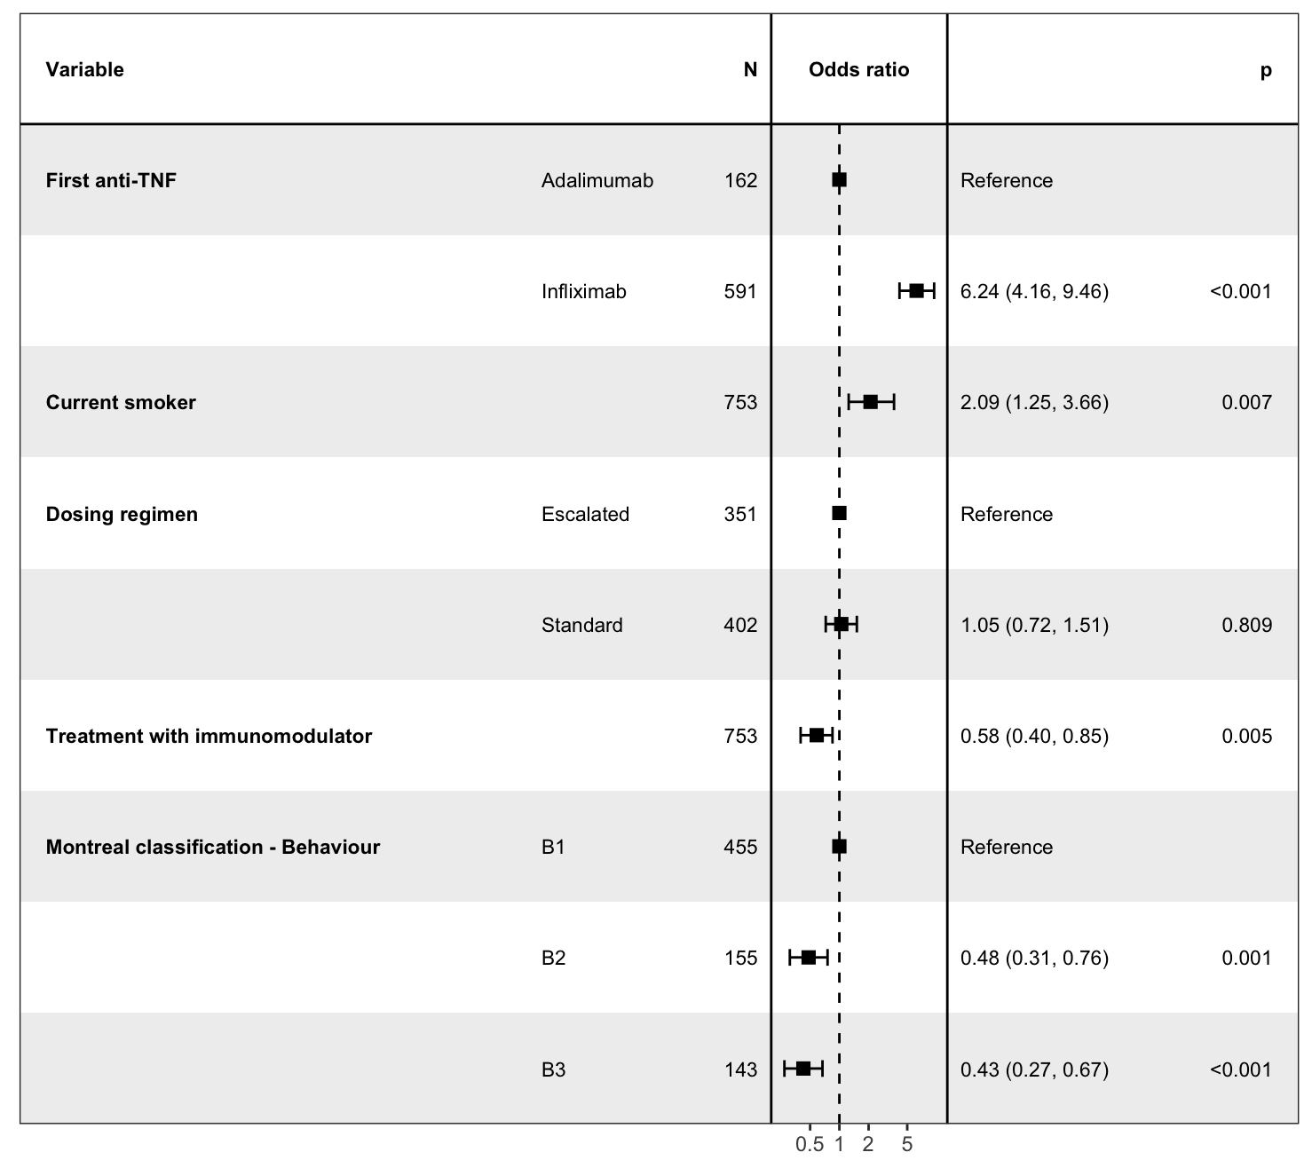
Supplemental Figure 1: Forest plot showing the coefficients from a multivariable logistic regression model of associations with immunogenicity first anti-TNF, stratified by condition (Crohn’s disease)

Supplemental Figure 2: Forest plot showing the coefficients from a multivariable logistic regression model of associations with immunogenicity first anti-TNF, stratified by condition (ulcerative colitis)

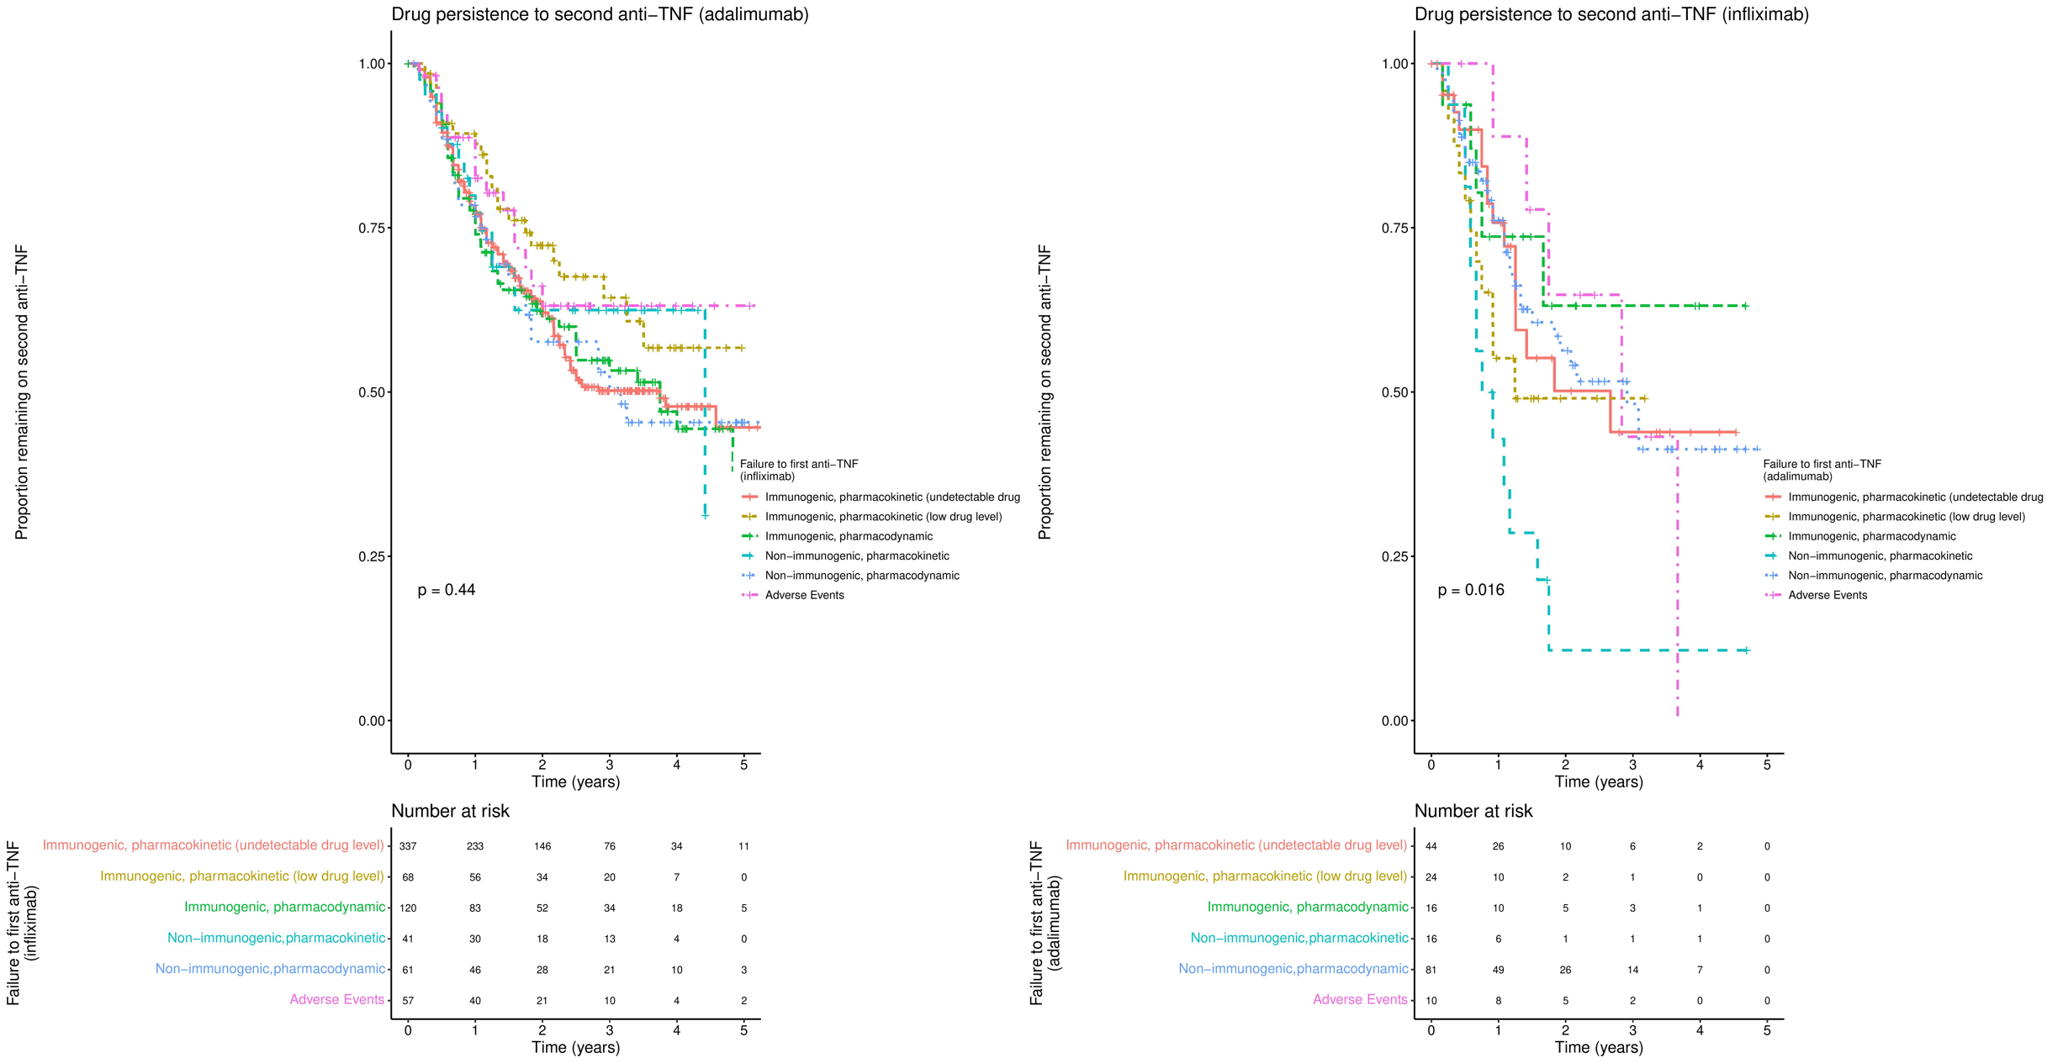
Supplemental Figure 3: Drug persistence to second anti-TNF, including stricter definition of immunogenic, pharmacokinetic failure (antibody present, undetectable drug level), stratified by first anti-TNF and type of failure to first anti-TNF

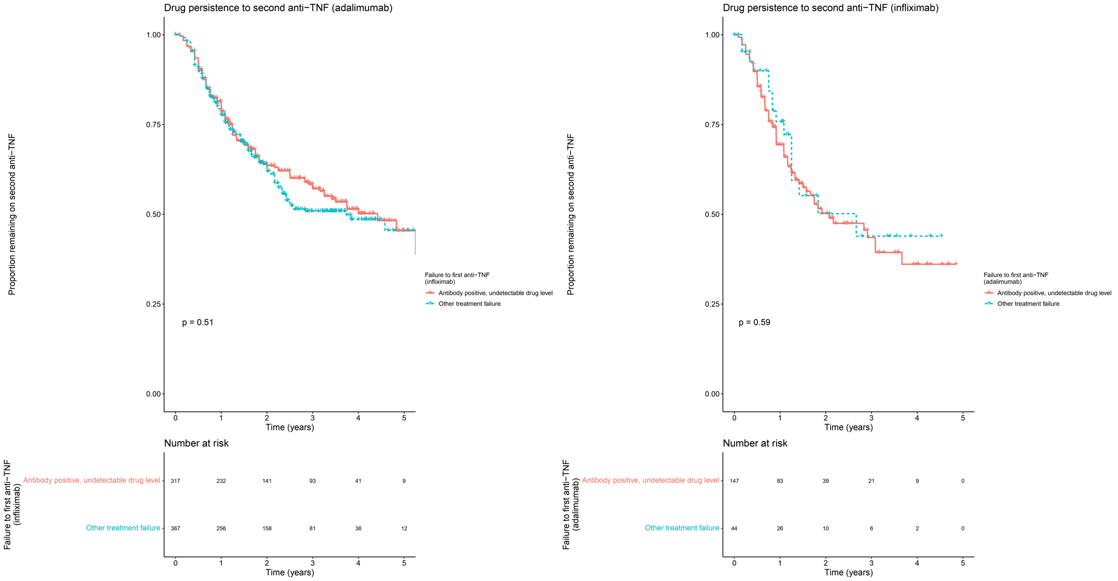
Supplemental Figure 4: Drug persistence to second anti-TNF, comparing patients who developed immunogenic-pharmacokinetic failure (antibody present, undetectable drug level) to patients who developed treatment failure for other reasons

