Vaccine escape, increased breakthrough and reinfections in infliximab-treated patients with IBD during the Omicron wave of the SARS-CoV-2 pandemic.
Authors: Nicholas A Kennedy, PhD^{1,2}* Malik Janjua, MBBS^{1,2*}, Neil Chanchlani, MBChB^{1,2}, Simeng Lin, MBChB^{1,2}, Claire Bewshea, MSc² , Rachel Nice, MSc^{2,3}, Timothy J McDonald, PhD³, Cressida Auckland, MBBS⁴, Lorna W Harries, PhD⁵, Merlin Davies, BSc⁵, Stephen L Michell, PhD⁶, Klaartje B Kok, PhD^{7,8}, Christopher A Lamb, PhD^{9,10}, Philip J Smith, MBBS¹¹, Ailsa L Hart, PhD¹², Richard CG Pollok, PhD^{13,14}, Charlie W Lees, PhD^{15,16}, Rosemary J Boyton, PhD^{17,18}, Daniel M Altmann, PhD¹⁹, Shaji Sebastian, MD^{20,21}, Nick Powell, PhD^{22,23}*, James R Goodhand, MBBS^{1,2}*, Tariq Ahmad, DPhil^{1,2}*
*Denotes shared authorship
Affiliations:
¹ Department of Gastroenterology, Royal Devon and Exeter NHS Foundation Trust, Exeter, UK
² Exeter Inflammatory Bowel Disease and Pharmacogenetics Research Group, University of Exeter, Exeter, UK
³ Department of Biochemistry, Exeter Clinical Laboratory International, Royal Devon and Exeter NHS Foundation Trust, Exeter, UK
⁴ Department of Microbiology, Royal Devon and Exeter NHS Foundation Trust, Exeter, UK
⁵ Institute of Clinical and Biomedical Sciences, University of Exeter, Exeter, UK
⁶ College of Life and Environmental Sciences, University of Exeter, Exeter, UK
⁷ Centre for Immunobiology, Blizard Institute, Barts and the London School of Medicine, Queen Mary University of London, London, UK
⁸ Department of Gastroenterology, Royal London Hospital, Barts Health NHS Trust, London, UK
⁹ Department of Gastroenterology, Newcastle upon Tyne Hospitals NHS Foundation Trust, Newcastle upon Tyne, UK
¹⁰ Translational & Clinical Research Institute, Faculty of Medical Sciences, Newcastle University, Newcastle upon Tyne, UK
¹¹ Department of Gastroenterology, Royal Liverpool Hospital, Liverpool University Hospitals NHS Foundation Trust, Liverpool, UK
¹² Department of Gastroenterology, St Marks Hospital and Academic Institute, London, UK
¹³ Department of Gastroenterology, St George's University Hospital NHS Foundation Trust, London, UK
¹⁴ Institute for Infection & Immunity, St George's, University of London, London, UK
¹⁵ Department of Gastroenterology, Western General Hospital, NHS Lothian, Edinburgh, UK
¹⁶ Institute of Genetic and Molecular Medicine, University of Edinburgh, Edinburgh, UK
¹⁷ Department of Infectious Disease, Imperial College London, London, UK
¹⁸ Lung Division, Royal Brompton and Harefield Hospitals, Guy’s and St Thomas’ NHS Foundation Trust, London, UK
¹⁹ Department of Immunology and Inflammation, Imperial College London, London, United Kingdom
²⁰ IBD Unit, Department of Gastroenterology, Hull University Teaching Hospitals NHS Trust, Hull, UK
²¹ Hull York Medical School, University of Hull, Hull, UK
²² Department of Metabolism, Digestion and Reproduction, Imperial College London, London, UK
²³ Department of Gastroenterology, Imperial College Healthcare NHS Trust, London, UK
Address for correspondence: Prof Tariq Ahmad, Exeter Inflammatory Bowel Disease and Pharmacogenetics Research Group, RILD building, Barrack Road, Exeter. EX2 5DW, UK, tariq.ahmad1@nhs.net
Conflicts of interest: see end of manuscript.
Author contributions: see end of manuscript
Running title: Vaccine escape, increased breakthrough and reinfections in infliximab-treated patients with IBD.
Word count: 4258

Abstract

Objective
Anti-tumour necrosis factor (TNF) drugs impair serological responses following SARS-CoV-2 vaccination. We sought to assess if a third dose of a mRNA-based vaccine substantially boosted anti-SARS-CoV-2 antibody responses and protective immunity in infliximab-treated patients with inflammatory bowel disease (IBD).
Design
Third dose vaccine induced anti-SARS-CoV-2 spike (anti-S) receptor-binding domain (RBD) antibody responses, breakthrough SARS-CoV-2 infection, reinfection and persistent oropharyngeal carriage in patients with IBD treated with infliximab were compared to a reference cohort treated with vedolizumab from the CLARITY IBD study.
Results
Geometric mean (standard deviation [SD]) anti-S RBD antibody concentrations increased in both groups following a third dose of a mRNA-based vaccine. However, concentrations were lower in patients treated with infliximab than vedolizumab, irrespective of whether their first two primary vaccine doses were ChAdOx1 nCoV-19 (1856 U/mL [5.2] vs 10728 U/mL [3.1], p <0.0001) or BNT162b2 vaccines (2164 U/mL [4.1] vs 15116 U/mL [3.4], p <0.0001). However, no differences in anti-S RBD antibody concentrations were seen following third and fourth doses of a mRNA-based vaccine, irrespective of the combination of primary vaccinations received. Post-third dose, anti-S RBD antibody half-life estimates were shorter in infliximab- than vedolizumab-treated patients (37.0 days [95% CI 35.6 – 38.6] vs 52.0 days [49.0 – 55.4], p <0.0001).

Compared to vedolizumab-, infliximab-treated patients were more likely to experience SARS-CoV-2 breakthrough infections fold change 2.23 [95% CI 1.46 to 3.38], p = 0.00018) and reinfections (hazard ratio 2.10 [95% CI 1.31 - 3.35], p = 0.0019), but this effect was uncoupled from third vaccine dose anti-S RBD antibody concentrations. Reinfections occurred predominantly during the Omicron wave and were predicted by SARS-CoV-2 anti-nucleocapsid concentrations after the initial infection. We did not observe persistent oropharyngeal carriage of SARS-CoV-2. Hospitalisations and deaths were uncommon in both groups.
Conclusions
Following a third dose of a mRNA-based vaccine, infliximab was associated with attenuated serological responses and more SARS-CoV-2 breakthrough infections and reinfections which were not predicted by the magnitude of anti-S RBD responses, indicative of vaccine escape by the Omicron variant.
Keywords: CLARITY; biological; infliximab; vedolizumab; COVID-19; immunosuppression; vaccination; inflammatory bowel disease

Summary Box
- What is already known about this subject?
- Vaccine induced anti-SARS-CoV-2 spike (anti-S) receptor-binding domain (RBD) antibody responses are attenuated and less durable in infliximab- than vedolizumab-treated patients with inflammatory bowel disease (IBD).
- During the delta wave of the coronavirus disease 2019 (COVID-19) pandemic, breakthrough SARS-CoV-2 infections were more common in infliximab- than vedolizumab-treated patients, and were associated with lower anti-S RBD antibody concentrations following two doses of SARS-CoV-2 vaccines.
- Higher, more sustained antibody concentrations are observed in patients with a history of SARS-CoV-2 infection prior to vaccination, but whether infliximab treatment is linked to increased risk of SARS-CoV-2 reinfection is unknown.
- What are the new findings?
- A third dose of a mRNA-based vaccine substantially boosted anti-S RBD antibody responses in infliximab- and vedolizumab-treated patients, however, anti-S RBD antibody concentrations remained attenuated in patients treated with infliximab, irrespective of the combination of primary vaccinations received.
- There was a diminishing return on anti-S RBD antibody responses with a fourth dose of a mRNA-based vaccine, irrespective of biological type or combination of primary vaccinations received.
- Breakthrough infections after a third dose of a mRNA-based vaccine were more common and occurred earlier in infliximab- than in vedolizumab-treated patients. Breakthrough infection was not associated with the magnitude of post-third dose vaccine anti-S RBD antibody concentrations.
- Reinfection with the B.1.1.529 (Omicron) variant was more common in patients treated with infliximab, compared to vedolizumab, and was predicted by SARS-CoV-2 anti-nucleocapsid concentrations after initial infection. We did not observe persistent oropharyngeal carriage.
- How might it impact on clinical practice in the foreseeable future?
- Despite Omicron variant breakthrough infections, vaccines continue to protect against severe illness, hospitalisations and death in infliximab- and vedolizumab- treated patients with IBD.
- A current correlate of protection from B.1.1.529 (Omicron) infection is unknown and at present there is no role for routine antibody concentration testing against ancestral anti-S RBD.
- Vaccination regimens for patients treated with anti-TNF therapy, should include at least one dose of an existing mRNA vaccine and booster vaccine doses need to be administered every 4 to 6 months.
- Anti-TNF treated patients have attenuated responses to vaccination and are at increased risk of breakthrough infection. Whether, in the setting of novel variants of concern, this will translate to an increased risk of severe COVID19 is unknown.

Introduction
The coronavirus disease 2019 (COVID-19) pandemic has been characterised by successive waves of more transmissible SARS-CoV-2 variants of concern (VOC), culminating most recently in B.1.1.529 (Omicron) and it’s subvariants BA.2-5 that are able to evade adaptive immunity following prior infection and vaccination. The B.1.1.529 (Omicron) variant of SARS-CoV-2 was designated a variant of concern by the World Health Organisation (WHO) on November 26th 2021,[1] and BA.4 and BA.5 are now the dominant variants in the United Kingdom (UK) and are spreading rapidly worldwide. Compared to the ancestral Wuhan strain, B.1.1.529 has more than 32 mutations including 15 in the spike receptor binding domain.[2] Current COVID-19 vaccines continue to protect against severe illness, hospitalisations and death.[3] However, the B.1.1.529 variant is causing high numbers of SARS-CoV-2 breakthrough infections and reinfection because of antigenic escape.[4]
By suppressing immune responses, immunosuppressive therapies, including biologicals, increase the risk of SARS-CoV-2 infection, persistent nasopharyngeal carriage and viral evolution.[5,6] We have recently shown that treatment with the anti-tumour necrosis factor (TNF) therapies, infliximab and adalimumab, impairs antibody responses following SARS-CoV-2 infection.[7,8] Furthermore, we demonstrated vaccine induced antibody responses are attenuated and less durable in patients treated with infliximab, translating to a 50% increased risk of breakthrough SARS-CoV-2 infection, compared to patients treated with vedolizumab, a gut-selective anti-integrin α4β7 monoclonal antibody.[9–11]
For patients with inflammatory bowel disease (IBD) treated with immunosuppressive therapies, these findings, along with data from other immunosuppressed patient cohorts,[11–13] provided evidence for the prioritisation of third primary SARS-CoV-2 vaccine doses,[14] even before the emergence of the B.1.1.529 (Omicron) variant.
We sought to assess if a third dose of a mRNA-based vaccine substantially improved anti-SARS-CoV-2 antibody responses, and if infliximab- compared to vedolizumab-treated patients are at increased risk of SARS-CoV-2 breakthrough infections, reinfection or persistent oropharyngeal carriage.

Methods

Study design, population and clinical setting
CLARITY IBD is a UK-wide, multicentre, observational cohort study investigating the impact of biological and/or concomitant immunomodulators on SARS-CoV-2 acquisition, illness and immunity in patients with IBD (www.clarityibd.org).
The overarching aims, study design and sample size calculations have been described previously.[8,9] In brief, 7224 consecutive patients were recruited at the time of attendance at infusion units between 22nd September 2020 and 23rd December 2020 (Supplementary Table 1). Patients with a diagnosis of IBD, aged 5 years and over, treated with infliximab or vedolizumab were eligible for inclusion. Follow-up visits coincided with biological infusions and typically occurred eight-weekly.
Data were linked by National Health Service (NHS) number or Community Health Index to NHS England, Public Health England, Scotland and Wales data who hold dates of vaccine uptake and dates and results of SARS-CoV-2 polymerase chain reaction (PCR) tests undertaken in the UK. When central data on vaccination were missing, we used patient reports. The alpha and B.1.1.529 (Omicron) variants are characterised by an S-gene deletion which leads to loss of one of the 3 gene targets employed in the SARS-CoV-2 Taq Path PCR assay [15] used by most UK public health laboratories. Therefore, S gene target failure can be used as a marker of infection with the alpha or the B.1.1.529 (Omicron) subvariants.
In the UK, vaccines were administered to the most clinically vulnerable, and then through progressively lower risk and younger age groups from December 2020. Citizens received either the mRNA-based vaccine, BNT162b2 or the adenovirus-vector vaccine, ChAdOx1 nCoV-19 for the first two doses. From 13th September 2021 patients deemed to be clinically extremely vulnerable, including those with IBD treated with anti-TNF therapies and vedolizumab were offered a third and fourth primary vaccine dose with a mRNA-based vaccine (either BNT162b2 [Pfizer-BioNTech] or mRNA-1273 [Moderna]) at least 8 weeks after their second dose.[14]

Here we report anti-SARS-CoV-2 antibody responses after a third primary and fourth dose with a mRNA-based vaccine, rates of SARS-CoV-2 breakthrough infections and reinfection, and persistent oropharyngeal carriage.

Outcomes
Participants were eligible for our immunogenicity analysis if they had had an anti-spike (S) receptor binding domain (RBD) antibody test between 14 and 70 days after a third and fourth vaccine dose with a mRNA-based vaccine.

Anti-SARS-CoV-2 antibody assays
To determine antibody responses specific to vaccination, we used the Roche Elecsys anti-SARS-CoV-2 spike (S) immunoassay alongside the nucleocapsid (N) immunoassay.[16,17] This double sandwich electrochemiluminescence immunoassay uses a recombinant protein of the RBD on the spike protein as an antigen for the determination of antibodies against SARS-CoV-2. Sample electrochemiluminescence signals are compared to an internal calibration curve and quantitative values are reported as units (U)/mL.
The Roche Elecsys anti-SARS-CoV-2 (N) immunoassay is a sandwich electrochemiluminescence immunoassay that uses a recombinant protein of the nucleocapsid antigen for determination of antibodies against SARS-CoV-2 infection. Using a cut-off index (COI) of 1, the manufacturer reports clinical sensitivity and specificity of 99.5% (97.0 - 100) and 99.8% (95% CI 99.7 - 99.9), respectively, >14 days after PCR-confirmed COVID-19. We have previously reported that anti-N antibody responses following SARS-CoV-2 natural infection are impaired in patients treated with infliximab compared to vedolizumab.[8] As such, a threshold of 0.12 COI was set using receiver operator characteristic curve and area under the curve analysis of anti-N antibody results from participants two weeks following a PCR-confirmed infection to maximise sensitivity and specificity, beyond which patients were deemed to have had prior SARS-CoV-2 infection.

Breakthrough SARS-CoV-2 infections
SARS-CoV-2 infections were defined by a positive PCR test to SARS CoV-2. Breakthrough infection was defined as a SARS CoV-2 infection, diagnosed by positive PCR test, more than 14 days after a third dose of a SARS-CoV-2 vaccine.

Reinfections with SARS-CoV-2 and persistent oropharyngeal carriage
We defined SARS-CoV-2 reinfection as a recurrence of symptoms compatible with COVID-19, accompanied by a positive PCR test, more than 90 days after the onset of the primary infection.[18]
Because PCR positivity may persist for prolonged periods following initial infection and asymptomatic carriage is common, it is difficult to differentiate reinfection from persistent oropharyngeal carriage. To assess the risk of persistent carriage, participants aged 18 years and over with a previous history of confirmed SARS-CoV-2 infection, but without ongoing symptoms, were invited to carry out a home buccal swab test between 20th May 2021 and 7th January 2022.
We used PCR to detect SARS-CoV-2 RNA, and in positive samples, for the presence of envelope (E) and subgenomic RNAs (sgRNA).[19] sgRNAs are generated after SARS-CoV-2 enters cells and are poorly incorporated into mature virions and can be used as marker for actively replicating, rather than inactivated or neutralized, virus. Methods have been reported previously.[19] In brief, RNA was extracted using the Chemagic Viral DNA/RNA Kit on the Chemagic 360D platform. Viral loads were measured by quantitative real-time PCR for E gene and E-gene derived sgRNA sequences respectively. Reactions were performed using the SuperScript™ One-Step RT-PCR System with Platinum™ Taq DNA Polymerase (Thermo Fisher, Waltham, USA). Reactions were carried out in 384 well plates on the QuantStudio™ 12K Flex Real-Time PCR System (Applied Biosystems, Foster City, USA). Probes and primers were obtained from Thermo Fisher (Waltham, USA). E gene and E sgRNA viral loads were determined in relation to known quantities of synthetic standards by standard curve analysis. Synthetic standards consisted of the probe and primer binding sites in a single long oligonucleotide for each of E gene and E gene-derived sgRNA sequences and were obtained from Invitrogen (Waltham, USA).

Variables
Variables recorded by participants were demographics (age, sex, ethnicity, comorbidities, height and weight, smoking status, and postcode), IBD disease activity (PRO2), SARS-CoV-2 symptoms aligned to the COVID-19 symptoms study (symptoms, previous testing, and hospital admissions for COVID-19), and vaccine uptake (type and date of primary vaccination). Study sites completed data relating to IBD history (age at diagnosis, disease duration, and phenotype according to the Montreal classifications, previous surgeries, and duration of current biological and immunomodulator therapy, COVID-19 hospitalisations and deaths. Data were entered electronically into a purpose-designed REDCap database hosted at the Royal Devon and Exeter NHS Foundation Trust.[20] Participants without access to the internet or electronic device completed their questionnaires on paper case record forms that were subsequently entered by local research teams.
Statistical analysis
Statistical analyses were undertaken in R 4.1.2 (R Foundation for Statistical Computing, Vienna, Austria). All tests were two-tailed and p-values <0.05 were considered significant. We included patients with missing clinical variables in analyses for which they had data and have specified the denominator for each variable. Continuous data are reported as median and interquartile range, and discrete data as numbers and percentages.
Anti-S RBD antibody concentrations are reported as geometric means and standard deviations. T-tests of log-transformed anti-S RBD antibody concentrations were used to compare antibody responses by vaccine type, biological drug type, breakthrough infection and reinfection status. Multivariable linear regression models were used to identify factors independently associated with log anti-S RBD concentration. Based on our previous findings,[9,10] a priori, we included age, ethnicity, biological medication and immunomodulator use. Results are presented after exponentiation, so that the coefficients of the model correspond to the fold change (FC) associated with each binary covariate. For age, a cut-off of >60 years was chosen based on graphical inspection of the relationship between age and anti-S RBD antibody concentrations.
We visualized durability of antibody responses by calculating 15-day rolling geometric mean anti-S RBD antibody concentrations. Anti-S RBD antibody half-lives were estimated using an exponential model of decay. Linear mixed models were fit using the lme4 and lmerTest package, with biological treatment and vaccine type as fixed effects and each subject as a random effect. Confidence intervals were calculated using likelihood ratios. P values for comparison of half-lives were estimated from the full linear mixed effects model that incorporated vaccine, biological drug and prior SARS-CoV-2 infection status.
Kaplan-Meier curves and Cox proportional hazard regression models were used to identify treatment and vaccine related factors associated with time to breakthrough infections and reinfections. Multivariable logistic regression analysis was used to identify factors associated with hospitalisation among those with a positive SARS-CoV-2 PCR across the pandemic. Where appropriate, the same analyses were used to compare antibody responses in participants with PCR evidence of SARS-CoV-2 infection at any time prior to vaccination.
Ethics and role of the funding source
CLARITY IBD is an investigator-led, UK National Institute for Health Research COVID-19 urgent public health study, funded by the Royal Devon and Exeter NHS Foundation Trust, Hull University Teaching Hospital NHS Trust, NIHR Imperial Biomedical Research Centre, Crohn’s and Colitis UK (M2021/1), Guts UK, and by unrestricted educational grants from F. Hoffmann-La Roche AG (Switzerland), Biogen Inc (USA), Celltrion Healthcare (South Korea), Takeda (UK), and Galapagos NV (Belgium). This study was supported by an NCSi programme UKRI award to RJB, DMA, NP and TA (MR/W020610/1). None of our funding bodies had any role in study design, data collection or analysis, writing, or decision to submit for publication.
The Surrey Borders Research Ethics committee approved the study (REC reference: REC 20/HRA/3114) in September 2020. The sponsor was the Royal Devon and Exeter NHS Foundation Trust. The protocol is available online at https//www.clarityibd.org. The study was registered with the ISRCTN registry, ISRCTN45176516.

Results

Patient characteristics
Between September 22nd 2020 and December 23rd 2020, 7224 patients were recruited to the CLARITY study from 92 UK hospitals. In our primary immunogenicity analyses, we included 918 infliximab- and 442 vedolizumab-treated participants without a history of prior SARS-CoV-2 infection, who had received uninterrupted biological therapy since recruitment and had an antibody test between 14 and 70 days after a third dose with a mRNA-based SARS-CoV-2 vaccine. Participant characteristics are shown in (Table 1). Additional analyses are presented for 512 infliximab- and 185 vedolizumab-treated participants with a history of SARS-CoV-2 infection before the third vaccine dose (Table 2).
Anti-SARS-CoV-2 (S) antibody level following third COVID-19 vaccine
The peak geometric mean (standard deviation [SD]) anti-S RBD antibody concentration was higher in recipients of three doses of a mRNA-based vaccine than recipients of two ChAdOx1 nCoV-19 vaccines and a third dose with a mRNA-based vaccine (4085 U/mL [5.1] vs 3275 U/mL [5.5], p=0.016). Geometric mean (SD) anti-S RBD antibody fold change (FC) between peak antibody concentrations after second and third vaccine doses was greater in recipients of two ChAdOx1 nCoV-19 vaccines, followed by a third dose with a mRNA-based vaccine, compared to recipients of three mRNA-based vaccine doses (FC 11.1 [4.0] vs FC 3.7 [4.1]), p<0.0001 (Figure 1).
Anti-S RBD antibody concentrations were lower in infliximab than vedolizumab-treated patients following a third dose with a mRNA-based vaccine (1978 U/mL [4.7] vs 12384 U/mL [3.3], p <0.0001), irrespective of whether they had received their first two vaccine doses with the ChAdOx1 nCoV-19 (1856 U/mL [5.2] vs 10728 U/mL [3.1], p <0.0001) or BNT162b2 vaccines (2164 U/mL [4.1] vs 15116 U/mL [3.4], p <0.0001) (Figure 2).

Multivariable linear regression analyses in patients without prior SARS-CoV-2 infection confirmed that antibody concentrations were reduced 5.5-fold in infliximab- compared with vedolizumab- treated patients after a third dose with a mRNA-based vaccine (FC 0.18 [95% CI 0.15 to 0.21], p<0.0001) (Figure 3). Age ≥ 60 years and methotrexate use were also independently associated with lower anti-S RBD antibody concentrations. Receipt of three doses of a mRNA-based vaccine and a longer interval between second and third vaccine doses were associated with higher anti-S RBD antibody concentrations.
In patients without prior infection, anti-S RBD antibody half-life estimates were shorter in infliximab than vedolizumab-treated patients following three doses of a SARS-CoV-2 vaccine: 37.0 days [95% CI 35.6 to 38.6] vs 52.0 days [95% CI 49.0 to 55.4], respectively. Antibody concentrations following a third vaccine dose were higher in patients with a prior history of SARS-CoV-2 infection (Supplementary Figure 1). Amongst patients with a history of SARS-CoV-2 infection at any point before third vaccination dose, geometric mean (SD) anti-S RBD antibody concentrations were lower in infliximab- compared with vedolizumab-treated patients after third vaccination with a mRNA-based vaccine (4059 U/mL [4.7] vs 18788 U/mL [3.0], p <0.0001).
Anti-SARS-CoV-2 (S) antibody level following fourth COVID-19 vaccine
Anti-S RBD antibody concentrations were lower in infliximab than vedolizumab-treated patients following a fourth dose with a mRNA-based vaccine (3353 U/mL [3.9] vs 18152 U/mL [2.6], p <0.0001), irrespective of whether they had received two doses of ChAdOx1 nCoV-19 (3257 U/mL [4.3] vs 17535 U/mL [2.6], p <0.0001) or BNT162b2 (3489 U/mL [3.4] vs 19183 U/mL [2.6], p <0.0001) vaccines first (Figure 1). There was no difference between geometric mean (SD) anti-S RBD peak antibody concentrations following third and fourth doses of a mRNA-based vaccine, irrespective of the combination of primary vaccinations received (Figure 2).

Breakthrough SARS-CoV-2 infections following three doses of vaccine
Incident SARS-CoV-2 infections across the entire CLARITY IBD cohort are shown in Figure 4. Overall, 15.0% (393/2619 [95% CI 13.6 to 16.4%]) patients had a breakthrough infection after the third vaccine dose. S gene target failure, indicative of infection with the B.1.1.529 (Omicron) variant, was observed in 74.9% (128/171) of those patients with breakthrough infection for whom PCR gene detection patterns were available.
Univariable factors associated with time to breakthrough infection are shown in Supplementary Table 2. Younger age, infliximab treatment, concomitant thiopurine and lack of exposure to steroids were associated with a shorter time to breakthrough infection. In a multivariable model including anti-S RBD antibody concentrations, infliximab-, compared with vedolizumab-treatment, and younger age, but not antibody responses, were significantly associated with a shorter time to breakthrough infection (Figure 5).
SARS-CoV-2 re-infection and persistent carriage
In our analyses of reinfections, we included 757 infliximab- and 274 vedolizumab-treated participants who had at least 91 days of follow-up following a first positive PCR test whilst treated with their original biological. Overall, 12.5% (129/1031 [95% CI 10.5 to 14.7%]) patients had a re-infection with SARS-CoV-2. S gene target failure was observed in 83.6% (56/67) patients for whom PCR gene detection patterns were available.
Time to reinfection was shorter in infliximab- than vedolizumab-treated patients (HR 2.10, 95% CI 1.31 to 3.35, p = 0.0019). Reinfection was associated with SARS-CoV-2 anti-N antibody level 2 to 10 weeks after the first PCR-confirmed infection. For every 10-fold rise in anti-N RBD antibody concentration, we observed a 0.73-fold (95% CI 0.56 to 0.95, p = 0.02) reduction in odds of reinfection. Reinfection was not associated with SARS-CoV-2 anti-S antibody level 2 to 10 weeks after the third vaccine dose.
Of note, 3.1% (68/2185) participants with an initial positive SARS-CoV-2 PCR had a further positive test between 15 and 90 days later. To investigate whether participants shed replication-competent virus beyond 14 days, 207 adult patients with SARS-CoV-2 infection (positive RT-PCR from nasopharyngeal swabs) within the previous 90 days were sent kits in the post to carry out a home buccal swab test for a SARS-CoV-2 RT-PCR. 168 patients returned the kits and 3 were positive for SARS-CoV-2, 16, 26 and 28 days after a positive PCR test. None of these samples tested positive for E gene or E gene derived sub-genomic RNA indicating non-replicating virus.

Overview of all COVID-19 infections, hospitalisations and deaths in the CLARITY cohort
In a Cox proportional hazards model of all infections across the entire CLARITY cohort, there were independent protective effects of prior infection and vaccination on the risk of SARS-CoV-2 infection. We observed a significant interaction between biological use and vaccination, whereby the protective effect of vaccination on the risk of infection was reduced in patients treated with infliximab compared with vedolizumab, irrespective of vaccine type (Figure 6). No interaction was seen between biological type and the protective effect of prior infection (Figure 7).
Overall, 26/2186 (1.2%) patients had been hospitalised with COVID-19 after a median of 2.5 (IQR 0 - 8) days following a positive PCR test. Univariable analyses demonstrated that hospitalisation was associated with treatment with vedolizumab, older age, higher BMI, comorbid heart disease, diabetes, lung disease and cancer and having had fewer than two vaccine doses. Multivariable logistic regression confirmed that hospitalisation with COVID-19 was independently associated with older age (per decade: odds ratio [OR] 1.69, 95% CI 1.28 to 2.25, p <0.0001) and a history of cancer (OR 113.63, 95% CI 14.12 to 1125.64, p < 0.0001), whereas having at least two doses of SARS-CoV-2 vaccine (OR 0.24, 95% CI 0.10 to 0.56, p = 0.0011) was protective (Supplementary Figure 2).
There were 15 deaths in the CLARITY cohort, three were due to COVID-19. Two deaths occurred in unvaccinated participants and one in a participant who had received two vaccine doses. The vaccinated patient had no comorbidities and received his last vedolizumab dose three weeks prior to testing positive for SARS-CoV-2.

Discussion
Key results
After primary vaccination, anti-SARS-CoV-2 spike antibody concentrations were highest in the recipients of three doses of a mRNA-based vaccine. Infliximab treatment was associated with attenuated, less durable anti-SARS-CoV-2 antibody responses and a two-fold increase in subsequent breakthrough SARS-CoV-2 infection. Unlike earlier in the pandemic, during the B.1.1.529 (Omicron) wave, magnitude of SARS-CoV-2 ancestral spike antibody concentrations did not predict protective immunity. Anti-SARS-CoV-2 antibody concentrations were higher and more sustained in participants with prior SARS-CoV-2 infection compared to those without prior infection. Reinfection occurred predominantly during the B.1.1.529 (Omicron) wave, were more common in infliximab- than vedolizumab-treated patients, and were predicted by SARS-CoV-2 anti-N concentrations. We did not observe persistent oropharyngeal carriage. Hospitalisations and deaths remained uncommon.
Interpretation
In keeping with the original vaccine trials,[21,22] after two vaccine doses, the highest anti-S RBD antibody concentrations were observed in recipients of the BNT162b2 vaccine. However, a third dose of a mRNA-based vaccine substantially improved responses in patients who had previously received the ChAdOx1 nCoV-19 vaccine, in support of previous studies demonstrating the benefit of heterologous booster vaccinations.[23,24] Few published studies have reported the impact of biological and immunomodulator drugs on anti-SARS-CoV-2 antibody responses after three or four doses of a COVID-19 vaccine in patients with IBD.[25]

Previous observational studies following one or two doses of a SARS-CoV-2 vaccine showed that most patients mount a serological response.[26–31] Drawing conclusions across studies, however, is limited by differences in study sample size, control populations, the numbers and types of vaccines administered, and the assays and seroconversion thresholds adopted to define response. Perhaps unsurprisingly then, results regarding the impact of specific biological and/or immunomodulator drugs are contradictory. Those studies that were adequately powered concluded that anti-TNF monotherapy attenuates serological responses, which are further impaired by combination immunomodulator use and in particular by methotrexate.[8,9,11] Our half-life estimates suggest that further booster doses may be required for infliximab-treated patients without prior infection, after about 4 months to maintain antibody concentrations above peak pre-third dose concentrations.[10] Based on our post fourth dose antibody responses, however, there appears to be a ceiling effect on peak anti-S RBD antibody concentrations, irrespective of biological type or combination of primary vaccinations received.
Overall, vaccination continued to provide protective immunity during the B.1.1.529 (Omicron) wave. However, breakthrough SARS-CoV-2 infections occurred more commonly and earlier in infliximab- than vedolizumab-treated patients. Because infliximab does not increase the risk of SARS-CoV-2 infection prior to vaccination, the increased risk of breakthrough infection observed here is likely mediated by attenuated vaccine responses. Our findings that anti-nucleocapsid concentrations predict re-infection reflects the conserved nature of the SARS-CoV-2 nucleocapsid sequence. In contrast, the spike sequence has rapidly evolved from the ancestral Wuhan Hu-1 strain sequence used in currently available vaccines. This is likely to explain why the anti-S-RBD antibody concentrations does not predict the risk of breakthrough infections with the omicron variant. In the age of VOCs, no reliable serological correlate of protection currently exists making routine anti-S RBD antibody testing to assess vaccine responses of limited utility, although it remains a useful marker demonstrating an immune response to vaccination.
As the pandemic evolved, reinfection with the new VOC has become more frequent. Similar to the situation in the general population, in this study, prior to the emergence of B1.1.529 (Omicron), breakthrough infection and reinfection with COVID-19 were relatively uncommon in our vaccinated population. Thereafter, treatment with infliximab was associated with a two-fold increased risk of reinfection compared to treatment with vedolizumab that was predicted by the immune responses at the time of the initial infection. Whilst we observed that 3.1% of our patients tested positive for SARS-CoV-2, 15 to 90 days after their index diagnosis, we did not observe persistent oropharyngeal carriage of replication-competent virus in our sub-study. Our findings may be limited by our sample size, however, against this, in the general population 13% of immunocompetent participants had evidence of persistent carriage of live virus.[19] However, and unlike Davies et al., we undertook this work during a low prevalence phase of the pandemic when the delta variant was dominant, and relied on cross-sectional rather than sequential testing with a longer interval between first and last PCR tests.
Despite the increased risk of breakthrough and recurrent SARS-CoV-2 infections in patients treated with infliximab, hospitalisations and deaths were reassuringly uncommon. This is likely to reflect the effectiveness of vaccination and the lower virulence of the B1.1.259 (Omicron) variant. Moreover, anti-TNF therapy may prevent severe illness through inhibition of systemic inflammatory response associated with severe COVID-19.[32,33] Whilst hospitalisations were uncommon, a large number of infected patients risk a high burden of long covid in a population who already experience increased rates of fatigue, cognitive dysfunction and mood disorders than the general population.[34,35] Several groups have suggested that anti-TNF therapy protects patients from severe COVID-19 illness.[36] Because long covid has been linked to more severe initial disease,[37] further work is needed to understand the effect of anti-TNF therapy on the prevalence and biology of long COVID.
Limitations and generalisability
We acknowledge the following limitations. First, our sample size although larger than similar studies, did not allow us to determine the effectiveness of vaccination against breakthrough infection with specific SARS-CoV-2 variants. Second, we have not been able to evaluate the impact of biological therapy on immunity that follows infection independent of vaccination, as only 5% of patients were unvaccinated at latest follow-up. Finally, we only assessed anti-S RBD antibody responses to infection, while a comprehensive appraisal of protective immunity would incorporate analysis of specific T cell immunity.

Anti-TNF drugs are used to treat a number of other immune-mediated inflammatory disease, which together affect about 3%–7% of Western populations including rheumatoid arthritis, ankylosing spondylitis, psoriatic arthritis, psoriasis, hidradenitis suppurativa and uveitis. Our findings are likely to be generalisable to other anti-TNF drugs including adalimumab, certolizumab, golimumab and etanercept and across these other disease indications. Recent data from the VIP study suggests that anti-SARS-CoV-2 antibody responses following vaccination are also impaired in patients with IBD treated with other systemic immunosuppressant drugs, including tofacitinib, and allowing for sample size constraints, ustekinumab.[11]
As a consequence of attenuated and less durable immunity, the potential benefits of vaccination against the risk of SARS-CoV-2 breakthrough infection and reinfection were reduced by infliximab treatment. The growing immunity in the population will potentially accelerate antigenic evolution, increasing the risk of reinfection and potentially for higher disease severity in reinfected patients.[38] Patients with attenuated responses to vaccination should be considered vulnerable to future more virulent SARS-CoV-2 variants.

Strategies that bypass the negative effect of the anti-TNF on vaccine induced immune responses are now required. Further work is needed to assess whether the next generation of anti-SARS-CoV-2 vaccines, temporarily withholding immunomodulators at the time of vaccination [39] and/or timing booster doses towards the end of an anti-TNF treatment cycle when drug levels are lowest [7] may induce greater immunogenicity. In the meantime, anti-TNF patients should be prioritised for booster vaccine doses with a mRNA-based vaccine.
Conclusion
Following a third and fourth dose of anti-SARS-CoV-2 mRNA-based vaccine, infliximab-treatment was associated with attenuated serological responses. Breakthrough SARS-CoV-2 infections and reinfections were not predicted by the magnitude of anti-S RBD responses, indicative of vaccine escape by the B1.1.529 (Omicron) variant occurred more commonly in patients treated with infliximab than vedolizumab

References
1 World Health Organization. Classification of Omicron (B.1.1.529): SARS-CoV-2 Variant of Concern. https://www.who.int/news/item/26-11-2021-classification-of-omicron-(b.1.1.529)-sars-cov-2-variant-of-concern. Classification of Omicron (B.1.1.529): SARS-CoV-2 Variant of Concern. https://www.who.int/news/item/26-11-2021-classification-of-omicron-(b.1.1.529)-sars-cov-2-variant-of-concern. 2021.
2 Hoffmann M, Krüger N, Schulz S, et al. The Omicron variant is highly resistant against antibody-mediated neutralization: Implications for control of the COVID-19 pandemic. Cell 2022;185:447-456.e11. doi:10.1016/J.CELL.2021.12.032
3 Lopez Bernal J, Andrews N, Gower C, et al. Effectiveness of the Pfizer-BioNTech and Oxford-AstraZeneca vaccines on covid-19 related symptoms, hospital admissions, and mortality in older adults in England: test negative case-control study. Published Online First: 2021. doi:10.1136/bmj.n1088
4 Andrews N, Stowe J, Kirsebom F, et al. Covid-19 Vaccine Effectiveness against the Omicron (B.1.1.529) Variant. https://doi.org/101056/NEJMoa2119451 Published Online First: 2 March 2022. doi:10.1056/NEJMOA2119451
5 Choi B, Choudhary MC, Regan J, et al. Persistence and Evolution of SARS-CoV-2 in an Immunocompromised Host. New England Journal of Medicine 2020;383:2291–3. doi:10.1056/NEJMC2031364
6 Avanzato VA, Matson MJ, Seifert SN, et al. Case Study: Prolonged Infectious SARS-CoV-2 Shedding from an Asymptomatic Immunocompromised Individual with Cancer. Cell 2020;183:1901-1912.e9. doi:10.1016/j.cell.2020.10.049
7 Chanchlani N, Lin S, Chee D, et al. Adalimumab and infliximab impair SARS-CoV-2 antibody responses: results from a therapeutic drug monitoring study in 11422 biologic-treated patients. J Crohns Colitis Published Online First: 2 September 2021. doi:10.1093/ecco-jcc/jjab153
8 Kennedy NA, Goodhand JR, Bewshea C, et al. Anti-SARS-CoV-2 antibody responses are attenuated in patients with IBD treated with infliximab. Gut 2021;70:865–75. doi:10.1136/gutjnl-2021-324388
9 Kennedy NA, Lin S, Goodhand JR, et al. Infliximab is associated with attenuated immunogenicity to BNT162b2 and ChAdOx1 nCoV-19 SARS-CoV-2 vaccines in patients with IBD. Gut Published Online First: 26 April 2021. doi:10.1136/gutjnl-2021-324789
10 Lin S, Kennedy NA, Saifuddin A, et al. Antibody decay, T cell immunity and breakthrough infections following two SARS-CoV-2 vaccine doses in inflammatory bowel disease patients treated with infliximab and vedolizumab. Nature Communications 2022;13:1379. doi:10.1038/s41467-022-28517-z
11 Alexander JL, Kennedy NA, Ibraheim H, et al. COVID-19 vaccine-induced antibody responses in immunosuppressed patients with inflammatory bowel disease (VIP): a multicentre, prospective, case-control study. The Lancet Gastroenterology & Hepatology Published Online First: February 2022. doi:10.1016/S2468-1253(22)00005-X
12 Prendecki M, Clarke C, Edwards H, et al. Humoral and T-cell responses to SARS-CoV-2 vaccination in patients receiving immunosuppression. Annals of the Rheumatic Diseases 2021;80:1322–9. doi:10.1136/annrheumdis-2021-220626
13 Mahil SK, Bechman K, Raharja A, et al. The effect of methotrexate and targeted immunosuppression on humoral and cellular immune responses to the COVID-19 vaccine BNT162b2: a cohort study. The Lancet Rheumatology 2021;3:e627–37. doi:10.1016/S2665-9913(21)00212-5
14 Joint Committee on Vaccination and Immunisation. Joint Committee on Vaccination and Immunisation (JCVI) advice on third primary dose vaccination. 2021.https://www.gov.uk/government/publications/third-primary-covid-19-vaccine-dose-for-people-who-are-immunosuppressed-jcvi-advice/joint-committee-on-vaccination-and-immunisation-jcvi-advice-on-third-primary-dose-vaccination (accessed 6 Sep 2021).
15 European Centre for Disease Prevention and Control/World Health Organization Regional Office for Europe. Methods for the detection and characterisation of SARS-CoV-2 variants - first update - 20 Dec 2021. 2021.
16 Roche Diagnostics GmbH. Elecsys® Anti-SARS-CoV-2 S assay method sheet. 2020.https://diagnostics.roche.com/gb/en/products/params/elecsys-anti-sars-cov-2-s.html (accessed 24 Mar 2021).
17 Muench P, Jochum S, Wenderoth V, et al. Development and validation of the elecsys anti-SARS-CoV-2 immunoassay as a highly specific tool for determining past exposure to SARS-CoV-2. Journal of Clinical Microbiology 2020;58:1694–714. doi:10.1128/JCM.01694-20
18 Yahav D, Yelin D, Eckerle I, et al. Definitions for coronavirus disease 2019 reinfection, relapse and PCR re-positivity. Clinical Microbiology and Infection 2021;27:315. doi:10.1016/J.CMI.2020.11.028
19 Davies M, Bramwell LR, Jeffery N, et al. Persistence of clinically relevant levels of SARS-CoV2 envelope gene subgenomic RNAs in non-immunocompromised individuals. International Journal of Infectious Diseases Published Online First: December 2021. doi:10.1016/j.ijid.2021.12.312
20 Harris PA, Taylor R, Minor BL, et al. The REDCap consortium: Building an international community of software platform partners. Journal of Biomedical Informatics. 2019;95. doi:10.1016/j.jbi.2019.103208
21 Voysey M, Clemens SAC, Madhi SA, et al. Safety and efficacy of the ChAdOx1 nCoV-19 vaccine (AZD1222) against SARS-CoV-2: an interim analysis of four randomised controlled trials in Brazil, South Africa, and the UK. The Lancet 2021;397:99–111. doi:10.1016/S0140-6736(20)32661-1
22 Walsh EE, Frenck RW, Falsey AR, et al. Safety and Immunogenicity of Two RNA-Based Covid-19 Vaccine Candidates. New England Journal of Medicine 2020;383:2439–50. doi:10.1056/nejmoa2027906
23 Costa Clemens SA, Weckx L, Clemens R, et al. Heterologous versus homologous COVID-19 booster vaccination in previous recipients of two doses of CoronaVac COVID-19 vaccine in Brazil (RHH-001): a phase 4, non-inferiority, single blind, randomised study. Lancet 2022;399:521–9. doi:10.1016/S0140-6736(22)00094-0
24 Atmar RL, Lyke KE, Deming ME, et al. Homologous and Heterologous Covid-19 Booster Vaccinations. New England Journal of Medicine 2022;386:1046–57. doi:10.1056/NEJMOA2116414/SUPPL_FILE/NEJMOA2116414_DATA-SHARING.PDF
25 Schell TL, Knutson KL, Saha S, et al. Humoral Immunogenicity of Three COVID-19 mRNA Vaccine Doses in Patients with Inflammatory Bowel Disease. medrxiv.org doi:10.1101/2021.12.22.21268217
26 Wong SY, Dixon R, Martinez Pazos V, et al. Serologic Response to Messenger RNA Coronavirus Disease 2019 Vaccines in Inflammatory Bowel Disease Patients Receiving Biologic Therapies. Gastroenterology 2021;161:715-718.e4. doi:10.1053/J.GASTRO.2021.04.025
27 Classen JM, Muzalyova A, Nagl S, et al. Antibody Response to SARS-CoV-2 Vaccination in Patients with Inflammatory Bowel Disease: Results of a Single-Center Cohort Study in a Tertiary Hospital in Germany. Digestive Diseases Published Online First: 10 December 2021. doi:10.1159/000521343
28 Cerna K, Duricova D, Lukas M, et al. Anti-SARS-CoV-2 Vaccination and Antibody Response in Patients With Inflammatory Bowel Disease on Immune-modifying Therapy: Prospective Single-Tertiary Study. Inflammatory Bowel Diseases Published Online First: 29 November 2021. doi:10.1093/ibd/izab301
29 Edelman-Klapper H, Zittan E, Bar-Gil Shitrit A, et al. Lower Serologic Response to COVID-19 mRNA Vaccine in Patients With Inflammatory Bowel Diseases Treated With Anti-TNFα. Gastroenterology Published Online First: 28 October 2021. doi:10.1053/J.GASTRO.2021.10.029
30 Jena A, Mishra S, Deepak P, et al. Response to SARS-CoV-2 vaccination in immune mediated inflammatory diseases: Systematic review and meta-analysis. Autoimmunity Reviews. 2022;21. doi:10.1016/j.autrev.2021.102927
31 Kappelman MD, Weaver KN, Boccieri M, et al. Humoral Immune Response to Messenger RNA COVID-19 Vaccines Among Patients With Inflammatory Bowel Disease. Gastroenterology 2021;161:1340-1343.e2. doi:10.1053/j.gastro.2021.06.016
32 Soy M, Keser G, Atagündüz P, et al. Cytokine storm in COVID-19: pathogenesis and overview of anti-inflammatory agents used in treatment. Clinical Rheumatology. 2020;39:2085–94. doi:10.1007/s10067-020-05190-5
33 Akiyama S, Hamdeh S, Micic D, et al. Prevalence and clinical outcomes of COVID-19 in patients with autoimmune diseases: A systematic review and meta-analysis. Annals of the Rheumatic Diseases 2021;80:384–91. doi:10.1136/annrheumdis-2020-218946
34 Tadin Hadjina I, Zivkovic PM, Matetic A, et al. Impaired neurocognitive and psychomotor performance in patients with inflammatory bowel disease. Scientific Reports 2019 9:1 2019;9:1–13. doi:10.1038/s41598-019-50192-2
35 Goodhand JR, Wahed M, Mawdsley JE, et al. Mood Disorders in Inflammatory Bowel Disease: Relation to Diagnosis, Disease Activity, Perceived Stress, and Other Factors. Published Online First: 2012. doi:10.1002/ibd.22916
36 Gianfrancesco M, Hyrich KL, Hyrich KL, et al. Characteristics associated with hospitalisation for COVID-19 in people with rheumatic disease: Data from the COVID-19 Global Rheumatology Alliance physician-reported registry. Annals of the Rheumatic Diseases 2020;79:859–66. doi:10.1136/annrheumdis-2020-217871
37 Crook H, Raza S, Nowell J, et al. Long covid—mechanisms, risk factors, and management. BMJ 2021;374. doi:10.1136/BMJ.N1648
38 Markov P v, Katzourakis A, Stilianakis NI. Antigenic evolution will lead to new SARS-CoV-2 variants with unpredictable severity. Nature Published Online First: 2022. doi:10.1038/s41579-022-00722-z
39 Park JK, Lee MA, Lee EY, et al. Effect of methotrexate discontinuation on efficacy of seasonal influenza vaccination in patients with rheumatoid arthritis: A randomised clinical trial. Annals of the Rheumatic Diseases 2017;76:1559–65. doi:10.1136/annrheumdis-2017-211128

Contributions
NAK, JRG, CB, SS, NP, TA participated in the conception and design of this study. CB was the project manager and coordinated patient recruitment. RN and TJM coordinated all biochemical analyses and central laboratory aspects of the project. NAK, MJ, NC, SL, CB, LWH, MD, KBK, CAL, PJS, ALH, RCP, CWL, RJB, DMA, SS, NP, JRG, TA were involved in the acquisition, analysis, or interpretation of data. CA and SM performed SARS-CoV-2 variants characterisation analysis and interpretation. LWH, MD performed and interpreted RNA and sub genomic analyses. Data analysis was done by NAK. Drafting of the manuscript was done by NAK, MJ, NC, SL, JRG, and TA. TA and RJB obtained the funding for the study. All the authors contributed to the critical review and final approval of the manuscript. NAK, NP, JRG and TA have verified the underlying data.
Declarations of interest
Dr Kennedy reports grants from F. Hoffmann-La Roche AG, grants from Biogen Inc, grants from Celltrion Healthcare, grants from Galapagos NV, non-financial support from Immundiagnostik, during the conduct of the study; grants and non-financial support from AbbVie, grants and personal fees from Celltrion, personal fees and non-financial support from Janssen, personal fees from Takeda, personal fees and non-financial support from Dr Falk, outside the submitted work. Dr S Lin reports non-financial support from Pfizer, non-financial support from Ferring, outside the submitted work. Prof Harries declares an interest in SENISCA Ltd as founder and Chief Scientific Officer. Dr Kok reports personal fees from Janssen, personal fees from Takeda, personal fees from PredictImmune, personal fees from Amgen, outside the submitted work. Dr Lamb reports grants from Genentech, grants and personal fees from Janssen, grants and personal fees from Takeda, grants from AbbVie, personal fees from Ferring, grants from Eli Lilly, grants from Pfizer, grants from Roche, grants from UCB Biopharma, grants from Sanofi Aventis, grants from Biogen IDEC, grants from Orion OYJ, personal fees from Dr Falk Pharma, grants from AstraZeneca, outside the submitted work. Dr Smith reports speaker fees and advisory board sponsorship from Janssen, Celltrion, Abbvie, Tillotts Pharma, Galapagos, Amgen, Dr Falk and Takeda outside the submitted work. Dr Hart reports personal fees from Abbvie, personal fees from Allergan, personal fees from BMS, personal fees from Celltrion, personal fees from Falk, personal fees from GSK, personal fees from Takeda, personal fees from Pfizer, personal fees from Janssen, personal fees from Galapogos, personal fees from Astra Zeneca, outside the submitted work. Prof. Pollok reports acting as consultant, advisory board member, speaker or recipient of educational grant from Dr Falk, Ferring, Janssen, Pharmacosmos and Takeda, outside the submitted work. Prof. Lees reports personal fees from Abbvie, personal fees from Janssen, personal fees from Pfizer, personal fees from Takeda, grants from Gilead, personal fees from Gilead, personal fees from Galapagos, personal fees from Iterative Scopes, personal fees from Trellus Health, personal fees from Celltion, personal fees from Ferring, personal fees from BMS, during the conduct of the study. Prof Boyton and Prof Altmann are members of the Global T cell Expert Consortium and have consulted for Oxford Immunotec outside the submitted work. Prof. Sebastian reports grants from Takeda, Abbvie, AMGEN, Tillots Pharma, personal fees from Jaansen, Takeda, Galapagos, Celltrion, Falk Pharma, Tillots pharma, Cellgene, Pfizer, Pharmacocosmos, outside the submitted work. Dr. Powell reports personal fees from Takeda, personal fees from Janssen, personal fees from Pfizer, personal fees from Bristol-Myers Squibb, personal fees from Abbvie, personal fees from Roche, personal fees from Lilly, personal fees from Allergan, personal fees from Celgene, outside the submitted work; and Dr. Powell has served as a speaker/advisory board member for Abbvie, Allergan, Bristol Myers Squibb, Celgene, Falk, Ferring, Janssen, Pfizer, Tillotts, Takeda and Vifor Pharma. Dr Goodhand reports grants from F. Hoffmann-La Roche AG, grants from Biogen Inc, grants from Celltrion Healthcare, grants from Galapagos NV, non-financial support from Immundiagnostik, during the conduct of the study. Prof. Ahmad reports grants and non-financial support from F. Hoffmann-La Roche AG, grants from Biogen Inc, grants from Celltrion Healthcare, grants from Galapagos NV, non-financial support from Immundiagnostik, during the conduct of the study; personal fees from Biogen inc, grants and personal fees from Celltrion Healthcare, personal fees and non-financial support from Immundiagnostik, personal fees from Takeda, personal fees from ARENA, personal fees from Gilead, personal fees from Adcock Ingram Healthcare, personal fees from Pfizer, personal fees from Genentech, non-financial support from Tillotts, outside the submitted work. The following authors have nothing to declare: Malik Janjua, Neil Chanchlani, Claire Bewshea, Rachel Nice, Timothy J McDonald, Merlin Davies, Cressida Auckland, and Stephen L Michell.
Acknowledgements
CLARITY IBD is a UK National Institute for Health Research (NIHR) Urgent Public Health Study. The NIHR Clinical Research Network supported study set-up, site identification, and delivery of this study. This was facilitated by Professor Mark Hull, the National Speciality Lead for Gastroenterology. We acknowledge the contribution of our Patient Advisory Group who helped shape the trial design around patient priorities. Our partners, Crohn’s and Colitis UK (CCUK), continue to support this group and participate in Study Management Team meetings. We thank Professor Graham Cooke and Dr Katrina Pollock for their helpful discussions and review of the data. Laboratory tests were undertaken by the Exeter Blood Sciences Laboratory at the Royal Devon and Exeter NHS Foundation Trust. The Exeter NIHR Clinical Research Facility coordinated sample storage and management. Tariq Malik and James Thomas from Public Health England, Guy Stevens, Katie Donelon, Elen de Lacy from Public Health Wales, Johanna Bruce and Eva Lahnsteiner from Public Health Scotland, and the team from NHS Digital Access Request Service supported linkage of central SARS-CoV-2 PCR test results with study data. Roche Diagnostics Limited provided the Elecsys Anti-SARS-CoV-2 immunoassay for the study. The Department of Microbiology at the Royal Devon and Exeter NHS Trust performed SARS-CoV-2 PCR and antibody tests, and subgenomic experiments were performed by the RNA-mediated disease mechanism group at the University of Exeter. SL is supported by a Wellcome GW4-CAT fellowship. NC acknowledges support from CCUK. CAL acknowledges support from the NIHR Newcastle Biomedical Research Centre and the support of the Programmed Investigation Unit at Royal Victoria Infirmary, Newcastle upon Tyne. CWL is funded by a UKRI Future Leaders Fellowship. RJB and DMA are supported by MRC (MR/W020610/1, MR/S019553/1, MR/R02622X/1 and MR/V036939/1), NCSi4P, NIHR EME NIHR134607 and NIHR COV-LT2-0027, Innovate UK SBRI894, NIHR Imperial BRC Institute for Translational Medicine and Therapeutic, Cystic Fibrosis Trust SRC (2019SRC015), and Horizon 2020 Marie Skłodowska-Curie Innovative Training Network (ITN) European Training Network (No 860325). NP is supported by the NIHR Imperial Biomedical Research Center (BRC). We acknowledge the study co-ordinators of the Exeter Inflammatory Bowel Disease Research Group: Marian Parkinson and Helen Gardner-Thorpe for their ongoing administrative support to the study. This research used data assets made available by National Safe Haven as part of the Data and Connectivity National Core Study, led by Health Data Research UK in partnership with the Office for National Statistics and funded by UK Research and Innovation (research which commenced between 1st October 2020 – 31st March 2021 grant ref MC_PC_20029; 1st April 2021-30th September 2022 grant ref MC_PC_20058). This study was supported by an NCSi programme UKRI award to RJB, DMA, NP and TA (MR/W020610/1). The sponsor of the study was the Royal Devon and Exeter NHS Foundation Trust.
Patient involvement
The Exeter IBD Patient Panel reviewed the study protocol. A member of the Exeter IBD Patient Panel sits on the study management committee, ensuring patient involvement in all aspects of study delivery, data analysis and dissemination of findings.
Data sharing
The study protocol including the statistical analysis plan is available at www.clarityibd.org. Individual participant de-identified data that underlie the results reported in this article will be available immediately after publication for a period of 5 years. The data will be made available to investigators whose proposed use of the data has been approved by an independent review committee. Analyses will be restricted to the aims in the approved proposal. Proposals should be directed to tariq.ahmad1@nhs.net; to gain access data requestors will need to sign a data access agreement.
Table 1: Baseline characteristics of participants without a history of prior SARS-CoV-2 infection, who received uninterrupted biological therapy since recruitment and had an antibody test between 14 and 70 days after a third dose with a mRNA-based SARS-CoV-2 vaccine.

Variable | Level | Vedolizumab | Infliximab | Overall | p
Vaccine | BNT162b2 | 41.9% (185/442) | 41.5% (381/918) | 41.6% (566/1360) | 0.91
 | ChAdOx1 nCoV-19 | 58.1% (257/442) | 58.5% (537/918) | 58.4% (794/1360)
Age (years) |  | 51.7 (37.9 - 63.4) | 43.7 (32.3 - 55.6) | 46.3 (33.6 - 58.3) | <0.0001
Sex | Female | 50.6% (223/441) | 46.4% (424/914) | 47.7% (647/1355) | 0.12
 | Male | 49.2% (217/441) | 53.4% (488/914) | 52.1% (706/1355)
 | Intersex | n<5 | n<5 | n<5
 | Prefer not to say | n<5 | n<5 | n<5
Ethnicity | White | 93.0% (410/441) | 95.2% (870/914) | 94.5% (1280/1355) | 0.32
 | Asian | 5.0% (22/441) | 2.7% (25/914) | 3.5% (47/1355)
 | Mixed | 1.1% (5/441) | 1.1% (10/914) | 1.1% (15/1355)
 | Black | n<5 | 0.5% (5/914) | 0.5% (7/1355)
 | Other | n<5 | 0.4% (4/914) | 0.4% (6/1355)
Diagnosis | Crohn's disease | 36.7% (162/442) | 70.2% (644/918) | 59.3% (806/1360) | <0.0001
 | UC/IBDU | 63.3% (280/442) | 29.8% (274/918) | 40.7% (554/1360)
Duration of IBD (years) |  | 10.0 (5.0 - 19.0) | 9.0 (4.0 - 17.0) | 9.0 (4.0 - 18.0) | 0.0064
Age at IBD diagnosis (years) |  | 36.0 (22.7 - 48.5) | 29.8 (21.4 - 41.6) | 31.2 (21.9 - 44.1) | <0.0001
Immunomodulators at vaccine |  | 19.9% (88/442) | 58.7% (539/918) | 46.1% (627/1360) | <0.0001
5-ASA |  | 33.9% (150/442) | 21.6% (198/918) | 25.6% (348/1360) | <0.0001
Steroids |  | 5.7% (25/442) | 2.4% (22/918) | 3.5% (47/1360) | 0.0038
BMI |  | 25.8 (23.1 - 29.7) | 26.1 (22.9 - 30.4) | 25.9 (23.0 - 30.3) | 0.88
Heart disease |  | 7.3% (32/440) | 2.9% (26/912) | 4.3% (58/1352) | 0.00029
Diabetes |  | 8.2% (36/440) | 4.5% (41/912) | 5.7% (77/1352) | 0.0082
Lung disease |  | 16.1% (71/440) | 12.0% (109/912) | 13.3% (180/1352) | 0.040
Kidney disease |  | 2.3% (10/440) | 1.2% (11/912) | 1.6% (21/1352) | 0.16
Cancer |  | 1.1% (5/440) | n<5 | 0.5% (7/1352) | 0.040
Smoker | Yes | 6.1% (27/440) | 8.4% (77/912) | 7.7% (104/1352) | 0.17
 | Not currently | 37.5% (165/440) | 33.3% (304/912) | 34.7% (469/1352)
 | Never | 56.4% (248/440) | 58.2% (531/912) | 57.6% (779/1352)
Exposure to documented cases of COVID-19 |  | 7.0% (31/440) | 7.5% (68/912) | 7.3% (99/1352) | 0.82
Income deprivation score |  | 0.090 (0.054 - 0.140) | 0.087 (0.053 - 0.142) | 0.088 (0.053 - 0.141) | 0.83
Active disease (PRO2) |  | 20.4% (85/416) | 23.5% (203/864) | 22.5% (288/1280) | 0.23
Time between first two vaccine doses (weeks) |  | 10.9 (10.0 - 11.1) | 11.0 (10.0 - 11.1) | 11.0 (10.0 - 11.1) | 0.51
Time between second and third vaccine doses (weeks) |  | 27.3 (25.6 - 28.9) | 26.8 (24.3 - 28.4) | 27.0 (24.7 - 28.7) | 0.00064
Time from second dose to serum sample (weeks) |  | 32.8 (30.4 - 35.4) | 32.1 (29.6 - 35.1) | 32.4 (29.9 - 35.1) | 0.016
Time from third dose to serum sample (weeks) |  | 5.6 (3.9 - 7.7) | 5.7 (3.7 - 7.6) | 5.7 (3.8 - 7.6) | 0.93

Abbreviations: IBD = inflammatory bowel disease; UC= Ulcerative Colitis; IBDU=IBD Unclassified; 5-ASA = 5-aminosalicylic acid; BMI = Body Mass Index; PRO2 = IBD disease activity. Values presented are median (interquartile range) or percentage (numerator/denominator). P values represent the results of a Mann Whitney U, Kruskal Wallis or Fisher’s exact test.

Table 2: Baseline characteristics of participants with a history of prior SARS-CoV-2 infection, who received uninterrupted biological therapy since recruitment and had an antibody test between 14 and 70 days after a third dose with a mRNA-based SARS-CoV-2 vaccine.
Variable | Level | Vedolizumab | Infliximab | p
Vaccine | BNT162b2 | 36.2% (67/185) | 41.2% (211/512) | 0.26
 | ChAdOx1 nCoV-19 | 63.8% (118/185) | 58.8% (301/512)
Max anti-N pre first dose |  | 0.3 (9.6) | 0.2 (3.4) | <0.0001
Max anti-S pre first dose |  | 1.6 (13.0) | 0.6 (3.8) | 0.00022
Max anti-N pre second dose |  | 0.7 (14.5) | 0.2 (3.9) | <0.0001
Max anti-N pre sampling post second dose |  | 4.2 (12.2) | 1.0 (7.5) | <0.0001
Max anti-N pre/at sampling post second dose >= 0.12 |  | 97.3% (180/185) | 95.3% (488/512) | 0.29
Pos PCR or patient reported swab pre sampling post second dose |  | 46.5% (86/185) | 53.1% (272/512) | 0.12
Age (years) |  | 45.3 (35.9 - 58.4) | 39.9 (30.3 - 51.5) | <0.0001
Sex | Female | 45.4% (84/185) | 42.0% (214/510) | 0.56
 | Male | 54.9% (101/185) | 57.8% (295/510)
 | Intersex | n<5 | n<5
 | Prefer not to say | n<5 | n<5
Ethnicity | White | 92.4% (171/185) | 89.8% (458/510) | 0.58
 | Asian | 4.9% (9/185) | 6.7% (34/510)
 | Mixed | n<5 | 1.4% (7/510)
 | Black | n<5 | 1.6% (8/510)
 | Other | n<5 | n<5
Diagnosis | Crohn's disease | 35.1% (65/185) | 64.8% (332/512) | <0.0001
 | UC/IBDU | 64.9% (120/185) | 35.2% (180/512)
Duration of IBD (years) |  | 10.0 (5.0 - 17.0) | 9.0 (3.0 - 16.0) | 0.059
Age at IBD diagnosis (years) |  | 33.3 (23.8 - 41.8) | 27.2 (20.1 - 37.6) | 0.00010
Immunomodulators at vaccine |  | 20.0% (37/185) | 59.4% (304/512) | <0.0001
5-ASA |  | 34.6% (64/185) | 21.3% (109/512) | 0.00049
Steroids |  | 5.4% (10/185) | 1.2% (6/512) | 0.0024
BMI |  | 26.7 (23.9 - 31.9) | 26.0 (23.4 - 29.6) | 0.028
Heart disease |  | 4.9% (9/185) | 1.6% (8/509) | 0.023
Diabetes |  | 5.9% (11/185) | 2.9% (15/510) | 0.073
Lung disease |  | 18.4% (34/185) | 12.5% (64/510) | 0.064
Kidney disease |  | 3.8% (7/185) | n<5 | 0.0019
Cancer |  | n<5 | 0.2% (1/510) | 0.17
Smoker | Yes | 6.5% (12/185) | 6.5% (33/510) | 0.0075
 | Not currently | 40.0% (74/185) | 27.8% (142/510)
 | Never | 53.5% (99/185) | 65.7% (335/510)
Exposure to documented cases of COVID-19 |  | 17.3% (32/185) | 13.8% (70/510) | 0.27
Income deprivation score |  | 0.107 (0.061 - 0.164) | 0.091 (0.053 - 0.164) | 0.085
Active disease (PRO2) |  | 17.3% (31/179) | 18.2% (88/484) | 0.91
Time between first two vaccine doses (weeks) |  | 10.9 (9.7 - 11.1) | 10.9 (9.9 - 11.1) | 0.93
Time between second and third vaccine doses (weeks) |  | 27.1 (25.6 - 29.1) | 27.6 (25.7 - 30.0) | 0.14
Time from second dose to serum sample (weeks) |  | 33.1 (30.1 - 35.9) | 33.4 (30.3 - 36.5) | 0.36
Time from third dose to serum sample (weeks) |  | 6.2 (3.7 - 7.6) | 5.7 (3.9 - 7.7) | 0.96

Abbreviations: IBD = inflammatory bowel disease; UC= Ulcerative Colitis; IBDU=IBD Unclassified; 5-ASA = 5-aminosalicylic acid; BMI = Body Mass Index; PRO2 = IBD disease activity. Values presented are median (interquartile range) or percentage (numerator/denominator). P values represent the results of a Mann Whitney U, Kruskal Wallis or Fisher’s exact test.

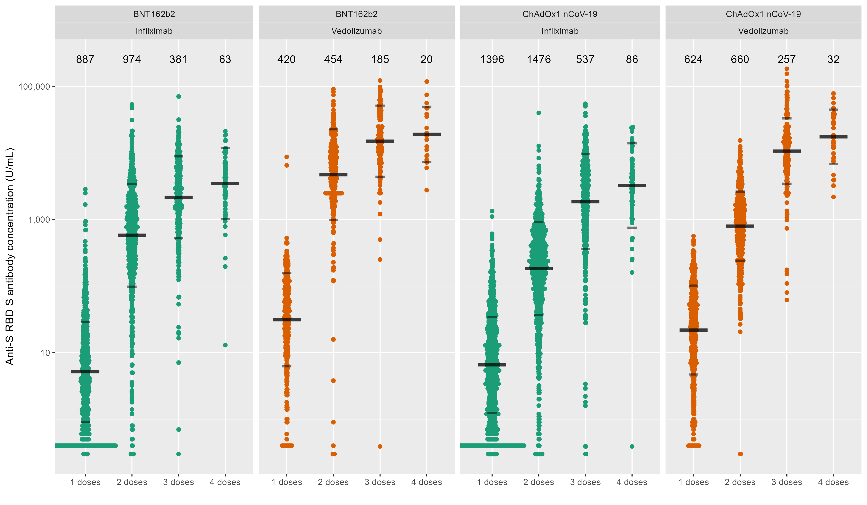
Figure 1: Anti-S RBD antibody concentration stratified by biological therapy (infliximab vs vedolizumab) and type of vaccine. The wider bar represents the geometric mean, while the narrower bars are drawn one geometric standard deviation either side of the geometric mean. The biological treatment infliximab is shown in green and vedolizumab in orange. The number of individuals tested for each group are shown in black at the top of each panel.

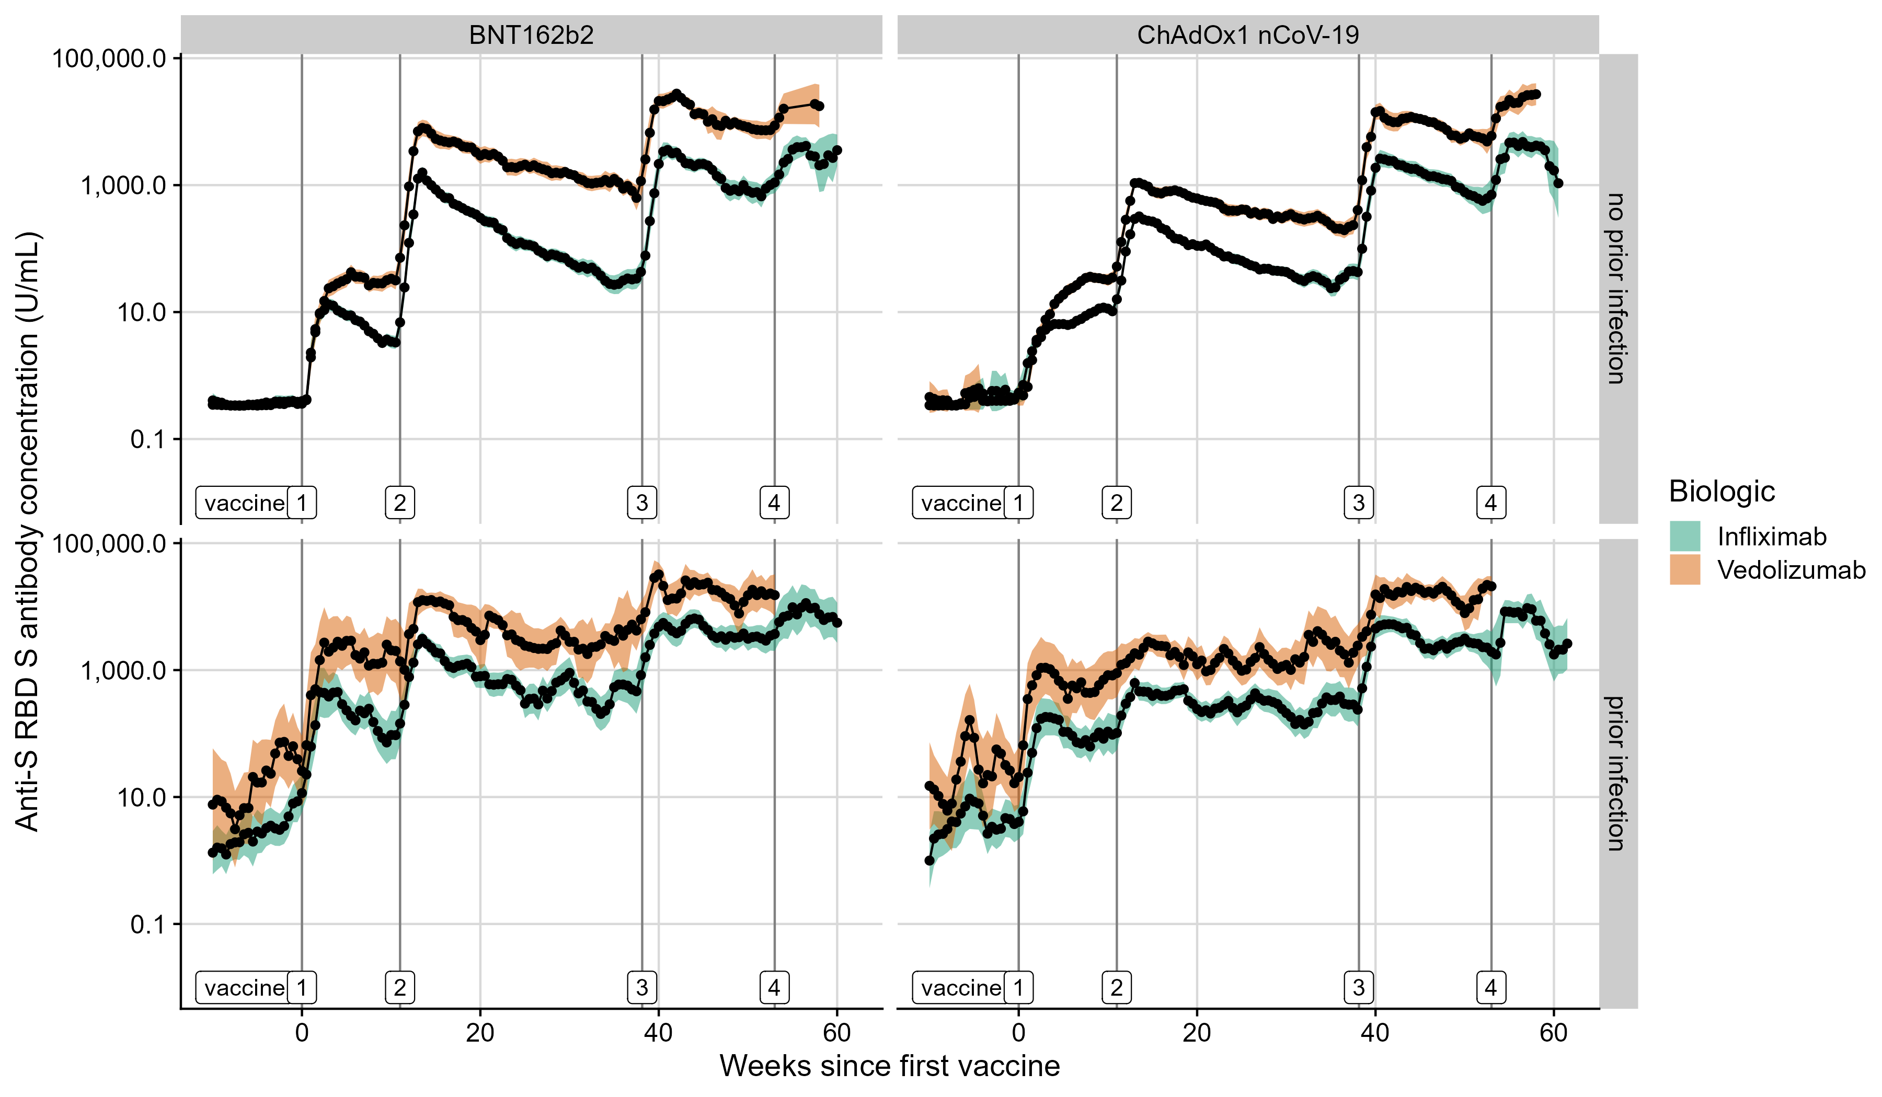
Figure 2: Rolling geometric mean anti-S RBD antibody concentration over time from the date of the first dose of the SARS-CoV-2 vaccine (week 0) stratified by biological therapy (infliximab vs vedolizumab), vaccine, and history of prior SARS-CoV-2 infection. Geometric means are calculated using a rolling 15-day window (i.e. 7 days either side of the day indicated). The shaded areas represent the 95% confidence intervals of the geometric means. Each dose of SARS-CoV-2 vaccine is marked out by vertical grey lines and annotated at the bottom of each panel. The biological treatment infliximab is shown in green and vedolizumab is shown in orange. The top panels represent those without prior infection and the bottom panels represent those who have had a prior infection.

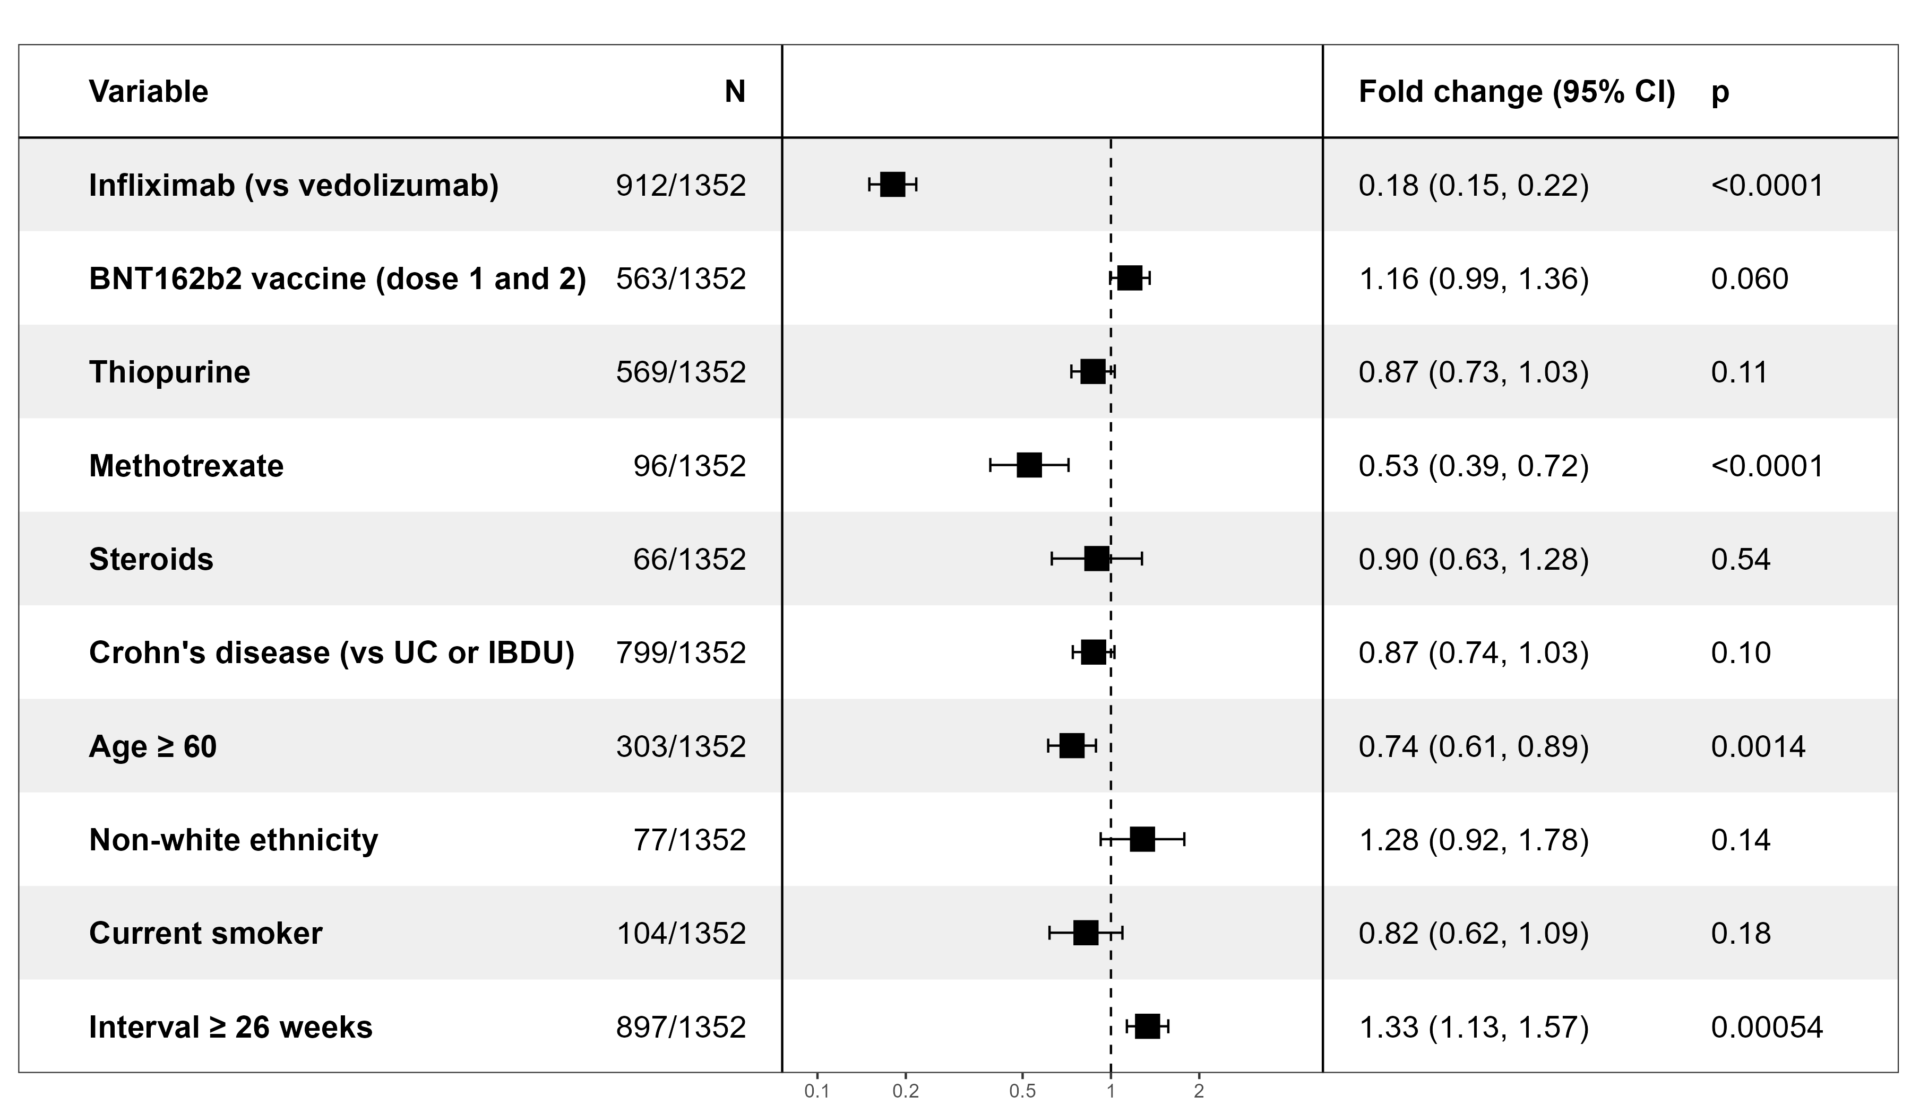
Figure 3: Exponentiated coefficients of linear regression models of log anti-S RBD antibody concentration after a third dose with a mRNA-based vaccine. The resultant values represent the fold change of antibody concentration associated with each variable. Abbreviations: UC= Ulcerative Colitis; IBDU=IBD Unclassified

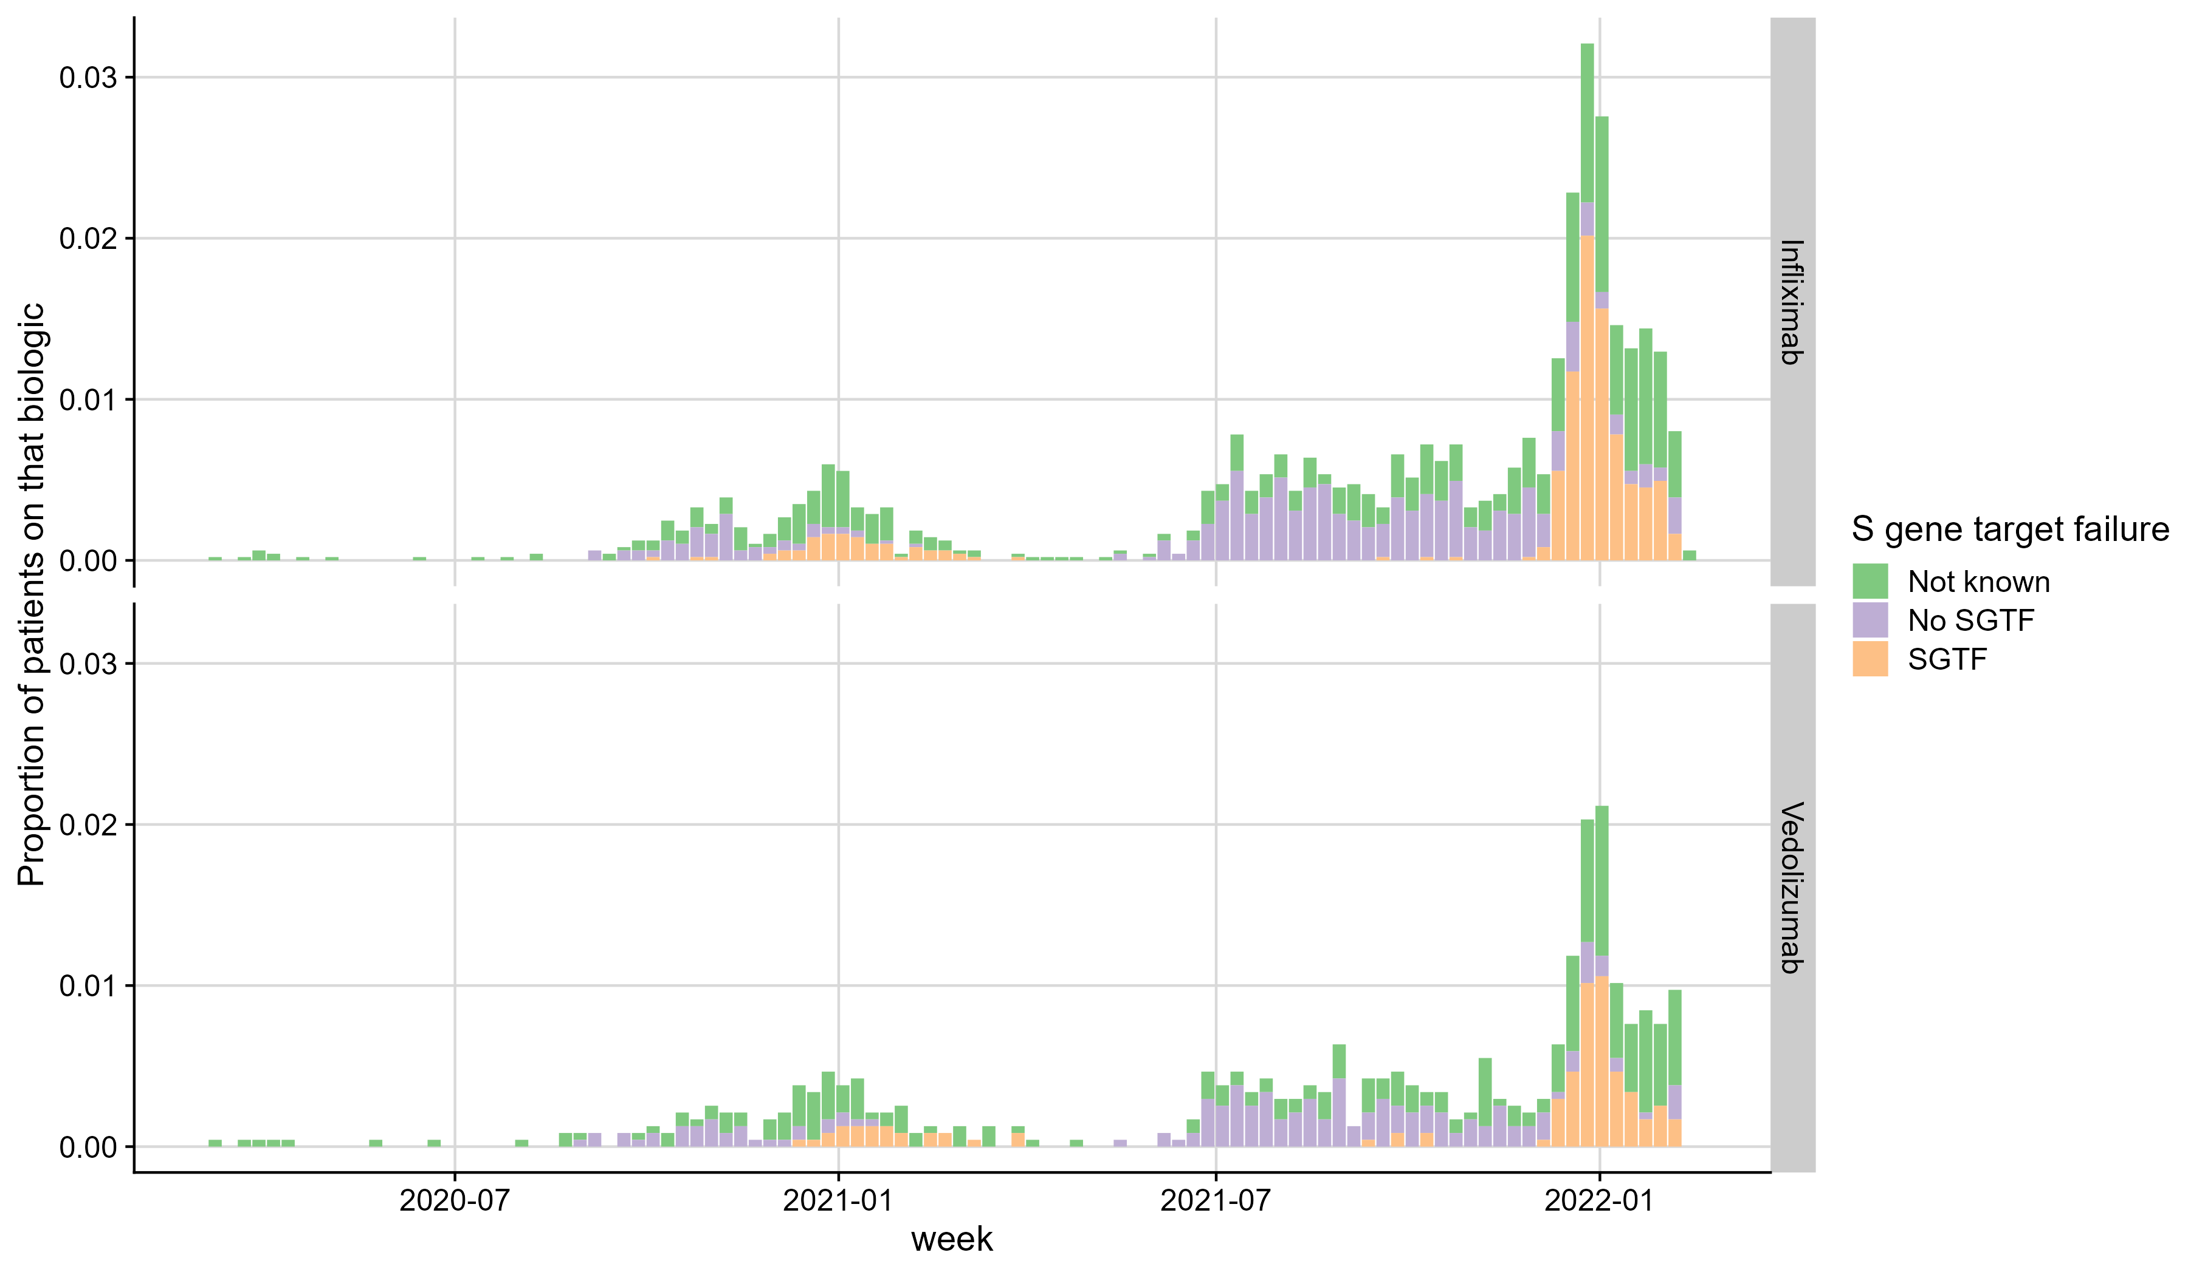
Figure 4: Proportion of patients with SARS-CoV-2 infections, stratified by biological therapy (infliximab vs vedolizumab) and S gene target failure over time. Proportion of PCR-positive SGTF infections shown in orange. Abbreviations: SGTF= S Gene Target Failure

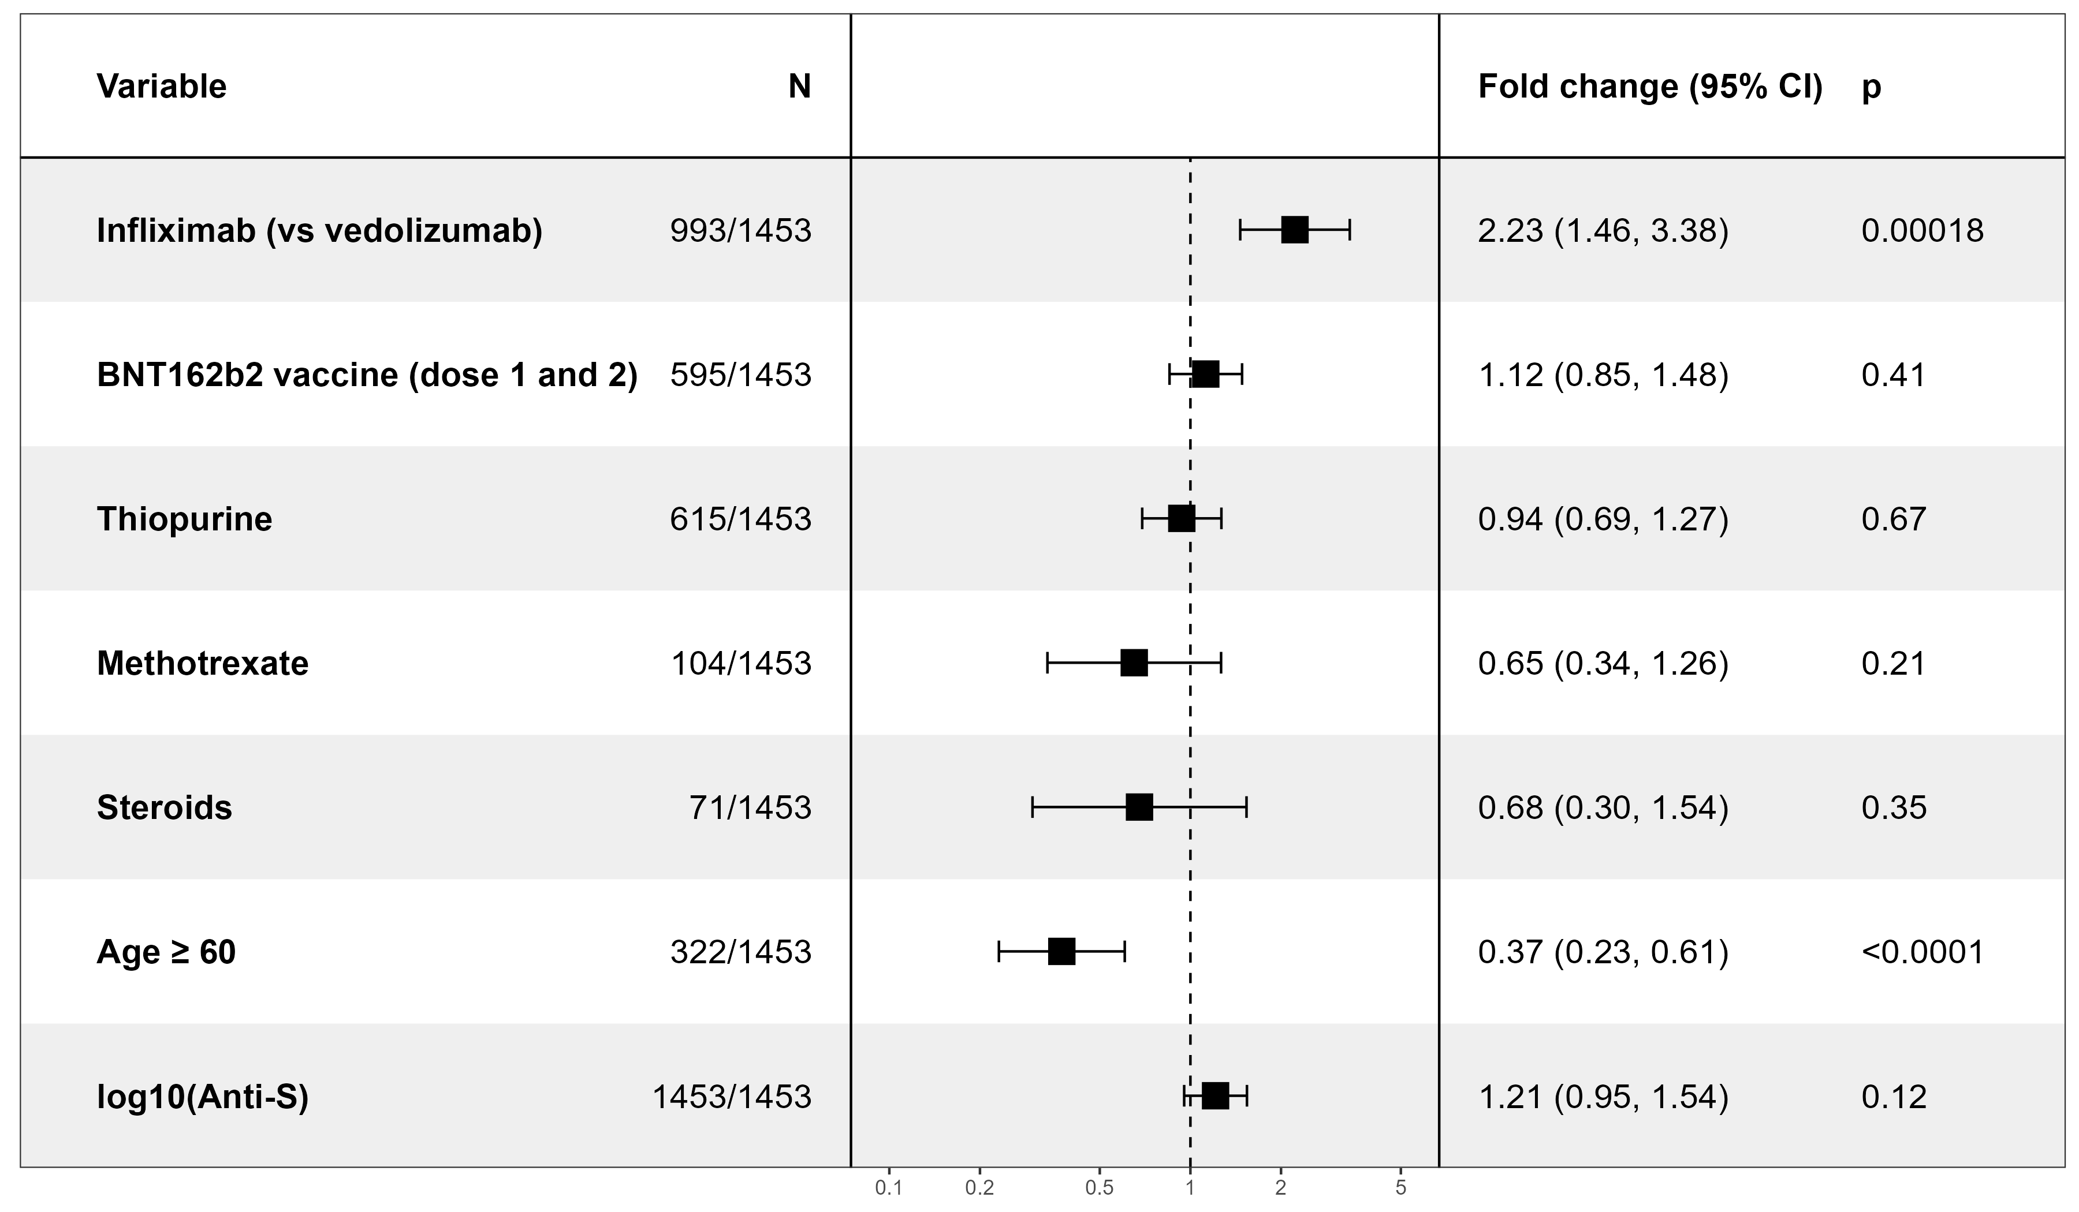
Figure 5: Exponentiated coefficients of linear regression models of time to breakthrough infection after a third dose with a mRNA-based vaccine. The resultant values represent the fold change of time to breakthrough infection associated with each variable.

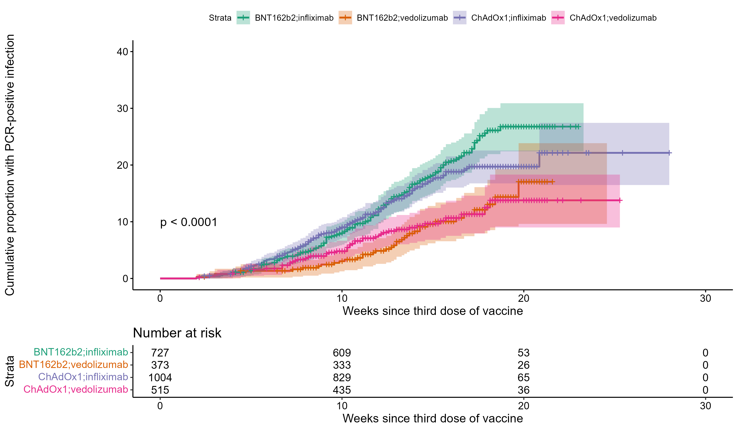
Figure 6: Kaplan-Meier graphs comparing the time to PCR-confirmed SARS-CoV-2 infection following a third dose of vaccine, stratified by biological therapy and vaccine type. Infliximab-treated patients are represented in green (those who received BNT162b2 for their first two doses) and purple (those who received ChAdOx1 nCoV-19 for their first two doses), and vedolizumab-treated patients in orange (those who received BNT162b2 for their first two doses) and pink (those who received ChAdOx1 nCoV-19 for their first two doses). The number of participants at each time point are displayed in black at the bottom of each figure. P-values are calculated using log-rank test.

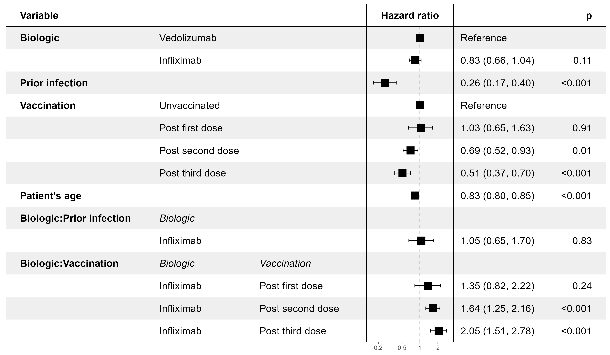
Figure 7: Cox proportional hazards model of factors associated with the risk of SARS-CoV-2 infection. The resultant values represent the hazard ratio of the risk of developing SARS-CoV-2 infection for each variable independently, and the interaction between biological treatment and prior infection, and biological treatment and each vaccine dose.

