Supplementary figures

Supplementary Figure 1. Pairwise linkage disequilibrium (LD) of TERC markers. The numbers inside the squares are |D’| x 100.
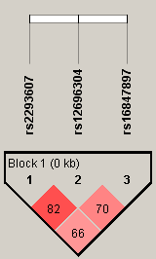

Supplementary Figure 2. Pairwise linkage disequilibrium (LD) of TERT markers. The numbers inside the squares are |D’| x 100.
