Chronic escalating-dose and acute binge cocaine treatments change the hippocampal cholinergic muscarinic system on drug presence and after withdrawal

Lidia E. W. Spelta^{a§}, Yuli Y. S. Torres^{a§}, Sarah C. W. S. E. F. de Oliveira^{a,b}, Maurício Yonamineª, Alexis Bailey^{c}, Rosana Camarini^{d}*, Raphael C. T. Garcia^{e}*, Tania Marcourakisª*

§These authors have contributed equally to this work and share first authorship

ª Department of Clinical and Toxicological Analysis, School of Pharmaceutical Sciences, University of São Paulo, Av. Prof. Lineu Prestes, 580, Bl. 13B, 05508-000, São Paulo/SP, Brazil.
^{b} Pharmacosciences Department, Federal University of Health Sciences of Porto Alegre, Porto Alegre, RS 90050-170, Brazil.
^{c} Pharmacology Section, Institute of Medical and Biomedical Education, St George’s University of London, Cranmer Terrace, SW17 0RE, London, England.
^{d} Department of Pharmacology, Laboratory of Neurochemical and Behavior Pharmacology, Institute of Biomedical Sciences, University of São Paulo, Av. Prof. Lineu Prestes, 1524, Prédio 1, 05508-900, São Paulo/SP, Brazil.
^{e} Institute of Environmental, Chemical and Pharmaceutical Sciences, Federal University of São Paulo, Rua São Nicolau, 210, 1° andar, 09913-030, Diadema/SP, Brazil.

*Corresponding authors:
tmarcour@usp.br (Tania Marcourakis)
camarini@icb.usp.br (Rosana Camarini)
raphael.garcia@unifesp.br (Raphael C.T.Garcia)

ABSTRACT
Cocaine addiction is a relapsing disorder with loss of control in limiting drug intake. Considering the involvement of acetylcholine in the neurobiology of the disease, our aim was to evaluate whether cocaine induces plastic changes in the hippocampal cholinergic muscarinic system. Male Swiss-Webster mice received saline or cocaine (ip) three times daily (60-min intervals) either acutely or in an escalating-dose binge paradigm for 14 days. Locomotor activity was measured in all treatment days. Dopaminergic and cholinergic muscarinic receptors (D₁R, D₂R, M₁-M_{5,} mAChRs), choline acetyltransferase (ChAT), vesicular acetylcholine transporter (VAChT) and acetylcholinesterase (AChE) were quantified in the hippocampus by immunoblotting one hour after the last injection (on drug) or after 14 days of abstinence (withdrawal). Escalating-dose group showed cocaine-induced locomotor sensitization from day 2. M₃ mAChR and ChAT significantly increased after the on-drug acute binge treatment. Escalating-dose on-drug group showed increased ChAT, M₁, M₅ mAChR and D₂R; and decreased D₁R. Acute-binge withdrawal group showed increased VAChT, M₂ mAChR, D₁R, and D₂R; and decreased M₁ mAChR. Escalating-dose withdrawal group presented increased D₁R and VAChT and decreased M₁ mAChR and D₂R. Locomotor activity was negatively correlated with M₁ mAChR and AChE in on-drug group and positively correlated with VAChT in withdrawal group. M₁ mAChR was positively correlated with M₂ mAChR and ChAT in on-drug group, whereas ChAT was positively correlated with M₅ mAChR in withdrawal group. The results indicate that cocaine induced an increase in the hippocampal cholinergic tone in the presence of the drug, whereas withdrawal causes a resetting in the system.
Keywords: cocaine; addiction; sensitization; acetylcholine; dopamine

- Introduction
Drugs of abuse are used for promoting pleasure and sociability or for relieving pain, stress, or anxiety. According to the World Drug Report 2020, around 269 million people aged 15–64 years used drugs of abuse in 2018; of these, 19 million were estimated to use cocaine (United Nations Office on Drugs and Crime, 2020). Data from the 3rd National Survey on Drug Use (Bastos et al., 2017) indicate that cocaine hydrochloride was the second most used illicit drug by the population aged 12–65 years in Brazil (Bastos et al., 2017).
Although cocaine use can be controlled and sporadic, some individuals undergo a transition to a compulsive pattern, losing control over the amount of drug used (Vanderschuren and Everitt, 2004). Such transition consists of a complex neurobiological phenomenon based on neuroplastic alterations in neural circuits related to motivation/drive, reward, conditioning/memory, executive control, interoception, and aversion/avoidance, possibly leading to substance use disorder (SUD) (Volkow and Morales, 2015).
). Drug-induced reward signaling triggers associative learning, pairing drug use to environmental cues that acquire incentive salience by mechanisms of synaptic plasticity (Koob and Volkow, 2016). This conditioned response is directly related to the heavy binge use of the drug, which increases the levels of neurotransmitters such as dopamine and acetylcholine (ACh), in the hippocampus, amygdala, striatum and prefrontal cortex, inducing strong craving (Volkow et al., 2016). In the absence of the drug, an unpleasant physical and emotional state begins, associated with the activation of the antireward systems and downregulation of mesocorticolimbic dopamine system (Koob, 2013).
ACh is a key neuromodulator of cognitive functions, especially in hippocampus-dependent learning (Haam and Yakel, 2017), and cholinergic inputs from the septohippocampal pathway are the main sources of hippocampal cholinergic innervation (Teles-Grilo Ruivo and Mellor, 2013). All five muscarinic acetylcholine receptors (mAChRs) are expressed in the hippocampus, where cholinergic signaling modulates theta and gamma oscillatory activity, excitability, and synaptic plasticity – all of which related to the neurobiology of learning and memory (Ballinger et al., 2016; De Vin et al., 2015; Martinello et al., 2015). In fact, cholinergic dysfunction or loss of cholinergic innervation (nucleus basalis of Meynert and the medial septal-diagonal band of Broca) are directly associated with neurodegenerative, cognitive, and neuropsychiatric disorders, including SUD (Ballinger et al., 2016; Maurer and Williams, 2017; Williams and Adinoff, 2008).
The meso-striatal cholinergic system plays a crucial role in neural responses underlying the cognitive mechanisms involved in drug addiction (Sofuoglu and Mooney, 2009; Williams and Adinoff, 2008). It is involved in the modulation of dopamine release in limbic areas and the formation of contextual memory in the hippocampus (You et al., 2008). Several studies have reported that increases in hippocampal and striatal ACh levels are associated with cocaine self-administration in rodents (Berlanga et al., 2003; Crespo et al., 2006; Imperato et al., 1993; Mark et al., 1999; Smith et al., 2004b, 2004a). Moreover, rodents take less time to self-administer cocaine as ACh levels in the NAc rises (Crespo et al., 2006) suggesting a clear correlation between speed of cocaine self-administration (SA) and Ach levels in the Nac. Evidence shows that long-term cocaine use induces neuronal changes that affect the basal forebrain cholinergic neurons, thus contributing to the onset of compulsion and relapse (Williams and Adinoff, 2008).
Thus, this study aimed to evaluate neuroplastic changes caused by binge intoxication and withdrawal on the hippocampal cholinergic muscarinic system of mice subjected to drug use. We used a cocaine-treatment model that closely mimic the pattern of chronic cocaine abuse observed in humans and the pattern of rodent cocaine self-administration under high-dose extended-access conditions, by administration of cocaine three times per day with progressive dose increase or acutely (Bailey et al., 2008, 2007; Fragou et al., 2013; Zhang et al., 2013).

- Materials and methods

  - Drugs
Cocaine was kindly donated by the Institute of Criminology of São Paulo, for research purposes, to the Laboratory of Toxicological Analyses of the School of Pharmaceutical Sciences, University of São Paulo. The drug was purified and converted into cocaine hydrochloride by bubbling hydrochloric acid into the mixture of purified cocaine dissolved in diethyl ether (GARCIA et al., 2015). Cocaine purity was confirmed as 95% using the ultraperformance liquid chromatography coupled to tandem mass spectrometry (UPLC-MS/MS), and corrected to 100% for animal injections.
  - Animals
Forty-eight Swiss-Webster male mice, eight weeks old (35–45 g) were obtained from the animal facility of the University of São Paulo, São Paulo, Brazil. Animals were housed in plastic cages and kept in a temperature-controlled room (22 ± 1°C) under a 12:12 hours light/dark cycle (lights on at 7:00 a.m.), with food and water ad libitum. All experiments comply with the ARRIVE guidelines and were conducted following the guidelines of the National Council for Control of Animal Experimentation (CONCEA), according with Law number 11,794 of October 8, 2008, Decree 6899 of July 15, 2009, and National Institutes of Health guide for the care and use of Laboratory animals (NIH Publications No. 8023, revised 1978). This study was approved by the Ethics Committee of Animal Use of the School of Pharmaceutical Sciences, University of São Paulo (protocol number CEUA/FCF/502 and 503).

  - Cocaine treatments
The treatment started after 7 days of acclimatization at the experimental facility. All experiments were performed during light period (7 a.m. to 12 a.m.), and all animals were weighed daily throughout the study. Animals were randomly divided into four experimental groups: the chronic binge escalating dose group (n = 12) and its control group (n = 12); and the acute binge group (n = 12) and its control group (n = 12). Half of the animals from each one was then randomly distributed to on drug, in which animals were euthanized one hour after the last cocaine or saline administration; and the withdrawal group, in which animals were euthanized after remaining at their home cages without any manipulation for 14 days after the last administration of cocaine or saline, to mimic a protracted abstinence period.

    - Acute binge treatment
In a single day, animals received three intraperitoneal (ip) injections of saline 0.9% or cocaine 30 mg/kg with one-hour intervals (Bailey et al., 2008). Then, animals were euthanized by decapitation either one hour (on drug) or 14 days (withdrawal group) after the last injection.

    - Chronic escalating-dose binge paradigm
Animals received three daily ip injections of saline 0.9% (control group) or cocaine in escalating-dose binge paradigm with one-hour intervals for a 14-day period. Each injection cycle was performed with a 21-hour interval from the previous one as to characterize a brief withdrawal (TSUKADA et al., 1996; BAILEY et al., 2008; ZHANG et al., 2013; FRAGOU et al., 2013). Cocaine doses were escalated according to BAILEY et al. (2008): 3 ×15 mg/kg/day from days 1 to 4; 3 × 20 mg/kg/day from days 5 to 8; 3 × 25 mg/kg/day from days 9 to 12; and 3 × 30 mg/kg/day on days 13 and 14. Animals were euthanized one hour or 14 days after the last injection.

    - Sample collection
After euthanasia, brains were rapidly removed for hippocampus dissection, immediately frozen with liquid nitrogen, and stored at -80 ºC until analysis. Blood samples (0.5 – 1 mL) were collected in heparinized (1 UI/mL) microtubes and plasma was separated (10,000 rpm for 5 minutes) and stored with 2% NaF at -80 ºC to measure the levels of cocaine and its main biotransformation product, benzoylecgonine (BZE).

  - Behavioral data
Cocaine-induced locomotor activity was measured in a circular open-field wall-enclosed arena with 40 cm length and height. The protocol for locomotor testing was performed as described by BAILEY et al. (2008). For basal activity measurement, mice were allowed to habituate to the environment for 60 minutes daily without treatment. After habituation, animals received an ip injection of saline or cocaine and immediately returned to the open field, where locomotor activity was assessed for 60 minutes. The subsequent injections were performed with 60-minute intervals, and locomotor activity was measured following the same procedure as described above. Locomotor activity was recorded during the whole experiment and analyzed in 5-minute bins using the EthoVision® XT 11.5 (Noldus Information Technology, Wageningen, The Nederlands).

  - Plasma cocaine and benzoylecgonine quantifications
Plasma cocaine and BZE levels were quantified by UPLC-MS/MS, using an Acquity series UPLC system (Waters, USA) equipped with a quaternary pump, column furnace, and automatic injector controlled by a communication module and MassLynx V4.1 software, and integrated into a Quattro Premier XE triple quadrupole mass spectrometer (Micromass, UK). The analyses were performed in positive mode (ESI+, [M + H]+) using the following source parameters: desolvation gas, 1100 L/h; gas cone, 100 L/h; desolvation temperature, 350 °C; source temperature, 120 °C; and capillary 3 KV. Chromatographic elution was performed on an Acquicty UPLC BEH C18 column, 2.1 × 100 mm, 1.7 μm (Waters, USA), eluted with a gradient of 1 mM ammonium formate buffer in water (Solution A) and 1 mM ammonium formate buffer in acetonitrile and water (95:5, v/v; Solution B), both solutions supplemented with 0.1% formic acid at a 400 μL/min a flow rate, 40 °C (0 - 3 minutes, 10 - 45% B; 8 minutes, 45-80% B, 3.8 - 4 minutes, 80 - 10% B, 4 - 7 minutes, 10% B).
Plasma samples (100 μL) were diluted with 20 μL of a pool of cocaine-D3 and benzoylecgonine-D3 internal standards (Ceriliant, 100 μg/mL and 500 ng/mL) and 880 μL of acetonitrile/methanol (80:20), obtaining 1 mL of solution. After centrifuging the samples for 6 minutes (9,000 g), the supernatant was collected (150 μL) and injected (3 μL) into the UPLC-MS/MS system. The limits of detection and quantification were both 1 ng/mL for cocaine and 0.5 ng/mL for BZE (PEGO et al., 2018). The correlation coefficient (R²) was greater than 0.99 for a 25–500 ng/mL range.

  - Immunoblotting analysis
M₁-M₅ mAChRs, choline acetyltransferase (ChAT), vesicular acetylcholine transporter (VAChT), acetylcholinesterase (AChE) were quantified by means of immunoblotting, performed according to the protocol described by Torres et at. (2015). As dopaminergic and cholinergic systems interact in different brain regions – including the hippocampus (Nomikos, 2006) – and the imbalance between these systems leads to a series of disorders, such as the development of addictive and compulsive behaviors (Williams and Adinoff, 2008), we also evaluated D₁-like and D₂-like dopaminergic receptors.
Briefly, hippocampus samples were thawed on ice and homogenates were prepared in ice-cold buffer containing 50 mM Tris-HCl (pH 7.4), 1 mM PMFS, and 1 mM protease inhibitor. Protein level was measured with the Bradford dye method using the Bio-Rad reagent (Bradford, 1976). The whole extract was treated with Laemmli sample buffer (LAEMMLI, 1970) and boiled for 5 minutes at 99 ºC. Equal quantities of protein (15 μg for M₁ and M₂ mAChR, ChAT, VAChT, and AChE; and 30 μg for M₃, M₄ and M₅ mAChR, D_{1,} and D₂R) from each sample were resolved by sodium dodecyl sulfate polyacrylamide gel electrophoresis (SDS-PAGE; 15% polyacrylamide) and transferred onto polyvinylidene difluoride (PVDF) membranes. After blocking non-specific sites with 5% (w/v) casein, membranes were incubated overnight at 4–8 °C with primary antibodies, as shown in Table 1.

Table 1 near here

Then, membranes were washed with Tris-buffered saline containing 0.1% Tween 20 (3 × 10 min) and incubated with a peroxidase-conjugated secondary antibody for 2 hours at room temperature. After a new set of washes (3 × 10 minutes), immunoreactive bands were visualized using the enhanced chemiluminescence (ECL) detection system (Thermo Scientific, Rockford, USA), and images were captured with ImageQuantTM 400 v.1.0.0 (Amersham Biosciences, Pittsburg, USA). Band intensities were quantified using ImageQuant 400 (GE Healthcare), and the results were normalized to the intensity of β-actin (Sigma-Aldrich, St. Louis, USA).

  - Statistical analyses
Data normality was assessed using the Kolmogorov-Smirnov test. Since all parameters had normal distribution, the total locomotor activity of animals from the chronic-escalating dose treatment was evaluated using two-way repeated measures analysis of variance (ANOVA), adopting treatment (cocaine or saline) as the between-subject factor and day as the within-subject factor and repeated measure. The basal locomotor activity of groups treated with saline and cocaine during the habituation phase was likewise compared using two-way repeated measures ANOVA, as well as the effects of both treatments in the total locomotor activity (180 min) during the 14 days of the experiment. The locomotor effects in cocaine-treated mice were evaluated using one-way repeated measures ANOVA. Post-hoc analysis was performed by Bonferroni’s multiple comparison test. Planned comparisons (Student's t-test) were used to compare the locomotor activity in the last 15 minutes of the third dose of cocaine with the same period of habituation in cocaine-treated mice, based on a priori hypothesis (Bailey et al, 2008). It was hypothesized that the escalating dose paradigm would increase the duration of cocaine-induced locomotor stimulation over time, as indicative of behavioral sensitization. This comparison was made for days 1, 2, 5, 9 and 13. Data from acute binge treatment were evaluated by comparing the total locomotor activity of saline- and cocaine-treated animals using unpaired Student’s “t” test, as well as immunoblotting data, evaluated by comparing cocaine and saline treatments in both on-drug and withdrawal groups separately.
Regarding protein analysis, the low quality of blots for both protein targets and normalizer proteins represented one exclusion criterion. Plasma cocaine and BZE levels in cocaine-treated animals from acute binge and chronic escalating-dose binge groups were also compared by unpaired Student’s “t” test. Pearson correlations were performed for cocaine-treated animals from the escalating dose binge group between (i) total locomotor activity (14th day) and proteins densities measured by the immunoblotting; (ii) the different protein densities; and (iii) cocaine plasma levels and locomotor activity. Statistical analyses were performed using the GraphPad Prism 8.0, considering a significance level of α < 0.05. Numerical data are presented as mean ± SEM.

- Results

  - Locomotor activity during chronic escalating-dose and acute binge cocaine administration
In the acute binge protocol, both control and cocaine groups exhibited similar patterns of basal locomotor activity (Figure 1A; Student's test), before initiation of cocaine treatment. After treated with cocaine, mice showed significantly increase in the locomotor activity when compared to those treated with saline (p < 0.0001). The activity of mice treated for just one day (3 × 30 mg/kg) returned to baseline 60 minutes after each of the three cocaine injections and in the ending of the experiment, no difference was found between the last fifteen minutes of habituation and the last cocaine dose (p = 0.739).
From the analysis of the total basal locomotion of mice treated with either cocaine or saline during the 60 minutes of daily habituation throughout the escalating dose experiment (1–14 days) using two-way repeated measures ANOVA, we verified a significant effect of day (F_{(13, 143)} = 5.942; p < 0.0001) and treatment X day interaction (F_{(13, 143)} = 58.075; p < 0.0001). According to the Bonferroni post-hoc analysis, both groups showed a similar locomotion from day 1 to day 7 and on day 12; on the remaining days, control animals had a higher basal activity (day 8: p = 0.028; day 9: p = 0.033; day 11: p = 0.0002; days 10, 13 and 14: p < 0.0001; see Figure 1 and supplemental Figure 1).
When compared to the control group, cocaine-treated mice presented a significantly higher total locomotor activity in all escalating-dose days, as two-way repeated measures ANOVA showed a significant effect of day (F_{(13, 143)} = 3.714; p < 0.0001), treatment (F_{(1, 11)} = 35.06; p = 0.0001) and treatment X day interaction (F_{(13, 143)} = 3.685; p < 0.0001). The locomotor sensitization was apparent when compared day 2 with day 1 (p = 0.004). No further increases were detected in the subsequent days (5, 9 and 13), suggesting a plateau effect. However, paired Student’s “t” tests showed an increased duration of cocaine-induced hyperactivity on these days, remaining higher than the basal activity in the last 15 minutes of the third injection (day 5: 18191 ±, 16260, p = 0.0026; day 9: 23793 ± 19360, p = 0.0013; day 13: 20113 ± 16679, p = 0.0015). This finding indicates a persistent locomotor sensitization that is unlikely to be due to a dose effect, as locomotion decreased to baseline one hour after the last injection on day 1 (807,6 ± 1790, p = 0.15) and day 2 (422,6 ± 1582, p = 0.37) and in mice subjected to acute binge (204,7 ± 2076, p = 0.739).

Figure 1 near here

  - Quantification of cocaine and benzoylecgonine in plasma by UPLC-MS/MS
Cocaine and BZE plasma samples levels from the on-drug cocaine-treated animals are shown in Table 2. Although all animals received the same dose of cocaine on the day, those on the chronic escalating-dose binge treatment had higher plasmatic cocaine levels and BZE than those from the acute binge group, as verified by the unpaired Student’s “t” test. Animals from the withdrawal group presented neither cocaine nor BZE.

Table 2 near here

  - Quantification of muscarinic receptors and cholinergic molecules by Immunoblotting
Immunoblotting analyses show that exposure to both cocaine treatments induced alterations on the cholinergic and dopaminergic hippocampal systems. Figures 2 and 3 present the quantification of mAChRs and cholinergic molecules after the acute binge and chronic escalating-dose treatments, respectively.
One hour after the last cocaine injection (on-drug group), the acute binge treatment induced an upregulation of M₃ mAChR (100.0 ± 1.6 % vs. 109.6 ± 3.6 %, p = 0.03, t-test, Figure 2C) and ChAT (100.0 ± 3.1 % vs. 111.3 ± 2.3 %, p = 0.04, t-test, Figure 2G). After 14 days of abstinence (withdrawal group), we observed an upregulation of M₂ mAChR (100.0 ± 2.0 % vs. 109.2 ± 2.5 %; p = 0.01, t-test, Figure 3B) and VAChT (100.0 ± 2.1 % vs. 141.1 ± 13.6 %; p = 0.003, t-test, Figure 3H); and a downregulation of M₁ mAChR (100.0 ± 1.8 % vs. 93.7 ± 2.0 %; p = 0.04, t-test, Figure 3A). No changes were detected in the other proteins of interest neither in on drug nor withdrawal groups.

Figures 2 and 3 near here

Regarding escalating-dose treatment, animals from the on-drug group showed an upregulation of M₁ (100.0 ± 2.3 % vs. 110.1 ± 2.27 %, p = 0.012, t-test – Figure 4A), M₅ (101.3 ± 3.1 % vs. 116.1 ± 5.7 %, p = 0.04, t-test – Figure 4E), and ChAT (100.0 ± 3.8 % vs. 119.5 ± 7.35 %, p = 0.03, t-test – Figure 4G). This finding indicates that cocaine injection in a binge pattern might induce an upregulation of the cholinergic tone. After 14 days of abstinence (withdrawal group), animals presented an upregulation of VAChT (100.0 ± 2.5 % vs. 111.0 ± 3.0 %; p = 0.013 – Figure 5H) and a downregulation of M₁ mAChR (100.0 ± 1.6 % vs. 91.9 ± 1.5 %; p = 0.004 – Figure 5A). No changes were detected in the other proteins of interest neither in on drug nor withdrawal group.

Figures 4 and 5 near here

  - Quantification of dopaminergic receptors by Immunoblotting
The immunoblotting analyses showed that exposure to cocaine treatments, either acute or chronic escalating-dose binge, induced alterations in both D₁ and D₂ dopaminergic receptors.
Regarding acute binge treatment, neither of the receptors suffered alterations in the on-drug group (Figure 6), whereas both of them were upregulated in the withdrawal group (Figure 7; D₁R: 100.0 ± 2.8 % vs. 107.0 ± 0.2 %; p = 0.03 – Figure 7A; and D₂R: 100.0 ± 3.3 % vs. 114.9 ± 3.2 %; p = 0.008 – Figure 7B).

Figures 6 and 7 near here

As for the chronic escalating-dose treatment, animals from the on-drug group showed a downregulation of D₁R (100.0 ± 0.8 % vs. 88.3 ± 4.8 %, p = 0.03, t-test – Figure 8A) and an upregulation of D₂R (100.0 ± 3.1 % vs. 113.8 ± 5.76 %, p = 0.008, t-test – Figure 8B). On the withdrawal group, the results were the opposite: D₁R was upregulated (100.0 ± 2.8 % vs. 116.8 ± 2.59 %; p = 0.002 – Figure 9A) and D₂R was downregulated (100.0 ± 2.3 % vs. 91.4 ± 2.4 %; p = 0.028 – Figure 9B).

Figures 8 and 9 near here

  - Correlations between locomotor activity and cholinergic markers densities in the hippocampus
The correlation between the different protein densities or between protein densities versus locomotor activity on day 14 were evaluated for cocaine treated mice from the chronic escalating dose binge group, using Pearson’s correlations. As described in Table 3, the on-drug group showed a negative correlation between locomotor activity and M₁ mAChR (p = 0.02) and AChE densities (p = 0.037), whereas M₁ mAChR was positively correlated with M₂ mAChR (p = 0.01) and ChAT (p = 0.047). In turn, the withdrawal group showed positive correlations between locomotor activity and VAChT (p = 0.03), as well as between ChAT and M₅ mAChR densities. No other correlations were observed.

Table 3 near here

- Discussion
Despite the breadth of literature investigating the effects of psychostimulants on dopaminergic function, little is known about their influence on the cholinergic muscarinic system, especially regarding the hippocampus. To the best of our knowledge, this is the first study to show the effects of an acute and escalating-dose binge cocaine administration in the hippocampal muscarinic cholinergic system, both on drug and during withdrawal. Considering that the hippocampus plays a key role in cognition processes and in the neuroscience of addiction, our results are particularly important for studies on cocaine addiction. After the on drug treatment, the cholinergic tone is upregulated, due to higher amounts of ChAT and G_{q}-couple muscarinic receptors. However, after 14 days of withdrawal, the system is resetting, although VAChT was elevated, M₁ mAChR, the prevalent muscarinic receptor was downregulated, the autorreceptor M₂ mACHR was upregulated, and the other molecules once upregulated came back to basal.
Plasma cocaine levels showed a different pharmacokinetic pattern after acute binge and chronic escalating-dose binge treatment. In fact, the administration of repeated doses may change cocaine kinetics, such as during binge use. Nayak et al. (1976) found that chronically-treated rats presented higher cocaine plasma levels than single-dose-treated rats, corroborating our results. Moreover, there is a considerable inter-animal variation in cocaine levels, which may result from individual metabolic differences and reflects the variabilities in behavioral responses observed by most experimenters (Benuck et al., 1987; Javaid, and Davis, 1993; Nayak et al., 1976; Saady et al., 1995). Interestingly, cocaine pharmacokinetic patterns after an intraperitoneal administration are comparable to those seen after an intranasal administration by humans (Allain et al., 2015; Benuck et al., 1987; Javaid and Davis, 1993).
In our study, chronically-treated animals presented significantly higher BZE levels when compared to those from the acute group. According to Cone (1995), BZE appears on plasma 15 - 30 minutes after cocaine administration and its plasmatic levels is much more stable than cocaine, being detected for long periods of time after cocaine administration (Jufer et al., 2000; Saady et al., 1995). The rate of BZE elimination is shorter than its rate of formation, which is related to its longer half-life and capacity to accumulation in prolonged cocaine exposures (Cone, 1995).
As expected, all cocaine-treated animals showed higher locomotor activity than animals from the control group (Bailey et al., 2008; Fragou et al., 2013; Job et al., 2014; Oh et al., 2015; Schlussman et al., 2005, 2003; Unterwald et al., 1994; Zhang et al., 2013). The locomotor sensitization observed on the second day of cocaine administration is in line with that reported in different studies (Bailey et al., 2007; Boudreau and Wolf, 2005; Unterwald et al., 1994). After sensitization, mice displayed sustained locomotor activity until the 14th experimental day. As the dose increased (20 - 30 mg/kg), locomotor activity did not drop to baseline levels over the 60-minute intervals between each cocaine administration. According to cocaine toxicokinetics, after an intraperitoneal injection the drug peaks in the brain and plasma are achieved after 5 and 2.5 minutes, respectively, with a half-life of elimination estimated as 16 minutes (Benuck et al., 1987). Thus, after 60 minutes, approximately four cocaine half-lives have passed, so the maintenance of the elevated locomotion in sensitized animals after the third cocaine administration, a pattern that was not verified in the acute binge group and on the first two days of cocaine administration, is more likely to be due to sensitization rather than to a dose effect.
The rewarding effects of cocaine are correlated with its dopaminergic effects, and the transition from casual to compulsive use allegedly involves an imbalance between D₁ and D₂ receptors (Park et al., 2013; Thompson et al., 2010). Our results indicate a predominance of D₂ in the on-drug and of D₁ in the withdrawal group after chronic treatment.
Although dopaminergic signaling is determinant to cocaine-induced behavioral sensitization, other neurotransmitters appear to be involved in this phenomenon (Jiang et al., 2021; McDougall et al., 2017). Anticholinergic muscarinic agents such as scopolamine and the M₁ antagonist biperiden can potentiate behavioral sensitization (Itzhak and Martin, 2000; Ramos et al., 2012). In line with this observation, we verified an inverse correlation between locomotor activity and both M₁ mAChR and AChE in the on-drug group suggesting a modulatory role M1 mAChR on cocaine sensitization. In agreement, a study conducted with knockout animals for M₁ mAChR reported increased locomotor activity and decreased cocaine- and morphine-induced conditioned place preference (CPP) (Carrigan and Dykstra, 2007).
Animals from the on-drug group showed an upregulation and positive correlation between M₁ mAChR and ChAT. Along with the positive correlation verified for M₁ and M₂ mAChR, these results suggest an increased cholinergic transmission. M₁ mAChR is involved in hippocampal cognitive functions by depolarizing pyramidal neurons and facilitating long-term potentiation (LTP) and drug-induced conditioned learning (Dasari and Gulledge, 2011; Shinoe et al., 2005). With regards to cocaine rewarding effects, this receptor attenuates cocaine reinforcing and discriminative stimulus effects (Joseph and Thomsen, 2017; Thomsen et al., 2012, 2010), besides reducing cocaine seeking and self-administration behaviors in mice and rats (Stoll et al., 2017; Weikop et al., 2020).
We also detected an increased expression of M₅ mAChR in the on-drug group. This may be a result of cocaine-induced dopaminergic alterations, as this receptor is present in high levels in the dopaminergic mesolimbic reward pathway from VTA and substantia nigra (Bender et al., 2018; Steidl et al., 2011). The coexpression of M₅ mAChR and D₂R in the midbrain plays an important role in dopamine–ACh interactions and in the neurobiology of substance use disorder. M₅ mAChR activation stimulates striatal dopamine release, thus comprising an exciting therapeutic target for SUD treatment (Foster et al., 2014; Garzón and Pickel, 2013; Vuckovic et al., 2019; Wasserman et al., 2013). During withdrawal, M₅ mAChR knockout or receptor blockade reduced cocaine self-administration (Gunter et al., 2018; Thomsen et al., 2005), cocaine-induced CPP, and signs of anxiety (Fink-Jensen et al., 2003).
Administration of D₁ and D₂ agonists increased hippocampal ACh levels in a dose-dependent manner (Imperato et al., 1996; Zocchi and Pert, 1993). Moreover, studies have showed that D₁-like knockout mice have lower basal hippocampal ACh levels (Laplante et al., 2004). Cocaine administration enhances ACh levels in the hippocampus (Imperato et al., 1993; Smith et al., 2004a), brainstem nuclei (Smith et al., 2004b) and NAc (Mark et al., 1999), which may justify the upregulation of ChAT in the on-drug group after chronic cocaine binge administration. The upregulated cholinergic tone detected in mice from chronically-treated on-drug group may be associated with the D₂ upregulation.
This may indicate that D₂R signaling stimulates ACh release in the hippocampus, favoring cocaine-induced conditioning and learning. ACh–dopamine interactions via D₂R and mAChR in the hippocampus are important for controlling cognitive processes (Levin et al., 1990; Nyberg et al., 2016; Rocchetti et al., 2015) as verified by studies that show that antagonism into D₂R and mAChR impaired learning, whereas D₂R agonism attenuated this effect and stimulated ACh release in the ventral hippocampus (Fujishiro et al., 2005; Umegaki et al., 2001).
Cocaine-induced changes in M₁ and M₂-like mAChRs are dynamic and may be related to administration and withdrawal periods. This occurs because these periods entail different and complex brain processes, each regulated by different neural circuits. In this scenario, understanding the neurobiological changes during withdrawal is essential to prevent relapse (Everitt, 2014; Koob and Kreek, 2007; Koob, 2013).
In our study, after the 14 days of withdrawal from chronic treatment, M₁ mAChR was downregulated, ChAT and M₅ mAChR returned to basal levels, and VAChT was upregulated. These alterations were concomitant with D₂R downregulation and D₁R upregulation, which probably reflects an attempt to reduce the once upregulated cholinergic tone or came back to the basal state. Some studies described changes in M1- and M2-like receptors after cocaine treatment in brain structures like striatum, hippocampus and amygdala. Authors describe an upregulation followed by normal basal levels (48h) in acute withdrawal (12h) (Lipton et al, 1991) and downregulation in more prolonged withdrawal periods (5, 21 or 30 days) (Macêdo et al, 2004; Lipton et al, 1995; Ziegler et al, 1991). These findings suggest that cholinergic tone increased with acute withdrawal, but decreased with protracted withdrawal.
Cocaine acute binge treatment upregulated M₃ mAChR and ChAT in the on-drug group. Although a few studies investigate the function of this receptor in the brain, the literature is scarce about cocaine effect on this receptor. When compared to other muscarinic receptor subtypes, M₃ mAChR is expressed in the brain at lower levels, with higher densities in the striatum, hippocampus, and amygdala (Levey et al., 1994). However, this receptor plays a key role in central nervous system (CNS) functions underlying cognition, besides being the main muscarinic receptor involved in the inhibition of excitatory synaptic transmission in the hippocampal CA1 area and in the efficacy of CA3-CA1 synapses (De Vin et al., 2015; Mans et al., 2014). Studies have shown that M₃ knockout mice presented learning, memory, and fear conditioning deficits (Poulin et al., 2010). Thus, we hypothesized that the upregulation observed in our study may be a direct consequence of cocaine, which elevated the dopaminergic hippocampal drive and stimulated ACh release by cholinergic interneurons (as ChAT also increased).
After 14 days of withdrawal from acute binge, M₃ mAChR and ChAT returned to basal levels, but M₂ mAChR and VAChT were both upregulated. As autoreceptors, M₂ mAChRs are important for controlling ACh release, so that its overexpression might reduce cholinergic tone. Two studies indicate that M₂ mAChR indirectly influences cocaine effects by controlling ACh release. Cholinergic inputs from the laterodorsal tegmental area to the VTA participate in the control of behaviors motivated by natural and cocaine reward (Mark et al., 2011) and selective inhibition of M₂ mAChR attenuate cocaine discriminative stimulus (Joseph and Thomsen, 2017).
There is evidence that VAChT expression influences ACh levels and cognitive functions. In vitro studies have shown that VAChT acts as a limitation factor to cholinergic neurotransmission (Veroqui et al, 1996) and small alterations in its expression can disturb cholinergic transmission, (Edwards, 2007; Varoqui and Erickson, 1996). Mice with reduced expression of VAChT have impaired performance in hippocampal dependent cognitive tasks (De Castro et al., 2009; Prado et al., 2006), whereas the overexpression of VAChT increases the cholinergic tone (Song et al., 1997). and the ACh release in the hippocampus (Nagy and Aubert, 2012) and striatum (Janickova et al., 2017). Interestingly, mice with overexpression of VAChT exhibit increased behavioral sensitization to cocaine (Janickova et al., 2017) and amphetamine, as well as higher scores of amphetamine-induced stereotypy (Crittenden et al., 2014). We showed in the present study that both, acute and chronic cocaine treatments, led to increased VAChT levels in the withdrawal group, together with a positive correlation with locomotor activity just in the chronic binge treatment.
VAChT and ChAT encode genes are organized in a single gene locus with a close regulation of the transcription of both genes, that has been repeatedly reported in cholinergic tissues (Dolezal et al., 2001). In rat brain, the developmental expression pattern of VAChT and ChAT mRNA is coordinated in time, but not the protein expression. Regarding ChAT, the increase in mRNA preceded the enzyme activity about 2 days, whereas the increase of VAChT is delayed by 10–20 days after its mRNAs expression (Holler et al., 1996). Taken together, we propose that the higher density of VAChT observed after 14 days of withdrawal might be a delayed response of the upregulated cholinergic transmission present in the on drug group, which included upregulation of ChAT. We can also suggest that the downregulation of M₁ mAChR and the upregulation of the autoreceptor M₂ mAChR in the withdrawal group, can be an attempt to reduce the cholinergic tone from the upregulated state after cocaine administration.
This study has some methodological limitations: 1) animal locomotion was not recorded during the withdrawal period; 2) animals were not challenged with cocaine after 14 days of withdrawal; and 3) only males were used.

- Conclusions

Our results show that binge cocaine treatments influence hippocampal dopaminergic and muscarinic cholinergic systems, which may affect behavior. Our results suggest that, immediately after the final cocaine administration, the on-drug group increased cholinergic tone and as well as D₂R, probably due to the higher levels of dopamine release. This may contribute to drug-context associations and drug-induced learning and memory. However, hippocampal cholinergic tone appears to be going out of an upregulated state after 14 days of withdrawal which was concomitant with an increase of D₁R. Indeed, the neurotransmitters interaction is a complex phenomenon and connectivity is determinant for functional relationships in the brain. The comprehension of the role of the muscarinic cholinergic system in cocaine-induced plasticity can help to find pharmacologic targets to treat cocaine use disorder.

Declaration of Competing Interest
The authors declare that there are no conflicts of interest.

Acknowledgment
The authors acknowledge Dr. José Luiz da Costa, from UNICAMP, for providing the cocaine used in this study. This study was supported by the São Paulo Research Foundation (Fundação de Amparo à Pesquisa do Estado de São Paulo–[FAPESP], no. 2014/09230-1), Coordination for the Improvement of Higher Personnel (Coordenação de Aperfeiçoamento de Pessoal de Nível Superior–[CAPES], Finance Code 001), and National Counsel of Technological and Scientific Development (Conselho Nacional de Desenvolvimento Científico e Tecnológico–[CNPq]). M.Y., R.C. and T.M. are CNPq research fellows.

References

Allain, F., Minogianis, E.A., Roberts, D.C.S., Samaha, A.N., 2015. How fast and how often: The pharmacokinetics of drug use are decisive in addiction. Neurosci. Biobehav. Rev. 56, 166–179. https://doi.org/10.1016/j.neubiorev.2015.06.012
Bailey, A., Gianotti, R., Ho, A., Kreek, M.J., 2007. Downregulation of κ-opioid receptors in basolateral amygdala and septum of rats withdrawn for 14 days from an escalating dose “Binge” cocaine administration paradigm. Synapse 61, 820–826. https://doi.org/10.1002/syn.20436
Bailey, A., Metaxas, A., Yoo, J.H., McGee, T., Kitchen, I., 2008. Decrease of D2 receptor binding but increase in D 2-stimulated G-protein activation, dopamine transporter binding and behavioural sensitization in brains of mice treated with a chronic escalating dose “binge” cocaine administration paradigm. Eur. J. Neurosci. 28, 759–770. https://doi.org/10.1111/j.1460-9568.2008.06369.x
Ballinger, E.C., Ananth, M., Talmage, D.A., Role, L.W., 2016. Basal Forebrain Cholinergic Circuits and Signaling in Cognition and Cognitive Decline. Neuron 91, 1199–1218. https://doi.org/10.1016/j.neuron.2016.09.006
Bastos, F.I.P.M., Vasconcellos, M.T.L. de, Boni, R.B. De, Reis, N.B. dos, Coutinho, C.F. de S., 2017. III LEVANTAMENTO NACIONAL SOBRE O USO DE DROGAS PELA POPULAÇÃO BRASILEIRA. Secretaria Nacional de Políticas Sobre Drogas; Fundação Oswaldo Cruz.
Bender, A.M., Cho, H.P., Nance, K.D., Lingenfelter, K.S., Luscombe, V.B., Gentry, P.R., Voigtritter, K., Berizz, A.E., Sexton, P.M., Langmead, C.J., Christopoulos, A., Locuson, C.W., Bridges, T.M., Chang, S., O’Neill, J.C., Zhan, X., Niswender, C.M., Jones, C.K., Conn, P.J., Lindsley, C.W., 2018. Discovery and Optimization of Potent and CNS Penetrant M5 - Preferring Positive Allosteric Modulators Derived from a Novel, Chiral N-(Indanyl)piperidine Amide Scaffold. ACS Chem. Neurosci. 9, 1572–1581. https://doi.org/10.1021/acschemneuro.8b00126.Compound
Benuck, M., Lajtham, A., Reith, M.E.A., 1987. Pharmacokinetics of Systemically Administered Cocaine and Locomotor Stimulation in Mice. J. Pharmacol. Exp. Ther. 243, 144–149.
Berlanga, M.L., Olsen, C.M., Chen, V., Ikegami, A., Herring, B.E., Duvauchelle, C.L., Alcantara, A.A., 2003. Cholinergic interneurons of the nucleus accumbens and dorsal striatum are activated by the self-administration of cocaine. Neuroscience 120, 1149–1156. https://doi.org/10.1016/S0306-4522(03)00378-6
Boudreau, A.C., Wolf, M.E., 2005. Behavioral sensitization to cocaine is associated with increased AMPA receptor surface expression in the nucleus accumbens. J. Neurosci. 25, 9144–9151. https://doi.org/10.1523/JNEUROSCI.2252-05.2005
Carrigan, K.A., Dykstra, L.A., 2007. Behavioral effects of morphine and cocaine in M1 muscarinic acetylcholine receptor-deficient mice. Psychopharmacology (Berl). 191, 985–993. https://doi.org/10.1007/s00213-006-0671-1
Cone, E.J., 1995. Pharmacokinetics and pharmacodynamics of cocaine. J. Anal. Toxicol. 19, 459–478. https://doi.org/10.1093/jat/19.6.459
Crespo, J.A., Sturm, K., Saria, A., Zernig, G., 2006. Activation of muscarinic and nicotinic acetylcholine receptors in the nucleus accumbens core is necessary for the acquisition of drug reinforcement. J. Neurosci. 26, 6004–6010. https://doi.org/10.1523/JNEUROSCI.4494-05.2006
Crittenden, J.R., Lacey, C.J., Lee, T., Bowden, H.A., Graybiel, A.M., 2014. Severe drug-induced repetitive behaviors and striatal overexpression of VAChT in ChAT-ChR2-EYFP BAC transgenic mice. Front. Neural Circuits 8, 1–12. https://doi.org/10.3389/fncir.2014.00057
Dasari, S., Gulledge, A.T., 2011. M1 and M4 receptors modulate hippocampal pyramidal neurons. J. Neurophysiol. 105, 779–792. https://doi.org/10.1152/jn.00686.2010
De Castro, B.M., Pereira, G.S., Magalhães, V., Rossato, J.I., De Jaeger, X., Martins-Silva, C., Leles, B., Lima, P., Gomez, M. V., Gainetdinov, R.R., Caron, M.G., Izquierdo, I., Cammarota, M., Prado, V.F., Prado, M.A.M., 2009. Reduced expression of the vesicular acetylcholine transporter causes learning deficits in mice. Genes, Brain Behav. 8, 23–35. https://doi.org/10.1111/j.1601-183X.2008.00439.x
De Vin, F., Choi, S.M., Bolognesi, M.L., Lefebvre, R.A., 2015. Presynaptic M3 muscarinic cholinoceptors mediate inhibition of excitatory synaptic transmission in area CA1 of rat hippocampus. Brain Res. 1629, 260–269. https://doi.org/10.1016/j.brainres.2015.10.031
Dolezal, V., Castell, X., Tomasi, M., Diebler, M.F., 2001. Stimuli that induce a cholinergic neuronal phenotype of NG108-15 cells upregulate ChAT and VAChT mRNAs but fail to increase VAChT protein. Brain Res. Bull. 54, 363–373. https://doi.org/10.1016/S0361-9230(00)00452-4
Edwards, R.H., 2007. The Neurotransmitter Cycle and Quantal Size. Neuron 55, 835–858. https://doi.org/10.1016/j.neuron.2007.09.001
Everitt, B.J., 2014. Neural and psychological mechanisms underlying compulsive drug seeking habits and drug memories - indications for novel treatments of addiction. Eur. J. Neurosci. 40, 2163–2182. https://doi.org/10.1111/ejn.12644
Fink-Jensen, A., Fedorova, I., Wörtwein, G., Woldbye, D.P.D., Rasmussen, T., Thomsen, M., Bolwig, T.G., Knitowski, K.M., McKinzie, D.L., Yamada, M., Wess, J., Basile, A., 2003. Role for M5 muscarinic acetylcholine receptors in cocaine addiction. J. Neurosci. Res. 74, 91–96. https://doi.org/10.1002/jnr.10728
Foster, D.J., Gentry, P.R., Lizardi-Ortiz, J.E., Bridges, T.M., Wood, M.R., Niswender, C.M., Sulzer, D., Lindsley, C.W., Xiang, Z., Conn, P.J., 2014. M5 receptor activation produces opposing physiological outcomes in dopamine neurons depending on the receptor’s location. J. Neurosci. 34, 3253–3262. https://doi.org/10.1523/JNEUROSCI.4896-13.2014
Fragou, D., Zanos, P., Kouidou, S., Njau, S., Kitchen, I., Bailey, A., Kovatsi, L., 2013. Effect of chronic heroin and cocaine administration on global DNA methylation in brain and liver. Toxicol. Lett. 218, 260–265. https://doi.org/10.1016/j.toxlet.2013.01.022
Fujishiro, H., Umegaki, H., Suzuki, Y., Oohara-Kurotani, S., Yamaguchi, Y., Iguchi, A., 2005. Dopamine D2 receptor plays a role in memory function: Implications of dopamine-acetylcholine interaction in the ventral hippocampus. Psychopharmacology (Berl). 182, 253–261. https://doi.org/10.1007/s00213-005-0072-x
Garzón, M., Pickel, V.M., 2013. Somatodendritic targeting of M5 muscarinic receptor in the rat ventral tegmental area: Implications for mesolimbic dopamine transmission. J. Comp. Neurol. 521, 2927–2946. https://doi.org/10.1002/cne.23323
Gunter, B.W., Gould, R.W., Bubser, M., McGowan, K.M., Lindsley, C.W., Jones, C.K., 2018. Selective inhibition of M 5 muscarinic acetylcholine receptors attenuates cocaine self-administration in rats. Addict. Biol. 23, 1106–1116. https://doi.org/10.1111/adb.12567
Haam, J., Yakel, J.L., 2017. Cholinergic modulation of the hippocampal region and memory function. Physiol. Behav. 142, 111–121. https://doi.org/10.1111/jnc.14052
https://doi.org/10.2174/1874143600802010070
Holler, T., Berse, B., Cermak, J.M., Diebler, M.F., Blusztajn, J.K., 1996. Differences in the developmental expression of the vesicular acetylcholine transporter and choline acetyltransferase in the rat brain. Neurosci. Lett. 212, 107–110. https://doi.org/10.1016/0304-3940(96)12808-1
Imperato, A., Obinu, M.C., Gessa, G.L., 1993. Stimulation of both dopamine D1 and D2 receptors facilitates in vivo acetylcholine release in the hippocampus. Brain Res. 618, 341–345. https://doi.org/10.1016/0006-8993(93)91288-4
Imperato, A., Obinu, M.C., Mascia, M.S., Casu, M.A., Zocchi, A., Cabib, S., Puglisi-Allegra, S., 1996. Strain-dependent effects of dopamine agonists on acetylcholine release in the hippocampus: An in vivo study in mice. Neuroscience 70, 653–660. https://doi.org/10.1016/S0306-4522(96)83004-1
Itzhak, Y., Martin, J.L., 2000. Scopolamine inhibits cocaine-conditioned but not unconditioned stimulant effects in mice. Psychopharmacology (Berl). 152, 216–223. https://doi.org/10.1007/s002130000537
Janickova, H., Prado, V.F., Prado, M.A.M., El Mestikawy, S., Bernard, V., 2017. Vesicular acetylcholine transporter (VAChT) over-expression induces major modifications of striatal cholinergic interneuron morphology and function. J. Neurochem. 142, 857–875. https://doi.org/10.1111/jnc.14105
Javaid, J I and Davis, J.M., 1993. Cocaine Disposition in Discrete Regions of Brain. Biopharm. drug Dispos. 14, 357–364.
Jiang, S.Z., Sweat, S., Dahlke, S.P., Loane, K., Drossel, G., Xu, W., Tejeda, H.A., Gerfen, C.R., Eiden, L.E., 2021. Cocaine-dependent acquisition of locomotor sensitization and conditioned place preference requires D1 dopaminergic signaling through a cyclic AMP, NCS-rapgef2, ERK, and Egr-1/Zif268 pathway. J. Neurosci. 41, 711–725. https://doi.org/10.1523/JNEUROSCI.1497-20.2020
Job, M.O., Shen, L.L., Kuhar, M.J., 2014. The inhibition Of Cocaine-Induced Locomotor Activity By CART55-102 Is Lost After Repeated Cocaine Administration. Neurosci. Lett. 179–183. https://doi.org/10.1016/j.neulet.2013.06.039.The
Joseph, L., Thomsen, M., 2017. Effects of muscarinic receptor antagonists on cocaine discrimination in wild-type mice and in muscarinic receptor M1, M2, and M4 receptor knockout mice. Behav. Brain Res. 329, 75–83. https://doi.org/10.1016/j.bbr.2017.04.023
Jufer, R.A., Wstadik, A., Walsh, S.L., Levine, B.S., Cone, E.J., 2000. Elimination of cocaine and metabolites in plasma, saliva, and urine following repeated oral administration to human volunteers. J. Anal. Toxicol. 24, 467–477. https://doi.org/10.1093/jat/24.7.467
Koob, G., Kreek, M.J., 2007. Transition to Drug Dependence. Am J Psychiatry 164, 1149–1159. https://doi.org/10.1176/appi.ajp.2007.05030503.Stress
Koob, G.F., 2013. Negative reinforcement in drug addiction: The darkness within. Curr. Opin. Neurobiol. 23, 559–563. https://doi.org/10.1016/j.conb.2013.03.011
Koob, G.F., Volkow, N.D., 2016. Neurobiology of addiction: a neurocircuitry analysis. The Lancet Psychiatry 3, 760–773. https://doi.org/10.1016/S2215-0366(16)00104-8
Laplante, F., Sibley, D.R., Quirion, R., 2004. Reduction in acetylcholine release in the hippocampus of dopamine D5 receptor-deficient mice. Neuropsychopharmacology 29, 1620–1627. https://doi.org/10.1038/sj.npp.1300467
Levey, A.I., Edmunds, S.M., Heilman, C.J., Desmond, T.J., Frey, K.A., 1994. Localization of muscarinic M3 receptor protein and M3 receptor binding in rat brain. Neuroscience 63, 207–221. https://doi.org/10.1016/0306-4522(94)90017-5
Levin, E.D., McGurk, S.R., Rose, J.E., Butcher, L.L., 1990. Cholinergic-dopaminergic interactions in cognitive performance. Behav. Neural Biol. 54, 271–299. https://doi.org/10.1016/0163-1047(90)90639-N
Lipton, J., Olsen, R., Ellison, G., 1995. Length of continuous cocaine exposure determines the persistence of muscarinic and benzodiazepine receptor alterations. Brain Res. 676, 378–385.
Macêdo, D.S., Correia, E.E., Vasconcelos, S.M.M., Aguiar, L.M.V., Viana, G.S.B., Sousa, F.C.F., 2004. Cocaine Treatment Causes Early and Long-Lasting Changes in Muscarinic and Dopaminergic Receptors. Cell. Mol. Neurobiol. 24, 129–136. https://doi.org/10.1023/B:CEMN.0000012718.08443.60
Mans, R.A., Warmus, B.A., Smith, C.C., McMahon, L.L., 2014. An acetylcholinesterase inhibitor, eserine, induces long-term depression at CA3-CA1 synapses in the hippocampus of adult rats. J. Neurophysiol. 112, 2388–2397. https://doi.org/10.1152/jn.00048.2014
Mark, G.P., Hajnal, A., Kinney, A.E., Keys, A.S., 1999. Self-administration of cocaine increases the release of acetylcholine to a greater extent than response-independent cocaine in the nucleus accumbens of rats. Psychopharmacology (Berl). 143, 47–53. https://doi.org/10.1007/s002130050918
Mark, G.P., Shabani, S., Dobbs, L.K., Hansen, S.T., 2011. Cholinergic modulation of mesolimbic dopamine function and reward. Physiol. Behav. 104, 76–81. https://doi.org/10.1016/j.physbeh.2011.04.052
Martinello, K., Huang, Z., Lujan, R., Tran, B., Watanabe, M., Cooper, E.C., Brown, D.A., Shah, M.M., 2015. Cholinergic afferent stimulation induces axonal function plasticity in adult hippocampal granule cells. Neuron 85, 346–363. https://doi.org/10.1016/j.neuron.2014.12.030
Maurer, S. V., Williams, C.L., 2017. The cholinergic system modulates memory and hippocampal plasticity via its interactions with non-neuronal cells. Front. Immunol. 8. https://doi.org/10.3389/fimmu.2017.01489
McDougall, S.A., Rudberga, K.N., Veliza, A., Dhargalkara, J.M., Garciaa, A.S., Romeroa, L.C., Gonzaleza, A.E., Mohd-Yusofa, A., Crawforda, C.A., 2017. Importance of D1 and D2 receptor stimulation for the induction and expression of cocaine-induced behavioral sensitization in preweanling rats. Physiol. Behav. 326, 226–236. https://doi.org/10.1016/j.bbr.2017.03.001.Importance
Nagy, P.M., Aubert, I., 2012. Overexpression of the vesicular acetylcholine transporter increased acetylcholine release in the hippocampus. Neuroscience 218, 1–11. https://doi.org/10.1016/j.neuroscience.2012.05.047
Nayak, P.K., Misra, A.L., Mulé, S.J., 1976. Physiological Chronically Disposition [ 3H ] Cocaine Treated and in Rats. J. Pharmacol. Exp. Ther. 196, 556–569.
Nomikos, G.G., 2006. Chapter 2.4 Dopamine-acetylcholine interactions in the brain studied by in vivo microdialysis. Handb. Behav. Neurosci. 16, 183–199. https://doi.org/10.1016/S1569-7339(06)16010-5
Nyberg, L., Karalija, N., Salami, A., Andersson, M., Wåhlin, A., Kaboovand, N., Köhncke, Y., Axelsson, J., Rieckmann, A., Papenberg, G., Garrett, D.D., Riklund, K., Lövdén, M., Lindenberger, U., Bäckman, L., 2016. Dopamine D2 receptor availability is linked to hippocampal-caudate functional connectivity and episodic memory. Proc. Natl. Acad. Sci. U. S. A. 113, 7918–7923. https://doi.org/10.1073/pnas.1606309113
Oh, J.H., Lee, D.K., Shim, Y.B., Ryu, I.S., Seo, S.Y., Kim, J., Yang, J.H., Cho, H.W., Choe, E.S., 2015. Dopamine D4 receptors linked to protein kinase G are required for changes in dopamine release followed by locomotor activity after repeated cocaine administration. Exp. Brain Res. 233, 1511–1518. https://doi.org/10.1007/s00221-015-4228-6
Park, K., Volkow, N.D., Pan, Y., Du, C., 2013. Chronic cocaine dampens dopamine signaling during cocaine intoxication and unbalances D1 over D2 receptor signaling. J. Neurosci. 33, 15827–15836. https://doi.org/10.1523/JNEUROSCI.1935-13.2013
Poulin, B., Butcher, A., McWilliams, P., Bourgognon, J.M., Pawlak, R., Kong, K.C., Bottrill, A., Mistry, S., Wess, J., Rosethorne, E.M., Charlton, S.J., Tobin, A.B., 2010. The M3-muscarinic receptor regulates learning and memory in a receptor phosphorylation/arrestin-dependent manner. Proc. Natl. Acad. Sci. U. S. A. 107, 9440–9445. https://doi.org/10.1073/pnas.0914801107
Prado, V.F., Martins-Silva, C., de Castro, B.M., Lima, R.F., Barros, D.M., Amaral, E., Ramsey, A.J., Sotnikova, T.D., Ramirez, M.R., Kim, H.G., Rossato, J.I., Koenen, J., Quan, H., Cota, V.R., Moraes, M.F.D., Gomez, M. V., Guatimosim, C., Wetsel, W.C., Kushmerick, C., Pereira, G.S., Gainetdinov, R.R., Izquierdo, I., Caron, M.G., Prado, M.A.M., 2006. Mice Deficient for the Vesicular Acetylcholine Transporter Are Myasthenic and Have Deficits in Object and Social Recognition. Neuron 51, 601–612. https://doi.org/10.1016/j.neuron.2006.08.005
Ramos, A.C., Andersen, M.L., Oliveira, M.G.M., Soeiro, A.C., Galduróz, J.C.F., 2012. Biperiden (M 1 antagonist) impairs the expression of cocaine conditioned place preference but potentiates the expression of cocaine-induced behavioral sensitization. Behav. Brain Res. 231, 213–216. https://doi.org/10.1016/j.bbr.2012.03.030
Rocchetti, J., Isingrini, E., Dal Bo, G., Sagheby, S., Menegaux, A., Tronche, F., Levesque, D., Moquin, L., Gratton, A., Wong, T.P., Rubinstein, M., Giros, B., 2015. Presynaptic D2 dopamine receptors control long-term depression expression and memory processes in the temporal hippocampus. Biol. Psychiatry 77, 513–525. https://doi.org/10.1016/j.biopsych.2014.03.013
Saady, J.J., Bowman, E.R., Aceto, M.D., 1995. Cocaine, ecgonine methyl ester, and benzoylecgonine plasma profiles in rhesus monkeys. J. Anal. Toxicol. 19, 571–575. https://doi.org/10.1093/jat/19.7.571
Schlussman, S.D., Zhang, Y., Yuferov, V., LaForge, K.S., Ho, A., Kreek, M.J., 2003. Acute “binge” cocaine administration elevates dynorphin mRNA in the caudate putamen of C57BL/6J but not 129/J mice. Brain Res. 974, 249–253. https://doi.org/10.1016/S0006-8993(03)02561-7
Schlussman, S.D., Zhou, Y., Bailey, A., Ho, A., Kreek, M.J., 2005. Steady-dose and escalating-dose “binge” administration of cocaine alter expression of behavioral stereotypy and striatal preprodynorphin mRNA levels in rats. Brain Res. Bull. 67, 169–175. https://doi.org/10.1016/j.brainresbull.2005.04.018
Shinoe, T., Matsui, M., Taketo, M.M., Manabe, T., 2005. Modulation of synaptic plasticity by physiological activation of M 1 muscarinic acetylcholine receptors in the mouse hippocampus. J. Neurosci. 25, 11194–11200. https://doi.org/10.1523/JNEUROSCI.2338-05.2005
Smith, J.E., Co, C., Yin, X., Sizemore, G.M., Liguori, A., Johnson, W.E., Martin, T.J., 2004a. Involvement of cholinergic neuronal systems in intravenous cocaine self-administration. Neurosci. Biobehav. Rev. 27, 841–850. https://doi.org/10.1016/j.neubiorev.2003.11.002
Smith, J.E., Vaughn, T.C., Co, C., 2004b. Acetylcholine turnover rates in rat brain regions during cocaine self-administration. J. Neurochem. 88, 502–512. https://doi.org/10.1046/j.1471-4159.2003.02222.x
Sofuoglu, M., Mooney, M., 2009. Cholinergic Functioning in Stimulant Addiction: Implications for Medications Development. CNS Drugs 23, 939–952. https://doi.org/10.2165/11310920-000000000-00000.Cholinergic
Song, H.J., Ming, G.L., Fon, E., Bellocchio, E., Edwards, R.H., Poo, M.M., 1997. Expression of a putative vesicular acetylcholine transporter facilitates quantal transmitter packaging. Neuron 18, 815–826. https://doi.org/10.1016/S0896-6273(00)80320-7
Steidl, S., Miller, A.D., Blaha, C.D., Yeomans, J.S., 2011. M 5 muscarinic receptors mediate striatal dopamine activation by ventral tegmental morphine and pedunculopontine stimulation in mice. PLoS One 6. https://doi.org/10.1371/journal.pone.0027538
Stoll, K., Hart, R., Lindsley, C.W., Thomsen, M., 2017. Effects of muscarinic M1 and M4 acetylcholine receptor stimulation on extinction and reinstatement of cocaine seeking in male mice, independent of extinction learning. Psychopharmacol. 235, 815–827. https://doi.org/10.1007/s00213-017-4797-0.Effects
Teles-Grilo Ruivo, L.M., Mellor, J.R., 2013. Cholinergic modulation of hippocampal network function. Front. Synaptic Neurosci. 5, 1–15. https://doi.org/10.3389/fnsyn.2013.00002
Thompson, D., Martini, L., Whistler, J.L., 2010. Altered ratio of D1 and D2 dopamine receptors in mouse striatum is associated with behavioral sensitization to cocaine. PLoS One 5. https://doi.org/10.1371/journal.pone.0011038
Thomsen, M., Conn, P.J., Lindsley, C., Wess, J., Boon, J.Y., Fulton, B.S., Fink-Jensen, A., Caine, S.B., 2010. Attenuation of cocaine’s reinforcing and discriminative stimulus effects via muscarinic M1 acetylcholine receptor stimulation. J. Pharmacol. Exp. Ther. 332, 959–969. https://doi.org/10.1124/jpet.109.162057
Thomsen, M., Lindsley, C.W., Conn, P.J., Wessell, J.E., Fulton, B.S., Wess, J., Caine, S.B., 2012. Contribution of both M1 and M4 receptors to muscarinic agonist-mediated attenuation of the cocaine discriminative stimulus in mice. Psychopharmacology (Berl). 220, 673–685. https://doi.org/10.1007/s00213-011-2516-9
Thomsen, M., Woldbye, D.P.D., Wörtwein, G., Fink-Jensen, A., Wess, J., Caine, S.B., 2005. Reduced cocaine self-administration in muscarinic M5 acetylcholine receptor-deficient mice. J. Neurosci. 25, 8141–8149. https://doi.org/10.1523/JNEUROSCI.2077-05.2005
Umegaki, H., Munoz, J., Meyer, R.C., Spangler, E.L., Yoshimura, J., Ikari, H., Iguchi, A., Ingram, D.K., 2001. Involvement of dopamine D2 receptors in complex maze learning and acetylcholine release in ventral hippocampus of rats. Neuroscience 103, 27–33. https://doi.org/10.1016/S0306-4522(00)00542-X
United Nations Office on Drugs and Crime (UNODC), 2020. Executive Summary, in: World Drug Report 2020. p. 62.
Unterwald, E.M., Ho, A., Rubenfeld, J.M., Kreek, M.J., 1994. Time course of the development of behavioral sensitization and dopamine receptor up-regulation during binge cocaine administration. J. Pharmacol. Exp. Ther. 270, 1387–1397.
Vanderschuren, L.J.M.J., Everitt, B.J., 2004. Drug seeking becomes compulsive after prolonged cocaine self-administration. Science (80-. ). 305, 1017–1019. https://doi.org/10.1126/science.1098975
Varoqui, H., Erickson, J.D., 1996. Active transport of acetylcholine by the human vesicular acetylcholine transporter. J. Biol. Chem. 271, 27229–27232. https://doi.org/10.1074/jbc.271.44.27229
Volkow, N.D., Koob, G.F., McLellan, A.T., 2016. Neurobiologic Advances from the Brain Disease Model of Addiction. N. Engl. J. Med. 374, 363–371. https://doi.org/10.1056/nejmra1511480
Volkow, N.D., Morales, M., 2015. The Brain on Drugs: From Reward to Addiction. Cell 162, 712–725. https://doi.org/10.1016/j.cell.2015.07.046
Vuckovic, Z., Gentry, P.R., Berizzi, A.E., Hirata, K., Varghese, S., Thompson, G., van der Westhuizen, E.T., Burger, W.A.C., Rahmani, R., Valant, C., Langmead, C.J., Lindsley, C.W., Baell, J.B., Tobin, A.B., Sexton, P.M., Christopoulos, A., Thal, D.M., 2019. Crystal structure of the M5 muscarinic acetylcholine receptor. Proc. Natl. Acad. Sci. U. S. A. 116, 26001–26007. https://doi.org/10.1073/pnas.1914446116
Wasserman, D.I., Wang, H.G., Rashid, A.J., Josselyn, S.A., Yeomans, J.S., 2013. Cholinergic control of morphine-induced locomotion in rostromedial tegmental nucleus versus ventral tegmental area sites. Eur. J. Neurosci. 38, 2774–2785. https://doi.org/10.1111/ejn.12279
Weikop, P., Jensen, K.L., Thomsen, M., 2020. Effects of muscarinic M1 receptor stimulation on reinforcing and neurochemical effects of cocaine in rats. Neuropsychopharmacology 45, 1994–2002. https://doi.org/10.1101/2020.03.10.972687
Williams, M.J., Adinoff, B., 2008. The role of acetylcholine in cocaine addiction. Neuropsychopharmacology 33, 1779–1797. https://doi.org/10.1038/sj.npp.1301585
You, Z.B., Wang, B., Zitzman, D., Wise, R.A., 2008. Acetylcholine release in the mesocorticolimbic dopamine system during cocaine seeking: Conditioned and unconditioned contributions to reward and motivation. J. Neurosci. 28, 9021–9029. https://doi.org/10.1523/JNEUROSCI.0694-08.2008
Zeigler, S., Lipton, J., Toga, A., Ellison, G., 1991. Continuous cocaine administration produces persisting changes in brain neurochemistry and behavior. Brain Res. 552, 27–35. https://doi.org/10.1016/0006-8993(91)90655-F
Zhang, Y., Schlussman, S.D., Rabkin, J., Butelman, E.R., Ho, A., Kreek, M.J., 2013. Chronic escalating cocaine exposure, abstinence/withdrawal, and chronic re-exposure: Effects on striatal dopamine and opioid systems in C57BL/6J mice. Neuropharmacology 67, 259–266. https://doi.org/10.1016/j.neuropharm.2012.10.015.Chronic
Zocchi, A., Pert, A., 1993. Increases in striatal acetylcholine by SKF-38393 are mediated through D1 dopamine receptors in striatum and not the frontal cortex. Brain Res. 627, 186–192. https://doi.org/10.1016/0006-8993(93)90319-I

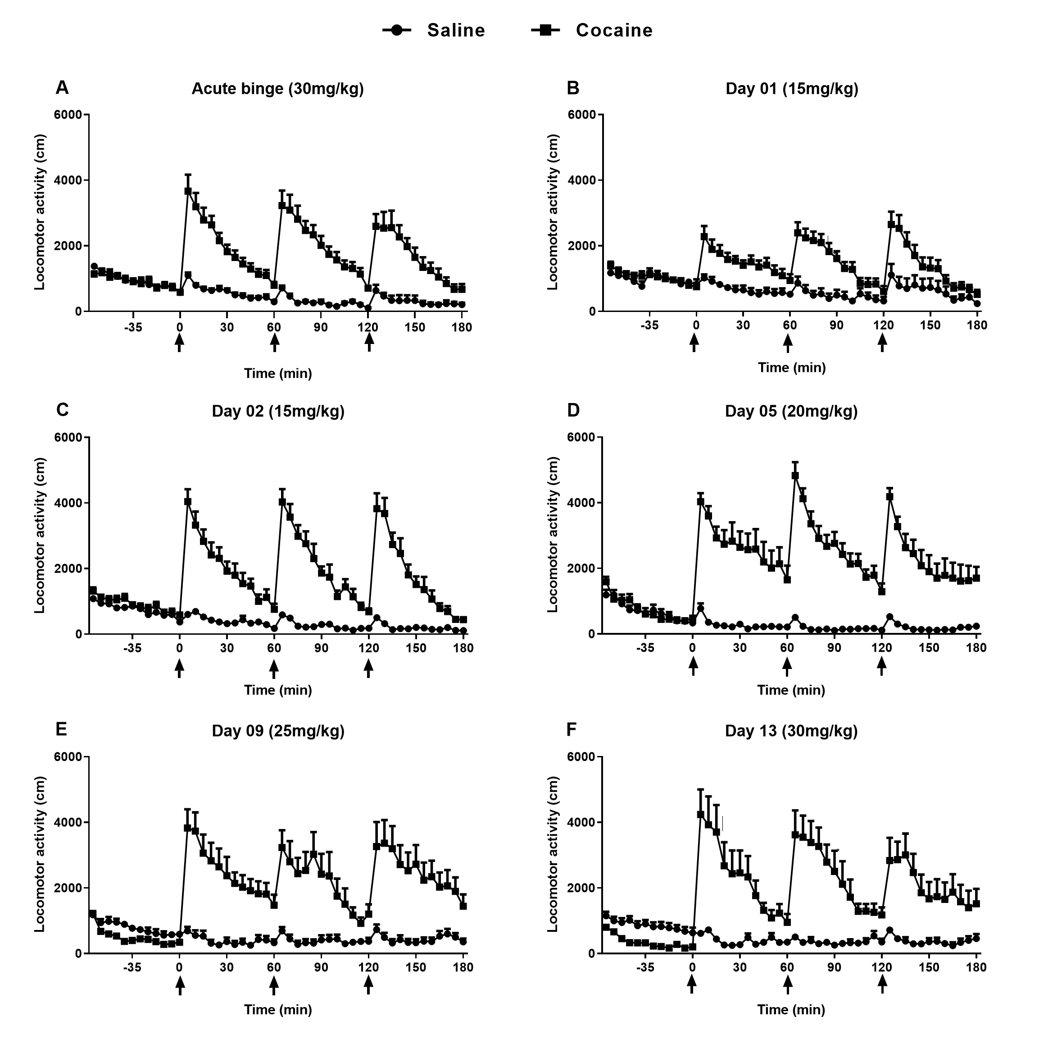
Figure 1: Locomotor activity of Swiss male mice after saline or cocaine treatment in an acute binge dose (A; 30 mg/kg; n = 12) or in a chronic escalating-dose binge (B - F; 15 – 30 mg/kg; n = 12). Animals received three daily ip injections cocaine with 60-minute intervals, after one hour of habituation. Animals from both acute (n = 12) and chronic (n = 12) control groups received saline. Cocaine/saline injections are indicated by the arrows. Locomotor activity data were collected every 5-minute following each injection (60, 120, and 180 minutes) and are expressed as mean ± SEM. Two-way ANOVA showed a significant main effect of treatment (p<0.0001), day (p=0.0001) and treatment X day interaction (p<0.0001) for both escalating and acute binge paradigms. Significant asterisks are not shown in the graph for clarity of presentation.

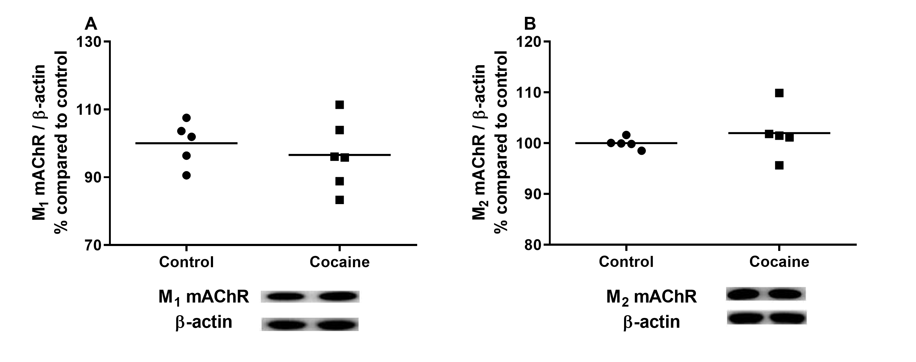
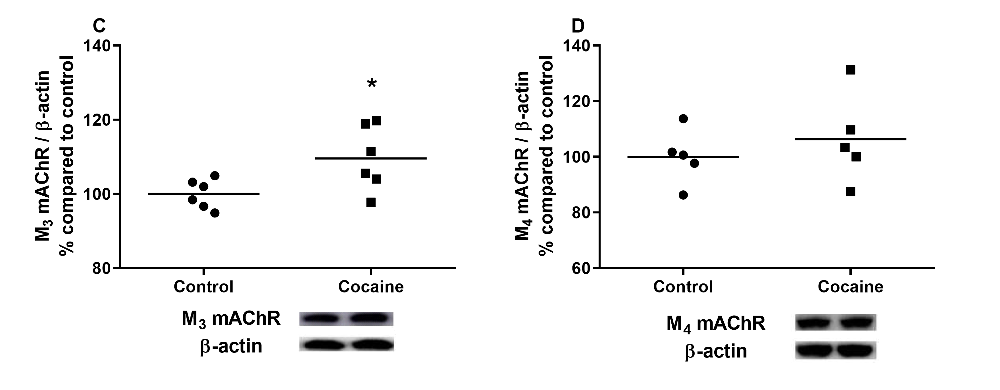
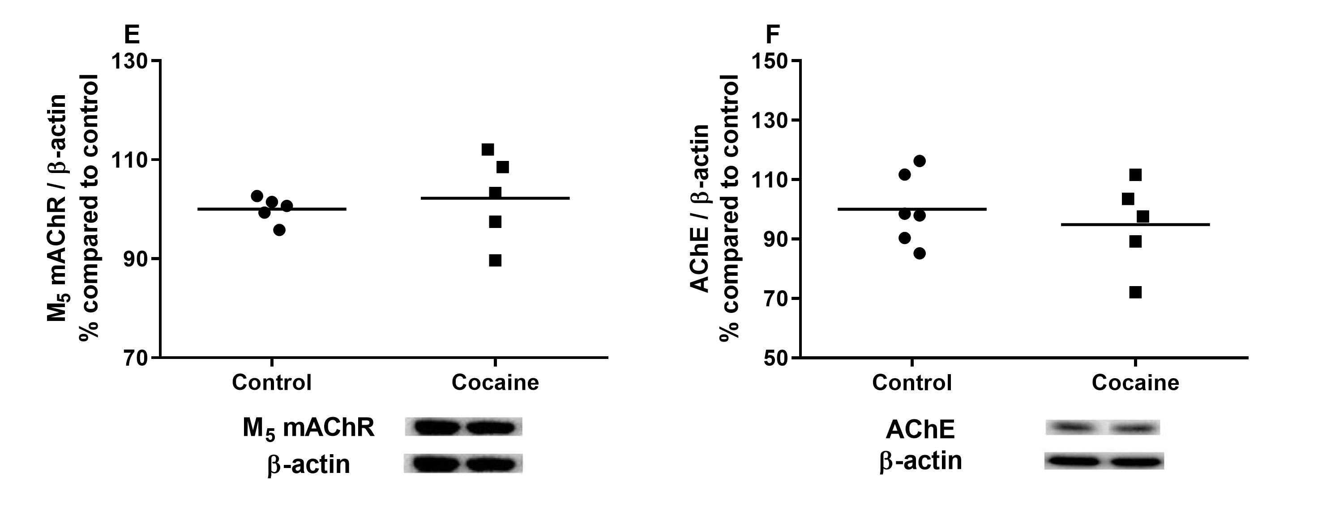
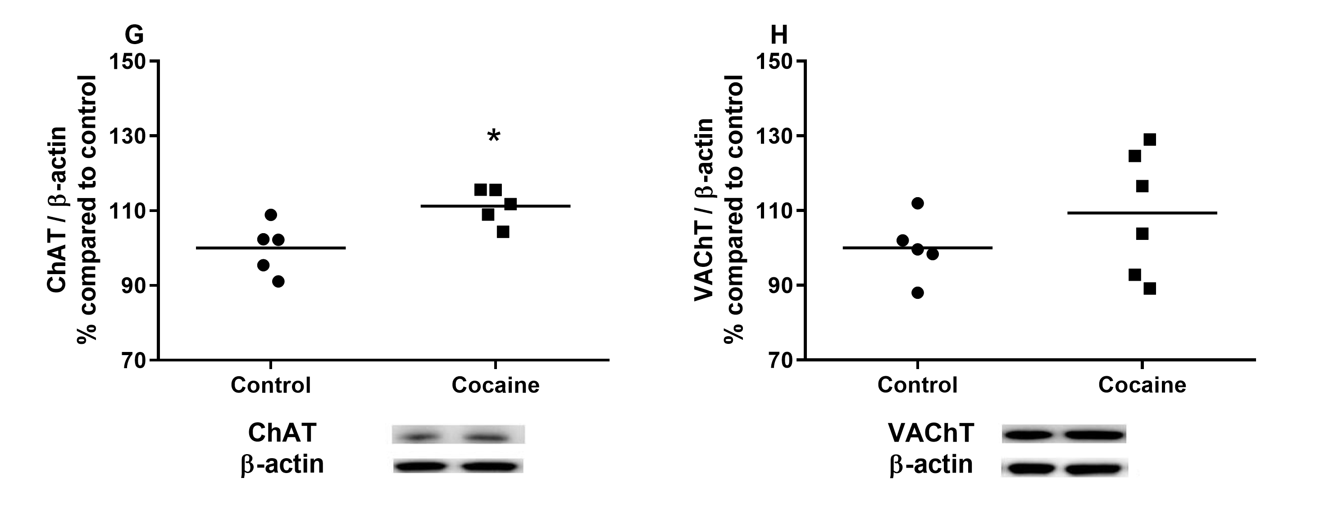
Figure 2: Quantification of M₁ - M₅ cholinergic muscarinic receptors, ChAT, VAChT, and AChE by immunoblotting in the hippocampus of Swiss male mice from the on-drug group (n = 5-6). The acute binge treatment consisted of three injections of cocaine 30 mg/kg (ip) with 60-minute intervals. Animals were euthanized one hour after the last cocaine injection. The same procedures were adopted for control animals (n = 6), treated with 0.9% saline solution. Data were analyzed using the Student's t-test for unpaired samples, and results are expressed as % relative to control (mean ± SEM). *p < 0.05.

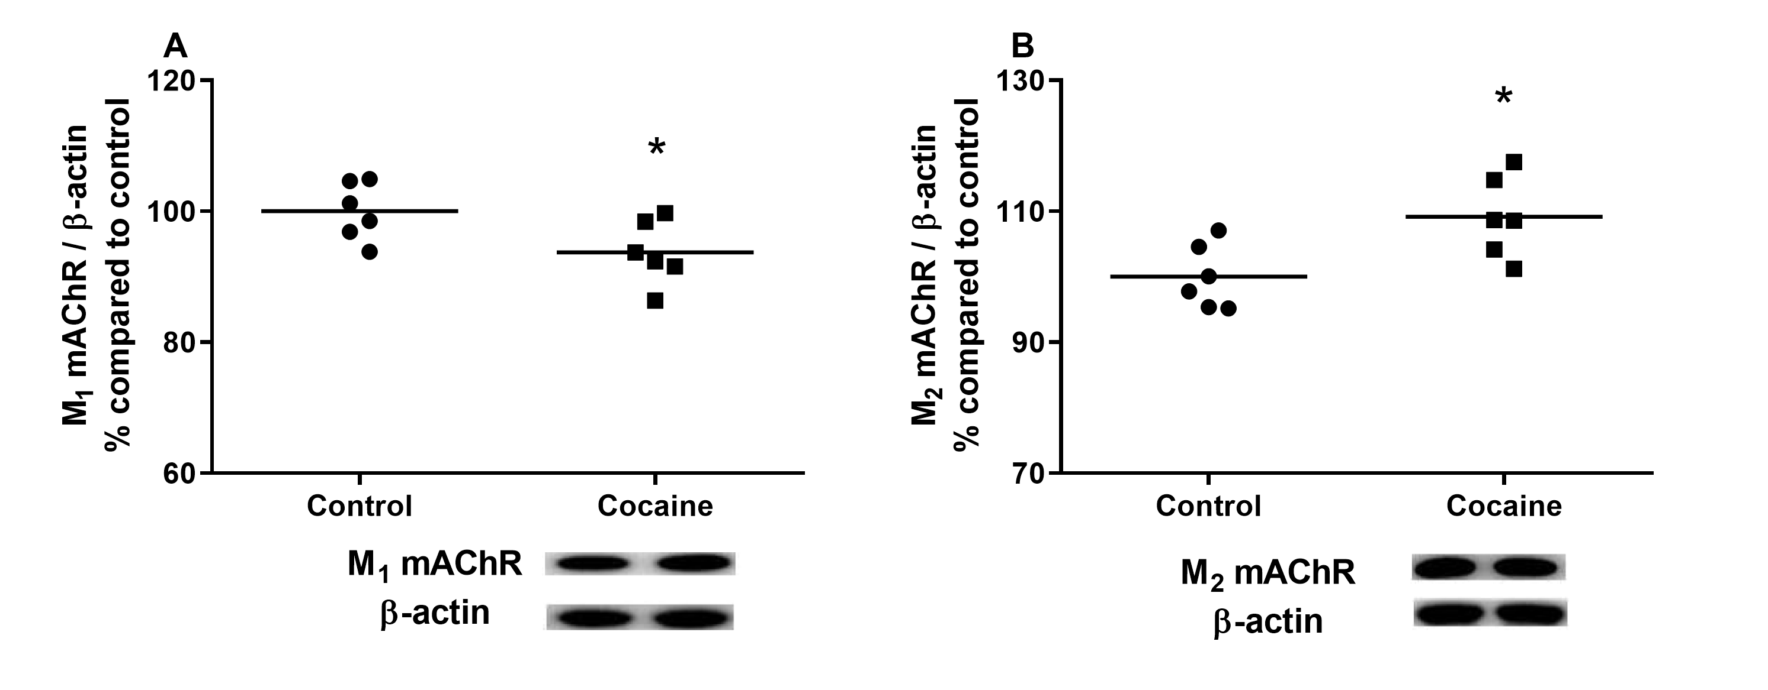
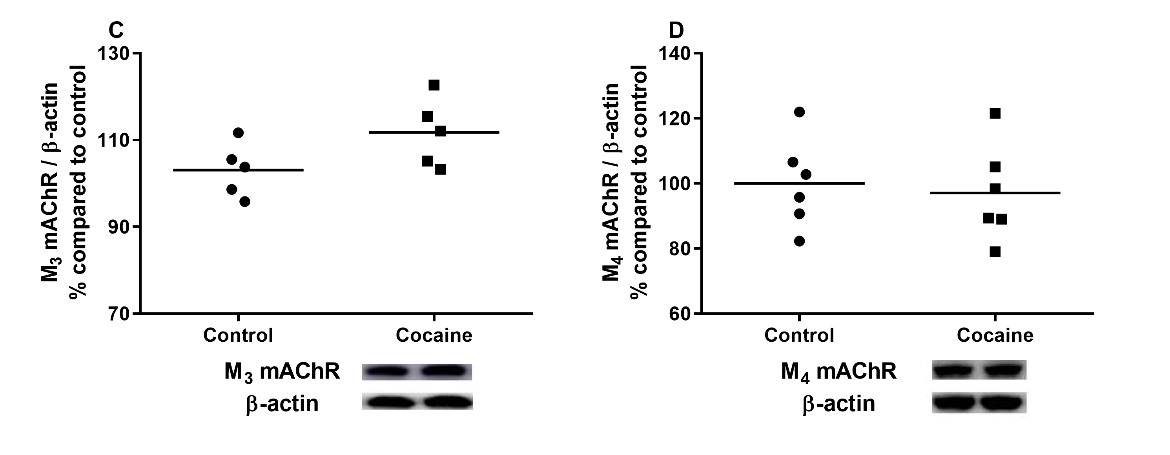
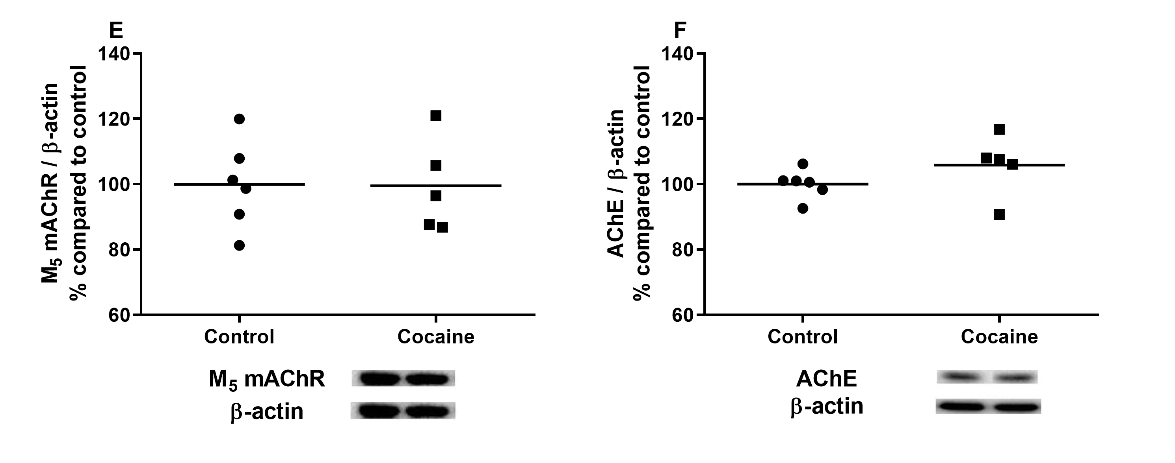
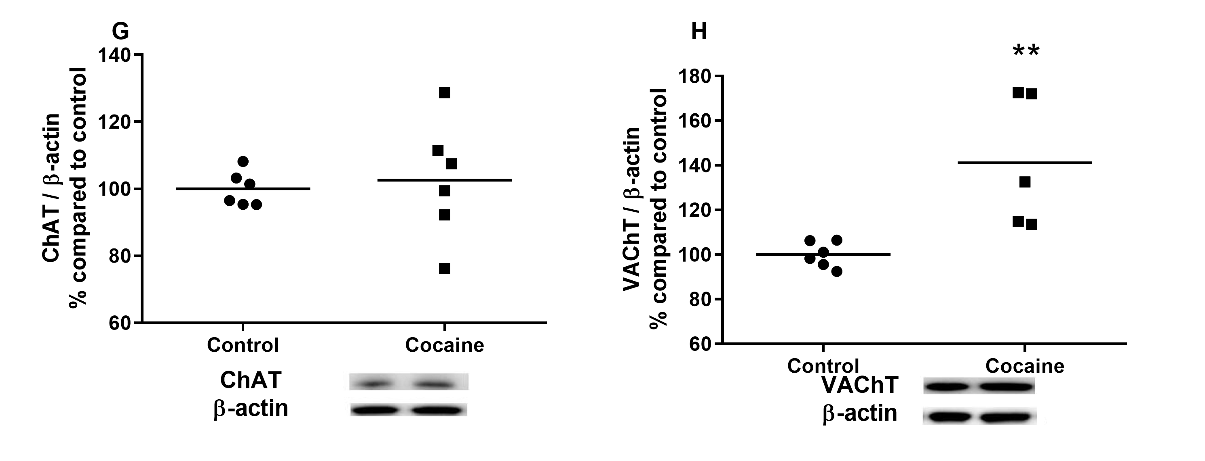
Figure 3: Quantification of M₁ - M₅ cholinergic muscarinic receptors, ChAT, VAChT, and AChE by immunoblotting in the hippocampus of Swiss male mice from the withdrawal group (n = 5-6). The acute binge treatment consisted of three injections of cocaine 30 mg/kg (ip) with 60-minute intervals. After the last cocaine injection, animals were kept in their home cages without any drugs for 14 days. The same procedures were adopted for control animals (n = 5-6), treated with 0.9% saline solution. Data were analyzed using the Student's t-test for unpaired samples, and results are expressed as % relative to control (mean ± SEM). *p < 0.05; ** p < 0.01

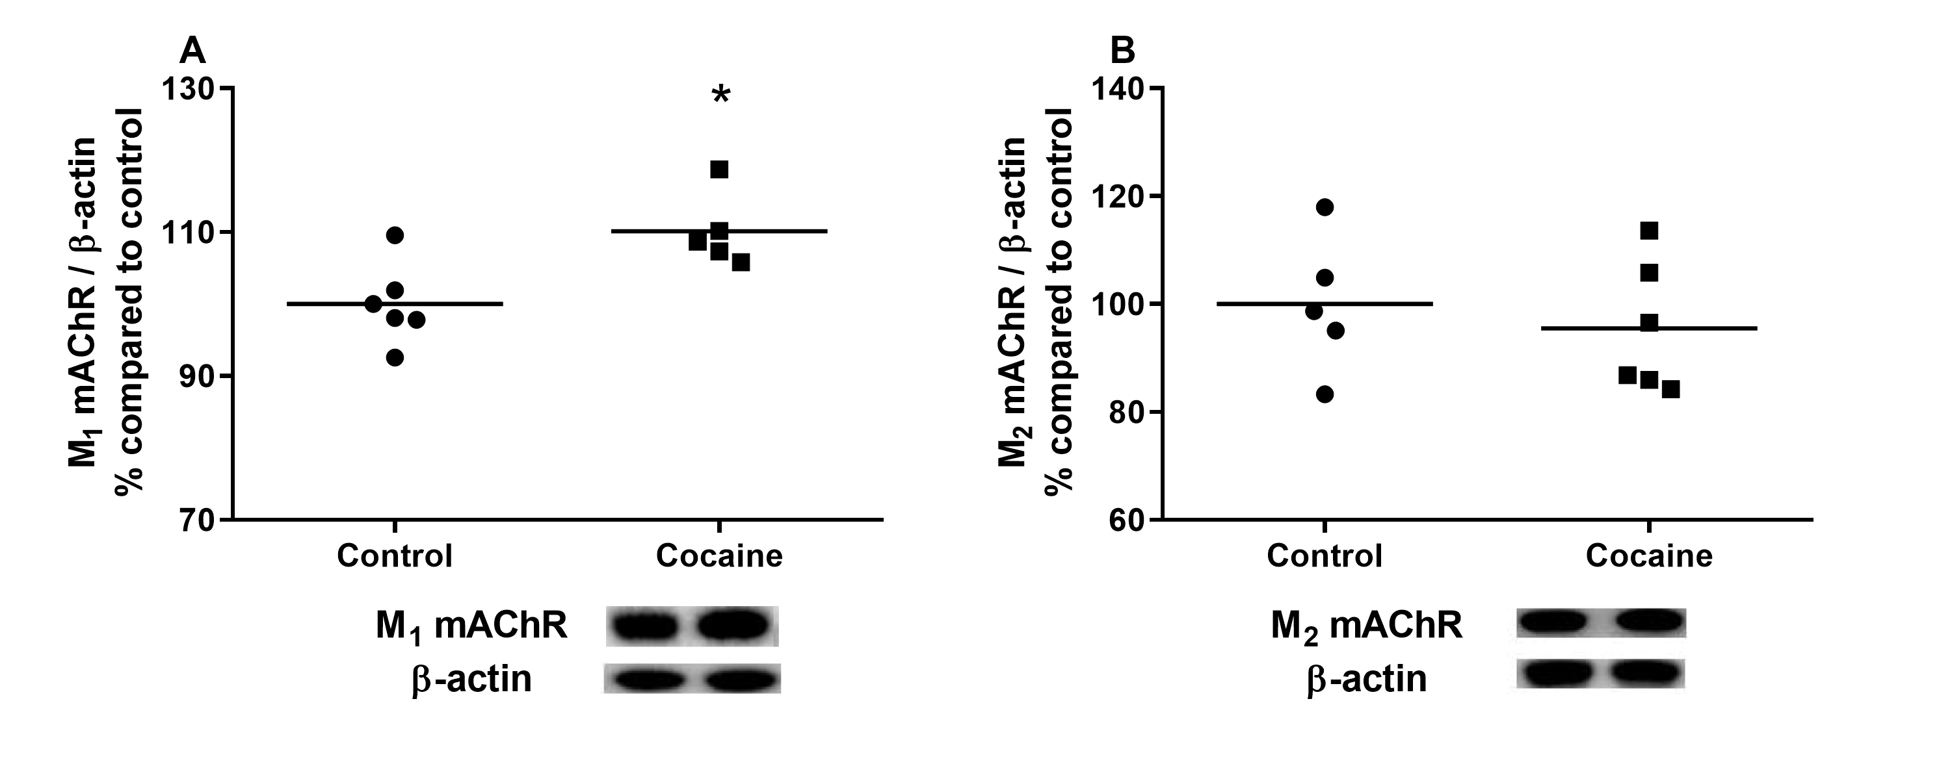
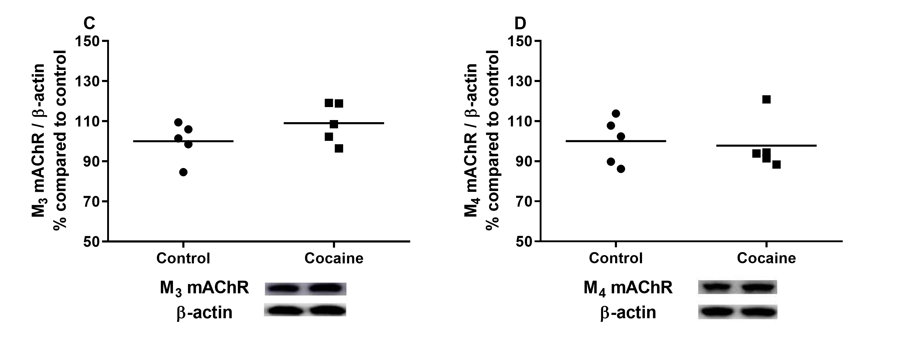
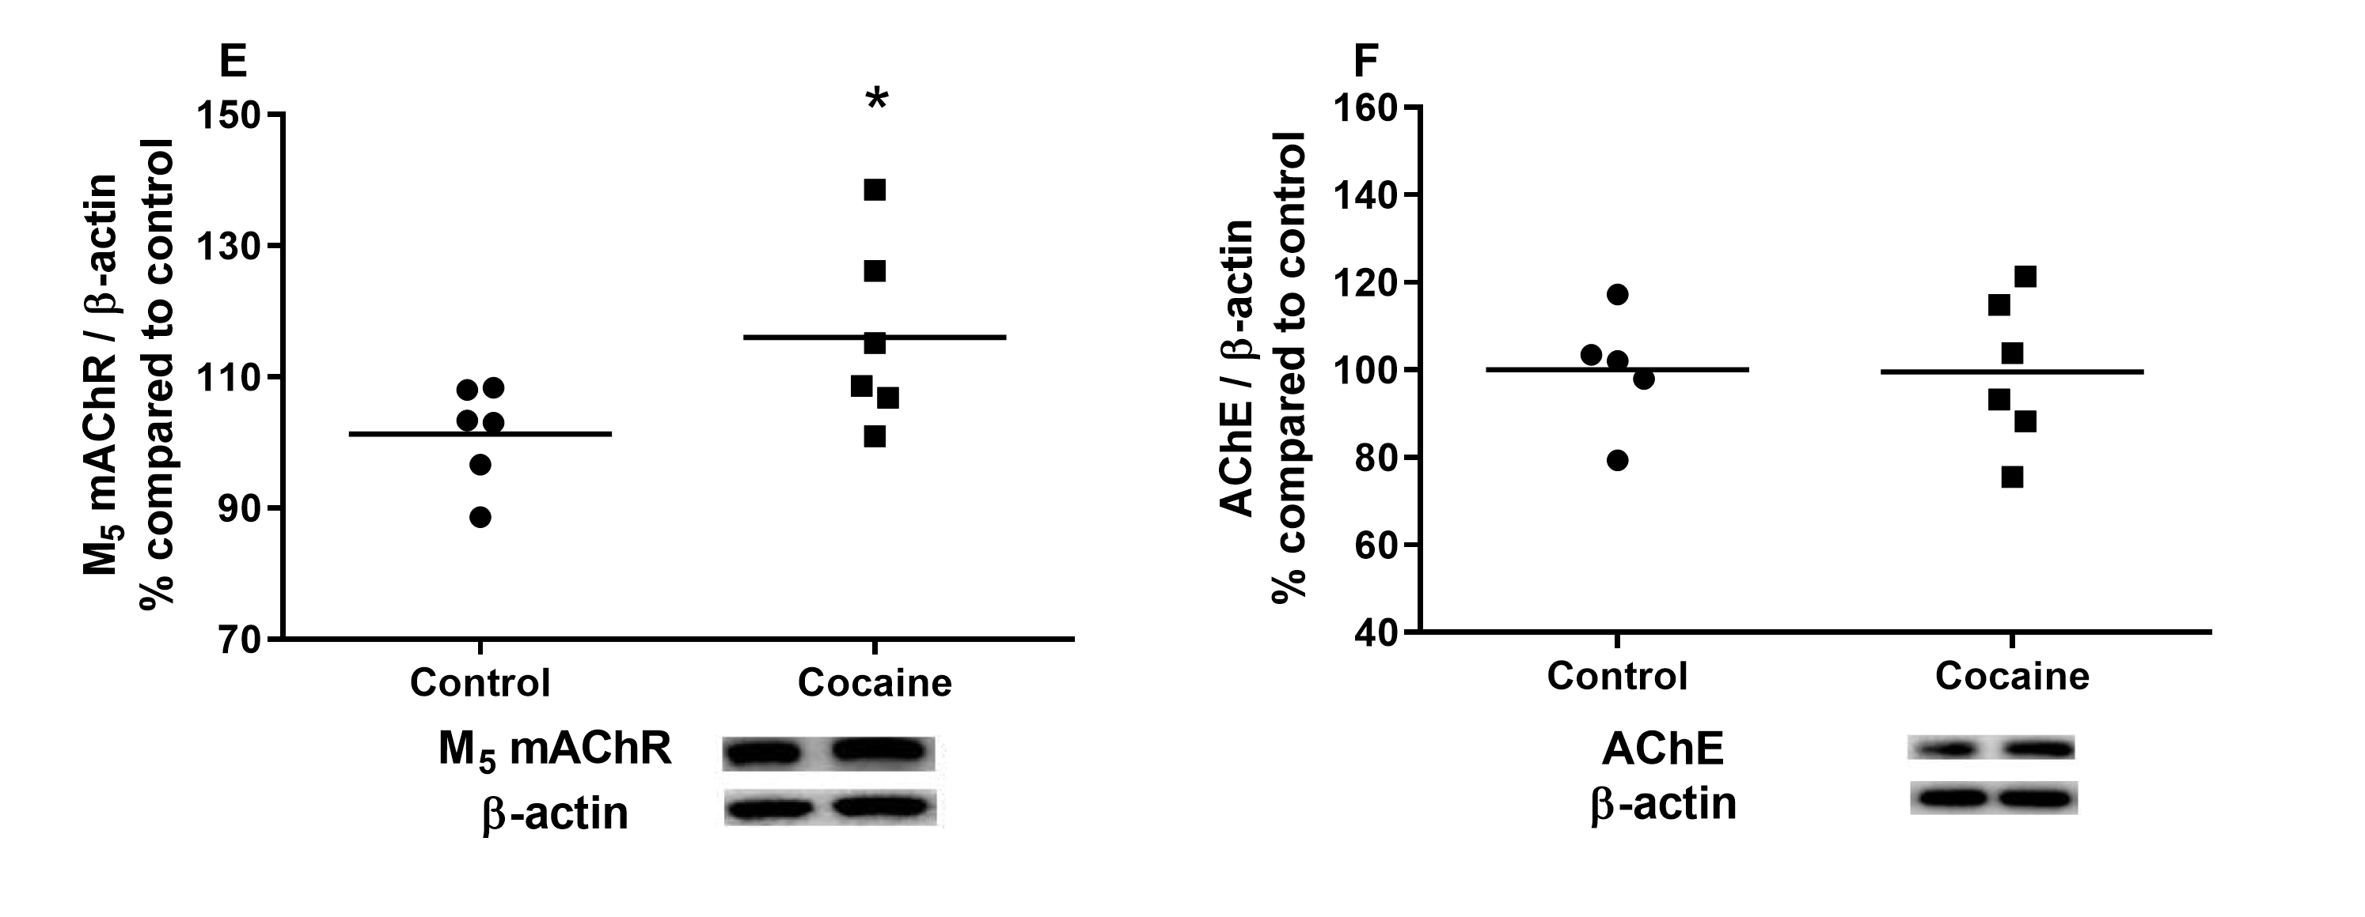
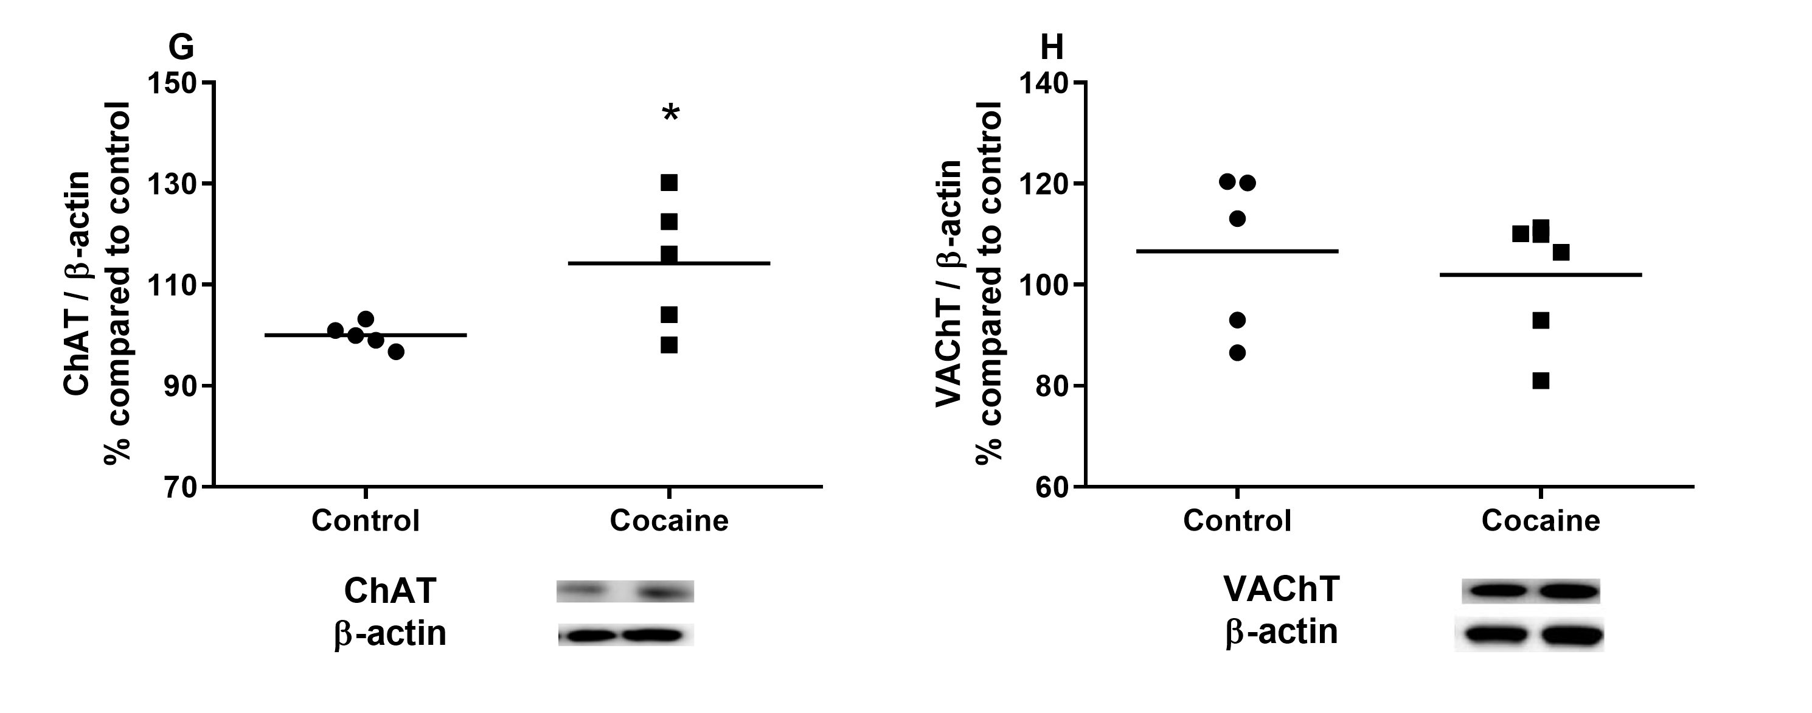
Figure 4: Quantification of M₁ - M₅ cholinergic muscarinic receptors, ChAT, VAChT, and AChE by immunoblotting in the hippocampus of Swiss male mice from the on-drug group (n = 5-6). The escalating dose binge treatment consisted of three cocaine injections administered with 60-minute intervals during 14 days; cocaine doses were escalated as follows: 3 × 15 mg/kg from days 1–4; 3 × 20 mg/kg from days 5–8; 3 × 25 mg/kg from days 9-12; and 3 × 30 mg/kg on days 13 and 14. Animals were euthanized one hour after the last cocaine injection. The same procedures were adopted for control animals (n = 5-6), treated with 0.9% saline solution. Data were analyzed using the Student's t-test for unpaired samples, and results are expressed as % relative to control (mean ± SEM). *p < 0.05.

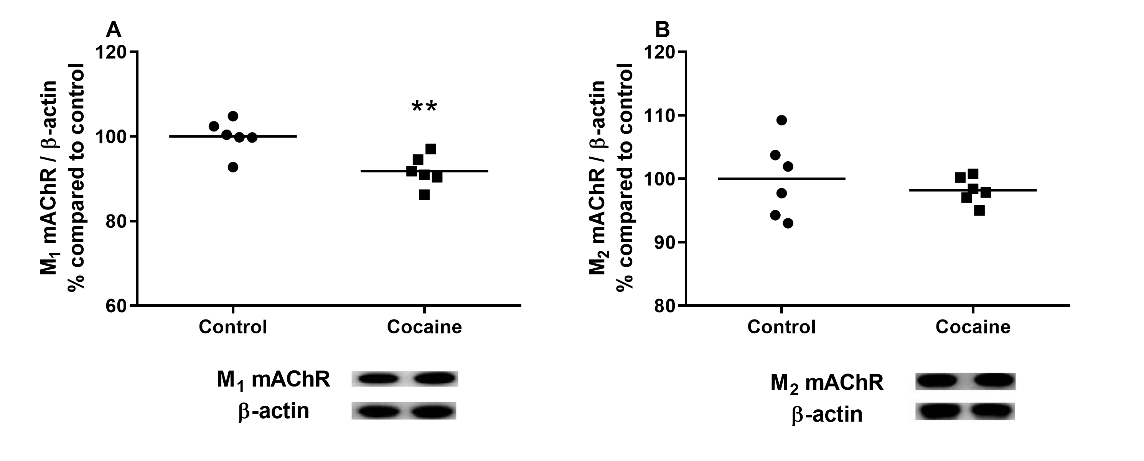
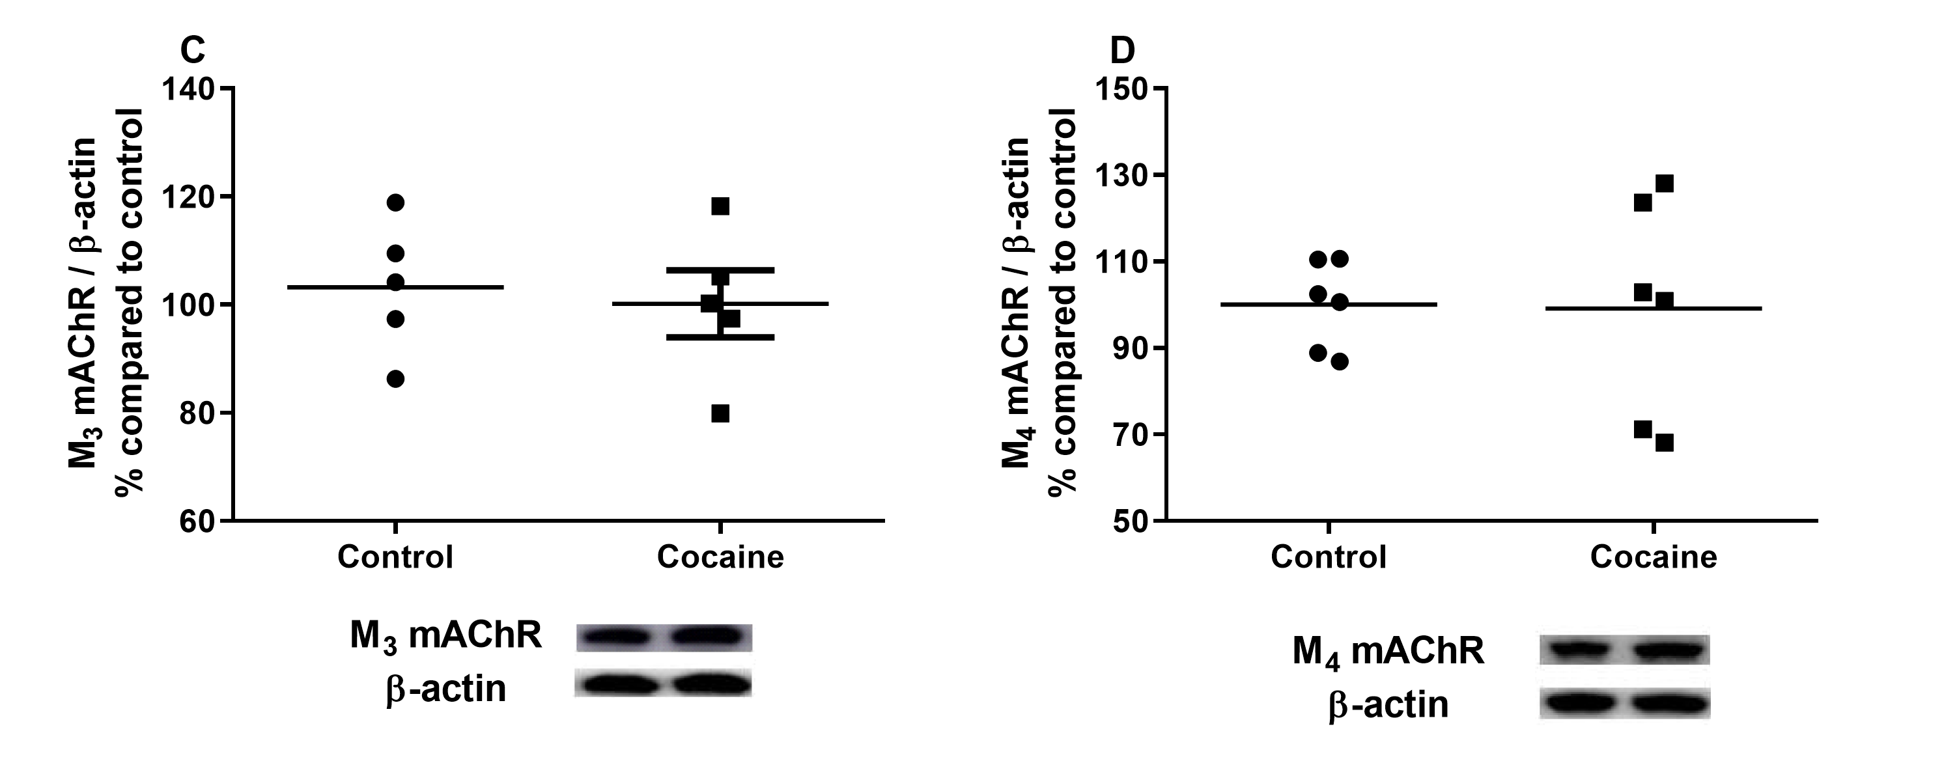
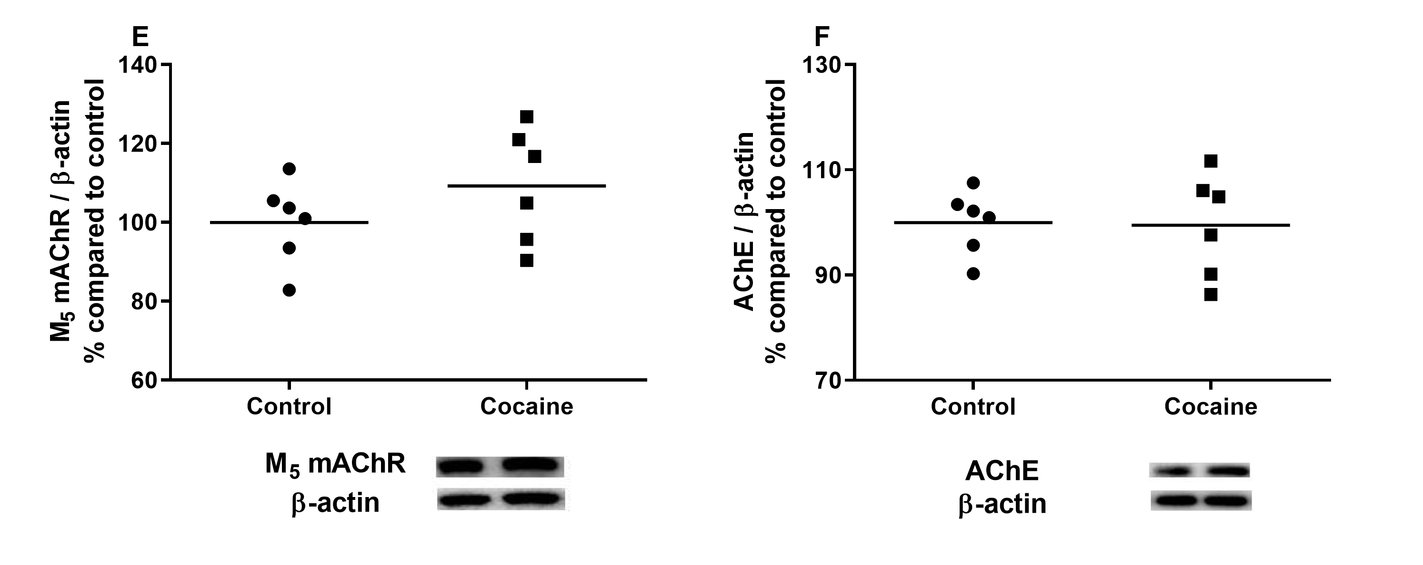
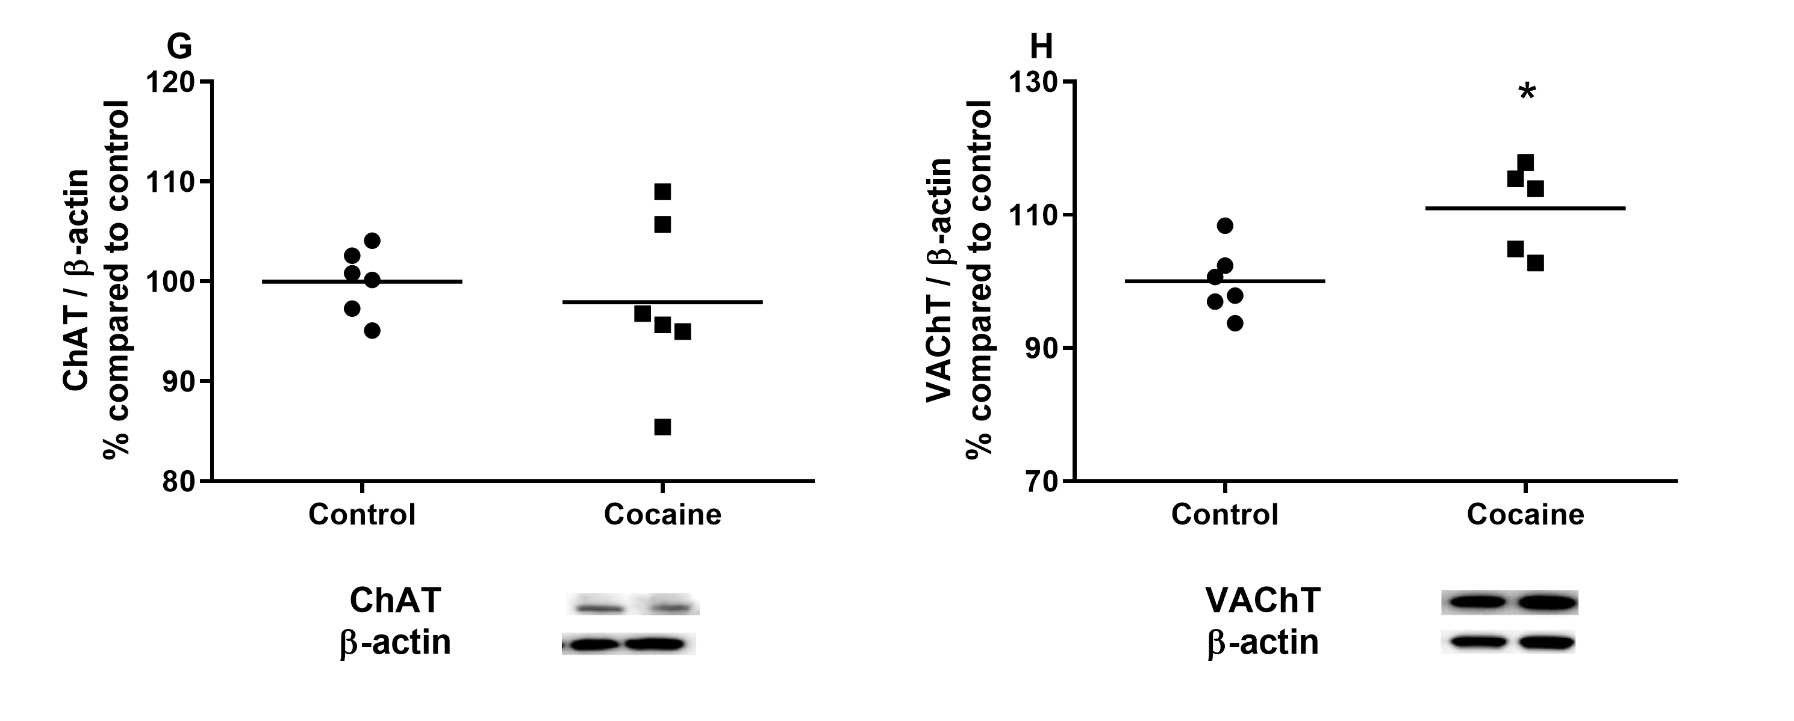
Figure 5: Quantification of M₁ - M₅ cholinergic muscarinic receptors, ChAT, VAChT, and AChE by immunoblotting in the hippocampus of Swiss male mice from the withdrawal group (n = 5-6). The escalating-dose binge treatment consisted of three cocaine injections administered with 60-minute intervals during 14 days; cocaine doses were escalated as follows: 3 × 15 mg/kg from days 1–4; 3 × 20 mg/kg from days 5–8; 3 × 25 mg/kg from days 9–12; and 3 × 30 mg/kg on days 13 and 14. After the last cocaine injection, animals were kept in their home cages without any drugs for 14 days. The same procedures were adopted for control animals (n = 5-6), treated with 0.9% saline solution. Data were analyzed using Student's t-test for unpaired samples, and results are expressed as % relative to control (mean ± SEM). *p < 0.05; **p < 0.01.

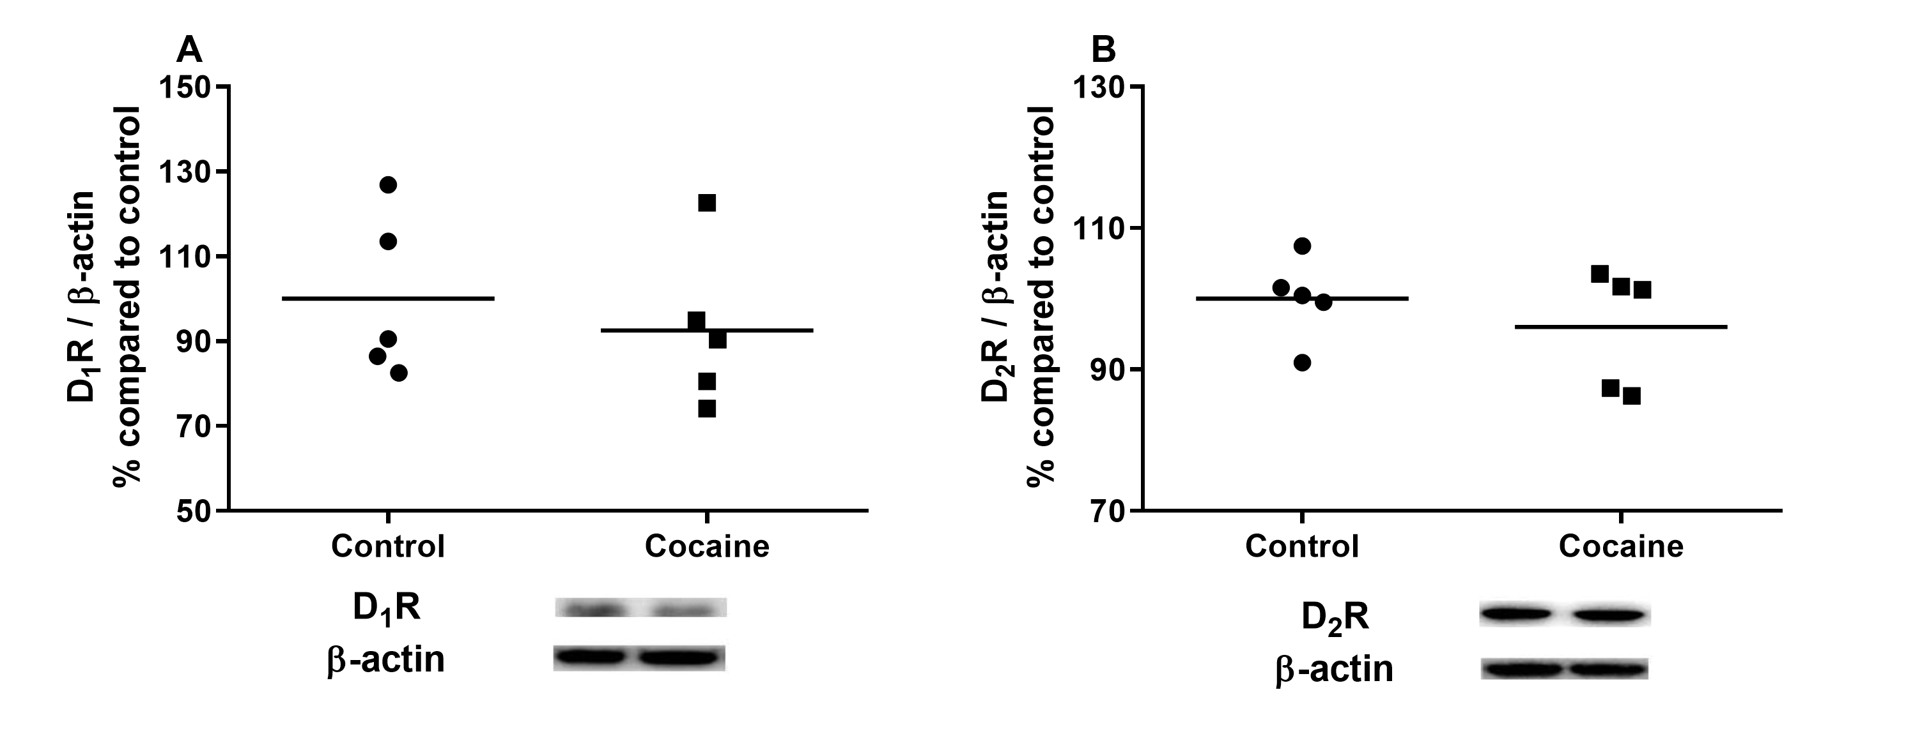

Figure 6: Quantification of D₁ and D₂ dopaminergic receptors by immunoblotting in the hippocampus of Swiss male adult mice from the on-drug group (n = 5-6). The acute treatment consisted of three injections of cocaine 30 mg/kg (ip) with 60-minute intervals. Animals were euthanized one hour after the last cocaine injection. The same procedures were adopted for control animals (n = 5-6), treated with 0.9% saline solution. Data were analyzed using Student's t-test for unpaired samples, and results are expressed as % relative to control (mean ± SEM).

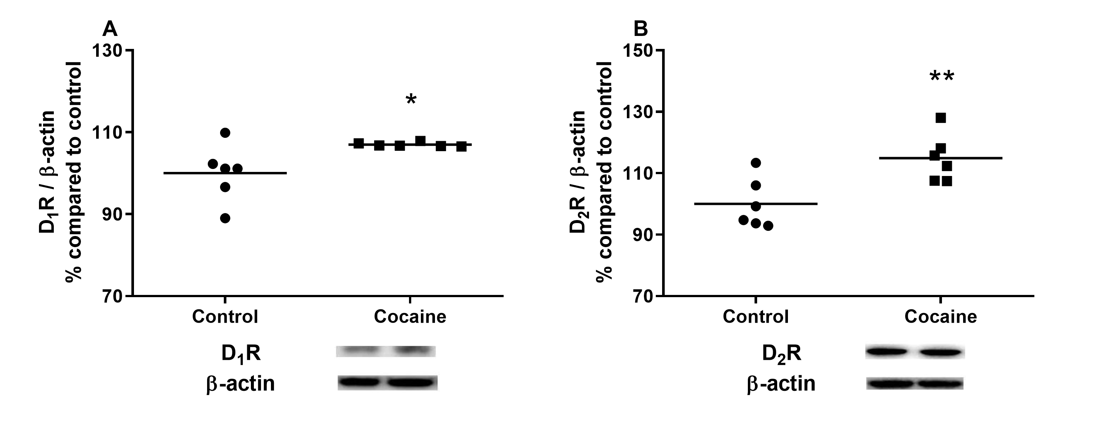
Figure 7: Quantification of D₁ and D₂ dopaminergic receptors by immunoblotting in the hippocampus of Swiss male adult mice from the withdrawal group (n = 5-6). The acute treatment consisted of three injections of cocaine 30 mg/kg (ip) with 60-minute intervals. After the last cocaine injection, animals were kept in their home cages without any drugs for 14 days. The same procedures were adopted for control animals (n = 6), treated with 0.9% saline solution. Data were analyzed using Student's t-test for unpaired samples, and results are expressed as % relative to control (mean ± SEM). *p < 0.05; **p < 0.01.

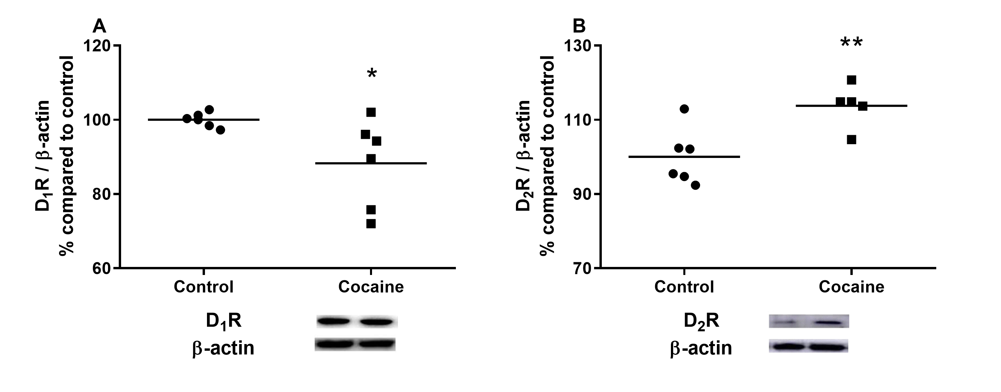
Figure 8: Quantification of D₁ and D₂ dopaminergic receptors by immunoblotting in the hippocampus of Swiss male mice from the on-drug group (n = 5-6). The escalating-dose binge treatment consisted of three cocaine injections administered with 60-minute intervals during 14 days; cocaine doses were escalated as follows: 3 × 15 mg/kg from days 1–4; 3 × 20 mg/kg from days 5–8; 3 × 25 mg/kg from days 9-12; and 3 × 30 mg/kg on days 13 and 14. Animals were euthanized one hour after the last cocaine injection. The same procedures were adopted for control animals (n = 5-6), treated with 0.9% saline solution. Data were analyzed using Student's t-test for unpaired samples, and results are expressed as % relative to control (mean ± SEM). *p < 0.05; **p < 0.01.

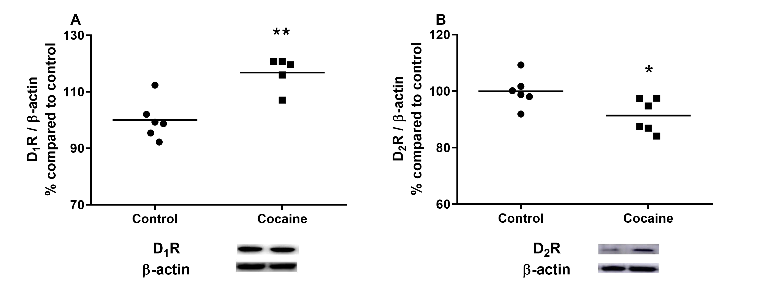
Figure 9: Quantification of D₁ and D₂ dopaminergic receptors by immunoblotting in the hippocampus of Swiss male mice from the withdrawal group (n = 5-6). The escalating-dose binge treatment consisted of three cocaine injections administered with 60-minute intervals during 14 days; cocaine doses were escalated as follows: 3 × 15 mg/kg from days 1–4; 3 × 20 mg/kg from days 5–8; 3 × 25 mg/kg from days 9–12; and 3 × 30 mg/kg on days 13 and 14. After the last cocaine injection, animals were kept in their home cages without any drugs for 14 days. The same procedures were adopted for control animals (n = 5-6), treated with 0.9% saline solution. Data were analyzed using Student's t-test for unpaired samples, and results are expressed as % relative to control (mean ± SEM). *p < 0.05; **p < 0.01.

Target | Source | Producer | Molecular weight | Dilution
D₁R | rabbit  polyclonal | Abcam | 49 kDa | 1:500
D₂R | rabbit polyclonal | Santa Cruz Biotechnology | ~ 48 kDa | 1:500
M₁ mAChR | rabbit polyclonal | Abcam | 51 kDa | 1:1500
M₂ mAChR | rabbit monoclonal | Abcam | 52 kDa | 1:5000
M₃ mAChR | rabbit polyclonal | Santa Cruz Biotechnology | 75 kDa | 1:750
M₄ mAChR | rabbit polyclonal | Santa Cruz Biotechnology | 74 kDa | 1:750
M₅ mAChR | rabbit polyclonal | Abcam | 60 kDa | 1:1500
ChAT | rabbit polyclonal | Abcam | ~ 72 kDa | 1:1000
VAChT | rabbit polyclonal | Abcam | ~ 59 kDa | 1:500
AChE | rabbit polyclonal | Santa Cruz Biotechnology | ~ 68 kDa | 1:500
β-actin | mouse  monoclonal | Sigma-Aldrich | 42 kDa | 1:1000
Table 1: Primary antibodies used for Immunoblotting semi-quantification

Plasma levels (ng/mL; mean ± SEM)
 | Cocaine | Benzoylecgonine
Saline | Undetected
Acute binge | 20,38 ± 3,4 |  | 224,6 ± 24,02
Withdrawal from acute binge | Undetected
Chronic escalating dose binge 14th day | 54,43 ± 7,84** |  | 375,1 ± 25,62***
Withdrawal from chronic escalating dose binge | Undetected
** p < 0.01; *** p < 0.001. Compared to “acute binge treatment” (unpaired “t” Test).
Table 2: Cocaine and benzoylecgonine plasma levels (ng/mL) in Swiss male mice (n = 6) treated with cocaine or saline during one and 14 days. Animals were euthanized 60 minutes after the last injection.

 | On drug |  | Withdrawal
 | R | p value | R | p value
Locomotion vs.
M₁ | -0.88 | 0.02 | ns
AChE | -0.84 | 0.037 | ns
VAChT | ns |  | 0.85 | 0.03
M₁ vs.
M₂ | 0.92 | 0.01 | ns
ChAT | 0.82 | 0.047 | ns
M₅ vs. | ns
ChAT | ns |  | 0.90 | 0.016
ns: not significant
Table 3: Significant Pearson’s correlations between locomotor activity on day 14 and hippocampal protein densities, or between different hippocampal protein densities, of cocaine treated mice from the chronic escalating dose binge treatment (n = 5-6).

Appendix A – Supplemental material

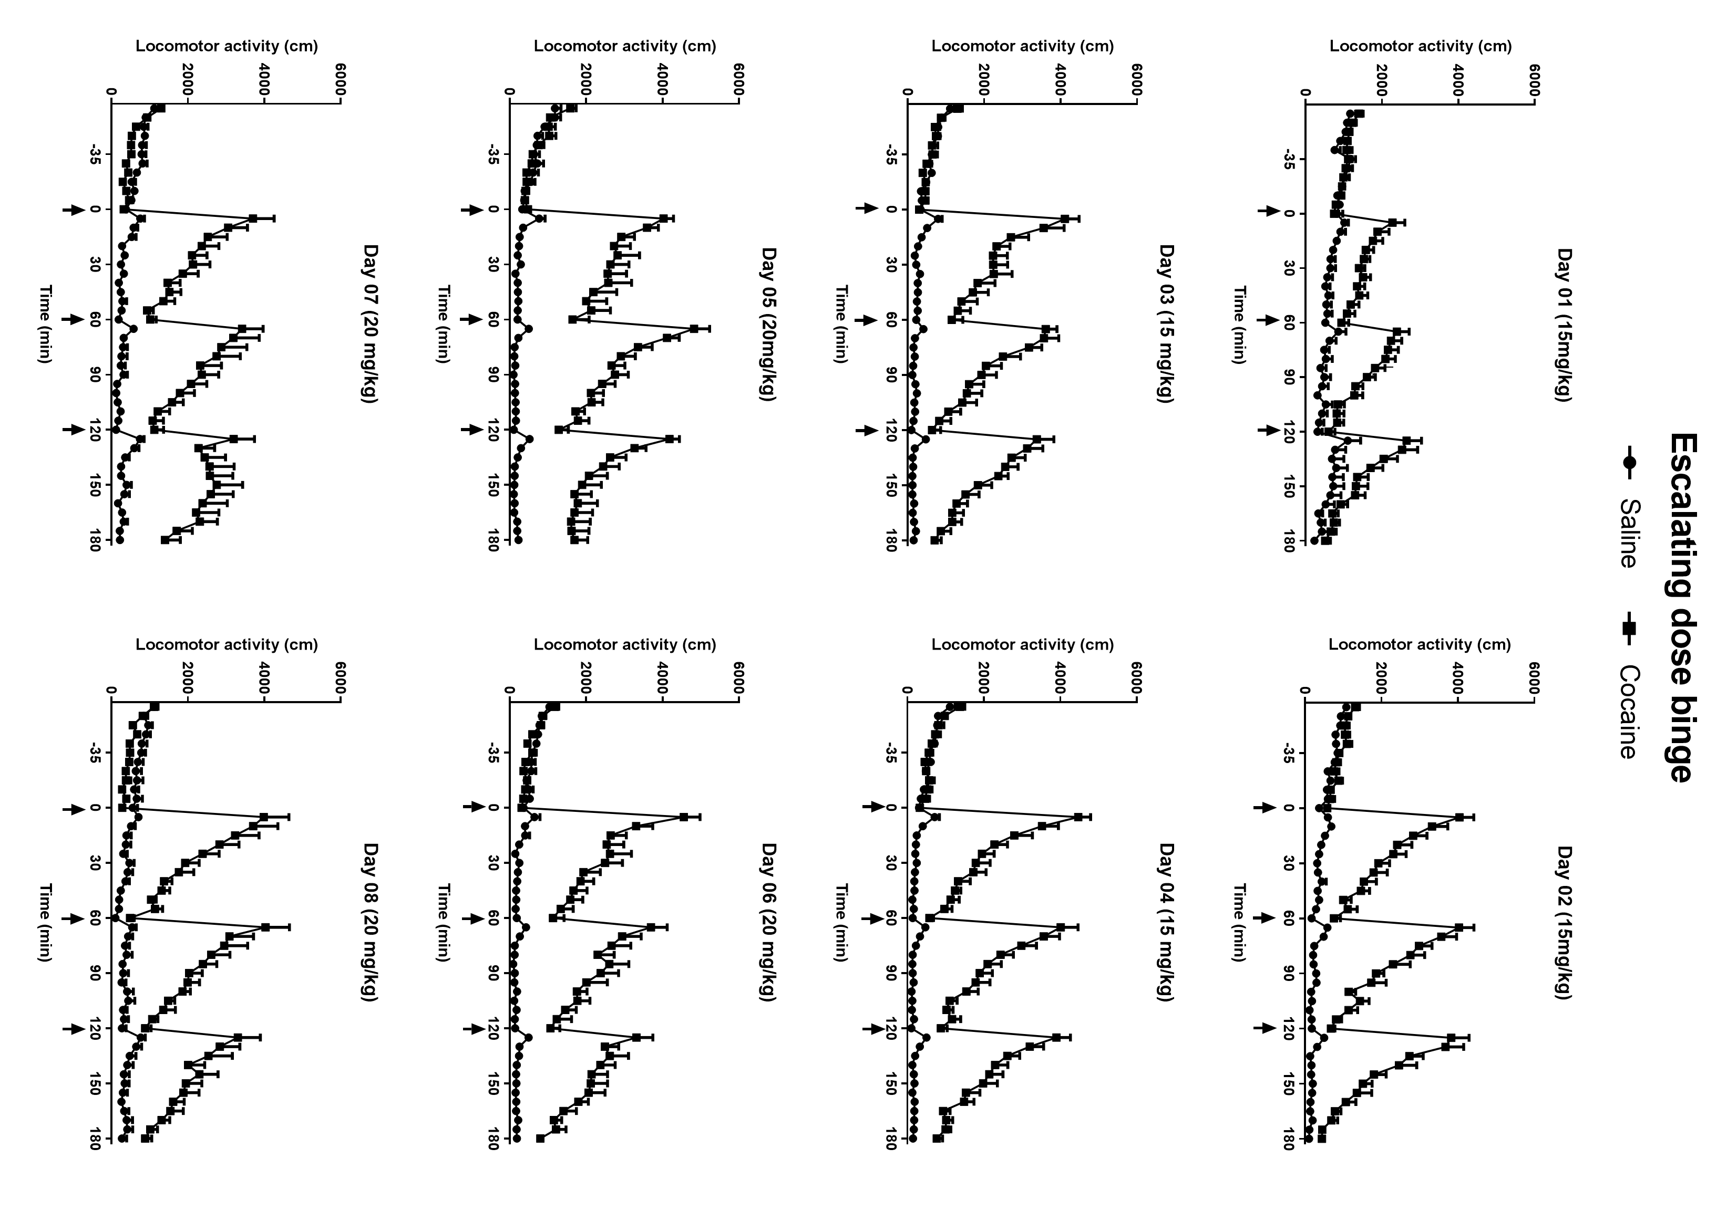
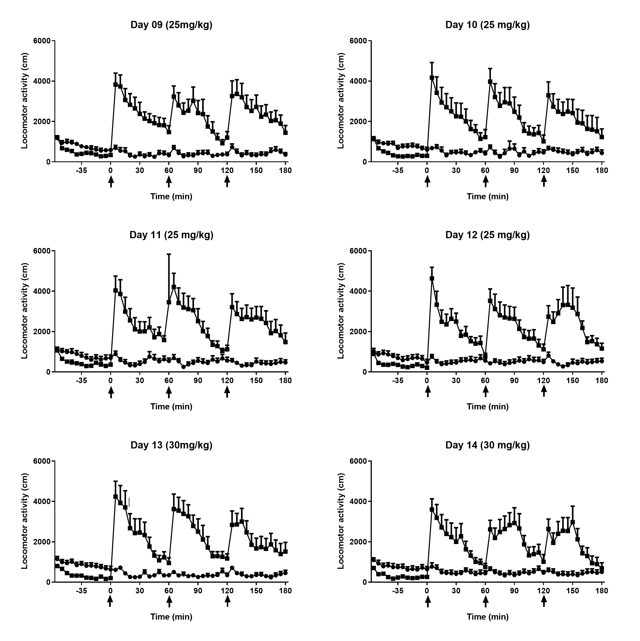
Supplemental figure 1: Locomotor activity of Swiss male mice after saline or cocaine treatment in a chronic escalating dose binge paradigm during 14 days. The animals received 3 daily ip injections of saline (n = 12) or cocaine (n= 12), 60 minutes apart, after one hour of habituation. Cocaine/saline injections are indicated by the sets. Data were collected in 5-minute bins following each injection and are expressed as mean ± SEM. Two-way ANOVA showed a significant main effect of treatment (P < 0.0001), day (P = 0.0001) and treatment X day interaction (P < 0.0001) for both escalating and cute binge paradigms. Significant asterisks were omitted from the graph for clarity of presentation.

