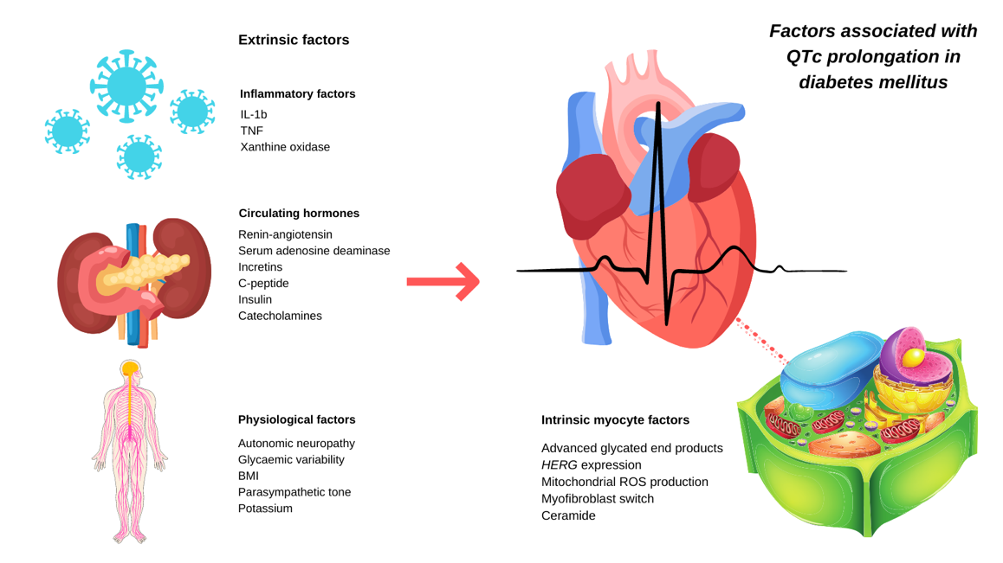
Figure 1
Figure 2: Factors implicated in QTc prolongation in human and animal models of diabetes mellitus. (Original diagram. Copyright © 2021 The authors).

Figure 2:
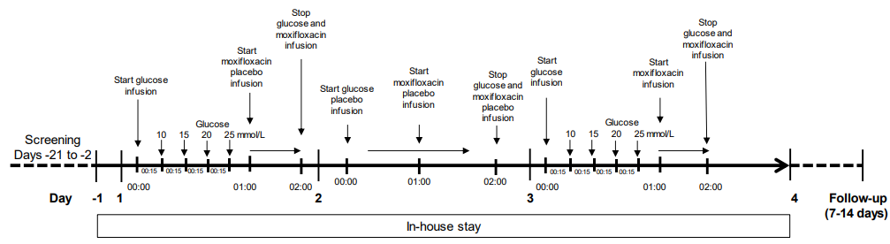
Figure 3. Study outline

Figure 3.
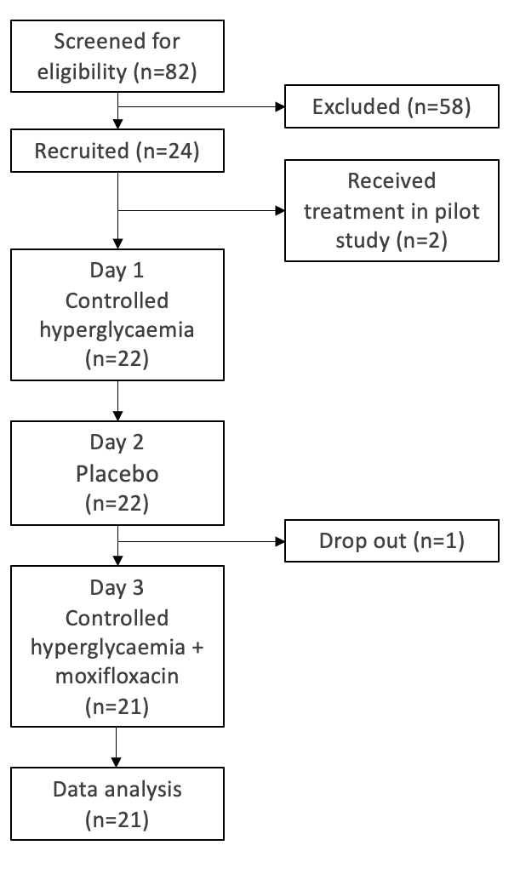
Figure 4. Consort Chart
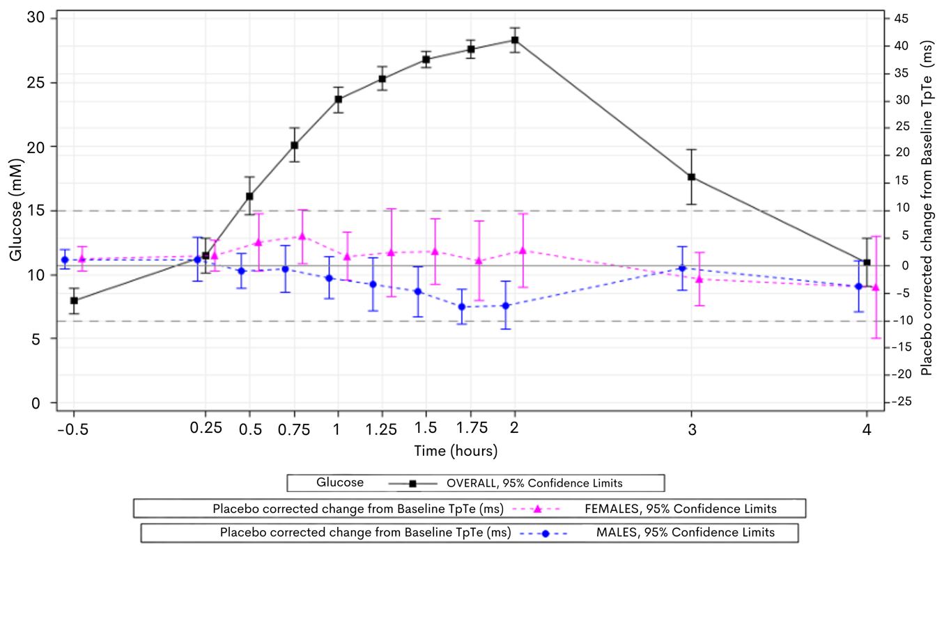
Figure 4: Mean ∆∆TpTe over time vs Mean Glucose over time on Day 1 – by gender– subinterval analysis of TpTe revealed a significant shortening of the TpTe subinterval in males, with a nadir of -7 ms (blue) but no significant change in the female cohort.

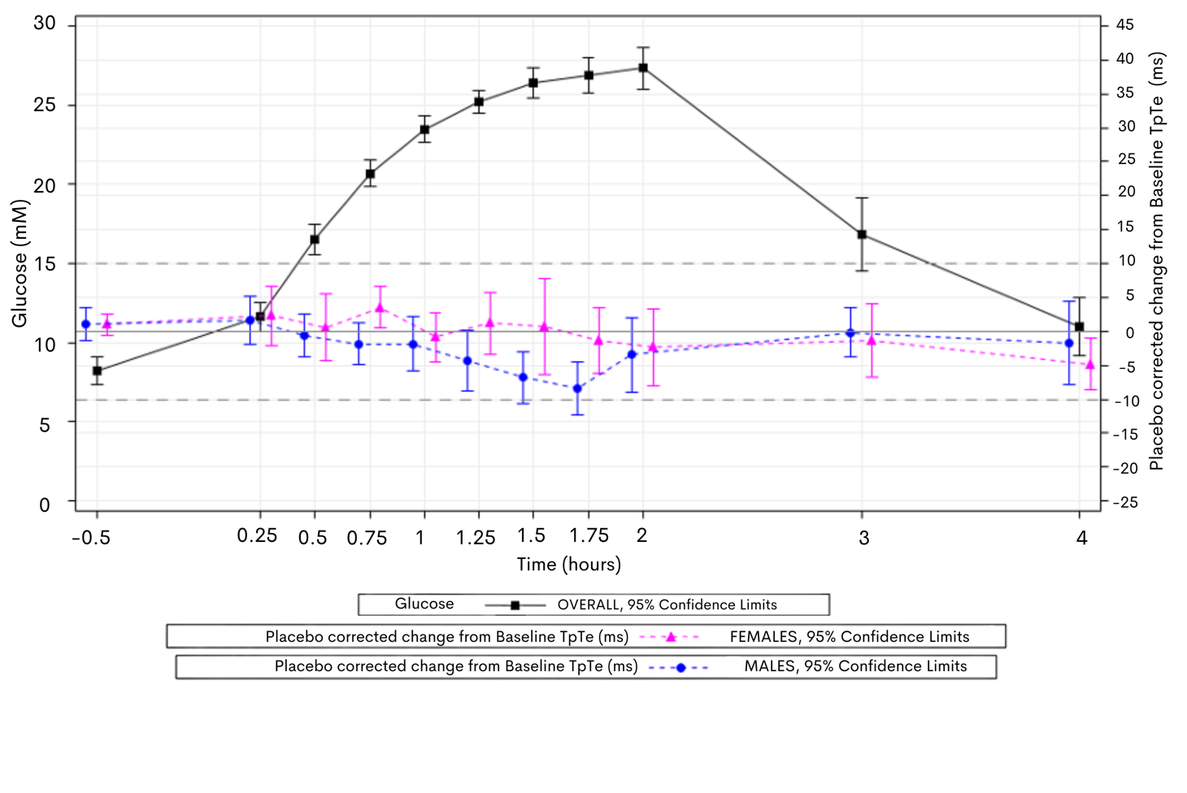
Figure 5: Mean ∆∆TpTe over time vs Mean Glucose over time on Day 3 – by gender– subinterval analysis of TpTe on Day 3 revealed a similar shortening in the male cohort which returned to baseline by around 2 hours, contributing to a more prolonged QTcF overall than compared to hyperglycaemia alone. Again, in females there was no significant change.

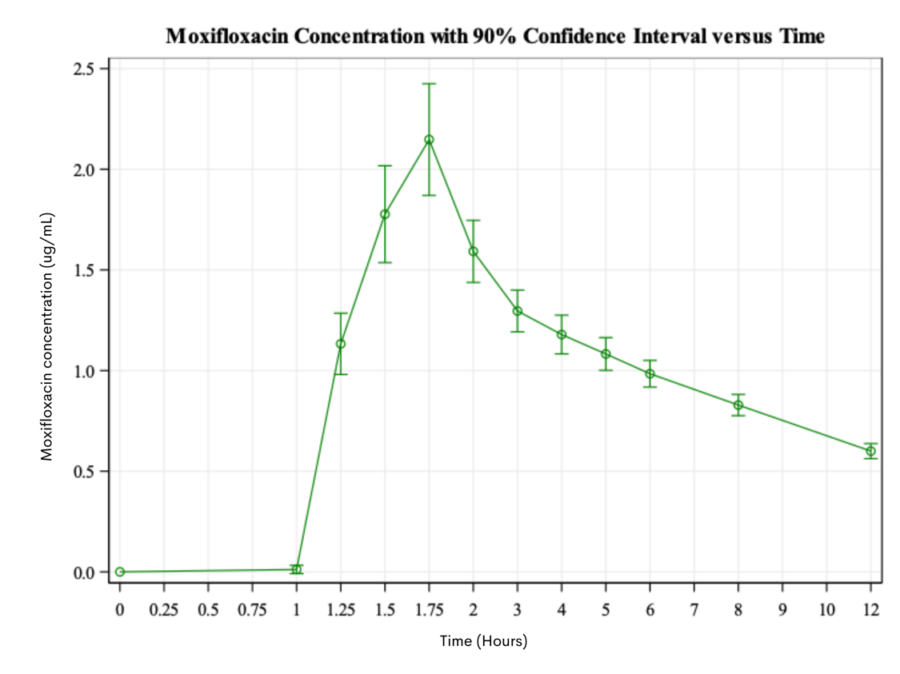
Figure 6. Moxifloxacin concentration over time on Day 3. C-max was 2.1 ug/mL at 1.75 hours.

Tables
Table 1:
Demographic Parameter |  | Males | Females
Sex | n (%) | 10 (47.6) | 11 (52.4)
Age [years] | Mean | 25.8 | 27.1
 | SD | 5.07 | 3.39
 | Range | 20-36 | 22-32
Weight [kg] | Mean | 78.1 | 63.6
 | SD | 8.9 | 5.7
 | Range | 64.9 – 93.9 | 54.7 – 73.2
Body Mass Index [kg/m²] | Mean | 24.4 | 22.7
 | SD | 2.4 | 1.4
 | Range | 19.7-27.6 | 21.1-26.4
Race, n (%) | Caucasian | 7 (70.0) | 11 (100.0)
 | Other | 3 (30.0) | 0 (0.0)

Table 1. Cohort Demographics
Type 3 Tests of Fixed Effects
Effect | Num DF | Den DF | F Value | Pr > F
Study Day | 1 | 175 | 5.66 | 0.0184
Sex | 1 | 19.5 | 3.60 | 0.0728
Sex* Study Day | 1 | 176 | 0.06 | 0.8025
ddGlucose | 1 | 182 | 67.51 | <.0001
Moxi | 1 | 178 | 2.18 | 0.1413
ddGlucose *Moxi | 1 | 178 | 3.40 | 0.0668

Table 2: Parameters of the primary model – ddGlucose was a highly significant factor on QTcF duration (p<0.0001) while the interaction between glucose and moxifloxacin (ddGlucose*Moxi) was borderline significant (p = 0.0668) as was sex (p = 0.07)

 |  | Day 1 |  |  | Day 3
Females |  | Oral (g) | I.V. (g) | TOTAL (g) | Oral (g) | I.V. (g) | TOTAL (g)
N=12 | Mean | 84.7 | 23 | 107.7 | 80.3 | 20 | 100.3
 | SD | 14.1 | 11.7 | 17.9 | 16.7 | 9.4 | 18.3
Males |  | Oral (g) | I.V. (g) | TOTAL (g) | Oral (g) | I.V. (g) | TOTAL (g)
N=10 | Mean | 135.2 | 32.9 | 168.1 | 128.7 | 32.9 | 161.6
 | SD | 24.2 | 12.5 | 22.9 | 29.9 | 9.7 | 34
Table 3: Total glucose administration to male and female cohorts. The mean total glucose requirement to maintain levels of 25 mM blood serum glucose for males was 56% greater on Day 1 and 61.1% on Day 3 versus females.

Type 3 Tests of Fixed Effects
Effect | Num DF | Den DF | F Value | Pr > F
ddGlucose | 1 | 183 | 66.89 | <.0001
Moxi | 1 | 177 | 2.39 | 0.1236
ddGlucose * Moxi | 1 | 176 | 3.78 | 0.0534
Study Day | 1 | 174 | 5.64 | 0.0186
Sex | 1 | 17.1 | 0.06 | 0.8055
Sex* Study Day | 1 | 175 | 0.06 | 0.8028
Insulin Regimen | 2 | 18.3 | 2.35 | 0.1236

Table 4: Insulin regime as an additional covariate to the primary linear model – when insulin regimen was added as a covariate to the primary linear model the ddGlucose remained highly significant, and insulin regimen itself reached neared statistical significance (p=0.12). Interestingly once insulin regimen was accounted for ddGlucose * Moxi reached significance (F 3.78 p=0.05).

