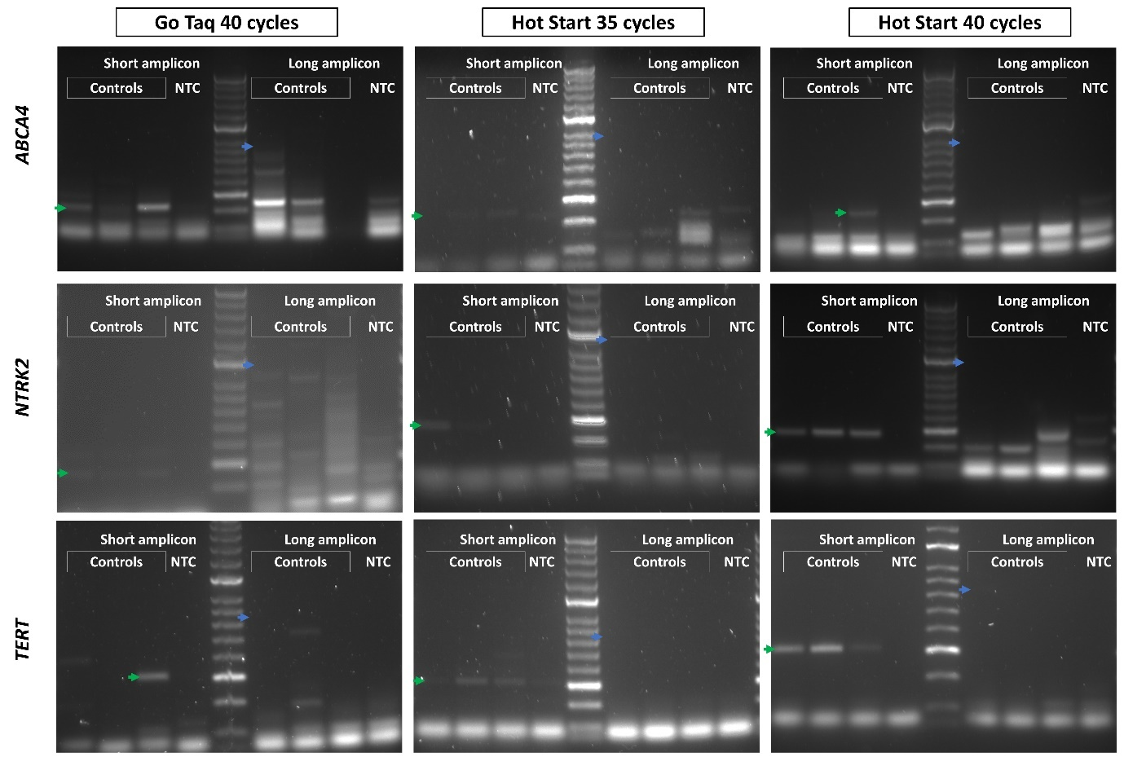

Supporting Figure S1. Comparisons of short and long amplicons RT-PCR for TERT, NRTK2 and ABCA4 under different PCR conditions. Reactions with GoTaq G2 polymerase for 40 cycles, Go Taq Hot Start polymerase with 35 cycles and 40 cycles were tested for the three genes with TPM values less than 1. Short amplicons were detected but long amplicons were absent in all three conditions.

Supporting Data D1

SOT189
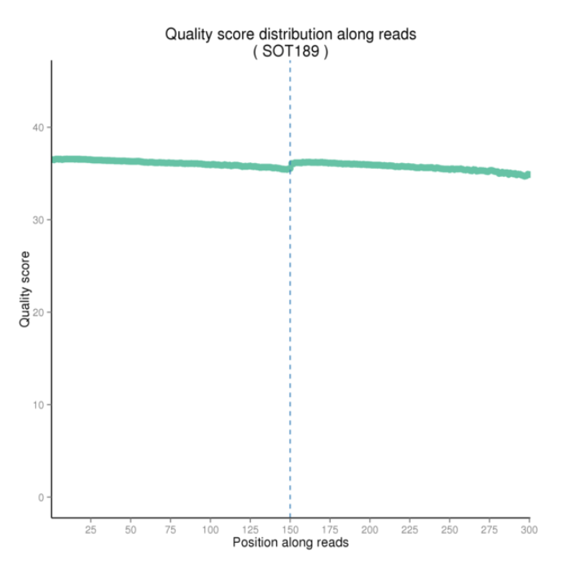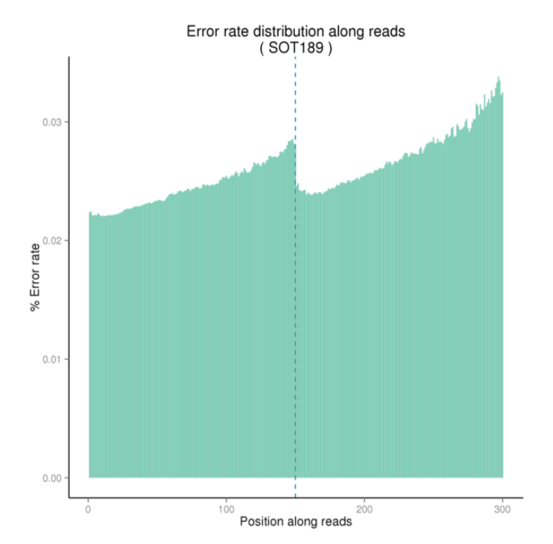
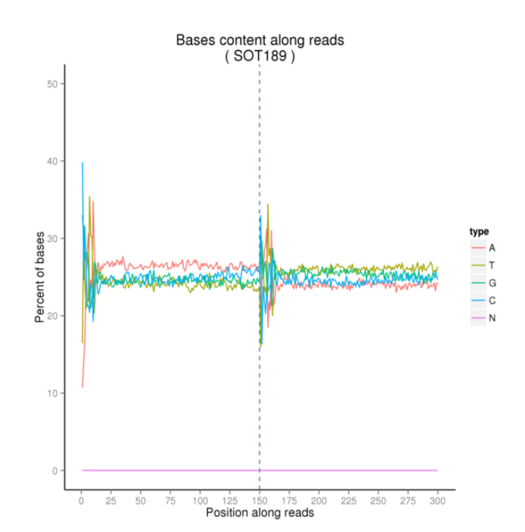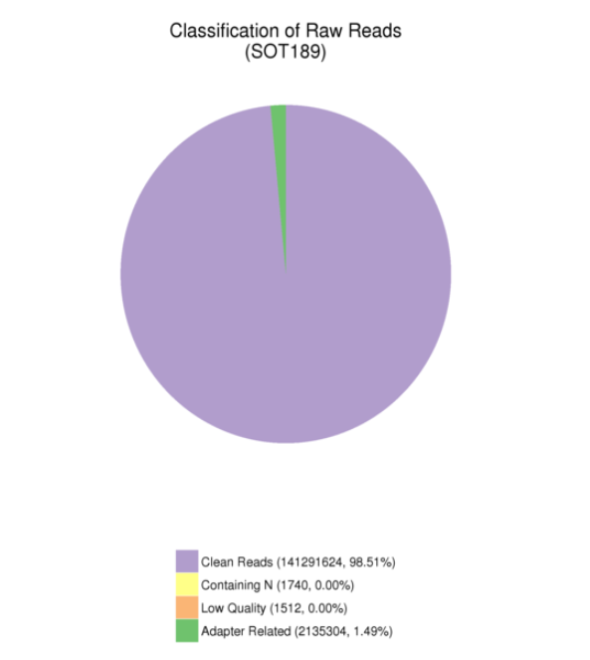

SOT158
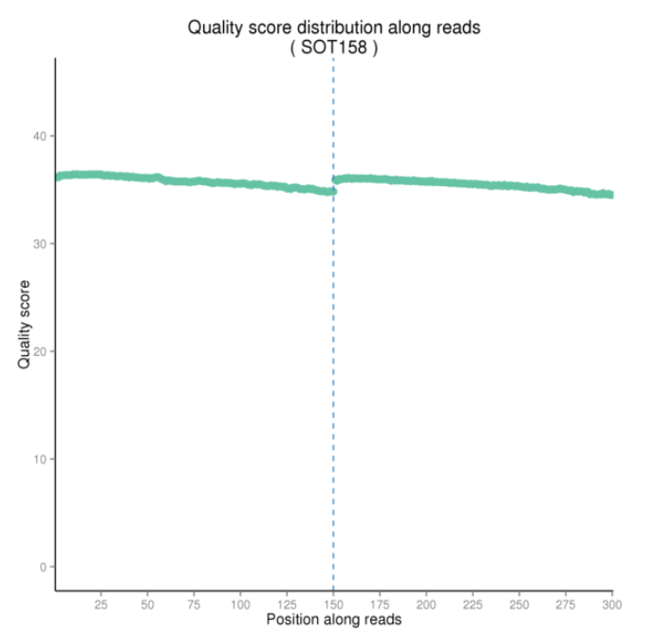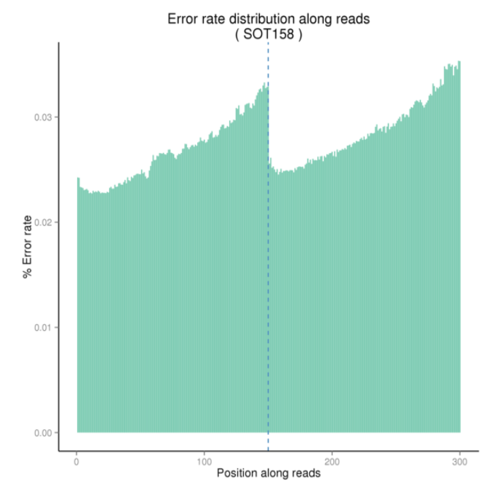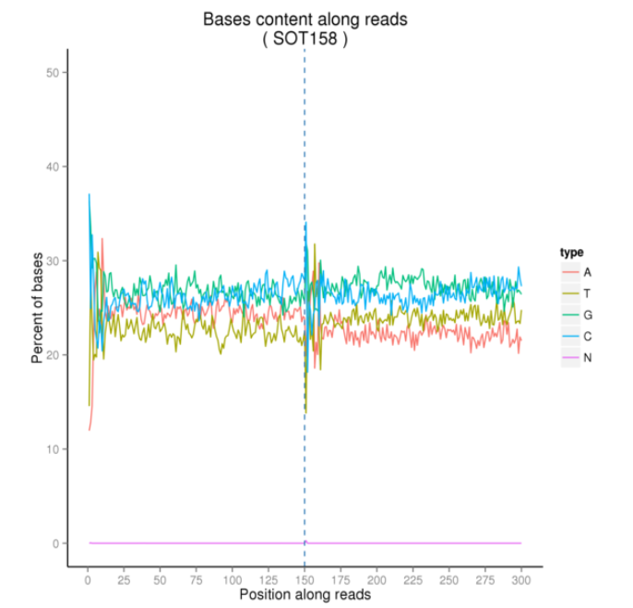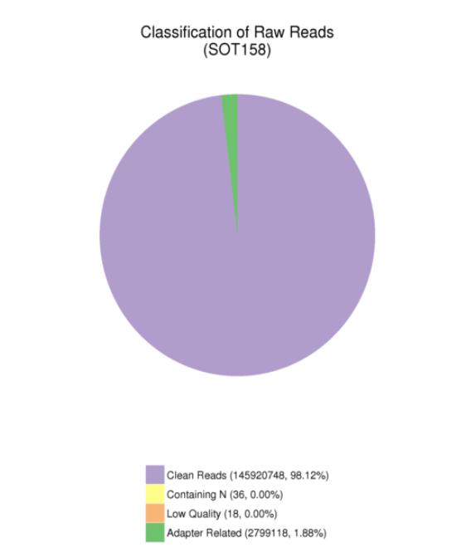

SOT168
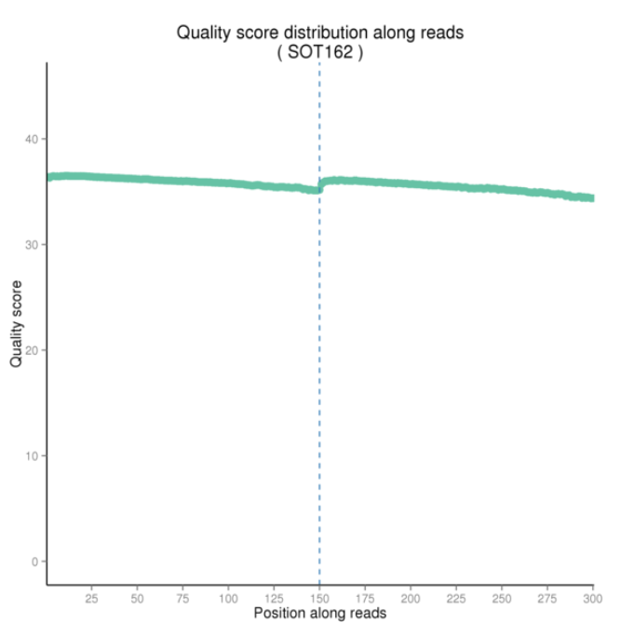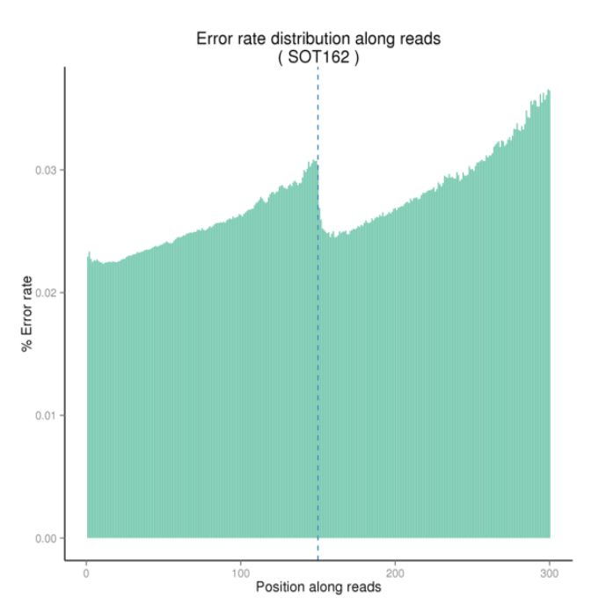
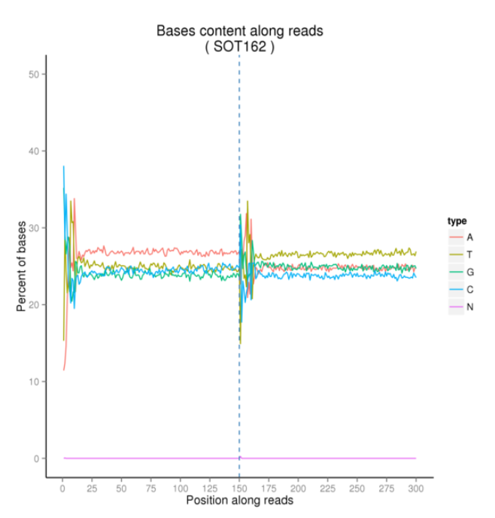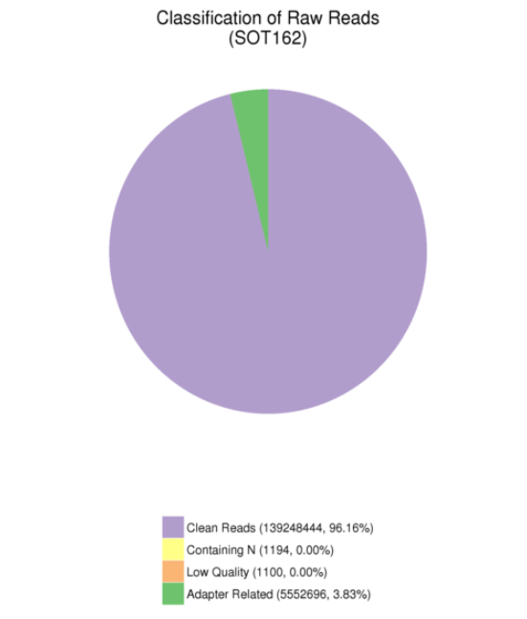

Supporting Data D2. Primer sequences for their respective VUSs.

VUS | Primer Sequence for short amplicon
COL5A2 c.961-10T>G | GTCTTCCAGGTCTGAAGGGT
 | CATACCATGTGCACCTCGT
TTN c.49346-1G>A | CTGCTGTGGTGGAAGTGAAC
 | TTCAGCCAACACACGGAATC
TTN c.63793G>A | GGAAACGGTGTAATGCTGCA
 | GGATCTGATGCAAGCACTGG
SYN1 c.838-2 A>G | TCAGCAGTACAACGTACCCC
 | AGTTCCCTGACACTGACGT
TCF4 c.550-3C>G | GGAGGCCTCTTCACAGTAGT
 | CCCAACATTCCTGCATAGCC
TERT c.3295+5G>T | CCCTCTGCTACTCCATCCTG
 | CTCACTCAGGCCTCAGACTC
TERT c.3157+3A>G | TGAACAGCCTCCAGACGG
 | CAGGAGTGGCACGTAGGT
ABCA4 c.5461-10T>C | TTCATCGGCATCAACAGCAG
 | CCATGGCAAACAGGTTCTTCC
PRPH c.421G>T | TAGCTCTGCGAACGGTGACT
 | CGTGCAGCTTCTTGAGGAAC
WT1c.871A>T | CAGTTCCCCAACCACTCATT
 | CAGGTCATGCATTCAAGCTG
NTRK2 c.287+3G>C | AAATGCAGTGCCTCTCGGAT
 | CTCGTCAGTTTGTTTCGGGT
DSP c.5510A>G | TGAGGCTGGAGTACGATGAC
 | GCTTGGAGTCTTTCGATCTCAC
COL1A1 c.2644C>T | CTGGAGCCAAAGGTGCTC
 | CACCAGGGGATCCTTTCTC

VUS | Primer Sequence for long amplicon
COL5A2 c.961-10T>G | GGTGAAGTGGGATTTGCAGG
 | GGACCTGCTTCTCCCTTCAT
SYN1 c.838-2 A>G | TTCGGAATGGGGTGAAGGTC
 | GCCTGAGCCATCTTGTTGAC
TERT c.3157+3A>G | GGCACGGCTTTTGTTCAGAT
 | GGTCTTGAAGTCTGAGGGCA
ABCA4 c.5461-10T>C | CGGGTGAACAAATCCAAGCA
 | GAACTCCGACACACAGCCT
NTRK2 c.287+3G>C | GAATTGGGTTGGAGCAGGAG
 | GGACTGGATTTAGCCTCTTGG
COL1A1 c.2644C>T | TGAAAGTGGTCCCAGCGG
 | ACCTTGTTTGCCAGGTTCAC

