(a)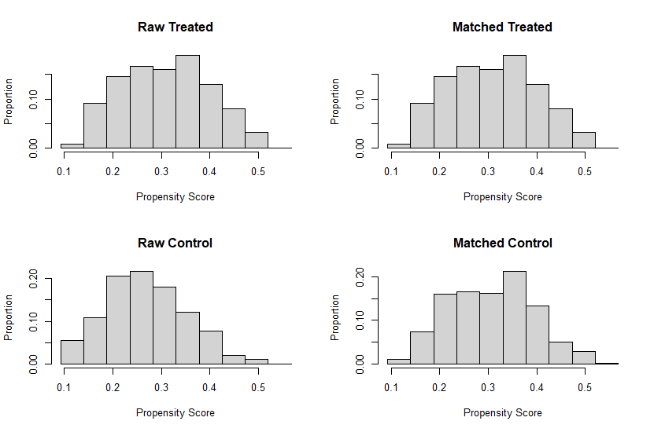(b)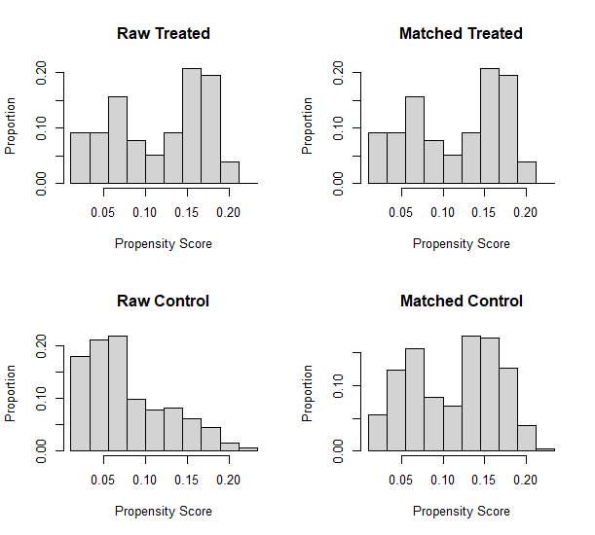
(c)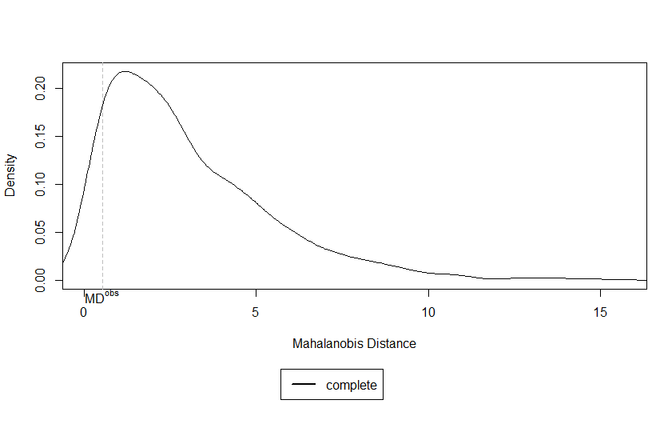(d)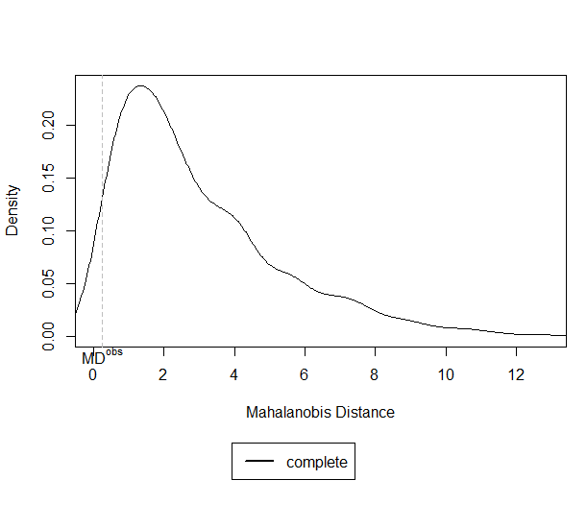

Figure S1. Propensity score histograms and Mahalanobis distance density plot checking for complete randomization. Groups were balanced regarding propensity scores (a and b, Delta and Omicron, respectively) and randomization check using Mahalanobis distance (c and d, Delta and Omicron, respectively) showed successful matching (P=0.908 and 0.965, Delta and Omicron, respectively).

