Supplemental Material
Dronedarone for the Treatment of Atrial Fibrillation with Concomitant Heart Failure with Preserved and Mildly Reduced Ejection Fraction: Post-Hoc Analysis of the ATHENA Trial
Muthiah Vaduganathan, MD MPH¹; Jonathan P. Piccini, MD, MHS²; A. John Camm, MD³; Harry J.G.M. Crijns, MD PhD⁴; Stefan D. Anker, MD PhD⁵; Javed Butler, MD MPH MBA⁶; John Stewart, MSc⁷; Rogelio Braceras, MD⁸; Alessandro P.-A. Albuquerque, MD MSc PhD⁸;
Mattias Wieloch, MD PhD^{9,10}; Stefan H. Hohnloser, MD¹¹

Supplemental Figure 1. Kaplan Meier Analysis for Death or Cardiovascular (CV) Hospitalization in Placebo-Treated Patients in ATHENA
Abbreviations: HF = heart failure; HFmrEF = heart failure with mildly reduced ejection fraction; HFpEF = heart failure with preserved ejection fraction; HFrEF / LVD = heart failure with reduced ejection fraction or left ventricular dysfunction
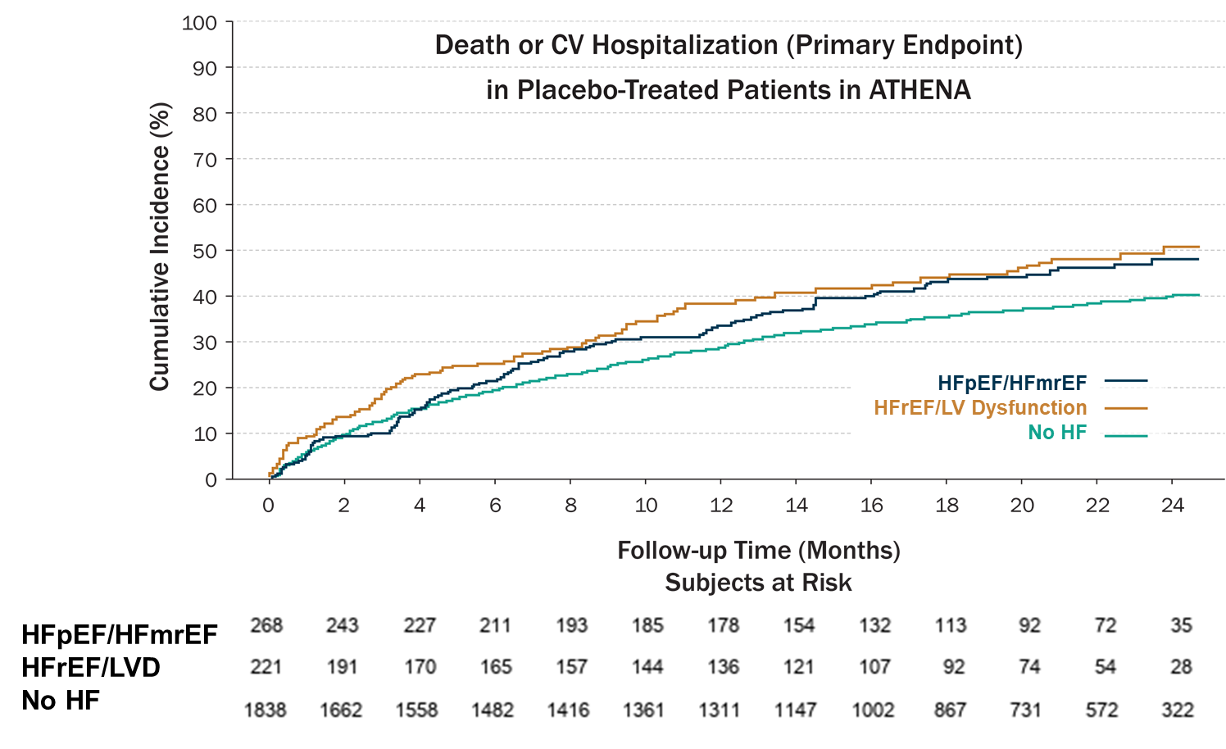

Supplemental Figure 2. Sensitivity Analysis with Less Stringent Criteria to Define Heart Failure with Preserved and Mildly Reduced Ejection Fraction (HFpEF/HFmrEF)
This sensitivity analysis evaluated the 2,353 individuals who met less stringent criteria for HFpEF/HFmrEF by removing requirement for structural heart disease.

